Topics discussed in this Class are as follows:
Docker File instrcutions
CMD instruction : It executed at the time of Container creation
----------------------------------------------------------------------------------------------------------------------
Run instruction : It executed at the time Image creation
--------------------------------------------------------------------------------------------------------------------------
creation of a docker container without assign any name to it
------------------------------------------------------------------------------------------------------------------------------
Defining Multiple cmd instructions in the Docker file
-------------------------------------------------------------------------------------------------------------------------------------
Execution working Process of Run instruction from Top to Bottom in a docker file(multiple Run instructions in a docker file would be executed from top to bottom)
------------------------------------------------------------------------------------------------------------------------------------
Execution process of CMD instruction in a docker file
----------------------------------------------------------------------------------------------------------------------------------
How to pass an Argument while creating any container
Passing Argument(parameter/cmd input) as CMD instruction while creating a container
-----------------------------------------------------------------------------------------------------------------------------------
Highest executable priority of particular cmd instruction when there are multiple cmd instructions define inside the docker image and passed as an cmd argument while creating a container from the docker image
only the last recent cmd instruction will be executed out of multiple cmd instrcutions define in a docker image
---------------------------------------------------------------------------------------------------------------------------------
Discussed about Entrypoint Instruction & purpose of this instruction.
difference between Run , CMD , Entrypoint Instructions
what is the actual difference between cmd and entrypoint instructions
define or writing multiple Entrypoint instruction in a docker file(executes only one instruction)
--------------------------------------------------------------------------------------------------------------------------------
Rebuilding A Docker image using existing docker file with new Entrypoint Instrcutions added inside the docker file.
Multiple Entrypoint instrcutions defined in the Docker file
passing a cmd argument while creating the new container based on the image
If the cmd instruction is not define inside the docker file then the cmd argument will not be executed inside the image while creating a container
--------------------------------------------------------------------------------------------------------------------------------
Q) can we keep cmd and entryppoint instructions in the docker file ?
A) Yes
What happens if we keep both cmd , entrypoint instrcutions in a docker file?
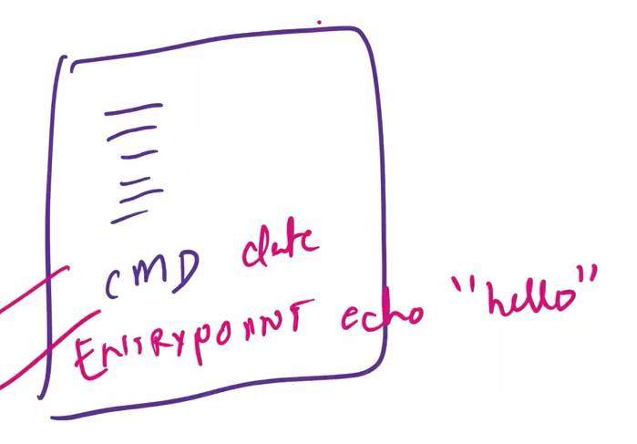
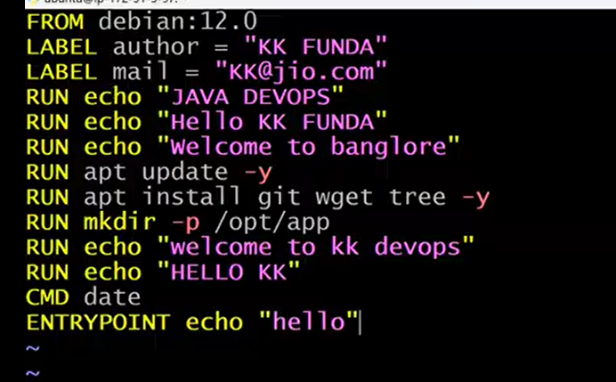
A) Entrypoint instruction has the highest priority .so only it would be executed while creating the container when the instuctions cmd , entrypoint are in the shell form
when the both instrcutions are in executable form then Entrypoint instruction would be executes but this time Entrypoint instruction would also execute the cmd instruction as well along with its command as shown in the below img
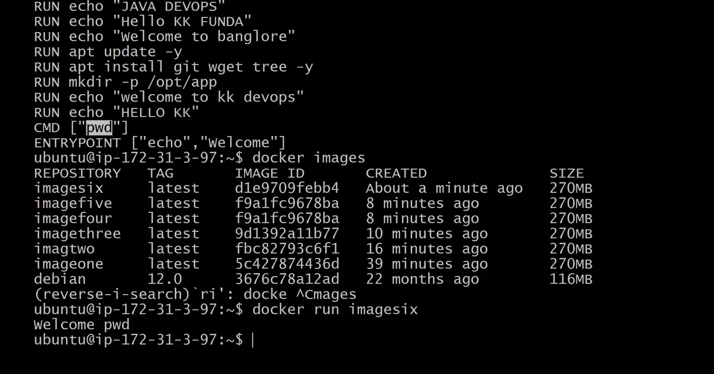
check the video stamp at 45:00
Another example shown in the below img
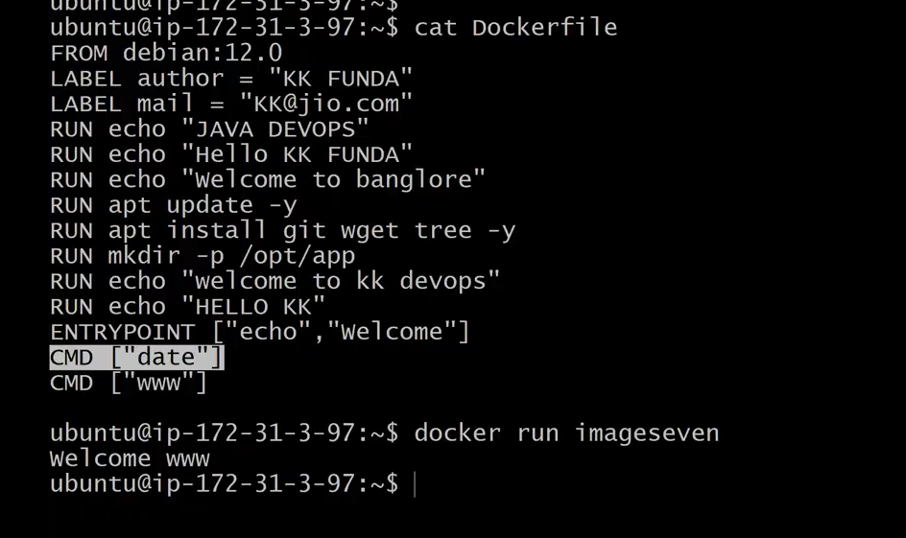
Another example shown in the below img
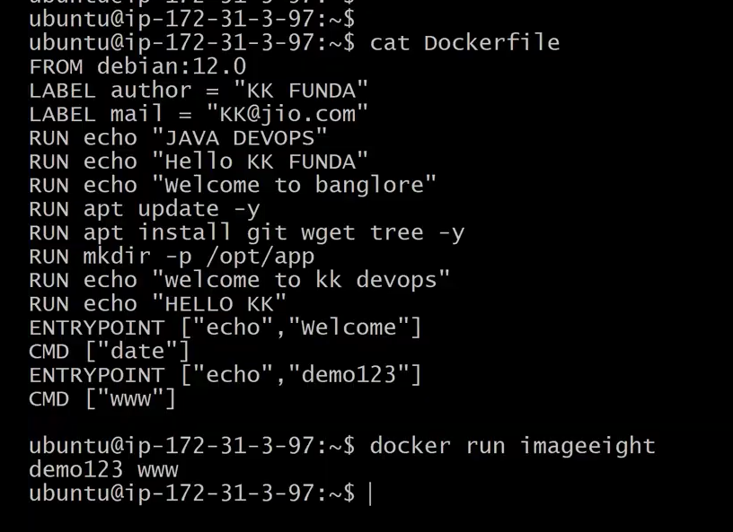
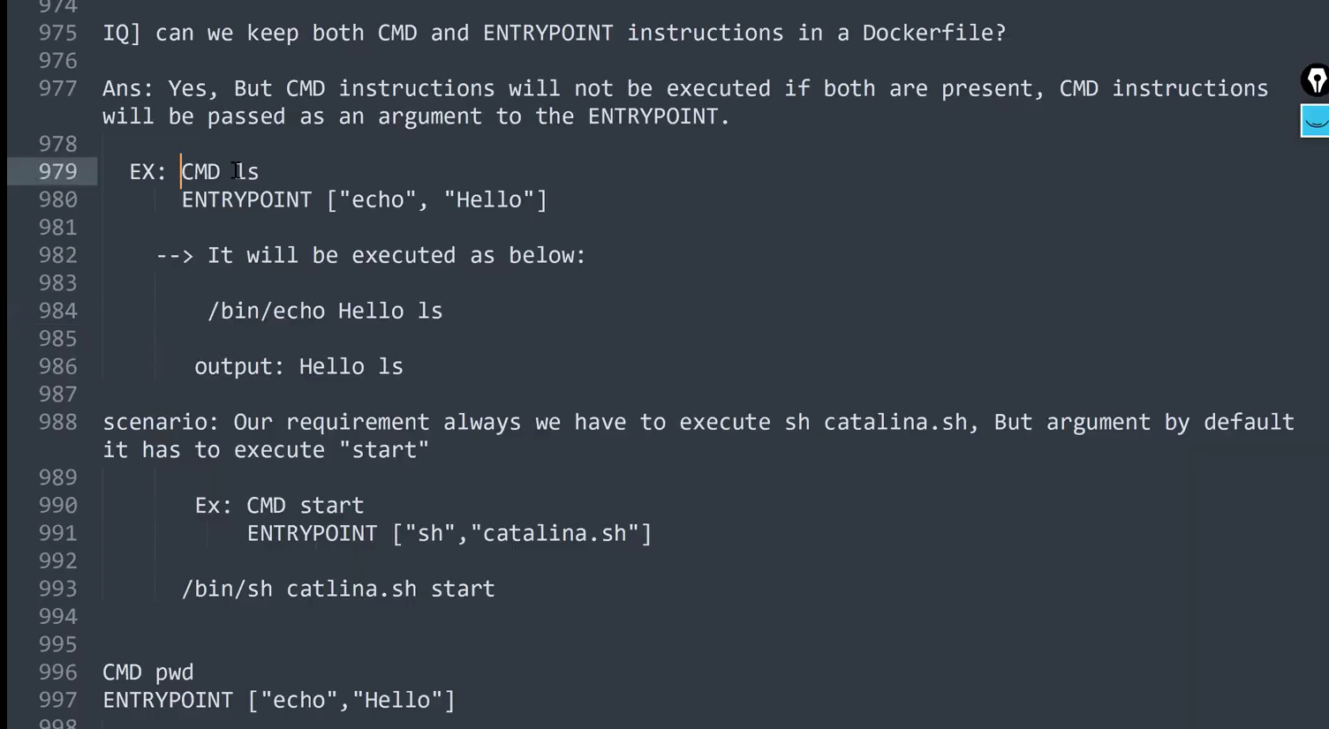
-------------------------------------------------------------------------------------------------------------------------
Executbale form is highly recommended when it comes to defining cmd , entrypoint instructions in a docker file
---------------------------------------------------------------------------------------------------------------------------------
How to create docker image from docker file without using cache a shown in the below img
All the instruction layers present in the docker file will be re executed without using the old cache when we execute the above build command as shown in the below img
Not using any cache for building the image as shown in the below img
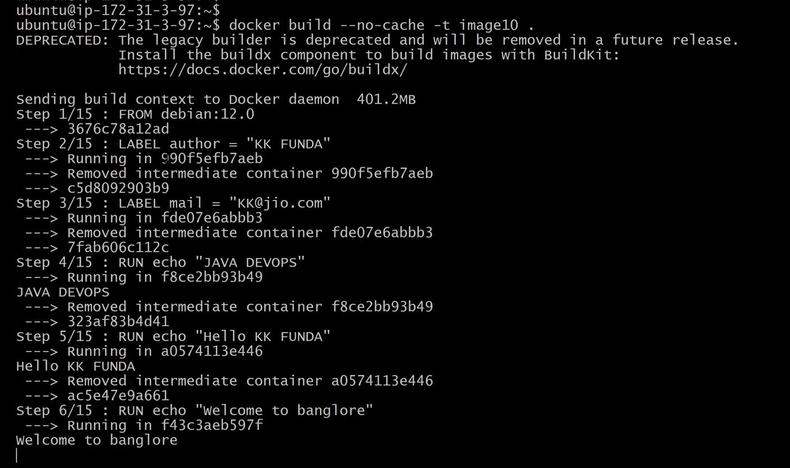
------------------------------------------------------------------------------------------------------------------------------------------
Let’s Remove all the docker images and docker containers by using the below commands
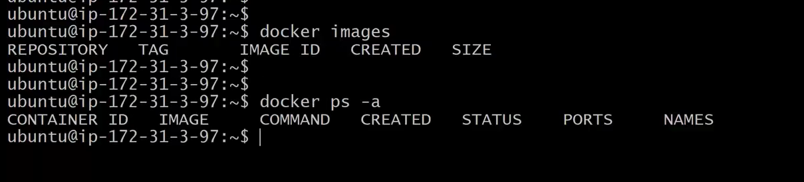
Lets try to build an image as shown in the below img
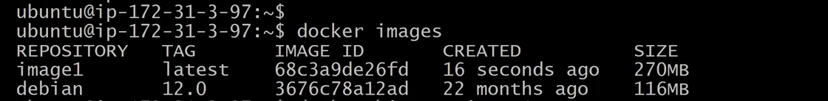
check the layers of the docker image image1 as shown in the below img
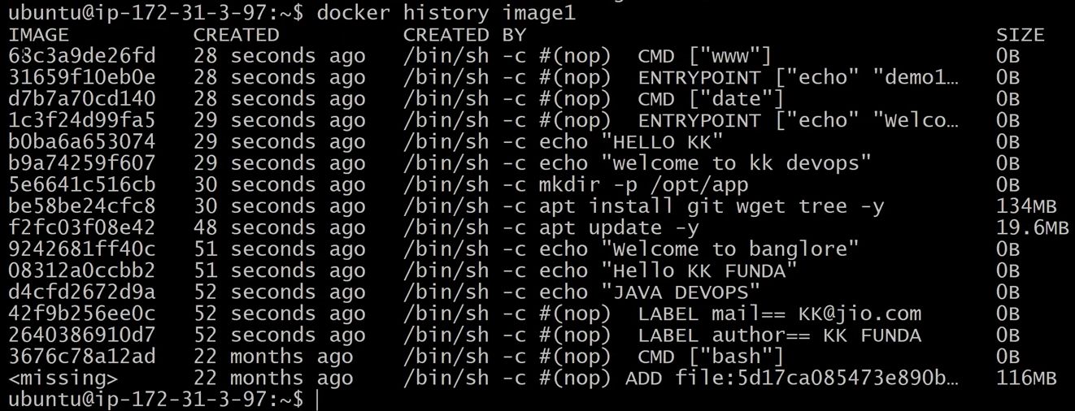
Interview question related to the docker image layer
Q) As a devops engineer how do you decrease the layers of the docker image?
- There are Multiple ways to decrease the docker image layers
1) open & edit the docker file as shown in the below img
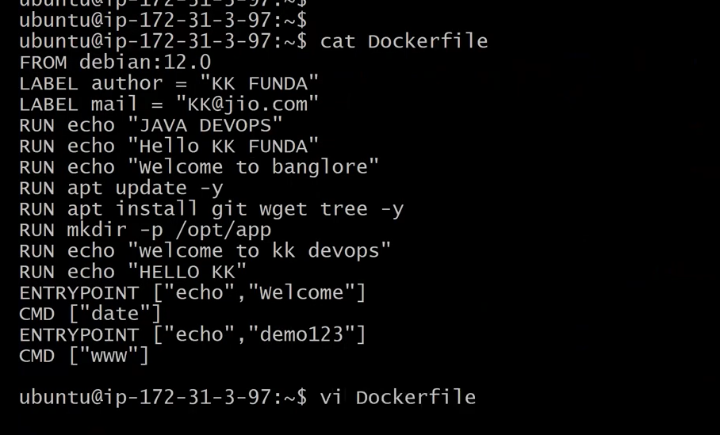
define all the Run instrcutions in a single line
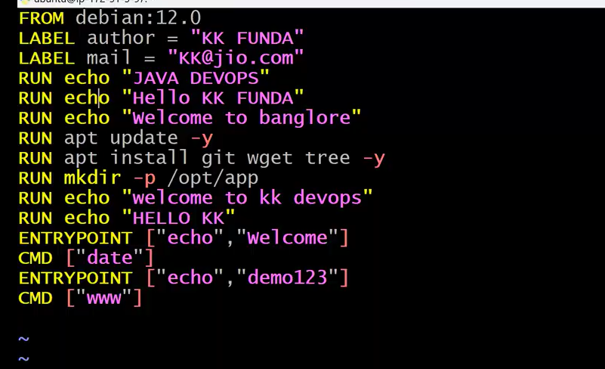
below img shows defining of run instruction in a single line using logical ‘&&’ operator
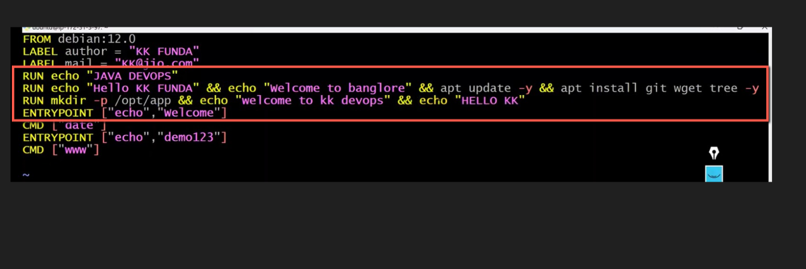
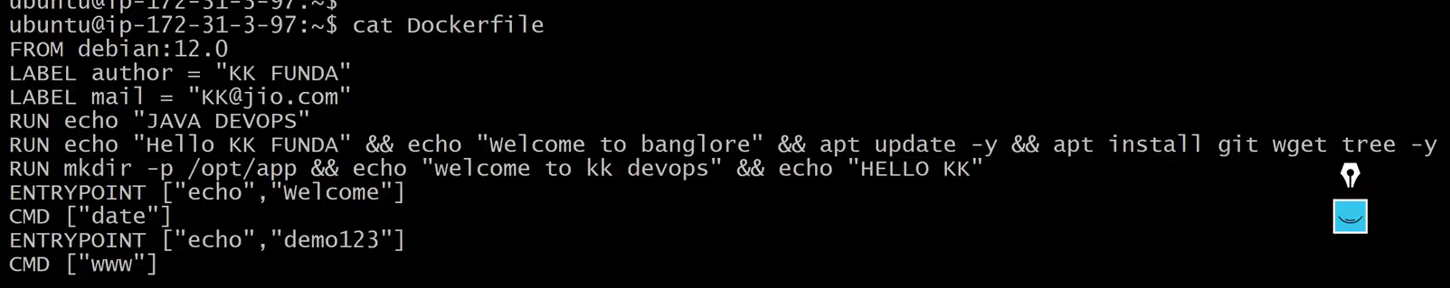
Now save the above edited docker file and build a docker image with the docker file
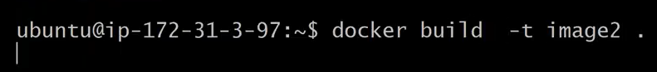
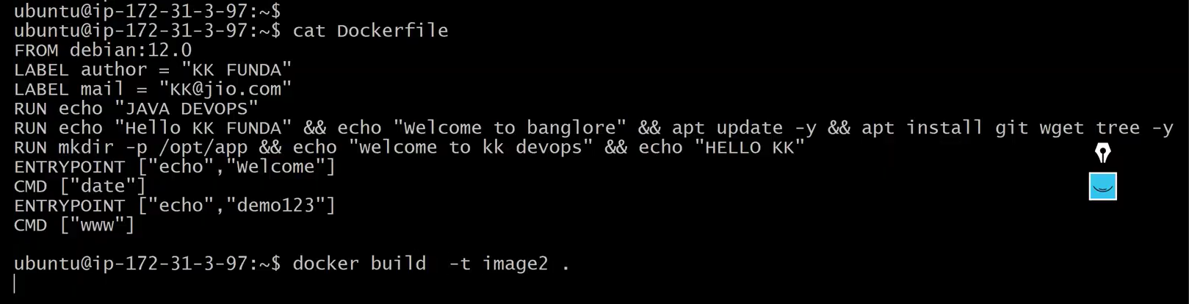
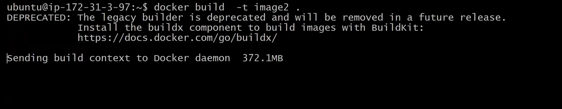
This time docker daemon will not use cache for building the image becoz we have change the instruction in the docker file using ‘&&’ operator
Finaly docker Image image2 got build as shown in the below img
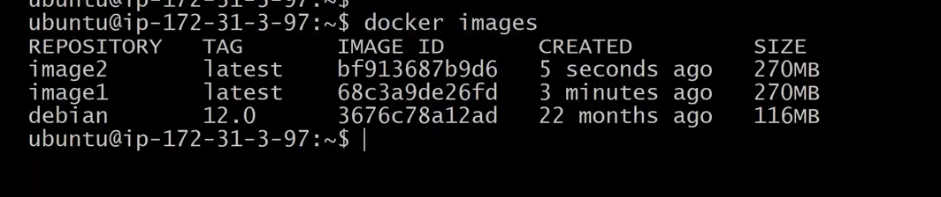
check the history of the image2 you will find no of layers of the docker image2 is decreases as shown in the below img
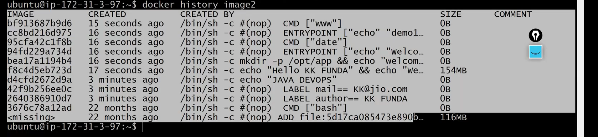
so by writing multiple run instructions in to a single line by using && operator in the docker file we can decrease the layers of the docker image
Now let’s Nullify the Docker File (deleting the content of the docker file) by using the below command >dockerfile
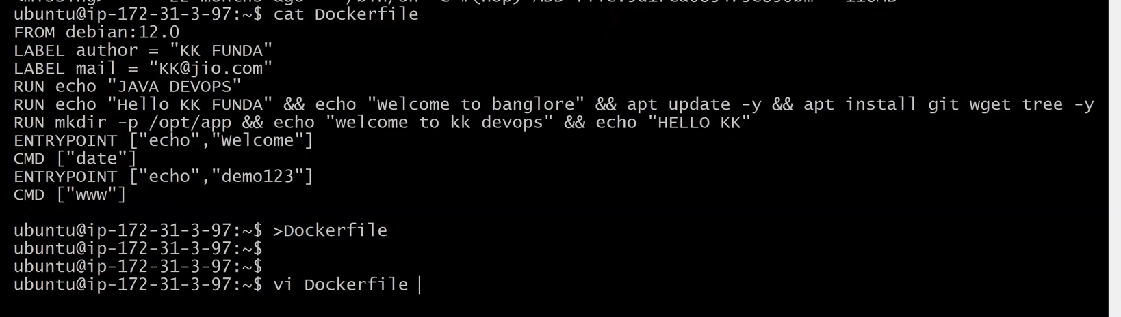
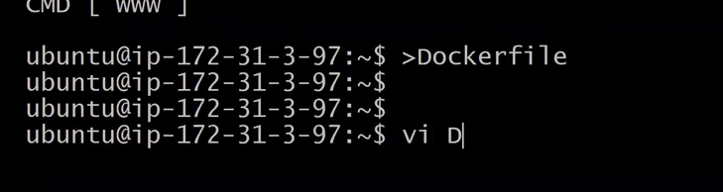
copy the content of the dockerfile before nullifying or deleting the docker file content and paste it in a notepad
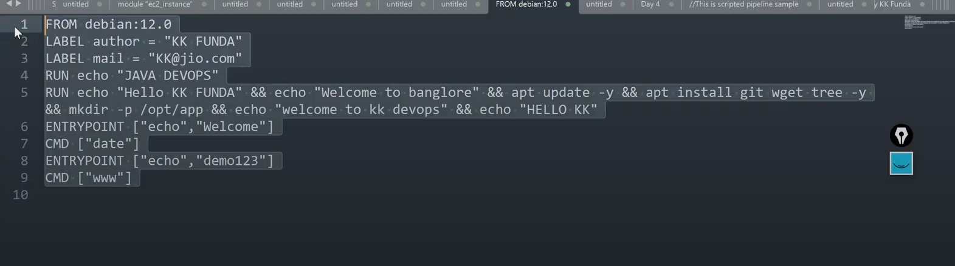
paste the dockerfile content in the docker file as shown in the below img
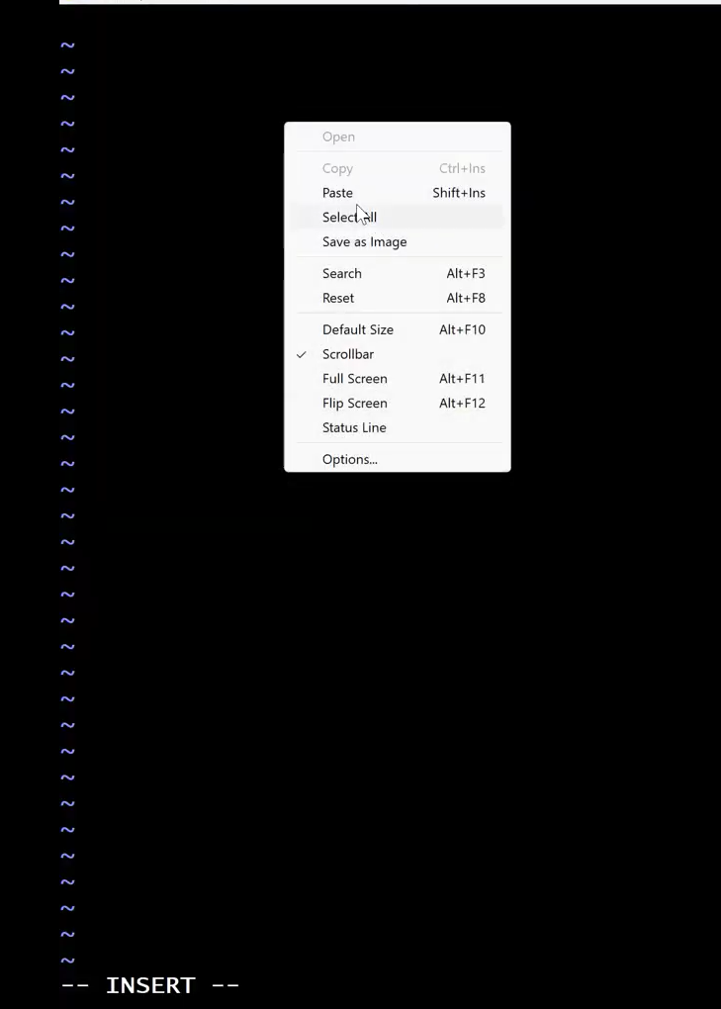
paste the content in the docker file as shown in the below img
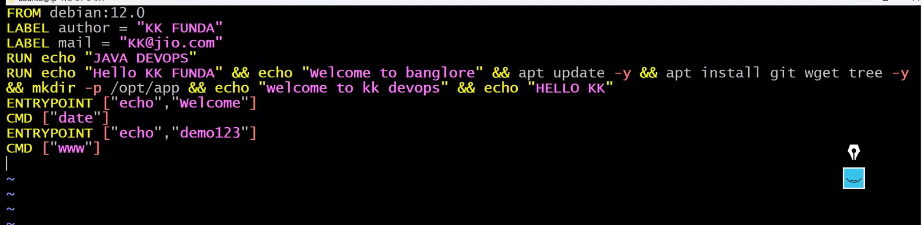
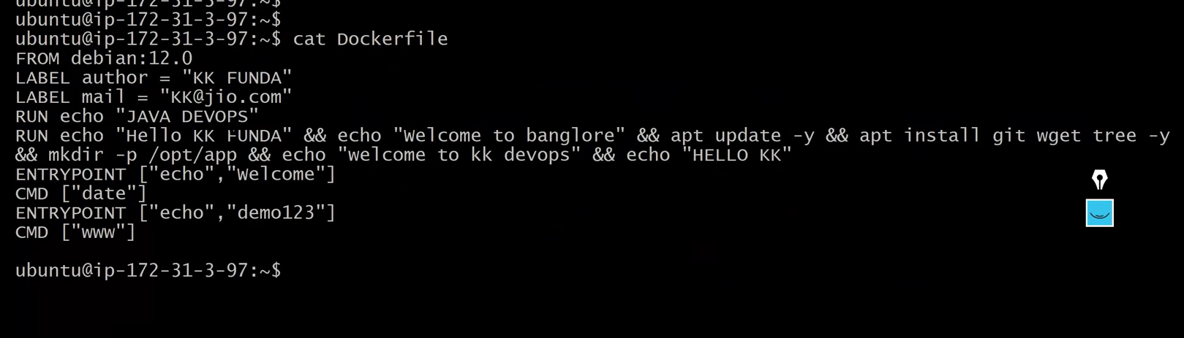
Lets build the docker image based on the new docker file as shown in the below img
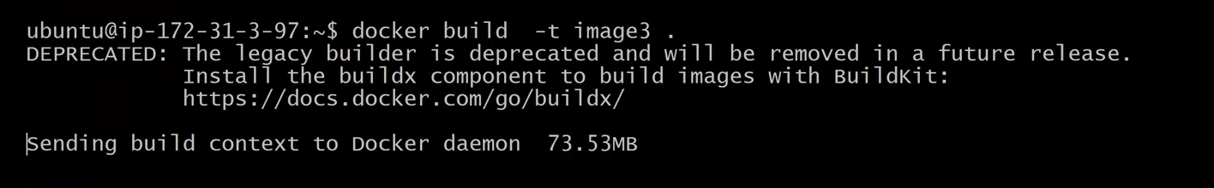
As you can see in the below img the docker image instrcutions got reduced
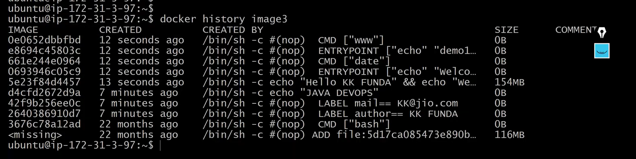
To increase the readability of the docker file use \(slash) in the run instruction as shown in the below img
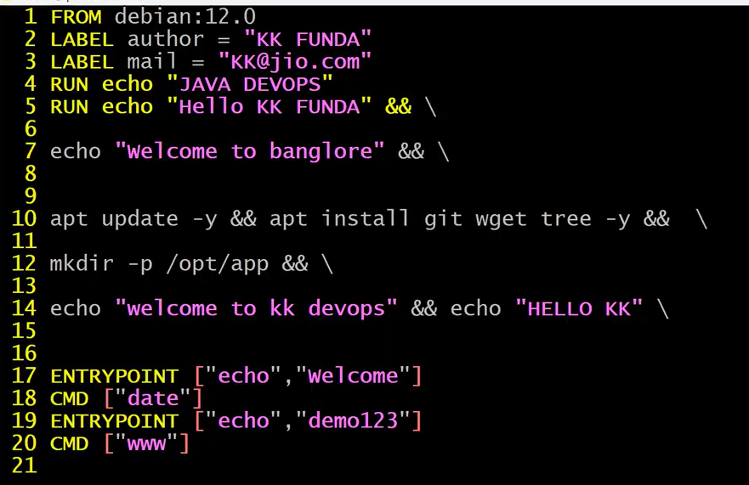
Save the above docker file and build docker image as shown below
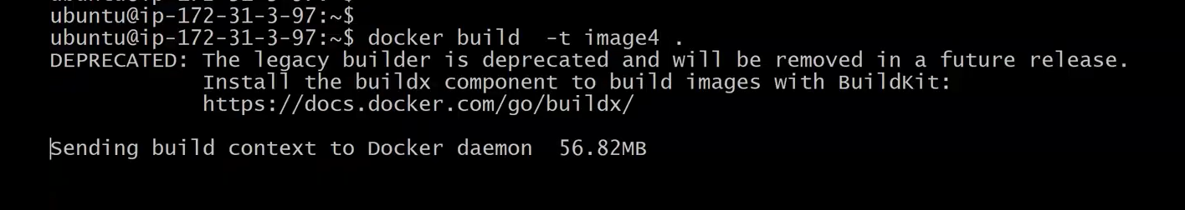
docker image4 got built as shown in the below img
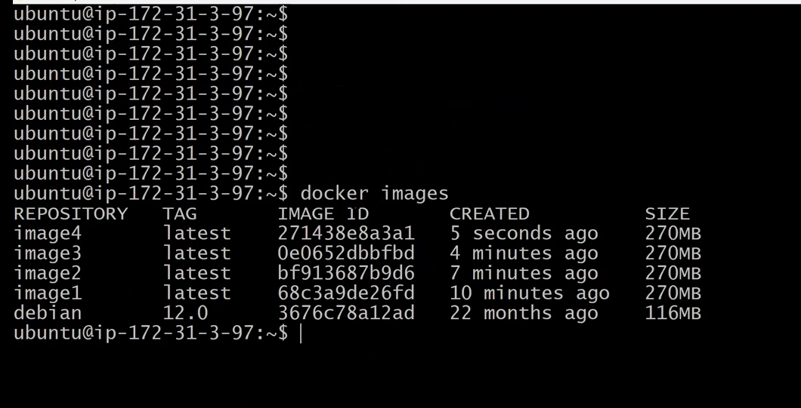
checker the Layers of the docker image4 you will find the layers are reduced with same memory
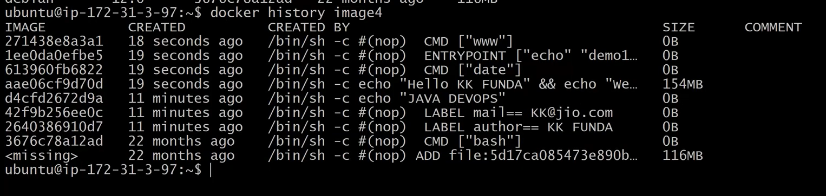
class ended

--------------------------------------------------------------------------------------------------------------------------------------------------------------------------------------------------------------------------------------------------------------------------------------------------------------------------------------------------------------------------------------------------------------------
check the docker images , running containers and try to stop all the running docker containers by executing the command docker stop $(docker ps -aq)
Let remove all the stopped containers by using the command as shown in the below img
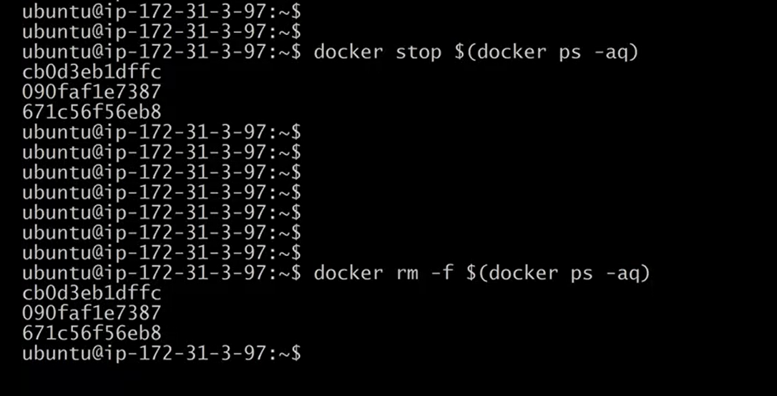
Remove the docker images also as shown in the below img
