Topics discussed in this class would be written below
------------------------------------------------------------------------------------------------------------------------------------------
So far we have discussed about docker instructions , difference between the docker instrcutions , docker image layers
-----------------------------------------------------------------------------------------------------------------------------------
Copying file/scripts from ec2 instance in to docker file
use the below command to copy and paste the any script that is avaialble in ec2 instance in to docker file as shown in the below img
open the docker file and try to copy the ddemo.sh script file from ec2instance in to the current docker file as shown below
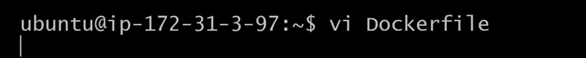
Docker file
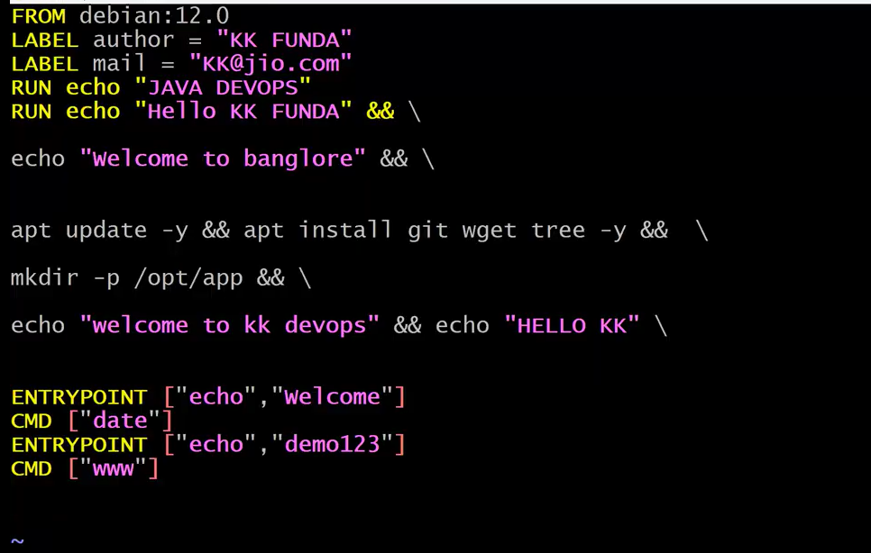
Now let to copy & paste one shell script from local host/ec2 instance in to the dockerfile as shown below
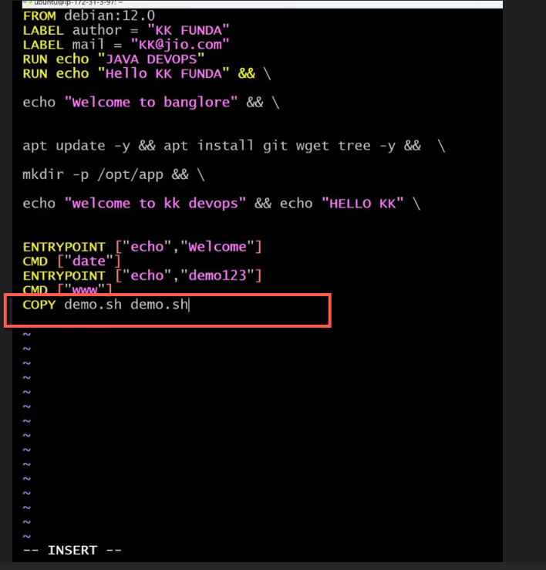
save the docker file and cat it as shown below
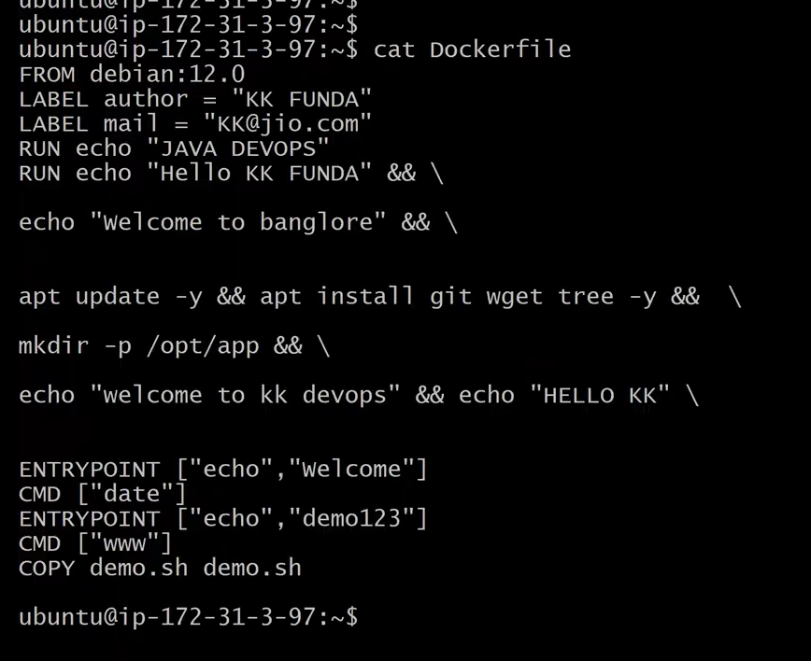
Let build the docker image as shown the below img
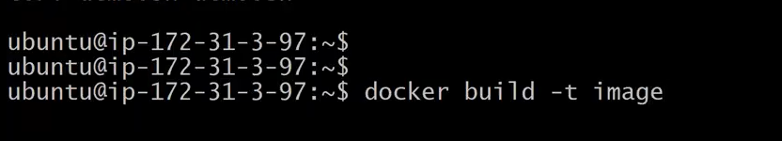
copy got failed
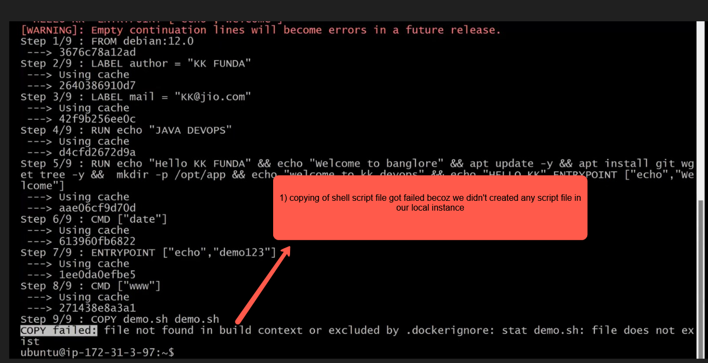
so the script file is not available in the docker file (build context)
lets create the script file demo.sh and try to copy it from local machine in to docker file and build the image and run the container
to check the files inside the container we use the command exec and then check the files by executing the command ls –lrth
Interview question without using copy instruction of the docker file How can you copy your local file in to docker image
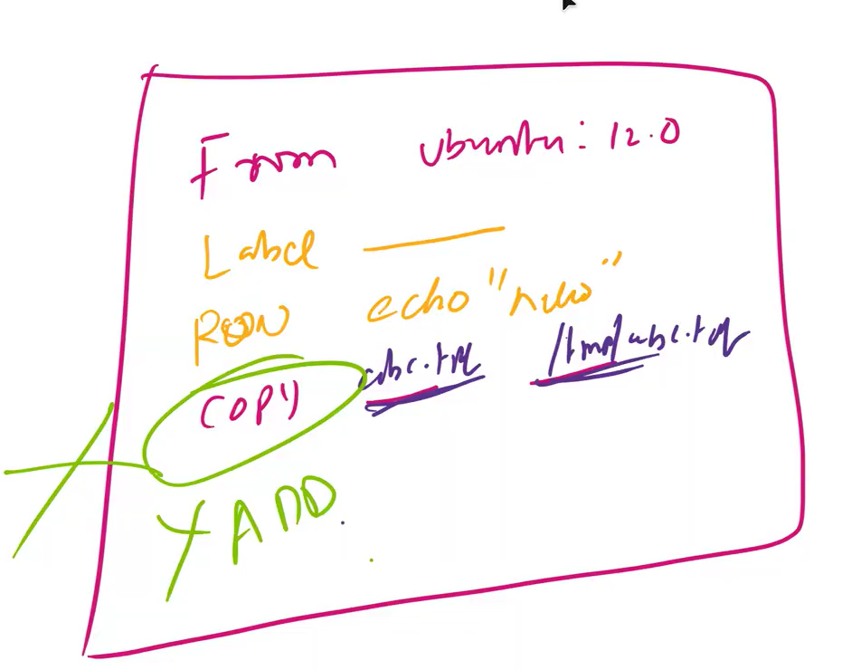
A) by using the run cp demo.sh /tomcat/demo.sh we can copy the file in to the docker image
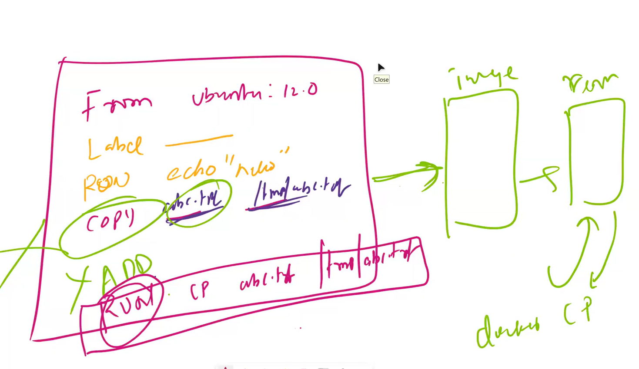
-------------------------------------------------------------------------------------------------------------------------------------------------------------------------------------------------------------------------------------------------------------
Argument Instructions
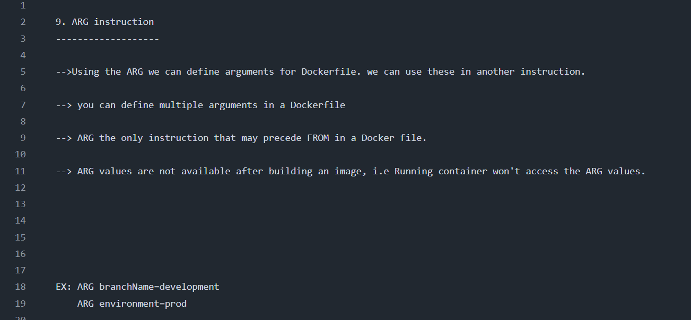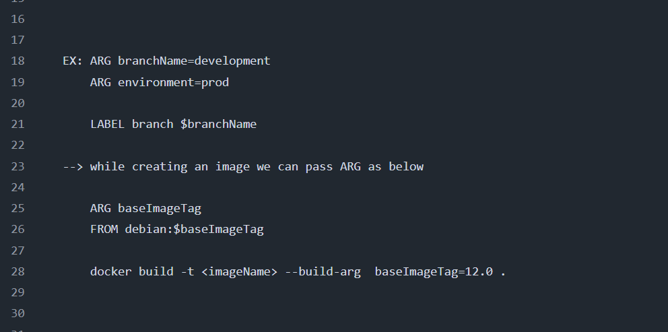
In a docker file we can define ARG variable before (precede) From instruction as shown in the below img
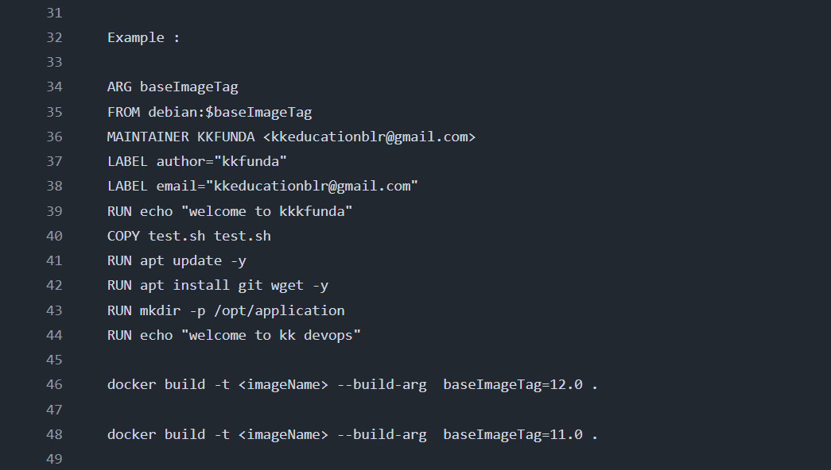
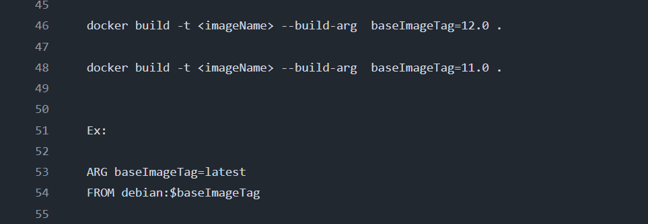
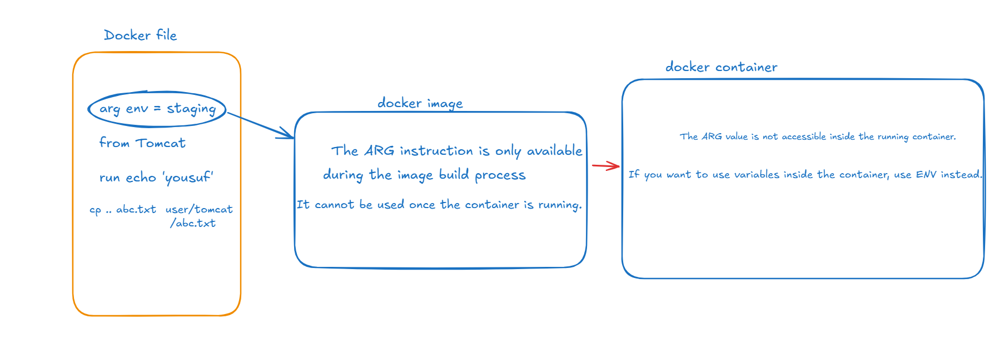
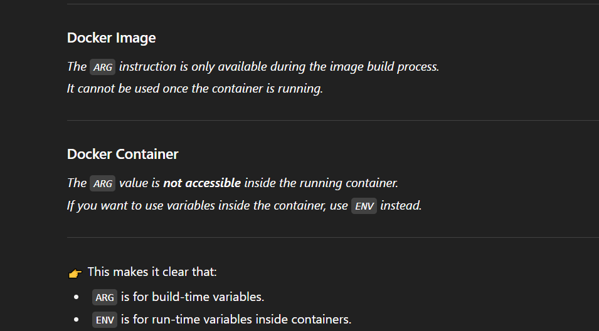
ENV instruction
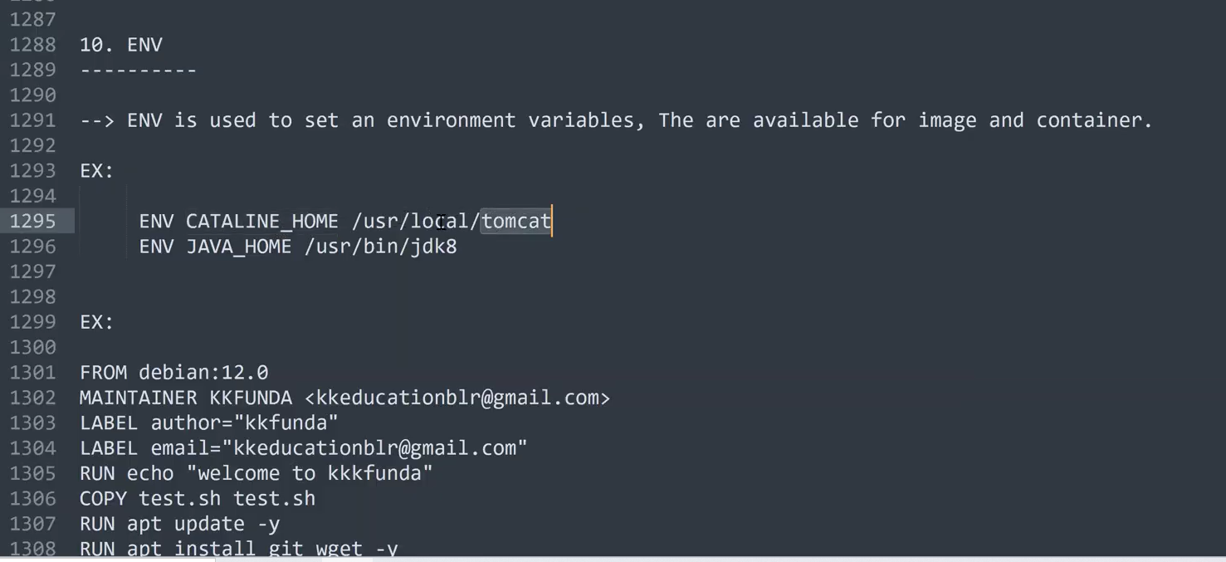
In the below img we have nullify the docker file and added the new data as shown in the below img
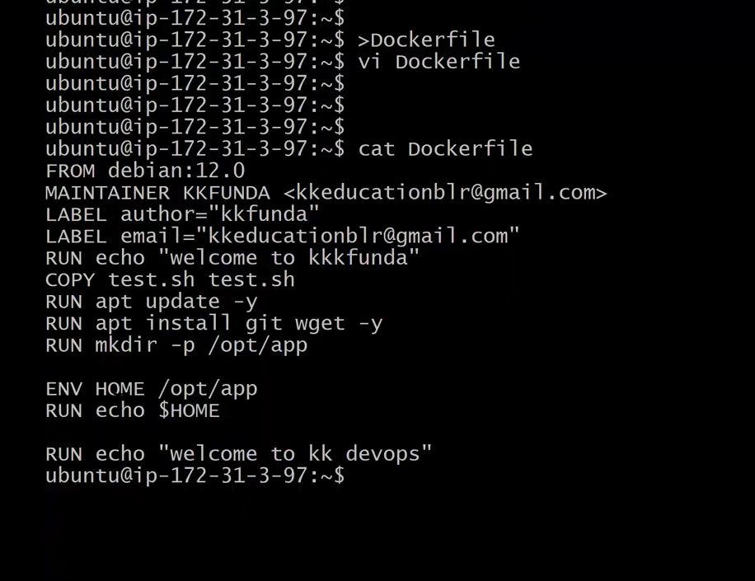
time stamp 32:00
build the docker image as shown below
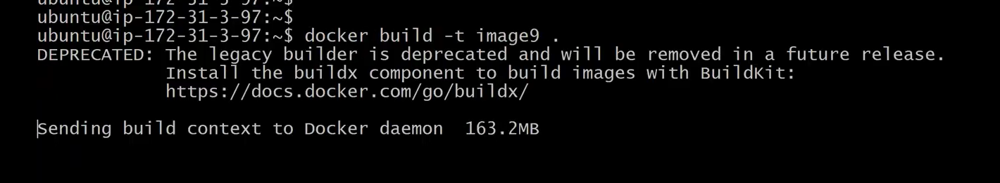
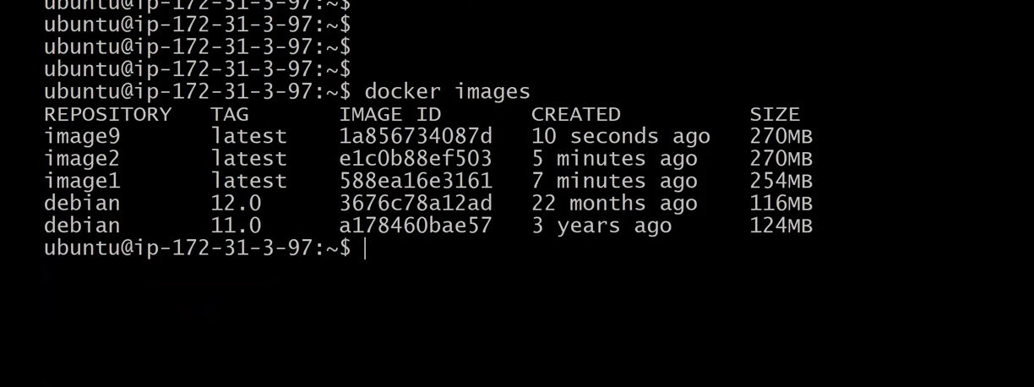
inspect docker inspect image9 and check the env variable as shown in the below img
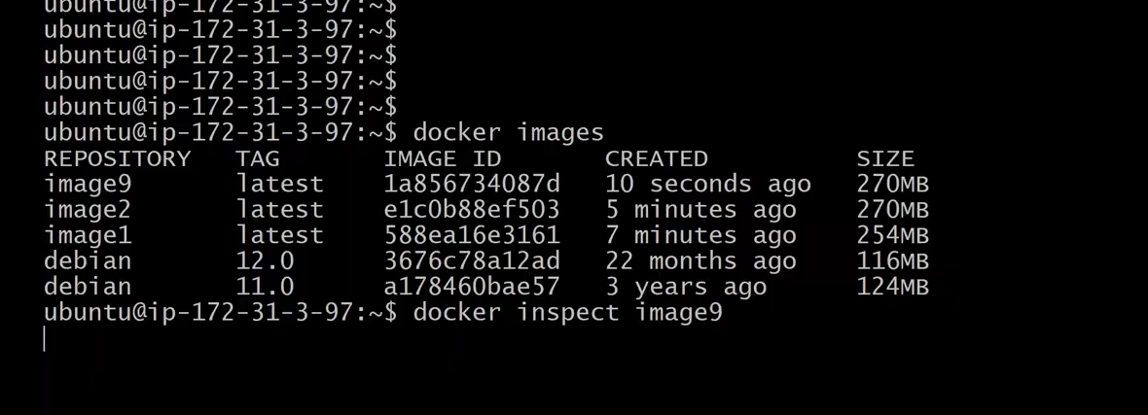
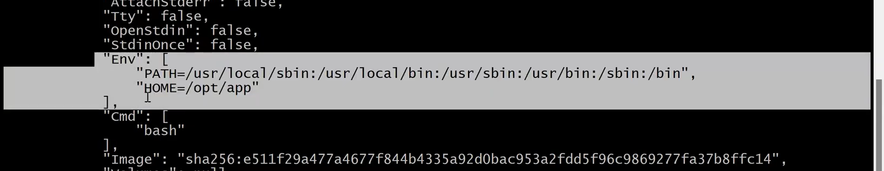
WORKDIR (very important instruction)
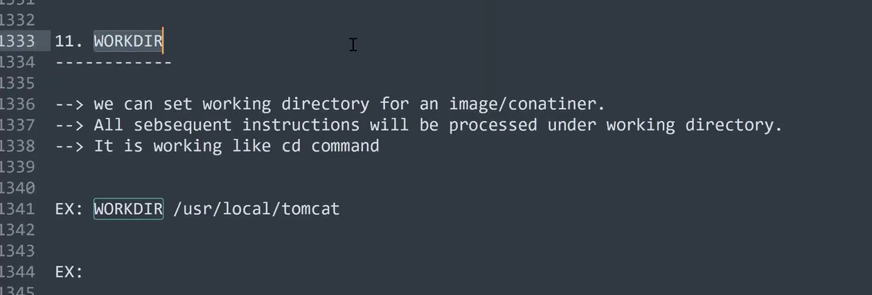
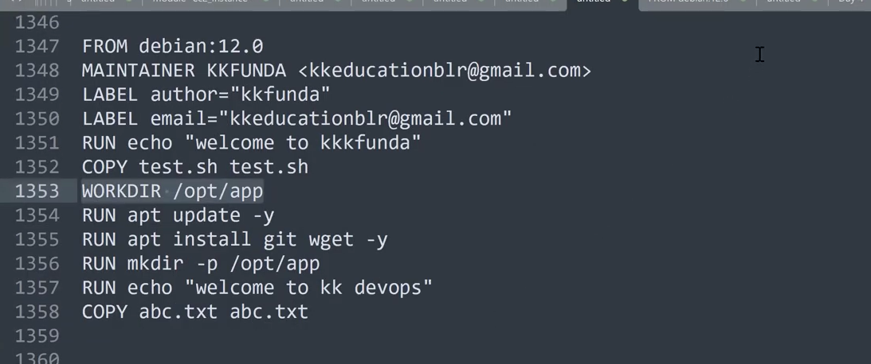
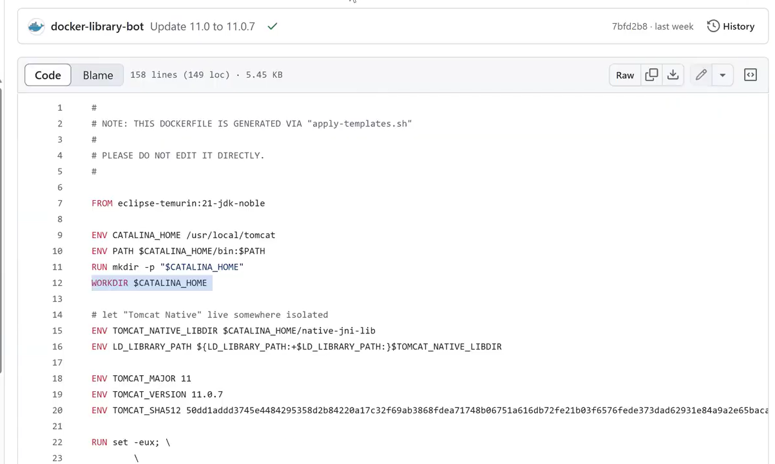
USER(instruction) very important
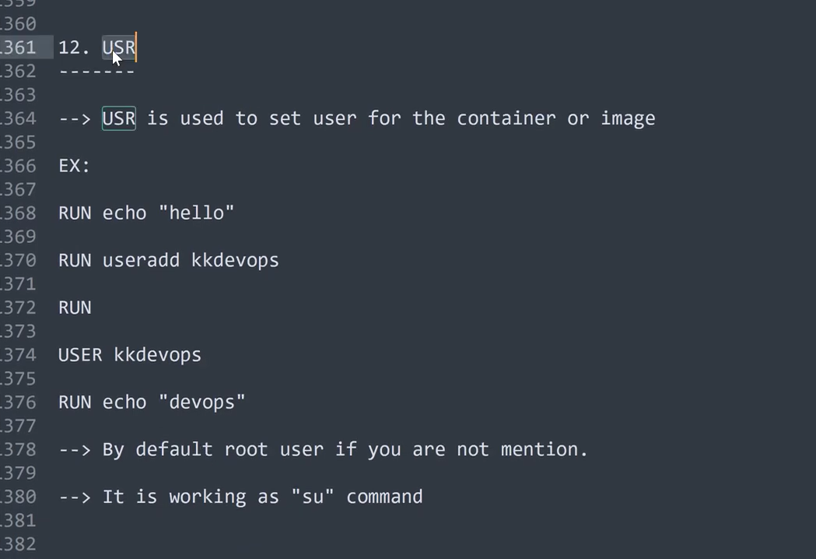
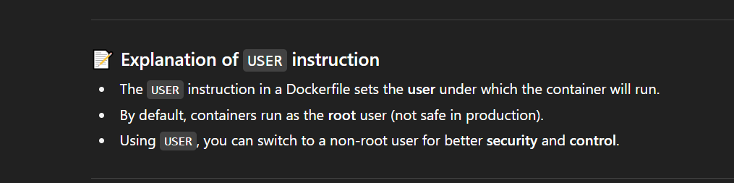
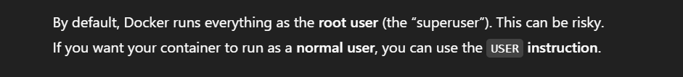
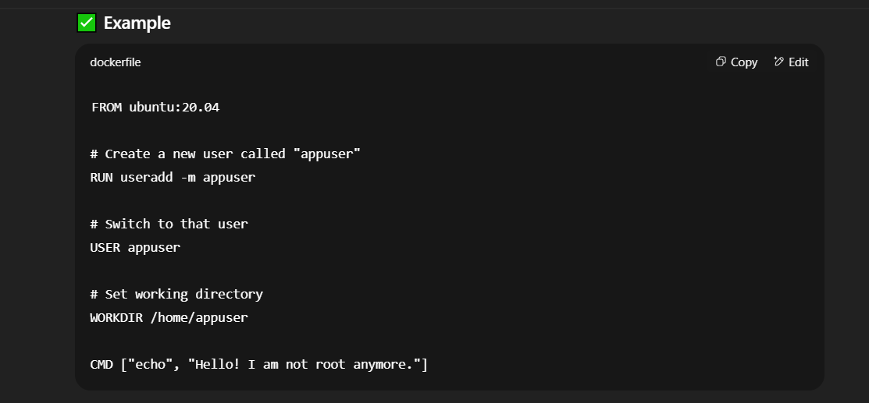
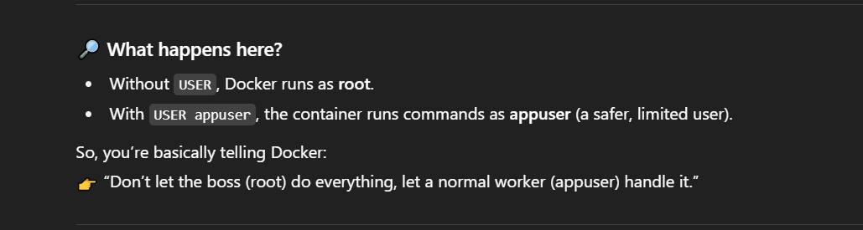
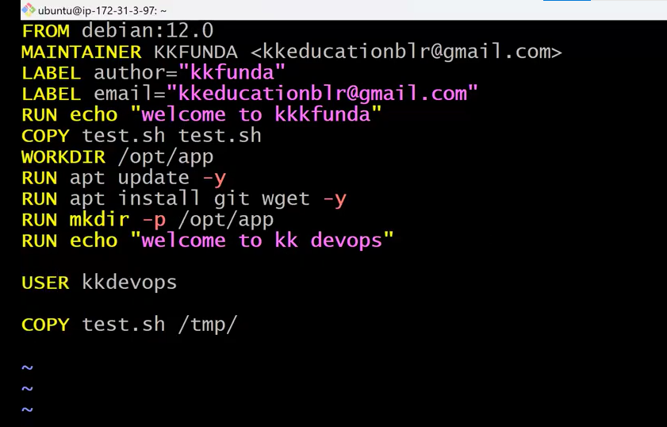
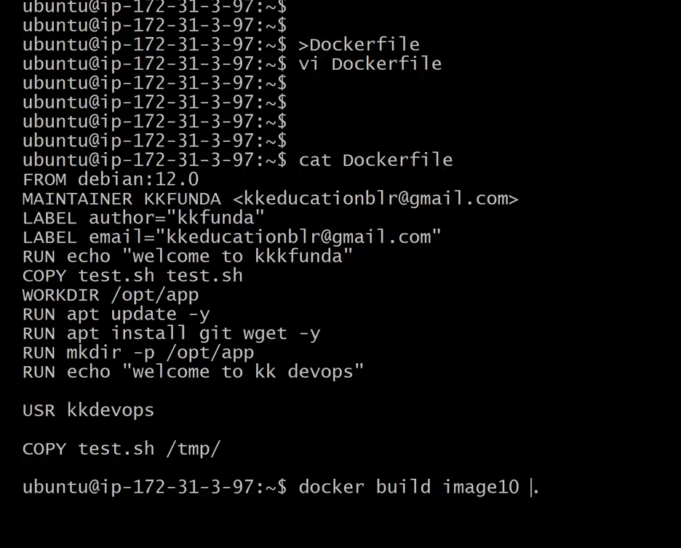
It will through an error as there is no user in the base image of the docker file as shown in the below img
Expose Instrcution
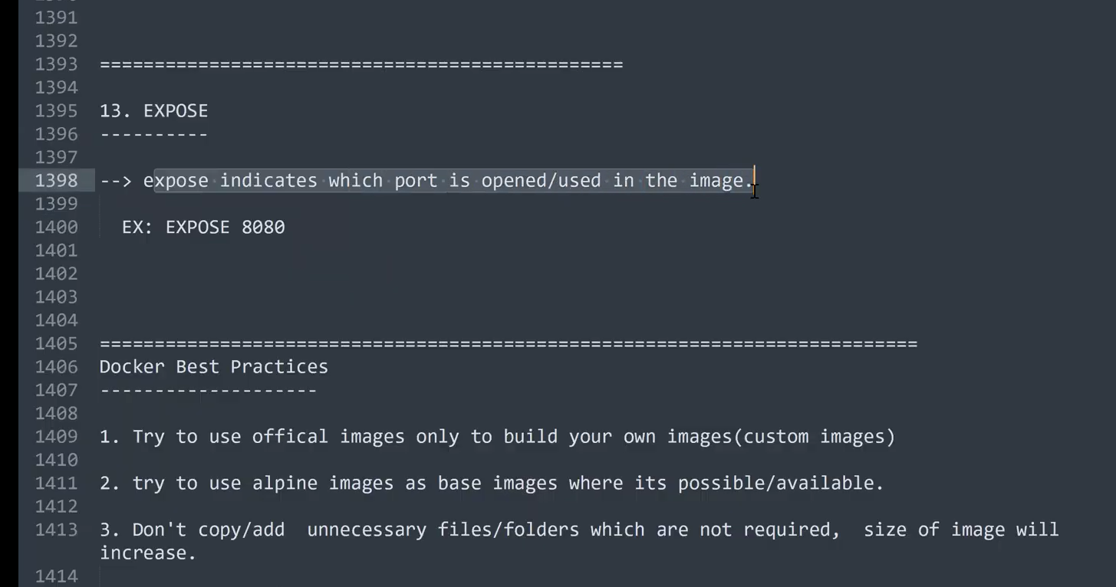
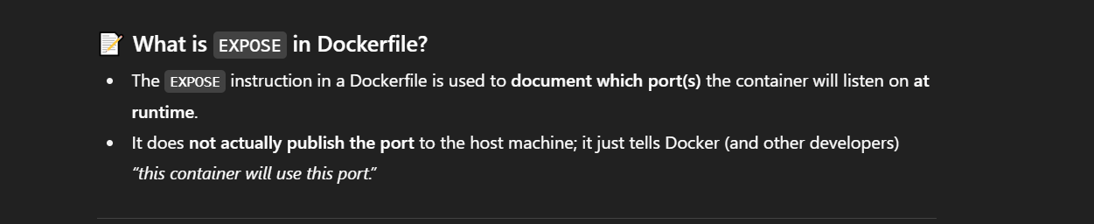
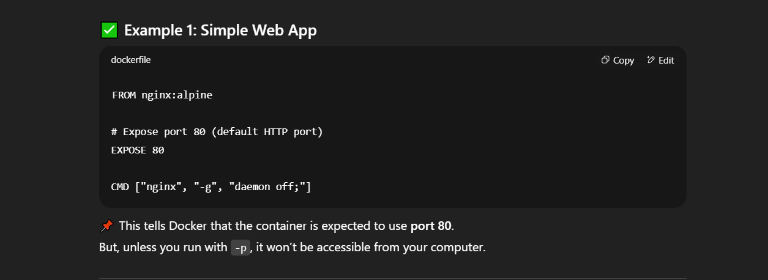
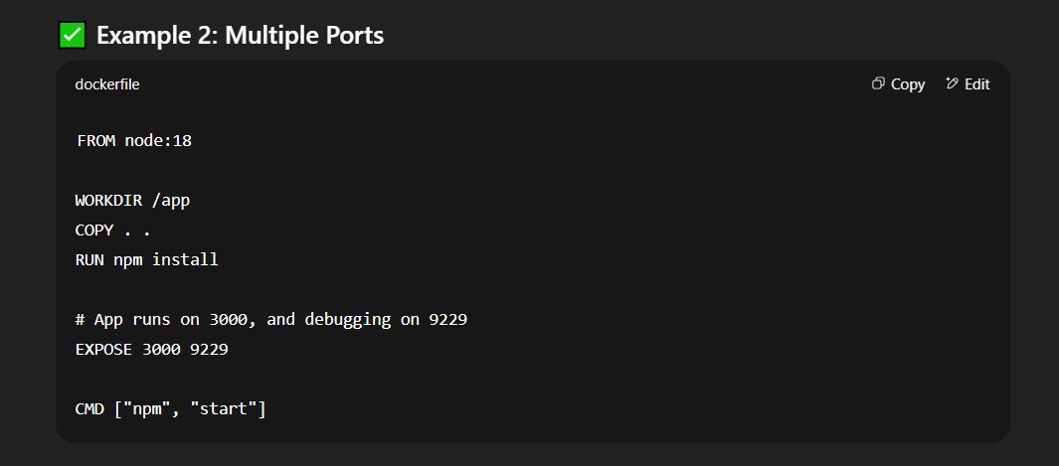
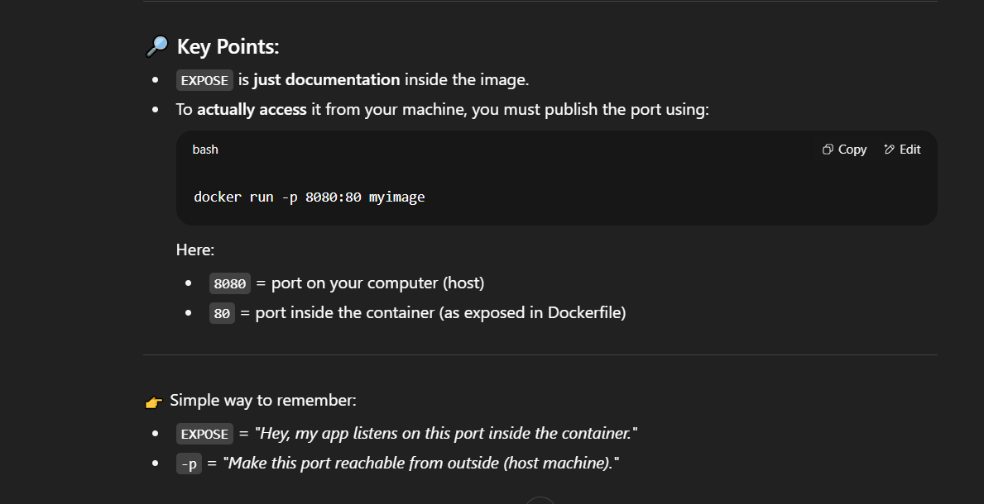
Q & A at 1:004

