In this class we will study Docker Networking (Interaction of Multiple containers in a Docker is called Docker Networking)
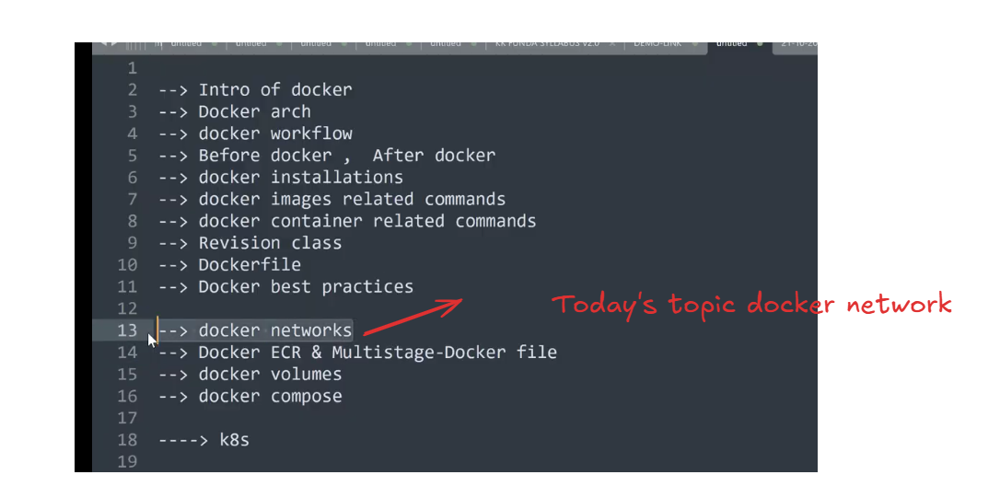
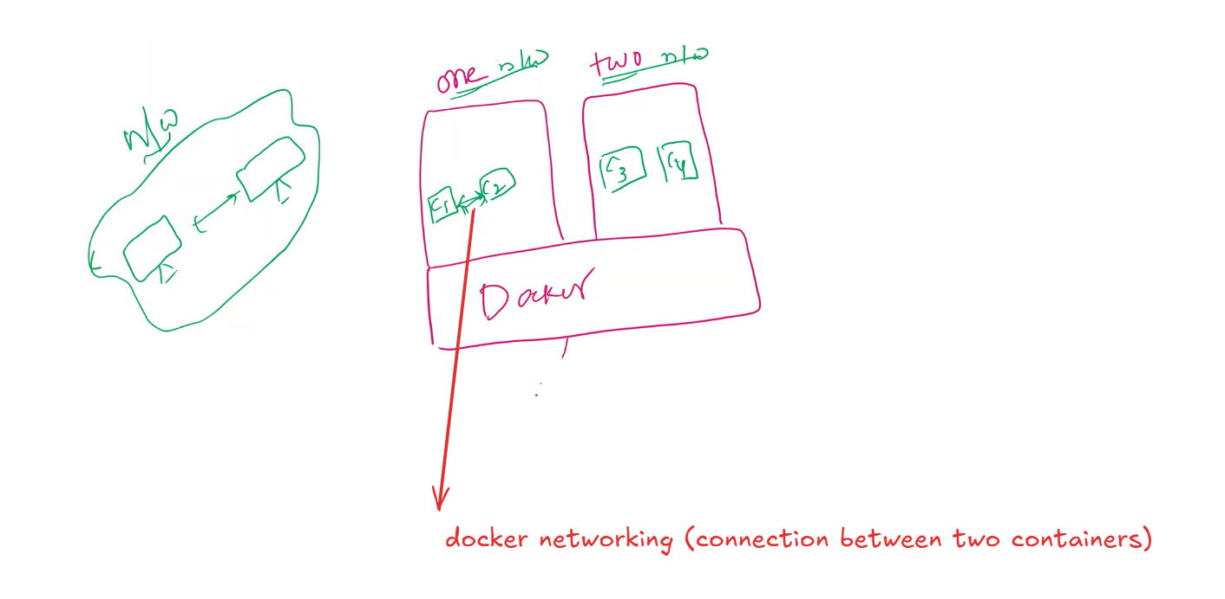
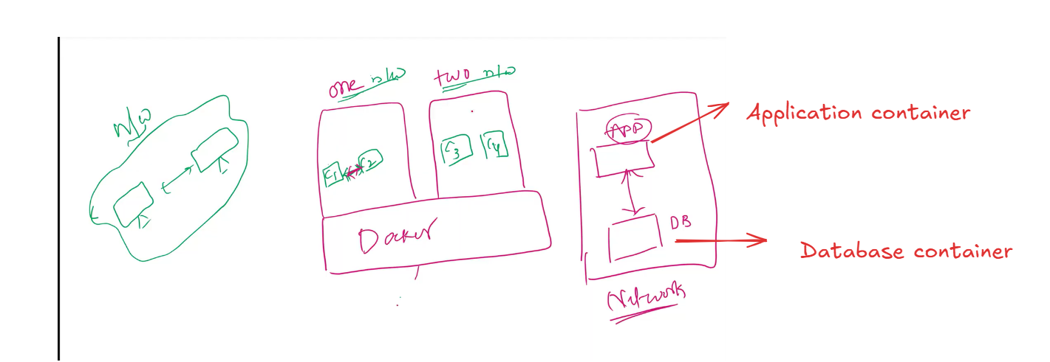
The containers must be in a network to establish the connection between them
Application container ---> Network
Database container ----> Network
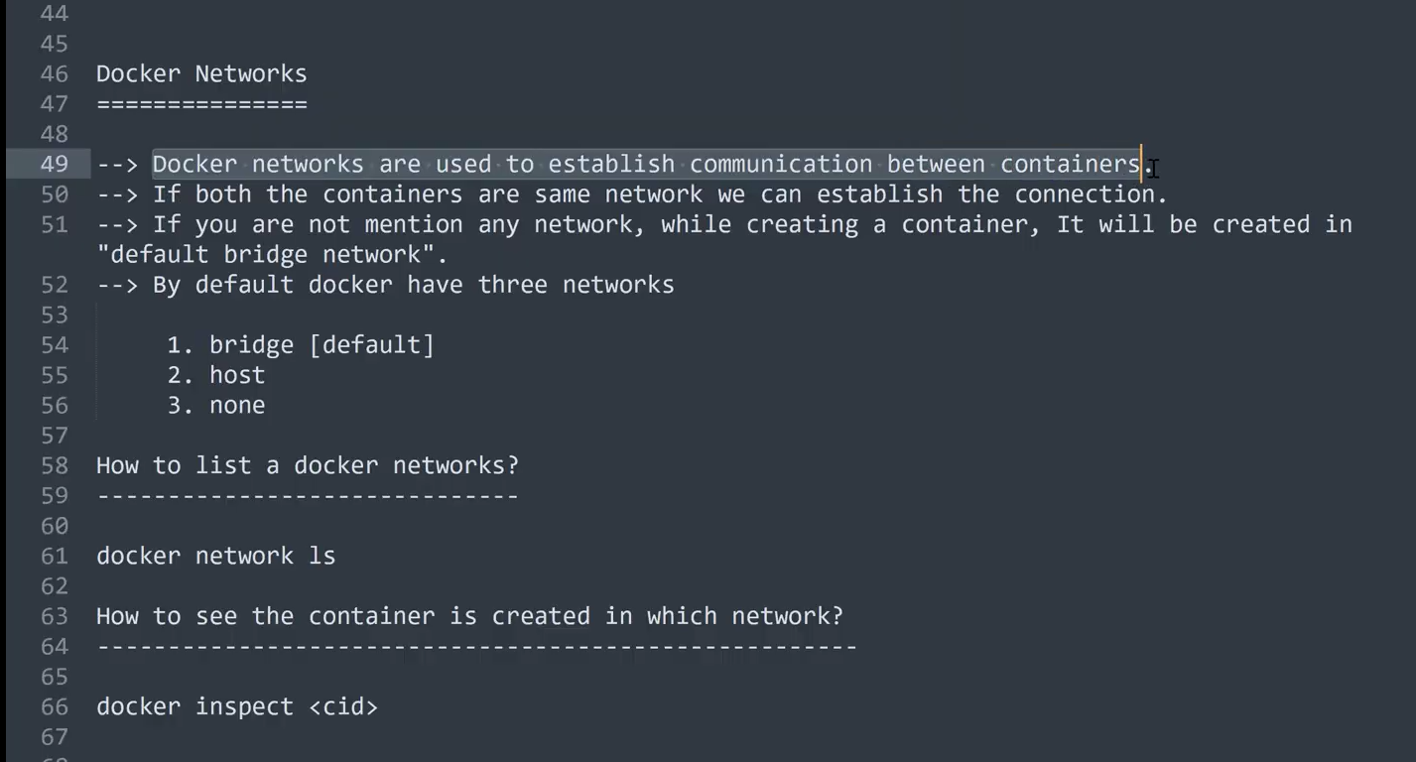
Lets connect to the Docker Instance
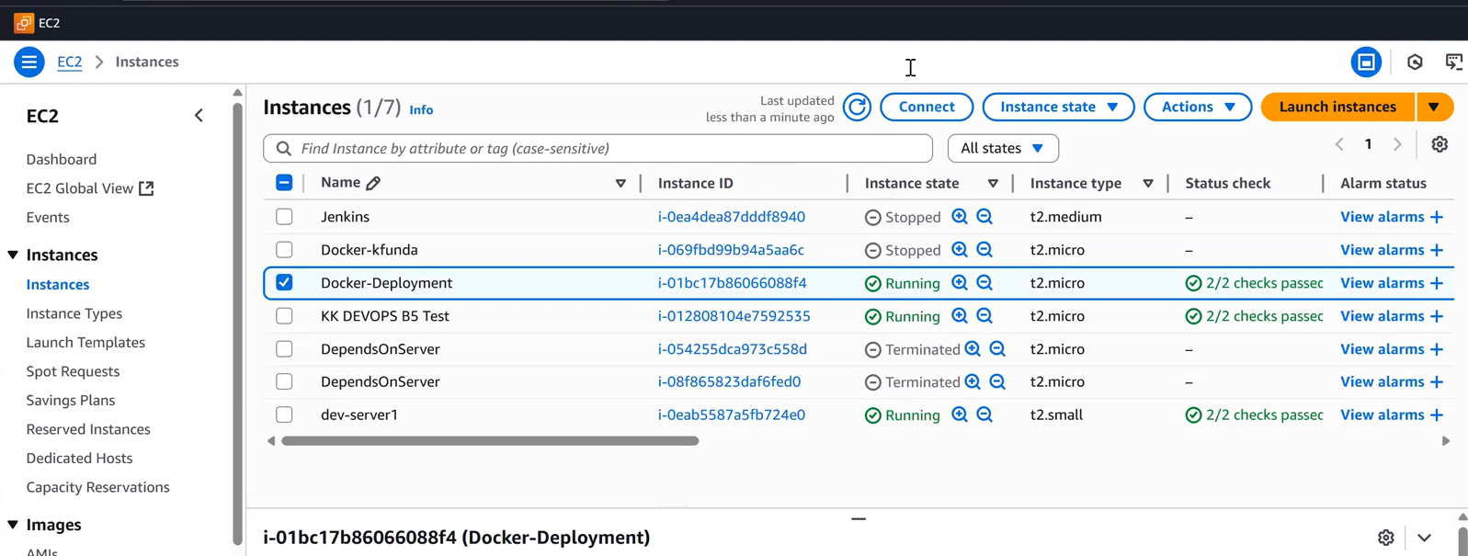
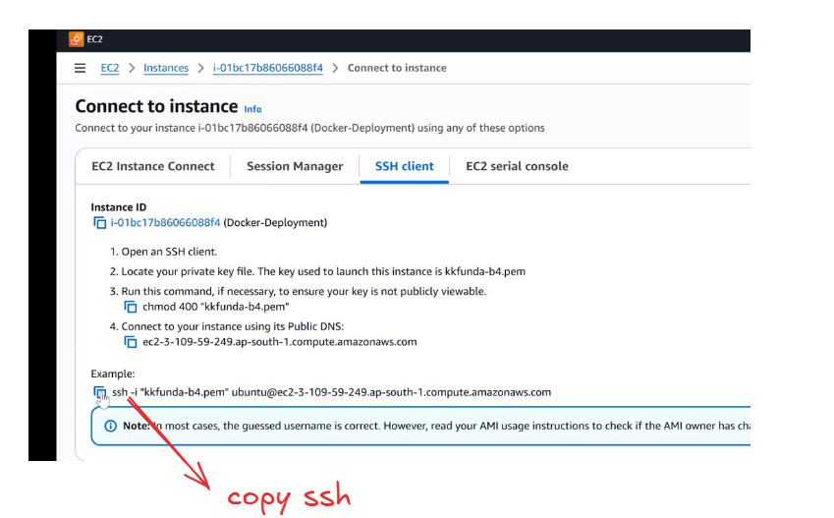
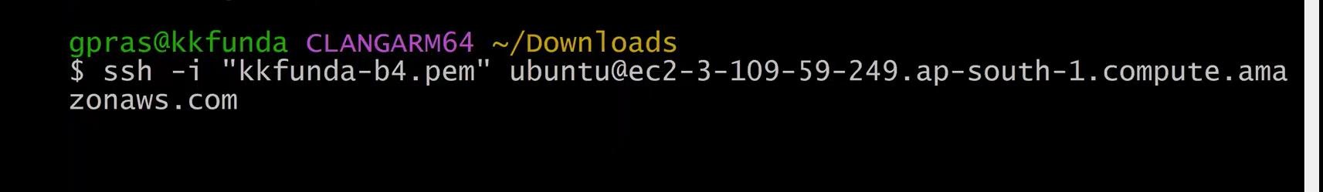
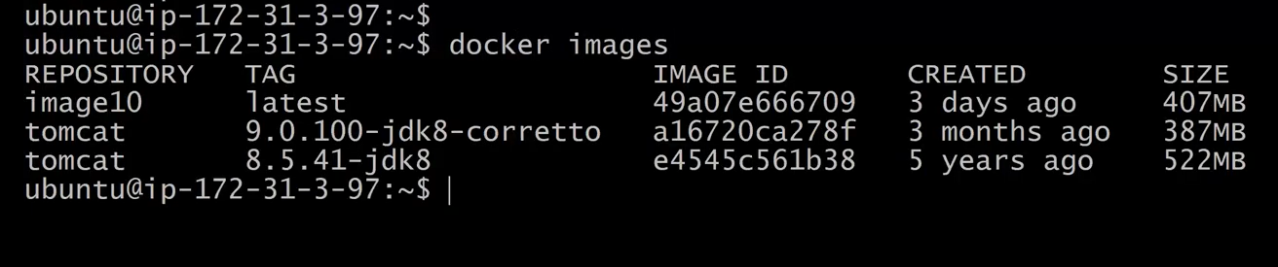
Remove the containers as shown below
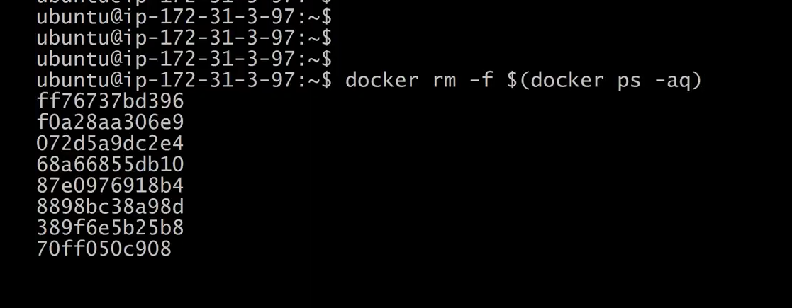
Remove images also
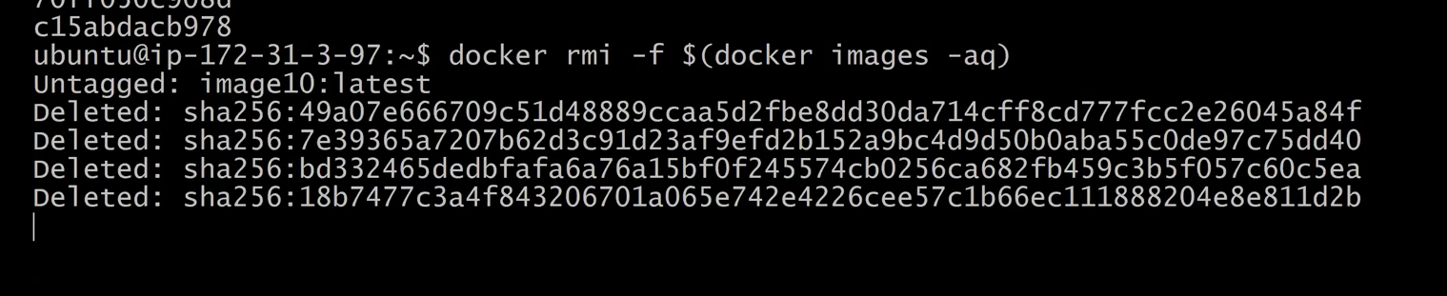
To list the Docker Networks we have to execute the command docker network ls
bydefault we have three docker networks
1) Bridge Network
2) Host network
3) None Network
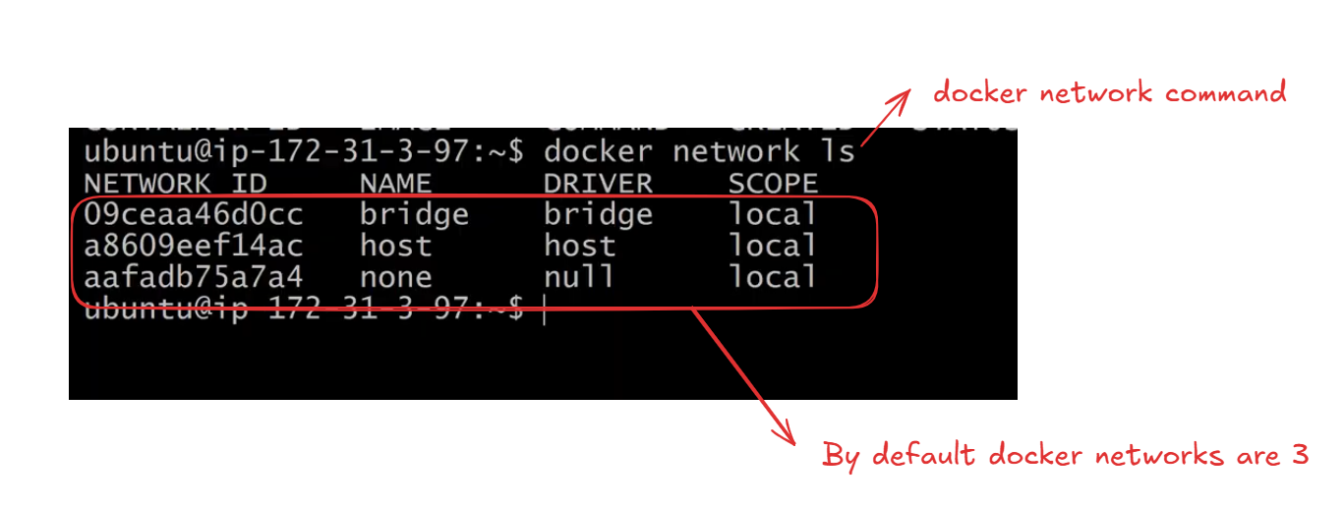
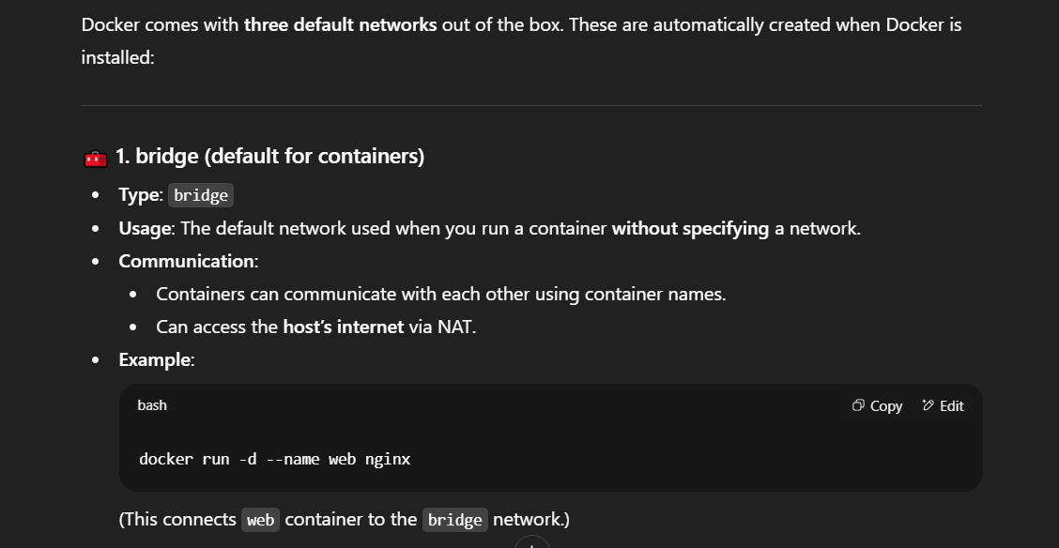
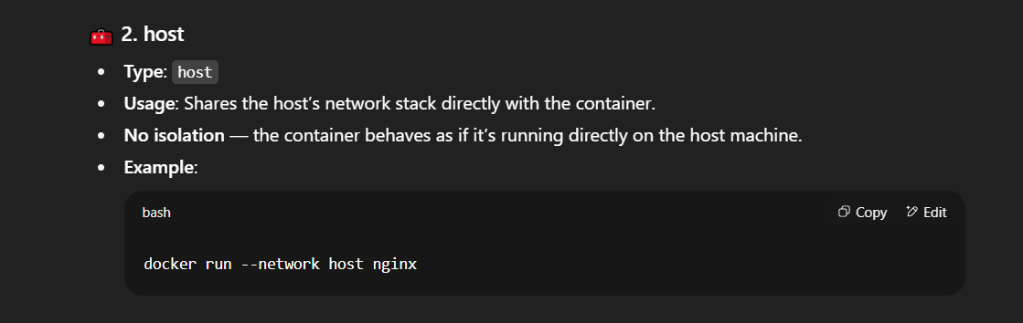
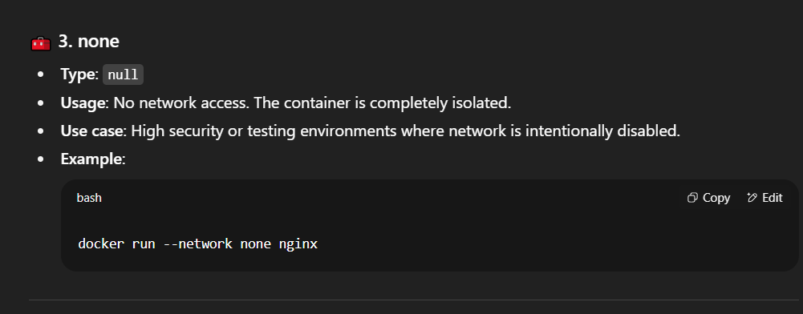
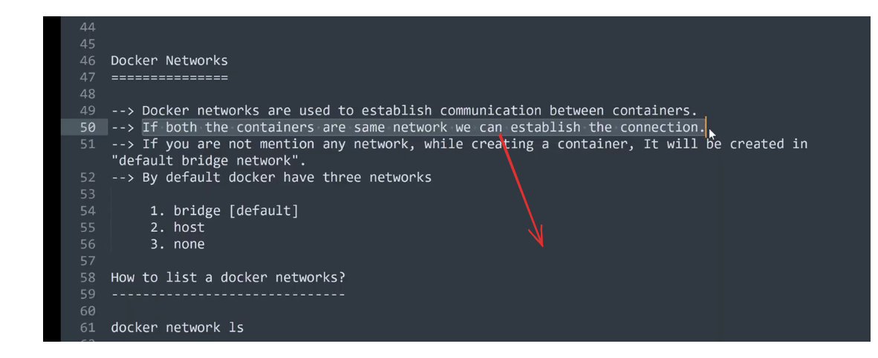
Let’s pull the docker image from docker hub as shown in the below img
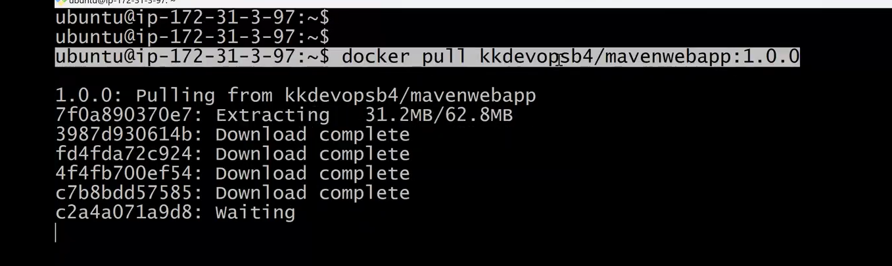
Lets create the container as shown below
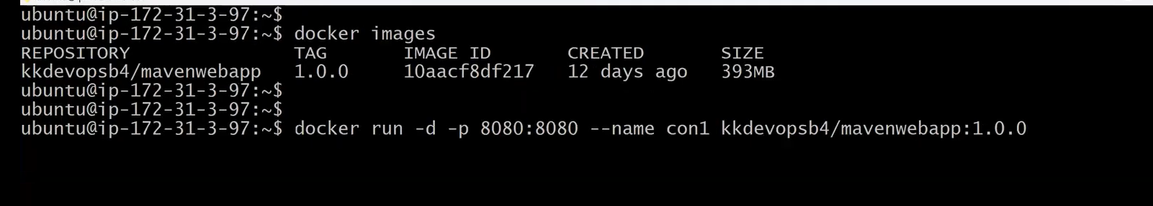
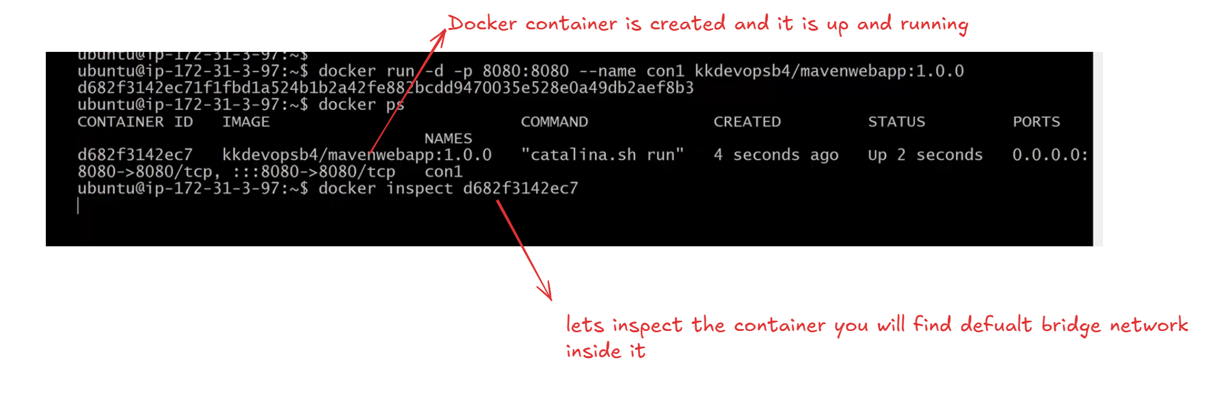
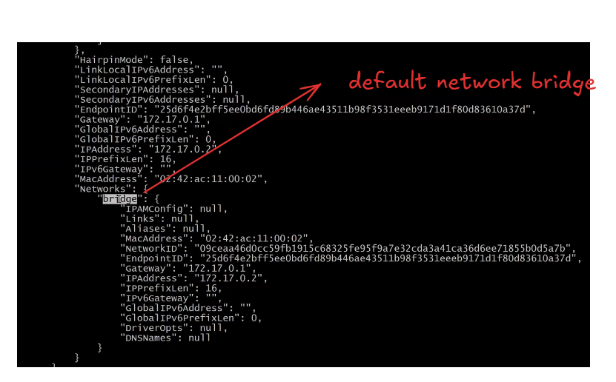
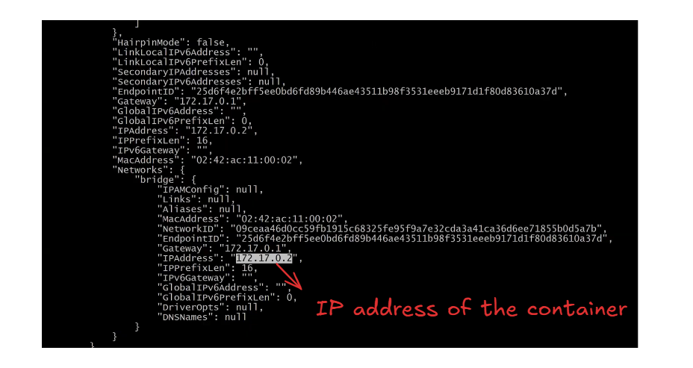
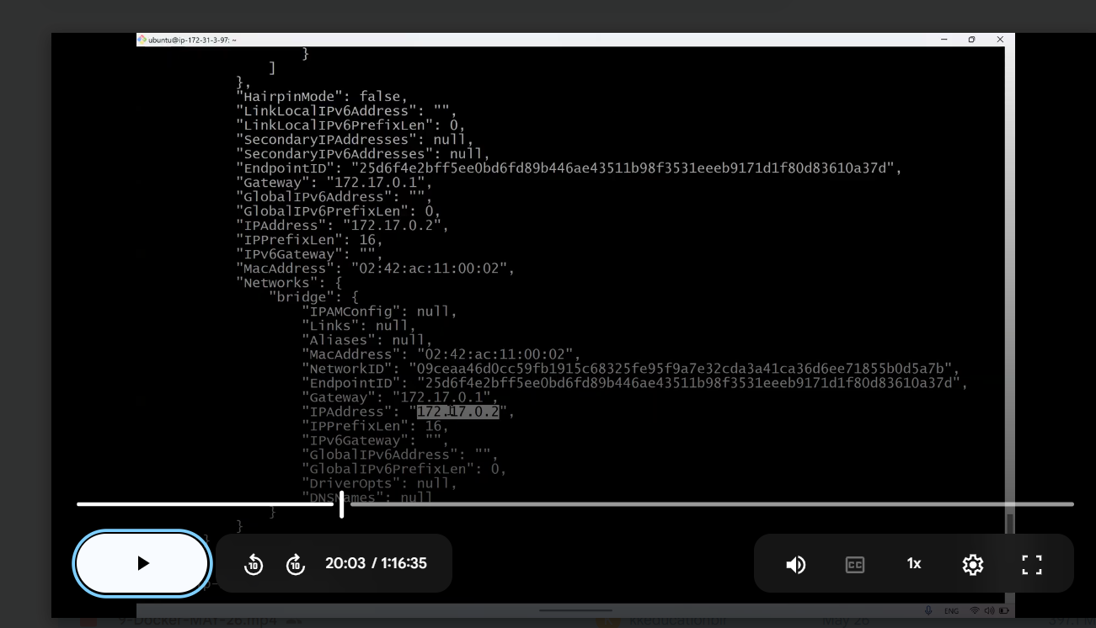
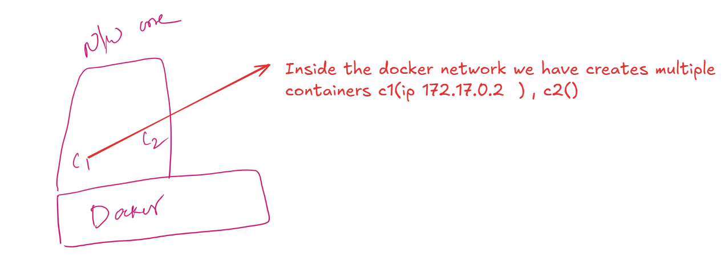
Let’s create another container2 with an ip address
once again check the docker networks by using the command docker network ls
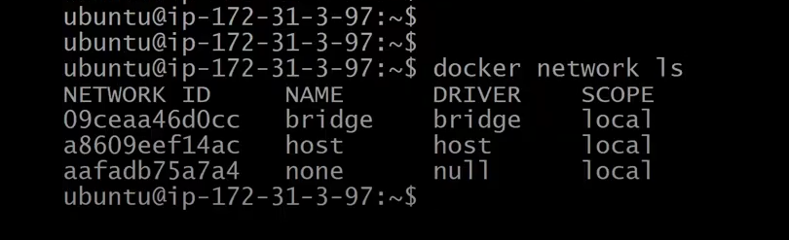
let’s create another container as shown below using the same docker image as we used for container 1
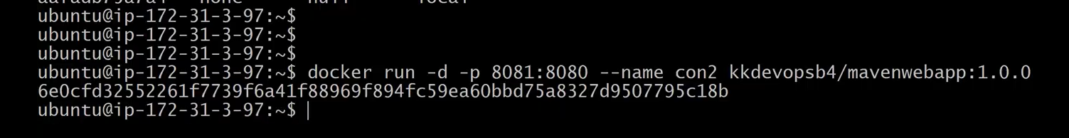
we have multiple conatiners as shown below open the second container and check the ip address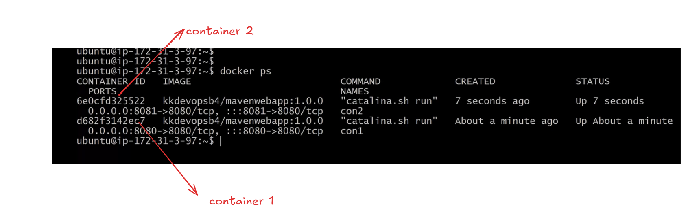
clear the screen
docker inspect
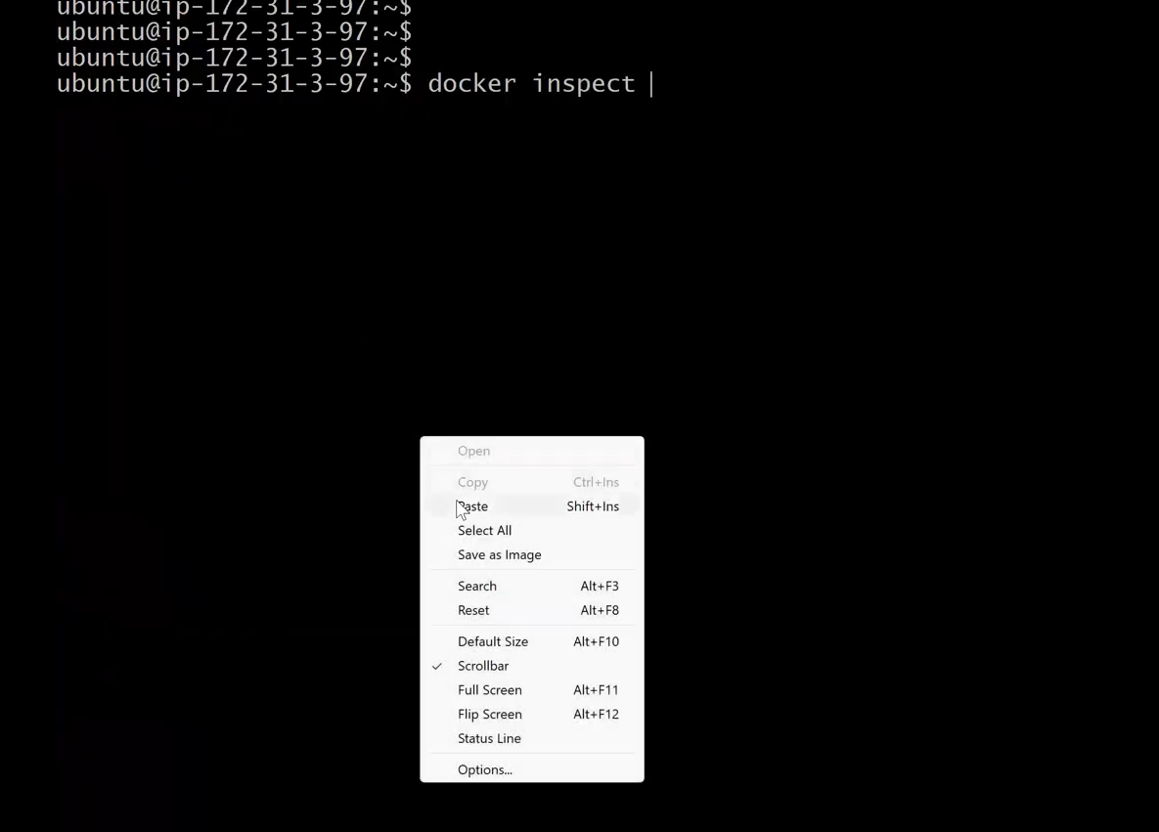
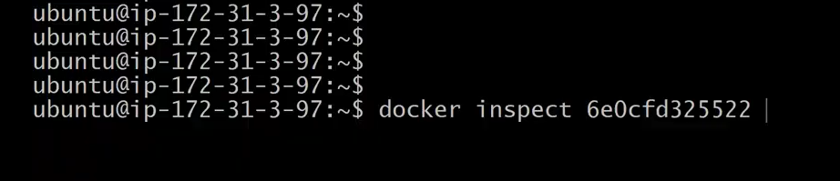
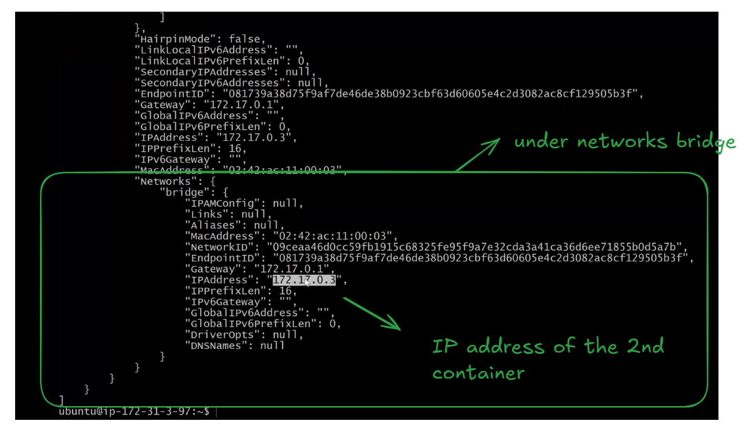
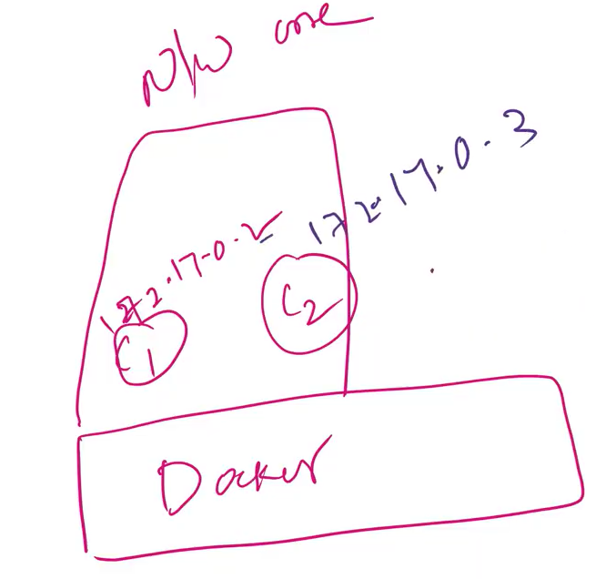
So far we have created two networks under the bridge network as shown below
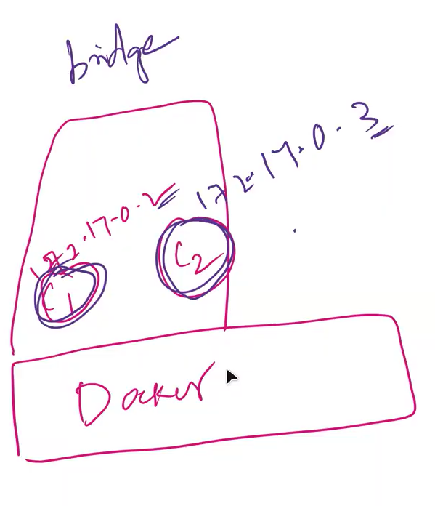
both the conatiners are in running state we have to establish the connection between these two containers as shown below
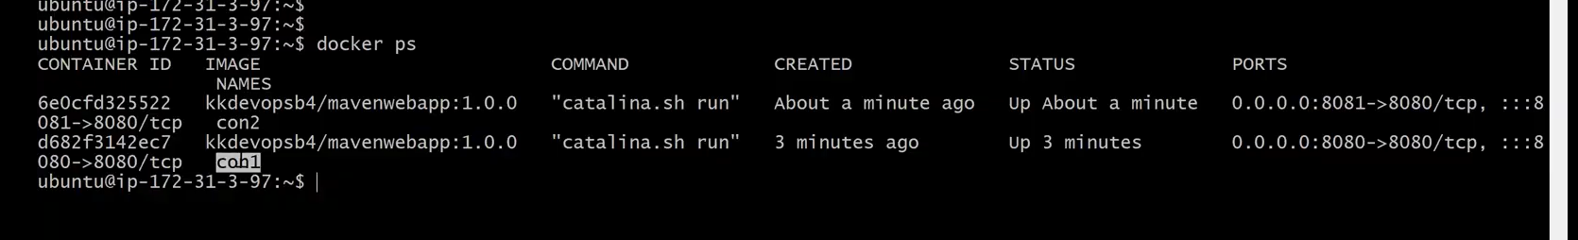
Let get inside the con1 container and ping the Ip address of the container 2 (con2) as shown below
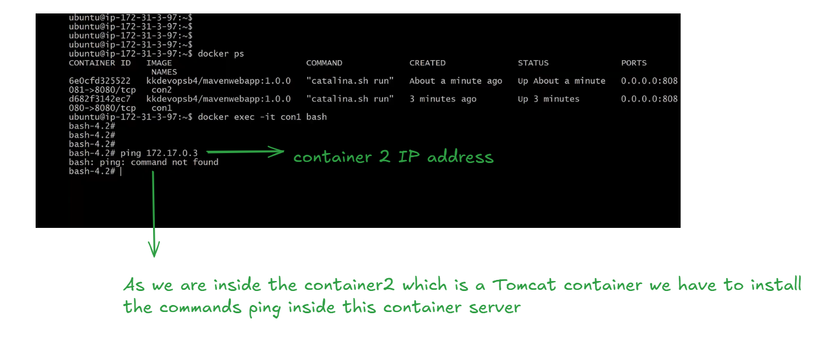
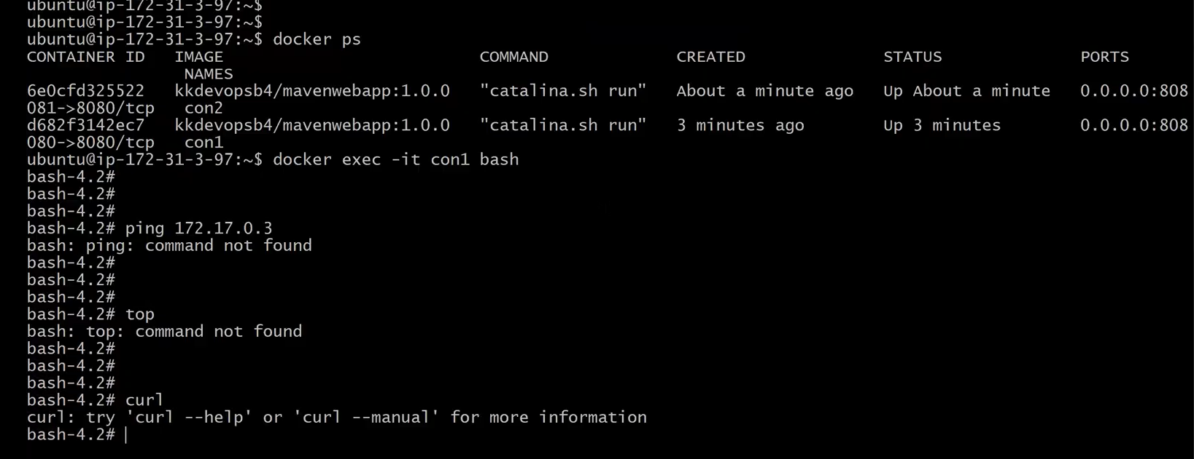
clear the screen
update the container server by executing the command
yum update -y
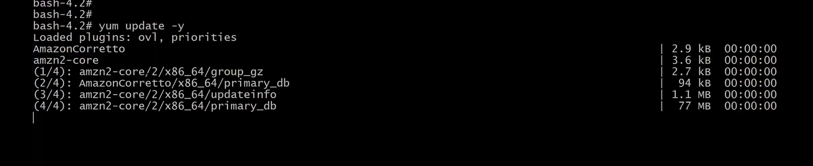
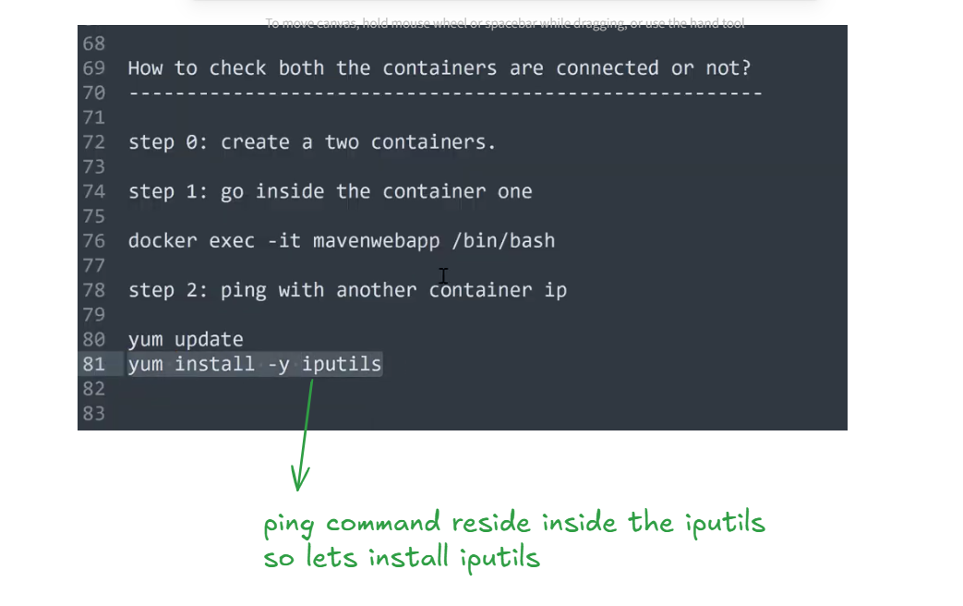
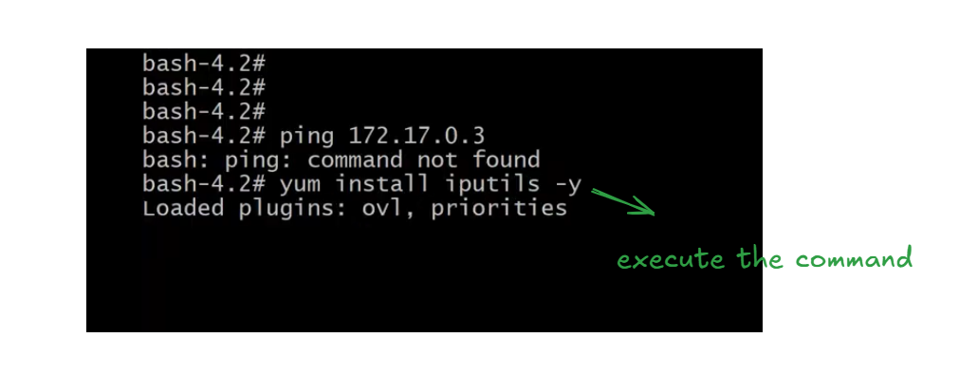
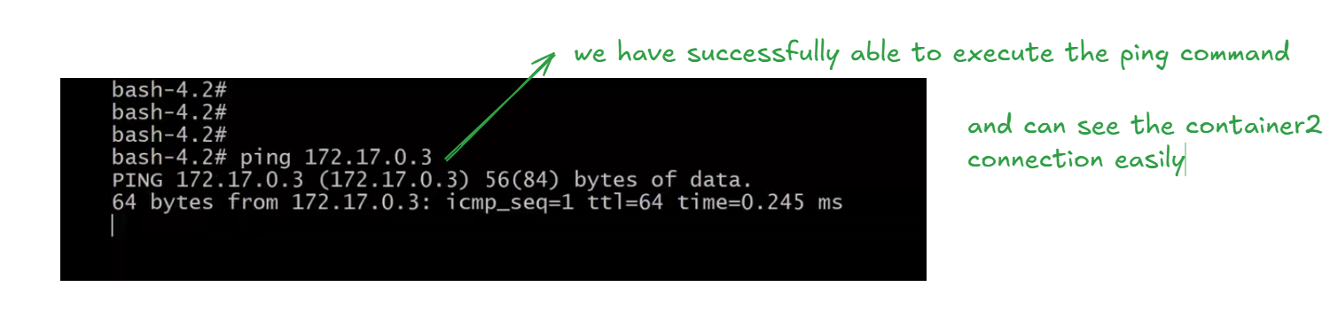
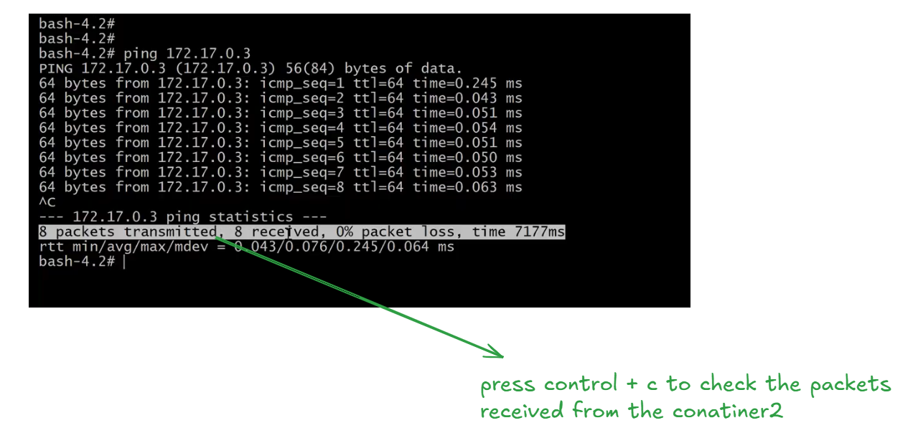
we are pinging container2 from container1 by using ping command instead of ping we can also use
curl command
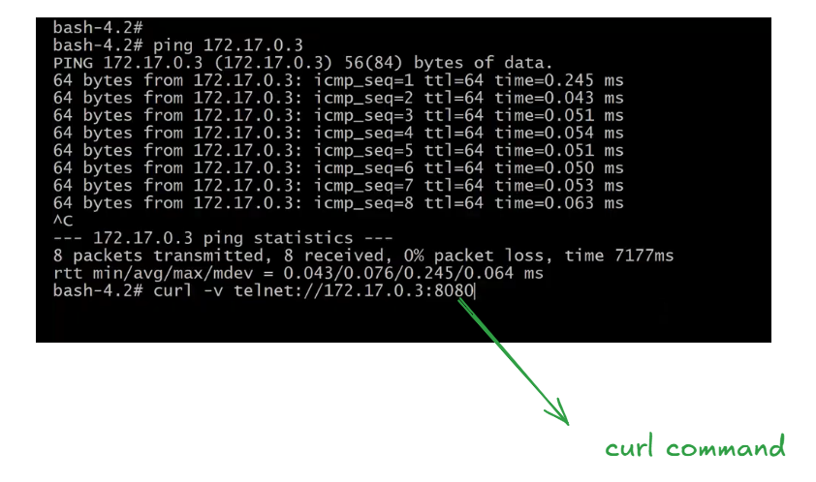
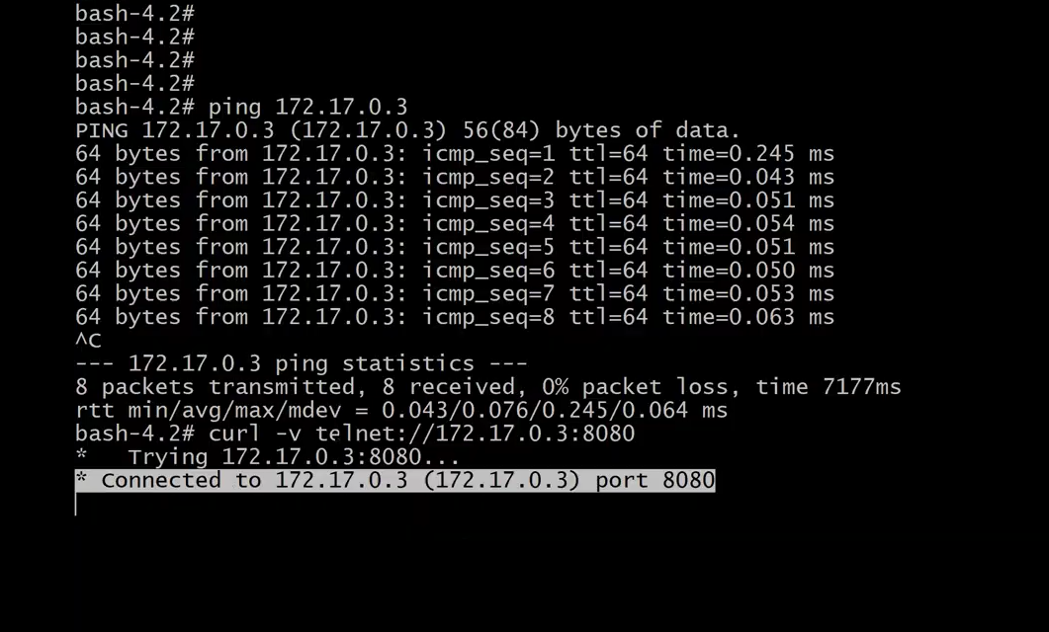
clear the screen
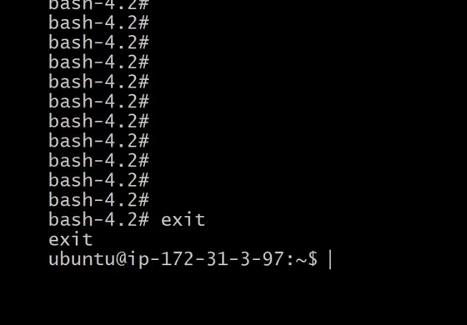
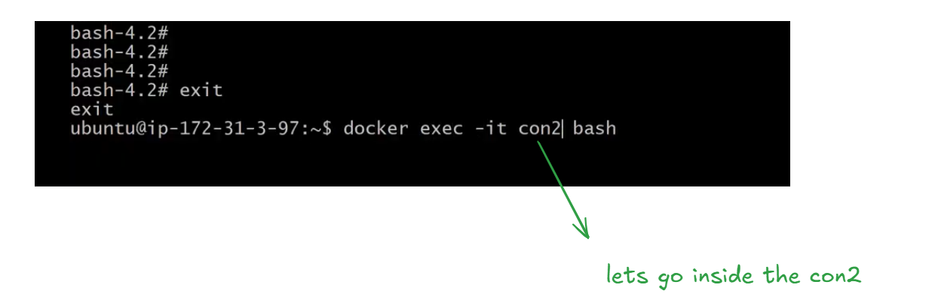
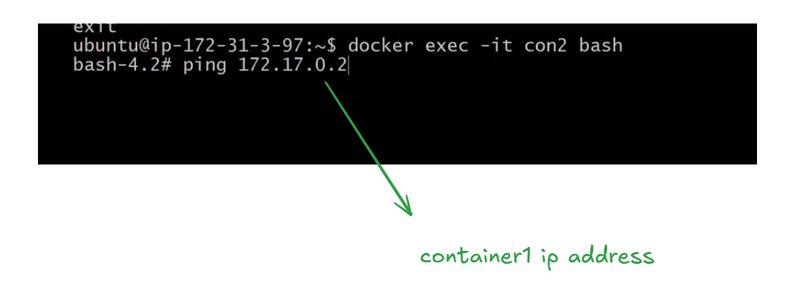
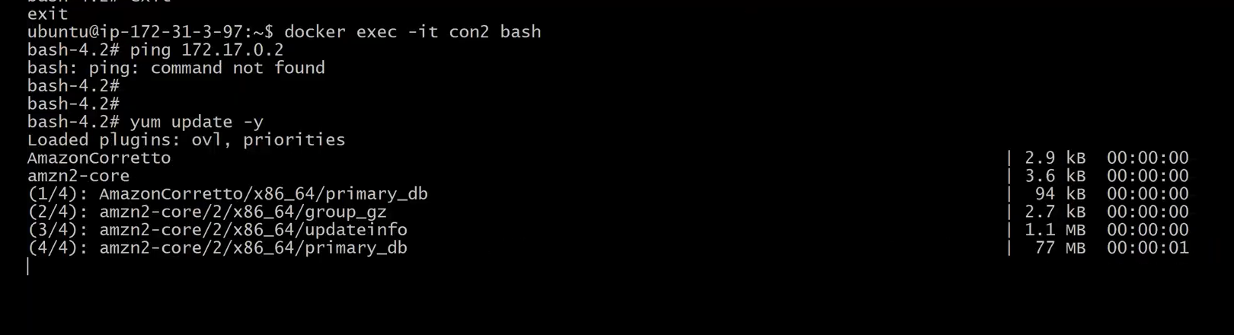
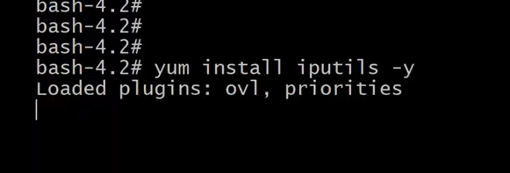
After installing iputils clear the screen
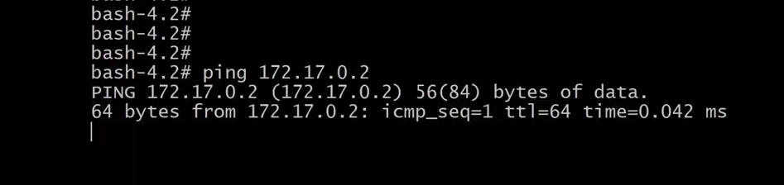
Let’s exit from container 2 as shown below
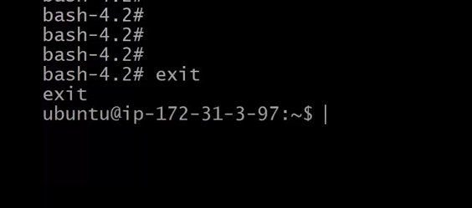
These are the containers that we have created con1,con2
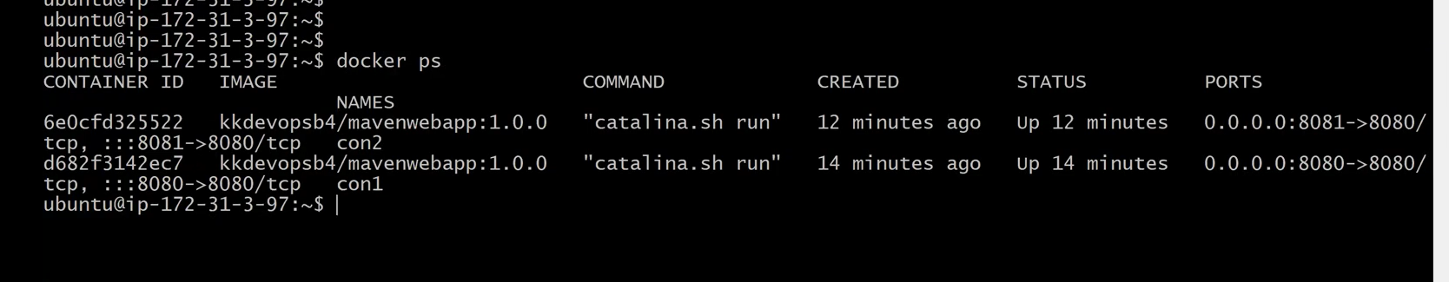
let’s go inside the container 2 as shown below

and ping container1 from container2
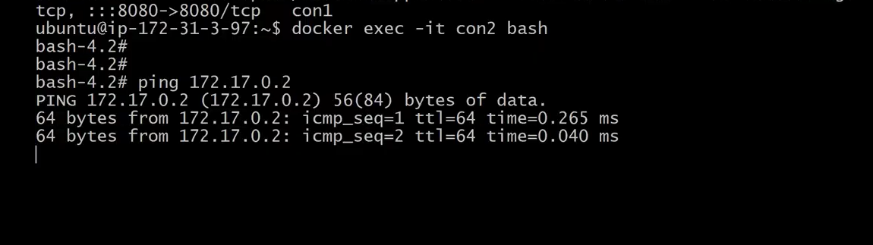
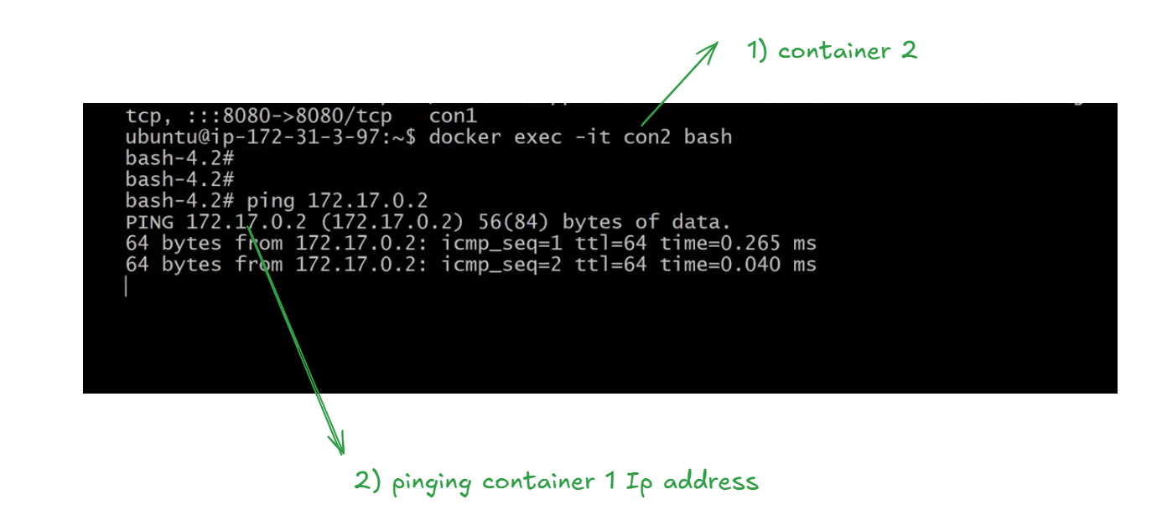
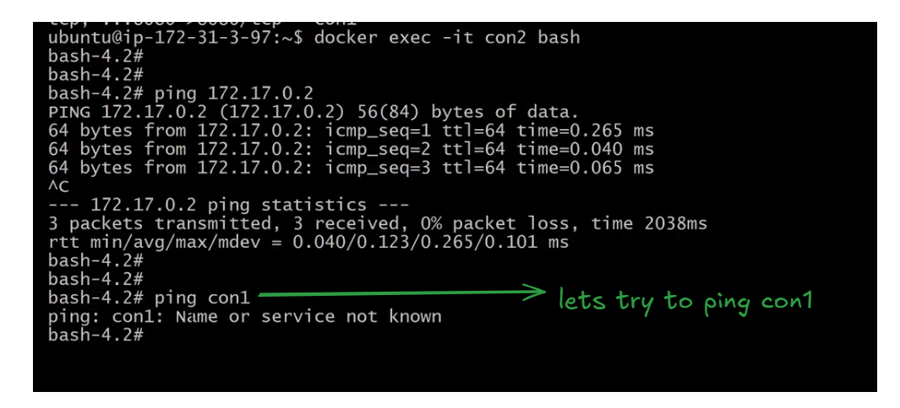
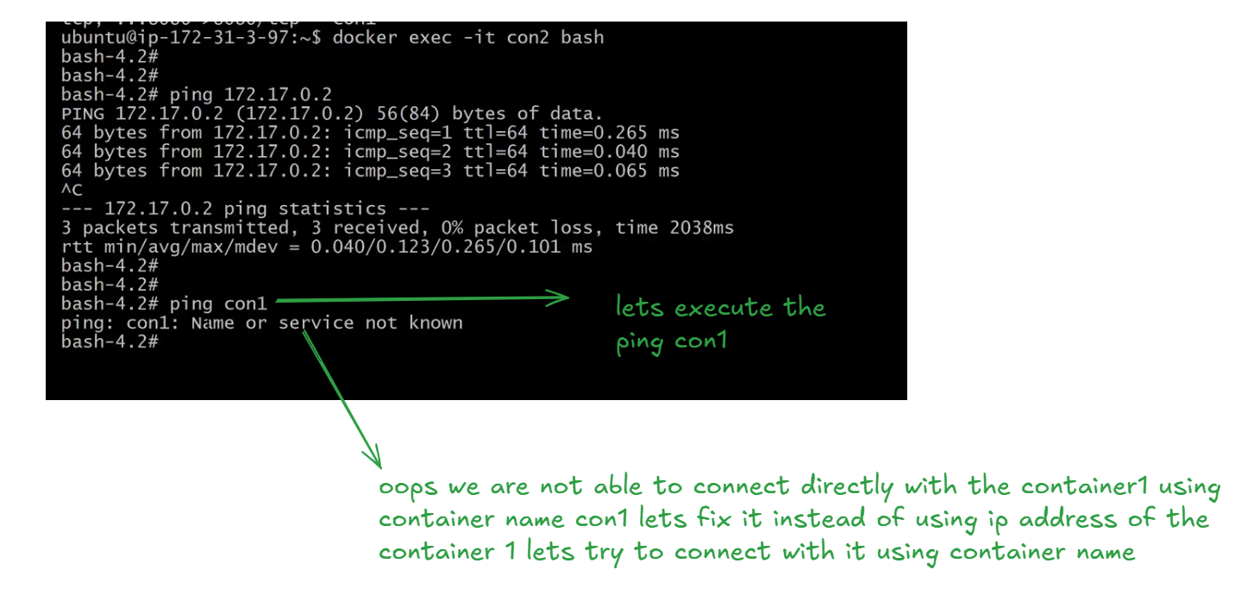
In practice, we don’t write code based on a container’s IP address; instead, we use the container name. If a container crashes due to a memory issue or is restarted, its IP address may change. When we try to reconnect, the container might have a new IP. Therefore, it is better to connect to containers using their container names rather than their IP addresses.
If we are using the default bridge network, containers can only communicate with each other through IP addresses. Instead, we should create a user-defined (custom) bridge network, which allows containers to communicate using their container names. This is more reliable, since container IP addresses may change if a container is restarted, but the container name remains the same.
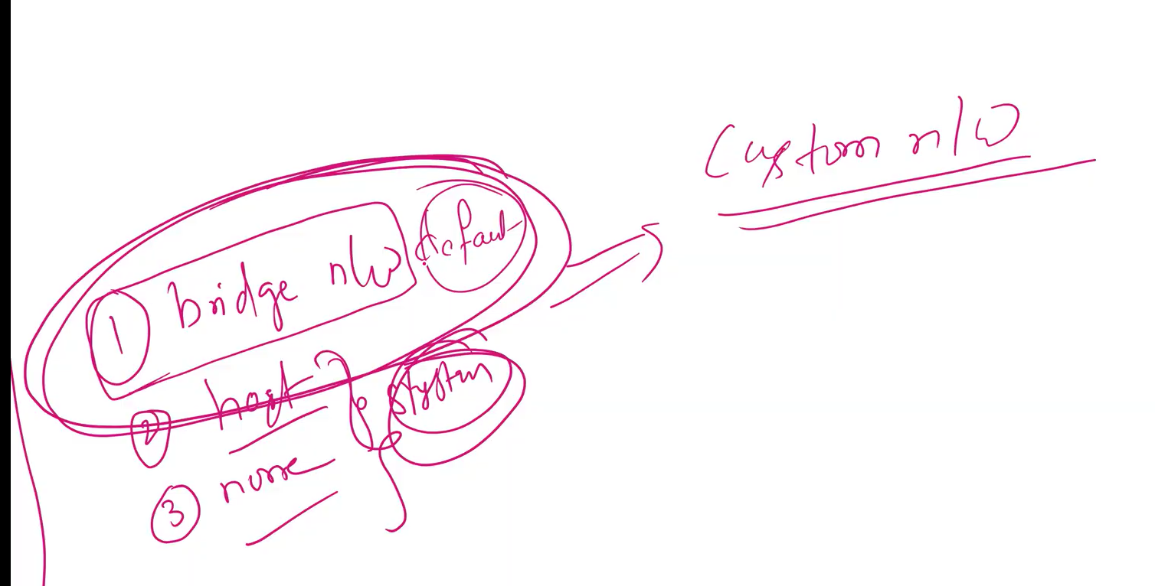
before creating the custom docker network let’s check the available docker networks by executing the command
docker network ls
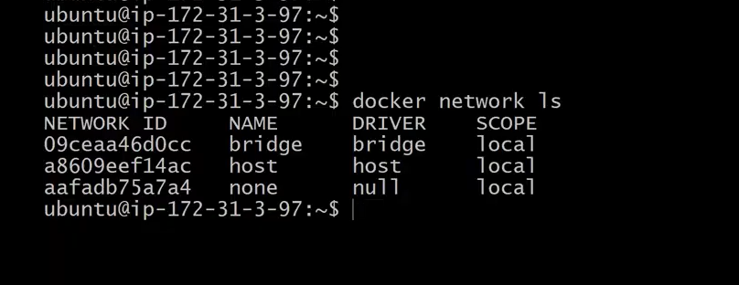
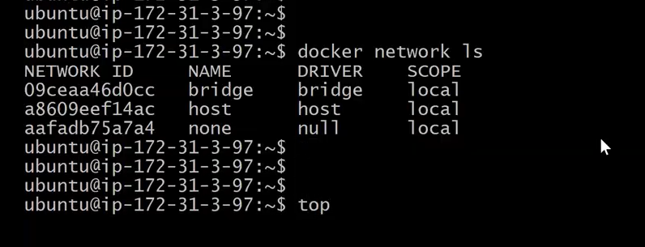
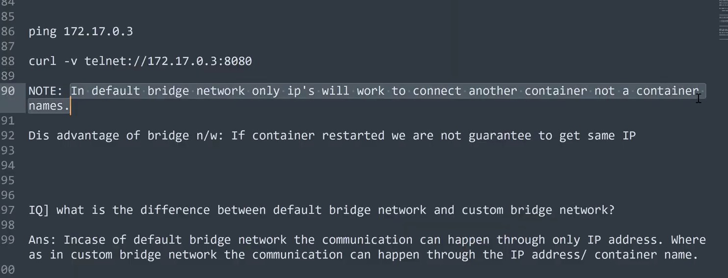
Lets create the custom bridge docker network
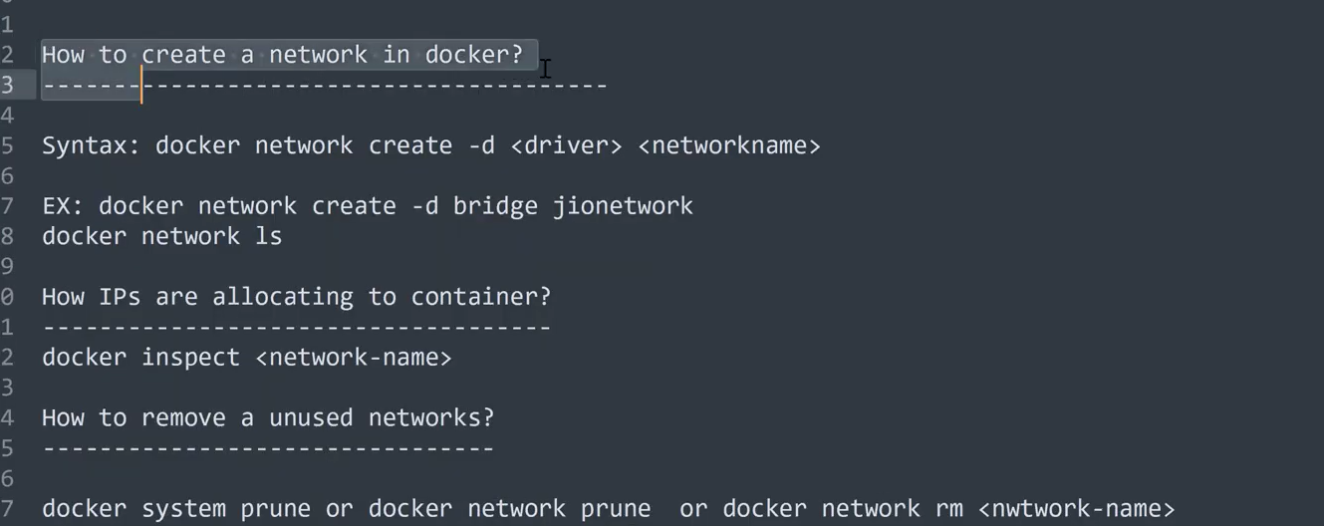
before creating custom network delete all the containers
create the conatiners after establishing the custom network
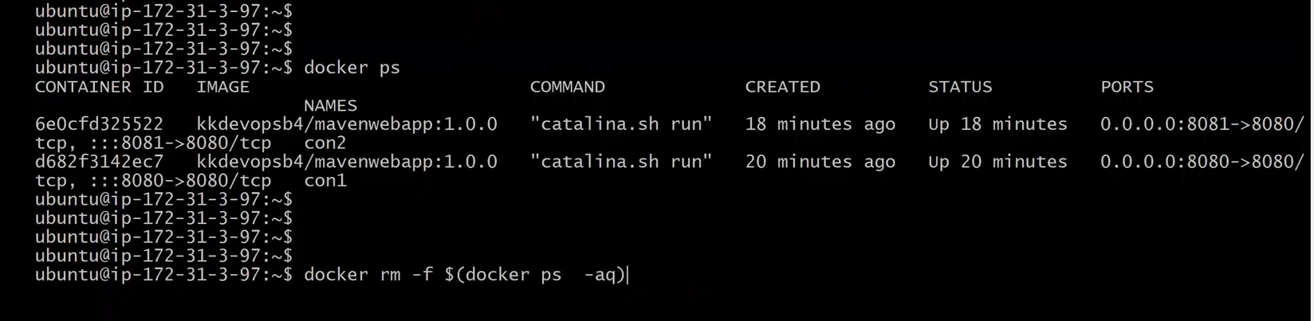
Now we have only docker image
so before creating the docker container we have to mention about the custom docker network
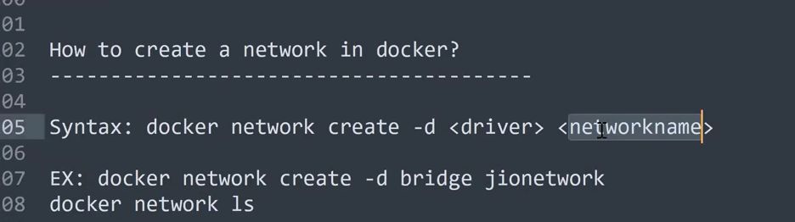
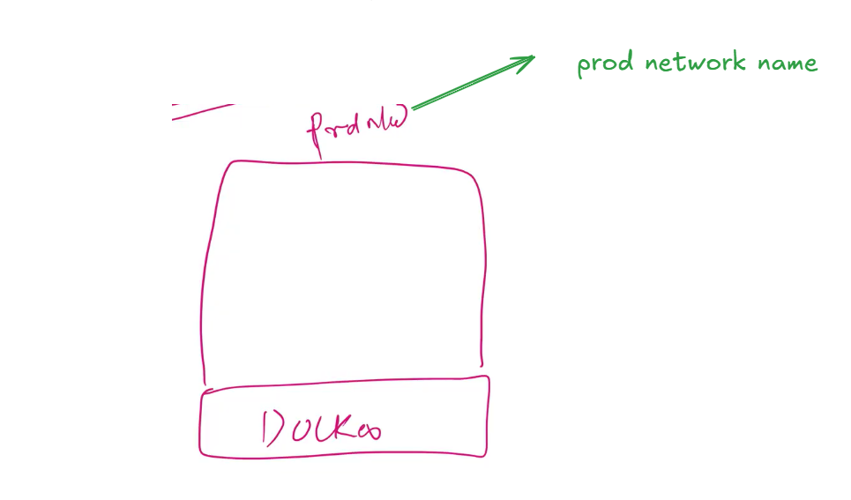
execute
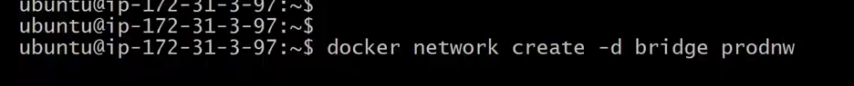
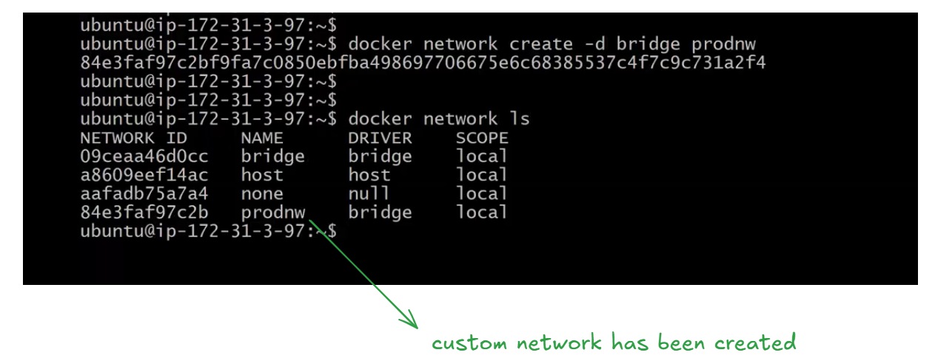
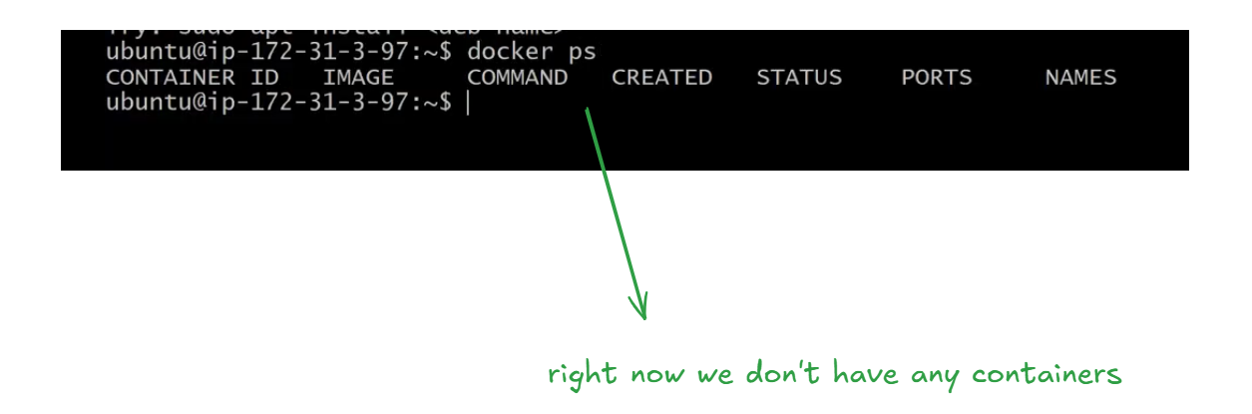
Lets create the container con1 associating with custom network prodnw as shown below
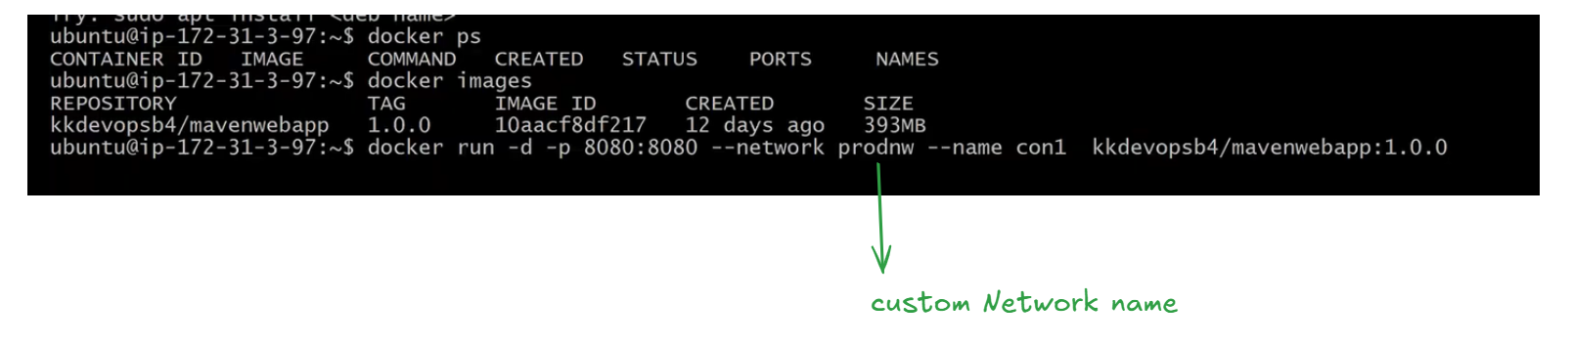
lets create the container 2 as shown below
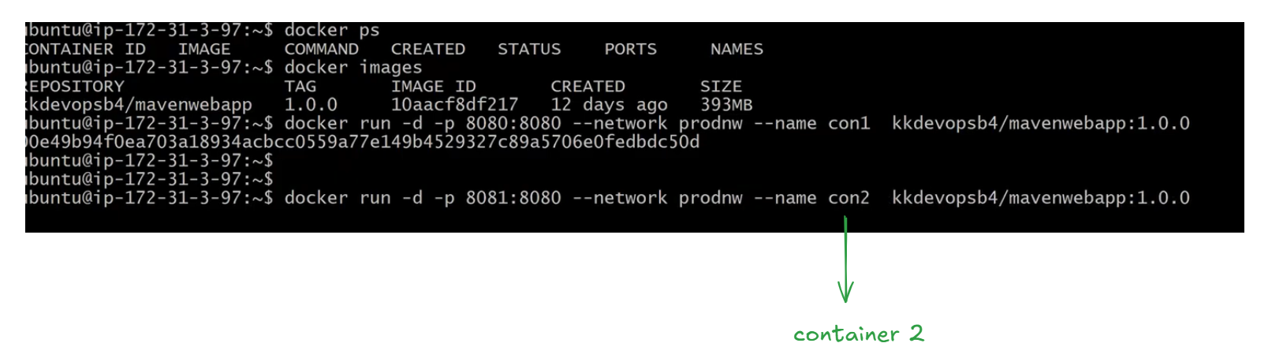
so far we have created containers con1 , con2 under the custom network prodnw
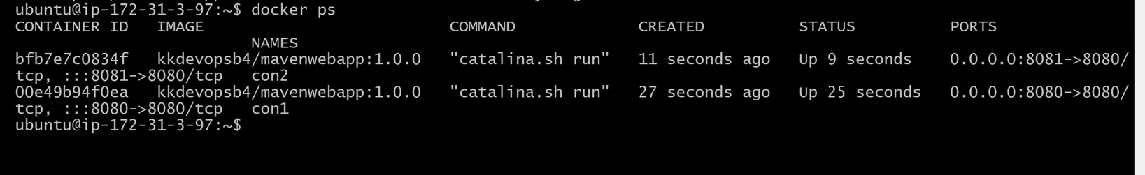
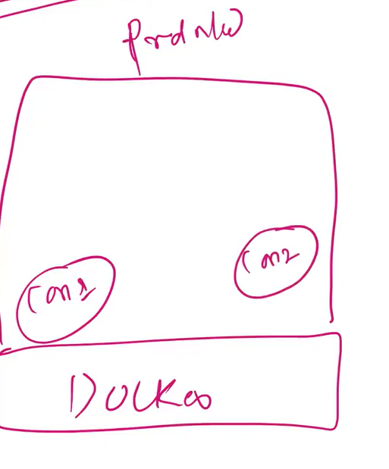
lets inspect container 1 as shown in the below img
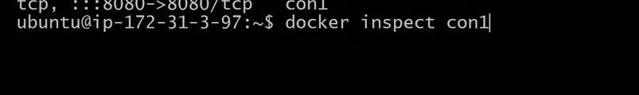
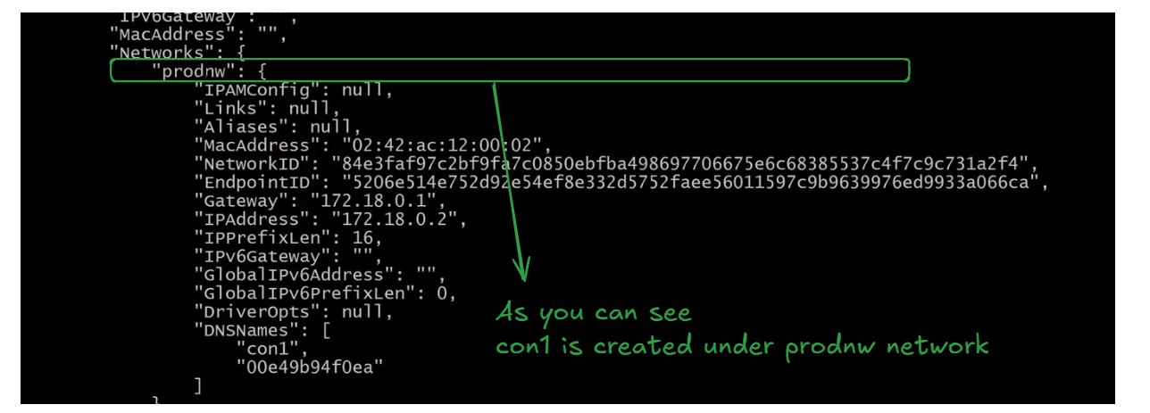
Ip addresss of the conatiners as shown below
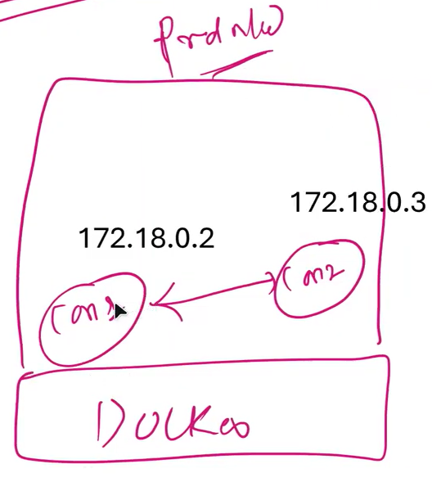
lets go inside the container con1 and update the con1 system
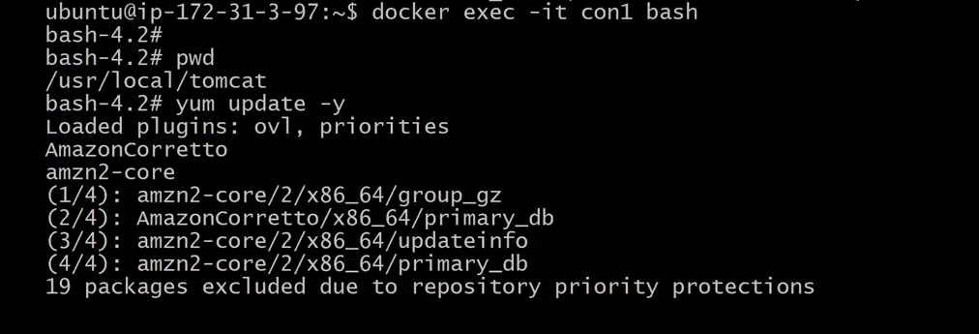
Install iputils as shown below
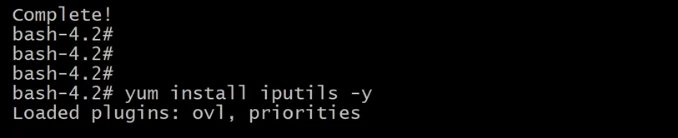
we have successfully installed inputils in container1(con1)
Now lets ping con2 ip address inside con1(container 1) and you will see the packets are coming from container 2 in to container 1 as shown below
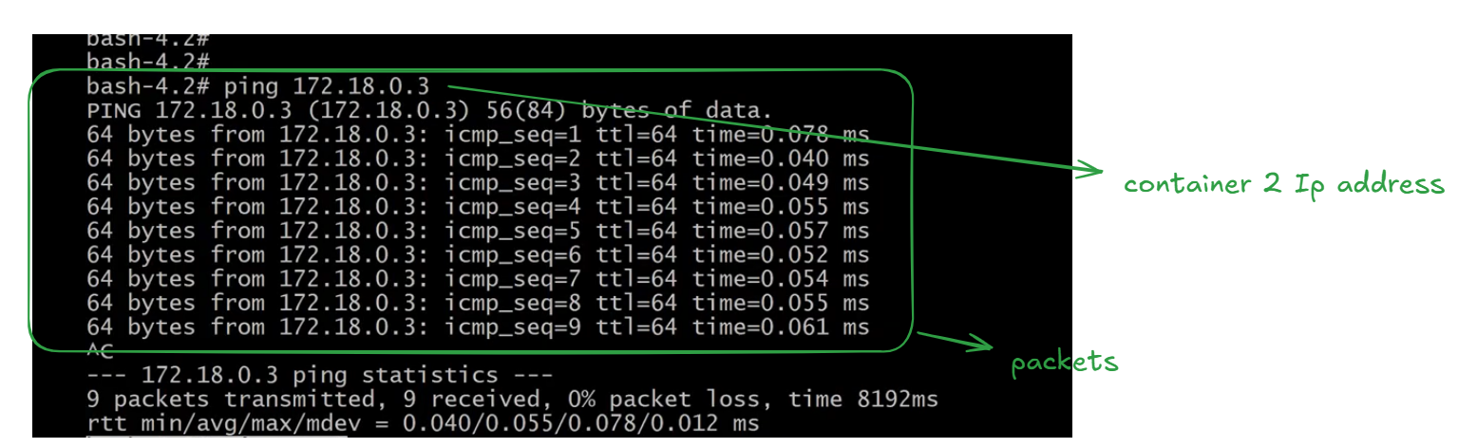
lets try to connect container2 using container name con2 as we are using custom network we will easily
get connected with con2 container name as shown below (ping con2)
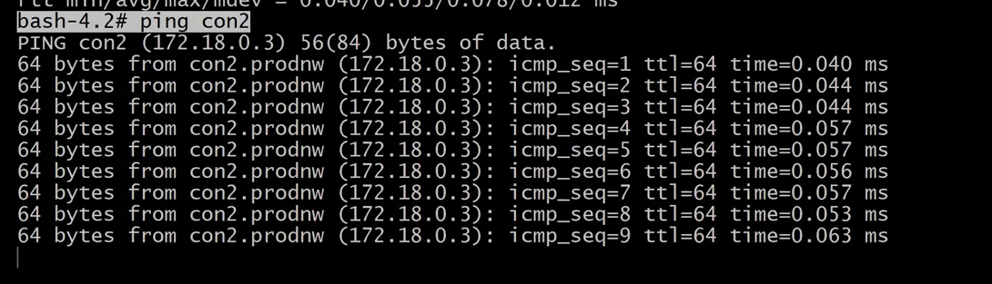
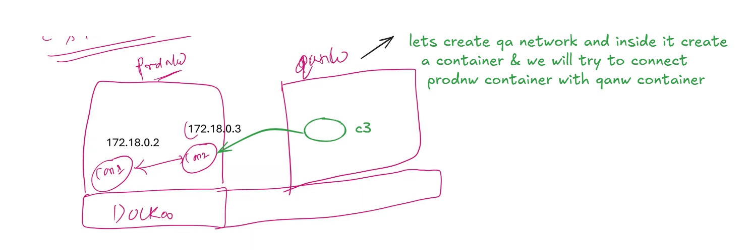
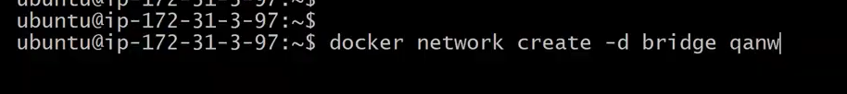
Lets create a container inside qanw
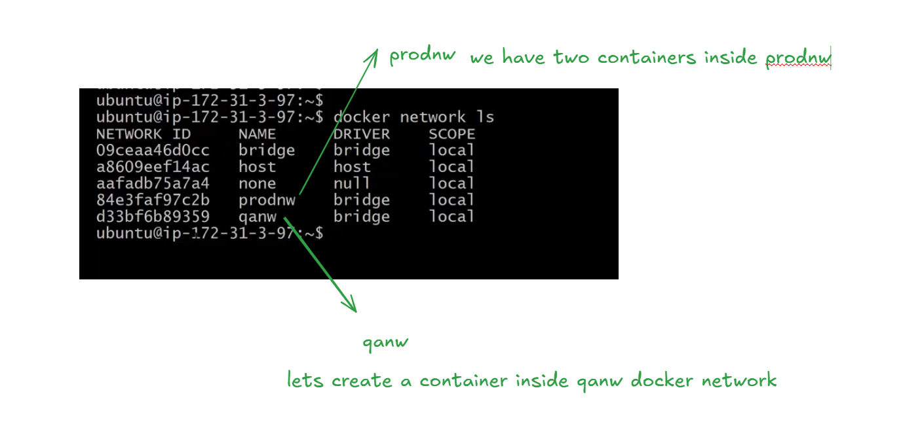
lets inspect the qanw as shown below
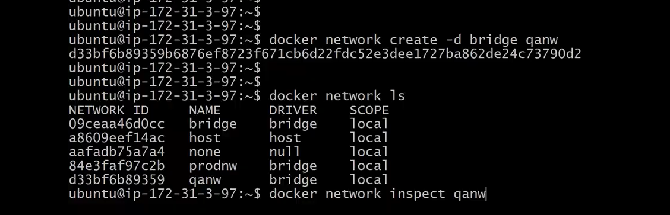
No container inside the qanw as shown below
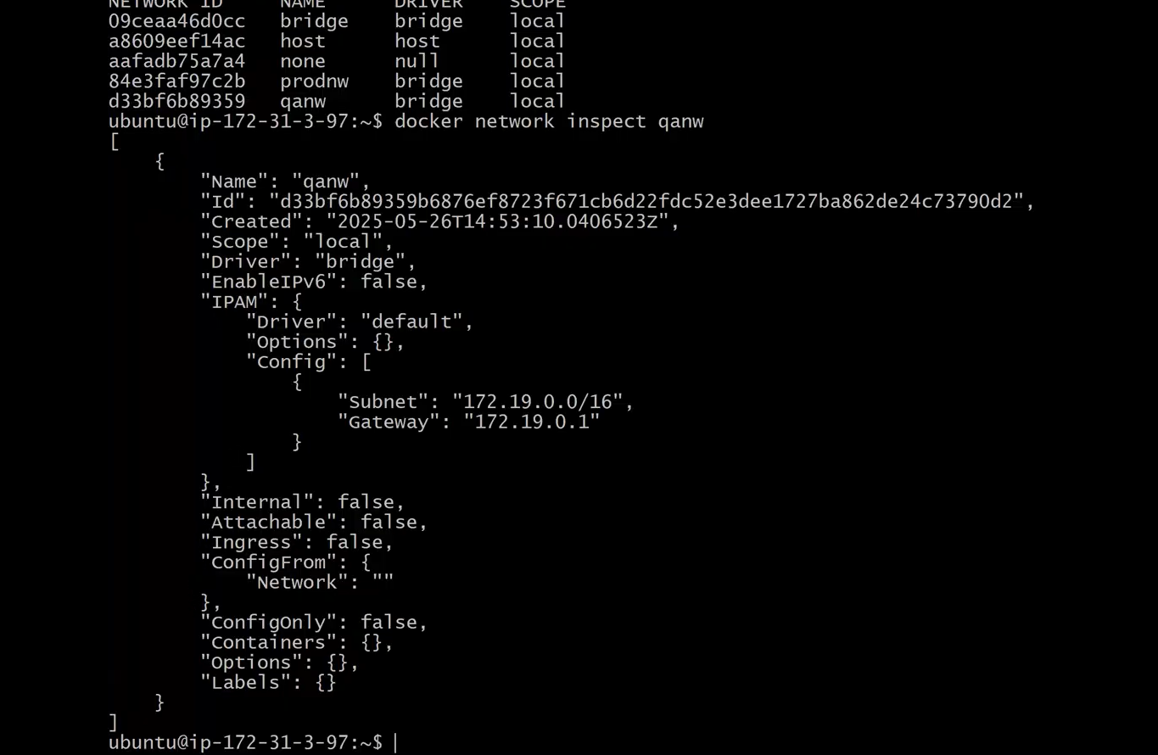
clear and execute top command

If you want to use existing container con1 from prodnw (network) in to qanw (network) then we have to use the below command docker network connnect
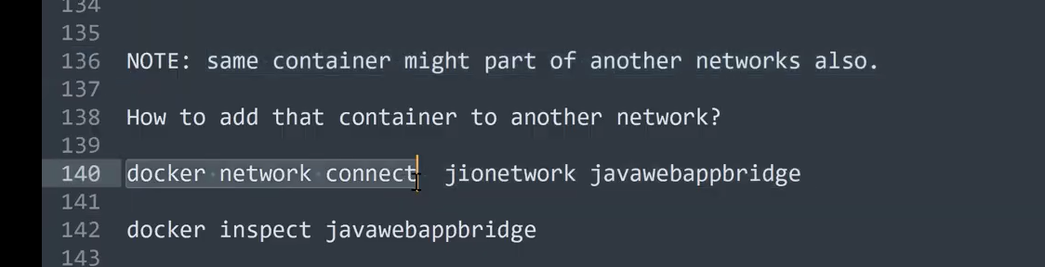
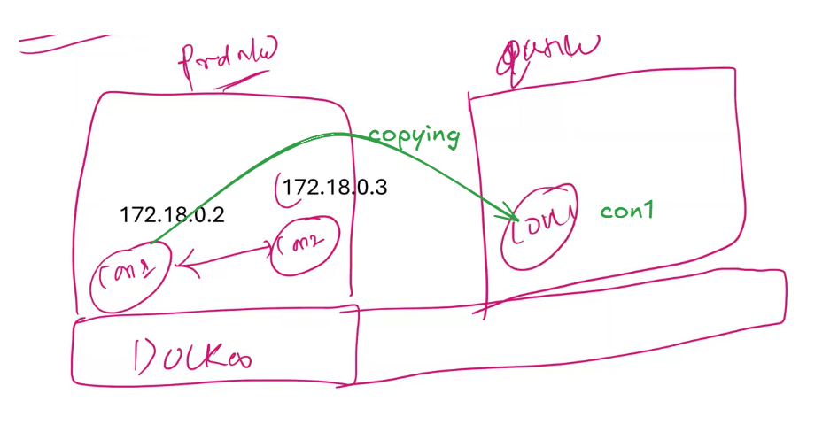
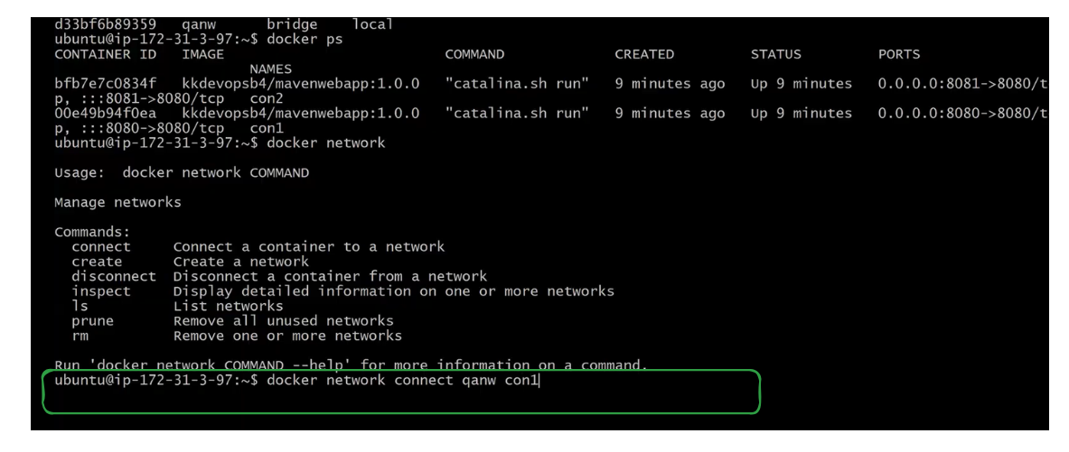
If we want to know wheather con1 from prodnw get copied in to qanw we have to inspect that particular container con1 as shown below
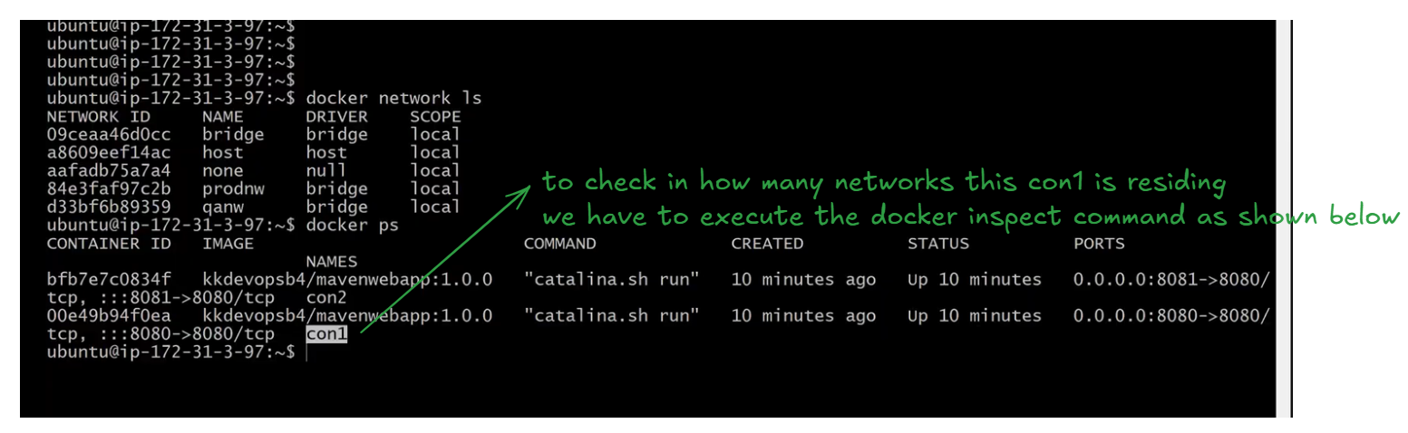
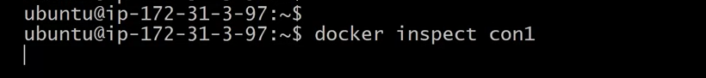
con1 conatiner is part of two networks (prodnw , qanw) as shown below
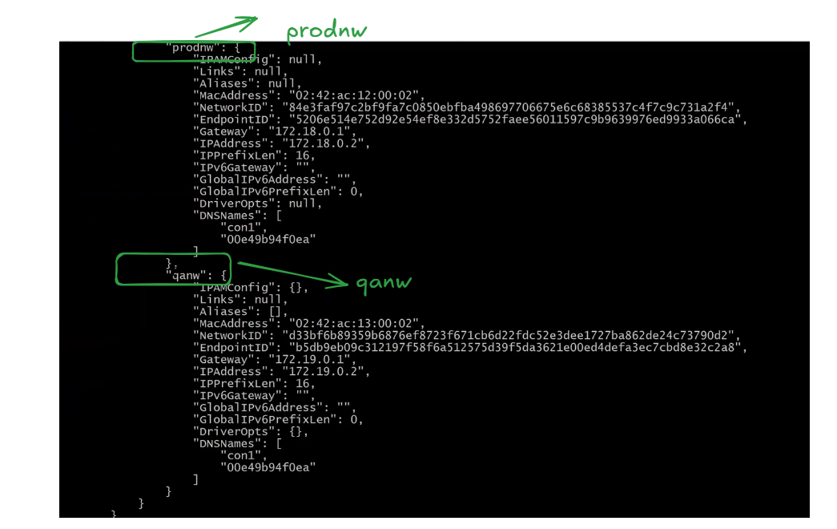
use the below command to check how many container are residing inside a network (qanw)
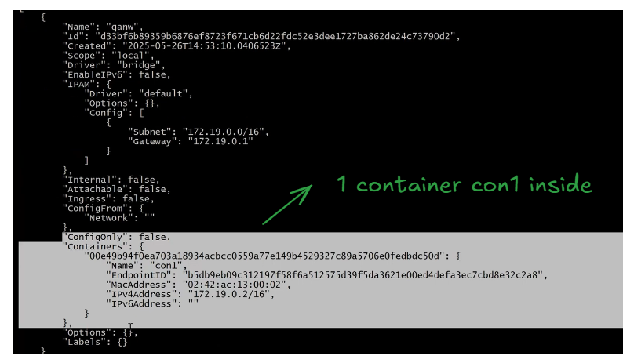
Now disconnect the con1 from the network qanw by the using the below command
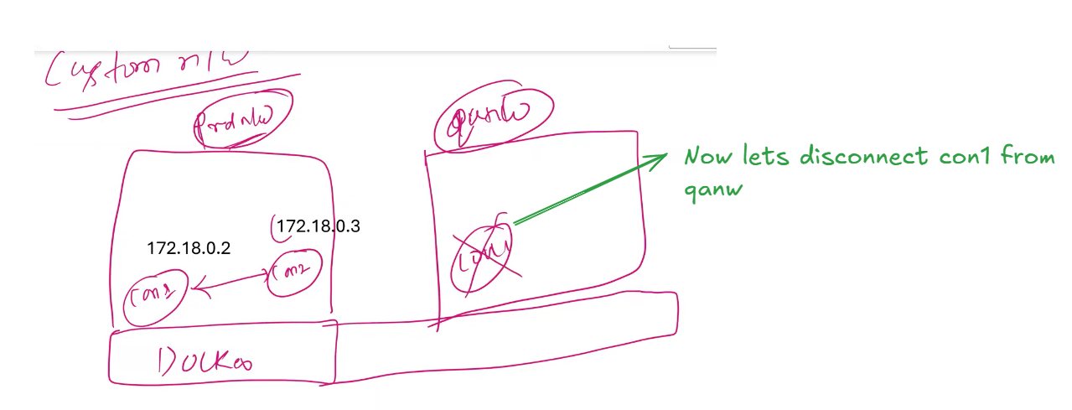
The container con1 has been disconnected from qanw . You can verify it by executing the below command
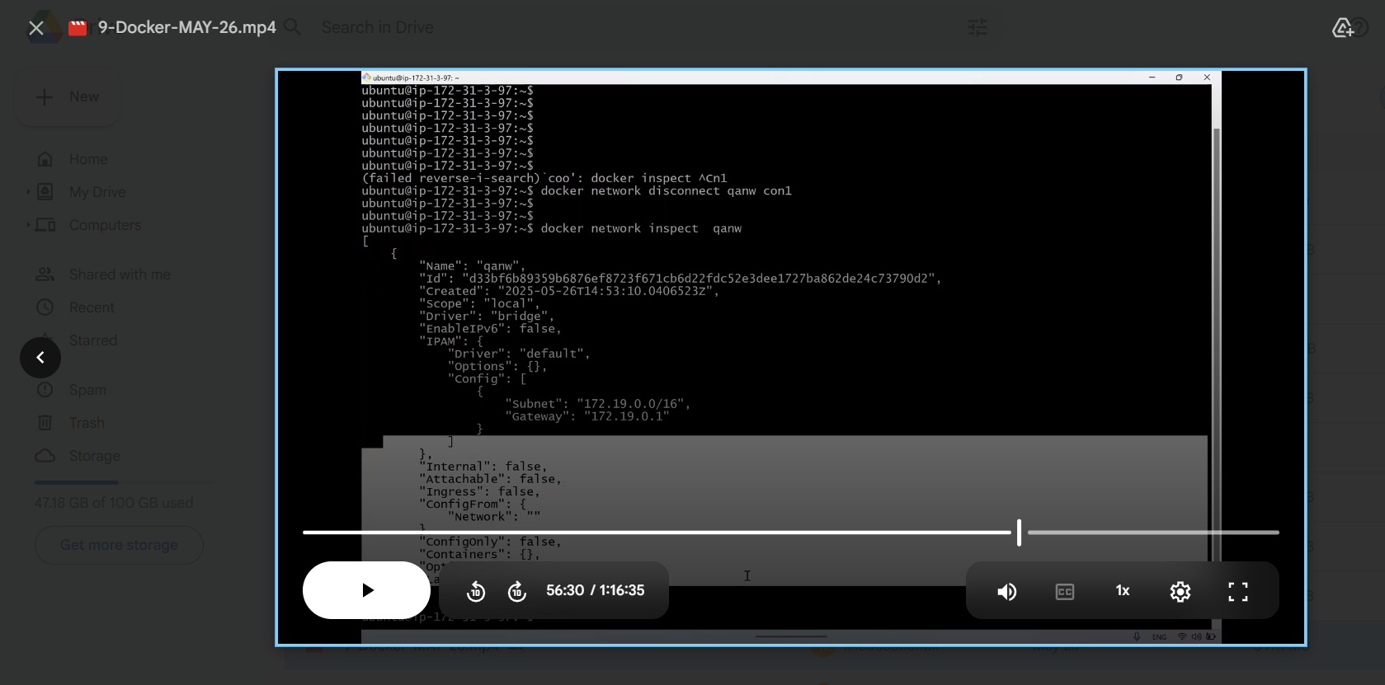
Inspect the container con1
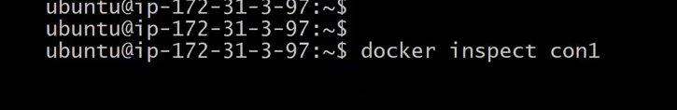
As you can see below con1 is only in one container
so for connecting or disconnecting any network we have to use the following rules/commands
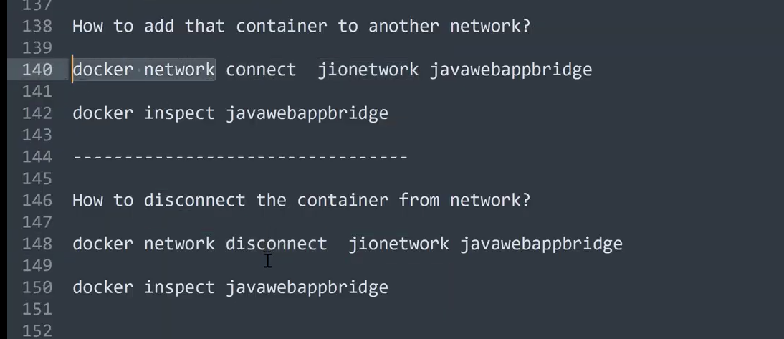
Next Topic is Host Network
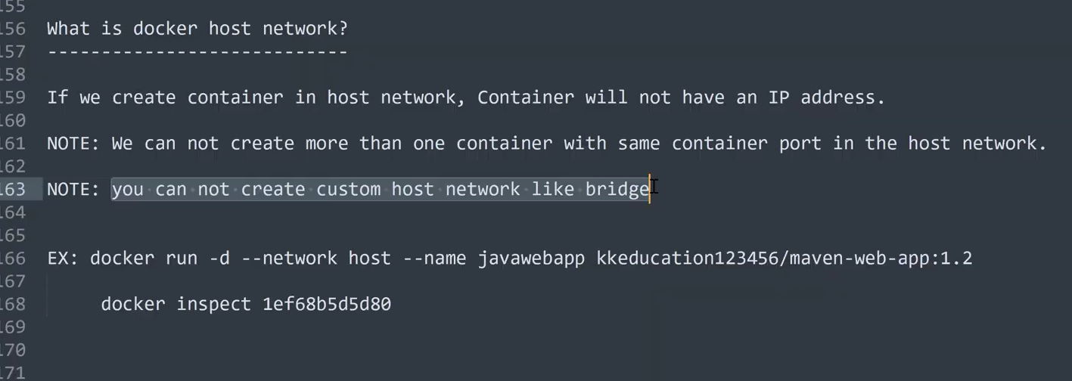
lets list the available containers by executing the command docker network ls as shown below
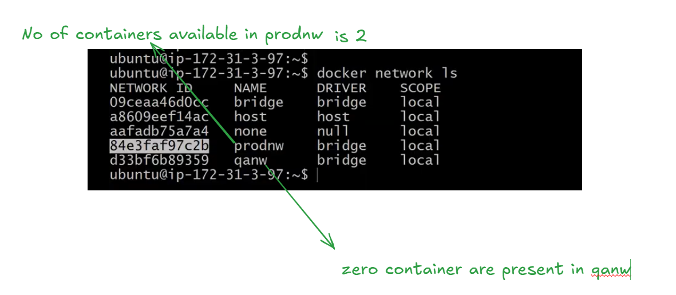
When we execute docker network prune then the unused custom network like qanw which does not have any containers will get deleted
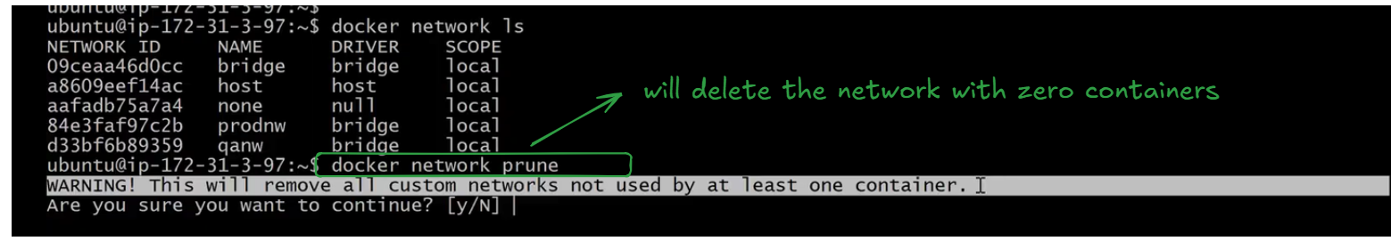
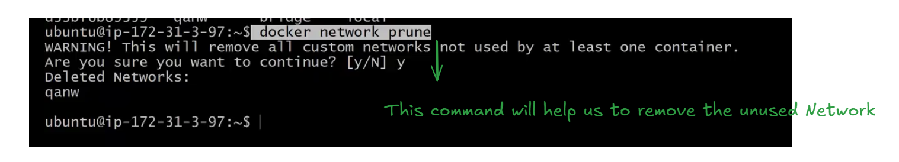
docker networks command will all the docker networks related commands as shown below
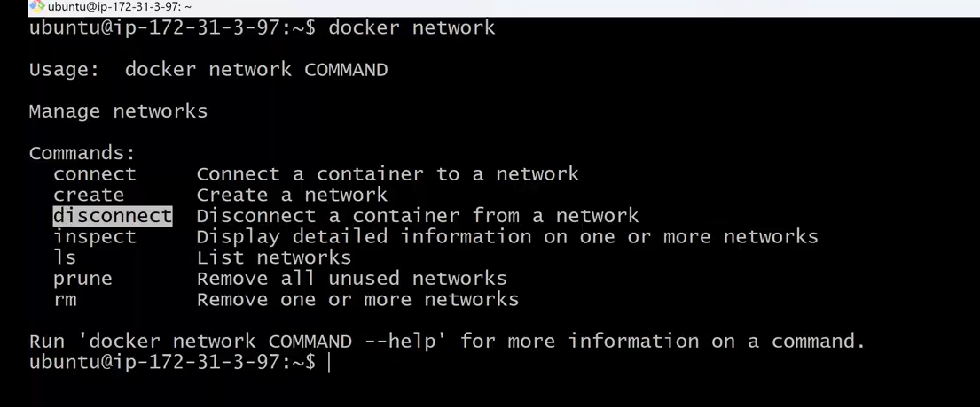
Q&A starts at 1:00:00

