

**Electric Power Generation, Transmission and Distribution**

**EE-335L**

Fall Semester, 2020

Course Instructor: Dr. Ahmad Usman

RA: Aiman & Rabbia Muhammad Qasmi

Table of Contents

Lab Project 2

IEEE 9-Bus System 2

Objective 2

Introduction 2

Deliverables 2

Task 1: To obtain the IEEE 9-bus system data 2

Task 2: To simulate the IEEE 9-bus system using PSS®E 2

Task 3: To obtain the power-flow solution 2

Task 4: To perform short-circuit analysis 3

Task 5: To modify the network and apply techniques of voltage regulation 3

Task 6: To identify the protection schemes required for protection of different components of the system 3

Task 7: To write a report concluding your work 3

Evaluation and Assessment 3

Assessment Rubric for Project 4

# Lab Project

# IEEE 9-Bus System

## Objective

To simulate the IEEE 9-bus system using PSS®E and carry-out its power flow and short-circuit analysis

## Introduction

This lab is designed to be an open-ended lab unlike the previous labs where your response was mostly guided. This lab allows you to work on the ***simulation based project*** having weightage of 14% of the total lab grade. The project is related to modelling of standard IEEE 9-bus system followed by its power-flow and short–circuit analysis. The task wise implementation is listed in the following section. You are expected to implement and practice the skills learnt and the knowledge gained in the previous lab sessions and theory classes. The maximum number of students working on the project together is 3.

## Deliverables

The task wise details of the project are listed below.

### Task 1: To obtain the IEEE 9-bus system data

1. Discuss what do you understand by IEEE and its standard transmission test bus-systems.

Standard test systems for transmission networks are used to model real-world networks where researchers try to implement new ideas and concepts. Transmission systems are usually balanced in design along with heavy presence of generation. Several test systems exist for separately studying Transmission networks (TNs). For TN studies, the most widely used systems are the ones developed by IEEE, for power flow, and transient stability studies. The Institute of Electrical and Electronics Engineers (IEEE) is a professional association for electrical and electronics engineering which is dedicated to advancing technology for the benefit of humanity. As of 2018, it is the world's largest association of technical professionals with more than 423,000 members in over 160 countries around the world. Some of the IEEE standard transmission test bus-systems are the 9, 14, 30, 39 and 118 bus systems. Other research groups and organizations have also developed their own test systems; for example, the 150- bus synthetic system from the University of Illinois, UrbanaChampaign, the 9-bus and 179-bus systems from the Western System Coordinating Council, used for transient stability studies.

1. Obtain the 9-bus system data using online resources (preferably research papers) required to simulate the system. This includes the following:

* Network layout and operating voltages
* Line data (impedance / admittance)
* Load data (load MW/MVAR)
* Generator data (type, impedance, ratings etc.)
* Transformer data (impedance, ratings etc.)

**Network layout:**

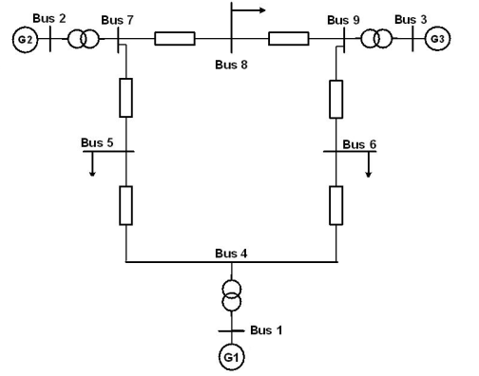

**Bus Operating Voltages:**

|  |  |  |  |
| --- | --- | --- | --- |
| **Bus** | **Type** | **Voltage (kV)** | **Voltage (pu)** |
| 1 | Swing Bus | 16.5 | 1.04 |
| 2 | Generator Bus | 18 | 1.025 |
| 3 | Generator Bus | 13.8 | 1.025 |
| 4 | Non-Generator Bus | 230 | 1.000 |
| 5 | Non-Generator Bus | 230 | 1.000 |
| 6 | Non-Generator Bus | 230 | 1.000 |
| 7 | Non-Generator Bus | 230 | 1.000 |
| 8 | Non-Generator Bus | 230 | 1.000 |
| 9 | Non-Generator Bus | 230 | 1.000 |

**Transmission line data:**

|  |  |  |  |  |
| --- | --- | --- | --- | --- |
| **Line** | | **R [pu]** | **X [pu]** | **B [pu]** |
| **From Bus** | **To Bus** |
| 4 | 5 | 0.0100 | 0.0850 | 0.1760 |
| 4 | 6 | 0.0170 | 0.0920 | 0.1580 |
| 5 | 7 | 0.0320 | 0.1610 | 0.3060 |
| 6 | 9 | 0.0390 | 0.1700 | 0.3580 |
| 7 | 8 | 0.0085 | 0.0720 | 0.1490 |
| 8 | 9 | 0.0119 | 0.1008 | 0.2090 |

**Load Data:**

|  |  |  |
| --- | --- | --- |
| **Bus** | **P (MW)** | **Q (MVAR)** |
| 5 | 125 | 50 |
| 6 | 90 | 30 |
| 8 | 100 | 35 |

**Transformer Data:**

|  |  |  |  |
| --- | --- | --- | --- |
| **Transformer** | | **R [pu]** | **X [pu]** |
| **From Bus** | **To Bus** |
| 2 | 7 | 0.000 | 0.0625 |
| 9 | 3 | 0.000 | 0.0586 |
| 4 | 1 | 0.000 | 0.0576 |

**Generator Data:**

|  |  |  |  |  |  |
| --- | --- | --- | --- | --- | --- |
| **Bus** | **Type** | **V [pu]** | **Pgen (MW)** | **R [pu]** | **X [pu]** |
| 1 | Swing | 1.04 | - | 0.0 | 0.2 |
| 2 | Generator Bus | 1.025 | 163 | 0.0 | 0.15 |
| 3 | Generator Bus | 1.025 | 85 | 0.0 | 0.25 |

### Task 2: To simulate the IEEE 9-bus system using PSS®E

1. Using the obtained data, create a single-line diagram on PSS®E with its associated network data that represents the standard 9-bus system. Each component used in the single-line diagram should be named properly. Add meaningful legend and title to your single-line diagram file using the options available in the software tool.

**Single-line diagram:**

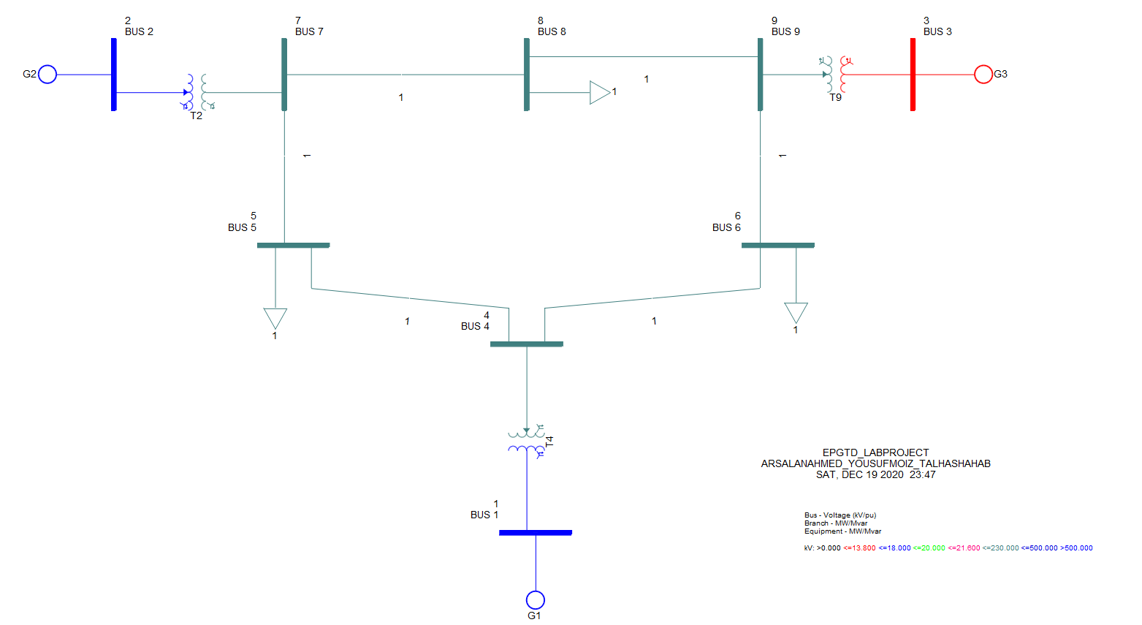

1. Identify the layout of this transmission network.

The layout of the transmission network shown above can be considered to be an **interconnected system**. This is because the feeder ring is being energized by multiple generating stations.

### Task 3: To obtain the power-flow solution

1. Obtain the power-flow solution of the system. Generate its report and display the results on single-line diagram.

* Active (MW) and Reactive (MVAR) Power with arrows to indicate the direction
* Bus Voltage (per-unit and kV)

**Load Flow Analysis with bus voltages:**

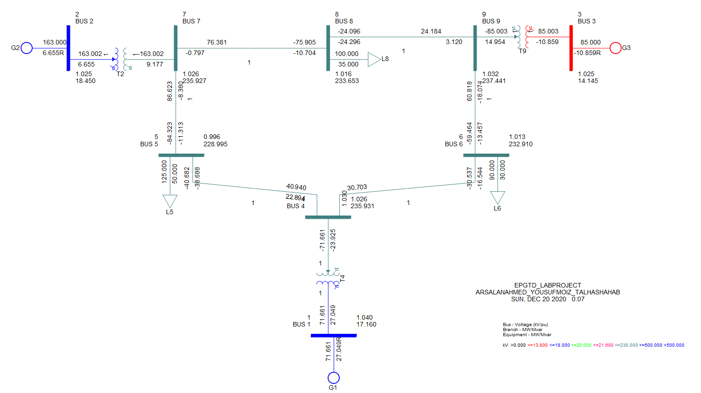

**Load Flow report:**

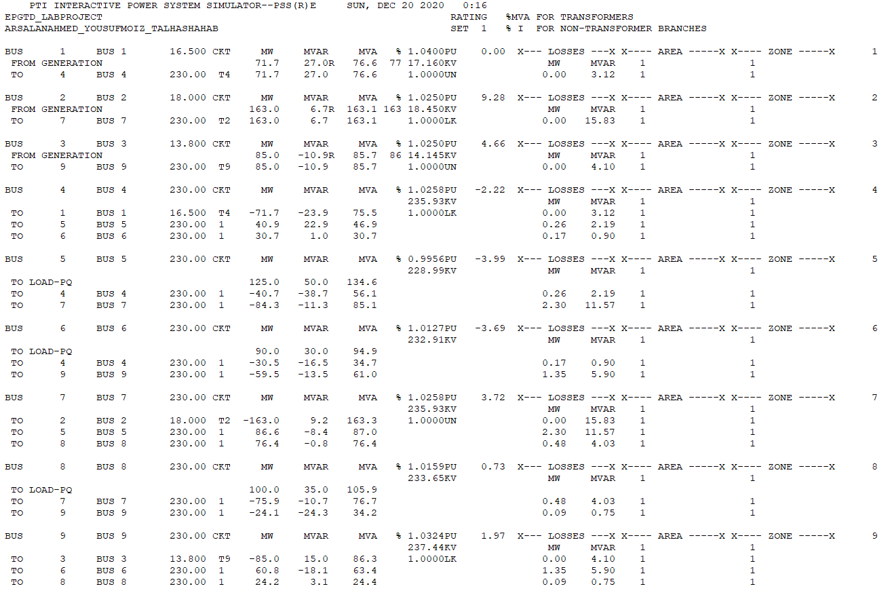

**Load Flow analysis indicating flow of power:**

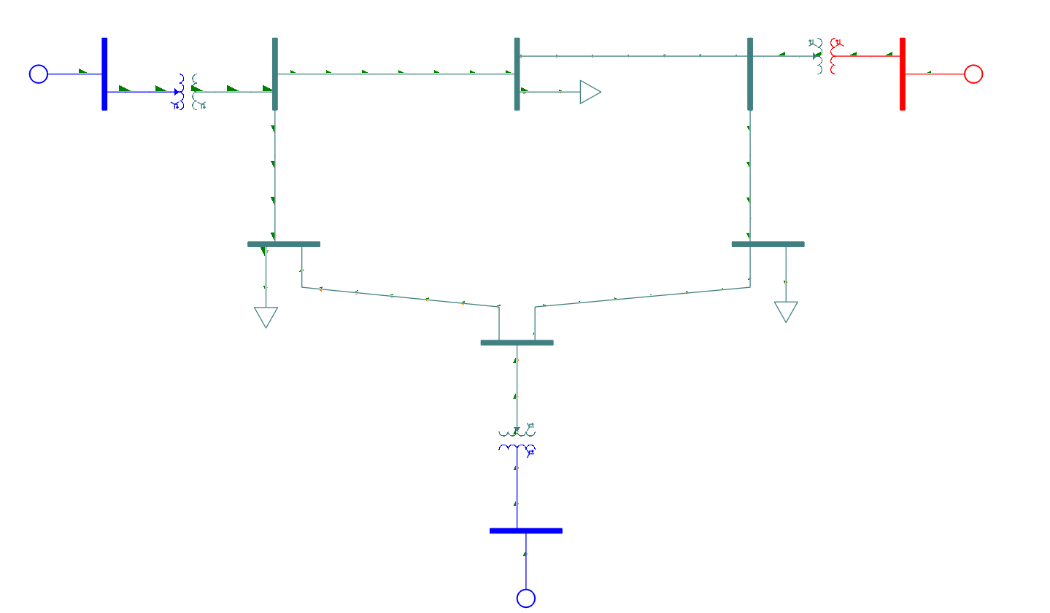

1. Using the results of power flow analysis, plot a ***voltage profile*** (bus voltages in pu on y-axis and number of bus at x-axis).

**Voltage Profile:**

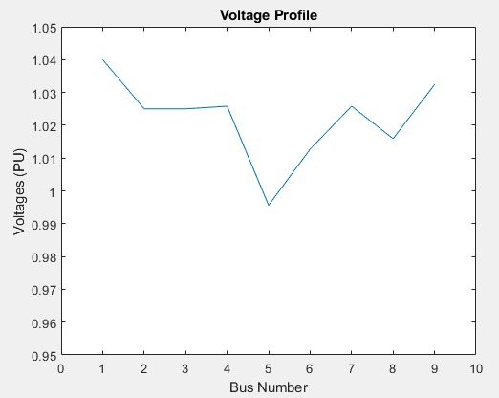

The above graph can be used to find out the respective per unit voltage for each bus in the network.

### Task 4: To perform short-circuit analysis

1. Carry-out short-circuit analysis for three-phase bolted faults on all buses.

Since we were simulating balanced faults, we did not need to give the values of sequence impedances, however, we required the values of resistance and reactance of the generators. The resistance and reactance data that was used for the short circuit analysis can be found in the generator data table in task 1.

1. Display the results on single-line diagram (Current in Amperes in Polar form).

**Short Circuit Analysis (values in PU):**

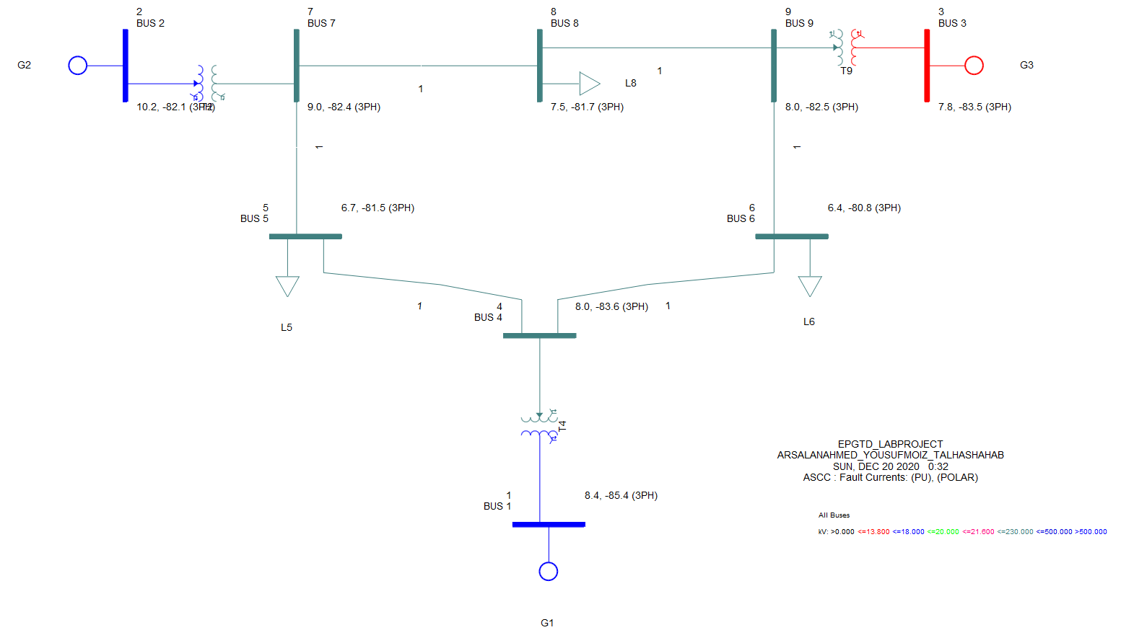

**Short Circuit Analysis (values in Amperes):**

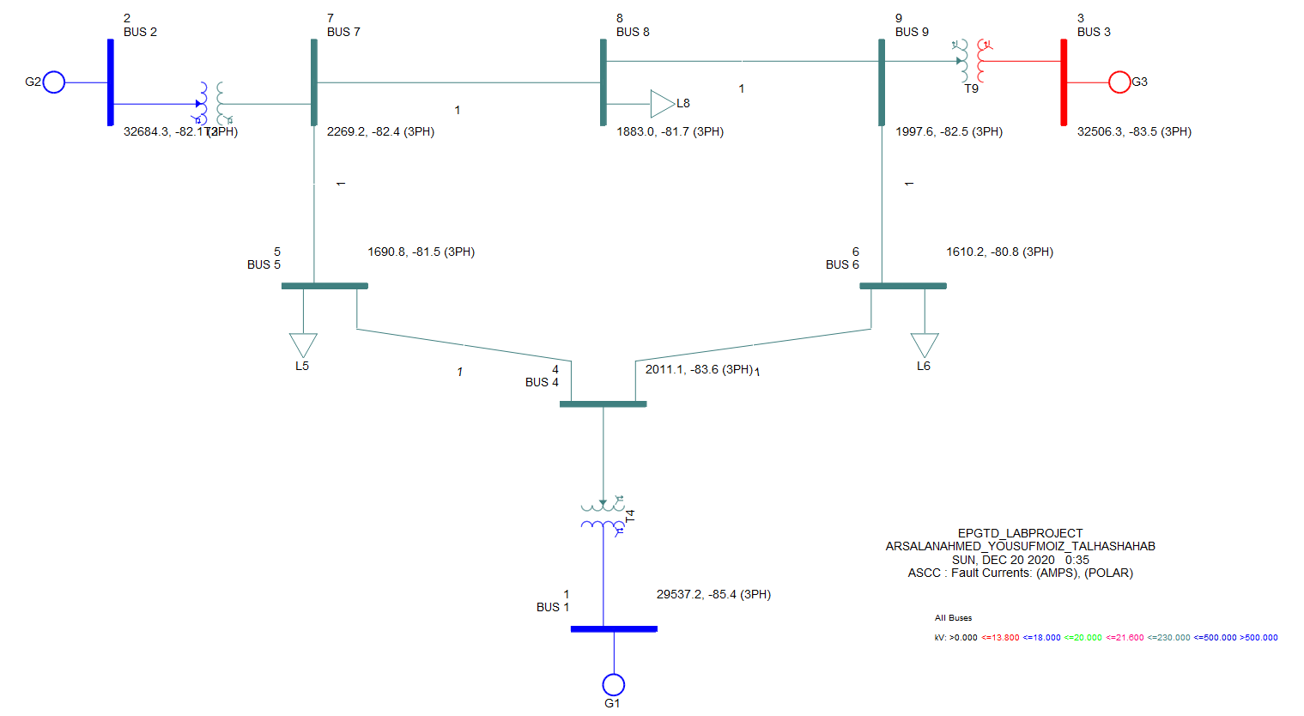

1. Generate the report.

**Short Circuit analysis report (values in PU):**

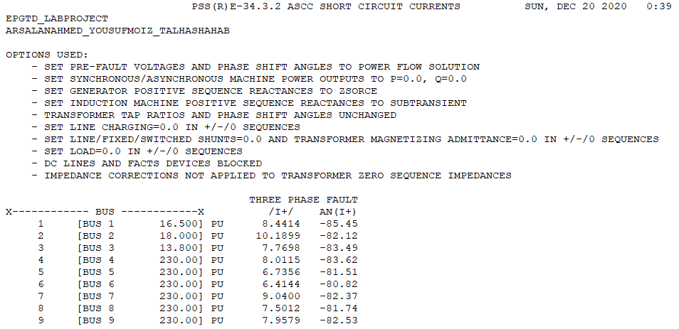

**Short Circuit analysis report (values in Amperes):**

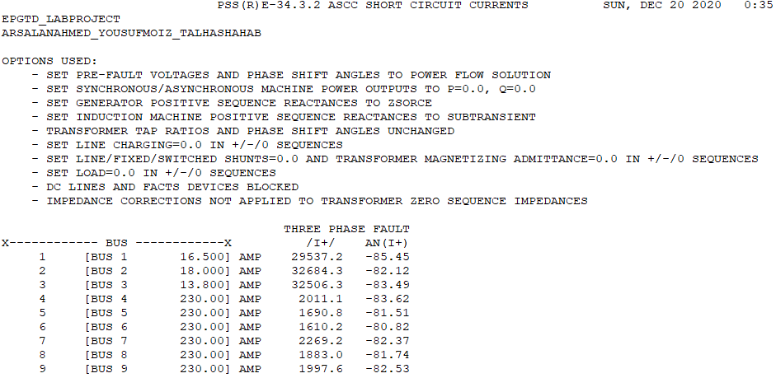

### Task 5: To modify the network and apply techniques of voltage regulation

1. Now modify the network such that the line connecting bus 4 and bus 6 is removed. Re-run the power-flow and obtain bus voltages.

**Power Flow results after removing bus 4 to bus 6 line:**

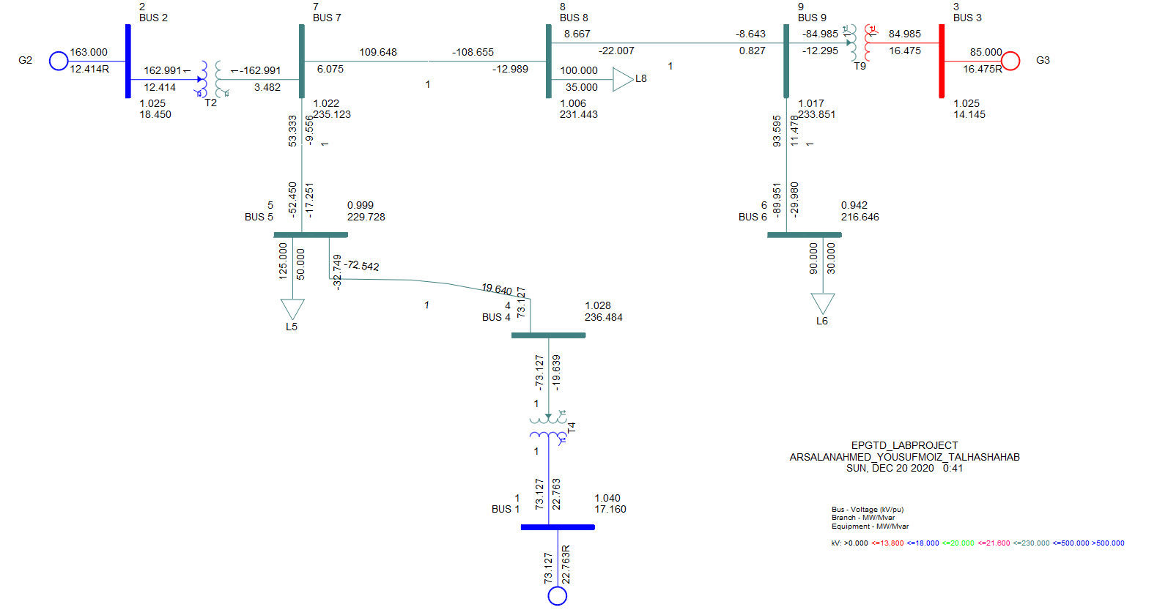

1. What is the impact of this modification on the supply to the loads? Is supply to any of the loads interrupted?

When the connection between the bus 4 and 6 was interrupted, most of the buses were not affected which shows the advantages of using an interconnected system. However, the load connected at bus 6 was affected as the voltage of the bus reduced from 1.013 pu to 0.942 pu which would have affected the supply to the load connected.

1. If the resulting voltage at any bus has been decreased below 0.96 pu, apply technique(s) to improve the voltage regulation.

**Technique used:** Adding a shunt capacitor supplying reactive power to the load.

**Updated power flow results after addition of shunt capacitor:**

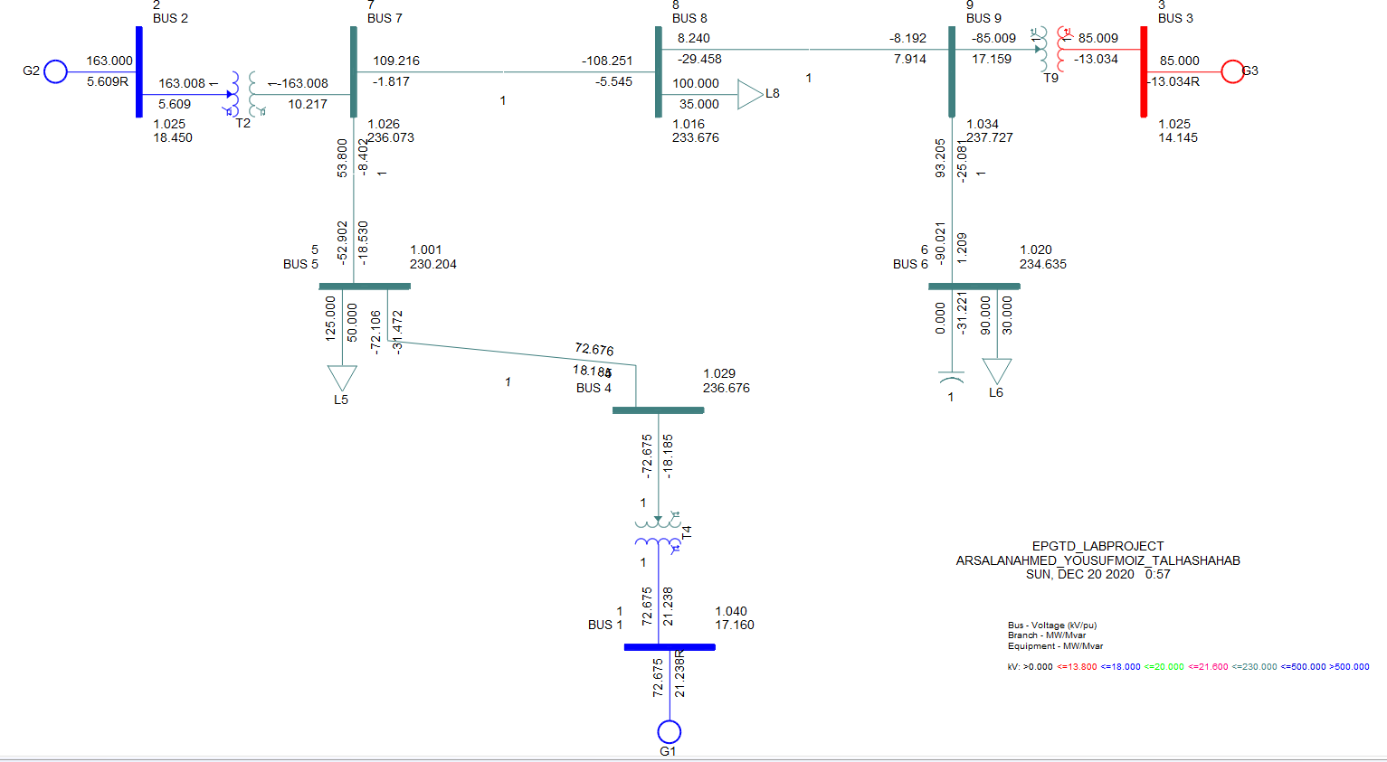

In the above single-line diagram, the shunt capacitor added has a rating of 30 MVAR, which is equal to the rating of the load in parallel. After running the load flow on the above network, it can be seen that voltage regulation of the bus 6 has improved and the voltage has increased from 0.942 pu to 1.020 pu.

### 

### Task 6: To identify the protection schemes required for protection of different components of the system

1. There are multiple components in the system (generators, transmission lines, transformers, feeders /loads, bus bars). Identify few protection schemes that can be applied to protect these components/systems in case of any potential fault. Discuss your recommendations and justify them with reasons.

The following protection schemes can be used to protect these components:

* **Over-Current Relays:**

The major function of an over-current relay is to detect whether the current flowing in the line has exceeded a set threshold. These relays can be used to protect the system from current surges by generating trip signals for the circuit breakers, thus breaking supply to the line. Definite time over-current relay (DTOCR) is also an over-current relay but with the added functionality of generating a trip signal only after waiting a definite amount of time. Therefore, if the fault is only minor and disappears after a certain time, the relay would not generate the trip signal and the supply to the line would not be interrupted.

* **Differential Relay:**

Differential relays work on the principle that the current entering a component should be the same as the current leaving the component. Therefore, they constantly monitor the current entering and leaving a component and whenever they sense any difference between the two currents, a trip signal is generated for the circuit breakers, thus breaking supply to the line. Hence, differential relays can be beneficial for the protection of equipment such as transformers, generators and loads.

* **Primary and Backup Protection:**

We can incorporate primary and backup protection in our system to provide two levels of protection. In the primary protection, we can protect each of the individual lines with an overcurrent relay, where a fault in a specific line would be cleared by the relay and circuit breaker connected to that line. In cases where for some reason, the primary relays are not able to clear the fault, the backup protection can takeover. In the backup protection, the over-current relays will be employed at the generating stations with sufficient time delay which first provides an opportunity for the primary relays to take action, and only takes over if the primary protection fails to take action in that time and cuts off supply to the whole transmission line.

### Task 7: To write a report concluding your work

1. Write a report to summarize all the work done in the above tasks. The report should contain task wise results and analysis where required.
2. The data and results should be presented in the form of tables. Include the single-line diagram representation of the obtained results. Attach the reports generated by the software in Appendices. All the tables and figures must be labeled in a meaningful way.

## Evaluation and Assessment

On the evaluation day, you will be asked to explain the work done using the model simulated in PSS®E. Viva will be conducted to assess the contribution and learning of each individual. Prepare for the evaluation according to the shared rubrics.

*10 % Bonus Marks will be awarded for exploring the untouched tools of the software.*

## Assessment Rubric for Project

**IEEE 9 Bus System – Project Evaluation Rubrics**

|  |  |  |
| --- | --- | --- |
|  | **Group Members** | |
| **1** | **ID:** 03482 | **Name:** Yousuf Moiz |
| **2** | **ID:** 03980 | **Name:** Arsalan Ahmed |
| **3** | **ID:** 03495 | **Name:** Muhammad Talha Shahab |

|  |  |  |  |  |  |  |  |
| --- | --- | --- | --- | --- | --- | --- | --- |
| **Tasks** | **Level 1** *Unsatisfactory*  *Points 0-1* | **Level 2:** *Developing*  *Points 2-5* | **Level 3:** *Good*  *Points 6-8* | **Level 4:**  *Exemplary*  *Points 9-10* | **Points Scored** | | |
|  |  |  |
| **Task 1:**  **System Data**  *Weightage:*  *20 %*  **CLO 1** | The standard IEEE 9 bus system layout and data have not been obtained. | The system layout and data have been obtained but not from standard sources. Response shows lack of understanding of the obtained data. | The data has been obtained from standard sources. The obtained data is correct and consistent. Response shows that the obtained data is not completely interpreted. | Standard IEE 9 bus system layout and data have been obtained from the standard sources which is interpreted correctly. |  |  |  |
| **Task 2:**  **Simulation Model using PSS®E**  *Weightage:*  *20 %*  **CLO 2** | PSS®E sld (single line diagram) file is not created for the collected data of IEEE 9 Bus System. | PSS®E sld file is created but the implemented sld is not consistent with the obtained data. | PSS®E sld file is created for the collected data of IEEE 9 bus system. The components are not given meaningful names. Titles / legends are not added. | PSS®E sld file is created for the collected data of IEEE 9 bus system with meaningful names. Titles / legends are also added. |  |  |  |
| **Task 3:**  **Power Flow Solution**  *Weightage:*  *15 %*  **CLO 2** | PSS®E Power flow tool is not run to obtain the power flow solution. | PSS®E Power flow tool is used to obtain the power flow solution. Response shows inability to interpret the results. | Power flow solution is obtained but the response shows inability to display the results on single line diagram. Report is generated. Voltage profile is not plotted. | Power flow solution is obtained; the results are displayed on the single line diagram. Report is generated. The results are interpreted correctly. Voltage profile is also plotted. |  |  |  |
| **Task 4:**  **Short-Circuit Analysis**  *Weightage:*  *15 %*  **CLO 2** | Short-circuit analysis is not performed. | Short-circuit analysis is performed but the different options are not utilized to obtain the short-circuit analysis for the given faults. The required data for short-circuit analysis is not obtained. | Short-circuit analysis is performed but the results are not displayed as required. Additional data required has been obtained and entered. Response shows inability to interpret the results completely. | Short-circuit analysis is performed. Results are being displayed as required. Report is generated and results are correctly interpreted. |  |  |  |
| **Task 5:**  **System Modification and Voltage Regulation**  *Weightage:*  *10 %*  **CLO 2** | System is not modified for the given changes. | System is modified as per the given changes. Load flow is not obtained correctly after the applied changes. | System is modified as per the given changes. Load flow is obtained correctly after the applied changes. Voltage regulation technique is applied. Results are not concluded. | System is modified and load flow is obtained. Voltage regulation technique is applied and results are interpreted. |  |  |  |
| **Task 6:**  **Identification of Protection Schemes**  *Weightage:*  *10 %*  **CLO 4** | None of the protection scheme is identified for any component. | For less than half of the system components, protection schemes are listed (names only). | For most of the components protection schemes are listed. Response shows lack of understanding behind the recommended schemes. | Protection schemes are recommended for most of the components. The listed schemes are interpreted and justified. |  |  |  |
| **Task 7:**  **Report**  *Weightage:*  *10 %*  **CLO 1** | Report is not submitted / Report contains very little information about the work done. | Report is not written as per the given guidelines. Data is not presented in a meaningful way. Important details are missing. | Report is written as per the given guidelines. Few details are missing. Results are not concluded or captions are not added for all the figures / tables. Reports generated by the software are not added in appendix. | Report contains all the important details presented in a meaningful way. The report is written as per the given guidelines. Results are summarized well. Reports generated by the software are also added. |  |  |  |
| Total: 100 % | | | | |  |  |  |
| Scaled: 14 Marks | | | | |  |  |  |