TA messages
1. For Poisson distributions, please provide an example showing how changing the time interval or region affects the mean (λ). You can use an example similar to Quiz Question 1(a) from the makeup quiz.
2. Introduce the general methods for integration. If time is tight or the material feels too challenging, we can skip part (6) for now.
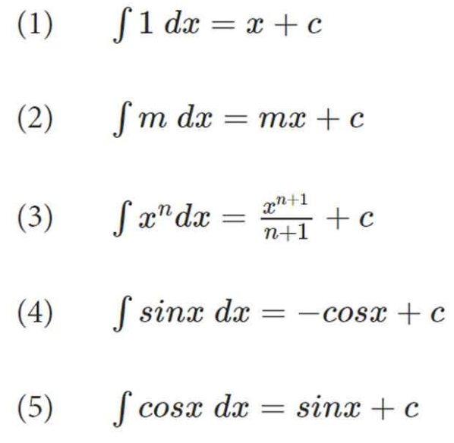
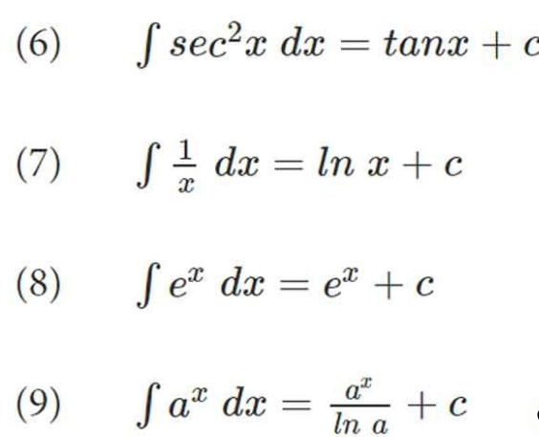
3. Please work through an example that demonstrates how to:
- Derive the CDF from a continuous PDF, and CDF to PDF
- Compute $E(X)$and $\text{Var}(X)$
Make sure the example is a purely continuous distribution with $f(X=x)=0$ for all $x$, and that the PDF has at least two non-zero segments (similar in structure to Quiz Question 2).

Please do not talk about exam questions in class. We still have one student hasn’t taken it yet. But you can mention that they can stop by your office hours for exam questions.

