Supplementary Figures
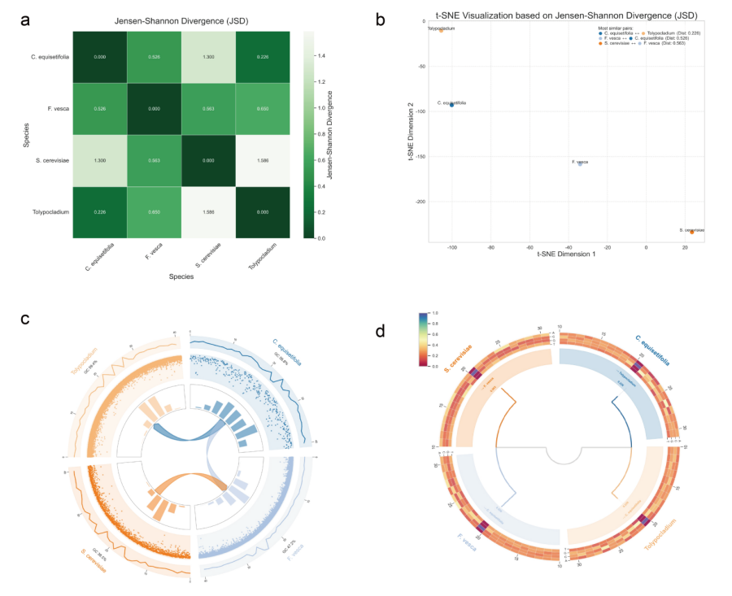
Fig. S1. Comprehensive analysis of 4mC sequence conservation and similarity relationships across diverse species. a, JSD heatmap; b, t-SNE visualization; c, Circos plot of multimodal sequence tracks; d, Hierarchical dendrogram of inter-species similarity.
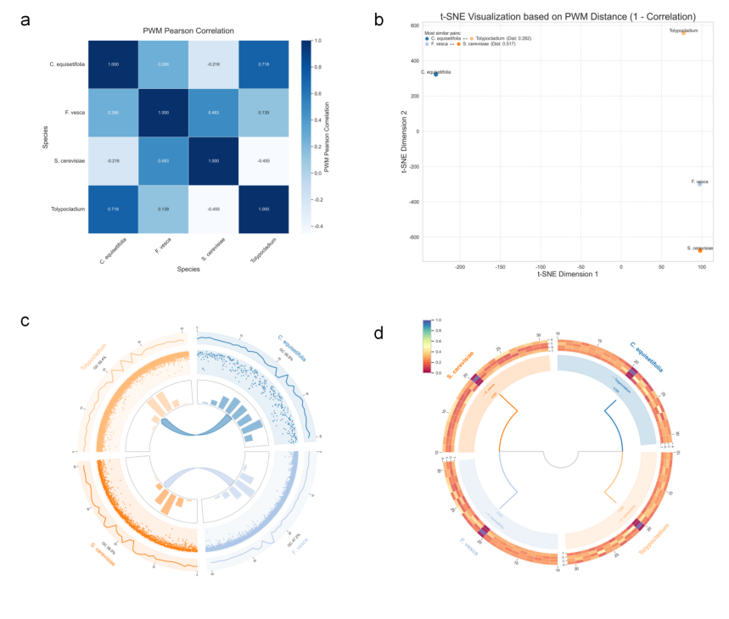
Fig. S2. Comprehensive analysis of 4mC sequence conservation and similarity relationships across diverse species. a, PWM heatmap; b, t-SNE visualization; c, Circos plot of multimodal sequence tracks; d, Hierarchical dendrogram of inter-species similarity.

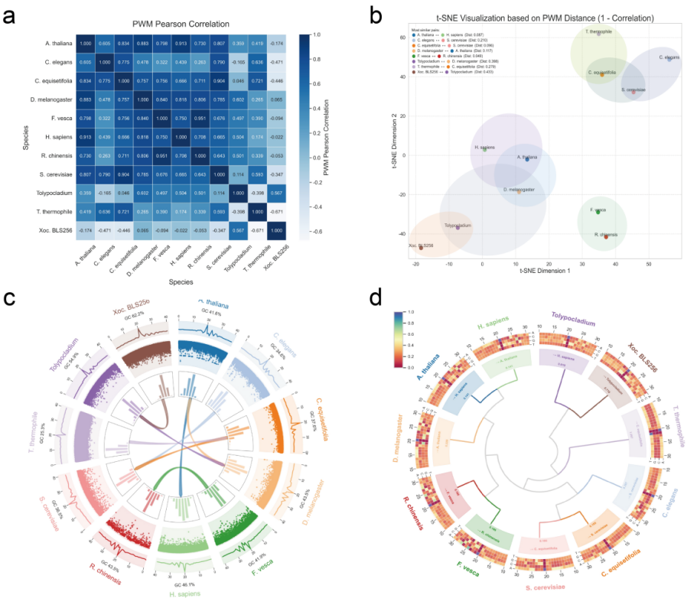
Fig. S3. Comprehensive analysis of 6mA sequence conservation and similarity relationships across diverse species. a, PWM heatmap; b, t-SNE visualization; c, Circos plot of multimodal sequence tracks; d, Hierarchical dendrogram of inter-species similarity.
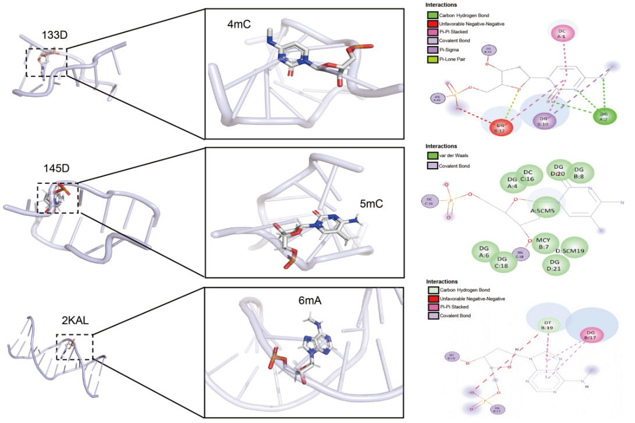
Fig. S4. Molecular structural profiles and 2D non-covalent interaction maps for 4mC (PDB ID: 133D), 5mC (PDB ID: 145D), and 6mA (PDB ID: 2KAL) sites.
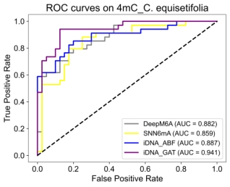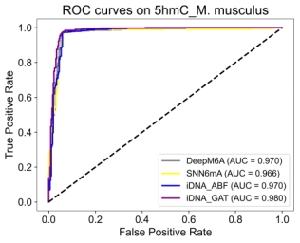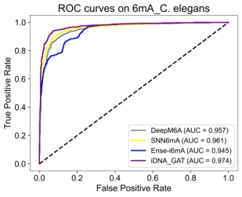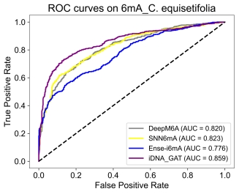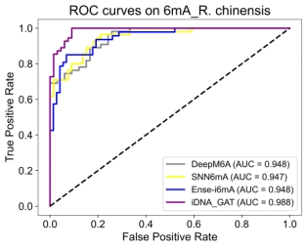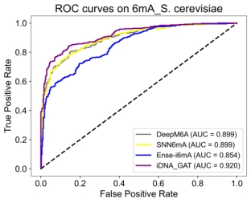
Fig. S5. ROC comparisons between iDNA_GAT and other DNA methylation site predictors.

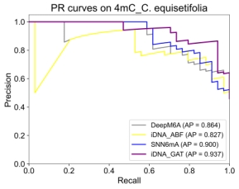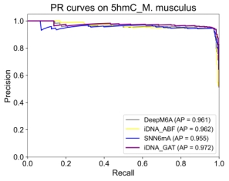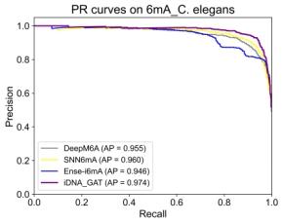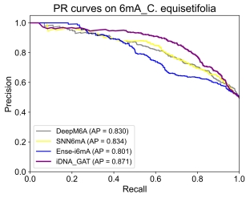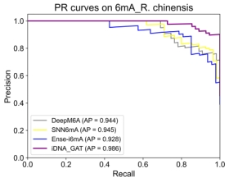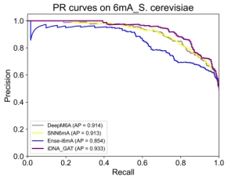
Fig. S6. PR comparisons between iDNA_GAT and other DNA methylation site predictors.

Supplementary Table
Table. S1. Detailed performance comparison between iDNA_GAT and other DNA methylation site prediction methods on 17 datasets.
Datasets | Methods | Sen | Spe | Acc | MCC | AUC | PR
4mC_C. equisetifolia | iDNA_ABF | 0.857 | 0.854 | 0.689 | 0.409 | 0.859 | 0.827
 | SNN6mA | 0.861 | 0.847 | 0.716 | 0.487 | 0.888 | 0.900
 | DeepM6A | 0.618 | 0.900 | 0.770 | 0.545 | 0.882 | 0.864
 | iDNA_GA | 0.912 | 0.750 | 0.824 | 0.663 | 0.910 | 0.913
 | iDNA_GAT | 0.824 | 0.875 | 0.851 | 0.700 | 0.941 | 0.937
4mC_F. vesca | iDNA_ABF | 0.904 | 0.662 | 0.781 | 0.582 | 0.875 | 0.861
 | SNN6mA | 0.853 | 0.855 | 0.854 | 0.708 | 0.925 | 0.909
 | DeepM6A | 0.933 | 0.720 | 0.825 | 0.667 | 0.923 | 0.914
 | iDNA_GA | 0.866 | 0.860 | 0.864 | 0.727 | 0.932 | 0.924
 | iDNA_GAT | 0.871 | 0.860 | 0.865 | 0.731 | 0.942 | 0.936
4mC_S. cerevisiae | iDNA_ABF | 0.673 | 0.748 | 0.710 | 0.415 | 0.773 | 0.791
 | SNN6mA | 0.779 | 0.652 | 0.715 | 0.434 | 0.795 | 0.827
 | DeepM6A | 0.709 | 0.732 | 0.720 | 0.441 | 0.800 | 0.821
 | iDNA_GA | 0.824 | 0.672 | 0.748 | 0.502 | 0.841 | 0.847
 | iDNA_GAT | 0.799 | 0.742 | 0.771 | 0.542 | 0.853 | 0.866
4mC_Tolypocladium | iDNA_ABF | 0.732 | 0.688 | 0.710 | 0.420 | 0.781 | 0.770
 | SNN6mA | 0.760 | 0.683 | 0.721 | 0.441 | 0.796 | 0.790
 | DeepM6A | 0.721 | 0.770 | 0.746 | 0.491 | 0.824 | 0.822
 | iDNA_GA | 0.690 | 0.788 | 0.739 | 0.480 | 0.818 | 0.815
 | iDNA_GAT | 0.761 | 0.764 | 0.763 | 0.525 | 0.844 | 0.841
5hmC_H. sapiens | iDNA_ABF | 0.996 | 0.888 | 0.943 | 0.890 | 0.951 | 0.917
 | SNN6mA | 0.992 | 0.888 | 0.940 | 0.885 | 0.952 | 0.909
 | DeepM6A | 0.991 | 0.901 | 0.946 | 0.897 | 0.946 | 0.897
 | iDNA_GA | 0.992 | 0.900 | 0.949 | 0.902 | 0.965 | 0.954
 | iDNA_GAT | 0.996 | 0.914 | 0.955 | 0.914 | 0.973 | 0.955
5hmC_M. musculus | iDNA_ABF | 0.974 | 0.930 | 0.953 | 0.906 | 0.966 | 0.962
 | SNN6mA | 0.971 | 0.941 | 0.952 | 0.913 | 0.970 | 0.955
 | DeepM6A | 0.971 | 0.940 | 0.956 | 0.911 | 0.970 | 0.961
 | iDNA_GA | 0.971 | 0.940 | 0.956 | 0.913 | 0.971 | 0.957
 | iDNA_GAT | 0.971 | 0.941 | 0.957 | 0.913 | 0.980 | 0.972
6mA_A. thaliana | iDNA6mA | 0.843 | 0.889 | 0.866 | 0.733 | 0.932 | 0.936
 | i6mADNC | 0.846 | 0.909 | 0.878 | 0.757 | 0.944 | 0.951
 | DeepM6A | 0.894 | 0.931 | 0.913 | 0.826 | 0.966 | 0.970
 | AL6mA | 0.862 | 0.905 | 0.884 | 0.768 | 0.945 | 0.944
 | LA6mA | 0.899 | 0.917 | 0.909 | 0.817 | 0.962 | 0.966
 | SNN6mA | 0.894 | 0.935 | 0.914 | 0.829 | 0.963 | 0.965
 | Ense-i6mA | 0.881 | 0.927 | 0.904 | 0.809 | 0.957 | 0.960
 | iDNA_GA | 0.904 | 0.915 | 0.910 | 0.820 | 0.964 | 0.968
 | iDNA_GAT | 0.884 | 0.945 | 0.915 | 0.831 | 0.969 | 0.972
6mA_C. elegans | iDNA6mA | 0.900 | 0.890 | 0.895 | 0.790 | 0.957 | 0.955
 | i6mADNC | 0.917 | 0.880 | 0.898 | 0.797 | 0.956 | 0.953
 | DeepM6A | 0.871 | 0.917 | 0.895 | 0.790 | 0.957 | 0.955
 | AL6mA | 0.827 | 0.864 | 0.846 | 0.691 | 0.920 | 0.918
 | LA6mA | 0.913 | 0.891 | 0.902 | 0.804 | 0.964 | 0.965
 | SNN6mA | 0.911 | 0.910 | 0.910 | 0.820 | 0.961 | 0.960
 | Ense-i6mA | 0.856 | 0.865 | 0.861 | 0.721 | 0.945 | 0.946
 | iDNA_GA | 0.902 | 0.886 | 0.906 | 0.816 | 0.963 | 0.963
 | iDNA_GAT | 0.908 | 0.948 | 0.928 | 0.857 | 0.974 | 0.974
6mA_C. equisetifolia | iDNA6mA | 0.743 | 0.756 | 0.750 | 0.499 | 0.818 | 0.831
 | i6mADNC | 0.725 | 0.733 | 0.729 | 0.458 | 0.816 | 0.823
 | DeepM6A | 0.698 | 0.789 | 0.744 | 0.489 | 0.820 | 0.830
 | AL6mA | 0.687 | 0.735 | 0.711 | 0.422 | 0.775 | 0.782
 | LA6mA | 0.725 | 0.735 | 0.730 | 0.445 | 0.811 | 0.823
 | SNN6mA | 0.726 | 0.759 | 0.743 | 0.481 | 0.823 | 0.834
 | Ense-i6mA | 0.687 | 0.654 | 0.671 | 0.342 | 0.776 | 0.801
 | iDNA_GA | 0.640 | 0.877 | 0.759 | 0.533 | 0.842 | 0.846
 | iDNA_GAT | 0.771 | 0.820 | 0.795 | 0.590 | 0.859 | 0.871
6mA_D. melanogaster | iDNA6mA | 0.883 | 0.843 | 0.863 | 0.727 | 0.937 | 0.948
 | i6mADNC | 0.869 | 0.917 | 0.893 | 0.787 | 0.947 | 0.956
 | DeepM6A | 0.901 | 0.939 | 0.920 | 0.841 | 0.969 | 0.975
 | AL6mA | 0.840 | 0.916 | 0.878 | 0.758 | 0.941 | 0.947
 | LA6mA | 0.909 | 0.915 | 0.912 | 0.824 | 0.966 | 0.971
 | SNN6mA | 0.909 | 0.937 | 0.923 | 0.846 | 0.967 | 0.972
 | Ense-i6mA | 0.890 | 0.936 | 0.913 | 0.827 | 0.961 | 0.967
 | iDNA_GA | 0.920 | 0.902 | 0.911 | 0.822 | 0.964 | 0.970
 | iDNA_GAT | 0.901 | 0.959 | 0.926 | 0.853 | 0.970 | 0.975
6mA_F. vesca | iDNA6mA | 0.916 | 0.936 | 0.926 | 0.852 | 0.976 | 0.972
 | i6mADNC | 0.941 | 0.900 | 0.921 | 0.843 | 0.975 | 0.974
 | DeepM6A | 0.942 | 0.929 | 0.936 | 0.871 | 0.979 | 0.978
 | AL6mA | 0.881 | 0.900 | 0.890 | 0.781 | 0.957 | 0.951
 | LA6mA | 0.926 | 0.891 | 0.908 | 0.817 | 0.971 | 0.967
 | SNN6mA | 0.942 | 0.948 | 0.932 | 0.865 | 0.977 | 0.975
 | Ense-i6mA | 0.921 | 0.937 | 0.929 | 0.858 | 0.974 | 0.975
 | iDNA_GA | 0.952 | 0.910 | 0.931 | 0.862 | 0.976 | 0.974
 | iDNA_GAT | 0.965 | 0.945 | 0.955 | 0.910 | 0.989 | 0.988
6mA_H. sapiens | iDNA6mA | 0.893 | 0.882 | 0.888 | 0.776 | 0.957 | 0.960
 | i6mADNC | 0.864 | 0.915 | 0.889 | 0.780 | 0.955 | 0.958
 | DeepM6A | 0.867 | 0.915 | 0.892 | 0.786 | 0.956 | 0.961
 | AL6mA | 0.845 | 0.889 | 0.867 | 0.735 | 0.938 | 0.941
 | LA6mA | 0.903 | 0.900 | 0.902 | 0.804 | 0.963 | 0.967
 | SNN6mA | 0.903 | 0.911 | 0.907 | 0.815 | 0.962 | 0.963
 | Ense-i6mA | 0.853 | 0.850 | 0.852 | 0.703 | 0.946 | 0.954
 | iDNA_GA | 0.921 | 0.888 | 0.905 | 0.810 | 0.958 | 0.940
 | iDNA_GAT | 0.898 | 0.930 | 0.914 | 0.829 | 0.969 | 0.972
6mA_R. chinensis | iDNA6mA | 0.873 | 0.773 | 0.818 | 0.643 | 0.923 | 0.914
 | i6mADNC | 0.872 | 0.772 | 0.818 | 0.643 | 0.925 | 0.925
 | DeepM6A | 0.891 | 0.803 | 0.843 | 0.691 | 0.948 | 0.944
 | AL6mA | 0.636 | 0.667 | 0.653 | 0.302 | 0.695 | 0.661
 | LA6mA | 0.727 | 0.758 | 0.744 | 0.484 | 0.810 | 0.788
 | SNN6mA | 0.800 | 0.879 | 0.843 | 0.863 | 0.947 | 0.945
 | Ense-i6mA | 0.936 | 0.808 | 0.858 | 0.727 | 0.947 | 0.928
 | iDNA_GA | 0.982 | 0.742 | 0.851 | 0.732 | 0.961 | 0.952
 | iDNA_GAT | 0.998 | 0.818 | 0.926 | 0.821 | 0.988 | 0.986
6mA_S. cerevisiae | iDNA6mA | 0.814 | 0.782 | 0.798 | 0.596 | 0.884 | 0.894
 | i6mADNC | 0.767 | 0.852 | 0.809 | 0.621 | 0.899 | 0.911
 | DeepM6A | 0.786 | 0.854 | 0.820 | 0.641 | 0.899 | 0.914
 | AL6mA | 0.705 | 0.844 | 0.773 | 0.553 | 0.852 | 0.874
 | LA6mA | 0.788 | 0.795 | 0.792 | 0.583 | 0.879 | 0.896
 | SNN6mA | 0.791 | 0.830 | 0.810 | 0.621 | 0.898 | 0.910
 | Ense-i6mA | 0.742 | 0.764 | 0.753 | 0.506 | 0.854 | 0.854
 | iDNA_GA | 0.829 | 0.779 | 0.805 | 0.610 | 0.900 | 0.914
 | iDNA_GAT | 0.812 | 0.873 | 0.842 | 0.691 | 0.920 | 0.933
6mA_T. thermophile | iDNA6mA | 0.926 | 0.801 | 0.868 | 0.740 | 0.930 | 0.910
 | i6mADNC | 0.945 | 0.779 | 0.863 | 0.736 | 0.927 | 0.906
 | DeepM6A | 0.933 | 0.801 | 0.868 | 0.742 | 0.931 | 0.913
 | AL6mA | 0.933 | 0.787 | 0.860 | 0.729 | 0.927 | 0.907
 | LA6mA | 0.930 | 0.810 | 0.872 | 0.750 | 0.938 | 0.922
 | SNN6mA | 0.950 | 0.800 | 0.875 | 0.759 | 0.938 | 0.921
 | Ense-i6mA | 0.799 | 0.825 | 0.812 | 0.624 | 0.929 | 0.915
 | iDNA_GA | 0.953 | 0.798 | 0.876 | 0.760 | 0.938 | 0.923
 | iDNA_GAT | 0.956 | 0.805 | 0.881 | 0.771 | 0.945 | 0.930
6mA_Tolypocladium | iDNA6mA | 0.688 | 0.823 | 0.756 | 0.516 | 0.835 | 0.842
 | i6mADNC | 0.745 | 0.770 | 0.757 | 0.515 | 0.836 | 0.842
 | DeepM6A | 0.718 | 0.791 | 0.754 | 0.510 | 0.833 | 0.835
 | AL6mA | 0.680 | 0.805 | 0.743 | 0.489 | 0.806 | 0.820
 | LA6mA | 0.688 | 0.802 | 0.746 | 0.494 | 0.829 | 0.822
 | SNN6mA | 0.659 | 0.845 | 0.772 | 0.550 | 0.842 | 0.852
 | Ense-i6mA | 0.680 | 0.681 | 0.680 | 0.361 | 0.767 | 0.792
 | iDNA_GA | 0.774 | 0.773 | 0.774 | 0.547 | 0.856 | 0.861
 | iDNA_GAT | 0.763 | 0.826 | 0.794 | 0.590 | 0.875 | 0.875
6mA_Xoc. BLS256 | iDNA6mA | 0.852 | 0.871 | 0.864 | 0.729 | 0.935 | 0.932
 | i6mADNC | 0.829 | 0.859 | 0.844 | 0.688 | 0.926 | 0.924
 | DeepM6A | 0.843 | 0.870 | 0.857 | 0.714 | 0.933 | 0.933
 | AL6mA | 0.843 | 0.855 | 0.849 | 0.698 | 0.926 | 0.925
 | LA6mA | 0.859 | 0.862 | 0.861 | 0.721 | 0.929 | 0.924
 | SNN6mA | 0.910 | 0.862 | 0.887 | 0.774 | 0.952 | 0.947
 | Ense-i6mA | 0.851 | 0.825 | 0.838 | 0.676 | 0.941 | 0.940
 | iDNA_GA | 0.906 | 0.858 | 0.882 | 0.765 | 0.951 | 0.948
 | iDNA_GAT | 0.895 | 0.907 | 0.901 | 0.802 | 0.958 | 0.953

