CSCI 572 Homework5

Name: Youzhi Qu

USCID: 5045807938

1. Steps for completing assignment:

Use Java to parse web pages data and create big.txt file.

Change solrconfig.xml(add search component and request handler).

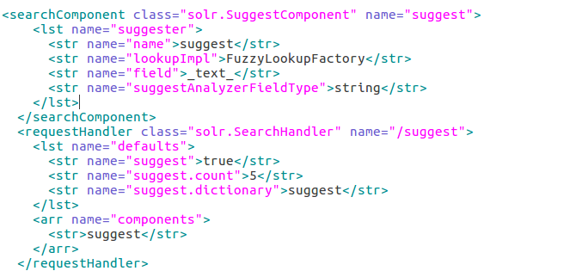

Use Java to parse web pages data to txt file for speeding up.

1. Analysis of the results

misspelled terms:

* donad trup

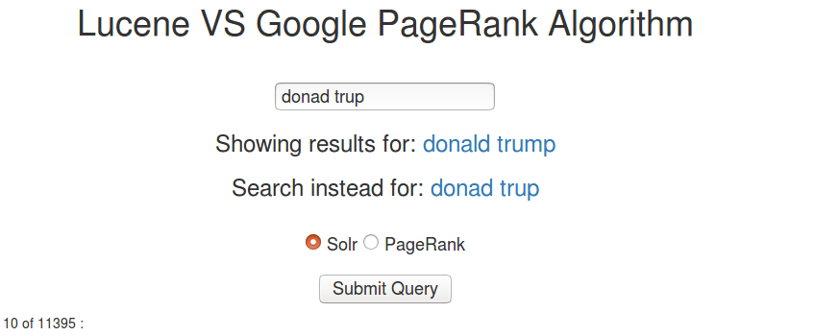

* californua

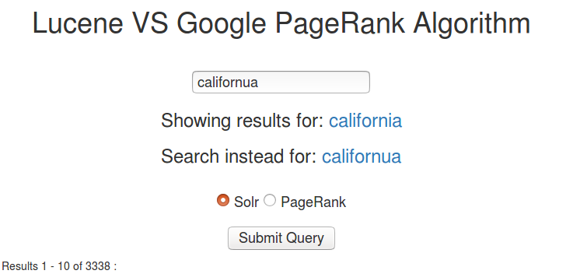

* universitu

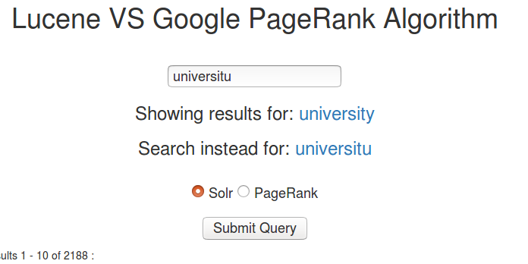

* enviroment

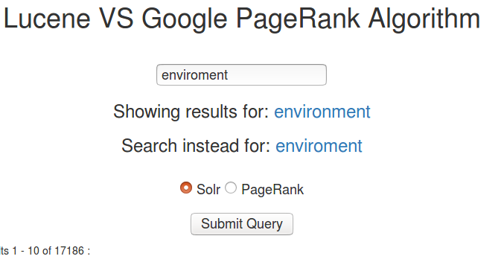

* new yook

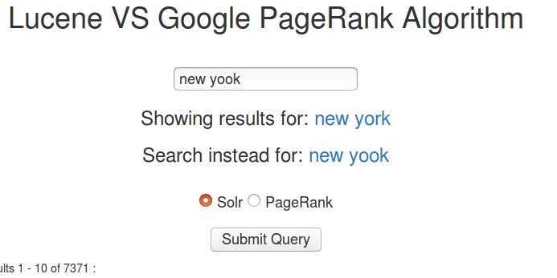

auto-completion:

* calif

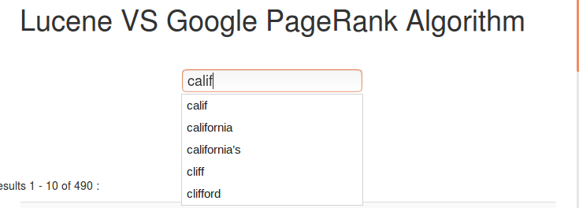

* trum

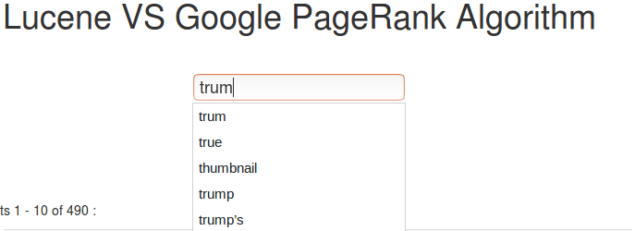

* sh

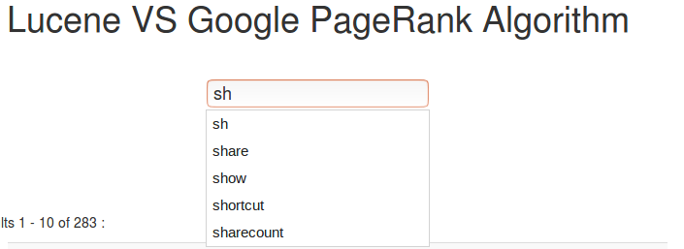

* univer

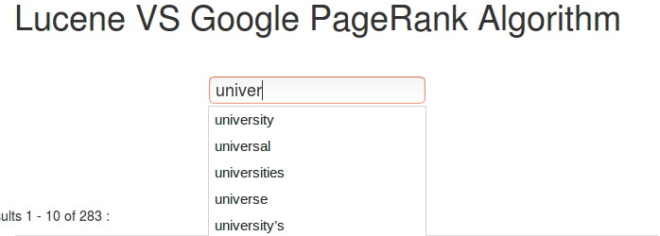

* pro

