11510726 Assignment 3 毛煦冰

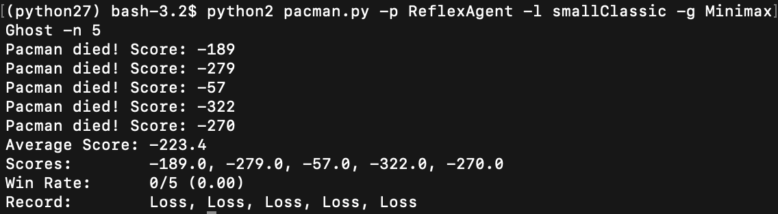

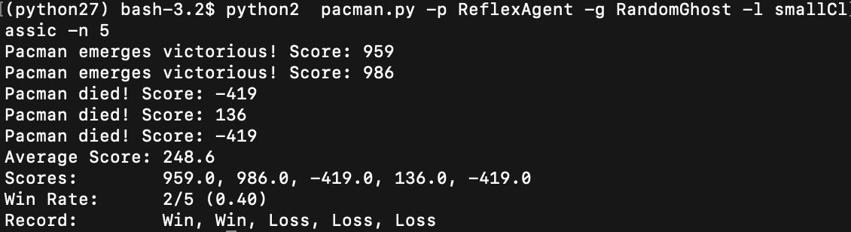

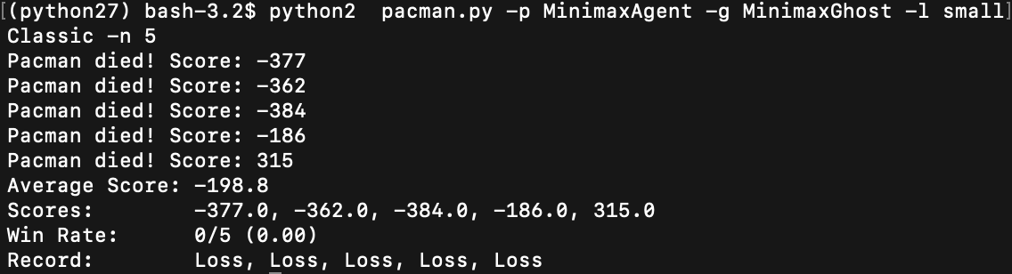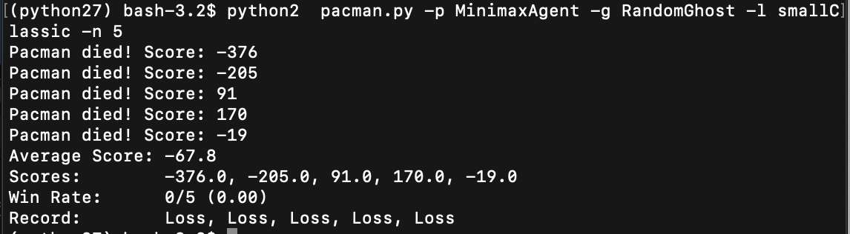

|  |  |  |
| --- | --- | --- |
| Map: smallClassic | Random Ghost | Minimax Ghost |
| Reflex Agent | Won: 2/5  Average Score: 248.6 | Won: 0/5  Average Score: -223.4 |
| Minimax Agent | Won: 0/5  Average Score: -198.8 | Won: 0/5  Average Score: -67.8 |

4. According to the table, we can find that minimax Ghost have lower score than Random Ghost. It can let ghost catch the agent more quickly in order to get a lower score.

5. Because they have same aim.