# Problem 3 – Christmas Tree

Bai Ivan and Ani are sooooo drunk that they thought it’s Christmas so they wanted to buy a christmas tree, it doesn’t matter that it is still August. Your task is to create a christmas tree on the console as big as they want it. See the examples below to understand your task better:

## Input

* Input data is read from the console.
* The number **N** stays alone at the first line.

The input data will always be valid and in the format described. There is no need to check it explicitly.

## Output

* The output data must be printed on the console.
* You must print at the console a Christmas tree of size **N** following the examples below.

## Constraints

* **N** will be an **odd** integer between **5** and **49**.
* Time limit: 0.25 seconds.
* Allowed memory: 16 MB.

## Examples

|  |  |  |  |  |  |  |  |
| --- | --- | --- | --- | --- | --- | --- | --- |
| **Input** | **Output** |  | **Input** | **Output** |  | **Input** | **Output** |
| 5 | '''''^'''''  ''''^^^''''  '''^^^^^'''  ''''^^^''''  '''^^^^^'''  ''^^^^^^^''  ''''| |''''  ''''| |''''  ''''| |''''  ----------- |  | 7 | '''''''^'''''''  ''''''^^^''''''  '''''^^^^^'''''  ''''^^^^^^^''''  ''''''^^^''''''  '''''^^^^^'''''  ''''^^^^^^^''''  '''^^^^^^^^^'''  ''''''| |''''''  ''''''| |''''''  ''''''| |''''''  ''''''| |''''''  --------------- | 9 | '''''''''^'''''''''  ''''''''^^^''''''''  '''''''^^^^^'''''''  ''''''^^^^^^^''''''  '''''^^^^^^^^^'''''  ''''''''^^^''''''''  '''''''^^^^^'''''''  ''''''^^^^^^^''''''  '''''^^^^^^^^^'''''  ''''^^^^^^^^^^^''''  ''''''''| |''''''''  ''''''''| |''''''''  ''''''''| |''''''''  ''''''''| |''''''''  ''''''''| |''''''''  ------------------- |

## Hints:

1. First of all you have to read the input and find the whole width of the tree, because you are going to need it

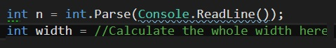

1. Next you need to find a dependence between the rows (For example from row 1 to row N / 2 the count of ‘^’ is raised by two)
2. Then you need to break the Christmas tree into smaller parts where each row in every part has the same dependence.

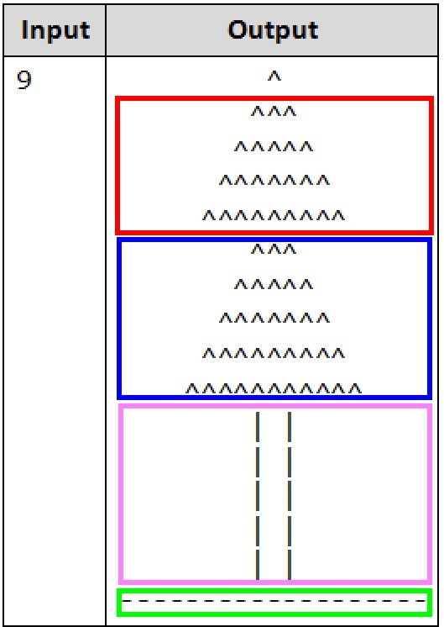

1. Use loop type by choice to iterate over the rows and draw them.

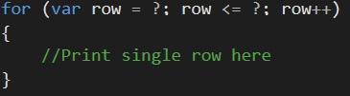

Note: 1. You need to replace '?' with proper values and you can use different type of loop

1. Keep in mind that there can be a line that is unique (For example the last rows)