# Problem 4 – Teleport Points

# Are you familiar with the Marvel universe? Chances are that you have at least heard of some of Marvel's most prominent heroes, such as Spider-Man, Captain America, Iron Man and Wolverine. Chances are, however that you haven't heard about some of Marvel's anti-heroes, mostly because anti-heroes tend to kill people, a LOT of people and thus don't usually get endorsed by the family-friendly mindset of Hollywood. Among these anti-heroes, is a character named Wade Wilson, also known as Deadpool, or “the merc with the mouth”. Wade is best known for his total disregard for human life, for being insane, for being practically immortal, and for having a love affair with Death herself. Deadpool's gear primarily consists of twin katana swords and two automated pistols. However, in some instances, he also possesses a teleportation device, which allows him to “body-slide” to short distances. The device has been destroyed during his last mission and he is now trying to acquire a new one. He already has the device built and he just needs someone to create the software for it, which will calculate possible teleportation points within a certain radius. Since you are the first computer programmer that he finds, you are appointed to do the job. You wouldn't want to disappoint Deadpool now, wouldn't you?

The program is very basic. The device can **teleport** a person **to any point** within a **radius R**. It also has a **step H**, which is the **distance between two neighboring points**. H has to be set manually, so **it cannot change** in the middle of a calculation. The device can only be used **within rectangular rooms** and the teleport **cannot pass through walls**. Deadpool knows that you are a junior developer, so your algorithm must work only **within a two-dimensional space**.

You will be given the coordinates of the **four points of the rectangle**, which will represent **the room**. You will also be given the **value R**, which is the **radius** of the device and the **value H**, which is the device's **step**. Deadpool's position will **always be 0,0**. Your task is to count **all possible points** Deadpool can **teleport** **to**. Points that will make him teleport **within a wall**, are **not considered valid**.

You should probably start working now. Deadpool does not regard patience as a virtue. He did draw you a pretty picture however, so that you can get a better understanding of your task.

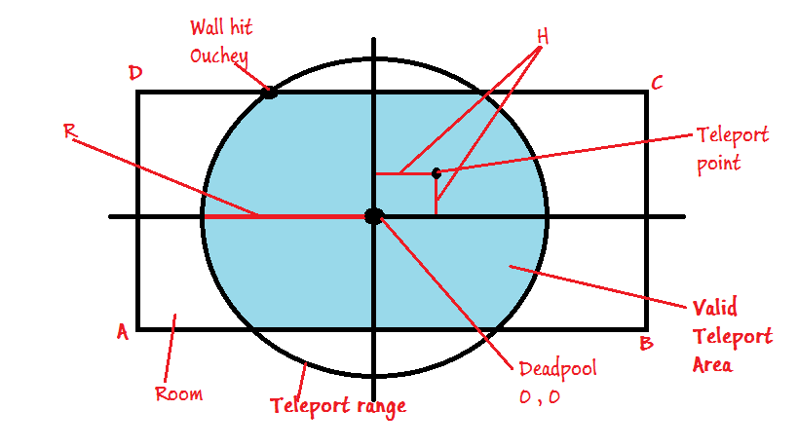

**Input**

The input should be read from the console and will consist of exactly 6 lines.

* The first **4 lines** will contain the **[X Y] coordinates** for each of the **four points** of the room.
* The **X** and the **Y** values will be separated by a **single space**.
* **Lines 5 and 6** will contain the values of the radius **R** and the step **H** respectfully.

1. **[X Y]** – coordinates for point A
2. **[X Y]** – coordinates for point B
3. **[X Y]** – coordinates for point C
4. **[X Y]** – coordinates for point D
5. **R** – Radius
6. **H** – Step

**Output**

* The output should consist of a single number, representing the count of valid teleport points.

**Constraints**

* **X and Y** will always be in the range [-30.5 … 30.5]
* **R and H** will always be in the range [0.1 … 30.5]
* **A, B, C, D** will always form a rectangle.
* Allowed working time for your program: 0.25 seconds.
* Allowed memory: 16MB.

**Examples**

|  |  |  |  |  |  |
| --- | --- | --- | --- | --- | --- |
| **Input** | **Output** | **Explanation** |  | **Input** | **Output** |
| -20 -3  20 -3  20 3  -20 3  10  0.4 | 731 | The room is **40** wide and **6** tall. The circle has radius of **10**. Total points within the area with step **0.4** are **731**. |  | -7.2 -8.8  10.4 -8.8  10.4 9.1  -7.2 9.1  30.5  1 | 324 |