Scanner Calibration

How it will work

Adrian Bowyer

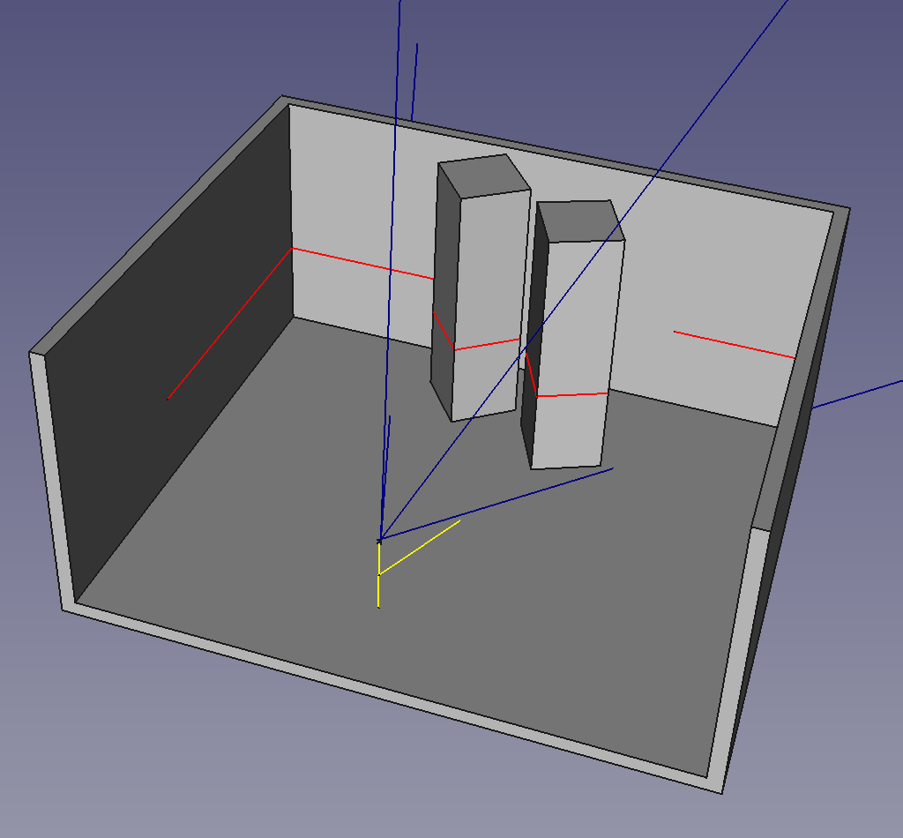
2 March 2021

Consider the setup shown in the picture. The scanner is in a room containing some calibration objects – the two vertical columns. These are square in cross section, of known size, and arranged so that one vertical edge is facing the scanner.

The scanner will see two V-shaped images, which represent 45-45-90 triangles in the real world corresponding to half the cross section of the square columns. (In practice the columns could be short, and on legs to make sure they are at the same height of the light sheet.)

The scanner will have been set up with nominal positions and orientations for its light projector and camera that will be close, but not exactly equal, to how they are in real life. Correcting that difference is the point of doing the calibration.

In what follows I assume that the light sheet is parallel to the floor (easily achieved by moving a stick about the room, touching the floor with it, and seeing where the visible version of the sheet intersects it), and that the columns are genuinely vertical (again, easily achieved by looking at where the light sheet cuts their edges). If the sheet were not at right-angles to the vertical axes of the columns, the intersection triangles would not be right-angled.

The scanner calculates the (in general erroneous) positions of the corners of the triangles. It can now calculate the squared error, which is the sum of the squares of the differences between the measured triangle side lengths and their known true values. If we include the implied hypotenuse in the squared-error calculation at √2 times the squares’ side lengths that automatically forces the triangles to have all the correct angles as well as side lengths. (This is better than working out angles, as summing squared errors in angles with lengths is problematic; they are not dimensionally equivalent.)

We now have to adjust that parameters of the scanner to minimise the squared errors. This is a problem of multidimensional optimisation. I shall start by trying methods of gradient descent, like Newton-Raphson. We have the advantage that the scanner’s nominal configuration should be very near the true values, and so such an approach is unlikely to get stuck in local optima. To get the needed partial derivatives, we will perturb the scanner’s parameters by a small random amount and recalculate the squared error.

To experiment with this I have set up the simulator with two scanner models:

- The scanner with nominal parameters that we need to adjust and
- A secret true scanner as it “actually” is, with randomly perturbed parameters.

The error correction works by feeding the triangle corners into the secret scanner to get the pixel coordinates corresponding to them from its camera, and then using those pixels in the nominal scanner model to get the erroneous triangles that the nominal scanner will deduce. The Newton-Raphson will then adjust the parameters of the nominal scanner and (we hope) cause it to converge on the parameters of the secret scanner.

There is one extra piece of information that I am not currently using that could be included in the calculations: if there are multiple columns, and hence multiple triangles, we know that all the corners of those triangles lie in the same plane – the plane of the light sheet. Deviations from the best-fit plane through all the corners could be added into the squared error calculation.

