**CO2402 Coursework**

**Yehan Banura Kapurubandara – G20943498**

CO2402 Assignment Checklist for Yehan Banura Kapurubandara G20943498

Please fill in the grid to indicate which features you have attempted, and (where appropriate) which code file we should look in to see the implementation of that feature. This will help us mark your work more efficiently and avoid the possibility of us missing something in your code.

|  |  |  |
| --- | --- | --- |
| **Feature** | **Attempted** | **Code file(s) (if appropriate)** |
| **Any Grade > 0%** | | |
| Video demo showing code compiling and running |  |  |
| Copy of console output |  |  |
| **Bare Pass 40% =** | | |
| Adherence to style guide | X |  |
| Code commented throughout | X |  |
| CSquare class | X |  |
| Dice roll function | X |  |
| Console outputs for dice roll and square names | X |  |
| Passing Go and collecting £200 | X |  |
| Final money and winner output | X |  |
| **Third 40% +** | | |
| Collection of pointers to CSquares | X |  |
| CProperty class derived from CSquare | X |  |
| Implemented rules for buying or renting properties | X |  |
| Output player balance at the end of each turn | X |  |
| **Lower Second 50% +** | | |
| CJail class (derived from CSquare) | X |  |
| CGoToJail class (derived from CSquare) | X |  |
| CFreeParking class (derived from CSquare) | X |  |
| CStation class (derived from CSquare) | X |  |
| Square pointers all base class pointers, not derived | X |  |
| Over-ridden function for landing on a square in each of the derived classes | X |  |
| Output as expected from derived classes | X |  |
| **Upper Second 60% +** | | |
| Class diagram | X |  |
| CPlayer class | X |  |
| CBonus class (derived from CSquare) | X |  |
| CPenalty Class (derived from CSquare) | X |  |
| No global variables | X |  |
| No Memory Leaks (screenshot evidence required) | X |  |
| Genuine polymorphism  (no asking what type of square it is) | X |  |
| **First 70% +** | | |
| Colour grouping and rent doubling of properties | X |  |
| Use of typedef (or using) for vectors |  |  |
| Fully OO solution including Game class | X |  |
| Smart pointers instead of new/delete | X |  |
| **High First 85% +** | | |
| Rules on mortgaging and redeeming properties | X |  |
| Players can become bankrupt |  |  |
| Additional players | X |  |

Contents

Console output of program 3

Debug output which shows there is no memory leaks 14

UML class diagram 15

# Console output of program

Welcome to Monopol - ish

Dog rolls 1

Doglands on: Red Road

Dog buys Red Road for £60

Dog has £1440

Car rolls 6

Carlands on: Jail

Car is just visiting

Car has £1500

Shoe rolls 3

Shoelands on: Bonus

Receive a bequest Gain £200

Shoe has £1700

Hat rolls 6

Hatlands on: Jail

Hat is just visiting

Hat has £1500

Dog rolls 6

Doglands on: Brown Road

Dog buys Brown Road for £140

Dog has £1300

Car rolls 5

Carlands on: Orange Street

Car buys Orange Street for £180

Car has £1320

Shoe rolls 4

Shoelands on: Brown Road

Shoe Pays £20

Shoe has £1680

Hat rolls 6

Hatlands on: Orange Way

Hat buys Orange Way for £200

Hat has £1300

Dog rolls 6

Doglands on: Free Parking

Dog is resting

Dog has £1320

Car rolls 1

Carlands on: Orange Way

Car Pays £25

Car has £1295

Shoe rolls 6

Shoelands on: Free Parking

Shoe is resting

Shoe has £1680

Hat rolls 3

Hatlands on: Yellow Street

Hat buys Yellow Street for £240

Hat has £1085

Dog rolls 4

Doglands on: Green Road

Dog buys Green Road for £260

Dog has £1060

Car rolls 1

Carlands on: Free Parking

Car is resting

Car has £1295

Shoe rolls 1

Shoelands on: Yellow Road

Shoe buys Yellow Road for £220

Shoe has £1460

Hat rolls 3

Hatlands on: Green Street

Hat buys Green Street for £280

Hat has £805

Dog rolls 4

Doglands on: Blue Street

Dog buys Blue Street for £300

Dog has £760

Car rolls 3

Carlands on: Penalty

Buy a coffee in Starbucks lose £20

Car has £1275

Shoe rolls 3

Shoelands on: Green Road

Shoe Pays £35

Shoe has £1425

Hat rolls 3

Hatlands on: Blue Street

Hat Pays £45

Hat has £760

Dog rolls 6

Doglands on: Red Road

Dog Passes Go and collects £200

Dog has £1040

Car rolls 6

Carlands on: Blue Way

Car buys Blue Way for £320

Car has £955

Shoe rolls 5

Shoelands on: Blue Way

Shoe Pays £45

Shoe has £1380

Hat rolls 5

Hatlands on: GO

Hat Passes Go and collects £200

Hat has £960

Dog rolls 1

Doglands on: Red Street

Dog buys Red Street for £80

Dog has £960

Car rolls 4

Carlands on: GO

Car Passes Go and collects £200

Car has £1200

Shoe rolls 5

Shoelands on: Red Road

Shoe Pays £10

Shoe Passes Go and collects £200

Shoe has £1570

Hat rolls 1

Hatlands on: Red Road

Hat Pays £10

Hat has £950

Dog rolls 4

Doglands on: Jail

Dog is just visiting

Dog has £980

Car rolls 2

Carlands on: Red Street

Car Pays £20

Car has £1180

Shoe rolls 1

Shoelands on: Red Street

Shoe Pays £20

Shoe has £1550

Hat rolls 3

Hatlands on: Grey Road

Hat buys Grey Road for £100

Hat has £850

Dog rolls 2

Doglands on: Brown Street

Dog buys Brown Street for £160

Dog has £860

Car rolls 3

Carlands on: Grey Street

Car buys Grey Street for £120

Car has £1060

Shoe rolls 1

Shoelands on: Bonus

Receive a rent rebate Gain £100

Shoe has £1650

Hat rolls 1

Hatlands on: Grey Street

Hat Pays £15

Hat has £835

Dog rolls 3

Doglands on: Orange Street

Dog Pays £25

Dog has £835

Car rolls 5

Carlands on: Orange Road

Car buys Orange Road for £180

Car has £920

Shoe rolls 5

Shoelands on: Brown Street

Shoe Pays £40

Shoe has £1610

Hat rolls 3

Hatlands on: Brown Street

Hat Pays £40

Hat has £795

Dog rolls 3

Doglands on: Yellow Road

Dog Pays £30

Dog has £885

Car rolls 6

Carlands on: Penalty

Pay your broadband bill lose £50

Car has £870

Shoe rolls 5

Shoelands on: Free Parking

Shoe is resting

Shoe has £1640

Hat rolls 3

Hatlands on: Orange Street

Hat Pays £25

Hat has £770

Dog rolls 3

Doglands on: Green Road

Dog has £885

Car rolls 6

Carlands on: Blue Way

Car has £895

Shoe rolls 6

Shoelands on: Go to Jail

Shoe goes to Jail

Shoe pays £50

Shoe has £1590

Hat rolls 4

Hatlands on: Yellow Street

Hat has £770

Dog rolls 3

Doglands on: Blue Road

Dog buys Blue Road for £300

Dog has £585

Car rolls 3

Carlands on: Purple Street

Car buys Purple Street for £420

Car has £475

Shoe rolls 1

Shoelands on: Brown Road

Shoe Pays £40

Shoe has £1550

Hat rolls 4

Hatlands on: Go to Jail

Hat goes to Jail

Hat pays £50

Hat has £720

Dog rolls 5

Doglands on: Purple Street

Dog Pays £50

Dog has £575

Car rolls 4

Carlands on: Bonus

It's your birthday Gain £300

Car Passes Go and collects £200

Car has £1025

Shoe rolls 5

Shoelands on: Orange Way

Shoe Pays £25

Shoe has £1525

Hat rolls 2

Hatlands on: Brown Street

Hat Pays £40

Hat has £705

Dog rolls 5

Doglands on: Grey Road

Dog Pays £15

Dog Passes Go and collects £200

Dog has £800

Car rolls 1

Carlands on: Grey Road

Car Pays £15

Car has £1010

Shoe rolls 1

Shoelands on: Free Parking

Shoe is resting

Shoe has £1525

Hat rolls 3

Hatlands on: Orange Street

Hat Pays £25

Hat has £710

Dog rolls 4

Doglands on: Brown Street

Dog has £800

Car rolls 3

Carlands on: Brown Road

Car Pays £40

Car has £995

Shoe rolls 6

Shoelands on: Go to Jail

Shoe goes to Jail

Shoe pays £50

Shoe has £1475

Hat rolls 2

Hatlands on: Free Parking

Hat is resting

Hat has £710

Dog rolls 3

Doglands on: Orange Street

Dog Pays £25

Dog has £815

Car rolls 3

Carlands on: Orange Road

Car has £1020

Shoe rolls 1

Shoelands on: Brown Road

Shoe Pays £40

Shoe has £1435

Hat rolls 6

Hatlands on: Go to Jail

Hat goes to Jail

Hat pays £50

Hat has £660

Dog rolls 6

Doglands on: Green Road

Dog has £855

Car rolls 6

Carlands on: Penalty

Visit the SU shop for food lose £100

Car has £920

Shoe rolls 6

Shoelands on: Free Parking

Shoe is resting

Shoe has £1435

Hat rolls 3

Hatlands on: Railway Station

Hat buys Railway Station for £200

Hat has £460

Dog rolls 2

Doglands on: Go to Jail

Dog goes to Jail

Dog pays £50

Dog has £805

Car rolls 3

Carlands on: Go to Jail

Car goes to Jail

Car pays £50

Car has £870

Shoe rolls 6

Shoelands on: Go to Jail

Shoe goes to Jail

Shoe pays £50

Shoe has £1385

Hat rolls 4

Hatlands on: Free Parking

Hat is resting

Hat has £460

Dog rolls 2

Doglands on: Brown Street

Dog has £805

Car rolls 2

Carlands on: Brown Street

Car Pays £40

Car has £830

Shoe rolls 5

Shoelands on: Orange Street

Shoe Pays £25

Shoe has £1360

Hat rolls 2

Hatlands on: Yellow Street

Hat has £460

Dog has £845

Car has £855

Shoe has £1360

Hat has £460

Shoe Wins!

# 

# Debug output which shows there is no memory leaks

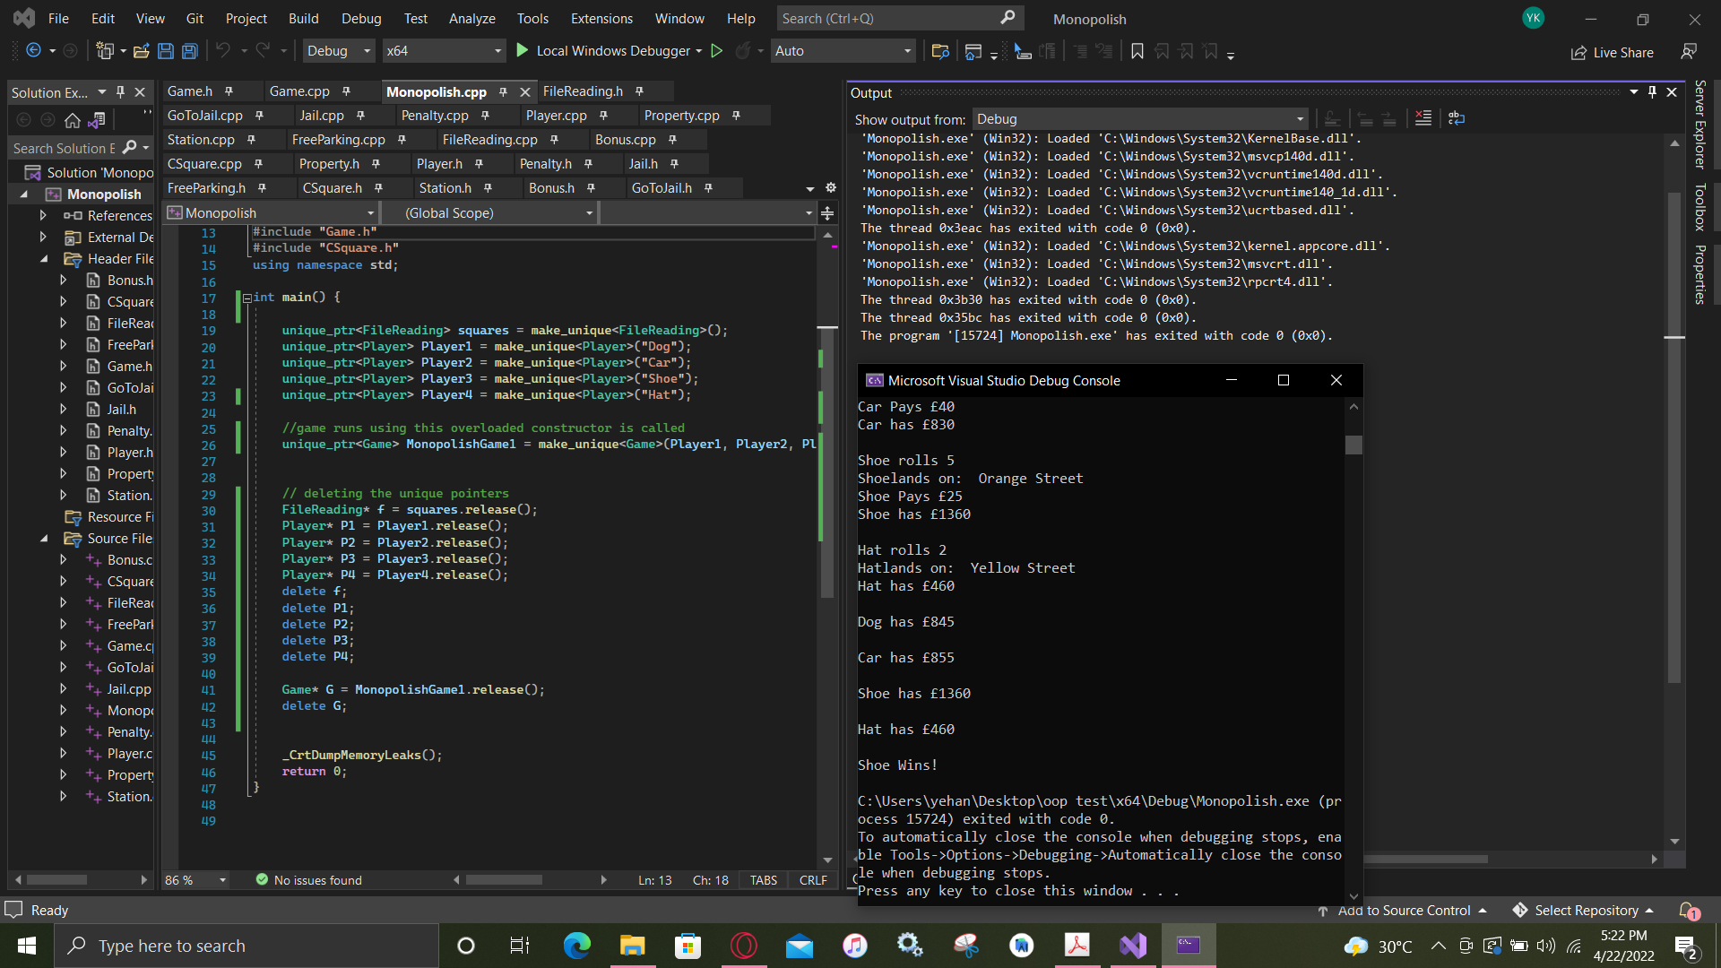

# 

# UML class diagram

