**Schema registry**

First we will see, what is the schema registry & its architecture.

**Confluent Schema Registry:**

1. Part of the confluent community edition.
2. Help us in validating schemas of messages that are being sent.
3. Enable us to reduce the size of the payload or size of the message.
4. Help us in evolving the schemas
5. Highly recommended component.
6. Separate cluster for schema registry.

Storage of schemas is done on kafka core cluster => __schemas topic

All the information which is relevant to schema, subject (with its corresponding version), metadata and compatibility configuration is appended to this topic.

**Architecture of Kafka** (Without schema registry)

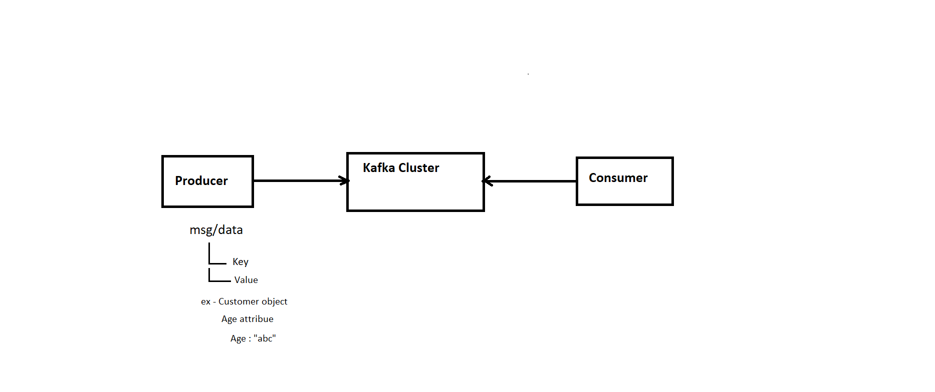

**Architecture with Schema Registry**

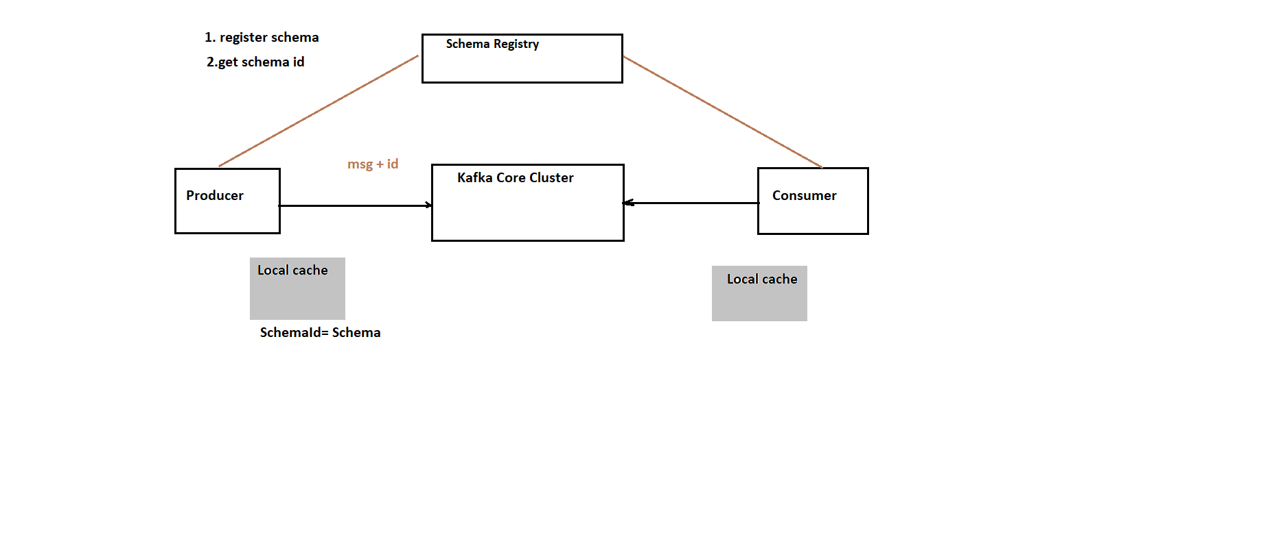

**Benefit**

1.Instead of sending the entire schema with each msg we are sent only the schemaId.

2.Schema validation happens in schema registry when we publish any new msg with

new schema

**Schema Evolution**

**Ex-**

2004 2011 2020

=> =>

customer customer customer

V1 V2 V3

(faxNumber) (email) (language+ email)

*With time schema evolved*

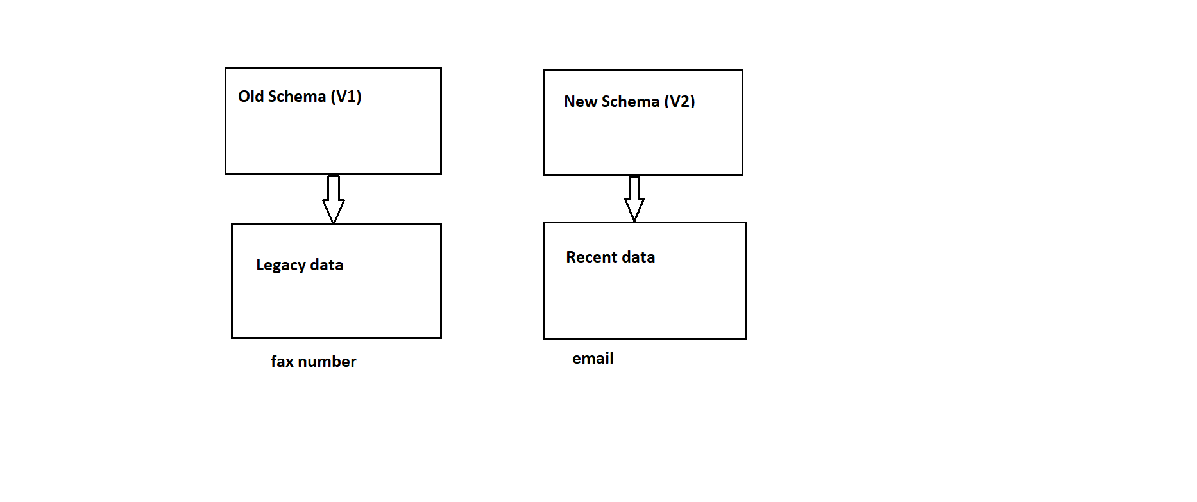

Old schema having legacy data & new schema writing the recent data.

1. When your new schema is able to read old data => Backward Compatible
2. When your old schema is able to read new data => Forward Compatible

Transitive=> we have version v1,v2,v3,v4

The schemas v4 are able to read msg from v3,v2,v1 then it is called as transitive.

Backward Compatible = deleting fields & add optional fields

Forward Compatible = adding fields & deleting optional fields