Bug Report

This report documents the bugs discovered in the buggy programs, including the failing test cases, root cause analysis, and the applied code fixes.

Bug Report 1: (Example)

1. Program Under Test
File: problemX.py
Class / Function: YourClassName.method_name()

2. Failing Test Case
Provide the unit test code from test_problemX.py that exposed the bug and failed during execution:

python
Paste your failing test method here
def test_example_failure(self):
pass

Provide the captured test runs from VSCode.

![alt text](assets/example_test_runs.png)

Test Output / Error Message:
text
Paste error traceback / assertion failure message here

3. Root Cause Analysis
Explain why the bug occurred and what incorrect behavior it caused:
Expected Behavior: (What should happen according to the specifications)
Actual Behavior: (What happened in the starter code)
Root Cause: (Explanation of the bug in the code logic)

4. Code Fix & Diff
Show the changes made to problemX.py to fix the bug:

diff
Original buggy code line
+ Corrected code line

Bug Report 2: (Your discovery)
1. Program Under Test
File: problem4.py
Class / Function:
MeetingRoom. book(self, booking_id: str, title: str, start_time: int, end_time: int, attendees: int)

2. Failing Test Case
Provide the unit test code from test_problem4.py that exposed the bug and failed during execution:

python
Paste your failing test method here
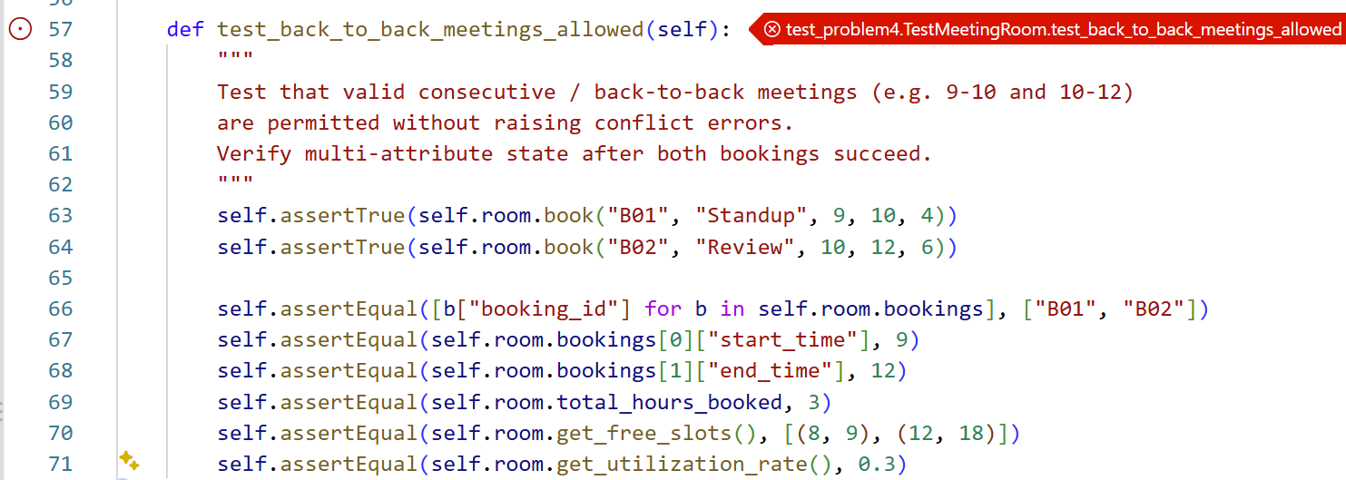

Provide the captured test runs from VSCode.
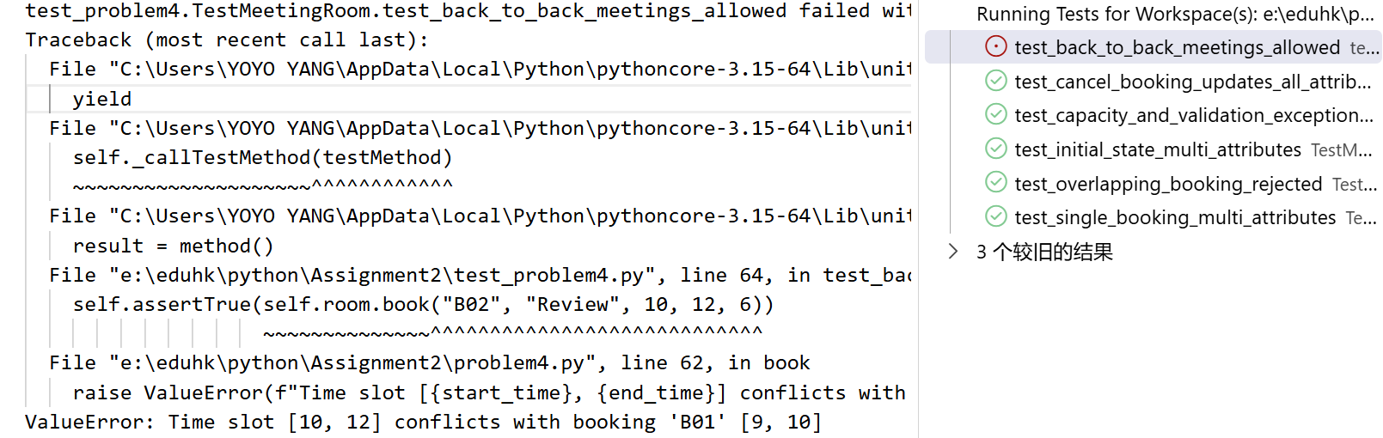

Test Output / Error Message:
ValueError: Time slot [10, 12] conflicts with booking 'B01' [9, 10]

3. Root Cause Analysis
Explain why the bug occurred and what incorrect behavior it caused:
Expected Behavior:
Back-to-back bookings such as [9, 10] and [10, 12] should be accepted
Actual Behavior:
The starter code rejects the second booking as a conflicting booking, even though the two meetings do not overlap in time
Root Cause: (Explanation of the bug in the code logic)
The code uses strict comparisons in the non-conflict condition.
When end_time == b["start_time"] or start_time == b["end_time"], the strict comparisons evaluate to False. As a result, bookings that only touch at their boundaries are incorrectly treated as overlapping.

4. Code Fix & Diff
Show the changes made to problem4.py to fix the bug:

Original buggy code line:
if not (end_time < b["start_time"] or start_time >=b["end_time"]):
Corrected code line:
if not (end_time <= b["start_time"] or start_time >= b["end_time"]):

Bug Report 3: (Your discovery)
1. Program Under Test
File: problem5.py
Class / Function: clean_and_aggregate #Compute aggregations

2. Failing Test Case
Provide the unit test code from test_problem5.py that exposed the bug and failed during execution:

python
Paste your failing test method here
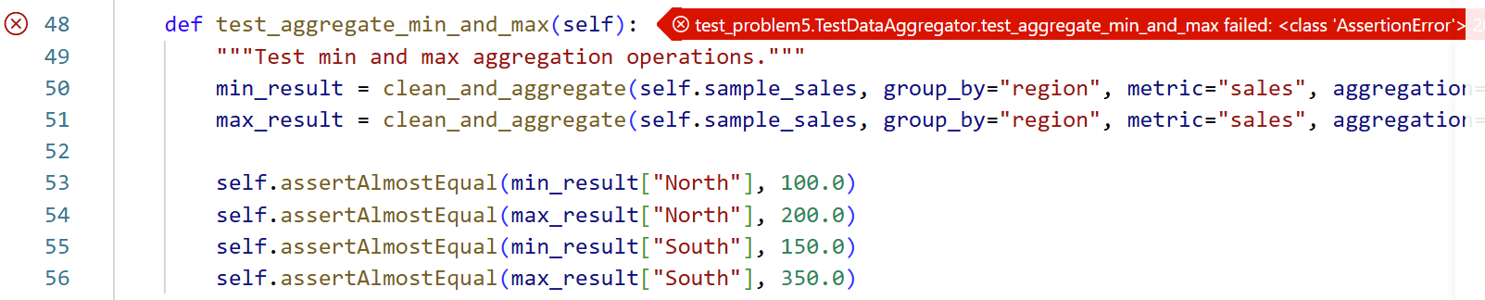

Provide the captured test runs from VSCode.
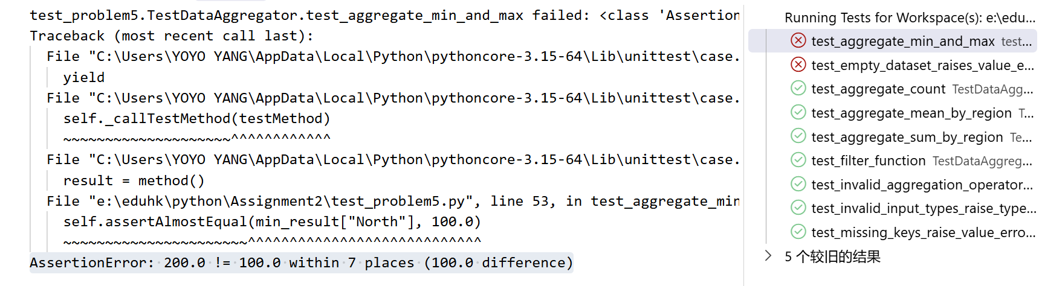

Test Output / Error Message:
AssertionError: 200.0 != 100.0 within 7 places (100.0 difference)

3. Root Cause Analysis
Explain why the bug occurred and what incorrect behavior it caused:
Expected Behavior:
When aggregation="min", the function should return the smallest metric value in each group.
When aggregation="max", it should return the largest metric value.
For the North region, the expected minimum is 100.0 and maximum is 200.0.
Actual Behavior:
The min operation returns the maximum value, while the max operation returns the minimum value.
Root Cause:
Two functions were written in reverse in the code. The min branch calls max(values), while the max branch calls min(values).

4. Code Fix & Diff
Show the changes made to problem5.py to fix the bug:

Original buggy code line:
elif agg_op == "min":
val = max(values)
elif agg_op == "max":
val = min(values)
Corrected code line:
elif agg_op == "min":
val = min(values)
elif agg_op == "max":
val = max(values)

Bug Report 4: (Your discovery)
1. Program Under Test
File: problem5.py
Class / Function: clean_and_aggregate

2. Failing Test Case
Provide the unit test code from test_problem5.py that exposed the bug and failed during execution:

python
Paste your failing test method here

Provide the captured test runs from VSCode.
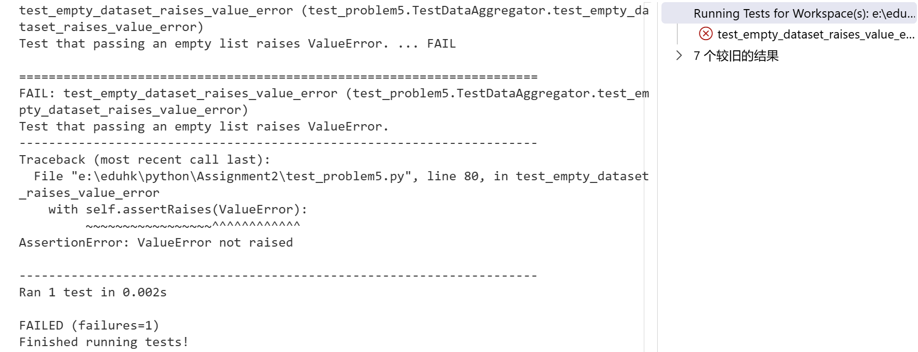

Test Output / Error Message:
AssertionError: ValueError not raised

3. Root Cause Analysis
Explain why the bug occurred and what incorrect behavior it caused:
Expected Behavior:
When an empty list is passed as records, the function should raise a ValueError
Actual Behavior:
Passing an empty list returns an empty dictionary {}
Root Cause:
The function validates the aggregation type but does not validate whether records is empty before entering the processing loop.

4. Code Fix & Diff
Show the changes made to problem5.py to fix the bug:

Original buggy code line:
if agg_op not in valid_aggregations:
raise ValueError(f"Invalid aggregation '{aggregation}'. Must be one of {valid_aggregations}")
Corrected code line:
if agg_op not in valid_aggregations:
raise ValueError(f"Invalid aggregation '{aggregation}'. Must be one of {valid_aggregations}")
if not records:
raise ValueError("Records cannot be empty")

