AI Light - Protect eyes health

First A. Li Kin Man1, Second B. Wong Lam Yeung2, and Third C. Yang Yuen Ting3

*1Sun Fong Chung College, Hong Kong*

*2 The Church of Christ in China Ming Yin College, Hong Kong*

*3 Lai King Catholic Secondary School, Hong Kong*

***Abstract*— This learning summary will include the motivation of our project, and describe how we solve the problems we met when we are working on the project. Moreover, the possible applications of our project will be included.**

1. Introduction/Background

Nowadays, many people are wearing glasses, especially teenagers. They get different eye diseases by using their phones in a dark environment just before they are ready to sleep, or watching the electronic devices without blinking for a long time. Their eyes will lack water and feel dry, which will increase the risk of eye infection in the long term.

DeArk Medical Centre based on [1], [2] shows that blue light emission from smartphone and laptop screens may seem harmless but may be toxic to the eyes and cause macular degeneration, a leading cause of vision loss in the US. On the light spectrum, blue light has a shorter wavelength, and thus carries more energy than red, yellow or green light. That extra energy (more intense in the dark) is why blue light can be bad for your eyes. Now, another molecule in your retinas normally acts as an antioxidant to prevent eye cells from dying. But the constant bombardment of blue light may overwhelm the antioxidant effect and may very well speed up someone’s chances of developing macular degeneration.

1. Exciting Solution

Normally, most phones could automatically adjust the phone's own brightness in a darker environment. On the market, there are lights that are voice-activated to turn on the lights. However, the phone cannot change the light intensity of the environment, and users may not be able to buy that light. Moreover, few products are aimed to remind blinking eyes, there are only eye drops used to lubricate dry eyes and help maintain moisture on the outer surface of eyes.

1. Aims

Our project ‘AI Light’ aimed at raising the awareness of the importance of eye health and do not take it lightly. The health of the eye depends on many factors, for instance, the distance of the object, the light intensity of the environment, the frequency of eye blinking, etc. We would like to develop a system or an app that has two main functions: calculating the frequency of blinking eyes, and detecting the light intensity of the environment.

1. Our Solution

The result is shown in our YouTube video, <https://youtu.be/4SLP0PbqHqo>.

You may find the code in this Github link : <https://github.com/YoyoWong16/AioT_Project.git>.

1. *Blinking eyes*

We used OpenCV in order to take a photo through the webcam connected every 0.1 second. We used Jupyter Notebooks, and a computer with a camera at front side to code and test it.

1. using AI to detect whether users have blinked their eyes or not.
2. if not for a long time, send a message to remind them.
3. The message will disappear after it detects that the user blinks.

The normal spontaneous blink rate is between 12 and 15/min [3]. That is to say, people usually blink their eyes every 4-5 seconds.

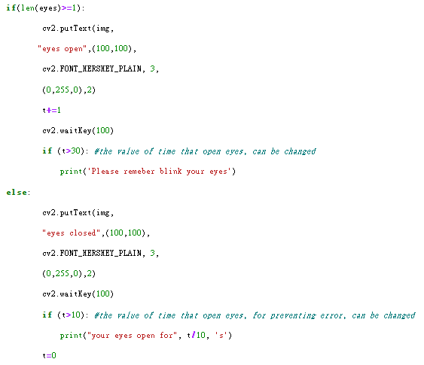

Fig. 1 A part of code which detecting whether user blink eyes and give response

When it detects a user blinking their eyes, it will give out the time between each blink. If the user opens it for too long, such as 10 seconds, it will show a reminder which will disappear until the user blink eyes again.



^ calculated the eyes open time ^reminding user blink eyes

1. *Light intensity*

We used App Inventor to try out the function for detecting the light intensity of the environment. The code is much simpler than we expected. However, we could not try out the last step as we didn’t have a light which can control the light intensity without a controller.

1. If detected the user uses the phone without the light,

2. send them a message which is about reminding them to turn on the light.

3. If they do not do so, just help them to turn on the light slowly and automatically.

1. Future Aspects/Application

If the whole idea is practicable, we would like to add the function of calculating the frequency of blinking. Besides, combine the two functions into one app, or even add more functions such as reminding users with some interesting cartoons, black or lock their screens if users do not blink eyes frequently. Moreover, we hope to run the app in the background while the devices are turned on, and without hindering the user from using the phone or computer.

AI Light can be a starting point for the future. It is suitable for everyone who wants to prevent having eye disease. It could reduce the rate of worsening eye disease, especially short-sightedness and Dry eye syndrome, which probably attracts many users to use. Furthermore, it is easy to use. There is no need to have other external equipment as it only requires the ambient light sensor and front camera of users’ phones or computers that have already.

1. Conclusion/Acknowledge

We would like to express our gratitude towards all of our professors, TAs, and mentors for giving us the inspiration to learn about Artificial Intelligence and the Internet of Things, and for guiding us in our GEF-AIoT journey.

Along the learning journey, we have gained a lot of experiences. Since all of us have nearly zero knowledge about coding and AIoT, we tried to follow the lesson step by step. Although we faced many difficulties during our learning path and the process of building our project, we are grateful to have the help of warmhearted teachers and teacher assistants. They honed our skills and mindset for coming challenges.

Thanks to AIoT programme, we reward friendship, mentorship, and opportunities. Through the courses, We are given a chance to explore the AIoT with numerous talented classmates, listened to the many sharings of professional experts, they provided us informative information about the AI-specific topics, and enlightened us about the possibilities of AI future development and its application. We are given invaluable opportunities to communicate with different guests and mentors, they provided us informative and useful ideas on our project.

Until now, we still are beginners, but we will keep developing and learning from others to improve our skills and knowledge. We believe that Practice Makes Perfect !

VII. Reference

1. Ratnayake K, Payton JL, Lakmal OH, Karunarathne A. Sci Rep. 2018 ; 8(1):10207.
2. Zhao ZC, Zhou Y, Tan G, Li J. Int J Ophthalmol. 2018; 11(12): 1999–2003.

[3] Doughty MJ. Consideration of three types of spontaneous eyeblink activity in normal humans: during reading and video display terminal use, in primary gaze, and while in conversation. Optom Vis Sci. 2001;78(10):712–725.