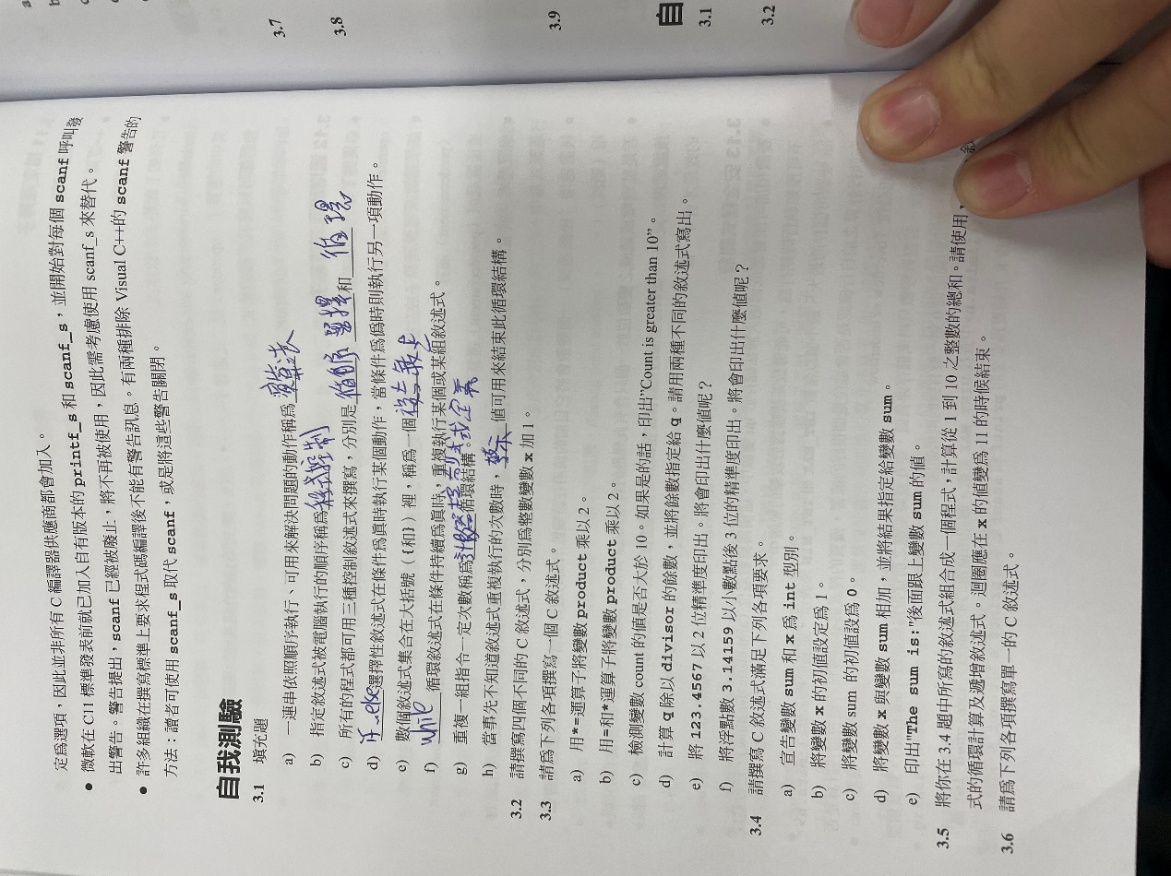

3.2

X=X+1;

X+=1;

X++

++X

3.3

A) Product \*=2;

B) Product = Product \*2;

C) If (count>10)

Puts (“Count is greater than 10.”);

D) q%=divisor;

q =q%divisor;

E) printf(“%.2f”,123.456)

F) printf(“%.3f”,123.456)

3.4

A) int sum,x;

B) x=1;

C)sum=0;

D)sum += x; or sum =sum+x

E)printf(“The sum is:%d\n,sum”);

3.5

Int main (void)

{

Int x=1,sum=0;

while(x<=10){

sum+=x;

++x;

}

printf(“The sum is : %u\n”,sum);

}

3.6 scanf(“%u”,&x);

B) scanf(“%u”,&y);

C) i = 1 ;

D) power = 1 ;

E) power \*=x

F) ++I;

G) while (i<=y)h)printf(“%d”,power)

3.7 #include<stdio.h>

int main (void){

int x=0,y=0 ,i=0,power=0;

{printf("enter fist integer");

scanf("%d",&x);

printf("enter second integer");

scanf("%d",&y);

while (i<=y){power\*=x;++i;}

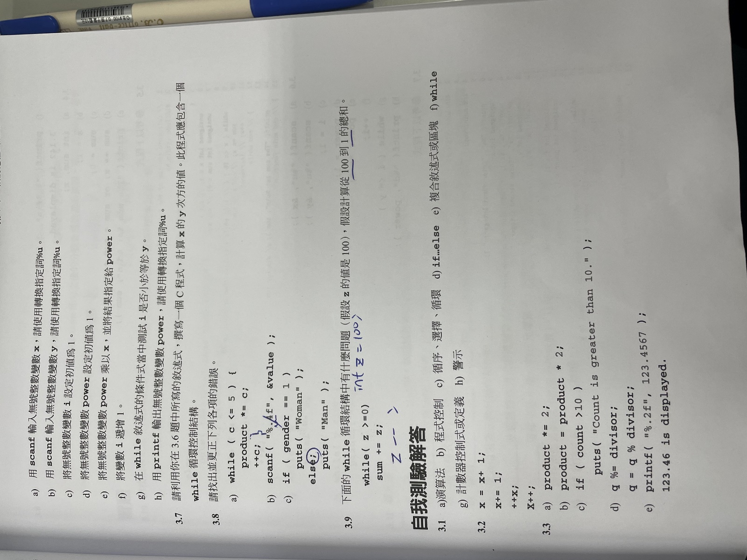printf("%d\n",power);}}