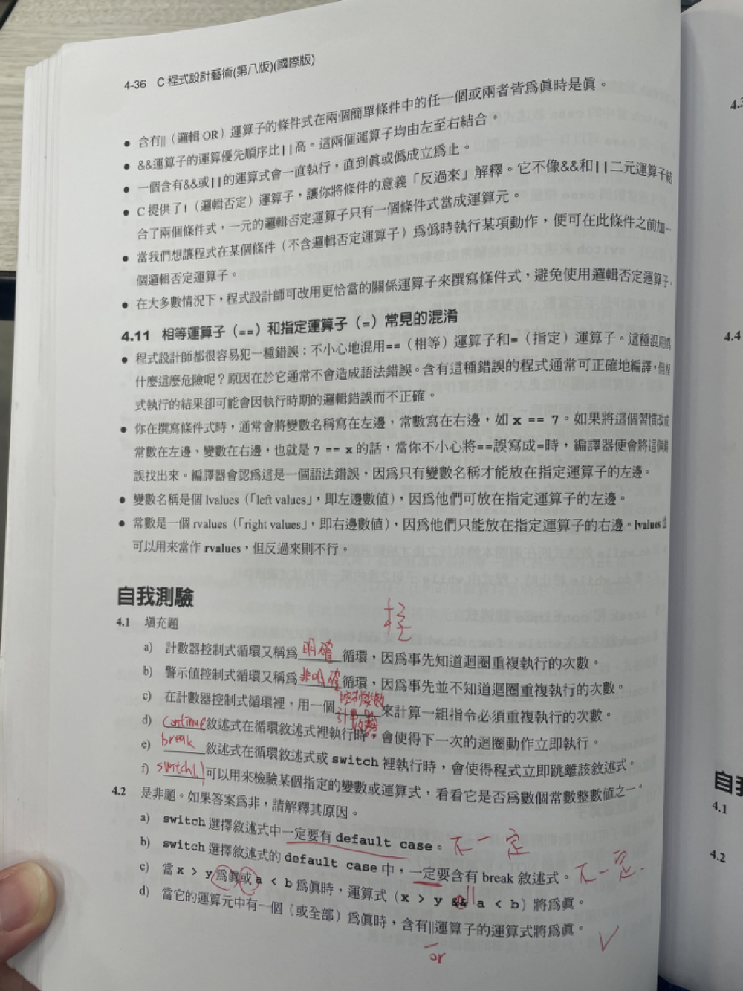

4.3 a) unsigned int sum =0

for (unsigned int count = 1; count <= 99; count +=2){

sum += count;

}

b)printf(“%-15.1f\n”333 . 546372) ;

printf(“%-15.2f\n”333 . 546372) ;

printf(“%-15.3f\n”333 . 546372) ;

printf(“%-15.4f\n”333 . 546372) ;

printf(“%-15.5f\n”333 . 546372) ;

c)printf (“%10.2f\n”,pow(2.5, 3)) ;

d)unsigned int x = 1;

while (x <= 20) {

printf (“%d”,x) ;

if (x % 5==0){

puts(“ ”)

}

else{

printf(“%s”,”\t”);

}

