Throughput:

Sleep 0 task

|  |  |  |  |
| --- | --- | --- | --- |
| Threads | Tasks | Time(ms) | Throughput |
| 1 | 100000 | 226 | 442.477 |
| 2 | 100000 | 715 | 139.86 |
| 4 | 100000 | 779 | 128.36 |
| 8 | 100000 | 751 | 133.15 |
| 16 | 100000 | 761 | 131.40 |

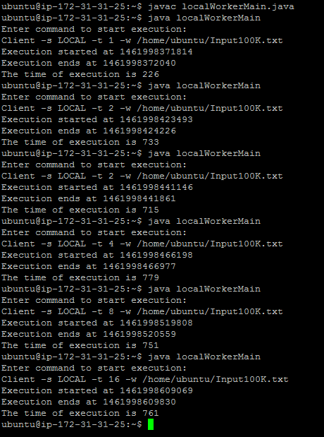

Efficiency:

Sleep 10 ms

|  |  |  |  |
| --- | --- | --- | --- |
| Threads | Tasks | Time | Efficiency |
| 1 | 1000 | 10161 | 98.41 |
| 2 | 2000 | 10155 | 196.94 |
| 4 | 4000 | 10167 | 393.42 |
| 8 | 8000 | 10162 | 787.24 |
| 16 | 16000 | 10214 | 1566.47 |

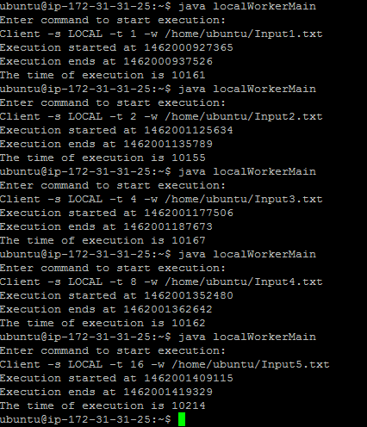

Sleep 1 sec

|  |  |  |  |
| --- | --- | --- | --- |
| Threads | Tasks | Time | Efficiency |
| 1 | 100 | 100006 | 99.99 |
| 2 | 200 | 100006 | 199.98 |
| 4 | 400 | 100009 | 399.96 |
| 8 | 800 | 100012 | 799.90 |
| 16 | 1600 | 100020 | 1599.68 |

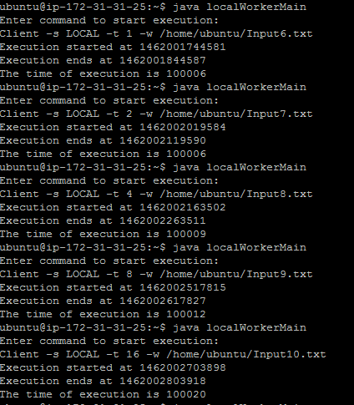

Sleep 10 sec

|  |  |  |  |
| --- | --- | --- | --- |
| Threads | Tasks | Time | Efficiency |
| 1 | 10 | 100004 | 99.99 |
| 2 | 20 | 100005 | 199.99 |
| 4 | 40 | 100005 | 399.98 |
| 8 | 80 | 100006 | 799.95 |
| 16 | 160 | 100008 | 1599.87 |

