############################################################################

# UBUNTU KUBERNETES INSTALLTION #

############################################################################

#######################===PRE-REQUISITES===################################

#Ref <https://kubernetes.io/docs/setup/independent/install-kubeadm>

# KMASTER

*Minimum 2 core CPU with 2 GB RAM

*Docker

*ssh

*kubeadm kubectl kubelet

----> Required ports

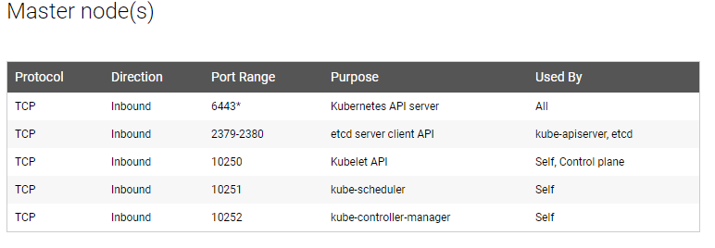

# KNODE

*Minimum 1 core CPU with 1 GB RAM

*Docker

*ssh

*kubeadm kubectl kubelet

-----> Required ports

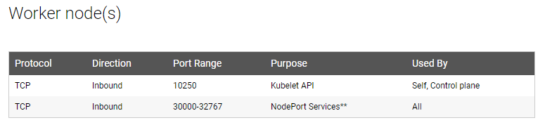

############################################################################

# Host Setup for kubernetes cluster #

############################################################################

#updating packages

apt-get update

#changing the hostname of master

hostnamectl set-hostname kmaster

#to make hostname permenant

exec bash

#if swap memory is there, we need to turn it off , first we need to check the swap memory and turn it off

df -h

#reason behind turn off swap memory :-

The idea of kubernetes is to tightly pack instances to as close to 100% utilized as possible.

All deployments should be pinned with CPU/memory limits. So if the scheduler sends a pod to a machine it should never use swap at all.

You don't want to swap since it'll slow things down.Its mainly for performance.

#trun off the swap memeory

swapoff-a

#we need cluster hosts in etc/hosts

vi /etc/hosts

#Ex : 192.168.10.80 kmaster

192.168.10.73 knode1

192.168.10.32 knode2

############################################################################ # DOCKER INSTALLTION #

############################################################################

#Update the apt package index:

sudo apt-get update

#Install packages to allow apt to use a repository over HTTPS:

sudo apt-get install \

apt-transport-https \

ca-certificates \

curl \

gnupg-agent \

software-properties-common

#Add Docker’s official GPG key:

curl -fsSL https://download.docker.com/linux/ubuntu/gpg | sudo apt-key add -

#adding figerprint key for repository

sudo apt-key fingerprint 0EBFCD88

#command to set up the stable repository

sudo add-apt-repository \

"deb [arch=amd64] https://download.docker.com/linux/ubuntu \

$(lsb_release -cs) \

stable"

#Update the apt package index.

sudo apt-get update

#Install the latest version of Docker CE and containerd, or go to the next step to install a specific version:

sudo apt-get install docker-ce docker-ce-cli containerd.io

#version checking

docker -v

# check the docker status

systemctl status docker

#Ref

# <https://docs.docker.com/install/linux/docker-ce/ubuntu/>

############################################################################

# kubernetes installation #

############################################################################

apt-get update && apt-get install -y apt-transport-https curl

curl -s https://packages.cloud.google.com/apt/doc/apt-key.gpg | apt-key add -

cat <<EOF >/etc/apt/sources.list.d/kubernetes.list

deb https://apt.kubernetes.io/ kubernetes-xenial main

EOF

apt-get update

apt-get install -y kubelet kubeadm kubectl

apt-mark hold kubelet kubeadm kubectl

#Checking the versions

kubectl version

kubeadm version

kubelet --version

#Ref

# <https://kubernetes.io/docs/setup/independent/install-kubeadm/>

############################################################################

# NOTE : above commands same for Kmaster and Knodes #

############################################################################

############################################################################

# Configuration setup in Kmaster server #

############################################################################

# Initilization of kmaster

# kubeadm init --apiserver-advertise-address= <internal ip address of master VM> --pod-network-cidr=192.168.0.0/16

#Ex :

kubeadm init --apiserver-advertise-address=10.1.3.71 --pod-network-cidr=192.168.0.0/16

#Execute the steps as normal user

mkdir -p $HOME/.kube

sudo cp -i /etc/kubernetes/admin.conf $HOME/.kube/config

sudo chown $(id -u):$(id -g) $HOME/.kube/config

#To verify, if kubectl is working or not, run the following command

kubectl get pods -o wide --all-namespaces

#installation of pod newtork

kubectl apply -f https://docs.projectcalico.org/v3.0/getting-started/kubernetes/installation/hosted/kubeadm/1.7/calico.yaml

kubectl get pods -o wide --all-namespaces

kubectl apply -f "https://cloud.weave.works/k8s/net?k8s-version=$(kubectl version | base64 | tr -d '\n')"

# make sure all services including coredns and calico network services are running

kubectl get pods -o wide --all-namespaces

#Master setup has been done successfully

############################################################################

# Nodes adding to Kmaster server #

############################################################################

#For generating the join token for node

kubeadm token create --print-join-command

#EX :

# kubeadm join 10.1.3.9:6443 --token w4vwwx.103s492wtfjfjed2 --discovery-token-ca-cert-hash sha256:42b3d314a1d0d7ffbcbb7b6895f1c477033a627d2ec28bf41e5cf047925b66d9

#Check the host list in kmaster and knode

cat /etc/hosts

#NOTE :

#Above has to be execute in the kmaster server and then we will get join token

#Copy the join token and connect to knodes and execute the token

#Now check the all node status in kmaster server

kubectl get nodes

#After some time node status will show READY

############################################################################

# CREATING THE DASHBORAD SERVICE #

############################################################################

#Ref <https://kubernetes.io/docs/tasks/access-application-cluster/web-ui-dashboard/>

kubectl apply -f <https://raw.githubusercontent.com/kubernetes/dashboard/master/aio/deploy/recommended/kubernetes-dashboard.yaml>

#Creating service account steps

kubectl create serviceaccount dashboard -n default

kubectl create clusterrolebinding dashboard-admin -n default \

--clusterrole=cluster-admin \

--serviceaccount=default:dashboard

kubectl get pods -o wide --all-namespaces

kubectl get svc --all-namespaces

#Curl <cluster_ip of dashboard> : <port>

#Edit the service file of kubernetes dashboard and change the type from ClusterIP to NodePort.

kubectl edit svc kubernetes-dashboard --namespace=kube-system

kubectl get svc --all-namespaces

#Now open the firefox and type public IP with 443 and another port number

#Example : https://12.111.33.111:3068

#For generating access token for Dashboard

kubectl get secret $(kubectl get serviceaccount dashboard -o jsonpath="{.secrets[0].name}") -o jsonpath="{.data.token}" | base64 --decode

kubectl get secrets

kubectl describe secrets/dashboard-token-zgphz