Methods

*Procedure and design*

A few days before the experiment the participant underwent a prescan to make sure the participant was healthy and comfortable in the scanner. Before the experiment, the participant was informed of her rights and last minutes security measures were taken.

Our experiment used a block design with two conditions, 30 seconds per block, 2 seconds per stimulus, and 12 minutes in total. She completed the experiment two times. The stimuli were divided into two separate sets per condition (e.g. Animals1, Animals2) and shown in a random order within the sets. We had the participant do a light task to keep her focused: For each stimulus, she was asked to evaluate if the object on the picture was larger than the previous object. In the scanner the participant had to press a button to report if the object was larger or not. This was to make sure the participant was actively thinking about what was on the pictures and to make sure she did not get too bored during the experiment. Before the experiment started we gave the impression this was the point of the experiment, to make sure she was focused on the task.

Afterwards a debriefing was performed in which the participant was calmly told we only collected the fMRI data. The experiment was set up in PsychoPy.

*Materials*

We used 60 carefully chosen pictures as stimuli. They were all black outlines on a gray background and was picked to be as comparable as possible. We tried to get all pictures to have the same amount of black and grey but were not completely successful.  Some pictures had more lines or thicker lines (as seen in the example), and were therefore a little different. All pictures were resized to have the same dimensions.

The animate condition consisted of different animals, in some of which you could see the face of the animal. The inanimate condition consisted of pictures of kitchen utensils and other traditional tools. Some were electrical.

We used a MAGNETOM Trio fMRI machine at Aarhus University Hospital to run the experiment.

*Example of stimuli in the two conditions*

|  |  |
| --- | --- |
| Animals | Tools |
| https://lh5.googleusercontent.com/IcqBabfn5fhrV8KKzLgsRTz83A9sazexALO7nudJjNZv1B4RqrJumE_kmzXaFquV6UjXHnj64l1lU5Bleul-gC4jElHMs5lsrDkW5hsKYyZF6dq3Ua1_K0YFCUkBPhrbyKnlTSqY | https://lh3.googleusercontent.com/OBKgRwgoS7m9YWlmSV96KGM_-nDO4mdI9LluTLGZu7imETr0K08Lelja8LF9LBkEIuzETFZkRL3DwiE0K8eaFm01GBKaxfybWum-BO97kkZ9N_VFaLaLutWLXF8MUc0Y78Q-U9EA |

*Participants*

There was only one participant in this experiment. A randomly selected 21-year old, right-handed female, who is a cognitive science student. Before the run of the experiment, she underwent a pre-scan.

*Data processing*

All data processing was performed in SPM12 (SPM122015).

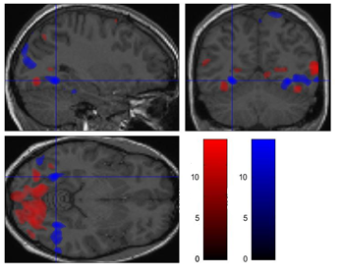Results

Animals

Tools

As can be seen in the figure 4, pictures of animals activated large portions of the occipital lobe at a p < .05 FWE corrected. With peak activation in the posterior areas of the occipital (z-score = Inf, x = -39 , y = -66, z = 25).   
Bilateral activation was found in the lateral parts of the fusiform gyrus (see figure 1 and 2), with peaks in (z-score = Inf, x = -31 , y = -69, z = 44) and (z-score = Inf, x = 40 , y = -74, z = 43).

Spots of activation were found in other areas of the brain, but mostly in the middle frontal gyrus (z-score = 7.10, x = -44 , y = 9, z = 56) as seen in figure 6.

Figure 1: Comparing activation in fusiform gyrus

*Zooming in on fusiform gyrus, contrasting the two activations against each other.*

*Red is animate condition, blue is inanimate condition. Notice that the inanimate-condition causes activation more to the front than animate-condition.*

Looking at the figure 5 of activation in the tool-condition, tools seem to activate more anterolateral parts of the occipital lobe, especially in the left hemisphere (z-score = Inf, x = -40 , y = -90, z = 17).

Strong bilateral activation was found in the more medial parts of the fusiform gyrus (see figure 1 and 3), peaking in (z-score = Inf, x = -29 , y = -58, z = -8) and  (z-score = Inf, x = 32 , y = -56, z = -10).

**Brain activation in three areas**

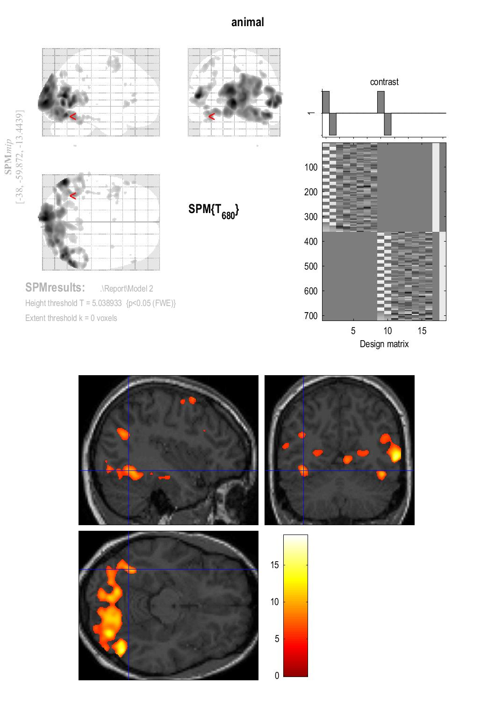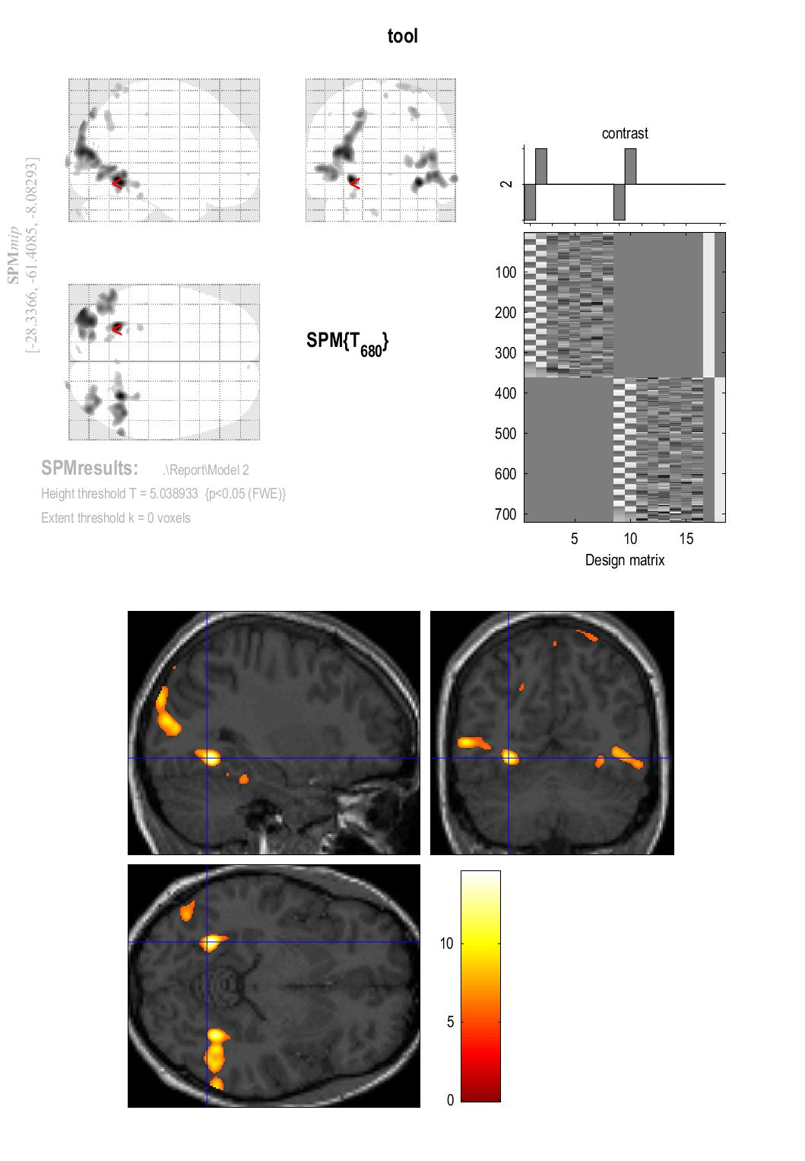**1. Fusiform gyrus**

Figure 2: Fusiform gyrus activation for animals

Notice great activation in lateral areas of the fusiform gyrus and in the occipital lobe (primary visual areas).

Figure 3: Fusiform gyrus activation for tools

Here we also find activation in fusiform gyrus. This activation is different from animate by being more medial.

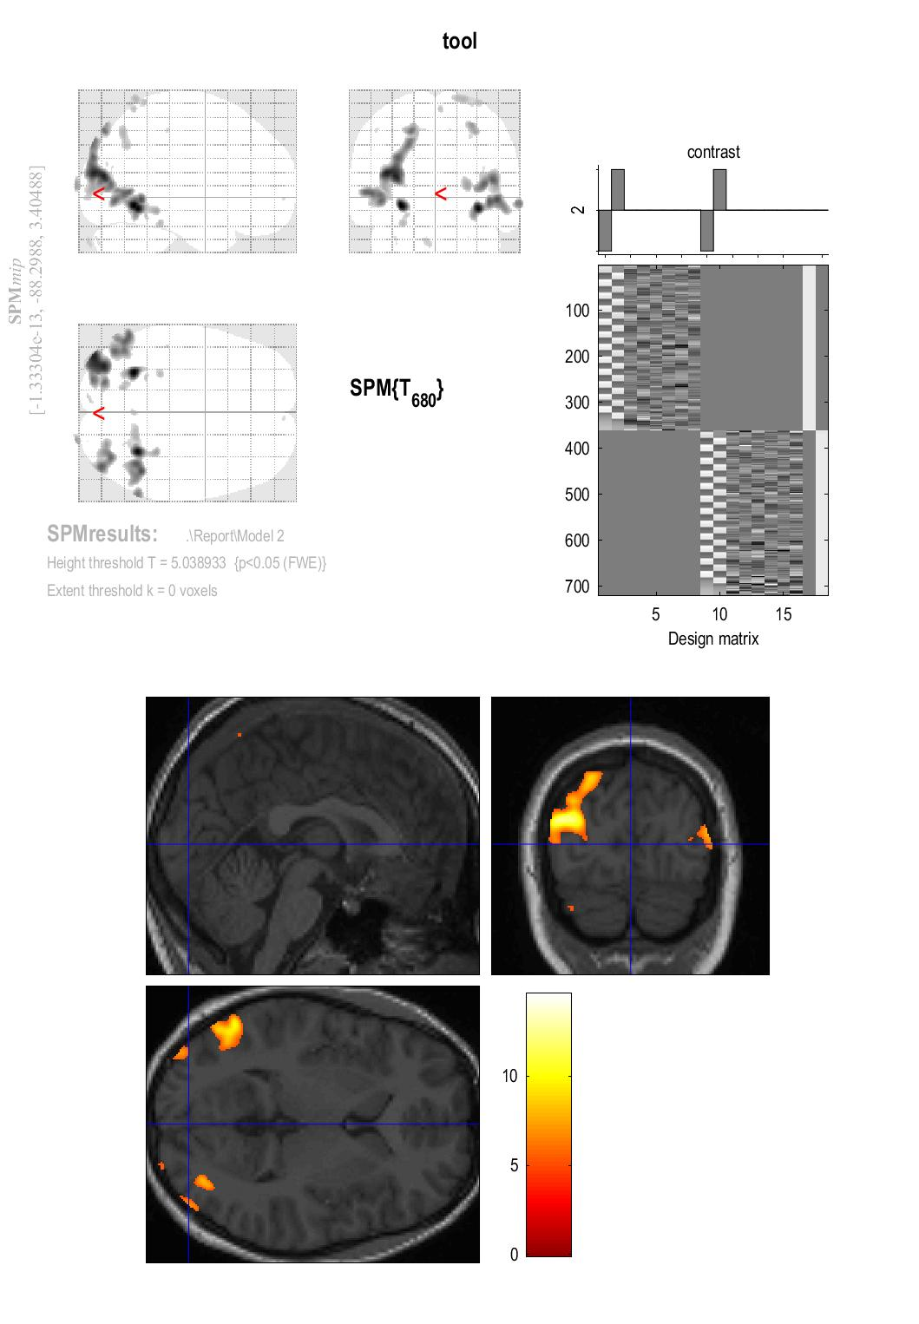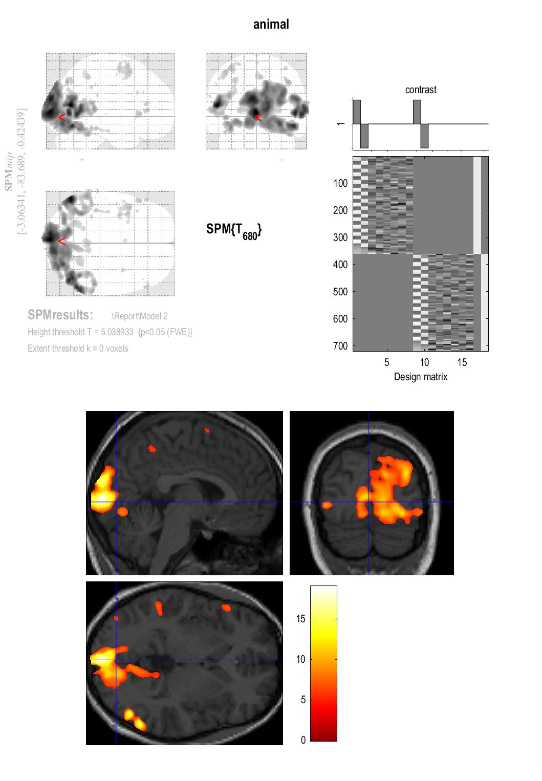**2. Occipital lobe**

Figure 5: Occipital lobe activation for Tools

Activation of the occipital lobe is much smaller for tools

Figure 4: Occipital lobe activation for animals

Large activation of the occipital lobe can be seen

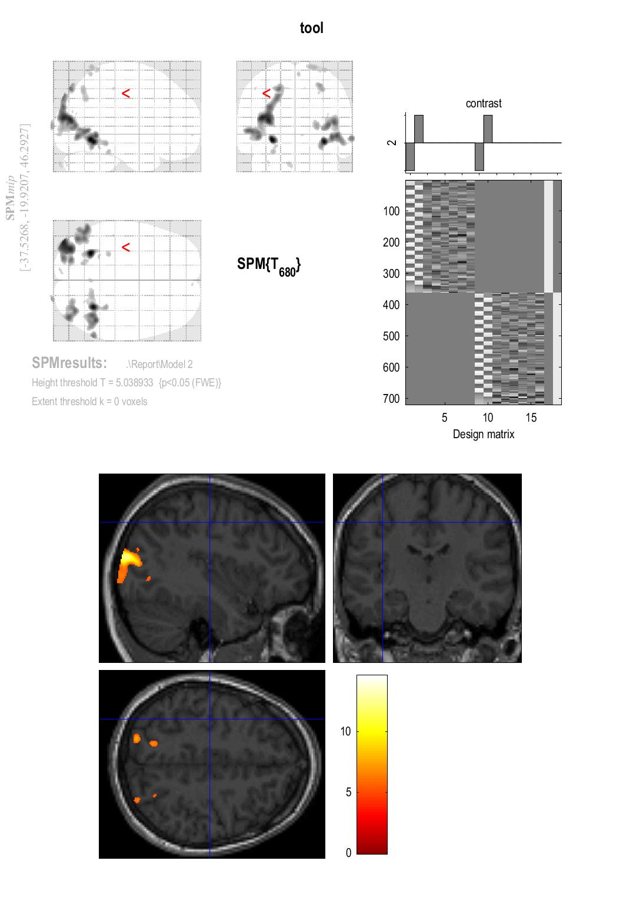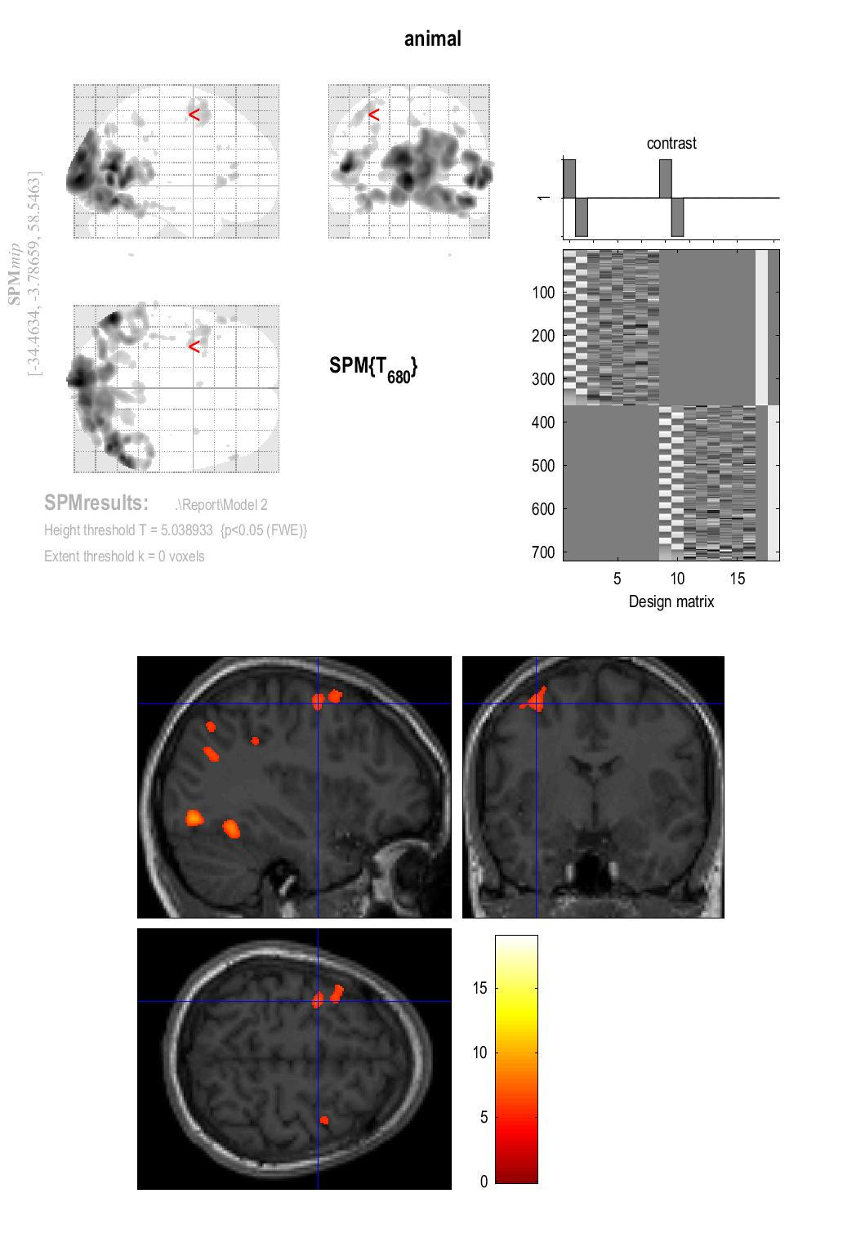**3. Motor cortex**

Figure 7: Motor cortex activation for tools

No increase in motor or premotor cortex activation can be seen

Figure 6: Motor cortex activation for animals

Activation in motor and premotor cortex can be seen