**ECE 414 – Embedded Systems**

**Report for Lab 01 – Introduction to the PIC 32 / Tool Familiarization**

GuoYuan Li (Scribe)

Harry Zhu

Aug 30, 2020

**1. Introduction**

In this week’s lab, we learned the basics of PIC 32 Microcontroller and the Microstick II development board. We studied the input and output pins on the Microstick II board and basic commands of the special function registers(SFR) to configure the ports. In addition, we installed and practiced relevant tools for conducting the lab: MPLAB X IDE, Atom text editor, and KiCad schematic editor. To accomplish these objectives, we wrote an elementary C program on MPLAB X IDE to program the microcontroller, which will be described detailedly in the next section.

**2. Requirements**

1. Revise the 3-bit binary counter provided into a 4-bit by connecting a fourth LED to pin RA3. (Handout 4.4-5)
2. Modify the KiCad Schematic provided for this 4-bit counter (Handout 4.4-6)
3. Make observations when constant SHAMT changes from 20 to 21 (Handout 4.5-6)
4. Make observations when constant SHAMT changes from 20 to 19 (Handout 4.5-7)
5. Demonstrate the working hardware implementation to instructor (Handout 4.5-8)

**3. Design Description**

We used the KiCad Schematic editor to generate the schematic for the 4-bit counter using another 360 ohm resistor connected in series with the fourth LED. Then, we implemented this on the breadboard using actual wires. Figure 1 below shows the KiCad Schematic. Then, we changed the mask value from 0x7 to 0xF to include the extra bit in the main program on MPLAB X. The code listing is also provided on Section 6. Then, we changed the shifting parameter SHAMT to 21 and 19 to make observations on the counting speed, which is included in the next section.

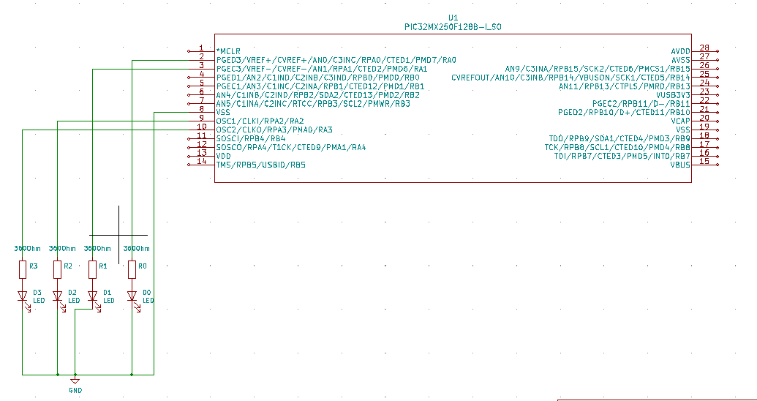

Figure 1 - Modified 4-bit counter KiCad Schematic

**4. Test Report**

Both the software and hardware implementations ran successfully. LEDs were lightened up in the binary counting sequence. When we changed SHAMT to 21, the counting speed decreased as the LEDs were lightened at a slower rate. When we changed SHAMT to 19, the counting speed increased as the LEDs were lightened at a faster rate.

**5. Conclusion**

We learned a lot of the fundamentals of the PIC32 microcontroller and the I/O pins on the Microstick II development board, especially how to configure those using SFRs. Furthermore, we learned to write basic C programs on MPLAB X to program the microcontroller as well as to use other editor tools for schematic generation and code communication. Overall, the lab results are promising and successful and we spend approximately 3 hours on this lab.

**6. Software Implementation(Code Listing for 4-bit counter)**

#pragma config FNOSC = FRCPLL, POSCMOD = OFF

#pragma config FPLLIDIV = DIV_2, FPLLMUL = MUL_20

#pragma config FPBDIV = DIV_1, FPLLODIV = DIV_2

#pragma config FWDTEN = OFF, JTAGEN = OFF, FSOSCEN = OFF

#include <xc.h>

#include <inttypes.h>

#define SHAMT 20

void main()

{

uint32_t count;

/* Set up all PORTA pins as digital outputs. */

ANSELA = 0;

TRISA = 0;

/* Simple counter. */

count = 0;

while (1) {

// output bottom 3 bits shifted to show progress

LATA = (count >> SHAMT) & 0xF;

count++;

}

}