Art Work

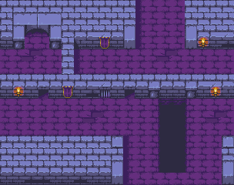

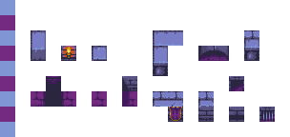

(Ansimuz, n.d.)

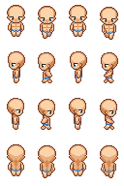 - changes were made to the image.

(Fabzy, 2014)

References

Ansimuz, n.d. *Patreons Top Down Collection*. [image] Available at: <https://ansimuz.itch.io/patreons-top-down-collection> [Accessed 23 April 2020].

Fabzy, 2014. *The Revolution - Sprites*. [image] Available at: <https://opengameart.org/content/the-revolution-sprites> [Accessed 28 April 2020].