**0727 Generative Model – 실습 문제 예시 답안**

**1. VAE**

**1) Visualize several decoded images and compare their qualities.**

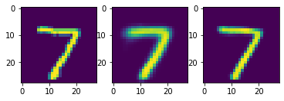 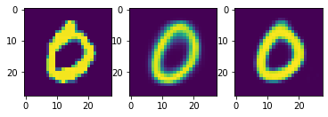

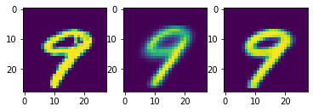 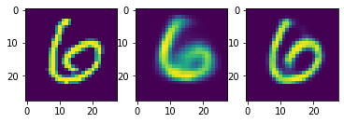

VAE with lower z dimension tends to reconstruct blurry images than the one with higher z dimension.

**2) Describe the reason of observed difference.**

Low-dimensional z space was not enough big to memorize every detail of original image.

This caused the latent variable to extract important information for reconstruction, such as the type of character, rather than subtle information, such as writing style.

As the latent variable contains only few information from original image, the decoder generates image with lack of detail.