**111_HW1-Arithmetic**

**資電院學士班二年級**

110504517 **李睿穎**

**Code and execution result**

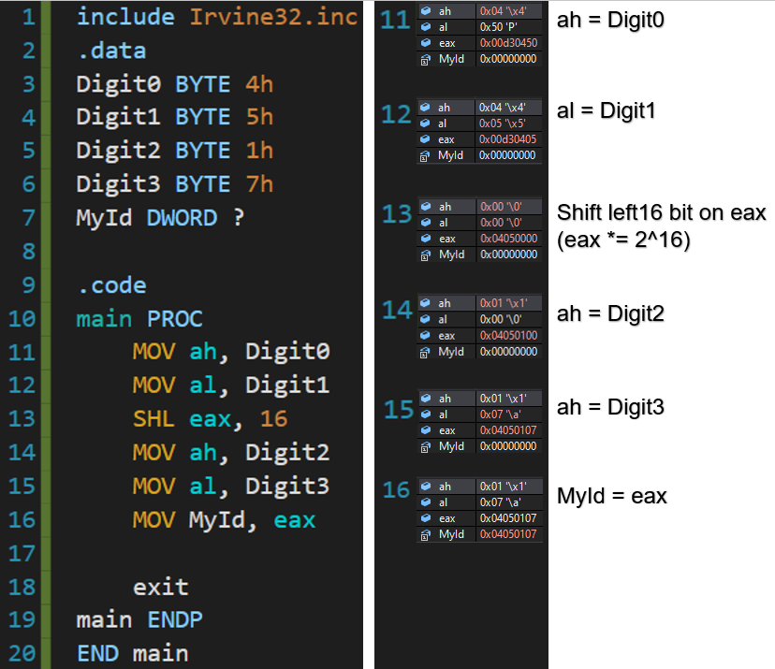

**Register change**

**Line 11**



**Line 12**



**Line 13**



**Line 14**

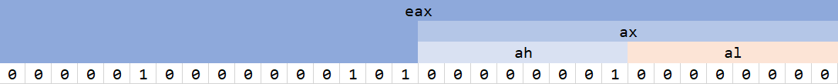

**Line 15**



**According to this work, we can practice the use of SHL.**

**And understand affect between eax, ah, and al**