**111_HW3-CountMatches**

**資電院學士班二年級**

110504517 **李睿穎**

**Full Code**

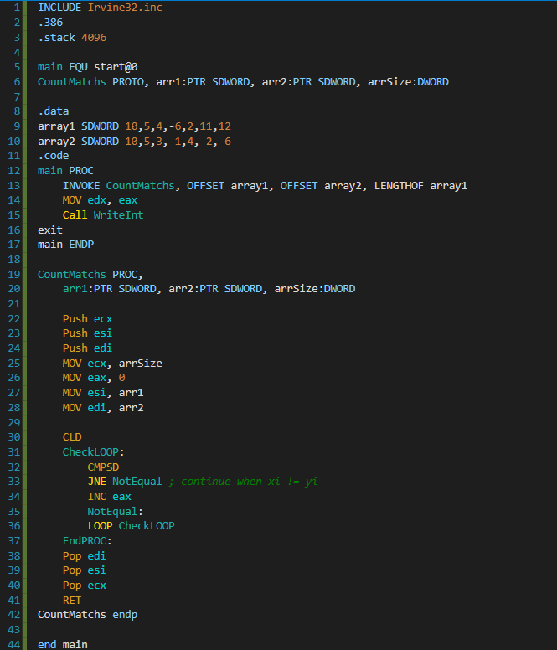

**Result Screenshot**

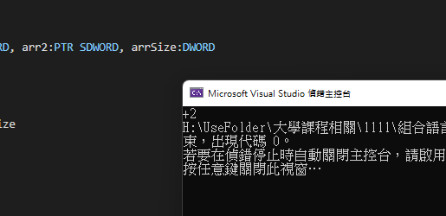

**Code Explain**

