**111_HW2-Procedure**

**資電院學士班二年級**

110504517 **李睿穎**

**Full Code**

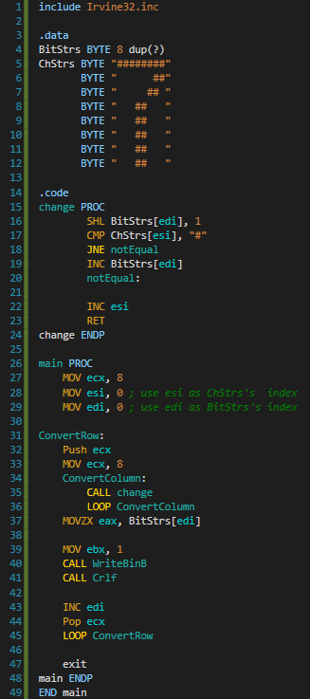

**Procedure “change”**

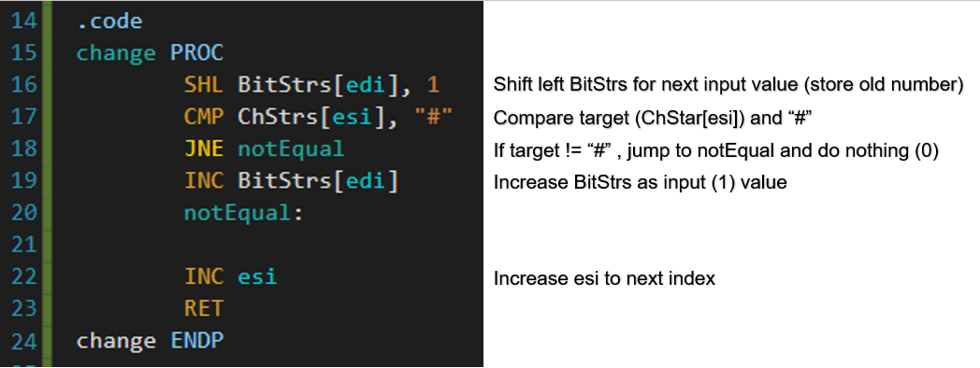

**main**

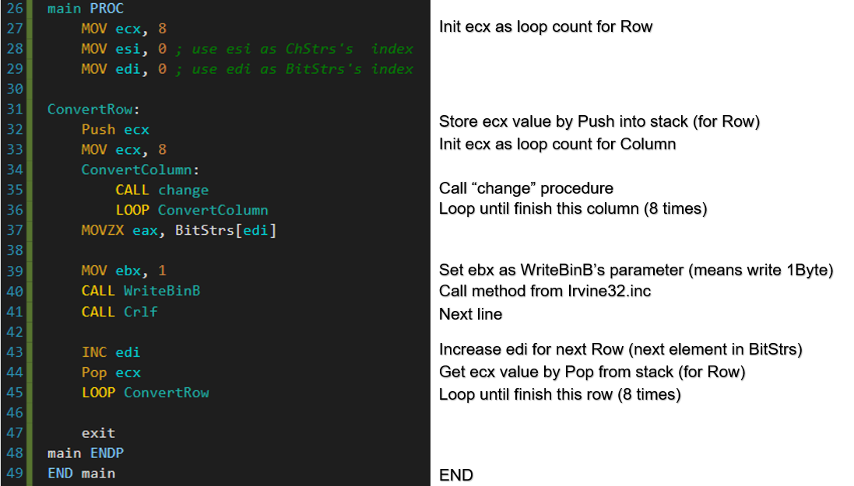

**WriteBinB’s document**

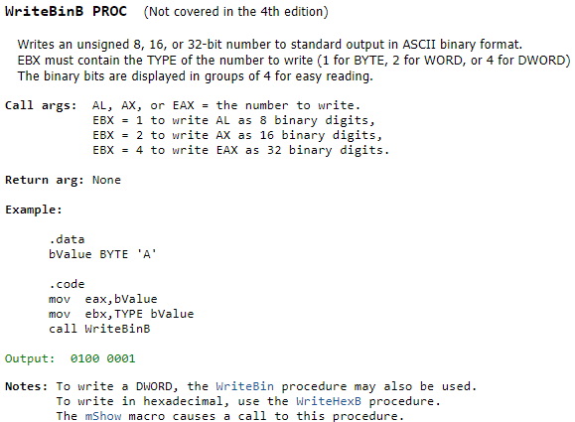

**Result Screenshot**

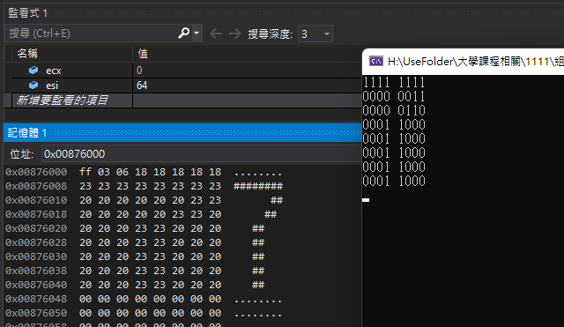

**According to this work, we can practice the use of Shift or Rotate, and nested loop.**

**But I think this is not a good question for practice Procedure, because in this question we don’t really need to use Procedure or even don’t use will let code better to read.**

**I think convert more number can be a solution, like make a procedure to convert a number, than input last 4 digit of student number.**