**Lab 10 Assembler**

**Group 65**

**Integrants: 110504517 李睿穎 (Leader)，110504518 鍾秉均 (Member)**

**Full Code**

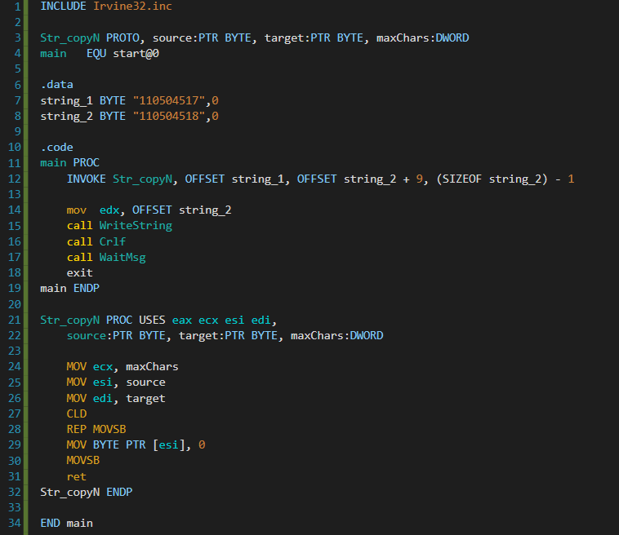

**Explanation**

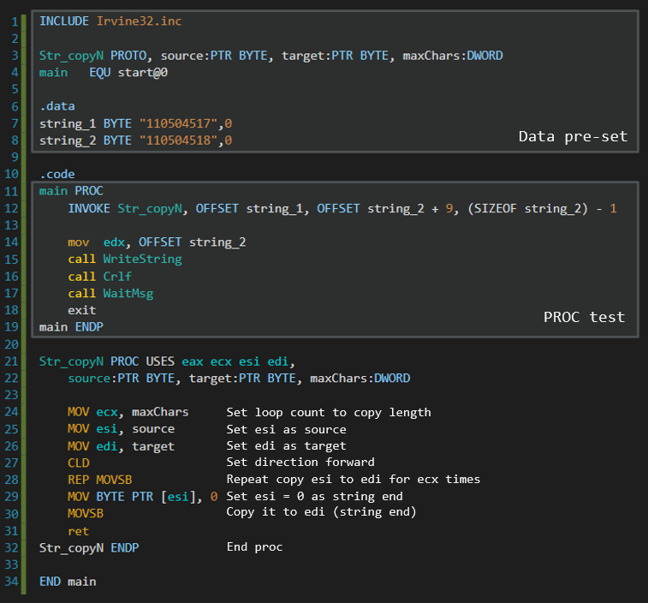

**Print Result**

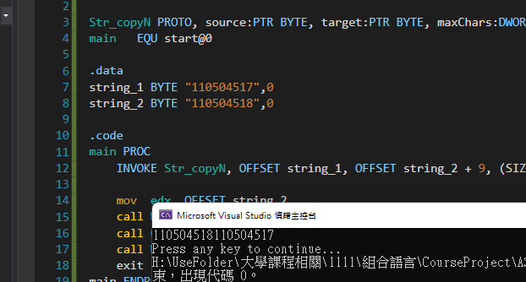

**Reflection**

This week’s lab was pretty much similar to last week’s lab, instead of removing certain amount of characters we combine both strings together.