**Lab 11 Assembler**

**Group 65**

**Integrants: 110504517 李睿穎 (Leader)，110504518 鍾秉均 (Member)**

**Full Code**

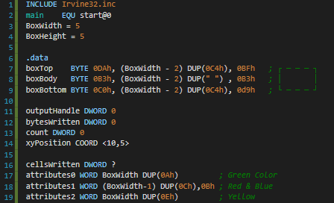

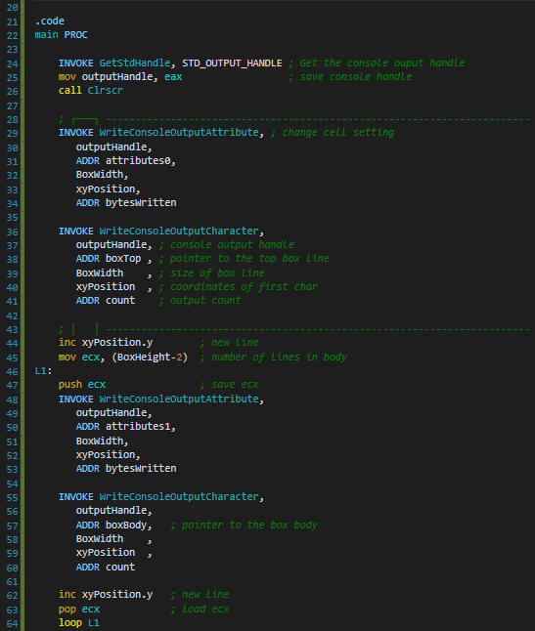

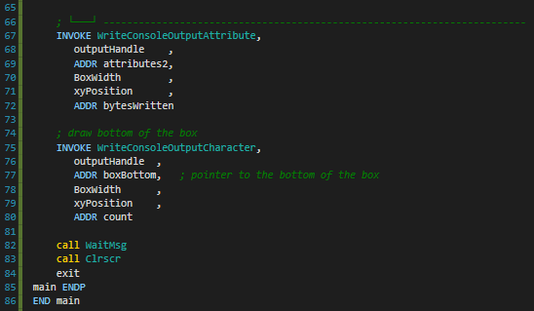

**Explanation**

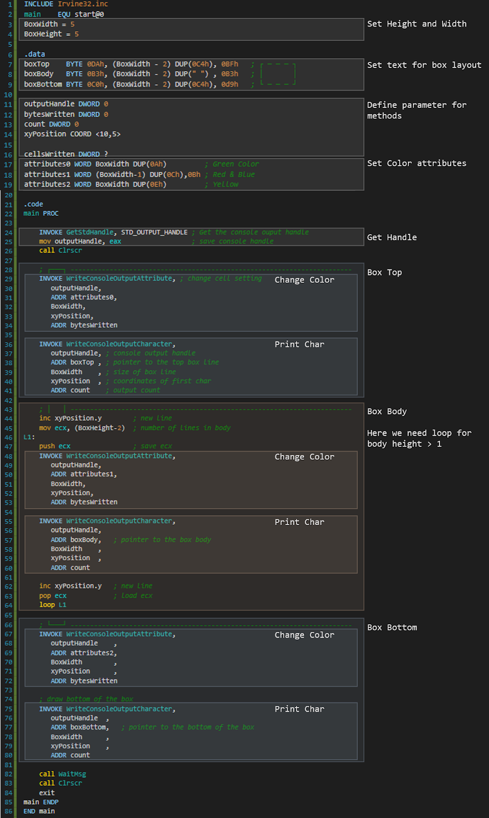

**Print Result**

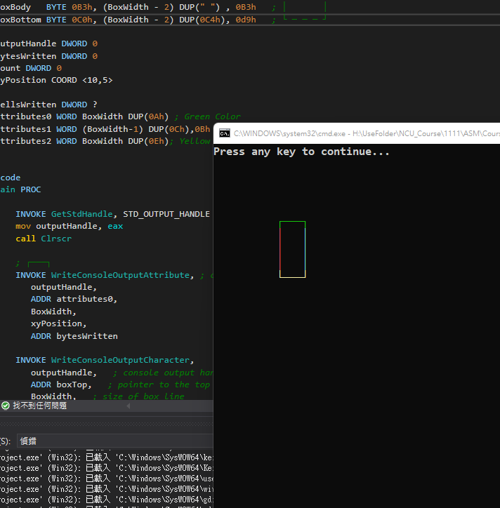

**Reflection**

. For this week’s Lab we learned how to draw things in the console by using the functions “WriteConsoleOutputAttribute” and “WriteConsoleOutputCharacter”, it is really useful because for our final projects it will be crucial to use those. At first we didn’t really know how to use the functions but with this lab and the TA’s comments we were able to implement what we learnt, including COORD, INVOKE and ADDR instructions.