**SET - 2**

1. **Simulate and implement stop and wait protocol for noisy channel.**

**OUTPUT. :**

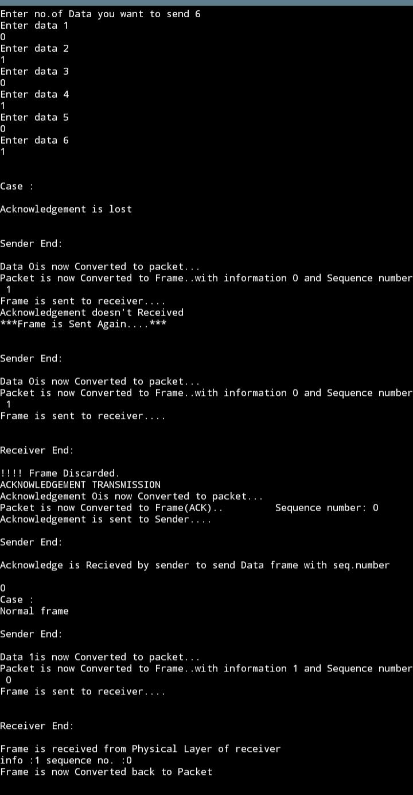

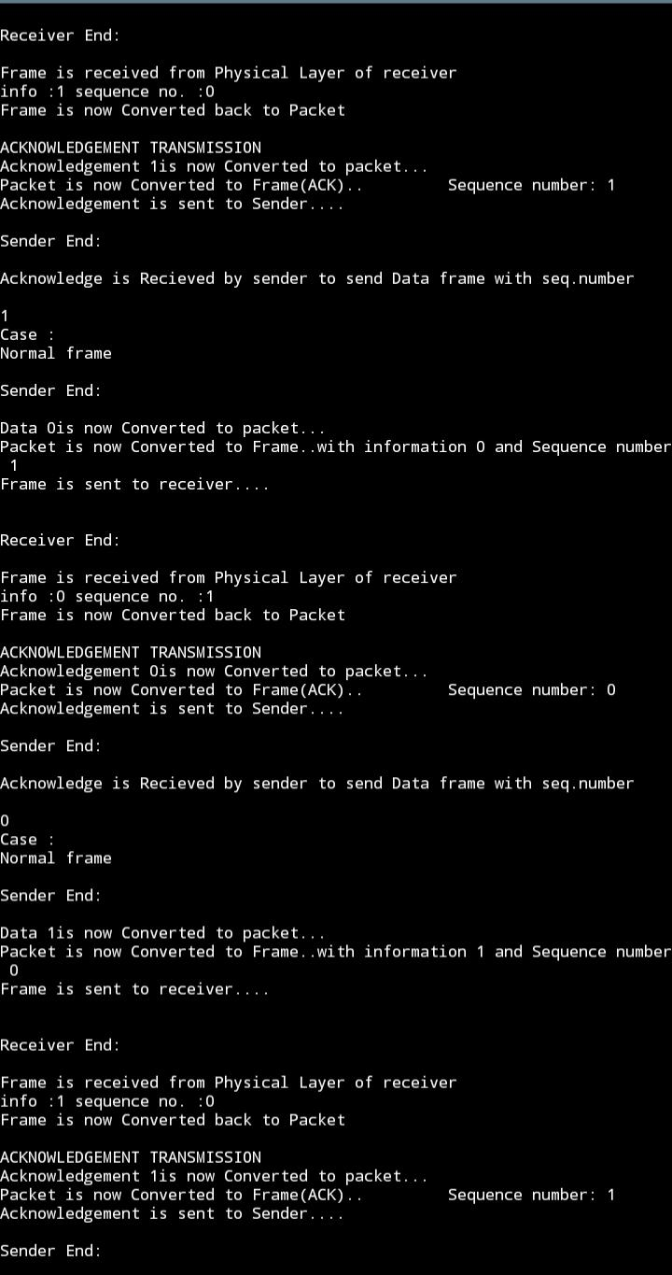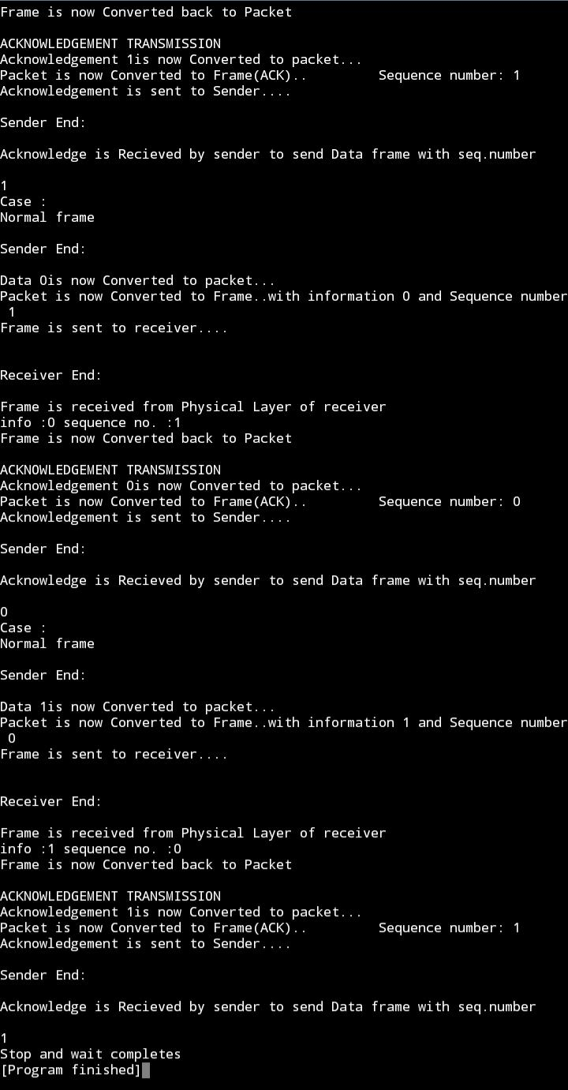

1. **Simulate and implement selective repeat sliding window protocol.**

