***Output*** :.

**Q1 :**

This is the preemptive version of SJF (Shortest Job First) algorithm. It is also called SJRF (Shortest Job Remaining First) algorithm. Basically SRTF / SJF algorithm can not apply in today's world as we don't know the future that when the process with short burst time arrive.

In this program, i have simulated the SRTF algorithm with sample inputs.

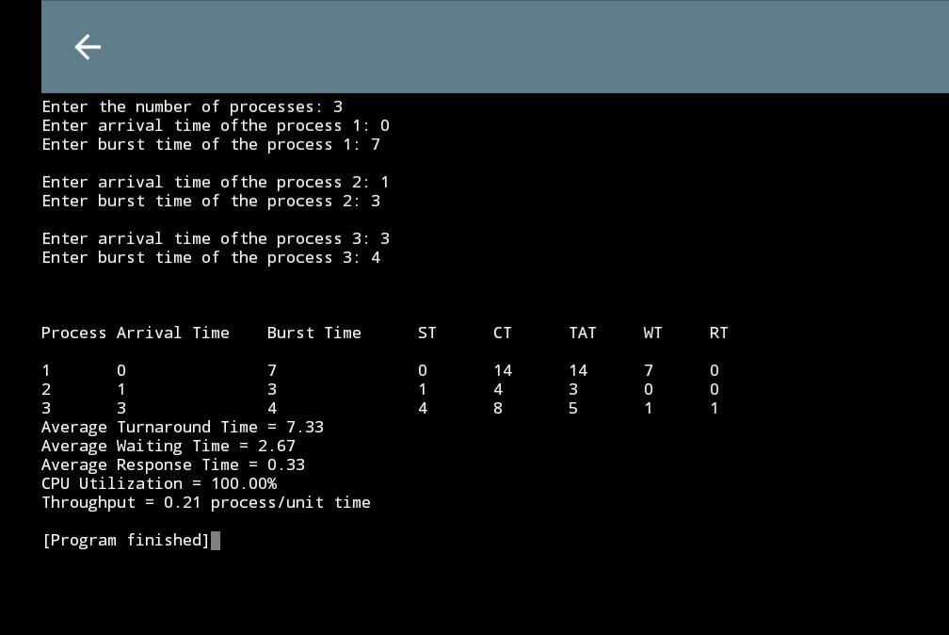

**Q2:**

In this program, we are demonstrating the fork() function which is used for creating sub / child processes.

