**IUT Online**

**Group No: 02**

**Members:**

1. Rezwanul Haque Ramim (144404)
2. Muhammad Shihab Rashid (144407)
3. Abir Mahmud Tasik (144408)
4. Md. Muniruzzaman (144409)
5. Kazi Rezoanur Rahman (144410)
6. Yemin Sajid (144412) (Group Leader)
7. Ariful Islam (144416)
8. Kasita Tawfik (144302)
9. Arif Haidary (144303)
10. Noor Ahmad (144304)
11. Nura din Mohammad (134307)
12. **Introduction:**

Communication between teachers, students and authority is very important in good varsity environment. It caters to the students’ needs and help them be more attached to varsity activities. IUT Online is an online platform to facilitate all the interactions between students, faculty members and administration.

1. **Problem Description:**

* Currently there is no way to communicate between teachers, students and authority. Students face problems regarding quiz syllabus, routines, class cancellation etc.
* Course contents cannot be found under one roof. They are segregated.
* Students have to wait till class time to talk to any faculties, there is no Q&A or FAQ.
* No way to watch live classes, or preview any class that has been already taken.
* Students who are not regular on facebook specially face huge problems to be notified about any quizzes or syllabuses.

1. **Objectives**

* Building an online platform, where every student, teachers and authority members can interact
* Write posts and ask questions directly to teachers or authority members
* Having a robust and dedicated system for IUT only, so it’s a lot more easier
* Keeping every materials under one roof

1. **Related Work**

* Google Classroom: [http://classroom.google.com](http://classroom.google.com/)
* Scoology:  [https://www.schoology.com](https://www.schoology.com/)
* Edomodo:  [https://www.edmodo.com](https://www.edmodo.com/)

1. **Project Features**
2. **Functionalities**

* Individual pages for each courses
* Posting questions or comments on a course page
* Sending and receiving messages
  + Private and group chats
* Sharing course materials
  + Course plan
  + Course material
  + Projects
* Viewing video lectures
* Online notice board
* Push notification
  + Exams and quizzes

1. **Unique Features**

* Dedicated platform for IUT
* Integrated Android app to get push notifications about exams and syllabuses
* FAQ section

1. **Challenges**

* Having to work with huge database
* Android integration as we have limited knowledge about android programming
* Live classes

1. **Diagrams**

**a. E-R (Initial):**

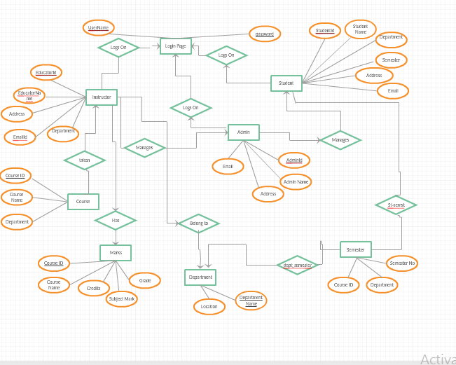

**b. System Architecture Diagram**

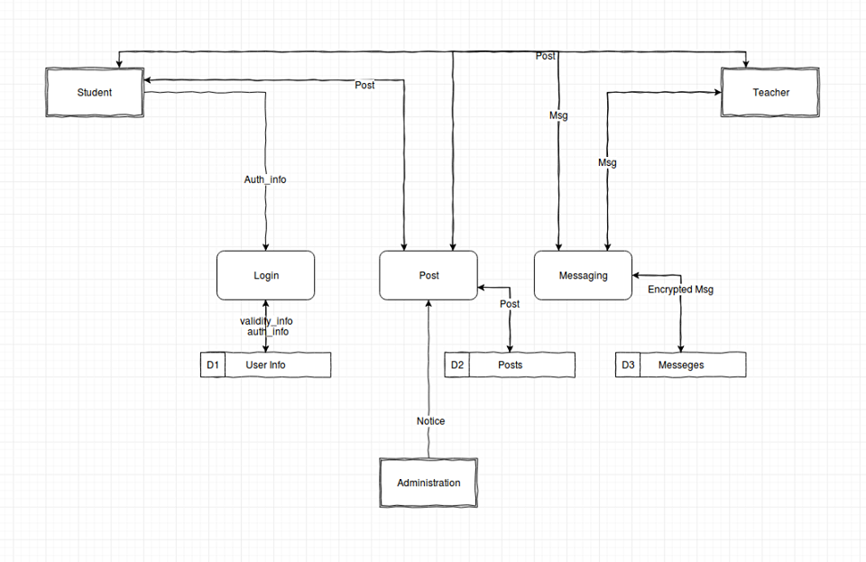

**c. Prototype Sketches**

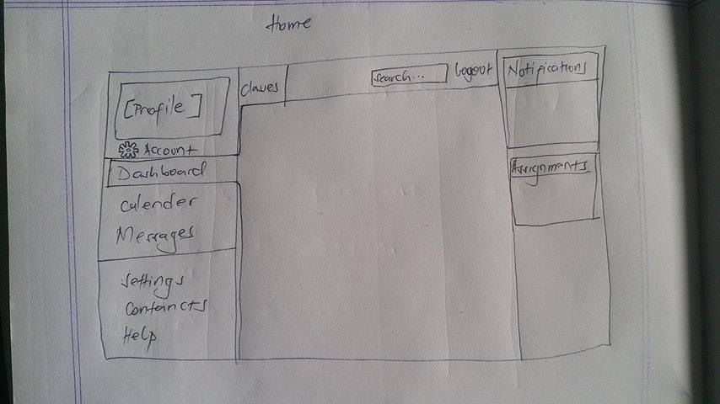

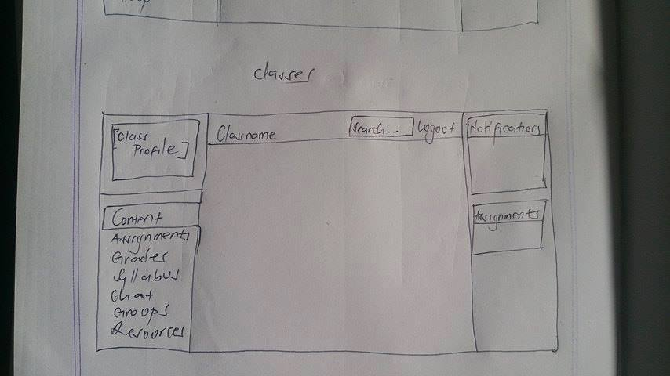

**5. Technologies Used**

**a. Language:** Python, HTML, CSS, JavaScript

**b. Frameworks Used:** Django, Jinja Template

**c. Libraries:** Bootstrap, Jet(For admin panel)

**d. Database:** Postgres DB

**6. Software Phases**

**Phase-I (Weeks 1-7):**

* Scoping problems in status quo, coming up with features and solutions
* Evaluating similar applications related to this project
* Distribution of work between project mates
* Start learning necessary languages and libraries

**Phase-II (Weeks 8-15):**

* Building demo applications with the language requirements. E.g. Building simple applications with Android, Python. Building simple websites using HTML, CSS
* Working to build the prototype interface
* Working with database

**7. Future Works**

**Phase-III (Weeks 16-24):**

* Working with online notice board
* Implementing push notifications

**Phase-IV (Weeks 25-32):**

* Materials posting
* Storing video lectures in database

**8. Conclusion**

Hopefully our project will help making the students communication with teachers easier and make their IUT academic life more comfortable.

**9. Appendix**

**a. Code:** The code can be found at: <https://github.com/Ysajid/IUT-Online>

1. **Implemented UI:**

