CS 549: Performance Analysis of Computer Networks
Lab Assignment 1
Submitted by – Yash Gupta , B21147

(I) Decription of Experiment :-
Goal :- To Measure the Delay-Throughput characterstics of the connection to an Internet Server. (Optional :- To identify the bottleneck in the connection)

System Defiinition :-

NIC of my Machine
WiFi Router
Gateway Router and all other Routers in between
Server system

Machine :- HP pavillion laptop , OS:- Ubuntu 22.04
Tools used:
- Ping
- Traceroute
- Python
- bash scripting
- ping.eu

Factors | Levels
Time of Day | 4 * 60 * 24 ( 20 sec intervals)
Server | 3
Access Points | 2 ( WiFi , LAN)
Size of Packets sent | Possibly Many ( 0 to MTU )
Number of Packets sent | Possibly many
Day of week | 7
ISP | Possibly Many
z
I have fixed the following :
- Day of week – Wednesday
- ISP - BSNL
- Number of packets sent – 30
- Size of each packet - 100 Bytes payload ( + 28 additional Header bytes )
- Access point – WiFi

I have performed the experiment for all the three servers concurrently ( multiprocessing for each server ping , included the code link at the last of the report) multiple times on different daytime ( 20 sec intervals).

Servers –
Within IIT Mandi :- Gateway Router ( 172.16.22.1).
Inside India :- 203.201.60.12 - Bell Teleservices India Pvt. Ltd.
Outside India :- 8.8.8.8 Google LLC California.

Pinging each of them 100 times ( variyng the factor – time of day ) , with fixed Number of packets = 30 , and fixed size of each packet Payload size = 100 Bytes , Header size = 28 bytes , overall = 128 Bytes.

For each iteration Calculating the following:
Delay expereinced as rtt_avg_ms
Throughput :
(size of packets * no of packets transmitted succesfully ) / time elapsed

so for each of the server we have :-
at different time of day – the delay and throughput

(II) a line graph with time on the x-axis, delay and throughput on the y-axis
On Next pages

For Gateway Router of my hostel - ( Server within IIT Mandi ) the plot of delay and throughput vs time is :-
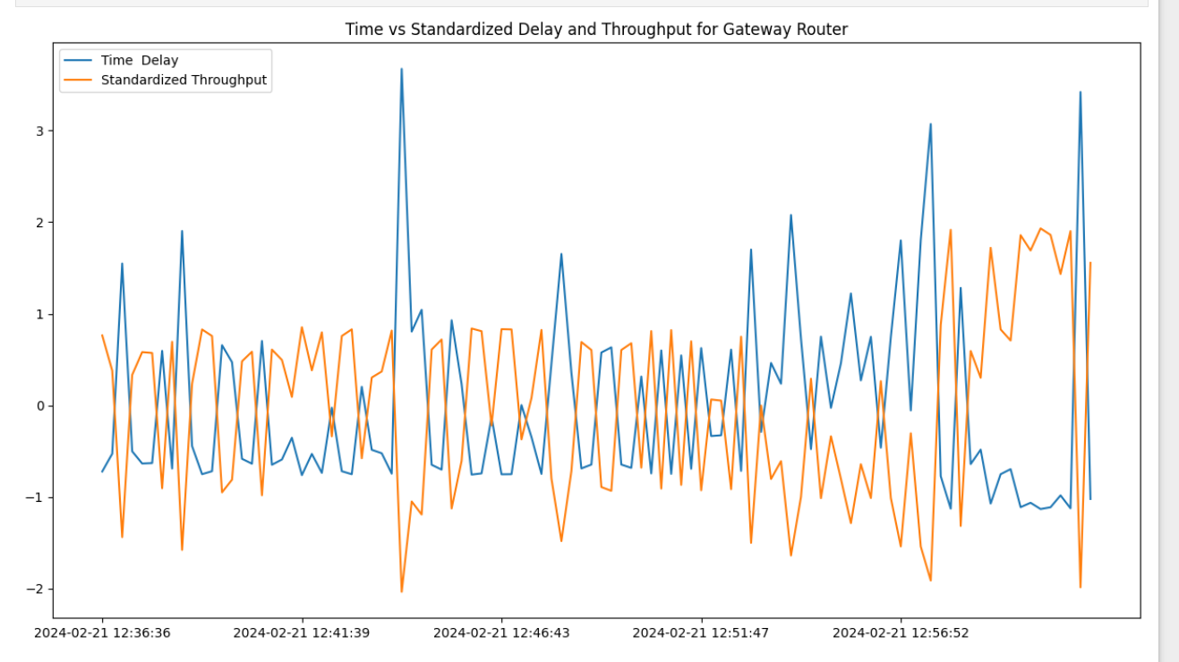

For Bell Teleservices India Pvt. Ltd. ( Distant part of India ) , The plot of delay and throughput vs time is
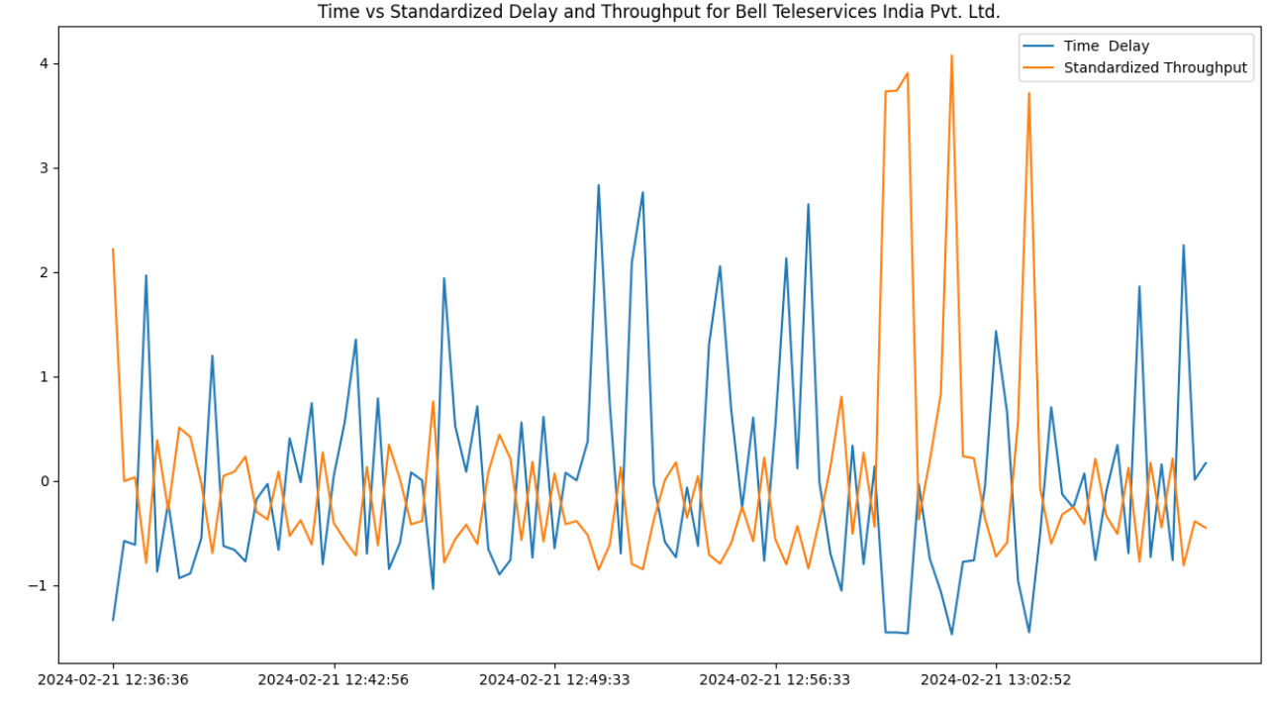
For Gooogle LLC in california ( 8.8.8.8) , Server outside India , the plot of delay and throughput vs time is
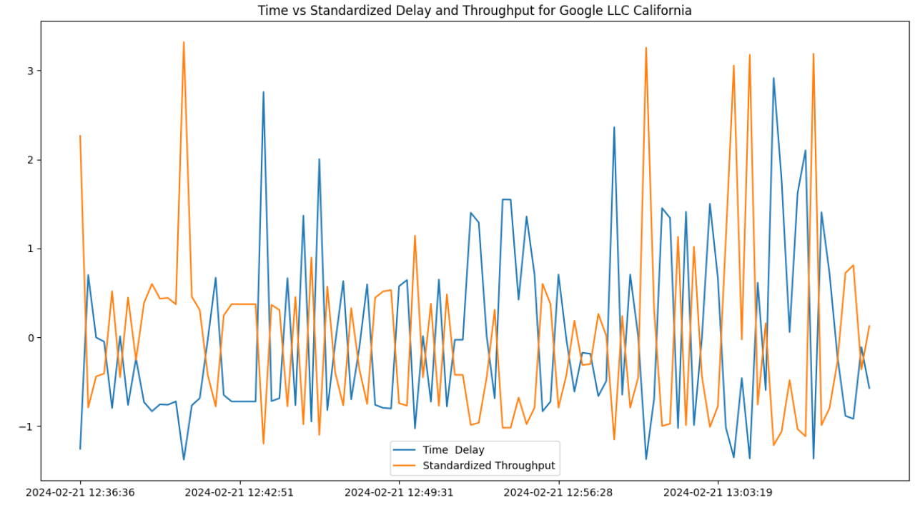
(iii) a line graph with delay on the y-axis and throughput on the x-axis
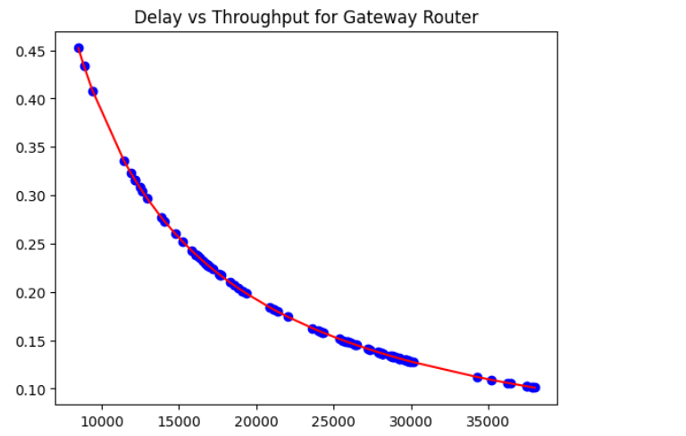
Throughput
Delay

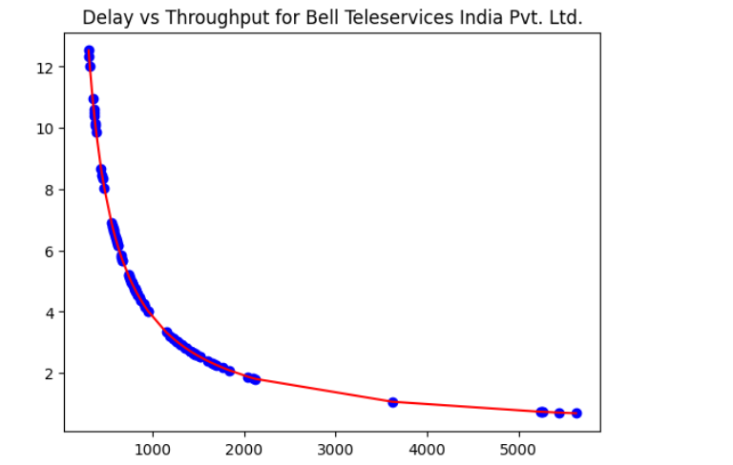

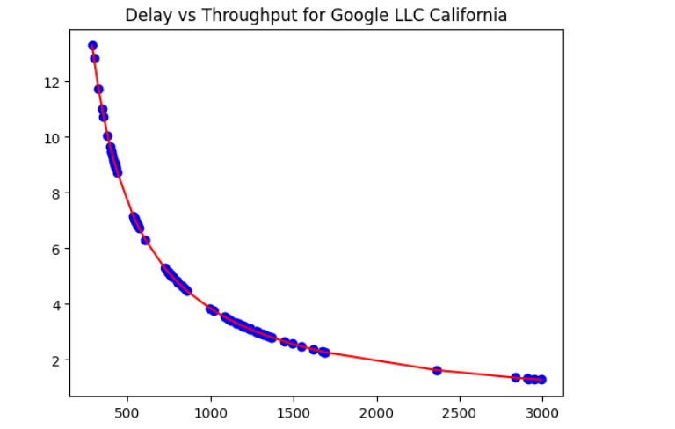

(IV) conclusions

As we can clearly see in the above graphs , whether the time vs ( delay and throughput ) or delay vs throughput , we can say whenever the throughput increases the delay decreases.
This may seems very unusual from the general concepts. But I have two explanations for this that might makek sense:

Firstly , Note that we are taking the average RTT as our delay for a single iteration( that sents multiple ICMP packets )

a) As the throuhput increases, the number of packets in the network increases and so maybe routers starts to drop the packets ( other than our packets also) and hence the avg delay is less for us.
b) As the throughput is increased there might be some kind of detection in Routing algo’s and maybe then packets are transferred from some other path which has less delay than the previous one.

Another Trivial observation is that for gateway router ( closet to me ) the Delay is very less as compared to other servers.

Code and script files :- https://github.com/YshGupta/COmputer_Networks_Analysis
This also includes the ipynb notebooks for importing and plotting the data.

