CS 549: Performance Analysis of Computer Networks

Lab Assignment 3
Submitted By : Yash Gupta , B21147

Creating four namespaces , NetNsA ...NetNsB
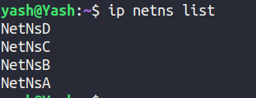

Different IP Addresses have been assigned to each interface on each namespace.

NetNsA – 172.16.17.1
NetNsB – 172.16.17.2
NetNsC – 172.16.17.3
NetNsD – 172.16.17.4

(a) Run ping between NetNsA and NetNsB. Observe the traffic using Wireshark.

Observations :- Initially I gave the IP addresses in the same range as my host machine i.e. 172.16.17.x / 24. The packets loss was around 90 % ( see the attached scrresnhot below ).
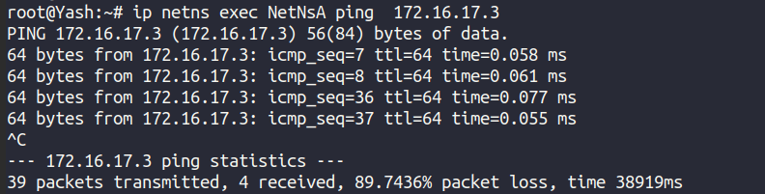
Later on when I changed the ip range to 192.0.2.x/24 for every namespace interface – the packets loss was 0 %.
( attached screenshot below )

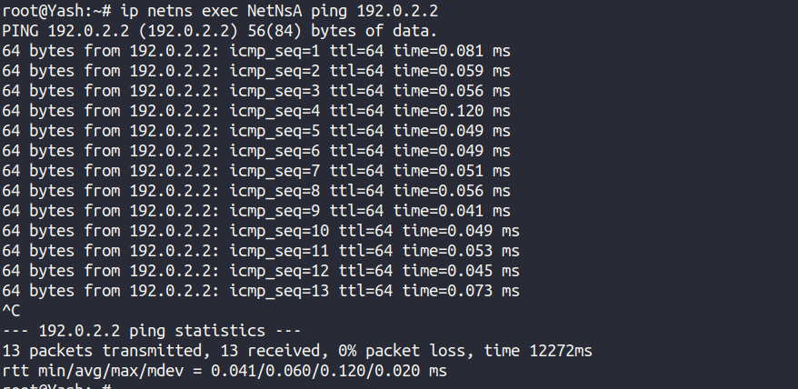

The network traffic visualized on wireshark is also attached :
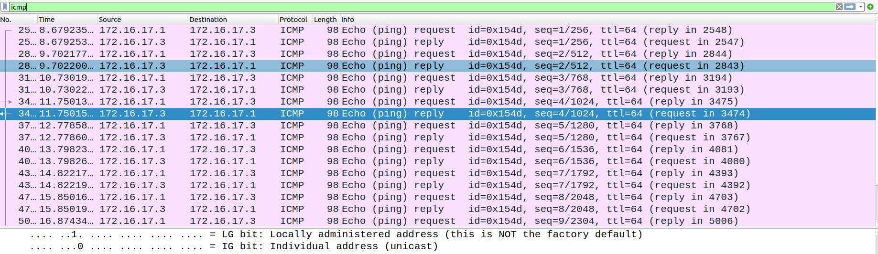
Every request and response is captured in wireshark for applied ICMP filter.

(b) Adding queue discipline with 20 % loss

There are 3 possibilities based on where we are adding the policy of 20% loss
- On the sender side
- on the receiver side
- On both sides

Conisdering the first option as most appropriate in accordance with the real world sceenario , where packets loss occcurs because of congestion in the network, Applying queuing discpline to sender side ( interface macvlanA in namespace NetNsA).

Now pinging 192.0.2.2 from this interface
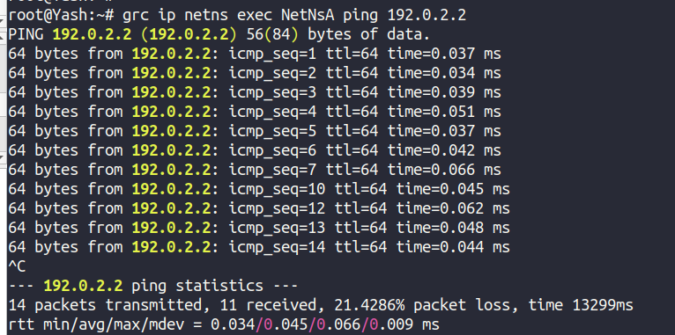
packets with seq no - 8 , 9 , 11 are lost. ( loss fraction = 3 / 14 = 0.21 )
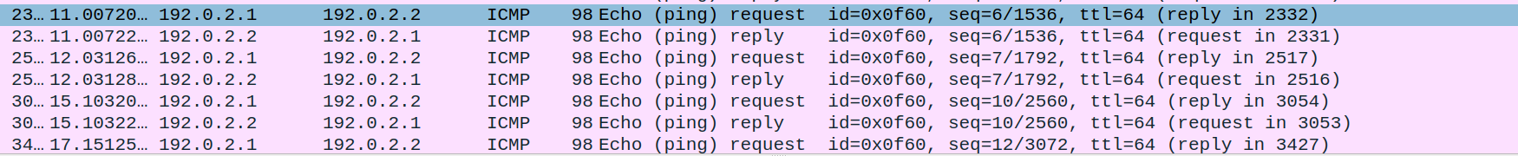
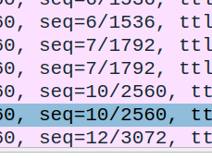

This is also captured in wireshark.
As packets with sequence number 8 , 9 , 11 are not captured by wireshark.

Hence the applied fixed loss of 20% in queuing discipline of sender is perfeclty reflected in the experiment results.

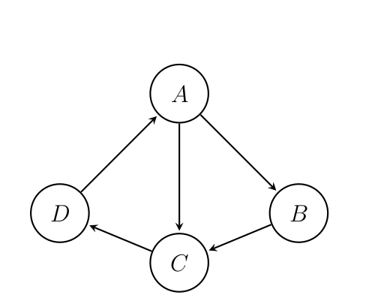
Part -2

From the requirements of the downstream tasks, it is very clear that We can not proceed in a way in which each namespace acting as a node having 1 interface only. Because we won’t be able to deactivate a particular edge using 100 % loss on queue discipline for a interface.

For ex: Lets’say we want to block Edge AC , Then setting 100 % loss for interface A will also block edge AB. Infact whole node A is now blocked.

As a solution to this, For a particular node, Lets create a different namespace for each outgoing link and one namespace corresponding to all the incoming links as well.

For example and clarity , in our given Graph diagram , The namespaces corresponding to node A will be

AC -> outgoing edge from A to C
AB -> outgoing edge from A to B
Ai -> for all incoming edges to A ( though we only have 1 in our case )

For Node B ,
BC , Bi ---> Outgoing from B to C and Incoming to B respectivley.

For node C,
CD , Ci -> Outgoing from C to D and Incoming to B respectivley.

For node D,
DA , Di namespaces.

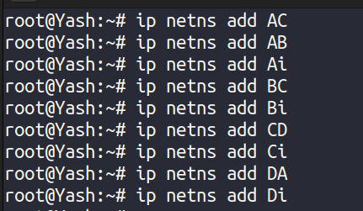

Now lets create a interface to each of the namespaces and assign IP to them.

The ip addresses associated with each namespace is given as:

AB ------> 192.0.2.1 / 24
AC ------> 192.0.2.2 / 24
Ai ------> 192.0.2.3 / 24
BC ------> 192.0.2.4 / 24
Bi ------> 192.0.2.5 / 24
CD ------> 192.0.2.6 / 24
Ci ------> 192.0.2.7 / 24
DA ------> 192.0.2.8 / 24
Di -------> 192.0.2.9 / 24

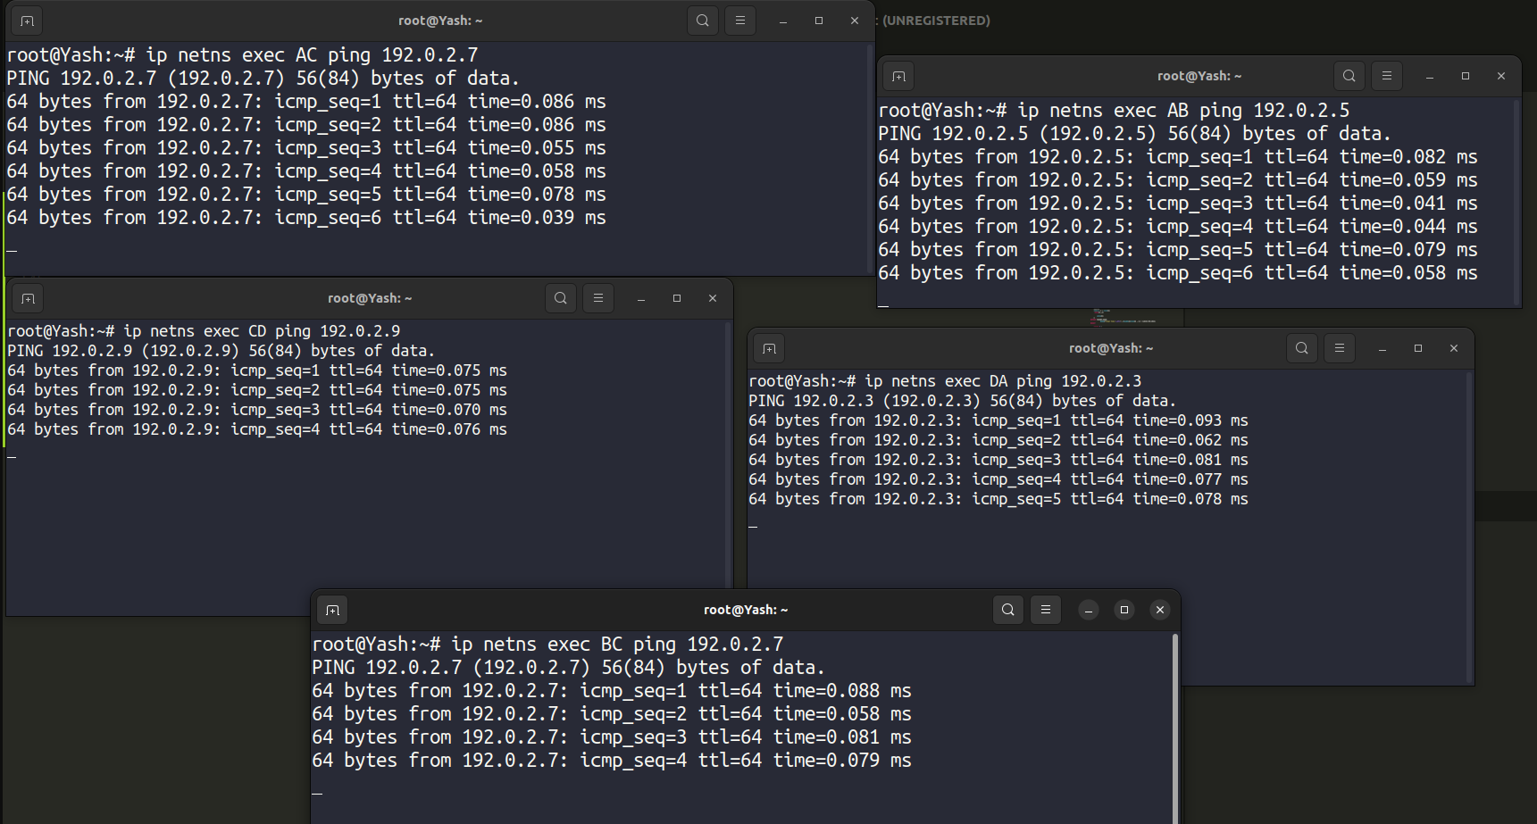
The above screenshot shows multiple terminals through which parallely I am able to send packets according to the given graph.

In this setup , The tasks are :-

(a) Deactivate a particular edge by setting 100 % loss on the corresponding
queue discipline, for a fixed duration of time. Revive the edge by removing
the loss constraint on the queue discipline after the fixed duration. Observe
the traffic using Wireshark.

--> Lets deactivate the edge AC

The script for this is quite simple
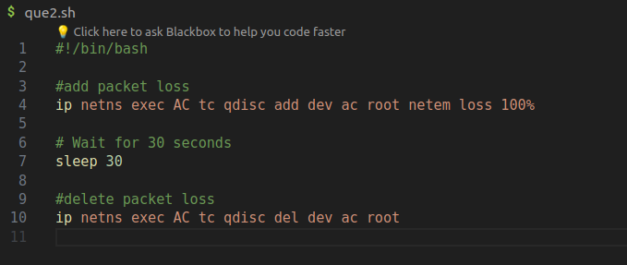

Adding 100% loss on AC namespace interface ( through which we were initially transferring the packets to Ci ) makes the edge AC blocked for 30 seconds.

Observing the traffic during these 30 seconds using wireshark:-
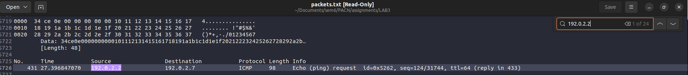
The 100 % loss is on the AC namespace interface which has a ip address of

192.0.2.2 and as shown in the screenshot above , the first packet that is captured by wireshark from this IP is sequenced with number 431. This is because for the first 30 seconds the edge from A to C was indeed get blocked ( from namespace AC interface with ip 192.0.2.2 to namespace Ci interface with IP 192.0.2.7 ). After 30 seconds, The edge gets revived again and the packets were again able to travel from 192.0.2.2 to 192.0.2.7 ( AC to Ci ).

This can also be visualized in the terminal
After 96 there is a gap in sequence number , this is because of the 30 seconds blocking time introduced for this path.

Task (b) -
(i) Probabilistic scheduling: Suppose that each edge is equally likely to
be activated, activate exactly 1 edge in each time slot.

Cosndering each time slot to be of 4 seconds and number of slots to be 10.
The output of such a link scheduling is shown below :
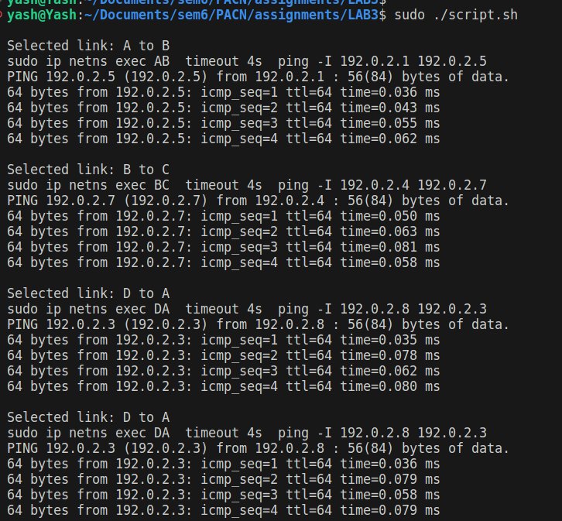
(ii) Deterministic scheduling: Divide the edges into maximally indepen-
dent sets, and activate one set of edges in each time slot.

According to given graph
The maximal independent based on the constraint that any node at a time can only be in one operation ( sending to one or receiving from one ) are :-

Set Number | Edges
S1 | AB , CD
S2 | BC , DA
S3 | AC

