INSERT INTO classroom VALUES ('Science Hall', '101', 50);

1 row created.

INSERT INTO classroom VALUES ('Science Hall', '102', 45);

1 row created.

INSERT INTO classroom VALUES ('EngineeringBldg', '201', 60);

1 row created.

INSERT INTO classroom VALUES ('EngineeringBldg', '202', 55);

1 row created.

INSERT INTO classroom VALUES ('Arts Center', 'A01', 40);

1 row created.

INSERT INTO classroom VALUES ('Arts Center', 'A02', 35);

1 row created.

INSERT INTO classroom VALUES ('Library', 'L1', 20);

1 row created.

INSERT INTO classroom VALUES ('Library', 'L2', 25);

1 row created.

INSERT INTO classroom VALUES ('Business Wing', 'B101', 30);

1 row created.

SQL> INSERT INTO classroom VALUES ('Business Wing', 'B102', 50);

1 row created.

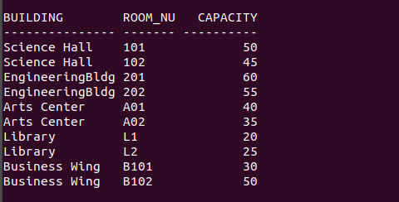
INSERT INTO department VALUES ('Computer Science', 'Science Hall', 120000.00);

1 row created.

INSERT INTO department VALUES ('Mathematics', 'EngineeringBldg', 80000.50);

1 row created.

INSERT INTO department VALUES ('Physics', 'Science Hall', 100000.75);

1 row created.

INSERT INTO department VALUES ('Chemistry', 'Research Center', 95000.00);

1 row created.

INSERT INTO department VALUES ('Biology', 'Life Sciences', 87000.00);

1 row created.

INSERT INTO department VALUES ('English', 'Arts Center', 60000.00);

1 row created.

INSERT INTO department VALUES ('History', 'Humanities Wing', 55000.00);

1 row created.

INSERT INTO department VALUES ('Business', 'Business Wing', 150000.00);

1 row created.

INSERT INTO department VALUES ('Economics', 'Business Wing', 92000.00);

1 row created.

SQL> INSERT INTO department VALUES ('Psychology', 'Social Sciences', 72000.25);

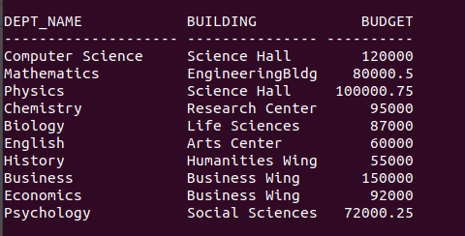
1 row created.
INSERT INTO course VALUES ('CS101', 'Introduction to Computer Science', 'Computer Science', 3);

1 row created.

INSERT INTO course VALUES ('CS201', 'Data Structures', 'Computer Science', 4);

1 row created.

INSERT INTO course VALUES ('MA201', 'Calculus I', 'Mathematics', 3);

1 row created.

INSERT INTO course VALUES ('MA101', 'Linear Algebra', 'Mathematics', 3);

1 row created.

INSERT INTO course VALUES (‘EE210', 'Classical Mechanics', 'Physics', 4);
ERROR:
ORA-01756: quoted string not properly terminated

INSERT INTO course VALUES ('EN101', 'Organic Chemistry', 'Chemistry', 4);

1 row created.

INSERT INTO course VALUES ('EE110', 'General Biology', 'Biology', 3);

1 row created.

INSERT INTO course VALUES ('LI101', 'English Literature', 'English', 3);

1 row created.

INSERT INTO course VALUES ('HI101', 'World History', 'History', 3);

1 row created.

SQL> INSERT INTO course VALUES ('BU101', 'Principles of Management', 'Business', 3);

1 row created.

SQL> INSERT INTO course VALUES (‘EE210', 'Classical Mechanics', 'Physics', 4);
ERROR:
ORA-01756: quoted string not properly terminated

SQL> INSERT INTO course VALUES ('EE210', 'Classical Mechanics', 'Physics', 4);

1 row created.
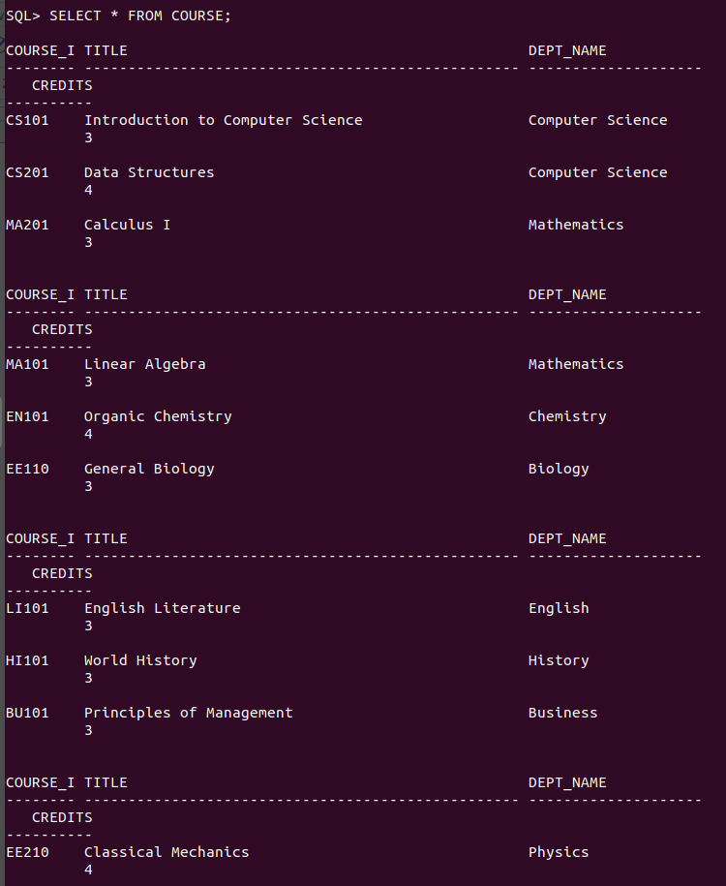
INSERT INTO instructor VALUES ('I001', 'John Doe', 'Computer Science', 50000.00);

1 row created.

INSERT INTO instructor VALUES ('I002', 'Jane Smith', 'Mathematics', 60000.00);

1 row created.

INSERT INTO instructor VALUES ('I003', 'David Lee', 'Physics', 55000.00);

1 row created.

INSERT INTO instructor VALUES ('I004', 'Sarah Jones', 'English', 45000.00);

1 row created.

INSERT INTO instructor VALUES ('I005', 'Michael Brown', 'Business', 70000.00);

1 row created.

INSERT INTO instructor VALUES ('I006', 'Emily Davis', 'History', 48000.00);

1 row created.

INSERT INTO instructor VALUES ('I007', 'Daniel Wilson', 'Psychology', 52000.00);

1 row created.

INSERT INTO instructor VALUES ('I008', 'Olivia Taylor', 'Computer Science', 65000.00);

1 row created.

INSERT INTO instructor VALUES ('I009', 'James Anderson', 'Mathematics', 58000.00);

1 row created.

SQL> INSERT INTO instructor VALUES ('I010', 'Sophia Clark', 'Physics', 49000.00);
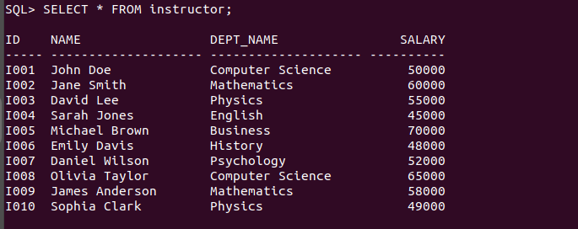
1 row created.
INSERT INTO section VALUES ('CS101', 'A1', 'Fall', 2023, 'Science Hall', '101', 'T1');

1 row created.

INSERT INTO section VALUES ('MA201', 'B1', 'Spring', 2024, 'Science Hall', '102', 'T2');

1 row created.

INSERT INTO section VALUES ('EE210', 'C1', 'Fall', 2023, 'EngineeringBldg', '201', 'T3');

1 row created.

INSERT INTO section VALUES ('EN101', 'D1', 'Spring', 2024, 'EngineeringBldg', '202', 'T4');

1 row created.

INSERT INTO section VALUES ('BU101', 'E1', 'Fall', 2023, 'Arts Center', 'A01', 'T5');

1 row created.

INSERT INTO section VALUES ('HI101', 'F1', 'Spring', 2024, 'Arts Center', 'A02', 'T6');

1 row created.

INSERT INTO section VALUES ('LI101', 'G1', 'Fall', 2023, 'Library', 'L1', 'T7');

1 row created.

SQL> INSERT INTO section VALUES ('CS201', 'H1', 'Spring', 2024, 'Library', 'L2', 'T8');

1 row created.

INSERT INTO section VALUES ('MA101', 'I1', 'Fall', 2023, 'Business Wing', 'B101', 'T9');

1 row created.

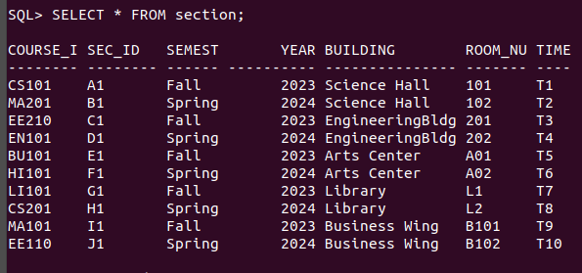
SQL> INSERT INTO section VALUES ('EE110', 'J1', 'Spring', 2024, 'Business Wing', 'B102', 'T10');

1 row created.
INSERT INTO teaches VALUES ('I001', 'CS101', 'A1', 'Fall', 2023);

1 row created.

INSERT INTO teaches VALUES ('I002', 'MA201', 'B1', 'Spring', 2024);

1 row created.

INSERT INTO teaches VALUES ('I003', 'EE210', 'C1', 'Fall', 2023);

1 row created.

INSERT INTO teaches VALUES ('I004', 'EN101', 'D1', 'Spring', 2024);

1 row created.

INSERT INTO teaches VALUES ('I005', 'BU101', 'E1', 'Fall', 2023);

1 row created.

INSERT INTO teaches VALUES ('I006', 'HI101', 'F1', 'Spring', 2024);

1 row created.

INSERT INTO teaches VALUES ('I007', 'LI101', 'G1', 'Fall', 2023);

1 row created.

INSERT INTO teaches VALUES ('I008', 'CS201', 'H1', 'Spring', 2024);

1 row created.

INSERT INTO teaches VALUES ('I009', 'MA101', 'I1', 'Fall', 2023);

1 row created.

SQL> INSERT INTO teaches VALUES ('I010', 'EE110', 'J1', 'Spring', 2024);

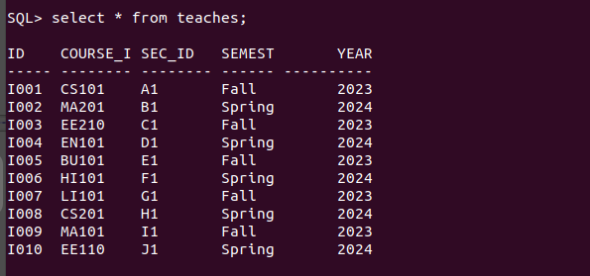
1 row created.
SQL> INSERT INTO student VALUES ('S1001', 'Alice', 'Computer Science', 30);

1 row created.

INSERT INTO student VALUES ('S1002', 'Bob', 'Mathematics', 45);

1 row created.

INSERT INTO student VALUES ('S1003', 'Charlie', 'Physics', 20);

1 row created.

INSERT INTO student VALUES ('S1004', 'David', 'English', 60);

1 row created.

INSERT INTO student VALUES ('S1005', 'Eve', 'Business', 15);

1 row created.

INSERT INTO student VALUES ('S1006', 'Frank', 'History', 35);

1 row created.

INSERT INTO student VALUES ('S1007', 'Grace', 'Psychology', 25);

1 row created.

INSERT INTO student VALUES ('S1008', 'Henry', 'Computer Science', 50);

1 row created.

INSERT INTO student VALUES ('S1009', 'Ivy', 'Mathematics', 40);

1 row created.

SQL> INSERT INTO student VALUES ('S1010', 'Jack', 'Physics', 10);

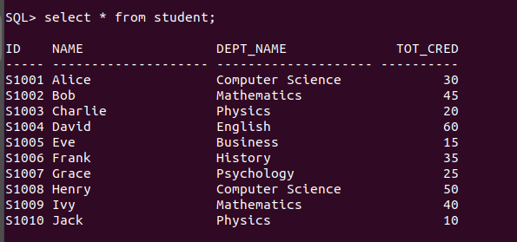
1 row created.

INSERT INTO takes VALUES ('S1001', 'CS101', 'A1', 'Fall', 2023, 'A');

1 row created.

INSERT INTO takes VALUES ('S1002', 'MA201', 'B1', 'Spring', 2024, 'B');

1 row created.

INSERT INTO takes VALUES ('S1003', 'EE210', 'C1', 'Fall', 2023, 'C');

1 row created.

SQL> INSERT INTO takes VALUES ('S1004', 'EN101', 'D1', 'Spring', 2024, 'A');

1 row created.

INSERT INTO takes VALUES ('S1005', 'BU101', 'E1', 'Fall', 2023, 'B');

1 row created.

INSERT INTO takes VALUES ('S1006', 'HI101', 'F1', 'Spring', 2024, 'C');

1 row created.

INSERT INTO takes VALUES ('S1007', 'LI101', 'G1', 'Fall', 2023, 'A');

1 row created.

INSERT INTO takes VALUES ('S1008', 'CS201', 'H1', 'Spring', 2024, 'B');

1 row created.

INSERT INTO takes VALUES ('S1009', 'MA101', 'I1', 'Fall', 2023, 'A');

1 row created.

SQL> INSERT INTO takes VALUES ('S1010', 'EE110', 'J1', 'Spring', 2024, 'C');

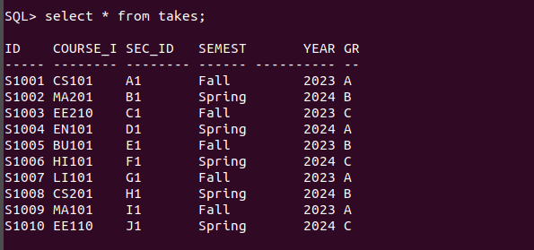
1 row created.
INSERT INTO advisor VALUES ('S1001', 'I001');

1 row created.

INSERT INTO advisor VALUES ('S1002', 'I002');

1 row created.

INSERT INTO advisor VALUES ('S1003', 'I003');

1 row created.

INSERT INTO advisor VALUES ('S1004', 'I004');

1 row created.

INSERT INTO advisor VALUES ('S1005', 'I005');

1 row created.

INSERT INTO advisor VALUES ('S1006', 'I006');

1 row created.

INSERT INTO advisor VALUES ('S1007', 'I007');

1 row created.

INSERT INTO advisor VALUES ('S1008', 'I008');

1 row created.

INSERT INTO advisor VALUES ('S1009', 'I009');

1 row created.

SQL> INSERT INTO advisor VALUES ('S1010', 'I010');

1 row created.
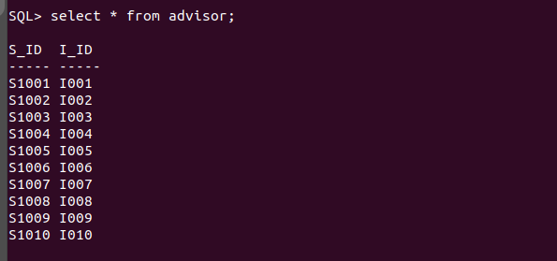
SQL> INSERT INTO time_slot VALUES ('T1', 'M', 9, 0, 9, 50);

1 row created.

INSERT INTO time_slot VALUES ('T2', 'W', 10, 0, 10, 50);

1 row created.

INSERT INTO time_slot VALUES ('T3', 'F', 11, 0, 11, 50);

1 row created.

SQL> INSERT INTO time_slot VALUES ('T4', 'M', 13, 0, 13, 50);

1 row created.

INSERT INTO time_slot VALUES ('T5', 'W', 14, 0, 14, 50);

1 row created.

INSERT INTO time_slot VALUES ('T6', 'F', 15, 0, 15, 50);

1 row created.

INSERT INTO time_slot VALUES ('T7', 'M', 16, 0, 16, 50);

1 row created.

INSERT INTO time_slot VALUES ('T8', 'W', 17, 0, 17, 50);

1 row created.

INSERT INTO time_slot VALUES ('T9', 'F', 18, 0, 18, 50);

1 row created.

SQL> INSERT INTO time_slot VALUES ('T10', 'M', 19, 0, 19, 50);
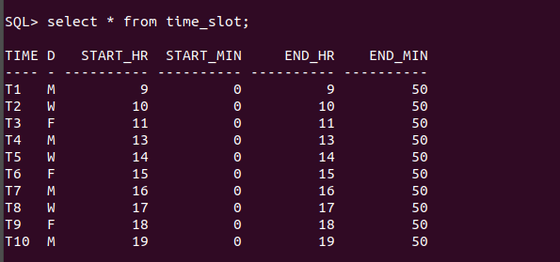
1 row created.
INSERT INTO prereq VALUES ('CS101', 'MA201');

1 row created.

INSERT INTO prereq VALUES ('MA201', 'CS101');

1 row created.

INSERT INTO prereq VALUES ('EE210', 'EN101');

1 row created.

INSERT INTO prereq VALUES ('EN101', 'EE210');

1 row created.

INSERT INTO prereq VALUES ('BU101', 'HI101');

1 row created.

INSERT INTO prereq VALUES ('HI101', 'BU101');

1 row created.

INSERT INTO prereq VALUES ('LI101', 'CS201');

1 row created.

INSERT INTO prereq VALUES ('CS201', 'LI101');

1 row created.

INSERT INTO prereq VALUES ('MA101', 'EE110');

1 row created.

SQL> INSERT INTO prereq VALUES ('EE110', 'MA101');

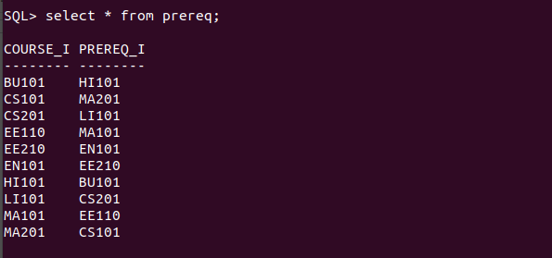
1 row created.

