DEPARTMENT OF MATHEMATICAL AND COMPUTATIONAL SCIENCES
NATIONAL INSTITUTE OF TECHNOLOGY KARNATAKA, SURATHKAL
MA611 – 2nd Semester MCA, 2024-2025
DATABASE SYSTEMS LAB
Assignment-5

1. Create the following tables with the following attributes and constraints on them.
a. Bank (bk_code, bk_name, bk_address)
b. Branch (br_id, br_name, br_address, bk_code)
c. Customer (cust_ID, cust_name, phone_no, address)
d. Account (acc_no, acc_type, balance, br_id)
e. Customer_Account (cust_ID, acc_no)
f. Loan (loan_ID, loan_type, amount, br_id)
g. Customer_Loan (cust_ID, loan_ID)

1. Create all the tables by defining primary key, foreign key and other appropriate constraints.

2. Insert atleast five records in each table.

3. List the details of all customers.

Select * from customer;
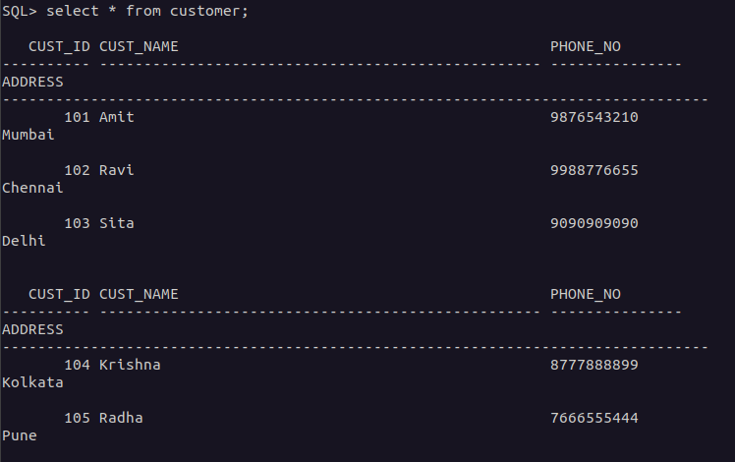
4. Find the cust_ID and phone number of customer ‘Ravi’.

select cust_id , phone_no from customer where cust_name = 'Ravi';
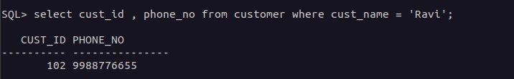
5. Find the Address of all branches of br_01.

select br_address from Branch where br_id = 'BR01';

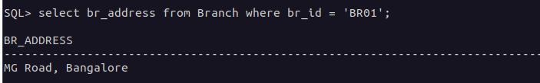

6. Find the details of Customer having ID 103.

select * from Customer where cust_id = '103';

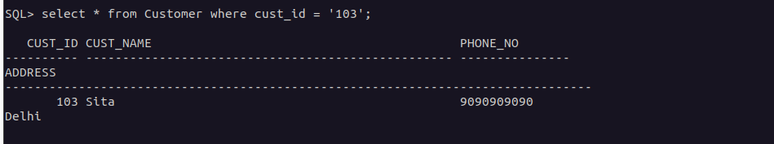

7. List the account details having balance more than 10000.

select * from Account where balance > 10000;


8. List the account details of branch br_02.
select * from Account where br_id = 'BR02';

9. List the loan details of branch br_01.
select * from Loan where br_id = 'BR01';

10. List the account details with their branch address.

select a.* ,b.br_address from Account a join Branch b on a.br_id = b.br_id;

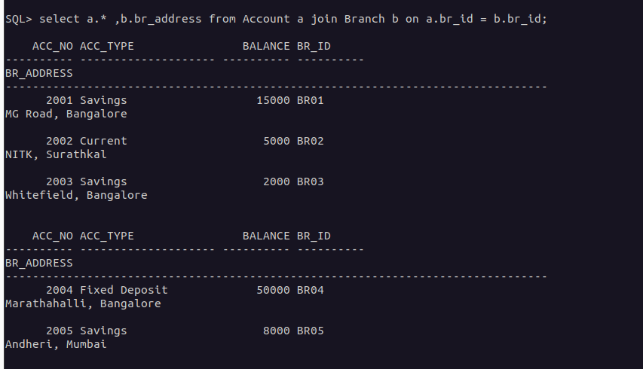

11. List the customer details with their account details.

select a.* , b.* from Customer a join Customer_Account b on a.cust_ID = b.cust_ID;

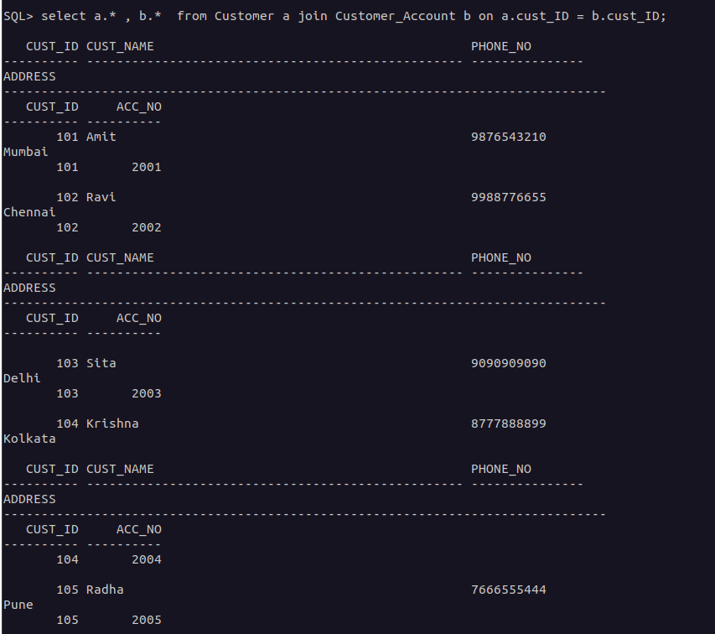

12. List the customer details having account type ‘savings’.

select c.*
from Customer c join Customer_Account cu on c.cust_ID = cu.cust_ID
join Account a on a.acc_no = cu.acc_no
where a.acc_type = 'Savings';

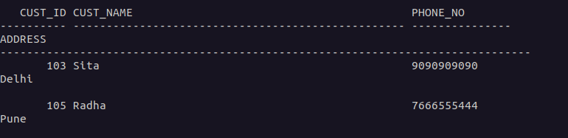

13. List the customer details having vehicle loan.

SQL> select c.* from Customer c join Customer_Loan cl on c.cust_ID = cl.cust_ID join Loan l on cl.loan_ID= l.loan_ID where l.loan_type = 'Vehicle Loan';



14. List the branch names of all accounts.

select a.* , b.br_name from Account a join Branch b on a.br_id = b.br_id;
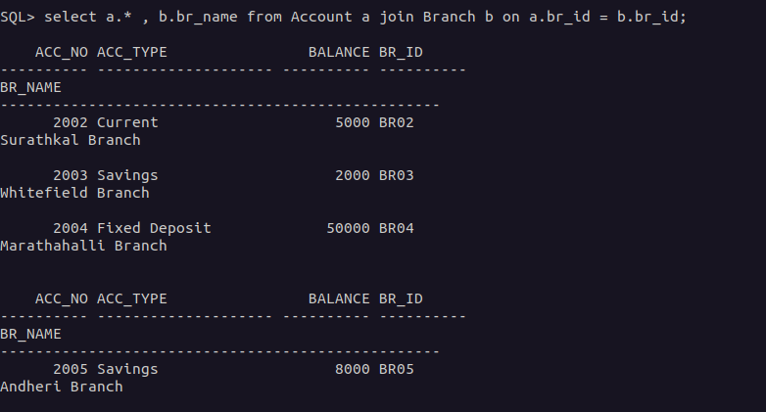

15. List the customer details going to ‘Surathkal’ branch.

select c.* from Customer c join Customer_Account cu on c.cust_ID = cu.cust_ID join Account a on a.acc_no = cu.acc_no join Branch b on b.br_ID = a.br_ID where b.br_name = 'Surathkal Branch';

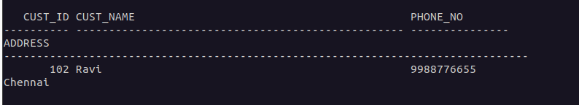

16. List the customers having loan account in ‘MG Road’ branch.
select cl.cust_ID from Customer_Loan cl join Loan l on cl.loan_ID = l.loan_ID join Branch b on l.br_id = b.br_id where b.br_name = 'MG Road Branch';
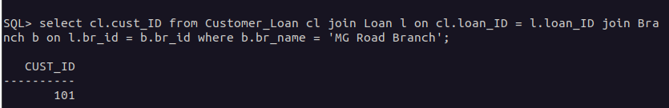

17. Find the customers having balance between 1000 to 10000 .
select ca.cust_ID from Customer_Account ca join Account a on ca.acc_no = a.acc_no where a.balance between 1000 and 10000;

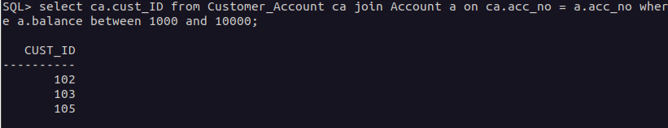
18. Give a bonus of rupees 100 to customers having more than 10000 balance.

19. Deduct 50 rupees from customers having less than 500 rupees in balance.
20. Give the customer details having home loan.
21.22. Add a column NOMINEE to the customer table with data type varchar (50).
23. List all the account numbers in ascending order of their balance.
24. Count the number of customers having account type savings.
25. Count the number of customers for each account type.
26. Find the total balance in Savings account.
27. Find the average balance of Current account.
28. Find the average balance for each account type.
29. Find the customer details having maximum balance.
30. Find the average amount for vehicle loan.
31. Find the average balance in each branch.

