SQL> create table classroom
2 (building varchar(15),
3 room_number varchar(7),
4 capacity numeric(4,0),
5 primary key(building,room_number)
6 )
7 ;

Table created.
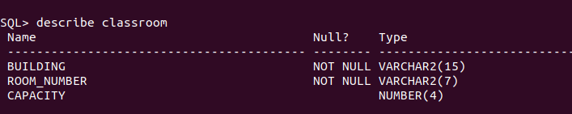

SQL> create table department
2 (dept_name varchar(20),
3 building varchar(15),
4 budget numeric(12,2) check (budget>0),
5 primary key(dept_name)
6 );

Table created.
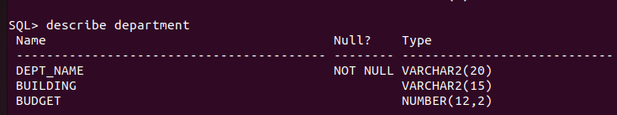

SQL> create table course
2 (course_id varchar(8),
3 title varchar
4 (50),
5 dept_name varchar(20),
6 credits numeric(2,0) check(credits>0),
7 primary key(course_id),
8 foreign key (dept_name)references department on delete set null
9 );

Table created.
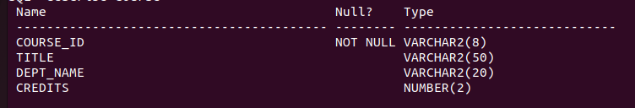

SQL> create table instructor
2 (
3 id varchar(5),
4 name varchar(20) not null,
5 dept_name varchar(20),
6 salary numeric(8,2) check (salary>29000),
7 primary key(ID),
8 foreign key (dept_name) references department on delete set null
9 );

Table created.
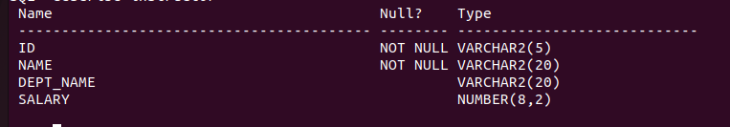

SQL> create table section
2 ( course_id varchar(8),
3 sec_id varchar(8),
4 semester varchar(6) check( semester in ('Fall' , 'Winter', 'Spring', 'Summer')),
5 year numeric(4,0) check(year>1701 and year<2100),
6 building varchar(15),
7 room_number varchar(7),
8 time_slot_id varchar(4),
9 primary key(course_id,sec_id,semester,year),
10 foreign key(course_id)references course on delete cascade,
11 foreign key(building,room_number)references classroom on delete set null
12 );

Table created.
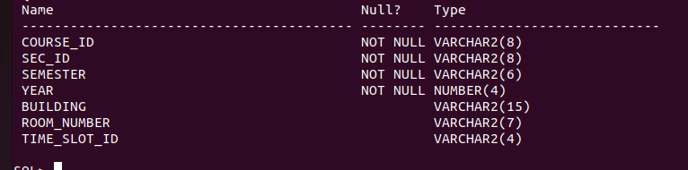

SQL> create table teachers
2 (id varchar(5),
3 course_id varchar(8),
4 sec_id varchar(8),
5 semester varchar(6),
6 year numeric(4,0),
7 primary key(ID , course_id, sec_id ,semester,year),
8 foreign key(course_id,sec_id,semester,year) references section on delete cascade,
9 foreign key(ID) references instructor on delete cascade
10 );

Table created.
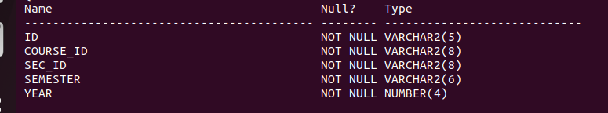

SQL> create table student
2 (ID varchar(5),
3 name varchar(20) not null,
4 dept_name varchar(20),
5 tot_cred numeric(3,0) check(tot_cred>=0),
6 primary key(ID),
7 foreign key(dept_name) references department on delete set null
8 );

Table created.
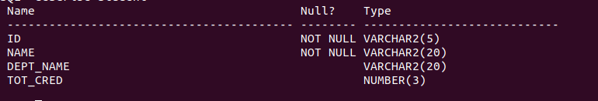

SQL> create table takes
2 (ID varchar(5),
3 course_id varchar(8),
4 sec_id varchar(8),
5 semester varchar(6),
6 year numeric (4,0),
7 grade varchar(2),
8 primary key(ID, course_id,sec_id,semester,year),
9 foreign key(course_id,sec_id,semester,year) references section on delete cascade,
10 foreign key(ID) references student on delete cascade
11 );

Table created.
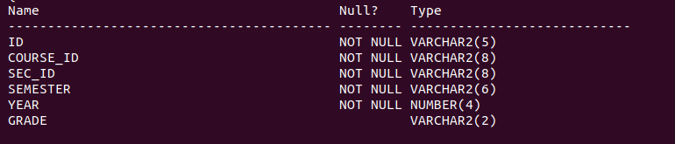

SQL> create table advisor
2 (s_ID varchar(5),
3 i_ID varchar(5),
4 primary key(s_ID),
5 foreign key(i_id) references instructor (ID) on delete set null,
6 foreign key(s_ID) references student(ID) on delete cascade
7 );

Table created.
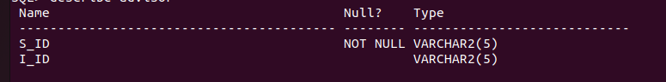

SQL> create table time_slot
2 (time_slot_id varchar(4),
3 day varchar(1),
4 start_hr numeric (2) check (start_hr>=0 and start_hr<24),
5 start_min numeric(2) check(start_min>=0 and start_min<60),
6 end_hr numeric(2) check(end_hr>=0 and end_hr<24),
7 end_min numeric(2) check(end_min>=0 and end_min<60),
8 primary key (time_slot_id,day,start_hr,start_min)
9 );

Table created.
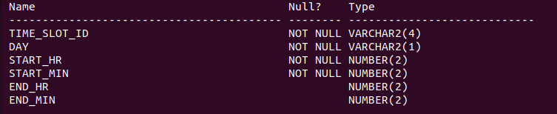

SQL> create table prereq
2 (course_id varchar(8),
3 prereq_id varchar(8),
4 primary key(course_id,prereq_id),
5 foreign key(course_id) references course on delete cascade,
6 foreign key(prereq_id)references course
7 );

Table created.
