**Name of the Project**: - SmartStock

**Problem Statement**: Many firms have struggle to achieve the sufficient stock in their inventory due to sales day and event or promotional sale days. As on those days the sales can go much higher than the non-event days. This problem leads them to “Out-Of-Stock” situation when they have orders to fulfill.

**Abstract**: - SmartStock is a Web-App designed for E-Commerce firms and all the organizations that have to keep their inventory management updated and up-to date every month. Many times, the firms have to keep a long record of their stock inventory and it can be a hassle to manage everything consistently. SmartStock is an easy and convenient way to manage everything at one place. Our Web-App allows the user to keep record of their inventory by letting the upload the sales data of their firm. The site then arranges and stores the data in our database. This way user can keep the record of their sales data of a longer period in one place.   
 Our Web-App will give a forecast about the inventory to the user on how much stock will be required in the inventory in the next month. So, they will provide the past sales data and in return they will get average sales of the current month and a forecast of the required stock in the inventory for the coming month. This is the main objective of our Web-App.

All the new users have to register in our site. On registration their credentials are stored in our database and only those users will be allowed to log in to our site whose credentials will match with the records in our database. This is to prevent any outsiders accessing the site. After successfully registering and logging in the site user will be taken to the main Dashboard page.

The Dashboard page is the main page of this Web-App which will allow the user to record store the sales data in the site. The site stores the data to the database so it saved and can be referred later. This data is also used in the future page for further calculations. In this page user have to input all the following things about the sales data.

* Date of sale
* ASIN (Unique code of the product)
* Product Title
* Brand
* Store Code
* Ordered Revenue (in ₹)
* Ordered Units
* Shipped Revenue (in ₹)
* Shipped Units
* Customer Returns

In this page, along with the manually entering the data, user will also get an option to upload an Excel sheet directly to the site, this way user can record the entries in bulk in one time. Along with the upload option, user will also get an option to Filter and Sort the entries. Filtering of the entries are done from ASIN and sorting of the entries will have multiple options like Date, ASIN, shipped revenue, Shipped units etc.

We then create a graph for the user by taking the dates and shipped units of a particular product from the database in a nice and easy to understand way. User can select any ASIN of the product and the respective graph will be presented to the user. The graph will also prepare an Average Sales of that particular product along with it. With the help of the prepared average user can get an estimation of their sales. The prepared Average is also stored in our database for the future reference. From the Graph page, user can go to the next page which will help them to calculate the forecast of their inventory.

In this page user will be able to calculate and see the forecast. For this they have to select an ASIN of a product from the given dropdown menu which will have a list of all the various ASINs stored in the database. Once they select the ASIN, the site will fetch the Product name and the average sales from the database of the respective AISN.

Then user will have to give few details which are necessary for the calculation of the forecast. Following will be the fields that user will have to fill in order to get the calculation processed.

* Multiplier (Number with which the Average sales is multiplied)
* Inventory (Current of a product that is stored in inventory)
* Non-Event Days (Number of days on which there was no Promotional sale)
* Event – Days (Number of days on which there was a Promotional sale)

On the basis of the above given details the user will get the following results:

* Sales average
* Inventory left for next month
* Total Inventory Required.

**Objective**: Following points can be said as the objective of our Web-App SmartStock.

* Record the Sales Data: Allow the users to record the Sales Data of the Firm. (Manual Entry + Excel upload)
* Review of the Sales Data: Reviewing the sales data saved in database.
* Visualization: User will be presented with a Graph based on the data stored in the database
* Average Calculation: User will be presented with an Average of sales based on the graph.
* Forecasting based on the input: User will be allowed to give input on the following points
  + Multiplier of the average.
  + Current inventory stock
  + Number of Non-Event days
  + Number of Event days
* Based on this information, user will be provided with the forecast of the inventory for the next month.

**Methodology**:

Our SmartStock Web-App was developed with a systematic and a planned approach. From the initial stage to the final stage, a methodical approached was taken. Below are the key points of the stages from start to completion.

* Gathering requirements and analysis
* Designing the structure
* Management of the Database
* Presentation
* Calculation
* Forecast
* Gathering requirements and analysis
  + This was the first and foremost stage of our project SmartStock Web-App. This stage involved the various components of identifying the basic features that were required for our project which included recording of the sales data, data calculation, data presentation and visualization
  + For that we determined and understood the technical requirements for the support of the excel file uploads and data analysis of the bulk data.
* Designing the Structure

* + Initially we developed the foundational structure of our Web-App while maintaining the usability of the page and ensuring the scalability.
  + Then we proceeded to select the technologies that were required for our project.
    - HTML & CSS for the Frontend.
    - JavaScript for the logic functionality
    - PHP for the Backend
* Management of the Database
  + Created and configured a database for the effective management and modification of Sales data, user input and inventory information.
  + Implemented features to store sales records along with the processing and handling of the uploaded Excel files.
  + Developed and curated the functionalities for retrieving the data back from the database to fulfil the analysis, presentation and forecasting purposes.
* Presentation
  + Integrated data visualization tool Chart.js to present the sales data in a graphical format.
  + Ensured that the user can easily interpret the data by providing clear and effective visual representations in the graph.
* Calculation
  + We developed a logic to calculate the average sales based on the data from the graph.
  + We designed formulas and developed an algorithm to process user inputs, including the average multiplier, event days and non-event days in order to calculate the inventory forecast.
* Forecast
  + Based on the user inputs, such as average multiplier, event days and non-event days, our Web-App will calculate the forecast and provides necessary adjustments to user that are useful in taking important decisions for the inventory.

**Conclusion**:

The development and integration of our Web-App SmartStock followed a structured and strategic approach with precision and prioritizing efficiency.

Below given are the essential insights we derived from the execution and outcomes of our project.

* Significance of Project.
  + Reliable Solution: Our Web-App successfully tackles the key challenges faced by E-commerce firms in the inventory management by providing an optimized and efficient solution.
  + Consistency: SmartStock enables businesses to analyze and centralize the sales data ensuring the consistency in inventory management.
  + Better Planning: Making use of past sales data for inventory forecasting so that important decisions can be made to minimize the risk of stockouts and overstocking.
  + Efficiency: SmartStock is filled with features like bulk data uploads, graphical representations and automated calculations to reduce the manual efforts and enhancing time efficiency.
* Objective Fulfilment
  + Secured and Controlled Access: The registration and login system restricts access to unauthorized users ensuring data-security and confidentiality.
  + Accurate Inventory Forecasting: SmartStock fulfils its primary objective by generating stock forecast for the upcoming month.
  + Centralized Data Management: Our Web-App allows businesses to systematically store and manage sales records along with the long-term data tracking ensuring seamless accessibility.
  + Automated Sales Analysis: By processing uploaded sales data, SmartStock calculates average sales figures and generates visual analytics, allowing users to efficiently identify and analyze the trends.
  + User friendly Data-Entry: We have support for both manual entry and bulk data entry via Excel sheets, ensuring seamless management while providing filtering and sorting options for quick and efficient access.
  + Enhanced Decision Making: With the help of predictive insights and inventory calculations, businesses can optimize their stock levels and minimize wastage.
* Outcome Evaluation
  + Accurate Inventory Forecasting and Management.
  + Enhanced Efficiency and Data Accessibility.
  + Improved Decision Making and Business Planning.
* Key Findings
  + Sales Data is a foundation for forecasting
  + Automation enhances efficiency and saves time.
  + Data visualization facilitates better Analysis.
  + Secure Access maintains Data integrity.
* Impact
  + Optimized inventory management: Business can optimize their stock levels, effectively minimizing the risk of overstocking and stockouts.
  + Time and effort saving: Automating data entry, analysis and forecasting reduces manual effort that enhances the efficiency of the inventory tracking.
  + Improved decision making in the business: Data-driven insights and sales forecasting helps businesses to make informed and strategic inventory decisions with greater precision.
* Practical Applications.
  + E-Commerce inventory management: Enables online retailers to track sales, monitor stock levels and accurately forecast future inventory needs.
  + Warehouse Stock Optimization: Helps warehouses in maintaining optimal inventory levels by forecasting demand using historical sales data.
  + Retail Business Planning: Empowers retail stores to analyze the sales trends and make data-driven stocking decisions, preventing shortage and overstocking.
  + Data-Driven Decision Making: Delivers precise sales insights, enhancing operational efficiency and supporting long-term strategic planning.
  + Supply Chain Efficiency: Optimizes supply chain operations by ensuring timely restocking, minimizing delays, and enhancing overall logistics management.
* Future Scope
  + Multi-Warehouse Management: Expanding the system to support inventory tracking across multiple warehouses, catering to the needs of large-scale businesses.
  + Integration with E-Commerce Platforms: Implementing direct integration with platforms like Amazon and Shopify to enable real-time inventory updates.
  + Cloud based Multi-User Collaboration: Facilitating real-time collaboration between teams (e.g., sales, warehouse, and procurement) through secure cloud-based access.
  + Automated Purchase Order System: Introducing an automated purchase order generation feature that triggers when inventory levels fall below a predefined threshold.

Project Definition – Purpose

SmartStock is a Web-App designed to assist E-commerce business in efficiently managing their inventory by tracking sales data and forecasting future stock requirements. Many companies face challenges in maintaining optimal stock levels, particularly during promotional events or peak sales period which often lead to “Out-Of-Stock” scenarios.

SmartStock aims to provide business with an efficient and structured solution for inventory management. It enables users to store sales data securely, analyze trends through graphical representations and generate accurate stock forecasts. Sales data can be entered manually or uploaded in bulk via Excel sheets, ensuring seamless record-keeping.

The application also calculates average sales and predicts inventory requirements for the upcoming month, helping business prevent shortages and make informed data-driven decisions.

By leveraging SmartStock, companies can streamline inventory management, optimize stock levels and enhance order fulfilment. Ultimately improving overall operational efficiency.

**Project Scope:**

**Functionality:**

SmartStock is engineered to streamline inventory management by offering a range of key functionalities.

**User Authentication**

* Secure registration and login system ensuring only authorized user to gain access
* User credentials are securely stored in a database for robust authentication.

**Sales Data Management**

* Users can manually input sales data including Date, ASIN, Product Title, Brand Code, Ordered Revenue, Ordered Units,Shipped Revenue, Shipped Units and Customer Returns.
* The system also supports bulk uploads via Excel sheets for efficient record keeping.
* Data can be filtered and sorted by various parameters such as Date, ASIN, Shipped Revenue and Shipped Units.

**Data Visualization (Graph Page)**  
• Generates graphical representations of shipped units over time for any selected ASIN.  
• Calculates and displays average sales for each product.  
• Stores average sales data in the database for ongoing analysis.

**Inventory Forecasting (Forecast Page)**  
• Allows users to select an ASIN from a dropdown menu populated with current product data.  
• Retrieves and displays the corresponding product name and average sales.  
• Users provide additional details (Multiplier, Current Inventory, Non-Event Days, and Event Days) to calculate the forecast.  
• Presents key forecast results, including:

* Sales Average
* Projected Inventory Left for Next Month
* Total Inventory Required

**Forecast Data Storage & Retrieval**

• Forecast results are stored in the database for future reference.

• A dedicated page dynamically displays previously stored forecast data, eliminating the need for repeated calculations.

**2. Features**

• User-Friendly Interface: A simple, intuitive UI ensures efficient data input and analysis.

• Bulk Data Upload: Convenient Excel file uploads facilitate the rapid entry of large datasets.

• Real-Time Data Filtering & Sorting: Quickly locate specific sales data using dynamic filtering and sorting options.

• Interactive Graphs: Clear visualizations help users analyse sales trends effectively.

• Automated Forecasting: Provides accurate estimates of stock requirements based on historical sales trends.

• Secure Data Storage: Both sales and forecast data are stored securely in a robust database for future use.

**3. Scope of the Project**

**Intended Users:**

• E-commerce businesses, online retailers, and companies managing large inventories.

**Business Benefits:**

• Minimizes stockout risks by accurately predicting inventory needs.

• Enhances stock procurement planning through data-driven insights.

• Saves time with automated sales data analysis and forecasting.

• Supports better decision-making with clear, actionable data.

**Future Scope & Enhancements:**

• Integration with third-party e-commerce platforms for automated data fetching.

• Advanced AI-driven forecasting for improved prediction accuracy.

• Download feature to download the forecasted data in Excel sheet format.

Overall, SmartStock serves as an efficient inventory management solution that optimizes stock levels, prevents shortages, and empowers businesses to make informed, data-driven decisions—ultimately enhancing overall operational efficiency.

**Technology Used**

SmartStock is developed using modern web technologies to ensure efficiency, security, and a user-friendly experience. Below is an overview of the technologies utilized in the project:

**1. Frontend Technologies**

• **HTML (Hypertext Markup Language):** Structures web pages and organizes content for a seamless user experience.  
• **CSS (Cascading Style Sheets):** Enhances the visual appeal and usability of the interface through styling.  
• **JavaScript:** Adds dynamic functionality, including filtering, sorting, and interactive elements.  
• **Chart.js:** A JavaScript library used for generating interactive and visually appealing sales data graphs.

**2. Backend Technologies**

• **PHP (Hypertext Preprocessor):** Manages server-side operations, including user authentication, database interactions, and forecasting calculations.  
• **MySQL:** A relational database management system used to store and manage sales data, user credentials, and forecast records.  
• **XAMPP:** A local development environment that integrates Apache, MySQL, and PHP, enabling seamless testing and execution of the project.

**3. Additional Technologies & Libraries**

• **jQuery:** A JavaScript library that simplifies DOM manipulation and AJAX requests for efficient data retrieval.  
• **Excel File Handling (PHPExcel or PHPSpreadsheet):** Enables bulk sales data uploads via Excel files for efficient record-keeping.

**Technology Stack Summary**

| **Technology** | **Purpose** |
| --- | --- |
| **HTML & CSS** | Structure and design of the web application. |
| **JavaScript & Chart.js** | Interactive elements and graphical data visualization. |
| **PHP** | Server-side scripting for data processing and calculations. |
| **MySQL** | Database management for storing sales and forecasted inventory data. |
| **XAMPP** | Local server environment for testing and development. |
| **Excel File Handling (PHPExcel/PHPSpreadsheet)** | Supports bulk sales data uploads. |

Together, these technologies create a powerful, efficient, and user-friendly web application for inventory management and forecasting.

**Feasibility Study**

Here’s a refined version of your feasibility study with a professional and natural tone:

**Feasibility Study**

A feasibility study assesses the practicality and viability of implementing the SmartStock web application. This evaluation considers key aspects, including technical, operational, economic, legal, and scheduling feasibility, to ensure the project's success and long-term benefits.

**1. Technical Feasibility**

The project is technically viable, leveraging widely adopted and well-documented web development technologies:

* **Frontend:** HTML, CSS, JavaScript, and Chart.js create a user-friendly interface with interactive data visualization.
* **Backend:** PHP and MySQL provide a stable and scalable foundation for database operations and business logic.
* **Data Storage:** MySQL efficiently manages large volumes of sales and forecast data.
* **File Handling:** PHPExcel or PHPSpreadsheet allows seamless bulk data entry via Excel file uploads.
* **Development Tools:** XAMPP serves as a reliable local development environment for testing and debugging.

Since all technologies used are open-source and extensively documented, the project can be developed and maintained efficiently with available resources.

**2. Operational Feasibility**

SmartStock effectively addresses a critical business challenge—inventory shortages during peak sales periods—by enhancing operational efficiency through:

* **Automated data entry**, supporting both manual input and bulk Excel uploads.
* **Comprehensive sales data visualization**, enabling better trend analysis through interactive graphs.
* **Accurate inventory forecasting**, helping businesses plan stock levels proactively.
* **Reliable data retrieval and storage**, ensuring businesses maintain historical records for future reference.

The system is designed to be user-friendly, making it accessible even to non-technical users, thus ensuring seamless adoption and usability.

**3. Economic Feasibility**

SmartStock is a cost-effective solution, offering several financial advantages:

* **Low Development Cost:** The use of open-source technologies (PHP, MySQL, JavaScript, Chart.js) eliminates licensing expenses.
* **Reduced Inventory Losses:** Accurate forecasting prevents overstocking and stockouts, leading to improved financial management.
* **Operational Cost Savings:** Automation reduces manual workload, minimizing errors and labour costs.
* **Potential for Future Expansion:** The system can be scaled and integrated with third-party e-commerce platforms, ensuring long-term value.

Given these benefits, the project’s financial advantages outweigh its initial development costs, making it an economically viable investment.

**4. Legal Feasibility**

SmartStock adheres to industry-standard data protection practices by implementing user authentication and secure database storage.

* The system exclusively handles business sales and inventory data, avoiding sensitive customer information.
* It complies with legal and regulatory standards, ensuring no violations in data handling and security.

Thus, SmartStock is legally feasible and can be implemented without legal concerns.

**Conclusion**

The feasibility study confirms that SmartStock is a practical and viable solution for inventory management and sales forecasting. The project is technically sound, operationally beneficial, economically justified, legally compliant, and achievable within a reasonable timeframe. Its ability to enhance efficiency, reduce costs, and improve stock management makes it a valuable asset for businesses.

2. System requirement & specification.

* 1. **User Characteristics**.
  2. **User access flow.**

**2.3 Current system.**

* 1. **Proposed system & advantage.**
     1. Proposed system.
     2. Advantage of proposed system.
  2. **Hardware & Software requirement.**

2.5.1 Hardware requirement.

2.5.2 Software requirement.

**User Characteristics.**

**1. User Roles and Accessibility**

SmartStock is designed for registered users only, ensuring secure and restricted access to inventory data. New users must complete the registration process before gaining access to the platform.

**2. User Actions in the System**

| **Feature** | **User Actions** |
| --- | --- |
| **User Registration & Login** | Users can create an account and log in using their credentials. Only registered users can access the dashboard. |
| **Dashboard Access** | Users can view, add, filter, and manage sales data for different products. |
| **Sales Data Entry** | Users can manually input sales records, including Date, ASIN, Product Title, Brand, Store Code, Ordered Revenue, Ordered Units, Shipped Revenue, Shipped Units, and Customer Returns. |
| **Bulk Data Upload** | Users can upload Excel files to efficiently enter large amounts of sales data in one step. |
| **Filter & Sort Sales Data** | Users can filter records by ASIN and sort them by date, ASIN, shipped revenue, shipped units, etc. |
| **Graphical Representation of Sales** | Users can select an ASIN to view a graph of shipped units over time, enabling trend analysis. |
| **Average Sales Calculation** | The system calculates and displays the average sales for a selected product. |
| **Inventory Forecasting** | Users can calculate the stock required for the next month by entering details such as Multiplier, Current Inventory, and Event & Non-Event Days. |
| **View Past Forecasts** | Users can retrieve previously calculated forecast data from the database without recalculating it. |
| **Logout** | Users can securely log out of their account when finished. |

**3. User Experience and Ease of Use**

* **Designed for Non-Technical Users:** The system features an intuitive interface, ensuring accessibility for users without technical expertise.
* **Simple Navigation:** Users can seamlessly switch between the Dashboard, Graph Page, and Forecast Page to perform various tasks.
* **Data Security:** Only registered users can access and manage data, preventing unauthorized access.
* **Fast Data Processing:** The system efficiently handles large datasets through bulk uploads and optimized database queries, ensuring smooth performance.

SmartStock prioritizes usability, security, and efficiency, making it a reliable solution for inventory management and forecasting.

**User Access Flow**

SmartStock provides a structured workflow that enables users to efficiently manage sales data and forecast inventory requirements.

**System Functions:**

* **User Authentication** – Secure registration and login to prevent unauthorized access.
* **Data Management** – Store, retrieve, and manage sales and forecast data.
* **Graph Generation** – Visualize sales trends for better decision-making.
* **Forecasting** – Predict inventory needs based on user inputs.

**Client (User) Flow:**

1. **Register/Login** – Users create an account and log in securely.
2. **Dashboard** – Users manually enter sales data or upload bulk data via Excel files.
3. **Sales Graphs** – Users select an ASIN to analyse trends and view average sales.
4. **Inventory Forecasting** – Users input necessary details to calculate future stock requirements.
5. **Retrieve Forecasts** – Users can access previously stored predictions for reference.
6. **Logout** – Users securely end their session.

**Access Flow Diagram:**

**User → Dashboard → Graphs → Forecasting → Retrieve Data → Logout**

This structured access flow ensures a seamless, efficient, and secure user experience for inventory management and forecasting.

**Proposed System**

SmartStock is a web-based application designed to streamline inventory management for e-commerce businesses. It enables users to efficiently store, manage, and analyse sales data while providing accurate inventory forecasting. The system allows users to input sales data manually or in bulk, visualize sales trends through interactive graphs, and generate stock predictions for the upcoming month. By leveraging historical sales data, SmartStock helps businesses prevent stockouts and optimize inventory levels.

**Advantages of the Proposed System**

* **Automated Data Management** – Eliminates manual record-keeping by securely storing and processing sales data in a structured database.
* **Bulk Data Upload** – Supports Excel file uploads for efficient and quick data entry.
* **Sales Trend Analysis** – Provides interactive graphs to help users visualize product performance over time.
* **Accurate Inventory Forecasting** – Utilizes historical sales data to predict future stock requirements.
* **Time-Saving & Efficient** – Reduces the effort needed to manually track and calculate inventory needs.
* **User-Friendly Interface** – Ensures easy navigation and seamless data entry for users of all skill levels.
* **Secure Access** – Restricts access to registered users, safeguarding inventory data.
* **Prevents Stock Shortages** – Helps businesses proactively plan inventory for both event and non-event days, minimizing out-of-stock situations.

**Hardware Requirements**

* **Processor:** Intel Core i3 or higher
* **RAM:** 4 GB or more
* **Storage:** 500 GB Hard Disk or SSD
* **Internet Connection:** Required for accessing the web application

**Software Requirements**

Since SmartStock is a web-based application, no software installation is required. The system operates on a web browser with the following technologies:

* **Front-End:** HTML, CSS, JavaScript (with Chart.js)
* **Back-End:** PHP
* **Database:** MySQL
* **Server:** Apache or any compatible web server
* **Browser Compatibility:** Google Chrome, Mozilla Firefox, Microsoft Edge

The only requirement for users is a stable internet connection and a compatible web browser to access and operate SmartStock efficiently.

**4. System Design**

**4.1 Data dictionary**

**1. Data Dictionary**

The data dictionary provides an overview of the database structure used in SmartStock, including key tables and their purposes.

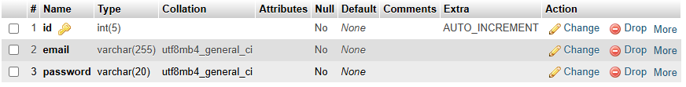**1.1 users Table (Stores user credentials)**

**1.2 dashboard Table (Stores sales data)**

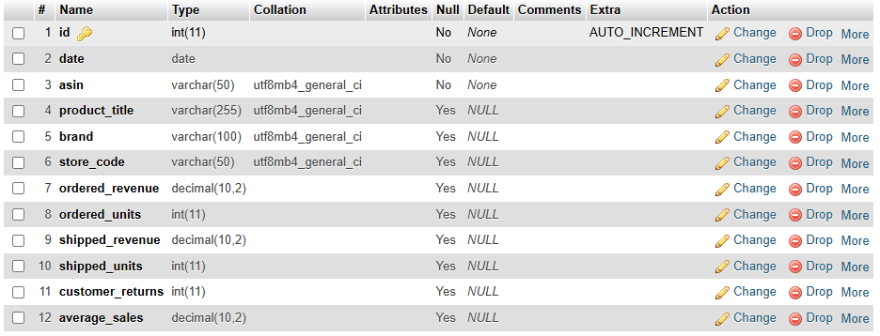**1.3 forecast_data Table (Stores inventory forecast results)**

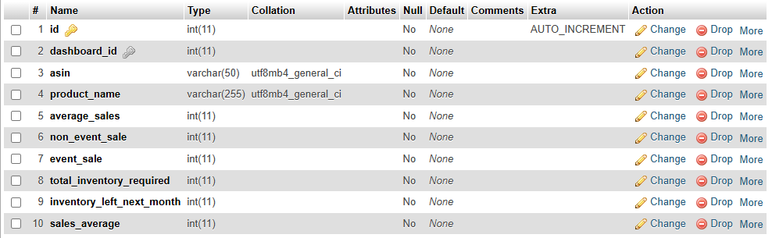

**4.2 Screenshots of Application**

**Registration Page**

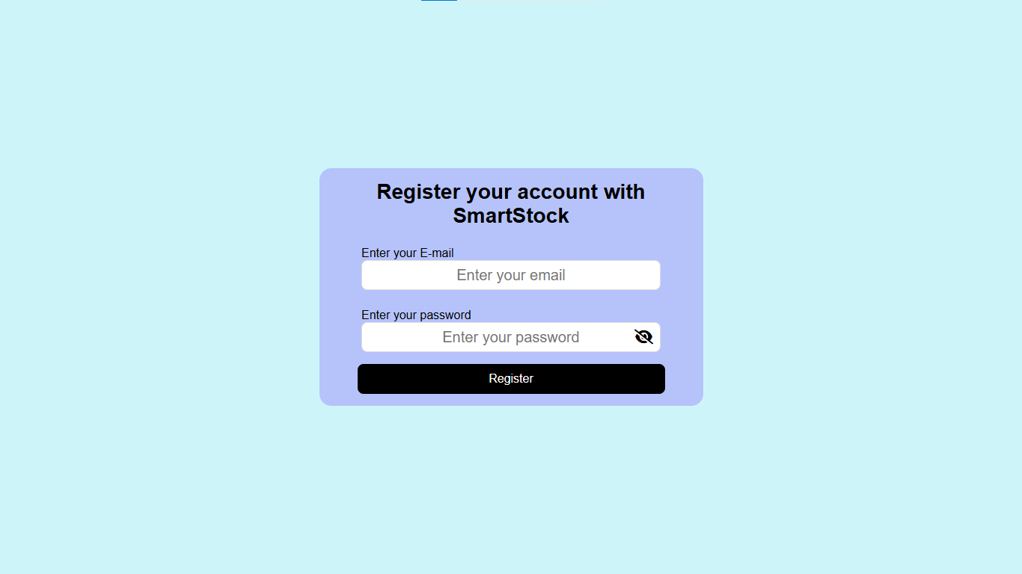**Login Page**

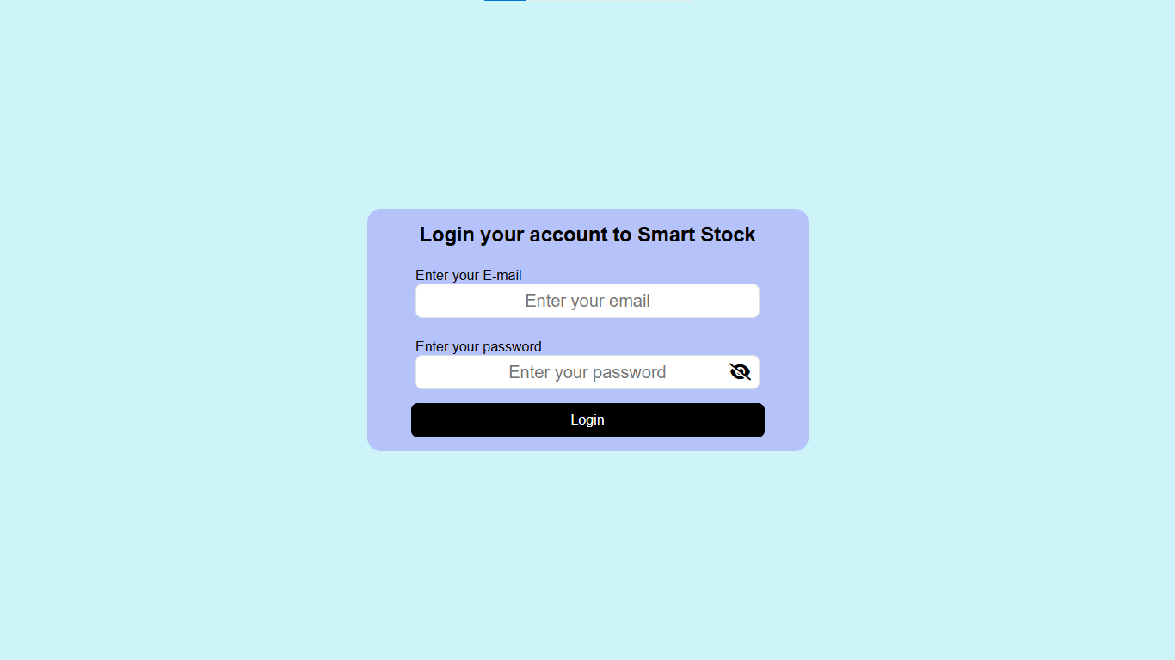**Dashboard Page**

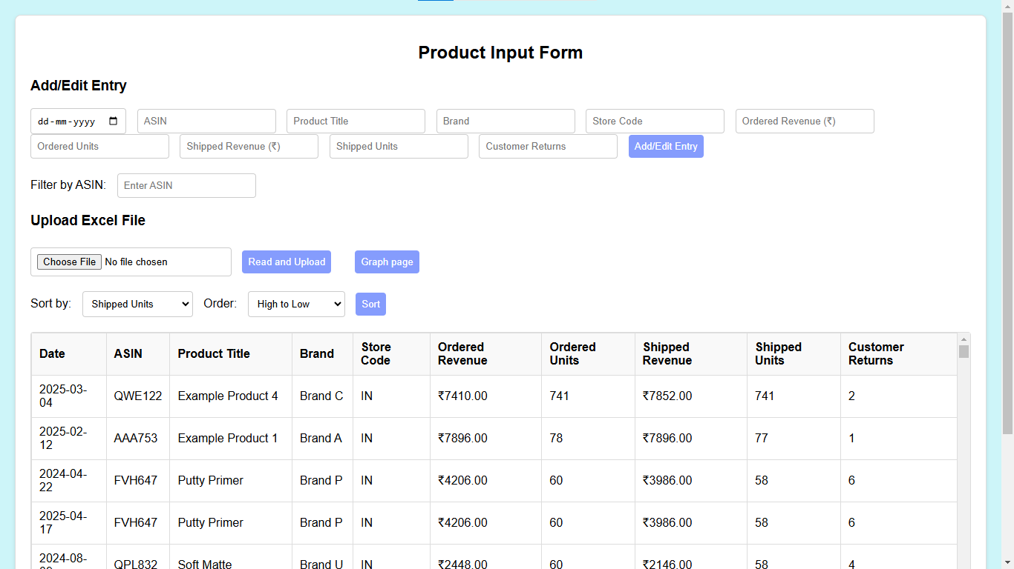**Graph Page**

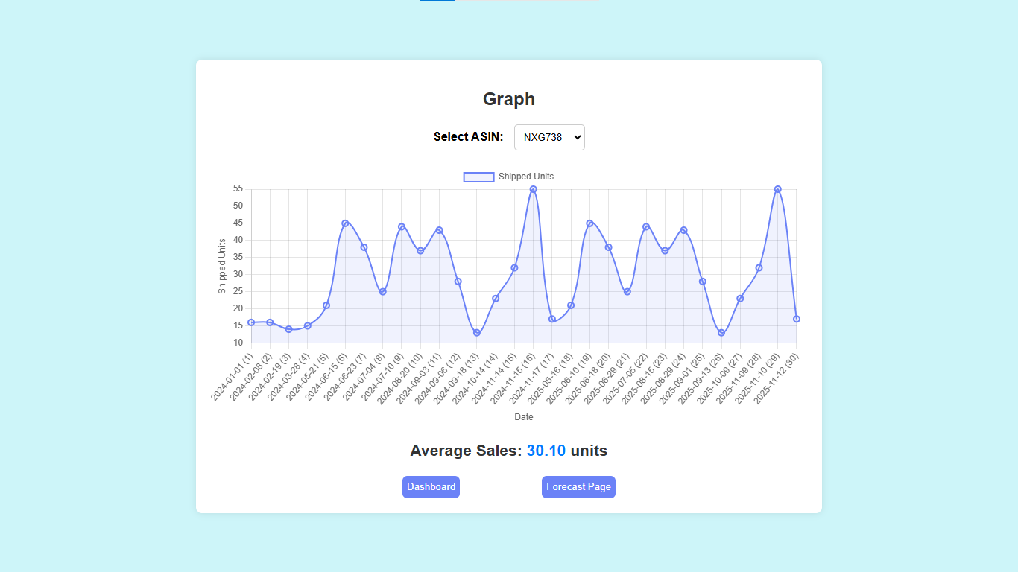**Forecast Calculation Page**

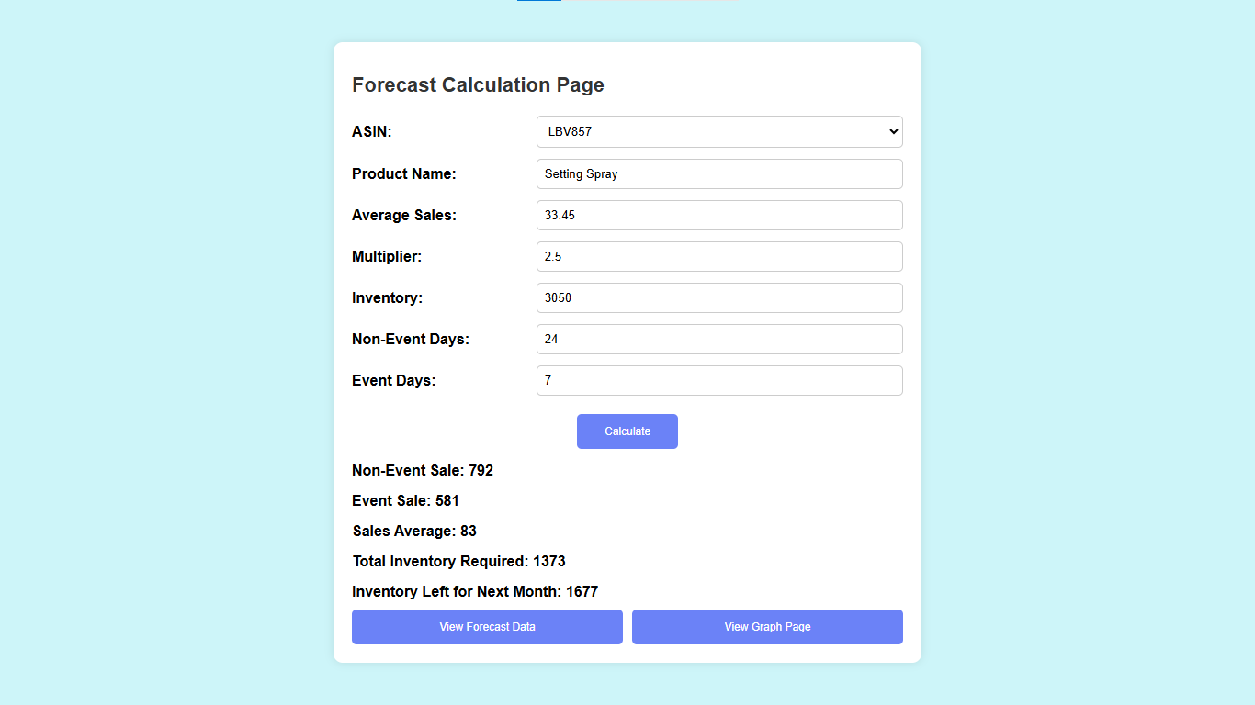**Forecast Results Page**

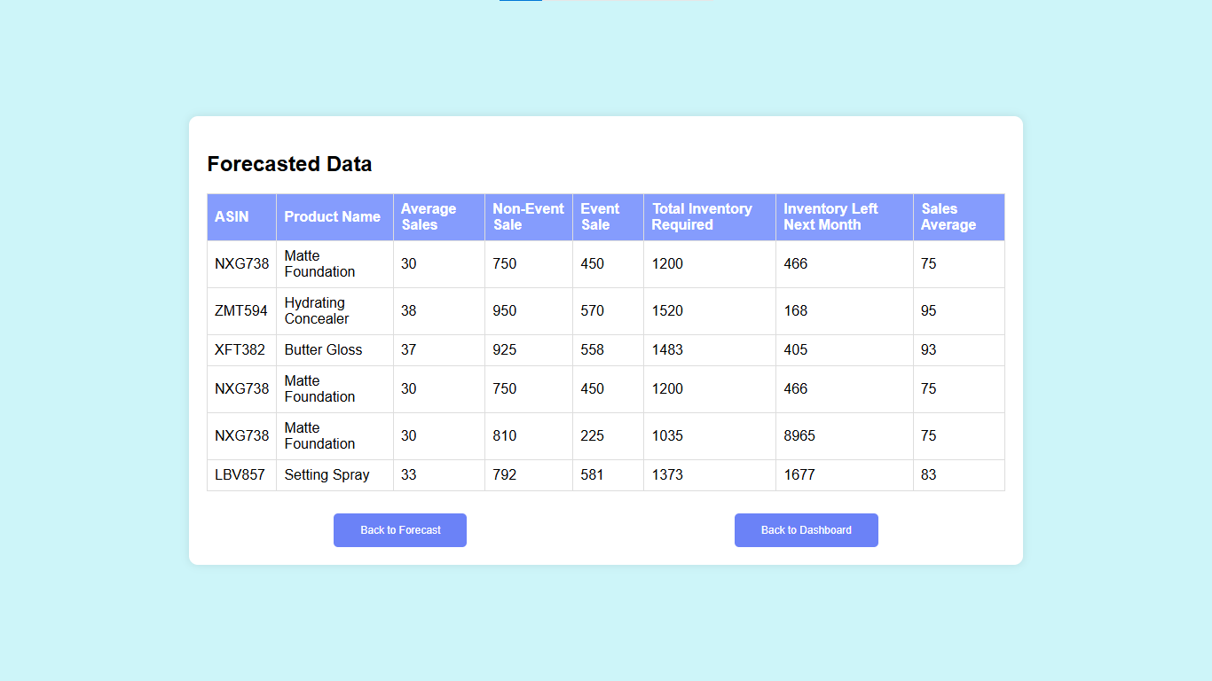

**Limitations**

While **SmartStock** provides significant advantages in inventory management, it has certain limitations that can be improved in future updates to enhance its functionality and adaptability.

* **Lack of Real-Time Inventory Updates:** The system does not currently support real-time synchronization with live inventory databases or e-commerce platforms, requiring manual data updates.
* **Dependence on Historical Sales Data:** Forecast accuracy relies on past sales trends, making it less effective for newly launched products with no prior sales history.
* **No Multi-Warehouse Support:** The system is designed for single-location inventory tracking, limiting its utility for businesses managing stock across multiple warehouses.
* **Manual Data Entry Required:** While bulk uploads via Excel are supported, users must manually enter sales data if an Excel file is unavailable.
* **Limited External Integrations:** SmartStock does not yet support direct integration with third-party ERP or inventory management software.
* **No AI-Based Predictions:** The forecasting model is based on a fixed multiplier rather than advanced machine learning algorithms, which could improve accuracy in future iterations.

Addressing these limitations in future updates will significantly enhance **SmartStock’s** capabilities, making it more efficient, scalable, and adaptable to diverse business needs.

**Conclusion**

The development of **SmartStock** has been guided by a structured and strategic approach to create an **intelligent, automated, and user-friendly** inventory management solution. This system effectively addresses the challenges faced by e-commerce businesses by enabling efficient stock tracking, real-time data visualization, and predictive forecasting. By reducing the risks of stock shortages and overstocking, **SmartStock** ensures seamless inventory control and enhanced operational efficiency.

**Key Benefits:**

* **Optimized Inventory Management:** Predicts stock requirements based on past sales trends, minimizing disruptions in the supply chain.
* **Automated Efficiency:** Features such as bulk data uploads, advanced filtering, sorting, and graphical insights improve productivity while reducing manual effort.
* **Data Security & Centralized Management:** Secure authentication ensures authorized access, while centralized data storage facilitates accurate tracking and analysis.
* **Enhanced Business Planning:** Automated sales analysis and predictive forecasting enable businesses to make informed inventory decisions, ensuring optimized stock levels.

**Key Findings:**

* Reliable sales data is essential for accurate forecasting.
* Automation significantly improves efficiency and minimizes human error.
* Data visualization enhances trend analysis and decision-making.
* Secure access mechanisms ensure data integrity and prevent unauthorized access.

**Impact & Applications:**

**SmartStock** is a valuable tool for **inventory planning, warehouse management, and retail operations**. By leveraging **data-driven decision-making**, businesses can efficiently track inventory, prevent shortages, and reduce excess storage costs. The system is particularly beneficial for **e-commerce platforms, retail stores, and warehouses**, helping them optimize stock levels and improve supply chain management.

**Future Scope:**

To further enhance functionality and scalability, **SmartStock** can be expanded with:

* **Multi-Warehouse Tracking** for monitoring inventory across multiple locations.
* **Integration with E-Commerce Platforms** like Amazon and Shopify for real-time inventory synchronization.
* **Cloud-Based Multi-User Collaboration** to facilitate seamless coordination between sales, procurement, and warehouse teams.
* **Automated Purchase Order System** that generates restocking alerts when inventory levels drop below a predefined threshold.

**Final Thoughts:**

**SmartStock empowers businesses** with **advanced analytics, automated forecasting, and secure inventory management**, ensuring greater accuracy, efficiency, and operational control. By leveraging historical sales data and automation, businesses can make **strategic, data-driven decisions** that enhance productivity, reduce costs, and drive long-term growth.

Context Diagram

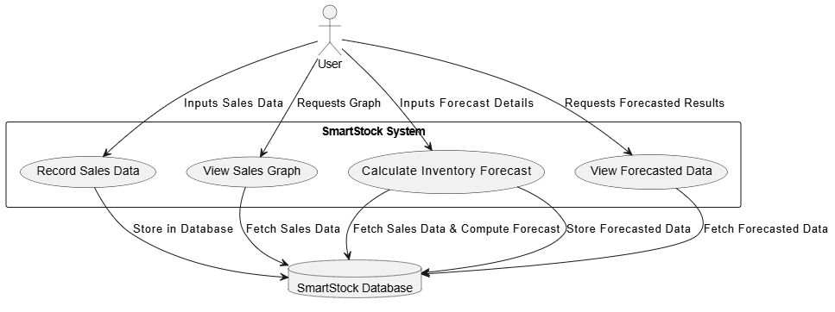

Data Flow Diagrams:

Data flow diagrams can be used to provide a clear representation of any business function. The technique starts with an overall picture of the business and continues by analyzing each of the functional areas of interest. This analysis can be carried out to precisely the level of detail required. The technique exploits a method called top-down expansion to conduct the analysis in a targeted way.

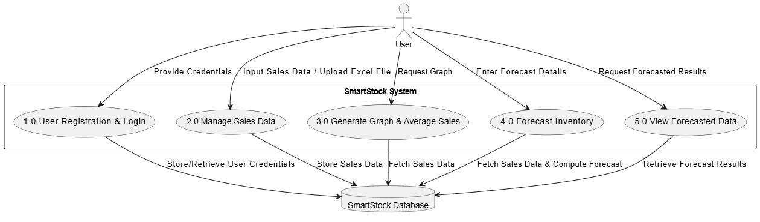DFD Level 1

DFD Level 2

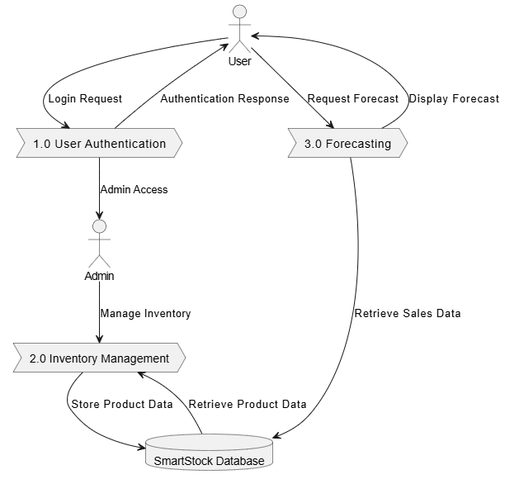

ER Diagram:

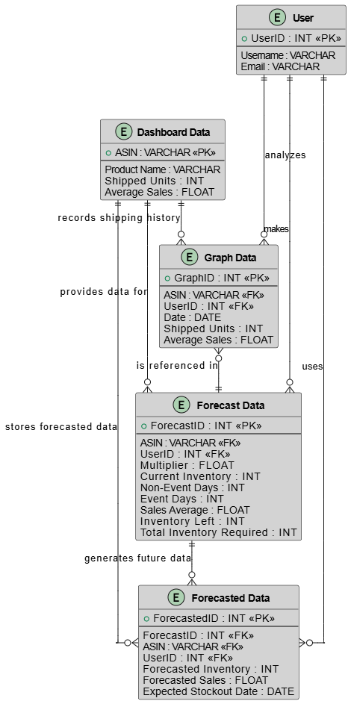

Use Case:

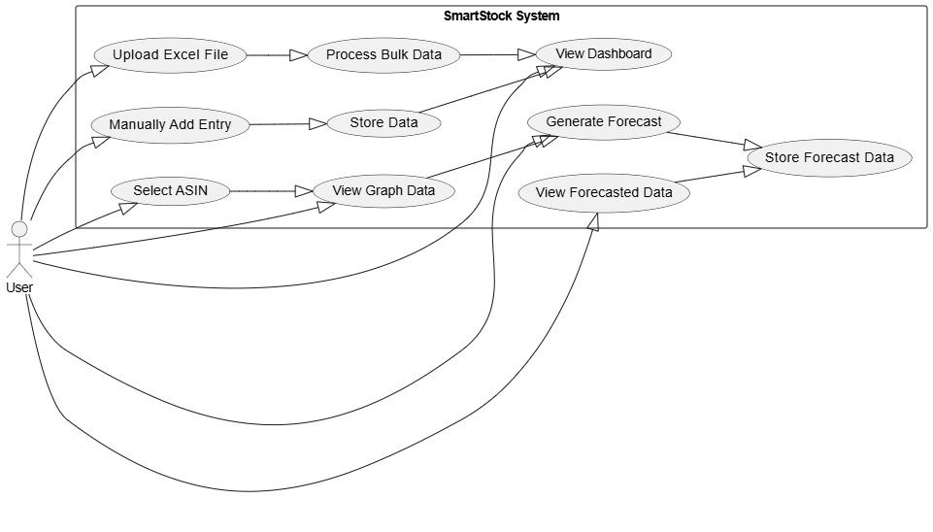Flow chart:

