Yuchen Jiang 18043763

Moci Xu 18043870

Hao zhou 19046061

Android 2D Game and LibGDX Framework

# Abstract

Games have gradually become an indispensable entertainment item in people’s daily life. I chose the design and development of a small game as my graduation project. The reason is that I have a strong interest in games and hope to achieve Realize a game of your own. I choose to use JAVA language to write this game. I think JAVA is better than C and C++ in image processing, and it supports more platforms. As a complete project, the game involves detailed processing of all aspects, including deployment framework, Swing animation, animation library, advanced graphics technology, persistence mechanism, game architecture, and some communication and synchronization technologies.

Table of Contents

abstract 1

Introduction 2

Project overview 3

Project Plan 3

Team members responsibilities 4

Production requirement 5

Market-related game analysis 7

Requirements analysis 14

Definition 14

User Requirements 14

Game features 15

Game design 15

Game implementation 15

Game style 15

Game module 15

Game requirements analysis 16

---------------------------- 16

----------------------------- 17

Design 19

Character Layout 19

Monster Layout 20

Map Layout 20

Start and End Cover Layout 20

Bibliography 22

# Introduction

This project is a platform-type game for the Android system. This game uses the player to control the character. Different maps have different styles of experience and difficulty. On the way to pass the level, the game character needs to collect gems to get more Strong ability, choose the right route and defeat the ultimate boss to complete the level and win. This game is similar to "I Wanna Be The Guy". Examples are as follows.

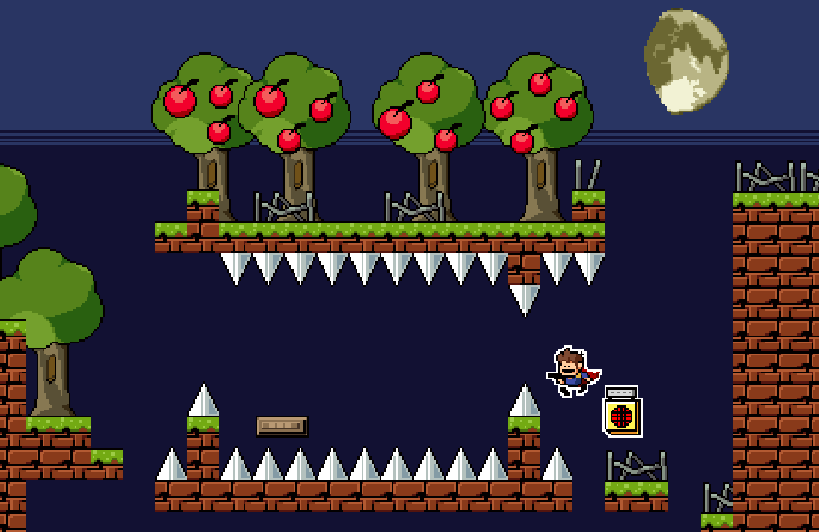

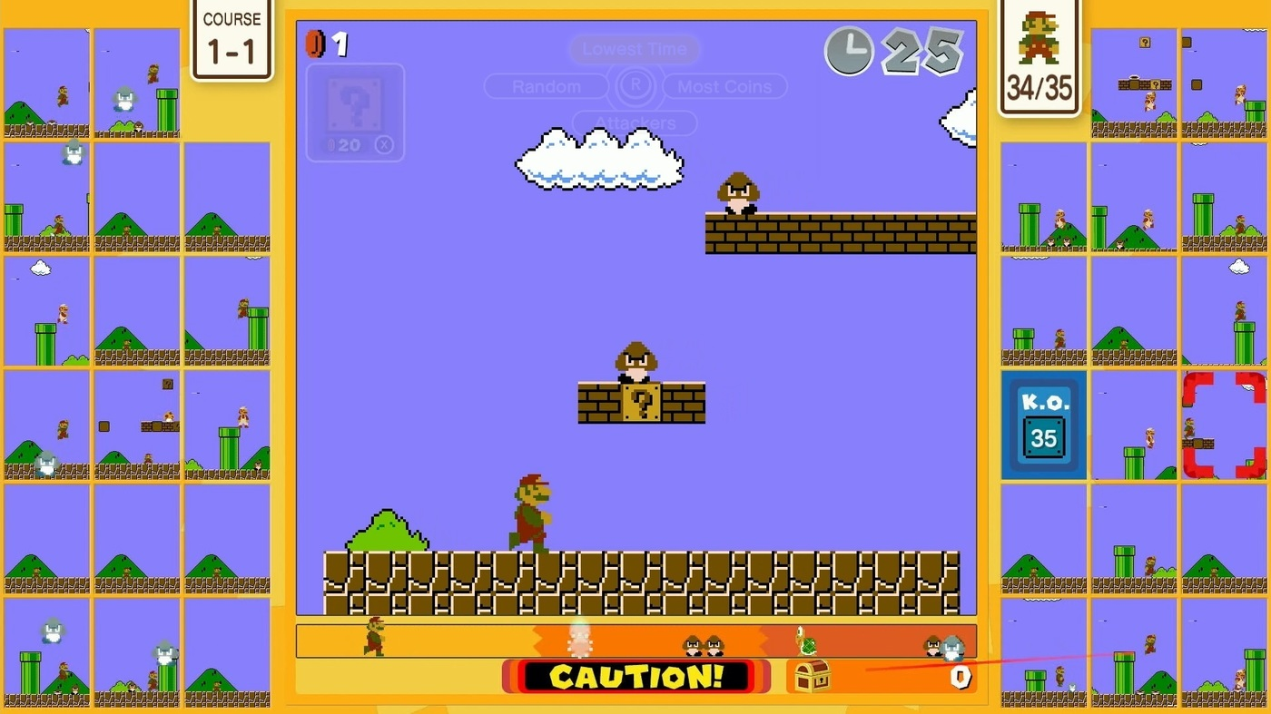

# Project Overview

## Project Plan

We analysed and discussed the needs of this project. We formulated this schedule together based on these needs, our own capabilities and division of labour.

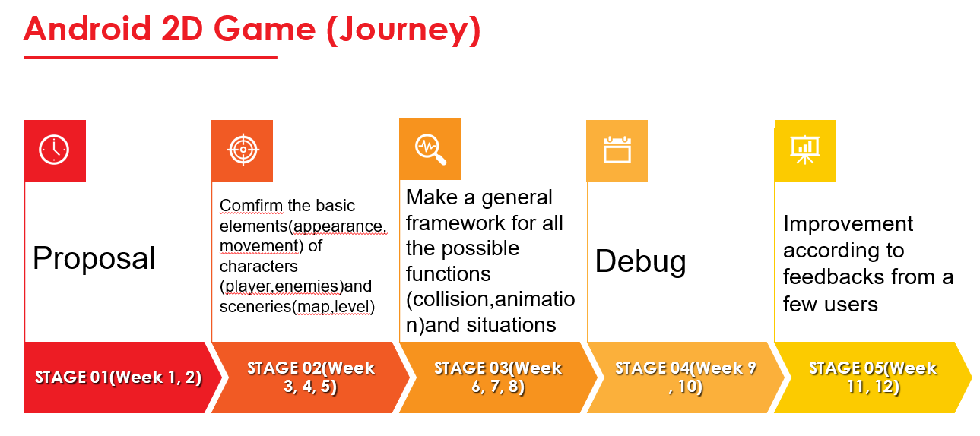

## Team members responsibilities

Yuchen Jiang (18043763) is responsible for arranging the overall tasks. He will allocate everyone's tasks reasonably. In his personal part, he is mainly responsible for using the framework to write programs and find suitable materials.

Moci Xu (18043870) is responsible for participating in the discussion and making this project. In her part, she needs to make maps and write programs to improve the difficulty of the game.

Hao Zhou (19046061) is responsible for participating in the production and discussion of this project. In her part, she needs to make the cover and ending interface of the game, and she needs to write code to perfect the details of the game.

.

## Production requirements

Framework requirements:

For this program, we mainly use two frameworks, Libgdx and Box2D

Software Requirements:

Write code on Android studio

Use Tiled to make game maps

Communication mode requirements:

Discord

WeChat

Mailbox

We will share the parts we made on GitHub.

# Market-related game analysis

When we haven't decided what Android platform mobile games to make, our team first searched on the Internet, inspected and analyzed the popularity of various mobile games, user usage time and frequency, etc.

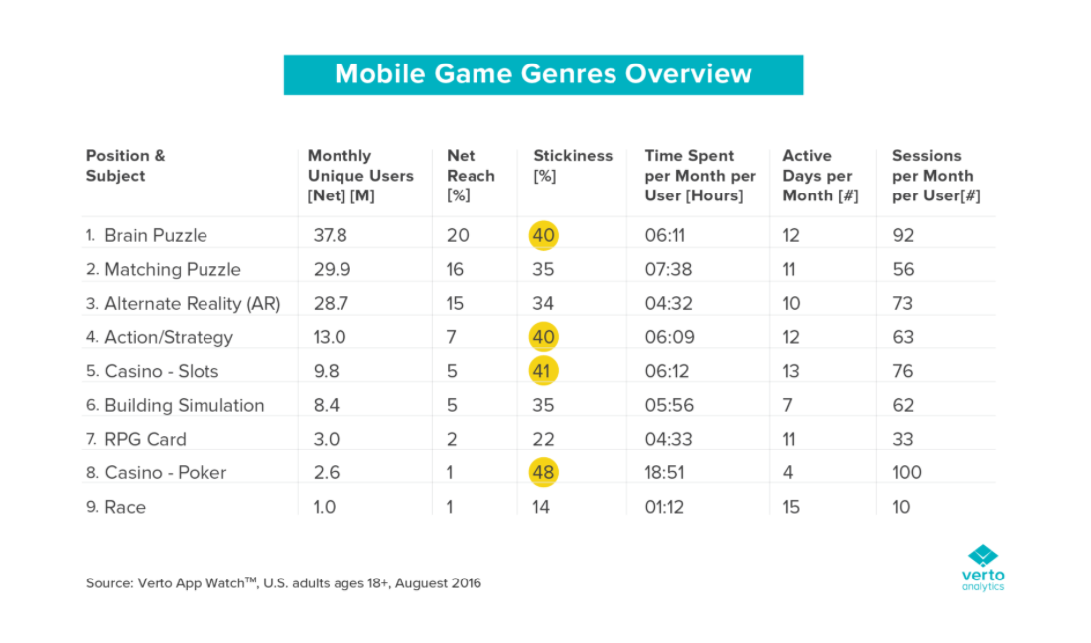

We found that action mobile games are very popular. More users are willing to spend more time on this kind of games. After a group discussion, we decided to make a mobile game similar to Super Mario. Users can easily control the characters moving, similar to jumping up, walking and backing. Users can improve the performance of the character by collecting gems, which will increase the user's interest in the map. However, some traps in the map will also increase the difficulty of the game. Most users are more like some challenging games.

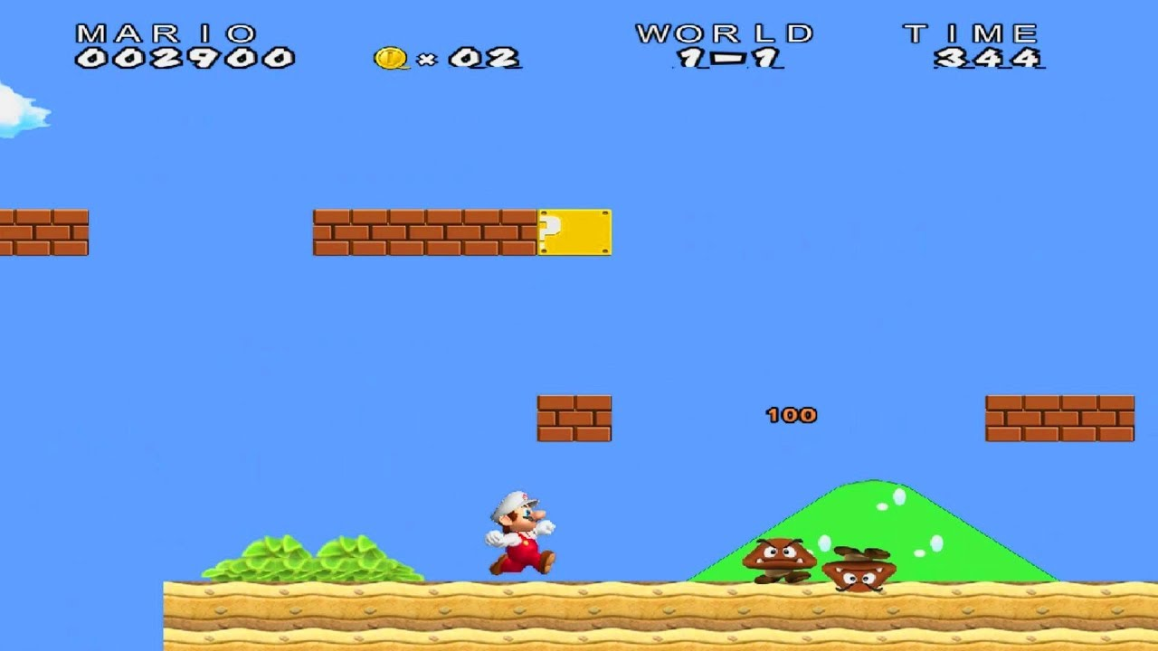

# Requirement analysis

# Definition

# User Requirement

# Game Features

# Design

# Character layout

We chose a cartoon character with red hair and blue clothes as the character. The irregular red hair can make users feel more adventurous. The combination of blue clothes and shoes makes the whole character very harmonious. And the character will be held in the initial state. A purple short knife. This will make the user feel that the game is very exciting and challenging. To a certain extent, the appearance of the cartoon character makes it impossible for the player to directly distinguish the gender of the character. This makes the player feel more substituting when playing the game.

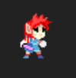

This character is on the left when he enters the field. This is in line with the habits of most players. Most of the character's actions are facing the right, and at the same time, the face and body on the right are shown to the player. The player can pass the left The virtual buttons control the player to move forward, backward, jump up and down, and attack monsters through the buttons on the right.

[pic]*4 or more

Players can control the character to go to every place on the map where they can go. In some places, blue gems will appear. When the characters collect these gems, they get a stronger weapon bonus than before to attack monsters. This is to a certain extent Improved the difficulty of the game. When the character holds the initial purple short knife, he may not be able to easily defeat the mobs and the final big boss. But if the character collects a lot of gems, his short knife will gain a lot of attack bonuses the colorful special effects will make the player feel that their power has become stronger. At this time, it will be much easier to defeat the mobs and the final big boss.

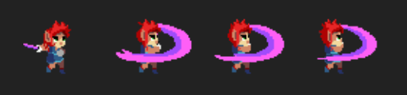

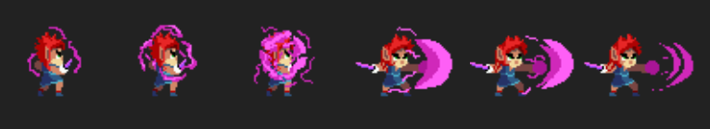

When the character is attacked by a monster, it will drop blood. When the blood volume is 0, when the blood bar is gone, it means the game is over. At this time, the player needs to watch the advertisement or recharge the half-blood to resurrect in place. So as to continue the game. Otherwise, the player can only start the adventure on the current map.

# Monster layout

Monsters will exist in different places on the map. The monsters that appear at the end of the map are the ultimate monsters, and the others are small monsters that are relatively easy to defeat. Since the characters are facing the right, the booth for the monsters must face the left. Or when a character attacks a monster, the monster will face the character. These orientations will make the player more immersive and desire to fight.

Each monster has its own characteristics, and different monsters allow players to maintain a sense of freshness when playing games. For the selection of the appearance of monsters, we are more inclined to the aesthetics of most users. From the perspective of users, monsters Creatures or non-creatures with a more special appearance are needed. We have selected five different types of monsters as the target of attack in the map. First, we will introduce four different types of mobs.

Flying monsters: bats.

Bats often live in dark and terrifying environments, so they often give people a terrible feeling. The cartoon image will weaken this feeling. Allow players to have the desire to fight without fearing them. These the bat will protrude purple ball-shaped objects to the character. Once the player touches these ball-shaped objects, they will lose a certain amount of blood. The player needs to move to avoid their attacks or kill them.



Land monster: green monster.

Green is the image of greed and evil revealing infinite humor, vivid and strange. It will make people feel the power and anxiety of the evil forces. Because compared with the warm purple tone, green is the color that produces warmth in the cold. These two alternating colors of cold and warm will give people a vicious, weird, and evil feeling. Purple is usually used for mysterious, powerful witchcraft, evil and noble powerful forces. The green is usually weird, humorous, and greedy monsters, usually monsters and dragons. Because green is a vivid color and green is the representative of life, so many evil and wild monsters are green. The green monsters combined with the sleek cartoon image will alleviate some horror. These will make users feel that these are real monsters!

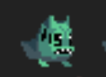

They will attack the character by running towards the character and opening their mouths.

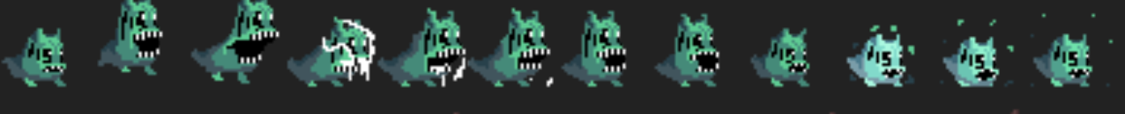

Crawling monster: stick insect.

The body color of most stick insects is dark brown. As the largest known rod-shaped insect, it can reach 8 inches (20 cm) in length and is usually covered with large spines. This is a dual role of camouflage and defensiveness. In most cases, this insect tries to merge with the surrounding environment. Interestingly, it also releases a chemical substance to scare away carnivores. The standing stick insects will look even more terrifying. When the characters are very close to them, they will wave their arms to attack the characters.

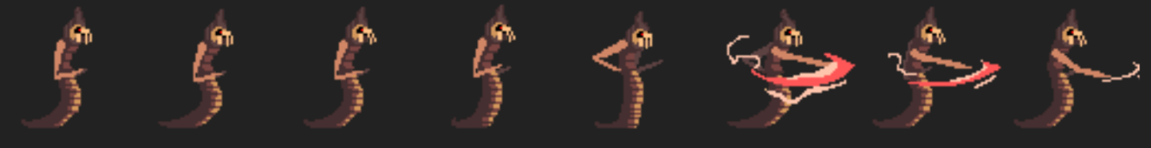

Plant monster: piranha.

Many flower lovers like potted flowers at home, because the flowers are not only pure and beautiful, but also can be used to decorate the room. Sometimes they exude a charming fragrance, but there is a very scary flower in the world, which will exude the very uncomfortable smell makes people afraid to approach it. This horrible flower is the piranha that we all know. Piranha can also be called Rafflesia. It is called the scariest flower in the world. It has no leaves and no stem length. It is very ugly overall. It has no time to bloom. Many people think that Piranha can eat. Human, very scary. The cartoon version of the piranha image is even weirder. Although they can't move, they will attack the character by shaking the stem. Like most users' memory of the piranha, they will attack with a big flower-like mouth. A character bitten by a piranha will lose blood.

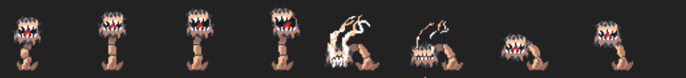

Ultimate Boss: Olecranon.

The eagle itself is a fierce bird. The eagle is carnivorous, with a sharp beak that is easy to tear and eat meat. Its feet have hooks and have a fierce temperament. The food includes small mammals, reptiles, other birds and fish. , Activities during the day. As the ultimate monster among cartoon monsters, they become standing monsters in cloaks. The dark black cloak adds a sense of insidiousness. They are armed with spears, which are also weapons for attacking characters. Monsters with weapons seem to be It looks more ferocious.

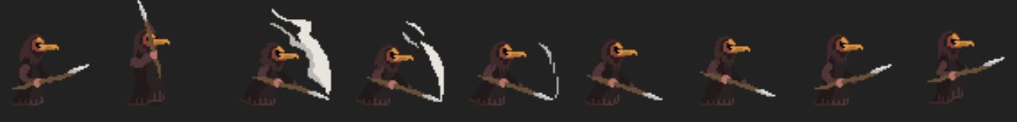

# Map layout

We used tiled software to make maps of two levels in the game. For 2D games, the layering and three-dimensionality in the scene rely on art effects, not 3D technology. After the overall drawing is completed, various elements such as collisions and triggers can be added.

The game map we discussed and made has a relatively simple screen and different layers. During the game, players have not only the fun of playing, but also the enjoyment of beautiful paintings. At the same time, the canvases of the two maps are unified the specifications, different painting and production styles.

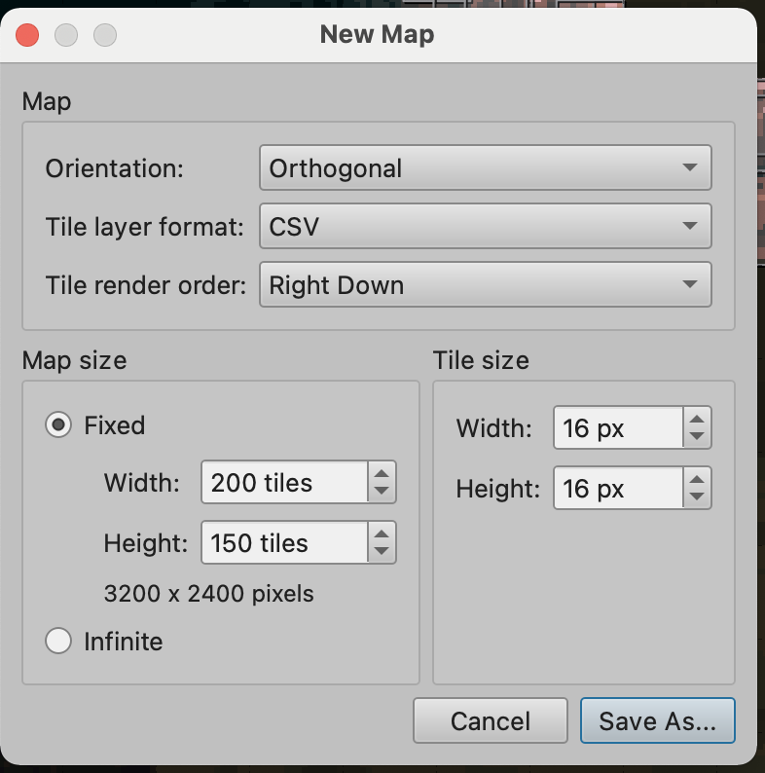

Map1:

The first map is mainly based on the background of green sky, dark green forest and brown mountains. These backgrounds are biased towards an abstract look. In this way, with the appearance of characters, monsters and other images, the picture will appear very harmonious. The ground of this map It is a dark land, which will increase the dark effect of this map. When players play the levels of this map, they will increase their excitement.

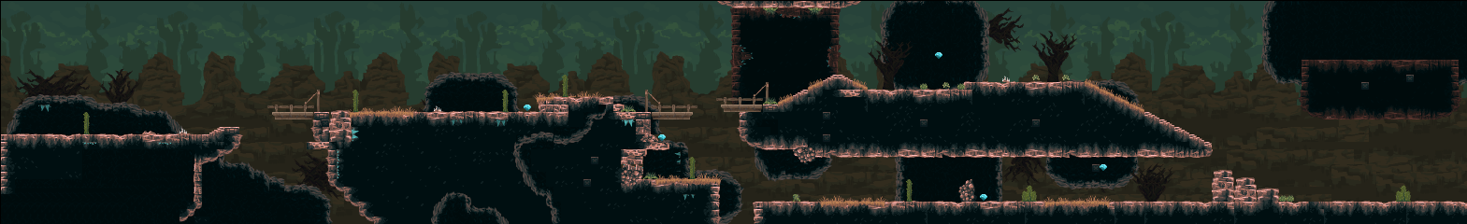

A lot of details have been added to the map. For example, the edge of the suspension bridge, the large green cactus, the withered grass on the ground and some ice crystals. These details will make the whole map more vivid and beautiful.

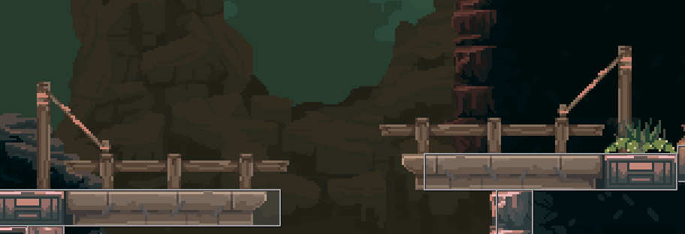

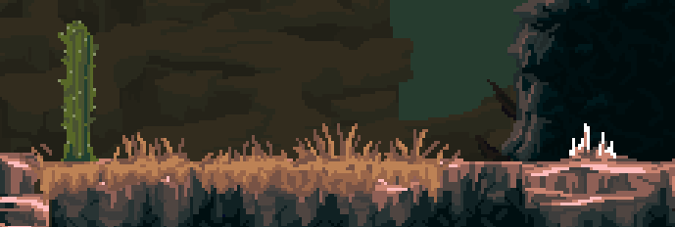

Map2:

The second map is mainly with pink sky, lavender undulating mountains and deep purple forests and ice crystals as the background. These backgrounds are biased towards an abstract look. In this way, with the appearance of characters, monsters and other images, the picture will look very Harmony. The ground of this map is a rocky ground with a mixture of dark black and ice crystals, which will increase the icy effect of this map. When the player plays the levels of this map, the color and color of the graphics will be more vivid, and the visual impact will be more obvious. Will add their freshness.

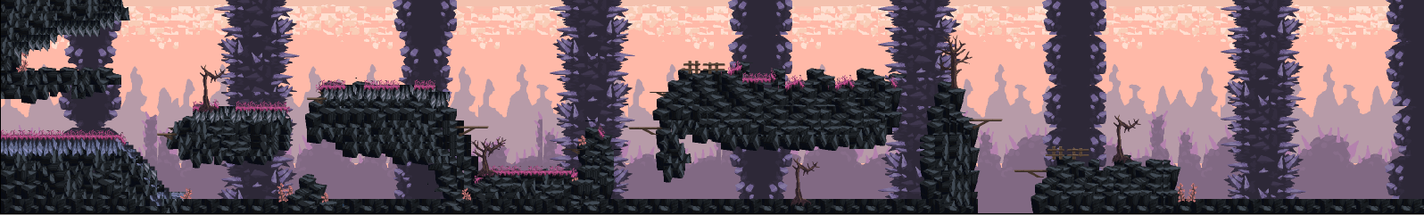

A lot of detailed pictures have been added to the map. For example, wooden boards for expenditure, brown dead trees, small pink flowers, some ice crystals and wooden signs at intersections. These details will make the whole map more vivid and beautiful.

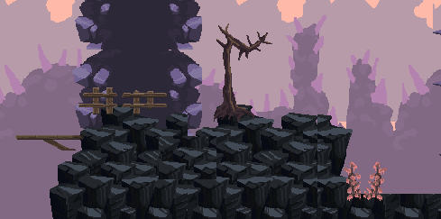

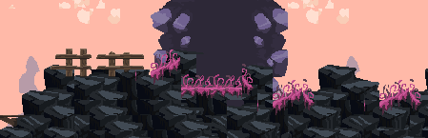

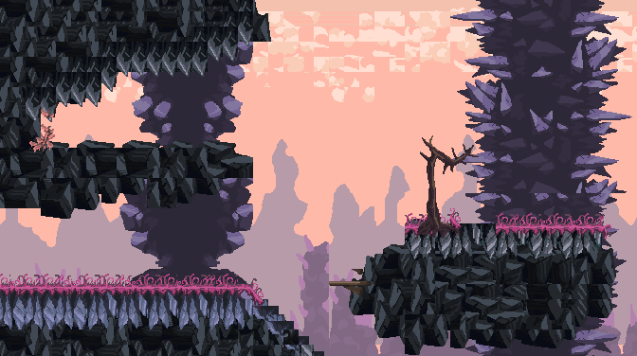

The character can move on the "squares" we set. These "squares" will be placed on the ground, or a place similar to the ground where you can stand. And the place where a "square" is framed is Characters cannot be reached. If players want to gain more powerful abilities, they must take various risks to get diamonds. These requirements sometimes make it difficult for players to complete, but they can definitely be completed.

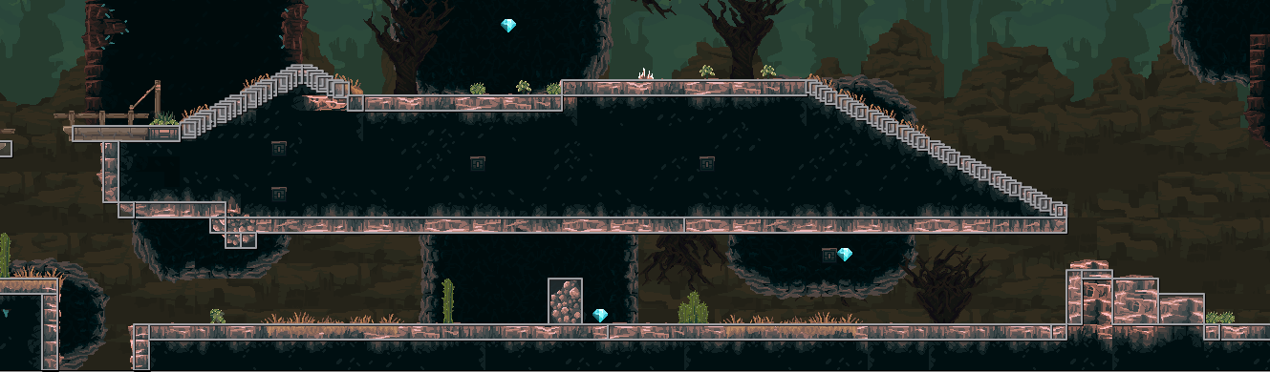

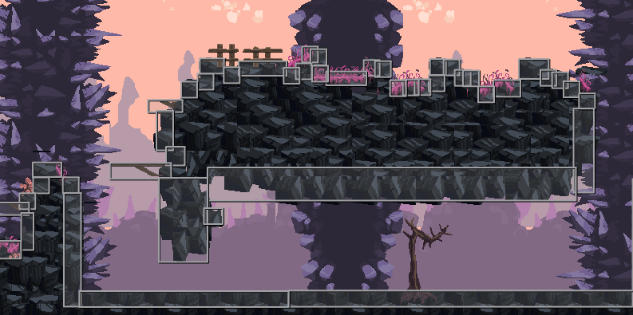

# Bibliography