Name_of_research

Abstract

Introduction
时差对人performance影响
实验室的局限性
体育的切入点（客观、定量、大样本真实世界数据），举重跟其他运动的优势与特点（公平、客观、裁判干预少、温度气候恒定、世锦赛提前1-2天到时差还有，奥运会提前一个月，所以只选世锦赛，公开数据横跨多少年……
上价值：以小见大，通过这个研究可以定量化时差对performance影响

（前两段或前两句，不要直接切入比赛，便于投综合性/和时差/旅行相关的期刊）
1.不要上来就谈比赛，背景可以宏大一点，先谈时差：大家都知道跨时区会对人有影响，那这个影响怎么进行表征，疲劳导致表现不好怎么去定量？而非直接讲体育
2.实验室里面可能有过做模拟时差的实验，但是还是和现实有差距（旅行疲劳之类的，和真实世界不一致）
3.才进入体育环节：为什么选这个项目、这个比赛（数据公开容易找，样本量够大…；举重比较好量化、客观、室内不受天气影响、绝对力量直观展现运动表现之类的）
4.上点价值之类的

The globalization of elite sports requires athletes to frequently undertake long-haul transmeridian travel to compete in premier international events, such as the International Weightlifting Federation (IWF) World Championships. Crossing multiple time zones rapidly exposes athletes to two distinct but frequently conflated physiological challenges: travel fatigue and jet lag [Waterhouse et al., 2004]. Travel fatigue is a transient state of exhaustion resulting from the physical constraints of the journey itself, such as prolonged immobility, sleep deprivation, and mild hypoxia in the aircraft cabin [Leota et al., 2025]. Conversely, jet lag (circadian desynchronization) occurs when the body’s endogenous circadian timing system falls out of alignment with the external geophysical time of the destination. For sports reliant on maximal strength and explosive power, such as Olympic weightlifting, this circadian misalignment can be particularly detrimental. Peak neuromuscular recruitment, central nervous system drive, and maximal force production are closely synchronized with the circadian rhythm of core body temperature []. Consequently, competing in a desynchronized state may severely impair an athlete's ability to express peak power, potentially dictating the difference between securing a podium finish and underperforming.
Despite the recognized impact of transmeridian travel, the temporal dynamics of jet lag on athletic performance remain complex, characterized by a well-documented directional asymmetry. Classical chronobiological studies suggest that eastward travel (requiring a phase advance) is generally more difficult to adapt to than westward travel (requiring a phase delay), primarily because the intrinsic human circadian period is slightly longer than 24 hours. However, the magnitude of this performance decrement in real-world sporting contexts remains equivocal. A substantial portion of the existing literature is constrained by small sample sizes, simulated laboratory environments, or the longitudinal tracking of single athletic cohorts. While these studies provide valuable mechanistic insights, they often lack the statistical power and ecological validity necessary to quantify the precise dose-response and directional effects of jet lag on performance during real-world, high-stakes international competitions.
Furthermore, translating observational data into actionable insights is hindered by two major methodological gaps. First, in real-world scenarios, the magnitude of jet lag is almost perfectly collinear with travel duration (i.e., crossing more time zones inherently requires longer flights). Previous epidemiological studies have rarely been able to statistically disentangle the transient effects of travel fatigue from the persistent physiological toll of circadian disruption. Second, it remains unclear whether the detrimental effects of jet lag exhibit homogeneity across different athletic subpopulations. Variables such as sex, age, competition experience, and body mass might theoretically moderate an athlete's resilience to circadian disruption [Solberg et al., 2019]. Evaluating these nuances in elite sports data—which are inherently characterized by unbalanced, repeated measures across multiple years—requires sophisticated statistical approaches, such as LMM (Linear Mixed Models), to appropriately partition within- and between-athlete variances and avoid the loss of statistical power associated with traditional repeated-measures ANOVAs [Newans et al., 2022; Vandenbogaerde & Hopkins, 2010].
Therefore, to address these critical gaps, the present study utilized a comprehensive, longitudinal dataset from the IWF World Championships to quantify the impact of transmeridian travel on elite weightlifting performance. Employing an LMM modeling framework, the primary objectives of this study were fourfold: (1) to determine the independent effect of jet lag on competitive performance and evaluate the presence of directional asymmetry (East vs. West); (2) to statistically isolate the effect of circadian disruption from general travel fatigue (flight duration); (3) to examine the homogeneity of the jet lag effect across prespecified athlete subgroups (sex, age, competition experience, and weight class); and (4) to validate the robustness of these moderation effects through continuous sensitivity analyses. We hypothesized that eastward travel would yield the most substantial performance decrements, that this circadian effect would persist independently of flight duration, and that the vulnerability to jet lag would remain largely consistent across different athlete profiles.

Methods

Data Collection and Processing
Competition results were retrieved from the publicly accessible International Weightlifting Federation (IWF) World Championships database (www.iwf.net) using a custom Python web-scraping script. Nations were eligible for inclusion if they ranked within the top 20 both by total number of entries and by competitive level (defined as mean finish position within the top-10 across all attended championships). The intersection of these two criteria yielded 13 nations (Armenia, China, Colombia, Iran, Japan, Kazakhstan, Republic of Korea, Mexico, Russia, Thailand, Chinese Taipei, Ukraine, and the United States). Only athletes with two or more championship appearances were retained to ensure that athlete-level random intercepts were identifiable. The final analytic sample comprised 2,186 competition records from 730 athletes (Table 1). Competition performance was quantified using the Sinclair Total, the IWF-standardised score that adjusts absolute lifted mass for body mass, enabling cross-weight-class comparisons. The formula is:
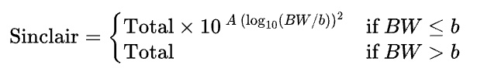
where Total is the sum of best snatch and clean-and-jerk (kg), BW is competition body mass (kg), and A and *b* are sex-specific parameters updated each Olympic cycle by the IWF. Parameters from the 2021–2024 Olympic cycle were applied uniformly across all competition years to ensure cross-year comparability (men: A = 0.7228, b = 193.609; women: A = 0.7870, b = 153.757).
Travel duration for each nation–year combination was estimated as the scheduled flight time of the most direct available commercial routing between each nation's capital city and the competition host city, identified from publicly available flight schedules at the time of each championship. Where direct flights were unavailable, the shortest-connection itinerary was used. Travel duration was grand-mean centred prior to model entry (TravelDuration_c = TravelDuration – 15.67 h). This nation-level approximation assumes comparable travel routes across athletes from the same country; deviations from this assumption are addressed in the Limitations.
Characteristic | Men | Women | Total
Athletes (n) | 392 | 339 | 730
Observations (n) | 1118 | 1068 | 2186
Age (yr), mean ± SD | 24.6 ± 3.7 | 23.8 ± 4.0 | 24.2 ± 3.9
Body mass (kg), mean ± SD | 87.0 ± 26.5 | 68.8 ± 21.2 | 78.1 ± 25.7
Sinclair Total (pts), mean ± SD | 435.7 ± 27.4 | 286.1 ± 26.2 | 362.6 ± 79.5
Obs. per athlete, median [IQR] | 2.0 [2.0–4.0] | 3.0 [2.0–4.0] | 3.0 [2.0–4.0]
Table 1

Jet Lag Quantification
To determine the optimal functional form for the jet lag predictor, three candidate model specifications were compared: an absolute-grouping model (Model A) that collapsed eastward and westward travel into unsigned 2-hour bins, a directional-grouping model (Model B) that retained travel direction as 11 mutually exclusive groups (five eastward, five westward, and one reference group Minimal 0–1 h), and a continuous model (Model C) that entered signed jet lag (JetLag_signed) as a single linear predictor. All three models were fitted by maximum likelihood (ML) and compared on the Akaike Information Criterion (AIC); the model with the lowest AIC was retained for primary inference.
The joint significance of the jet lag grouping was evaluated with a likelihood ratio test (LRT) comparing the primary model against a reduced model in which all jet lag group terms were omitted. Post-hoc contrasts between each jet lag group and the reference (Minimal, 0–1 h) were derived directly from the fixed-effect coefficients of the REML-fitted model. Because the model was specified without jet lag × covariate interaction terms, each group coefficient is algebraically equivalent to the marginal mean contrast against the reference conditional on covariate means, rendering separate marginal-means estimation unnecessary. The resulting 10 contrast p-values were adjusted for multiple comparisons using the Benjamini–Hochberg false discovery rate (FDR-BH) procedure (Benjamini & Hochberg, 1995). All other likelihood ratio tests in this study each constituted a single pre-specified test and were therefore not subject to multiplicity correction; this family-wise approach was adopted because each test addressed a distinct scientific question, and pooling conceptually heterogeneous hypotheses into a single correction family would not be statistically meaningful.
To disentangle circadian disruption from general travel fatigue, a secondary analysis added grand-mean-centred travel duration (TravelDuration_c) as a covariate alongside the jet lag grouping. Two nested LRTs were conducted on this augmented model, both using ML estimation. LRT-A tested the independent contribution of travel duration by comparing the full model (jet lag and travel duration) against a jet-lag-only model (H₀: β_TravelDuration = 0). LRT-B tested whether jet lag retained predictive value after accounting for travel duration by comparing the full model against a travel-only model (H₀: all β_JetLag = 0). A significant LRT-B would indicate that the jet lag effect cannot be attributed to flight duration alone, implicating circadian misalignment as an independent mechanism.

Statistical Analysis

只保留一个模型（分组变量+covariate），理由：（1）前人研究2个小时，（2）我们时差的数据分布=分组变量模型

待定核对：旅行距离变量（协变量还是主效应）：理由除了时差，旅行疲劳

模型：
辛克莱total=性别（主效应）+年龄（？不显著或者删除）+经验（？不显著或者删除）+时差分组（主效应）+旅行时长（主效应/协变量）+（运动员随机截距）？？？
还是说每个分开
总体检验：LRT（核对一下）
事后检验：核对一下 性别，时差分组，旅行时长（？）

世界地图+时差分组+比赛地点标记（欧洲一个例子，亚洲一个例子，美洲一个例子）

1.总体模型（包括所有变量+随机截距）
2.事后检验（分层分组讨论）

总体效应显著——事后检验去看到底哪造成总体显著
结构修改：
2.2 Statistical Model
LMM的选择理由与随机效应结构。数据为不平衡重复测量结构…采用线性混合效应模型。随机截距选择运动员Athlete_ID而非Nation，原因：以Nation截距则无法区分个体实力和时差效应…。
主模型：
主模型如下：
Sinclair_Total ~ Sex + JetLagGroup_dir + TravelDuration_c + (1 | Athlete_ID)
公式：
${Sinclair_Total}_{ij}=β_{0}+β_{1} {\text{Sex}}_{i}+\sum_{g=1}^{10}{β_{g}} 1\left[{\text{JetLagGroup}}_{ij}=g\right]+β_{12} {\text{TravelDuration}}_{c,ij}+u_{i}+ε_{ij}$,
$$u_{i}∼N\left(0, σ_{u}^{2}\right), ε_{ij}∼N\left(0, σ_{ε}^{2}\right)$$
其中 i为运动员，j为…${\text{TravelDuration}}_{c}$为旅行时长，作为协变量控制飞行疲劳；$u_{i}$为运动员随机截距。
分组编码的依据：将JetLag_signed以2小时为档划分为11组，原因：前人研究表明超过2小时的时差即可产生可测量的昼夜节律（文献）；分组变量模型相比连续变量模型拟合更优（AIC，分组变量LR = 49.2，连续变量LR = 12.49），时差与成绩之间存在非线性或方向不对称。
三个备选模型（绝对值分组、方向性分组、连续变量）的完整AIC/BIC比较见附录。
2.3 总体检验 + 事后比较（or事后检验放到2.4？）
总体效应检验。采用LRT对JetLagGroup_dir做整体效应检验，比较完整模型与去掉JetLagGroup_dir的简化模型的对数似然：
$$LR=2 \left(l_{full}-l_{reduced}\right)$$
$$LR∼χ2\left(df=10\right)$$
“时差分组作为整体是否对成绩有影响”
旅行疲劳的独立贡献另做两次嵌套LRT验证（LRT-A：加入TravelDuration_c是否改善拟合；LRT-B：控制TravelDuration_c后JetLagGroup_dir是否仍联合显著），以区分昼夜节律紊乱与飞行疲劳两种机制。

事后比较。在LRT确认整体效应后，提取各时差组相对于参照组的估计边际均值对比（EMMs）。因模型为纯加性结构（不含Sex × JetLagGroup交互项），各组的EMM对比在代数上等价于模型固定效应系数：
$$EMMg​-EMMref​=\left(β^{​}0​+β^{​}g​+w_{Sex}{​β^{​}}_{Sex}​\right)-\left(β^{​}0​+w_{Sex}{​β^{​}}_{Sex}​\right)=β^{​}g​$$
即Sex项在做差时被完全消掉，对比估计值、标准误及置信区间与直接读取模型输出完全一致，无需额外边际化步骤（引Lenth 2016）。针对10个非参照组与参照组的比较，原始p值采用BH-FDR校正。效应量报告$Cohen^{'}s d=β_{g}/σ_{ε}$。
2.4 分层
目的与调节变量定义。时差效应是否因运动员特征而异设定四个调节变量：性别、年龄、竞赛经验、体重。
交互项LRT与分层。对每个调节变量M，构建含 M×JetLagGroup交互项的完整模型与去掉交互项的简化模型（两者均保留Sex、TravelDuration_c及 MM 主效应），ML拟合后做LRT：
LR∼χ2(df=(J−1)×10)
J为调节变量水平数。全局LRT回答调节变量是否整体改变时差敏感度。

Results部分
3.2 Overall Effect of Directional Jet Lag
1 总体LRT结果，LRT确认JetLagGroup_dir对Sinclair Total有显著的整体效应（LR = 51.82, df = 10, p = 1.23×10⁻⁷）。模型拟合质量：ICC = 0.753（σ_u² = 532.3, σ_ε² = 174.9），75%的成绩变异来自运动员个体差异，证明随机截距设计合理。
2 事后比较。引Table 和Figure 1，说明经FDR校正后唯一显著的组是East 8–9h（β̂ = −7.77, 95% CI: −10.27 to −5.27, p_FDR < .001。整体模式：其余9个组无论东西方向、经FDR校正后均不显著；West 10–11h的正系数（+5.17）在FDR校正前接近显著但校正后不再保留（后续Discussion讨论？）。
3 旅行疲劳稳健性结果。TravelDuration_c在加入模型后本身显著（LRT-A: LR = 10.86, df = 1, p = 9.8×10⁻⁴, β̂ = −0.22，表明旅行时长每增加1小时成绩下降约0.22 Sinclair分）；控制TravelDuration_c后JetLagGroup_dir仍高度联合显著（LRT-B: LR = 53.27, df = 10, p = 6.6×10⁻⁸），证明时差效应不被飞行疲劳解释。引Table 2（协变量版系数，East 8–9h在控制TravelDuration后系数略微缩小为−5.58，但方向和显著性保持一致）。
3.3异质性分析——无显著，不放在正文
1 总结句 + 引Table 3。四个调节变量的交互项LRT均不显著（性别: LR = 3.66, df = 10, p = 0.961；年龄: LR = 12.64, df = 10, p = 0.245；经验: LR = 8.85, df = 10, p = 0.546；体重: LR = 18.75, df = 30, p = 0.945），时差效应在各亚组间呈现统计同质性。
2 分层描述性结果。引Figure 2，尽管各亚组线型有轻微差异，但East 8–9h的负效应模式在各亚组中均可见。

To examine whether the jet lag effect on performance was homogeneous across athlete subgroups, four pre-specified moderating variables were tested: sex (men vs. women), age (younger: <25 yr vs. older: ≥25 yr), competition experience (low: ≤2 prior starts vs. high: ≥3 prior starts), and body-mass-based weight class (four categories). The age cut-point of 25 years was adopted following Solberg et al. (2019), who reported a mean peak performance age of 26±3 years in elite weightlifters using IWF World Championships data, placing 25 years approximately one standard deviation below the estimated peak and thus separating athletes in the ascending phase of their career from those approaching or past peak performance. Competition experience was operationalised as the cumulative number of IWF World Championship appearances prior to and including the current event, derived by sorting each athlete's records chronologically and applying a within-athlete running count; this dynamic definition ensures that the same athlete may belong to different experience strata at different career stages.
Weight classes were defined as: Light (≤67 kg for men, ≤58 kg for women), Middle (68–89 kg / 59–77 kg), Heavy (90–110 kg / 78–86 kg), and Super-Heavy (>110 kg / >86 kg), approximating IWF competition weight categories.
For each moderator, a unified four-step procedure was applied. First, a global LRT compared a full model containing the moderator × jet lag group interaction against a reduced model without the interaction term, both fitted by ML; the test statistic follows a χ² distribution with (J-1)×10 degrees of freedom, where J is the number of moderator levels and 10 equals the number of non-reference jet lag groups (11 directional bins minus the Minimal(0–1h) reference). This omnibus test answers whether the moderator significantly changes the sensitivity of performance to jet lag. Second, if the global LRT was significant, stratified models were fitted within each subgroup to provide descriptive effect estimates; these stratum-specific coefficients are presented for interpretive purposes only and do not constitute additional inferential tests. Third, post-hoc contrasts within each stratum (each jet lag group vs. Minimal) were FDR-BH corrected independently within each stratum. Fourth, stratum-specific marginal effects across all jet lag bins were overlaid in a single panel to visualise the degree of subgroup convergence (Figure 2).
Control variables differed across analyses to reflect the specific confounding structure of each moderator. The sex analysis included only TravelDuration_c, as sex itself was the moderator. Age and experience analyses additionally included C(Sex) and BodyWeight_c, because body mass tends to shift systematically across career stages and could otherwise confound the moderator effects. Weight-class analyses included C(Sex) and TravelDuration_c. Body weight was grand-mean centred across the full analytic sample (x̄ = 78.1 kg) prior to inclusion. Because sex was simultaneously modelled as a fixed effect, the systematic offset in centred body weight between male and female athletes is absorbed by the sex coefficient, leaving BodyWeight_c to capture within-sex variation in body mass.

Results

Sample characteristics
The analytic sample comprised 2,186 competition entries from 730 athletes representing 13 nations, with 1,077 entries from male athletes and 1,109 from female athletes (Table 1). Athletes contributed a median of 3 entries each (range: 2–11). The intraclass correlation coefficient from the primary LMM was ICC = 0.753 (σ²_u = 532.3, σ²_ε = 174.9), confirming that athlete identity accounted for the majority of variance in Sinclair Total and justifying the use of athlete-level random intercepts.

Effect of directional jet lag on Sinclair Total
一个模型（有covariate）+ 事后检验 = results

总体检验结果
Model comparison by AIC identified the directional grouping model (Model B: AIC = 19,118) as the best-fitting specification, outperforming the absolute-magnitude model (Model A: AIC = 19,120) and the continuous model (Model C: AIC = 19,141). Although BIC marginally favoured Model A due to its lower parameter count, Model B was retained as the primary model to preserve directional interpretability. The overall likelihood ratio test for JetLagGroup_dir was significant (LR = 51.82, df = 10, p = 1.23 × 10⁻⁷), indicating that jet lag travel direction systematically influenced Sinclair Total after controlling for sex and athlete-level ability.
事后检验结果
Post-hoc contrasts against the reference group Minimal (0–1 h, n = 443) are presented in Table 2 and Figure 1. After FDR-BH correction, only the East 8–9 h bin reached significance (β = −7.77 Sinclair points, 95% CI: −10.27 to −5.27, p_FDR < 0.001), corresponding to a standardised effect size of d = −0.59. East 2–3 h showed a marginal negative trend (p_raw = 0.084) that did not survive correction (p_FDR = 0.358). All westward bins returned p_FDR > 0.35, with point estimates ranging from −3.32 to +1.00 Sinclair points. A direct comparison at the 8–9 h displacement confirmed a directional asymmetry: the East 8–9 h group performed 4.44 Sinclair points worse than the West 8–9 h group (SE = 2.24, p = 0.048).
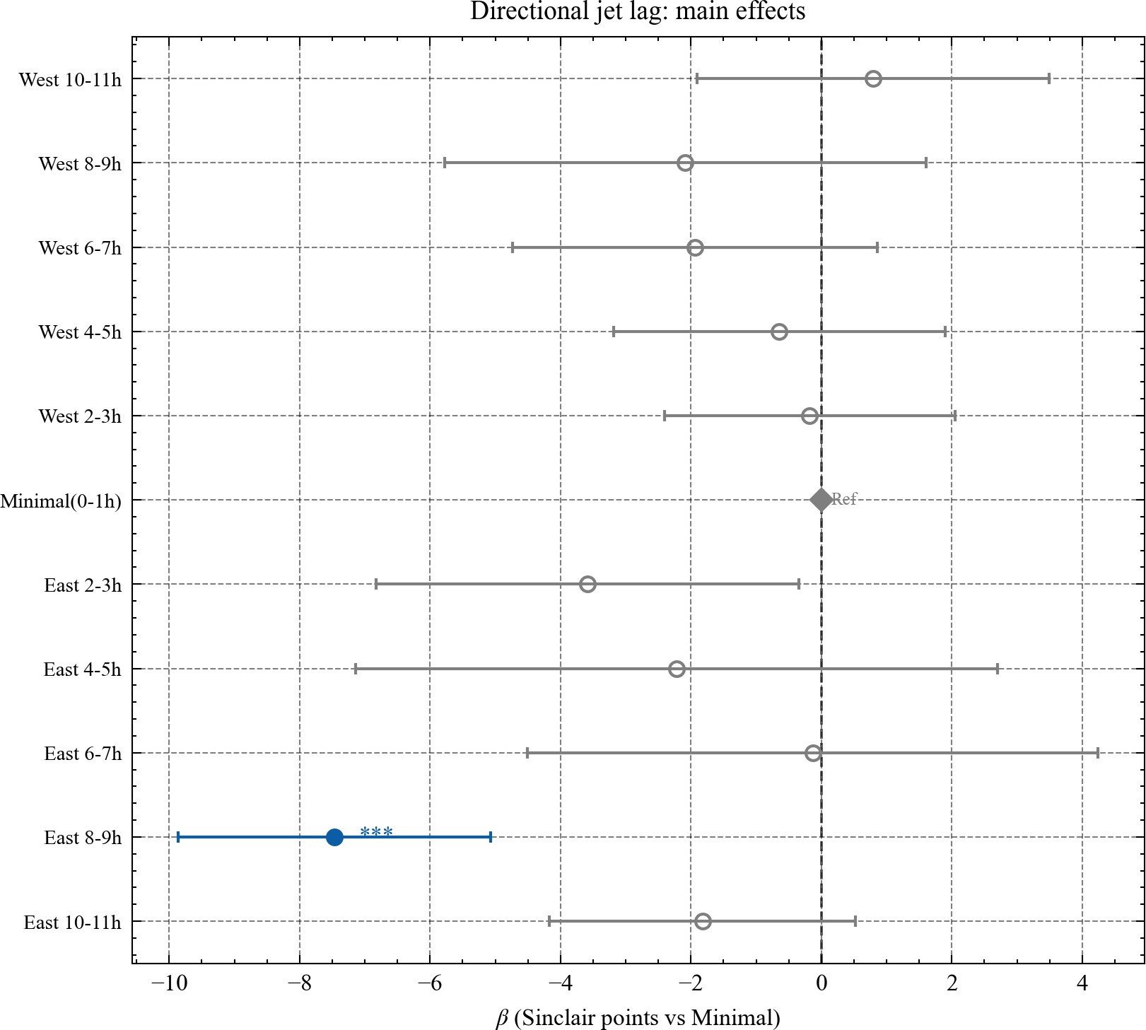
Figure 1: Effects of directional jet lag on Sinclair Total

Jet Lag Group | n | Estimate | SE | 95% CI | p | p_FDR
West 10–11 h | 160 | +1.00 | 1.40 | [−1.74, +3.74] | 0.475 | 0.792
West 8–9 h | 68 | −3.32 | 2.07 | [−7.37, +0.72] | 0.108 | 0.358
West 6–7 h | 212 | −1.83 | 1.46 | [−4.69, +1.02] | 0.209 | 0.418
West 4–5 h | 257 | −0.27 | 1.33 | [−2.88, +2.34] | 0.840 | 0.958
West 2–3 h | 308 | −0.06 | 1.17 | [−2.35, +2.23] | 0.958 | 0.958
East 2–3 h | 97 | −3.12 | 1.81 | [−6.66, +0.42] | 0.084 | 0.358
East 4–5 h | 36 | −1.26 | 2.76 | [−6.67, +4.16] | 0.649 | 0.927
East 6–7 h | 50 | +0.40 | 2.29 | [−4.10, +4.89] | 0.863 | 0.958
East 8–9 h | 289 | −7.77 | 1.28 | [−10.27, −5.27] | <0.001 | <0.001
East 10–11 h | 266 | −1.66 | 1.24 | [−4.08, +0.76] | 0.179 | 0.418
Table 2
Reference group: Minimal (0–1 h), n = 443.

Travel Fatigue and Circadian Disruption
Adding centred travel duration as a covariate confirmed that jet lag and travel fatigue make separable independent contributions to performance. As shown in Table 4 (rows LRT-A and LRT-B), the incremental contribution of travel duration given jet lag grouping was significant (LR = 10.86, df = 1, p < 0.001), as was the residual jet lag effect after accounting for travel duration (LR = 53.27, df = 10, p < 0.001). Following travel duration adjustment, the East 8–9 h coefficient attenuated from −7.77 to −5.58, consistent with physical travel fatigue accounting for part of the decrement while circadian misalignment retained a substantial independent contribution. The West 10–11 h group emerged as positively significant in the travel-adjusted model (β = +5.17, 95% CI: +1.47 to +8.86, p_FDR = 0.031); the interpretation of this finding is addressed in the Discussion.

Heterogeneity Analyse across Athlete Subgroups
Global likelihood ratio tests for each moderator × jet lag group interaction are reported in Table 3. No moderator reached significance: sex (LR = 3.66, df = 10, p = 0.961), age (LR = 12.64, df = 10, p = 0.245), competition experience (LR = 8.85, df = 10, p = 0.546), and weight class (LR = 18.75, df = 30, p = 0.945). As illustrated in Figure 2, the subgroup-specific effect profiles were qualitatively similar across all panels, with the depression at East 8–9 h visible in every stratum. None of the cross-stratum contrasts at any individual jet lag bin achieved significance after FDR correction. The age moderation remained non-significant when competitive experience was additionally controlled as both a main effect and an interaction with jet lag group (LR = 7.72, df = 10, p = 0.657), ruling out experience–age confounding as an explanation for the null age finding.
Table 3. Likelihood ratio tests for moderator × jet lag group interactions.
*Each test compares a full model (with interaction) against a reduced model (without interaction), both fitted by maximum likelihood. No moderator reached significance at α = 0.05.*
Moderator | Definition | LR | df | p
Sex | Men vs. Women | 3.66 | 10 | 0.961
Age | <25 vs. ≥25 yr | 12.64 | 10 | 0.245
Experience | ≤2 vs. ≥3 starts | 8.85 | 10 | 0.546
Weight class | 4 categories | 18.75 | 30 | 0.945
Table 3
LR = likelihood ratio statistic (χ²); df = interaction degrees of freedom.
df = (J−1) × 10, where J is the number of moderator levels and 10 reflects the 10 non-reference jet lag groups (11 directional groups total, reference = Minimal 0–1h).

Sensitivity analyses using continuous moderators
To evaluate whether the null heterogeneity results were attributable to information loss from dichotomisation, each moderator was re-examined as a continuous variable interacted with signed jet lag (Table 4, lower panel). None of the three interactions reached significance: age (LR = 0.12, df = 1, p = 0.731), body mass (LR = 0.29, df = 1, p = 0.591), and competition experience (LR = 0.94, df = 1, p = 0.333). These results confirm that the null findings in the categorical analyses were not an artefact of the chosen dichotomisation thresholds.
*LRT-A and LRT-B assess the independent contributions of travel duration and jet lag, respectively, in a model containing both predictors. Sensitivity tests examine whether continuous moderator variables linearly interact with signed jet lag (JetLag_signed) on Sinclair Total; each uses df = 1.*
Test | Null hypothesis | LR | df | p
LRT-A | Travel adds nothing beyond jet lag | 10.86 | 1 | 0.001
LRT-B | Jet lag adds nothing beyond travel | 53.27 | 10 | <0.001
Continuous moderator sensitivity
Age × jet lag | No linear age moderation | 0.12 | 1 | 0.730
Body mass × jet lag | No linear mass moderation | 0.29 | 1 | 0.591
Experience × jet lag | No linear experience moderation | 0.94 | 1 | 0.333
Table 4
LR = likelihood ratio statistic (χ²); all models fitted by maximum likelihood.

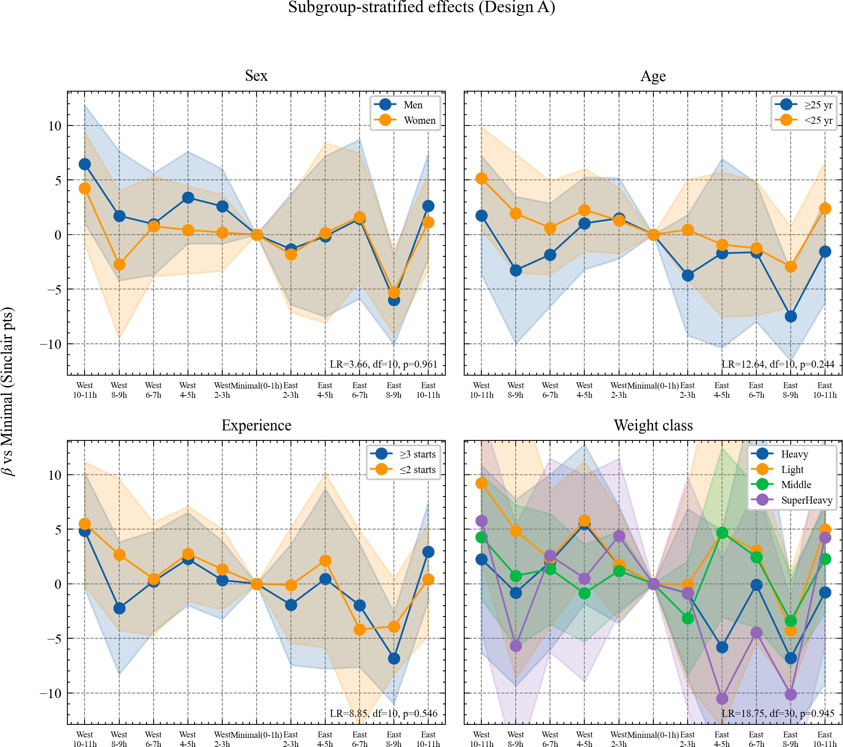
Figure 2: Subgroup-stratified jet lag effects across four moderating variables: sex (panel A), age (panel B), competition experience (panel C), and weight class (panel D)

Discussion

Jet Lag and Performance
The present study identified a pronounced and directionally asymmetric jet lag effect on Sinclair Total in elite weightlifters competing at IWF World Championships. Among the 11 jet lag bins examined, only the eastward 8–9 h group reached statistical significance after FDR correction (β = −7.77, d = −0.59), while all westward bins and shorter eastward bins remained non-significant. The directional asymmetry was further confirmed by a direct comparison at the 8-9 h magnitude: the eastward group performed 4.44 Sinclair points worse than the westward group at the equivalent displacement distance (SE = 2.24, p = 0.048). This asymmetry is consistent with the well-established circadian biology principle that human circadian rhythms have an intrinsic period slightly exceeding 24 hours (~24.2 h), making phase delay (westward travel) intrinsically more tractable than phase advance (eastward travel), which requires entrainment against the natural direction of the pacemaker drift. The observed rate of circadian adaptation — approximately one hour per day — means that an 8–9 h eastward displacement requires nearly two weeks for full re-entrainment, far exceeding the typical pre-competition window available to elite athletes.【Janse van Rensburg et al., 2021; Leota et al., 2022; Cook et al., 2022】
(补一下向东10-11h影响不显著的分析？

Independent contributions of travel fatigue
旅行疲劳分析
Incorporating travel duration as a covariate confirmed that jet lag and travel fatigue represent separable physiological stressors. Both LRT-A (LR = 10.86, p < 0.001), testing the independent contribution of travel duration given jet lag group, and LRT-B (LR = 53.27, p < 0.001), testing the residual contribution of jet lag after accounting for travel duration, reached significance. The attenuation of the East 8–9 h coefficient from −7.77 to −5.58 upon travel duration adjustment indicates that physical fatigue from long-haul travel accounts for a portion of the observed decrement, but circadian misalignment retains a substantial independent effect.
The positive coefficient for West 10–11 h after travel duration adjustment (β = +5.17, p_FDR = 0.031) warrants careful interpretation. Nations competing at this displacement magnitude are predominantly East Asian federations (China, Japan, Kazakhstan) travelling to competitions in Europe or the Americas, or vice versa. These long-haul events often attract a nation's top-tier athletes, introducing a selection effect that may not be fully captured by the athlete-level random intercept. This finding should not be interpreted as evidence that extreme westward travel enhances performance; rather, it may reflect a residual confound between competition importance and athlete selection at this distance range.【Doherty et al., 2023; Leota et al., 2025 (PNAS) (NatComm)】

Homogeneity Across Subgroups
None of the four pre-specified moderators — sex, age, competition experience, and weight class — significantly interacted with the jet lag group variable (all p > 0.24, Table 3). This pattern of homogeneity was robust to continuous-variable sensitivity analyses and to the experience-adjusted age model (p = 0.657), which specifically addressed the potential confounding between age and cumulative competitive exposure.
For sex, the absence of a moderating effect is consistent with evidence suggesting that although women and men differ in circadian period length and hormonal profiles, the neuromuscular consequences of circadian disruption — reduced motor unit recruitment efficiency, impaired reaction time, and degraded force production timing — operate through mechanisms that are not sex-differentiated at the performance level in highly trained populations. These findings align with Leota et al. (2025), who similarly observed that the dose–response relationship between evening exercise and sleep quality did not differ by sex in a large-scale wearable device cohort.
For age, the failure to detect a significant interaction (p = 0.245) diverges from laboratory-based evidence showing that older individuals exhibit slower circadian re-entrainment and greater sensitivity to sleep disruption. Two explanations are plausible. First, athletes continuing to compete at the IWF World Championships beyond the typical peak age represent a highly selected subpopulation in which age-related circadian deterioration may be offset by superior sleep hygiene and professional preparation practices. Second, the statistical power of the current dataset — particularly the smaller sample in the older subgroup — may be insufficient to detect a moderate age-moderation effect. The secondary sensitivity analysis using continuous Age_c yielded a trend (p ≈ 0.075 in the categorical interaction test), suggesting a weak signal that larger samples could potentially resolve. Importantly, the experience-adjusted age analysis confirmed that this null finding was not an artefact of age–experience confounding.
The finding that competitive experience did not attenuate jet lag sensitivity (p = 0.546) is physiologically coherent. Circadian re-entrainment is governed by the molecular timing of the suprachiasmatic nucleus and peripheral oscillators, which respond to zeitgebers (light, meal timing, social cues) rather than to the number of prior travel episodes. While experience may improve an athlete's subjective management of fatigue and psychological preparation, it does not alter the biological rate at which the circadian clock resets. Similarly, the null result for weight class (p = 0.945) is unsurprising given that Sinclair scoring already normalises for absolute mass-strength relationships, leaving a residual performance metric for which circadian impairment would be expected to exert a mass-independent effect.
Collectively, these findings suggest that eastward travel spanning 8–9 time zones constitutes a meaningful and universal performance risk for elite weightlifters. Coaching staff and sport scientists should therefore apply systematic circadian management protocols uniformly across all athlete profiles when scheduling eastward transoceanic travel. Strategies such as pre-travel sleep phase shifting, timed bright light exposure, and strategic melatonin administration have demonstrated efficacy in controlled settings and should be incorporated into standard pre-competition travel protocols for events requiring ≥8 h eastward displacement.【Fabunmi O A et al. (2026). “Unpacking the Impact of Travel and Jet Lag on Sleep and Performance of Athletes: A Narrative Review” (Curr. Sleep Med. Rep.)】

Limitations and Future Directions
数据局限、旅行时长估算、筛选-排除了部分国家的运动员
Several limitations should be acknowledged. First, the observational design precludes causal inference; unmeasured confounders such as individual pre-competition acclimatisation strategies, training load in the week preceding competition, and medication use cannot be excluded. Future research could address this by combining official competition records with longitudinal athlete monitoring data. Second, travel duration was estimated from origin-country to competition-city distances rather than actual departure dates, meaning that athletes who arrived several days early — and may have partially re-entrained — are treated identically to those who arrived on the day of competition. We were unable to control for this variation due to the absence of travel itinerary data, and future studies incorporating actual arrival dates would allow a more precise quantification of effective jet lag exposure. Finally, the analysis was restricted to 13 nations to ensure statistical reliability; the generalisability of these findings to smaller federations or developing nations with different travel logistics and resource contexts remains to be established.【Bernal-Rusiel et al., 2013; Vandenbogaerde & Hopkins, 2010; Newans et al., 2022; Janse van Rensburg et al., 2021】

Conclusion
研究目的——主效应（向东8-9h显著负面影响）——次要发现（同质性分析）——实践意义——局限&未来
Analysing 2,186 competition entries from 730 elite weightlifters across 13 nations competing at IWF World Championships between 1998 and 2025, we found that directional jet lag exerts a selective, dose-dependent effect on standardised performance. Eastward travel spanning 8–9 hours was the only jet lag bin to reach significance after FDR correction (β = −7.77 Sinclair points, 95% CI: −10.27 to −5.27, d = −0.59), and this effect remained robust after accounting for travel duration (LRT-B: LR = 53.27, p < 0.001), indicating that circadian misalignment operates as a mechanism independent of travel fatigue. Heterogeneity analyses across sex, age, competition experience, and body mass category yielded no significant moderator × jet lag interactions (all p > 0.24), a pattern confirmed by continuous sensitivity analyses and an experience-adjusted age model.
These findings suggest that the performance cost of substantial eastward jet lag is a broadly uniform physiological phenomenon in elite weightlifters, not attenuated by accumulated competitive experience or mediated by demographic characteristics. Practitioners should treat eastward crossings of ≥8 time zones as a universal performance risk requiring proactive circadian management strategies—such as pre-travel sleep scheduling or timed light exposure—regardless of athlete profile. Future research incorporating objective circadian biomarkers and individual travel itineraries would allow more precise quantification of the dose–response relationship and evaluation of countermeasure efficacy.

