Methods

2.1 研究设计、数据来源与样本构建
本研究为基于国际举重联合会（International Weightlifting Federation, IWF）世界锦标赛公开成绩的纵向观察性研究，覆盖1998—2025年间22届世锦赛。为同时保证样本具有足够的重复观测和较高的竞技代表性，首先分别按照参赛记录总数和进入单项前10名的次数筛选排名前20的国家和地区（下文统称为国家）：前一指标反映长期、稳定的参赛规模，后一指标反映在世界大赛中的竞技水平；再取两份名单的交集，以避免仅因参赛人数较多或偶有高名次而纳入代表性不足的国家，最终纳入13个国家。为形成同一运动员的纵向重复测量，使模型能够区分运动员之间的稳定差异与运动员自身的跨届变化，仅保留原始数据中至少参加过两届世锦赛的运动员。核心结果变量、时区信息或旅行时长无法匹配的记录按完整病例原则排除。最终分析样本包括2,186条比赛记录和730名运动员，来自上述13个国家。

2.1 Study design, data source, and analytic sample
This longitudinal observational study used publicly available results from 22 International Weightlifting Federation (IWF) World Championships held between 1998 and 2025. To ensure both sufficient repeated observations and representation of high-level competitive performance, nations and territories (hereafter collectively referred to as nations) were ranked separately by the total number of competition entries and by the number of top-10 finishes in individual events. The intersection of the top 20 lists for these two criteria was retained: the former captured sustained participation volume, whereas the latter reflected competitive performance at the World Championship level. This procedure reduced the likelihood of including nations represented only by high participation volume or by isolated top finishes and yielded 13 eligible nations. Athletes were then required to have competed in at least two World Championships in the original dataset, providing a repeated-measures structure in which stable between-athlete differences could be accounted for while associations across championship records were estimated. Records with missing outcome data or unmatched time-zone or travel-duration information were excluded using complete-case analysis. The final analytic sample comprised 2,186 competition entries from 730 athletes representing the 13 included nations.

2.2 研究变量及其测量

2.2 Study variables and measurement

2.2.1 结果变量：Sinclair Total
举重比赛的原始总成绩为抓举与挺举最好成绩之和，但该绝对重量同时受到性别和体重的影响，因此不同性别、不同体重级别运动员的公斤成绩不能直接比较。本研究采用Sinclair Total作为标准化竞技表现指标。Sinclair系数由IWF公布并按周期更新，使用性别特异的体重校正系数将原始总成绩换算为可在不同体重级别间比较的标准化分值；分值越高，表示运动员相对于其性别和体重的竞技表现越好。为避免不同年份使用不同周期系数而引入额外的时间不可比性，所有年份统一使用IWF 2021—2024周期的性别特异系数：男性A=0.722762521、b=193.609，女性A=0.787004341、b=153.757。
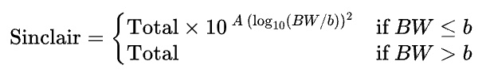

2.2.1 Outcome: Sinclair Total
In Olympic weightlifting, the raw total is the sum of the best successful snatch and clean-and-jerk. Because the absolute mass lifted depends strongly on sex and body mass, raw totals are not directly comparable across athletes of different sexes or weight categories. Competitive performance was therefore expressed as Sinclair Total, an IWF-derived standardised score that applies sex-specific body-mass coefficients to the raw total to permit comparisons across weight categories within each sex. Higher scores indicate better performance relative to the athlete's sex and competition body mass. To avoid introducing temporal incomparability through changes in coefficients across Olympic cycles, the 2021–2024 IWF coefficients were applied uniformly to all competition years (men: A=0.722762521, b=193.609; women: A=0.787004341, b=153.757).

2.2.2 有向时差的计算与分组
通常可用比赛地的协调世界时（UTC）偏移量减去运动员出发地的UTC偏移量来计算时差；但全球时区构成24小时循环，直接进行线性相减会在跨越国际日期变更线时夸大实际时差。例如，UTC+12与UTC−10直接相减得到22 h，而沿24小时圆周的最短距离实际仅为2 h。为使时差表示旅途中实际跨越的最短时区距离，本研究先以比赛地UTC偏移量减去运动员所属国家参考训练基地的UTC偏移量，再将结果按24小时圆周的最短路径折叠至−12至12 h。正值表示向东旅行，负值表示向西旅行。
首先计算未经圆周校正的时差：
$$ΔUTC_{ij}=UTC_{\text{venue},j}-UTC_{\text{athlete},i}$$
再折叠至24小时圆周上的最短路径：
$$JetLagSigned_{ij}=\left[\left(ΔUTC_{ij}+12\right) mod 24\right]-12$$
基于有向时差建立11水平分类变量。参照组Minimal的操作定义为绝对有向时差小于2 h，图表标签写作0–1 h；其余按方向分别划分为2–3、4–5、6–7、8–9和10–11 h五档。
$$\text{Minimal}⟺\left|JetLagSigned_{ij}\right|<2 \text{h}$$

2.2.2 Calculation and categorisation of directional jet lag
Directional jet lag was operationalised as the signed difference between the Coordinated Universal Time (UTC) offset of the competition venue and that of the athlete's reference point of origin. Because global time zones form a 24-h cycle, however, simple linear subtraction can substantially overstate displacement when travel crosses the International Date Line. For example, UTC+12 and UTC−10 differ by 22 h under direct subtraction but by only 2 h along the shortest path around the 24-h clock. We therefore subtracted the UTC offset of the reference national training base from that of the competition venue and folded the result to the shortest signed displacement within −12 to +12 h; positive values denoted eastward travel and negative values denoted westward travel. The equations above formalise this two-step procedure: the uncorrected UTC-offset difference was calculated first and then folded to the shortest path on the 24-h cycle.
$$ΔUTC_{ij}=UTC_{\text{venue},j}-UTC_{\text{athlete},i}$$
$$JetLagSigned_{ij}=\left[\left(ΔUTC_{ij}+12\right) mod 24\right]-12$$
The resulting signed displacement was categorised into 11 mutually exclusive levels. Minimal displacement, defined as an absolute signed jet lag of <2 h, served as the reference category and is labelled 0–1 h in tables and figures. Eastward and westward travel were each further classified into 2–3, 4–5, 6–7, 8–9, and 10–11 h categories.
$$\text{Minimal}⟺\left|JetLagSigned_{ij}\right|<2 \text{h}$$

2.2.3 旅行时长
旅行时长用于表征时差之外的长途旅行负担。出发地采用各国主要举重训练基地所在城市，目的地采用相应年份世界锦标赛的举办城市；若同一城市有多个机场，则选择其主要国际机场。航班信息统一通过携程官方网页查询，查询日期设为未来普通工作日，以减少节假日和临时班次造成的波动。检索时优先记录耗时最短的直飞航班；没有直飞航班时，记录一次中转航班中总时长最短者；若没有一次中转航班，再选择两次中转航班中总时长最短者。该指标反映典型航线安排下的估计旅行时长，按国家、比赛城市和比赛年份将其合并至比赛记录，以样本均值进行中心化，并作为长途旅行负担的代理变量纳入主模型。
$$TravelDuration_{c,ij}=TravelDuration_{ij}-\overline{TravelDuration}$$

2.2.3 Travel duration
Travel duration was used as a proxy for the burden of long-distance travel beyond time-zone displacement. Origin cities were the locations of the principal national weightlifting training bases, and destinations were the host cities of the corresponding World Championships. When a city had multiple airports, its principal international airport was used. Flight itineraries were retrieved from the official Ctrip website for a future, non-holiday weekday to minimise variation attributable to holiday schedules or temporary service changes. The shortest nonstop itinerary was selected where available; otherwise, the shortest one-stop itinerary was used, followed by the shortest two-stop itinerary when no one-stop option was available. The resulting measure represents estimated duration under a typical commercial routing rather than each athlete's actual itinerary. Travel duration was merged with competition records by nation, host city, and championship year, grand-mean centred, and entered into the primary model as a proxy for travel burden.
$$TravelDuration_{c,ij}=TravelDuration_{ij}-\overline{TravelDuration}$$

2.3 统计分析

2.3 Statistical analysis

2.3.1 主模型
由于同一运动员可跨年份多次参赛，且不同运动员的参赛次数并不相同，各条比赛记录不能视为相互独立。因此，本研究采用LMM线性混合效应模型，以Sinclair Total为结局变量，将性别、方向性时差分组和中心化旅行时长作为固定效应，并为每名运动员设置随机截距，以控制同一运动员重复观测的相关性及运动员之间稳定的能力差异。
统计分析依次按照主模型估计、方向性时差分组总体检验、事后比较和标准化效应量报告的顺序进行。主模型的固定效应及普通95%置信区间采用限制性最大似然法（REML）估计；涉及固定效应的嵌套模型比较时，使用最大似然法（ML）重新拟合相应模型。

2.3.1 Primary model
Because athletes could contribute observations across multiple championships and the number of observations varied between athletes, competition entries were not statistically independent. We therefore fitted a linear mixed-effects model (LMM) with Sinclair Total as the outcome; sex, directional jet-lag category, and grand-mean-centred travel duration as fixed effects; and a random intercept for athlete. The random intercept accounted for within-athlete correlation and stable between-athlete differences in competitive ability.
Analyses proceeded in four stages: estimation of the primary model, an omnibus test of the directional jet-lag factor, post hoc comparisons, and calculation of standardised effect sizes. Fixed-effect estimates and ordinary 95% confidence intervals (CIs) were obtained from models fitted by restricted maximum likelihood (REML). For comparisons of nested models differing in fixed effects, the relevant models were refitted using maximum likelihood (ML).

2.3.2 总体检验
时差分组的总体效应通过似然比检验评估，即比较完整主模型与删除全部方向性时差分组项、但保留性别和旅行时长的简化模型。(去掉了总体效应似然比的公式

2.3.2 Omnibus test
The overall contribution of directional jet-lag category was evaluated using a likelihood ratio test (LRT) comparing the full primary model with a reduced model that omitted all directional jet-lag terms while retaining sex and travel duration.

2.3.3 事后比较
总体检验显著后，以Minimal组为参照，报告10个非参照时差组的模型系数、标准误和普通95%置信区间。
10项事后比较的原始p值采用Benjamini–Hochberg方法控制错误发现率（FDR），置信区间不进行多重校正。

2.3.3 Post hoc comparisons
Following a significant omnibus test, the Minimal group was used as the reference, and model coefficients, standard errors, and ordinary 95% CIs were reported for the 10 non-reference directional jet-lag categories.
The 10 raw p values from these comparisons were adjusted using the Benjamini–Hochberg procedure to control the false discovery rate (FDR). Confidence intervals were ordinary coefficient-specific 95% CIs and were not adjusted for multiplicity.

2.3.4 标准化效应量
标准化效应量采用Cohen's d表示，即以各方向性时差组相对于Minimal组的模型系数除以REML主模型的残差标准差；该指标用于辅助判断组间差异的相对大小。

2.3.4 Standardised effect sizes
Standardised effect sizes were expressed as Cohen's d, calculated by dividing each directional jet-lag coefficient relative to Minimal by the residual standard deviation from the REML-fitted primary model. These values were used to aid interpretation of the relative magnitude of between-group differences.

Results

3.1 样本特征
在最终分析样本中，男性运动员392名、女性运动员338名；男性记录1,118条，女性记录1,068条。运动员平均年龄为24.18±3.86岁，平均体重为78.10±25.71 kg，Sinclair Total为362.62±79.45分；每名运动员参赛记录数的中位数为3，四分位距为2—4（Table 1）。

3.1 Sample characteristics
The final analytic sample comprised 730 athletes and 2,186 competition entries. Of the athletes, 392 were men and 338 were women; the corresponding numbers of entries were 1,118 and 1,068. Mean age was 24.18 ± 3.86 years, mean body mass was 78.10 ± 25.71 kg, and mean Sinclair Total was 362.62 ± 79.45 points. Athletes contributed a median of 3 entries (interquartile range, 2–4; Table 1).
Table 1. Characteristics of the analytic sample
Characteristic | Men | Women | Total
Athletes (n) | 392 | 338 | 730
Observations (n) | 1118 | 1068 | 2186
Age (yr), mean ± SD | 24.57 ± 3.69 | 23.78 ± 4.00 | 24.18 ± 3.86
Body mass (kg), mean ± SD | 86.97 ± 26.51 | 68.82 ± 21.21 | 78.10 ± 25.71
Sinclair Total, mean ± SD | 435.69 ± 27.44 | 286.12 ± 26.19 | 362.62 ± 79.45
Obs. per athlete, median [IQR] | 2.0 [2.0–4.0] | 3.0 [2.0–4.0] | 3.0 [2.0–4.0]
Note. Values are mean ± SD unless otherwise indicated. IQR, interquartile range.

3.2 方向性时差与比赛成绩
在控制性别、估计旅行时长和运动员个体随机截距后，方向性时差分组与Sinclair Total存在显著的整体关联（LR=53.27，df=10，p=6.63×10⁻⁸），表明不同方向和幅度的时差组之间总体上存在成绩差异。以Minimal（0–1 h）组为参照，BH-FDR校正后有两个组达到统计学显著（Table 2；Figure 1）。East 8–9 h组的Sinclair Total平均低5.58分（β=−5.58，普通95% CI −8.40至−2.77，pFDR=0.001，d=−0.42）；West 10–11 h组平均高5.17分（β=5.17，普通95% CI 1.47至8.86，pFDR=0.031，d=0.39）。其余8个非参照组在FDR校正后均无统计学显著差异。
在已经包含方向性时差分组的模型中，加入中心化旅行时长可进一步改善模型拟合（LR=10.86，df=1，p=9.80×10⁻⁴）。旅行时长每增加1 h，Sinclair Total平均降低约0.22分（β=−0.218，普通95% CI −0.347至−0.088）。

3.2 Directional jet lag and competition performance
After adjustment for sex and estimated travel duration, with athlete-specific random intercepts accounting for repeated observations, the omnibus test provided evidence of an overall association between directional jet-lag category and Sinclair Total (LR=53.27, df=10, p=6.63×10⁻⁸). This association reflected heterogeneity across categories defined by travel direction and magnitude. Relative to the Minimal category (0–1 h), two categories remained statistically significant after Benjamini–Hochberg FDR correction (Table 2; Figure 1). The East 8–9 h category was associated with a 5.58-point lower Sinclair Total (β=−5.58, ordinary 95% CI −8.40 to −2.77, FDR-adjusted p=0.001, d=−0.42), whereas the West 10–11 h category was associated with a 5.17-point higher Sinclair Total (β=5.17, ordinary 95% CI 1.47 to 8.86, FDR-adjusted p=0.031, d=0.39). None of the other eight non-reference categories was statistically significant after FDR correction.
In the model already containing directional jet-lag category, adding grand-mean-centred travel duration improved model fit (LR=10.86, df=1, p=9.80×10⁻⁴). Each additional hour of estimated travel duration was associated with a 0.22-point lower Sinclair Total (β=−0.218, ordinary 95% CI −0.347 to −0.088).
Table 2. Directional jet-lag contrasts versus the Minimal group in the travel-duration-adjusted model
Jet-lag group | n | β | SE | 95% CI | pFDR | Cohen's d
West 10–11 h | 160 | 5.17 | 1.88 | 1.47 to 8.86 | 0.031 | 0.39
West 8–9 h | 68 | -0.44 | 2.24 | -4.83 to 3.96 | 0.928 | -0.03
West 6–7 h | 212 | 0.82 | 1.66 | -2.44 to 4.08 | 0.776 | 0.06
West 4–5 h | 257 | 1.84 | 1.48 | -1.05 to 4.74 | 0.562 | 0.14
West 2–3 h | 308 | 1.34 | 1.24 | -1.09 to 3.77 | 0.562 | 0.10
East 2–3 h | 97 | -1.75 | 1.85 | -5.38 to 1.89 | 0.577 | -0.13
East 4–5 h | 36 | -0.25 | 2.78 | -5.69 to 5.19 | 0.928 | -0.02
East 6–7 h | 50 | 1.60 | 2.32 | -2.94 to 6.15 | 0.699 | 0.12
East 8–9 h | 289 | -5.58 | 1.43 | -8.40 to -2.77 | <0.001 | -0.42
East 10–11 h | 266 | 1.91 | 1.64 | -1.31 to 5.14 | 0.562 | 0.14
Note. Reference group: Minimal (0–1 h), operationally defined as |signed jet lag| <2 h. Confidence intervals are ordinary 95% confidence intervals; BH-FDR correction was applied to p values only.

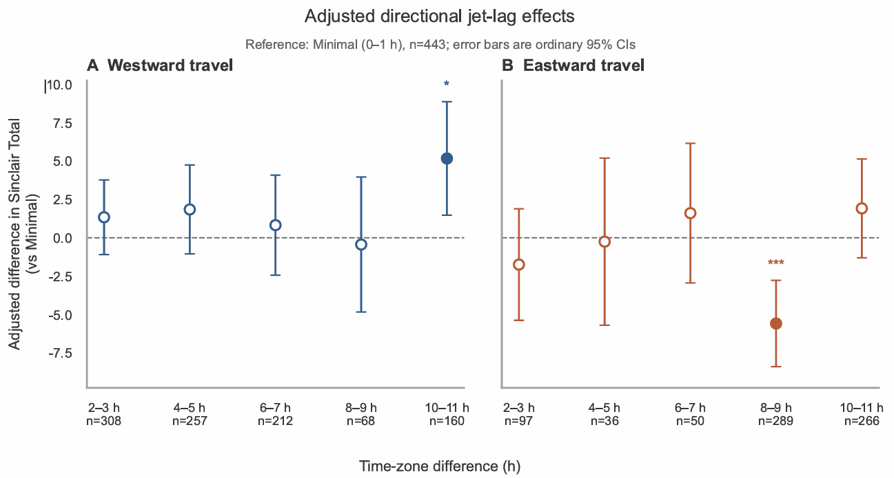
Figure 1. Adjusted associations between directional jet-lag categories and Sinclair Total, stratified by travel direction. Points represent model coefficients relative to Minimal (0–1 h), vertical error bars represent ordinary 95% confidence intervals, and sample sizes are shown below the x-axis. Asterisks indicate categories significant after Benjamini–Hochberg FDR correction.

3.3 补充稳健性结果（先不放正文
未控制旅行时长的补充模型同样显示时差分组整体显著（LR=51.82，df=10，p=1.23×10⁻⁷），其中East 8–9 h的估计为−7.77分（普通95% CI −10.27至−5.27，d=−0.59）。加入旅行时长后，该估计减弱至−5.58分但仍显著，说明East 8–9 h的负向关联不能被估计旅行时长完全解释。（Table 3）
与未控制旅行时长的模型相比，加入旅行时长后，多数方向性时差组的效应估计向正方向移动，但不同组的变化程度并不一致（Figure 2）。

3.3 Supplementary robustness analysis
The supplementary model without travel-duration adjustment also showed an overall association between directional jet-lag category and Sinclair Total (LR=51.82, df=10, p=1.23×10⁻⁷). In that model, the East 8–9 h estimate was −7.77 points (ordinary 95% CI −10.27 to −5.27, d=−0.59). After travel-duration adjustment, the estimate attenuated to −5.58 points but remained statistically significant, indicating that the negative association in the East 8–9 h category was not fully accounted for by estimated travel duration (Table 3).
Compared with the model without travel-duration adjustment, estimates for most directional jet-lag categories shifted in the positive direction after adjustment, although the magnitude of this change varied across categories (Figure 2).
Table 3. Robustness analyses for travel-duration adjustment
Analysis | LR | df | p
Directional jet-lag groups, unadjusted model | 51.82 | 10 | 1.23×10⁻⁷
LRT-A: travel duration beyond directional jet lag | 10.86 | 1 | 9.80×10⁻⁴
LRT-B: directional jet lag beyond travel duration | 53.27 | 10 | 6.63×10⁻⁸
Note. LRT-A tests the additional contribution of travel duration beyond directional jet-lag groups; LRT-B tests the joint contribution of directional jet-lag groups after adjustment for travel duration. All likelihood ratio tests were fitted by maximum likelihood.
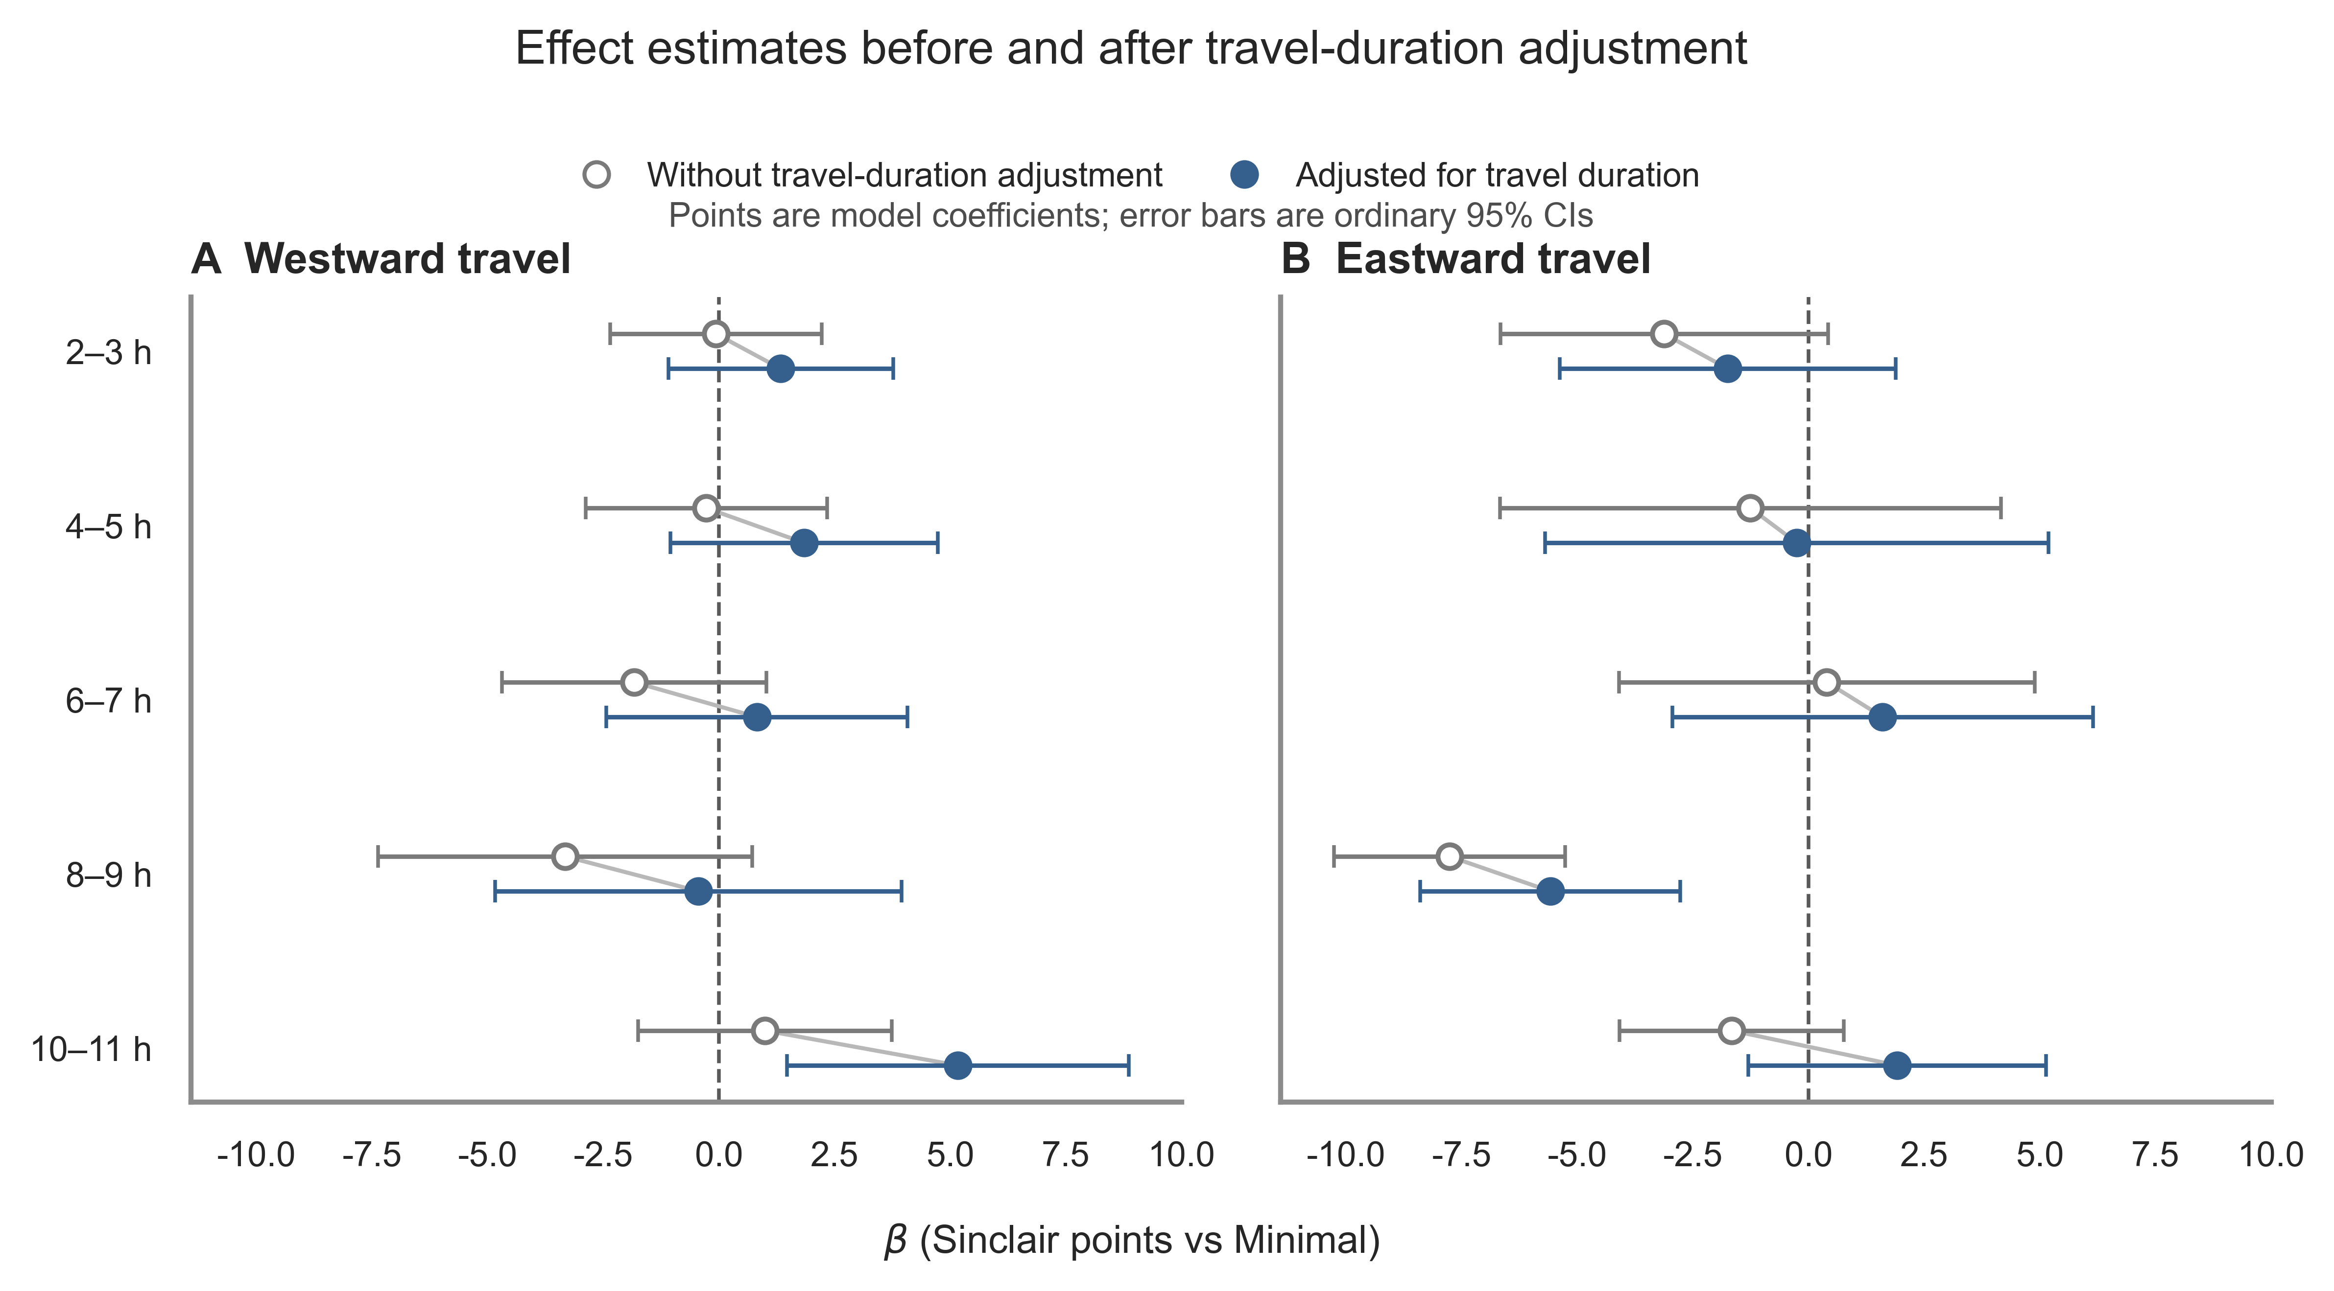
Figure 2. Comparison of directional jet-lag effect estimates before and after adjustment for travel duration. Open circles indicate estimates from the model without travel-duration adjustment, filled circles indicate estimates from the travel-duration-adjusted model, connecting lines link estimates for the same directional jet-lag group, and horizontal error bars indicate ordinary 95% confidence intervals. The Minimal (0–1 h) group is the reference.

