主模型拟合与似然比检验
LRT-B（时差总体效应） | Full vs 去掉 JetLagGroup_dir | 53.27 | 10 | 6.63 × 10⁻⁸
LRT-A（旅行疲劳独立贡献） | Full vs 去掉 TravelDuration_c | 10.86 | 1 | 9.80 × 10⁻⁴

主模型固定效应系数
固定效应 | β | SE | 95% CI | p
Intercept | 433.86 | 1.52 | [430.88, 436.83] | < .001
Women (vs Men) | −149.75 | 1.81 | [−153.30, −146.21] | < .001
TravelDuration_c (per h) | −0.22 | 0.07 | [−0.35, −0.09] | 0.001
West 2–3h | 1.34 | 1.24 | [−1.09, 3.77] | 0.281
West 4–5h | 1.84 | 1.48 | [−1.05, 4.74] | 0.212
West 6–7h | 0.82 | 1.66 | [−2.44, 4.08] | 0.621
West 8–9h | −0.44 | 2.24 | [−4.84, 3.96] | 0.845
West 10–11h | 5.17 | 1.88 | [1.47, 8.86] | 0.006
East 2–3h | −1.75 | 1.85 | [−5.38, 1.89] | 0.346
East 4–5h | −0.25 | 2.78 | [−5.69, 5.19] | 0.928
East 6–7h | 1.6 | 2.32 | [−2.94, 6.15] | 0.489
East 8–9h | −5.58 | 1.43 | [−8.40, −2.77] | < .001
East 10–11h | 1.91 | 1.64 | [−1.31, 5.14] | 0.244

数据分布
分组 | 记录数 | 占比
West_10–11h | 160 | 6.9%
West_8–9h | 82 | 3.6%
West_6–7h | 212 | 9.2%
West_4–5h | 257 | 11.1%
West_2–3h | 308 | 13.3%
Minimal(0–1h)（参照组） | 511 | 22.1%
East_2–3h | 119 | 5.2%
East_4–5h | 44 | 1.9%
East_6–7h | 50 | 2.2%
East_8–9h | 299 | 13.0%
East_10–11h | 266 | 11.5%

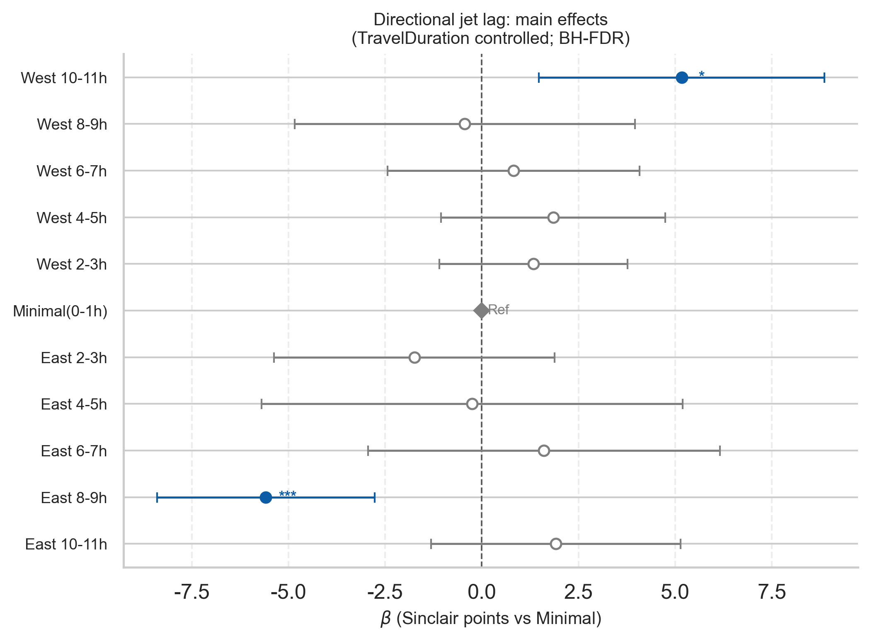

方向性时差组 vs 参照组 Minimal(0–1h) 的事后比较（上面的结果做了FDR校正之后的结果）
emmeans 等价对比 + BH-FDR；效应量 d = β / σ_ε（σ_ε = 174.47）。Minimal(0–1h)，n = 443（未列入下表）。
Jet lag group | n | β (vs Minimal) | SE | 95% CI | Cohen's d | p | p_FDR | Sig_FDR
West 10–11h | 160 | +5.17 | 1.88 | [1.47, 8.86] | 0.030 | .006 | .031 | *
West 8–9h | 68 | −0.44 | 2.24 | [−4.83, 3.96] | −0.003 | .845 | .928
West 6–7h | 212 | +0.82 | 1.66 | [−2.44, 4.08] | 0.005 | .621 | .776
West 4–5h | 257 | +1.84 | 1.48 | [−1.05, 4.74] | 0.011 | .212 | .562
West 2–3h | 308 | +1.34 | 1.24 | [−1.09, 3.77] | 0.008 | .281 | .562
East 2–3h | 97 | −1.75 | 1.85 | [−5.38, 1.89] | −0.010 | .346 | .577
East 4–5h | 36 | −0.25 | 2.78 | [−5.69, 5.19] | −0.001 | .928 | .928
East 6–7h | 50 | +1.60 | 2.32 | [−2.94, 6.15] | 0.009 | .489 | .699
East 8–9h | 289 | −5.58 | 1.43 | [−8.40, −2.77] | −0.032 | < .001 | < .001 | ***
East 10–11h | 266 | +1.91 | 1.64 | [−1.31, 5.14] | 0．011 | .244 | .562

