## Proforma Receipt

#### Receipt No: ORBIT/2025/1/{{receipt_no}} Date: {{date}}

#### Received from:

#### Customer Name: {{customer_name}}

#### Address: {{address_line1}}

#### Phone Number: {{phone}}

#### Email (if available): {{email}}

#### Payment Details:

#### Amount Received: Rs. {{amount_received}}/-

#### Payment Mode: {{payment_mode}}

#### Reference ID (if available): {{reference_id}}

#### Date of Payment: {{payment_date}}

**Towards:**

Full payment for Orbit PT Pro Electric Power Tiller

Balance amount of ₹ 0 /- to be paid before delivery.

Delivery date: {{delivery_date}}

**Acknowledgement:**

We acknowledge receipt of the above-mentioned amount as the final installment towards booking of the Orbit PT Pro Electric Power Tiller. This receipt confirms the reservation of your machine. The final invoice will be issued 1 week after full payment and delivery.

**Authorised Signatory**

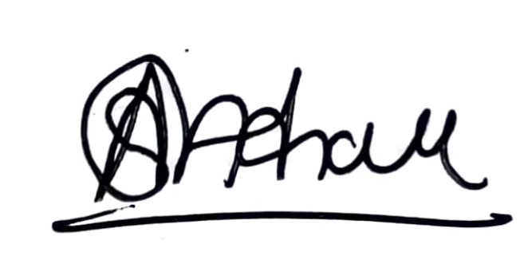

For Higher Orbit Agritech Pvt. Ltd.

GST: 27AAHCH1976Q1ZS

## Annexure

|  |  |
| --- | --- |
| Item Name | Quantity |
| 12 HP PT Pro | {{ quantity_pt_pro }} |
| Battery Sets | {{ quantity_battery }} |
| Fast Chargers | {{ quantity_charger }} |
| 1 Set of Sugarcane Blades(Weeding) | {{ quantity_blade_weeding }} |
| 1 Set of Sugarcane Blades(Earthing-up) | {{ quantity_blade_earthing }} |
| 1 Set of Tyres (5x10) | {{ quantity_tyres }} |
| Toolkit | {{ quantity_toolkit }} |
| Ginger Kit | {{ quantity_ginger }} |
| Seat | {{ quantity_seat }} |
| Jack | {{ quantity_jack }} |
| BuyBack Guarantee | {{ quantity_buyback_guarantee }} |
| Front Dead Weight | {{ quantity_front_dead_weight }} |
| Wheel Dead Weight | {{ quantity_wheel_dead_weight }} |