## Quotation Summary

Quotation No: ORBIT/2025/1/{{quotation_no}} Date: {{date}}

#### Customer Name: {{customer_name}}

#### Address: {{address_line1}}

#### Phone Number: {{phone}}

|  |  |
| --- | --- |
| Item Name | Quantity |
| 12 HP PT Pro | {{ quantity_pt_pro }} |
| Battery Sets | {{ quantity_battery }} |
| Fast Chargers | {{ quantity_charger }} |
| 1 Set of Sugarcane Blades(Weeding) | {{ quantity_blade_weeding }} |
| 1 Set of Sugarcane Blades(Earthing-up) | {{ quantity_blade_earthing }} |
| 1 Set of Tyres (5x10) | {{ quantity_tyres }} |
| Toolkit | {{ quantity_toolkit }} |
| Ginger Kit | {{ quantity_ginger }} |
| Seat | {{ quantity_seat }} |
| Jack | {{ quantity_jack }} |
| BuyBack Guarantee | {{ quantity_buyback_guarantee }} |

**Quotation Details:**

Total Price: Rs. **{{total_price}}/-**

Subsidy Applied: Rs. **{{subsidy}}/-**

Subsidised Price (All Inclusive): Rs. **{{final_price}}/-**

**Authorised Signatory**

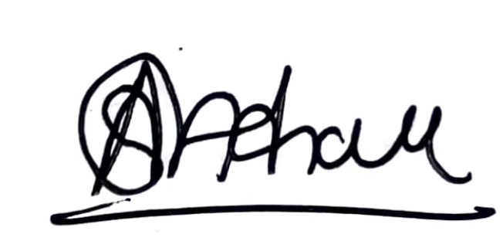

For Higher Orbit Agritech Pvt. Ltd.