UML and Process Diagrams
  - Amaranth v2 — context, data flow, use case, activity, sequence, component, deployment, state and ER diagrams
2026-10-19

Document control
Field | Value
Title | UML and Process Diagrams
Document ID | AMR-DOC-05
Version | 1.0
Date | 2026-10-19
Author | Amaranth development team [TO CONFIRM: names]
Status | Final draft for defense
Sources | Mermaid files in docs/diagrams/*.mmd; PNG and SVG renders beside them

Contents
- Diagram catalogue
- Context and data flow
- Use cases
- Activities
- Sequences
- Structure: layers, components, classes, deployment
- States
- Entity–relationship diagrams
All diagrams are drawn from the code. Each caption names the files the diagram was checked against. Edit the .mmd source and re-render to update a diagram (AMR-DOC-10 §8).

1. Diagram catalogue
ID | Diagram | File | Checked against
CTX-1 | System context | ctx-1-context | vercel.json, src/lib/supabase.ts, api/
DFD-0 | Data flow, level 0 | dfd-0-level0 | feature modules
DFD-1 | Data flow, level 1 | dfd-1-level1 | tables per module
UC-1 | Use cases: writers, editors, publishers | uc-1-writers-editors | app.article_before_write
UC-2 | Use cases: managers | uc-2-managers | role helpers, RLS
UC-3 | Use cases: Salingkusog team | uc-3-salingkusog | app.can_edit_sk, sk_team
UC-4 | Use cases: readers | uc-4-readers | public routes, /api/submit
ACT-1 | Article submission to publication | act-1-article-publication | workflow trigger
ACT-2 | Scheduling a game to an updated medal table | act-2-game-to-medal-table | salingkusog.sql
SEQ-1 | Login and role check | seq-1-login-role | LoginPage.tsx, AuthProvider.tsx, guards.tsx
SEQ-2 | Publish an article | seq-2-publish-article | transition_article, triggers
SEQ-3 | Enter results and medals | seq-3-enter-results | sk_set_placements, ResultsTab.tsx
SEQ-4 | Live score update | seq-4-live-score | Scorekeeper.tsx, skData.ts
SEQ-5 | Schedule import | seq-5-schedule-import | scheduleCsv.ts, ImportTab.tsx
SEQ-6 | Public form with CAPTCHA and attachments | seq-6-public-form | api/submit.ts, src/lib/sendForm.ts
ARCH-1 | Layered architecture | arch-1-layers | repository structure
CMP-1 | Front-end components | cmp-1-components | src/ folders
CLS-1 | Domain class model | cls-1-domain | core tables
DEP-1 | Deployment | dep-1-deployment | vercel.json, Supabase services
STATE-1 | Article lifecycle | state-1-article | app.article_before_write
STATE-2 | Game status | state-2-game | statusActions() in scoring.ts, sk_match_status
ERD-1 | Content ERD | erd-1-content | schema.sql (generated)
ERD-2 | People, intake and settings ERD | erd-2-people-intake | schema.sql (generated)
ERD-3 | Salingkusog ERD | erd-3-salingkusog | salingkusog.sql (generated)
ERD-4 | Statistics ERD | erd-4-statistics | stats.sql (generated)

2. Context and data flow

CTX-1 System context
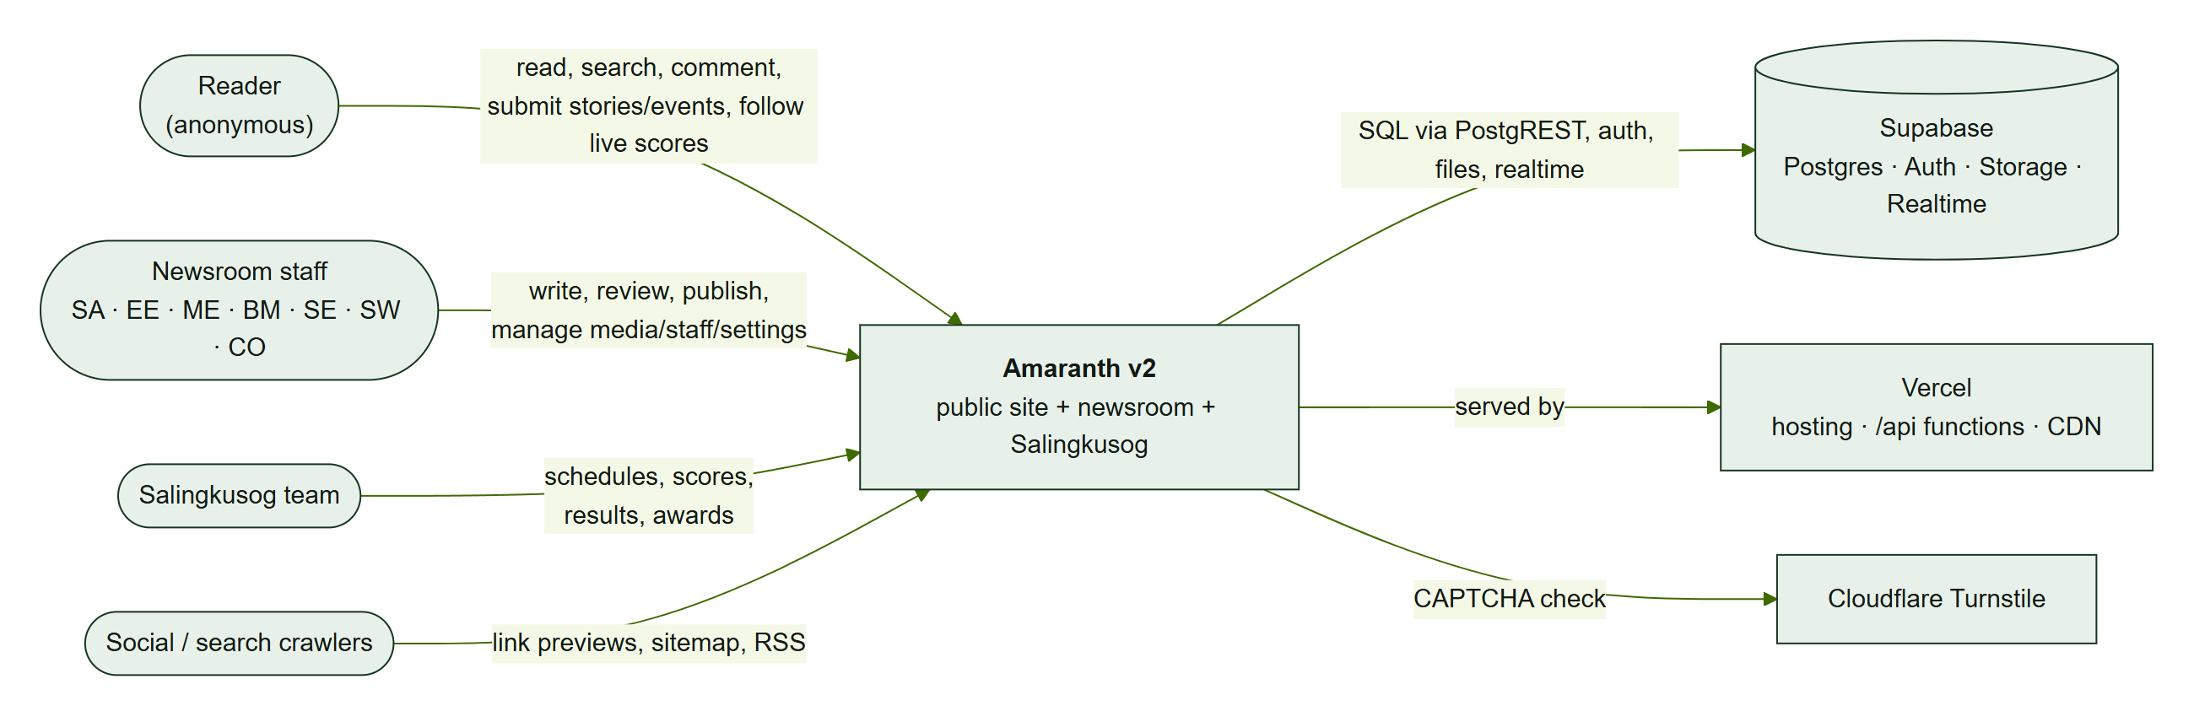
CTX-1 — Amaranth v2 and the people and services around it.
Amaranth v2 is one web application with three audiences. All persistent data and authentication are in Supabase; Vercel hosts the app and runs the small server functions; Cloudflare Turnstile checks public forms.

DFD-0 Level 0
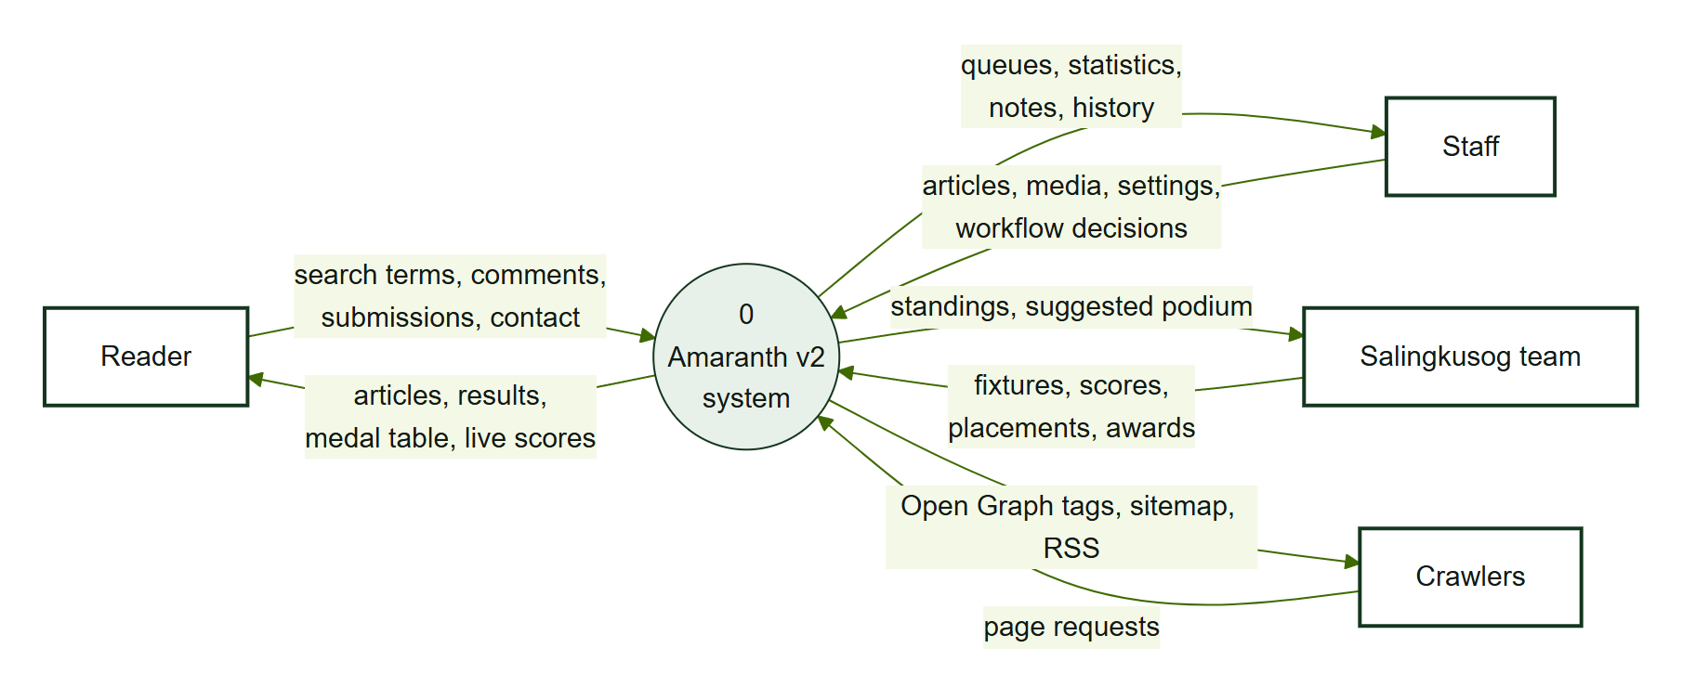
DFD-0 — the system as a single process with its external entities.

DFD-1 Level 1
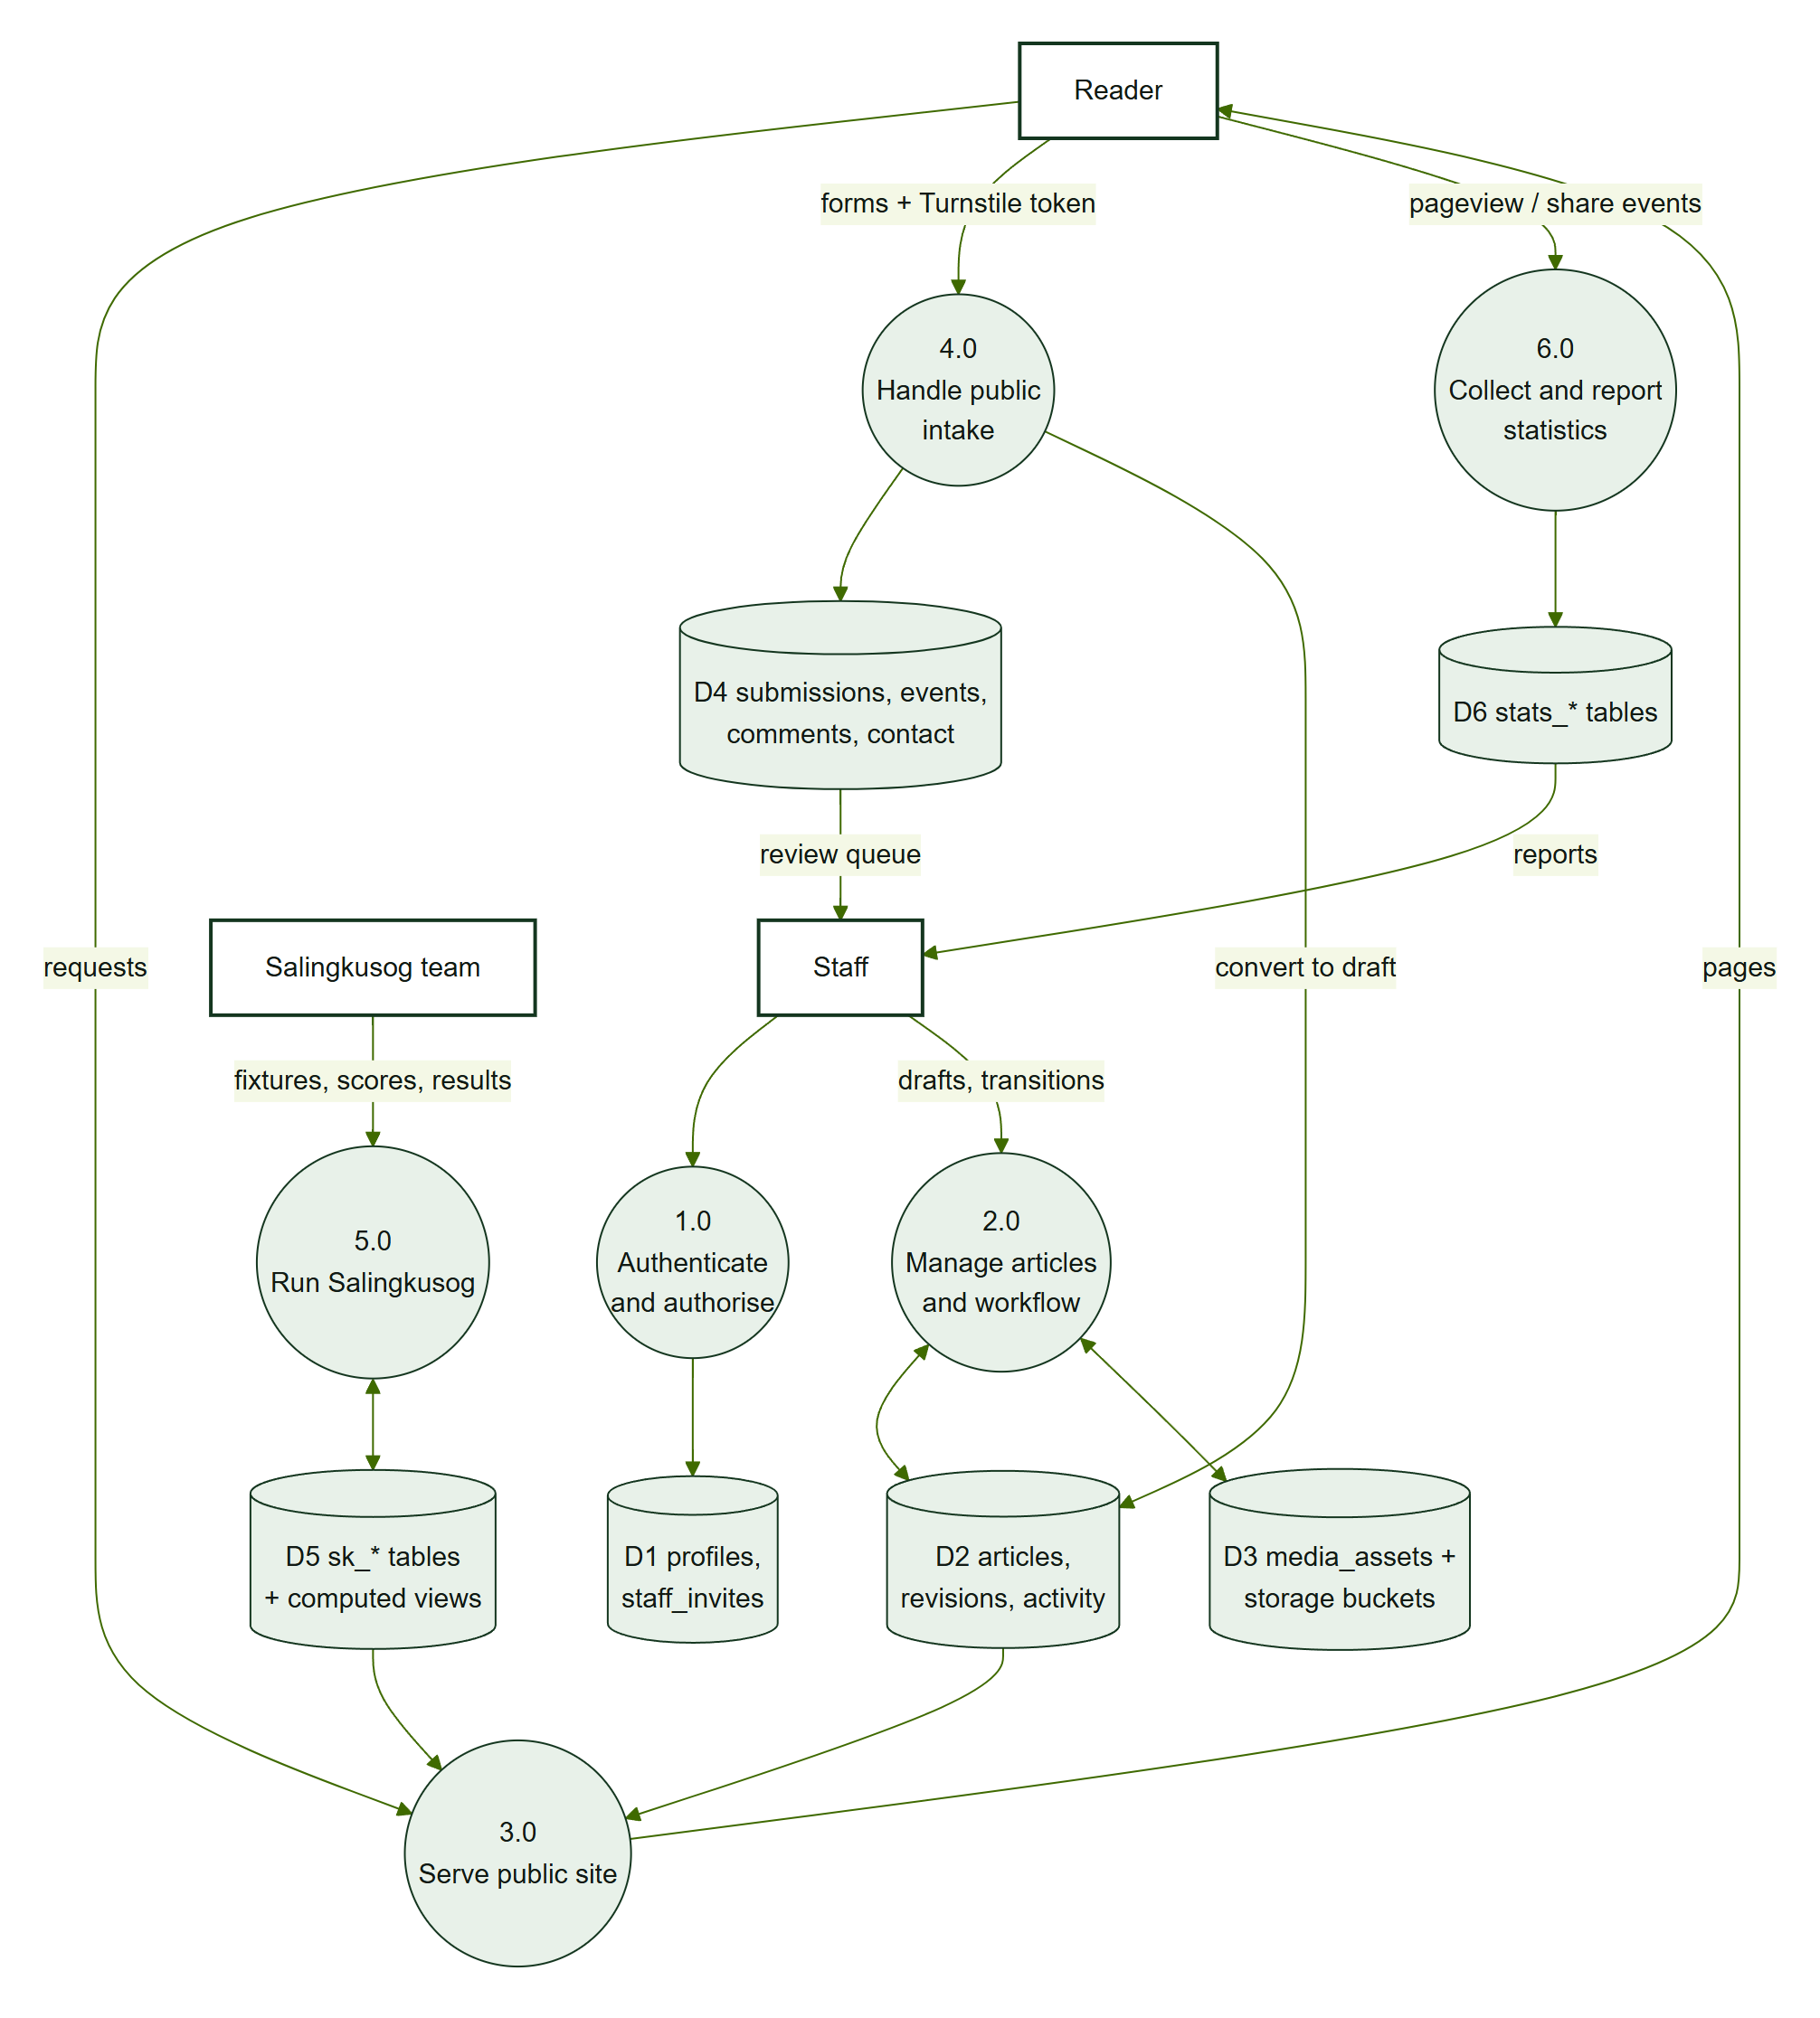
DFD-1 — six processes and their data stores.
Process | Main code | Data stores
1.0 Authenticate and authorise | features/auth, app.current_role | D1 profiles, staff_invites
2.0 Manage articles and workflow | features/cms/articles, transition_article | D2 articles, D3 media
3.0 Serve public site | features/public, api/r.ts, middleware.ts | D2, D5
4.0 Handle public intake | api/submit.ts, features/cms/intake | D4
5.0 Run Salingkusog | features/cms/salingkusog, salingkusog.sql | D5
6.0 Collect and report statistics | api/e.ts, stats.sql, features/cms/statistics | D6

3. Use cases

UC-1 Writers, editors and publishers
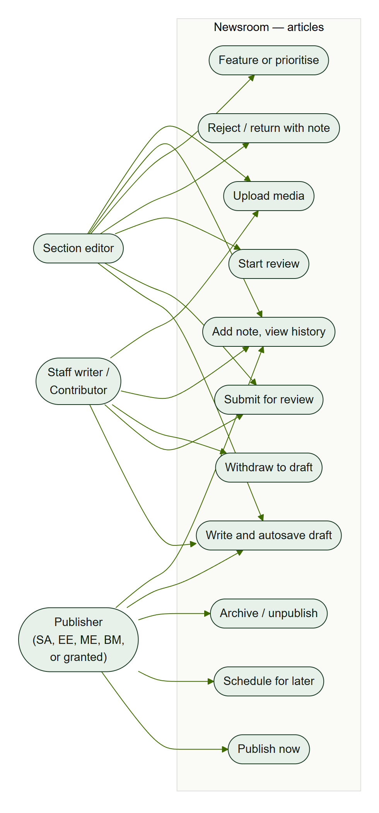
UC-1 — article use cases by role. “Publisher” means SA, EE, ME, BM or staff granted publishing access.

UC-2 Managers
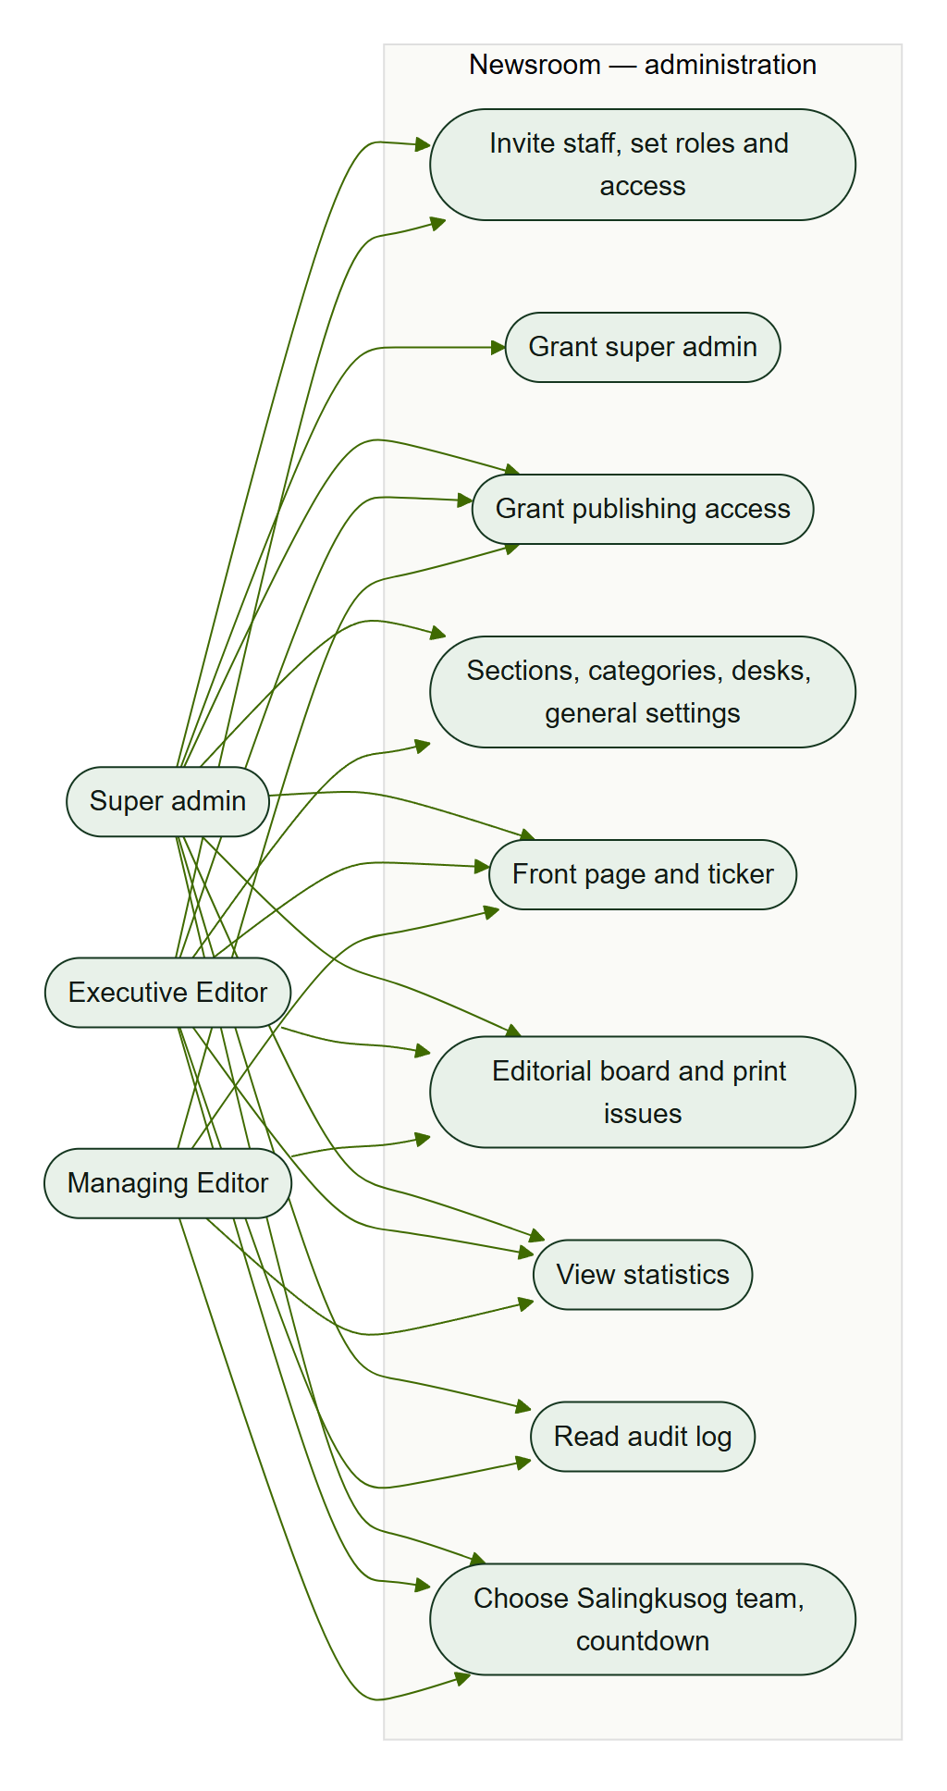
UC-2 — administration use cases for Super admin, Executive Editor and Managing Editor.

UC-3 Salingkusog team
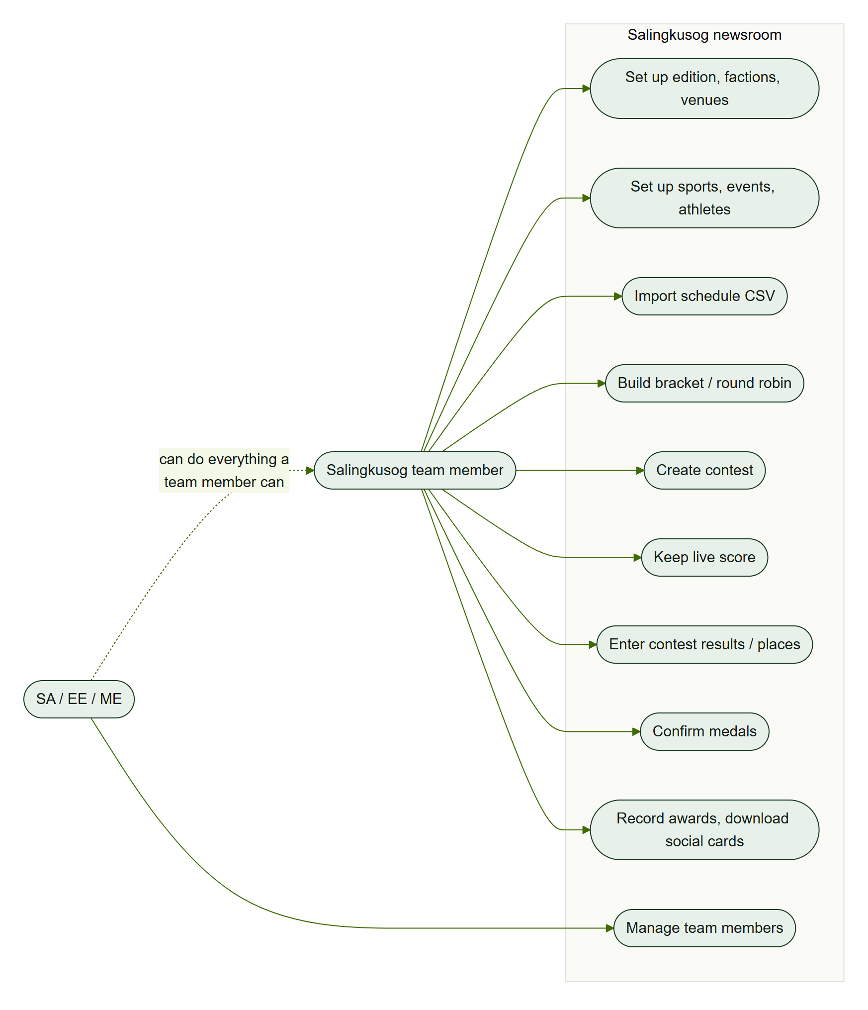
UC-3 — Salingkusog newsroom use cases.

UC-4 Readers
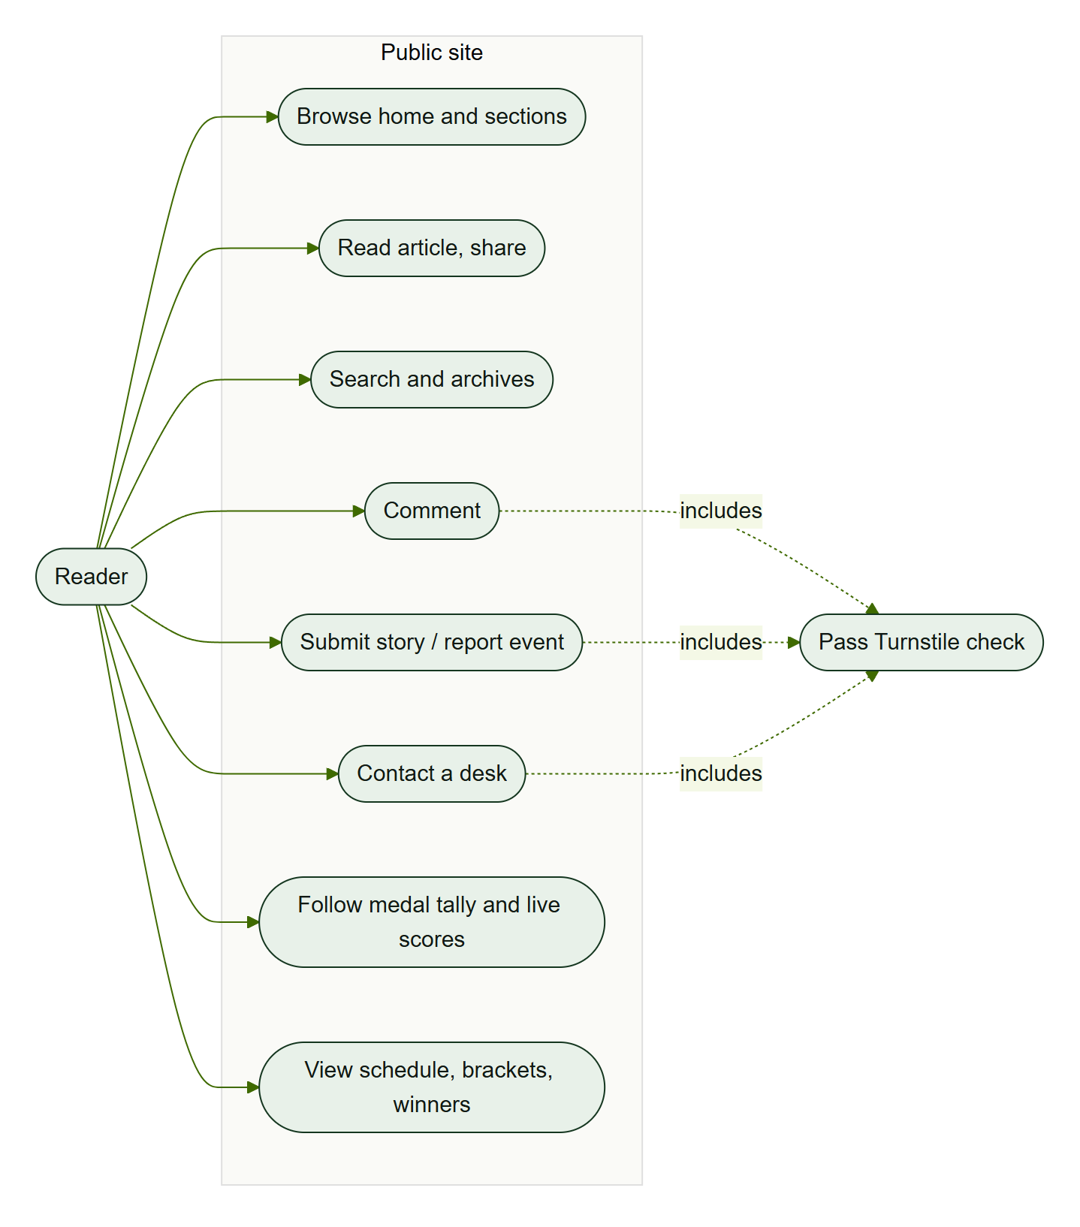
UC-4 — public use cases; forms include the Turnstile check.

4. Activities

ACT-1 Article submission to publication
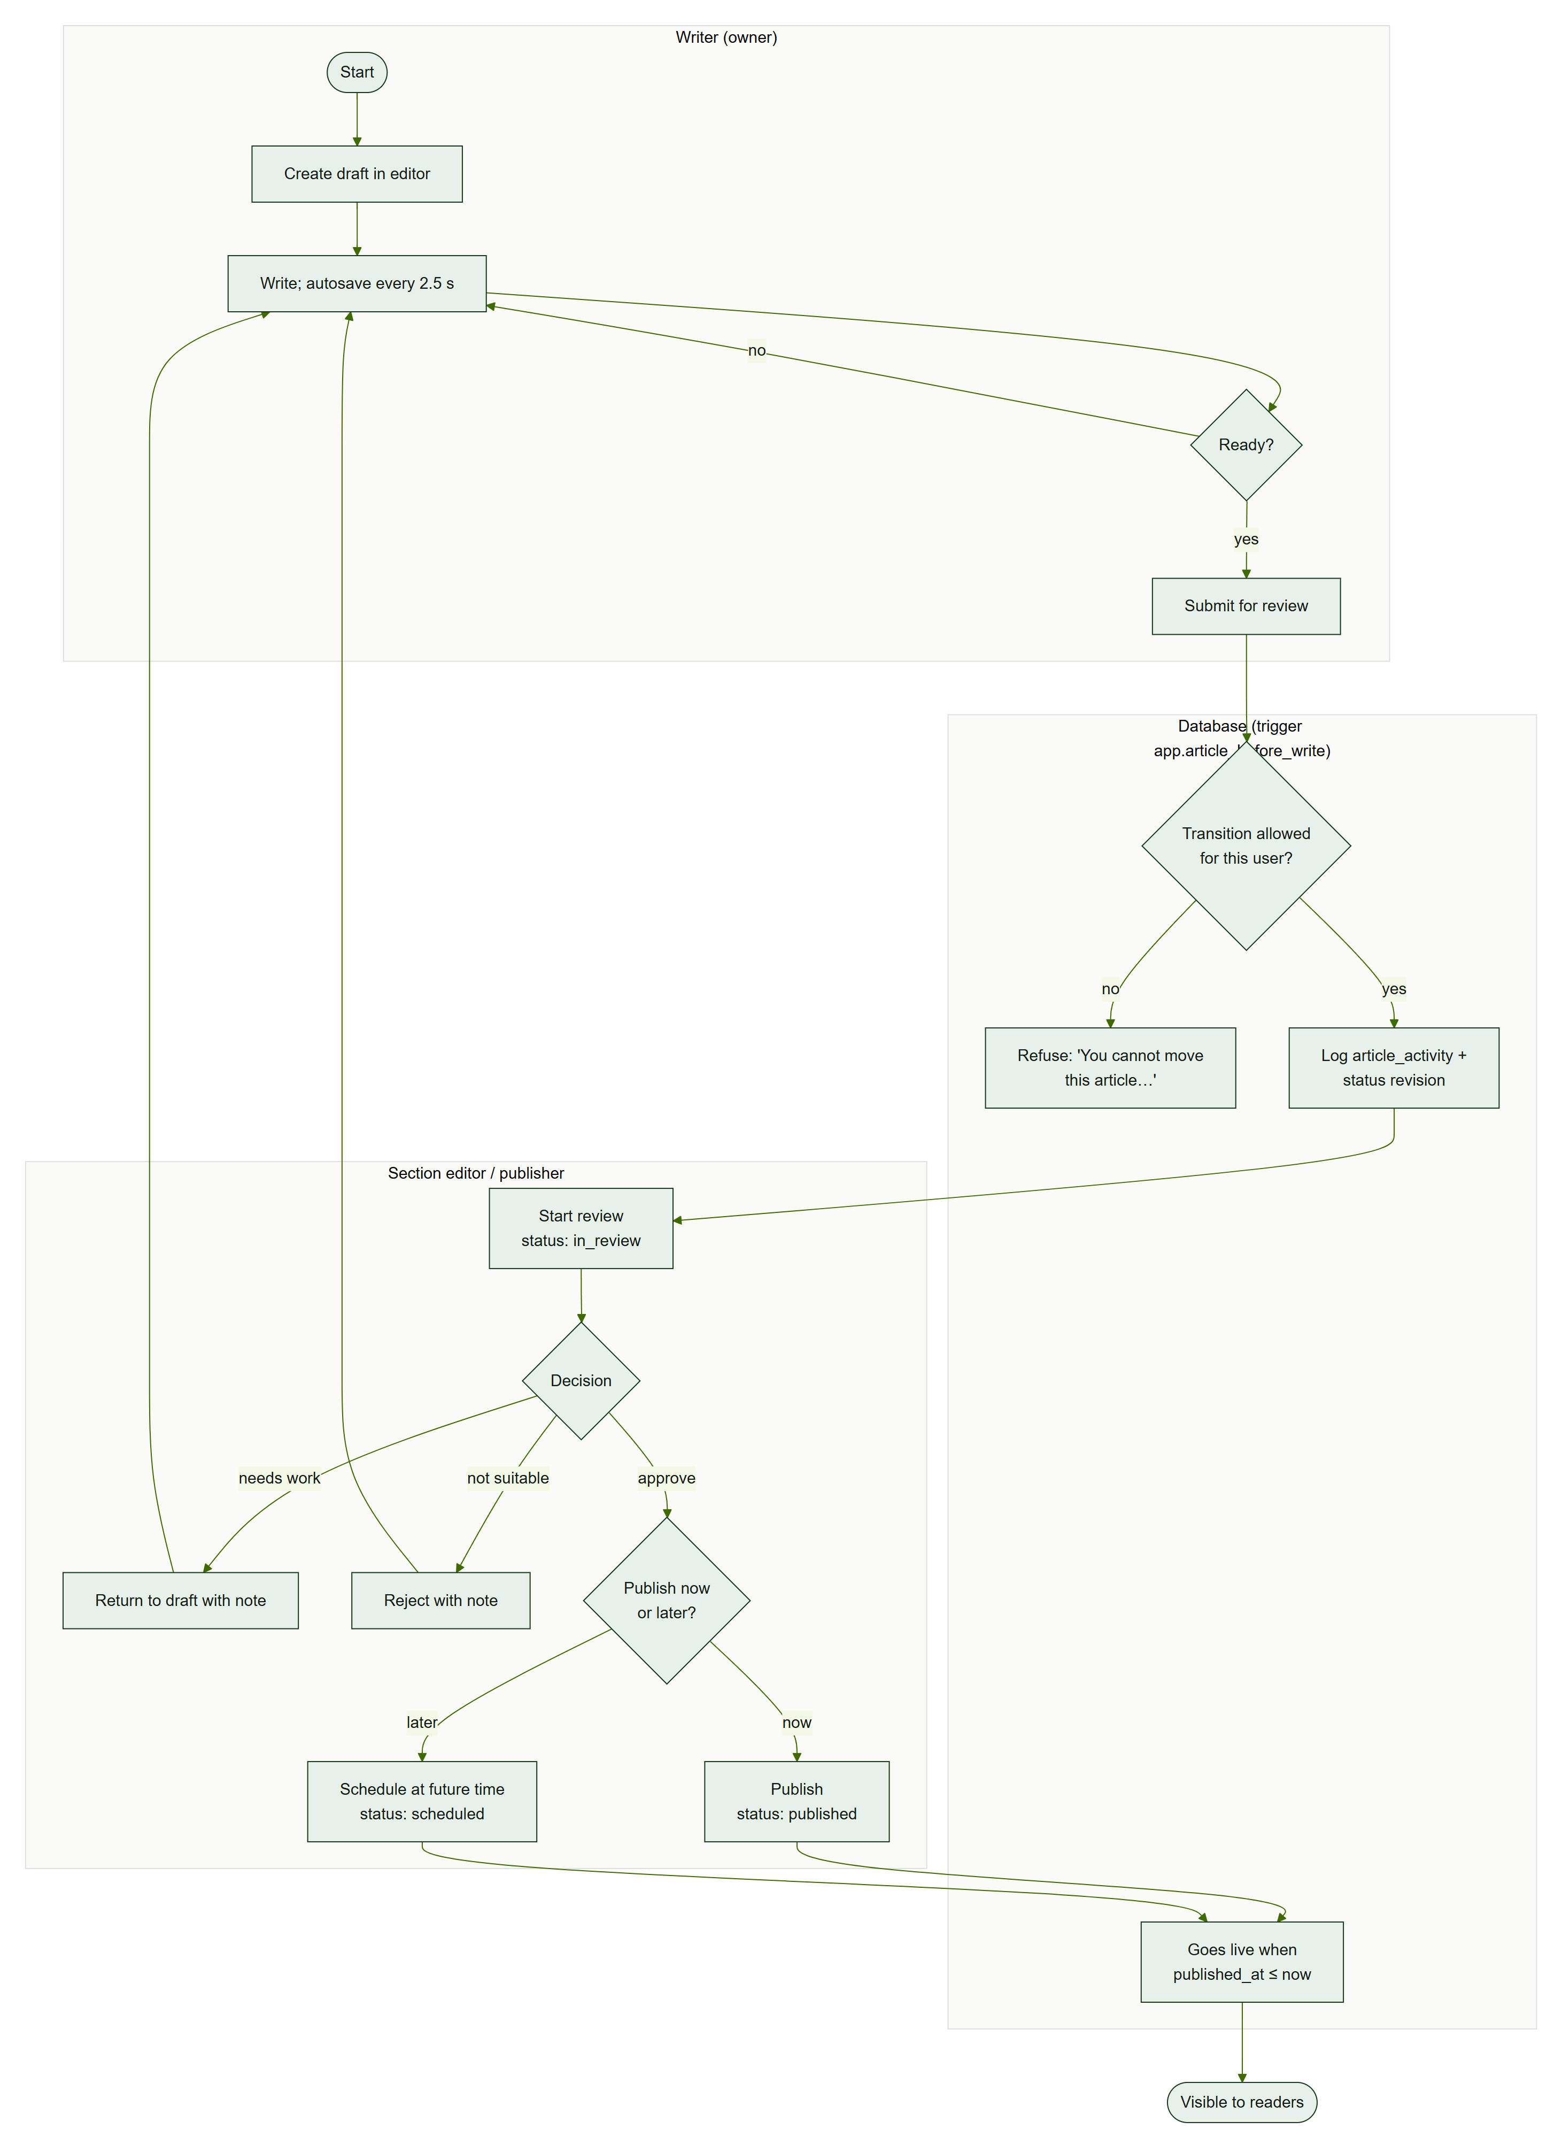
ACT-1 — from draft to a live article. Every transition is checked by the database trigger.

ACT-2 Scheduling a game to an updated medal table
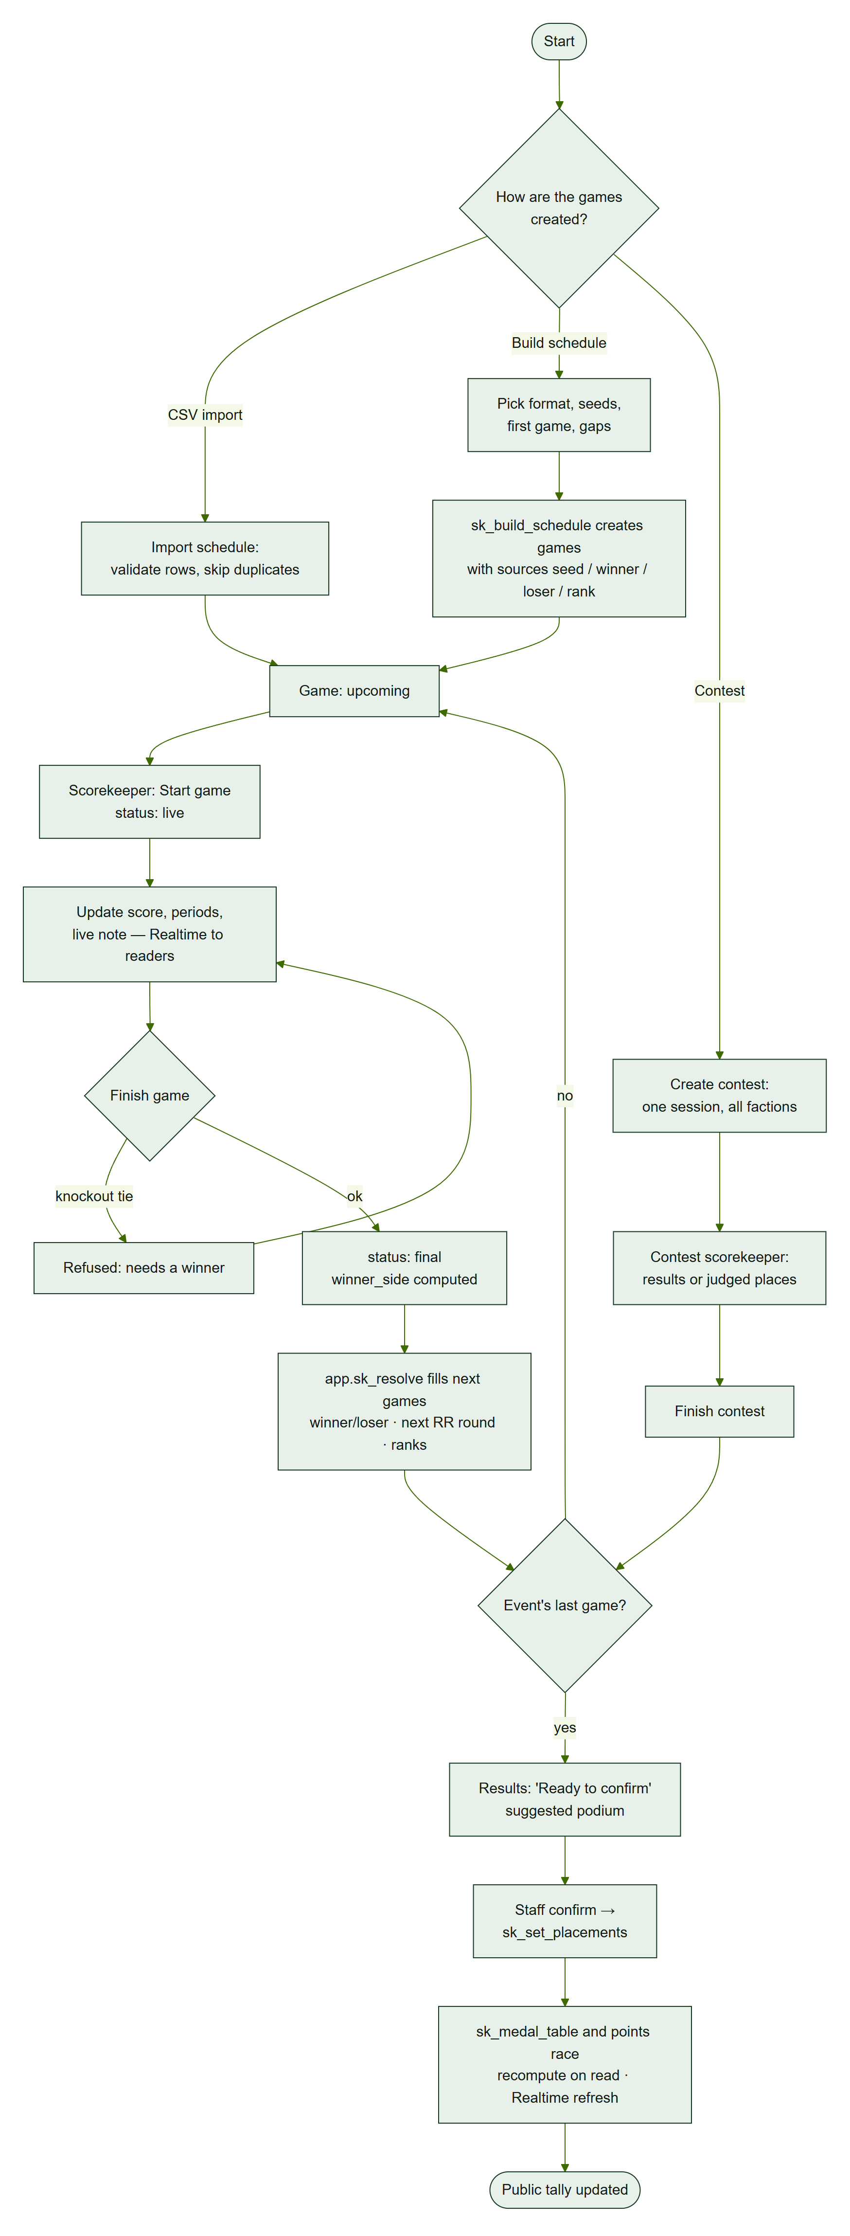
ACT-2 — three ways to create games, live scoring, automatic advancement and staff-confirmed medals.

5. Sequences

SEQ-1 Login and role check
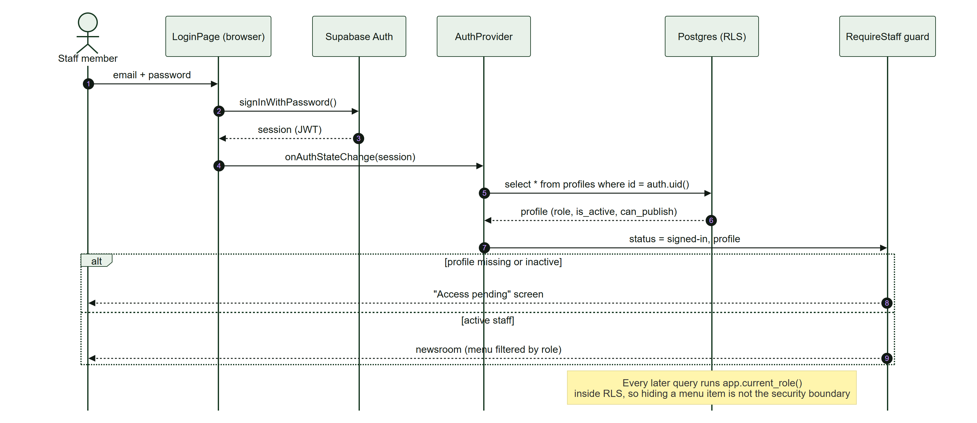
SEQ-1 — sign-in, profile load and the RequireStaff guard. The database re-checks the role on every query.

SEQ-2 Publish an article
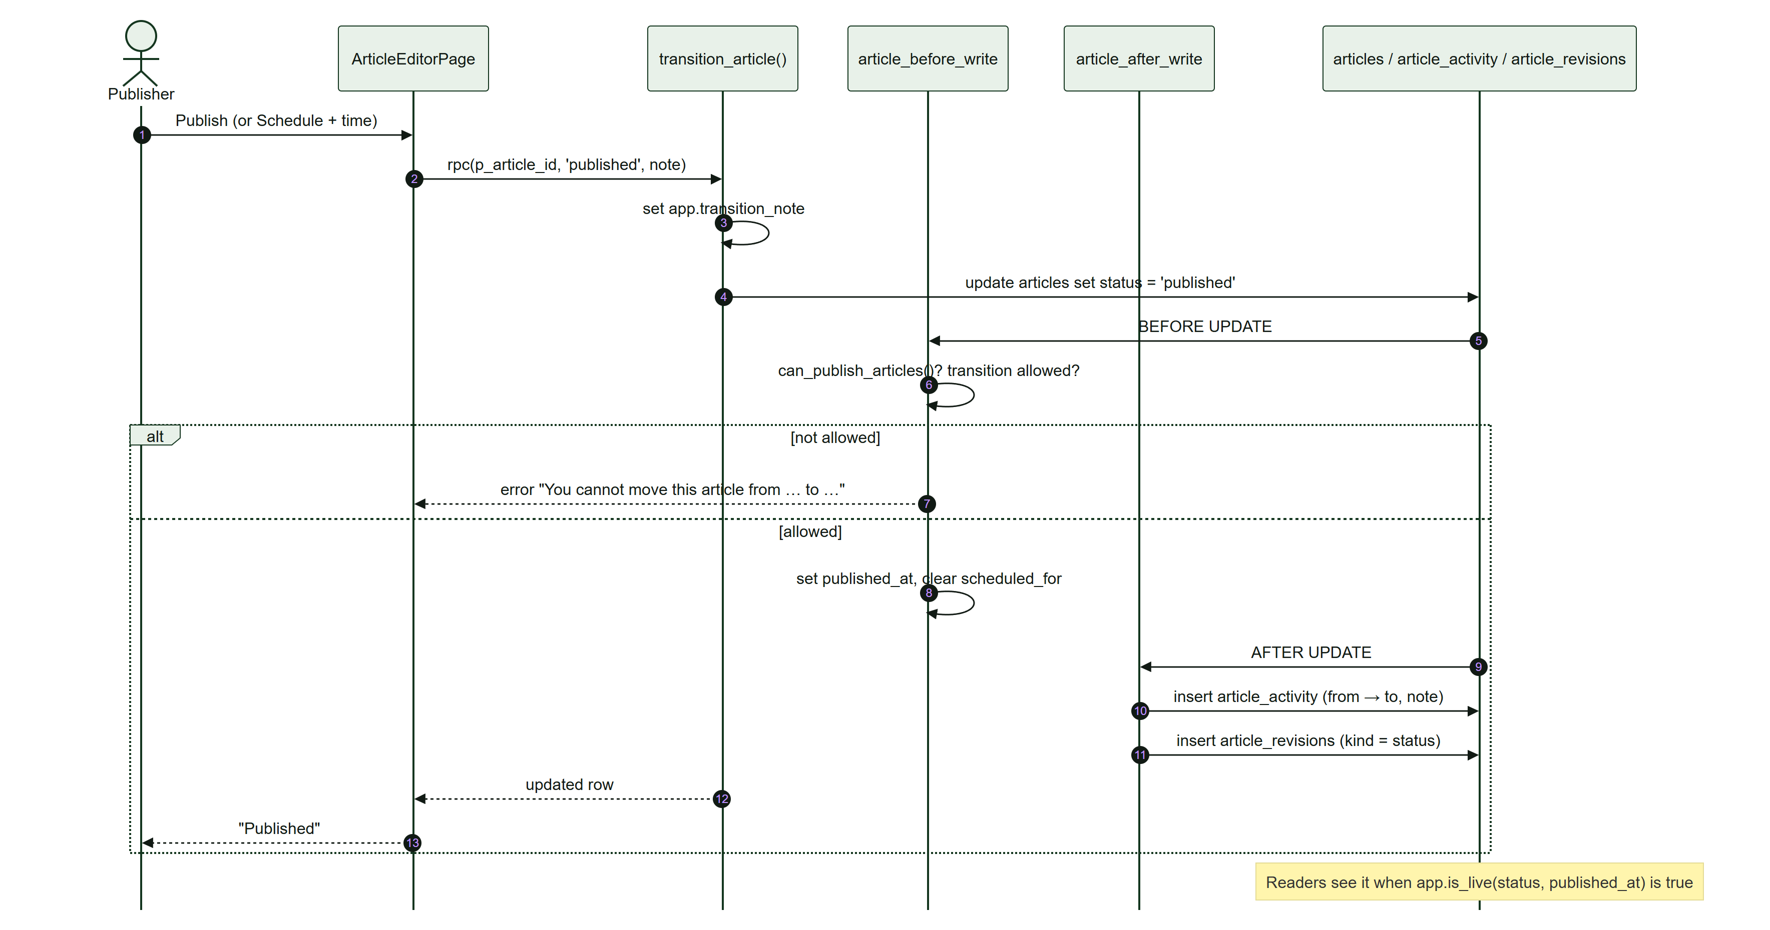
SEQ-2 — publishing through transition_article and the article triggers.

SEQ-3 Enter results and medals
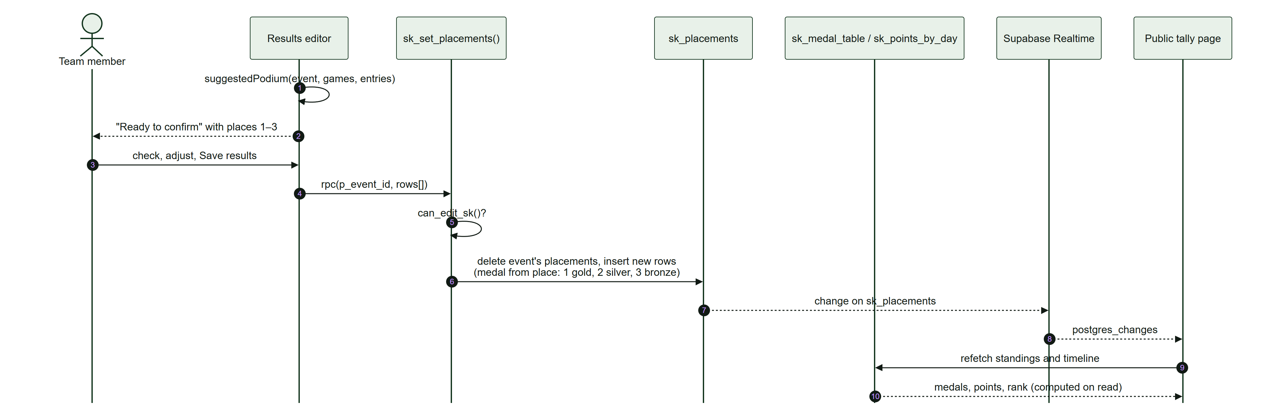
SEQ-3 — confirming medals; the medal table and points are computed when read.

SEQ-4 Live score update
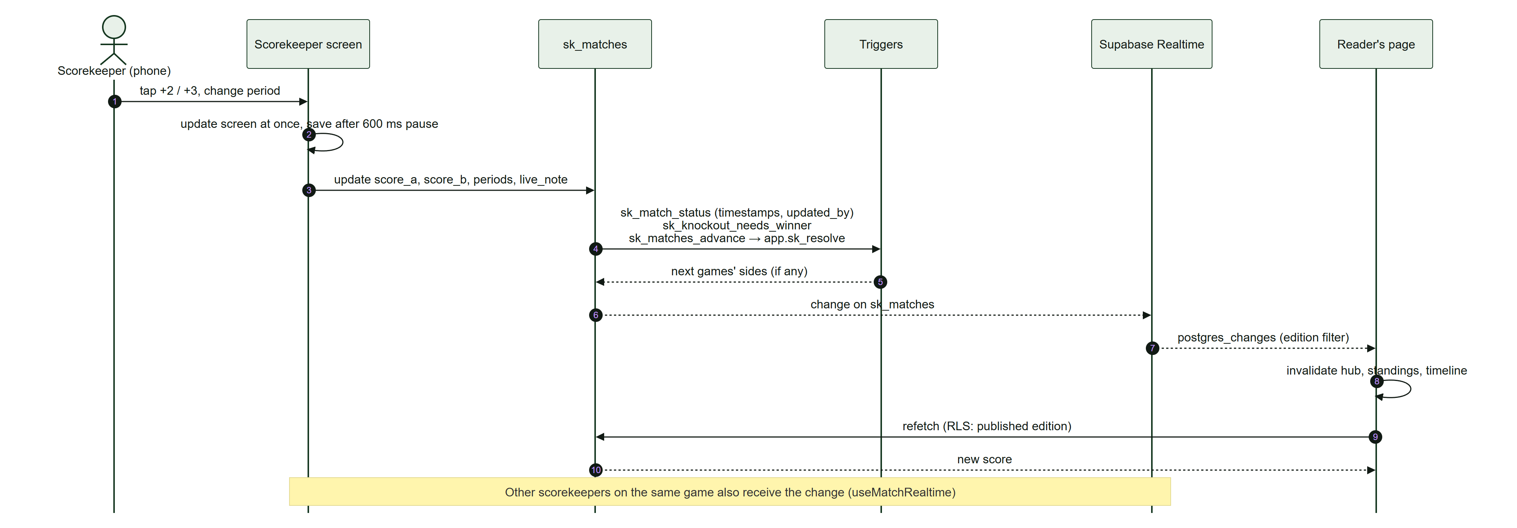
SEQ-4 — a score tap reaches every open page through Supabase Realtime.

SEQ-5 Schedule import
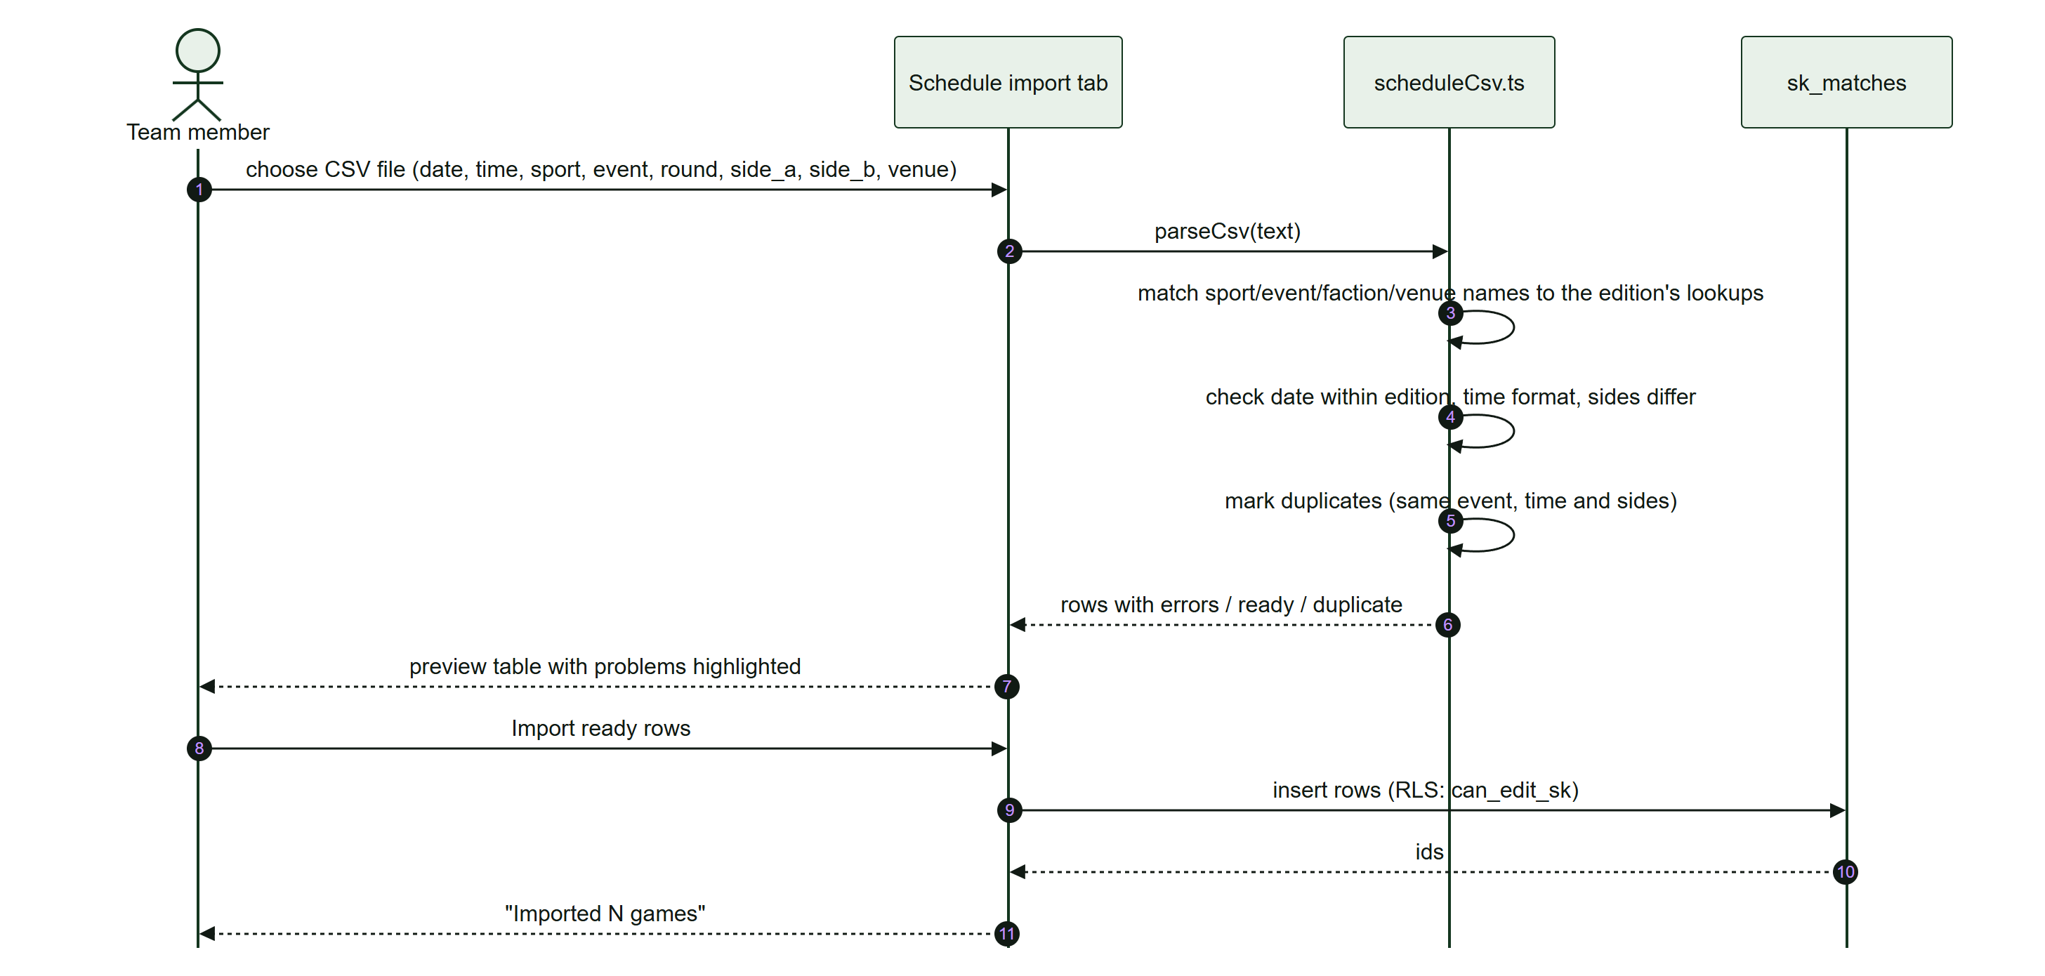
SEQ-5 — CSV import with validation and duplicate detection.

SEQ-6 Public form with CAPTCHA and attachments
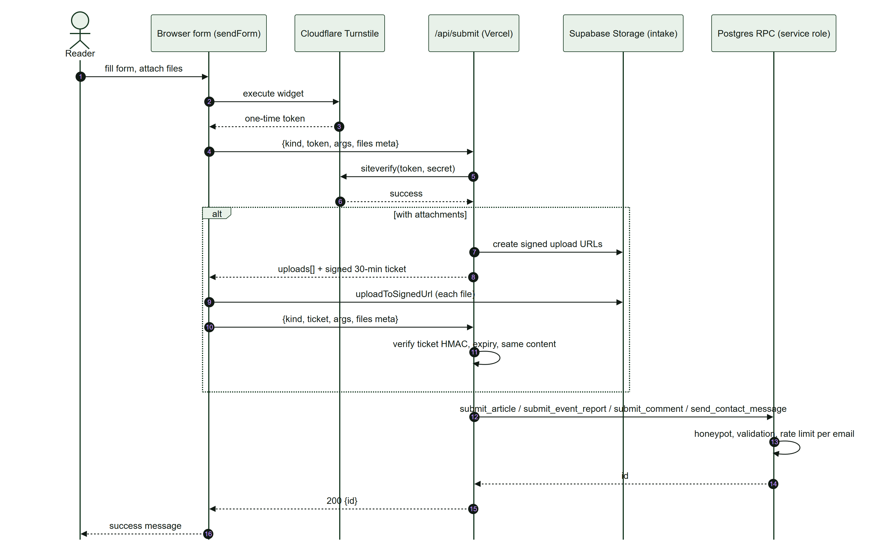
SEQ-6 — the /api/submit gateway: Turnstile, signed uploads, signed ticket, service-role RPC.

6. Structure

ARCH-1 Layered architecture
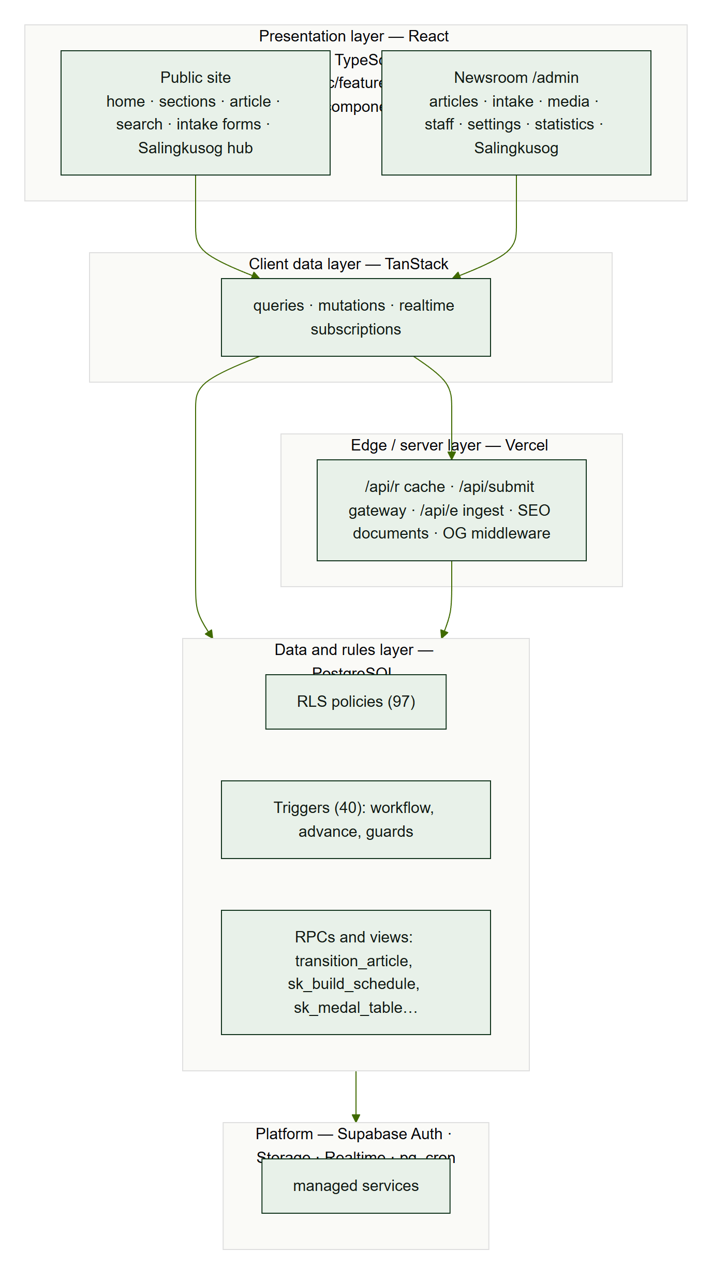
ARCH-1 — five layers from React pages to Supabase platform services.

CMP-1 Front-end components
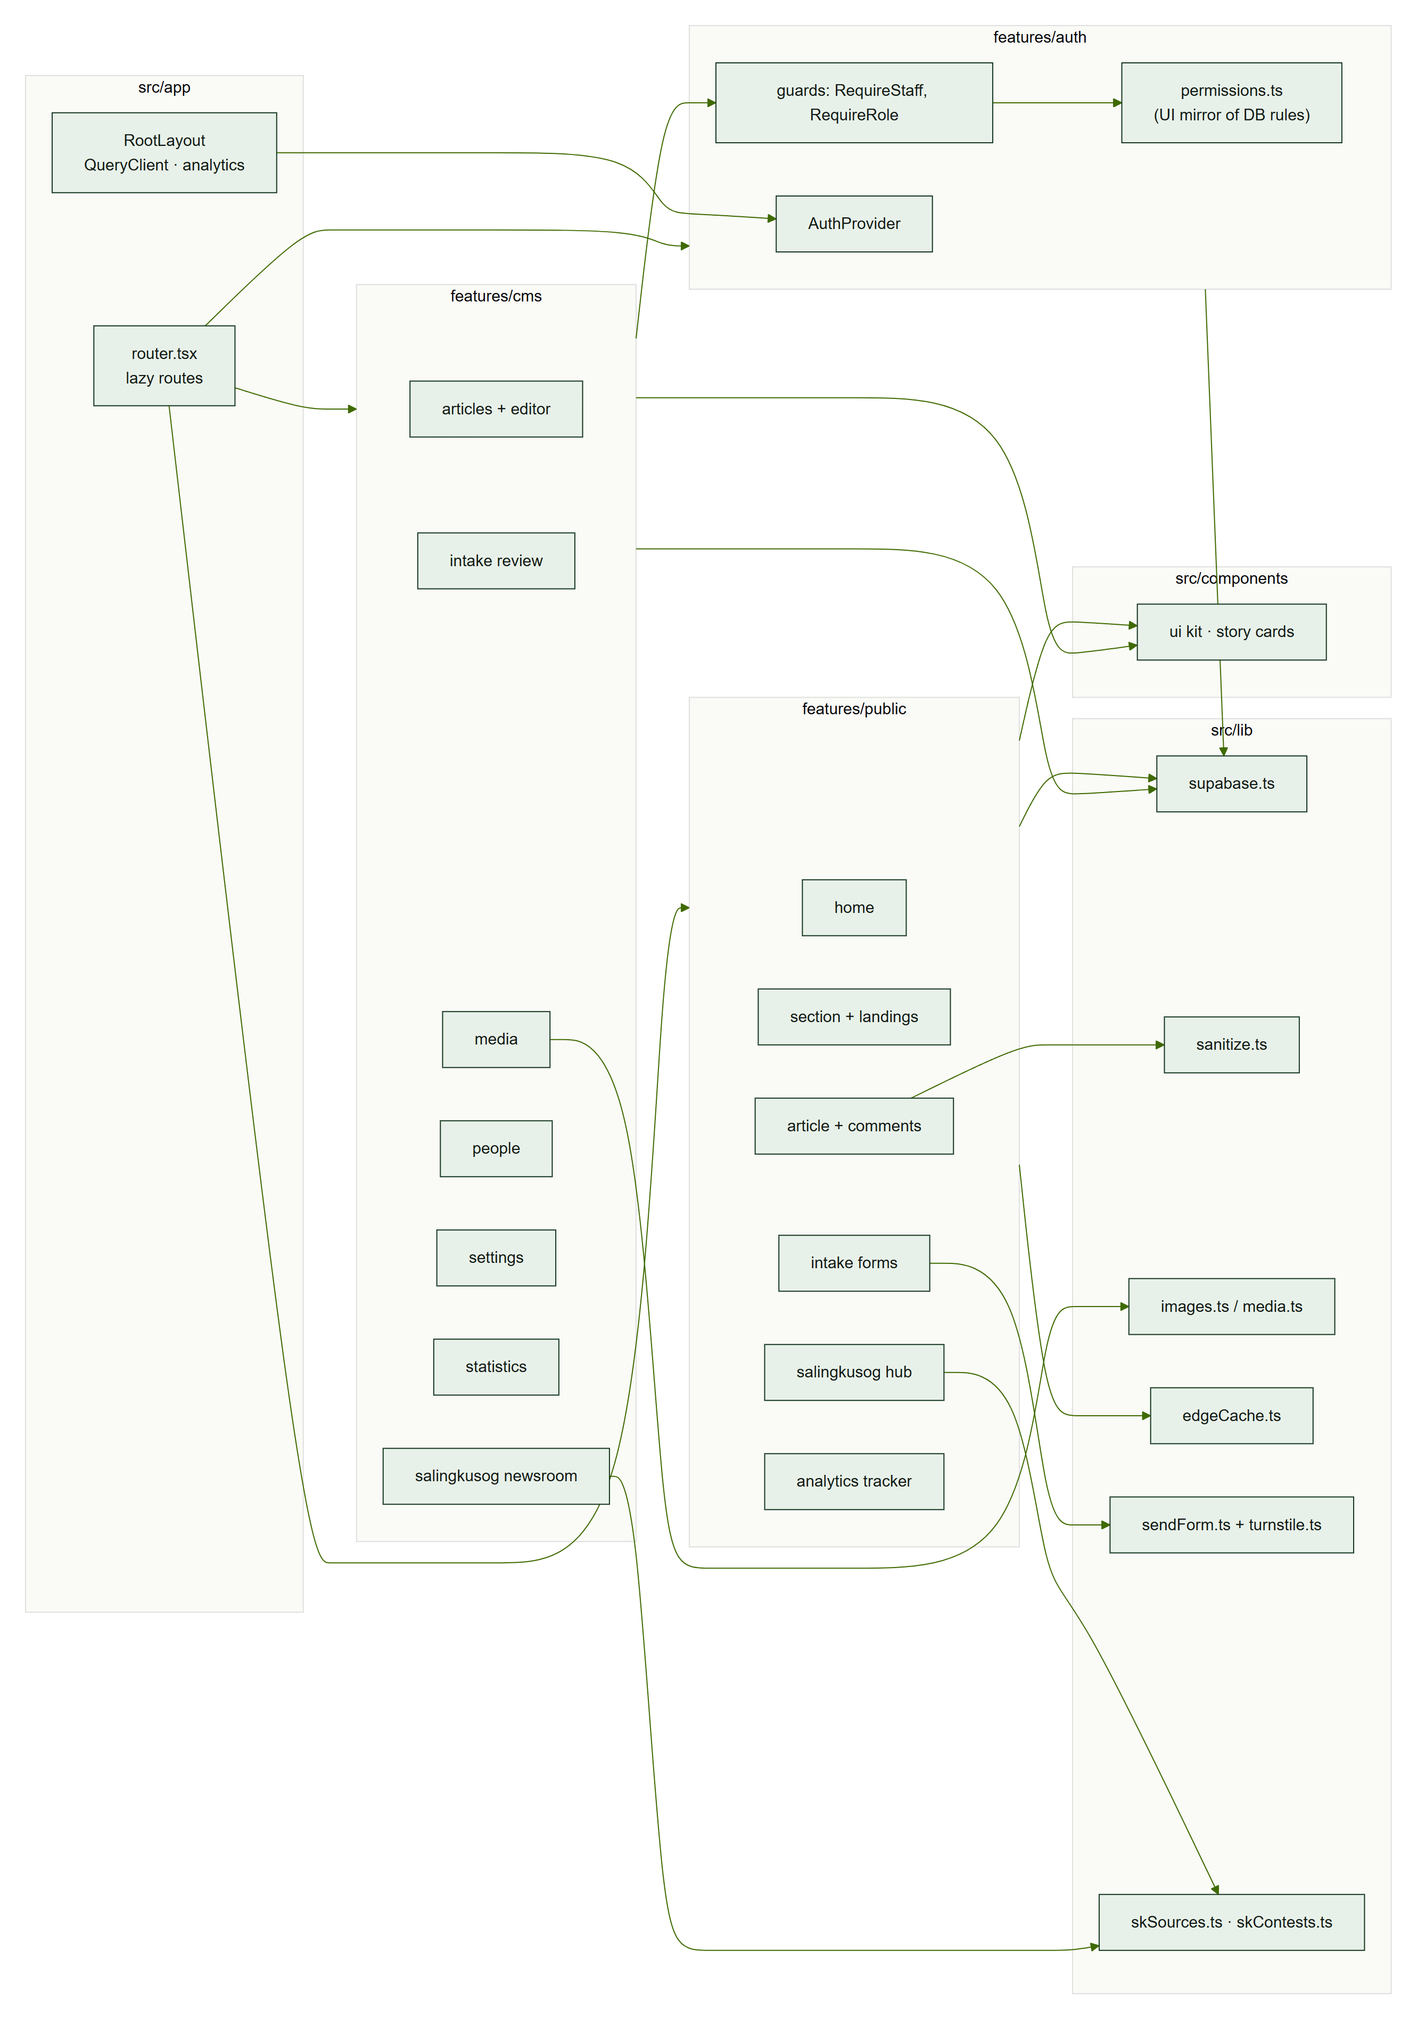
CMP-1 — main front-end modules and shared libraries.

CLS-1 Domain class model
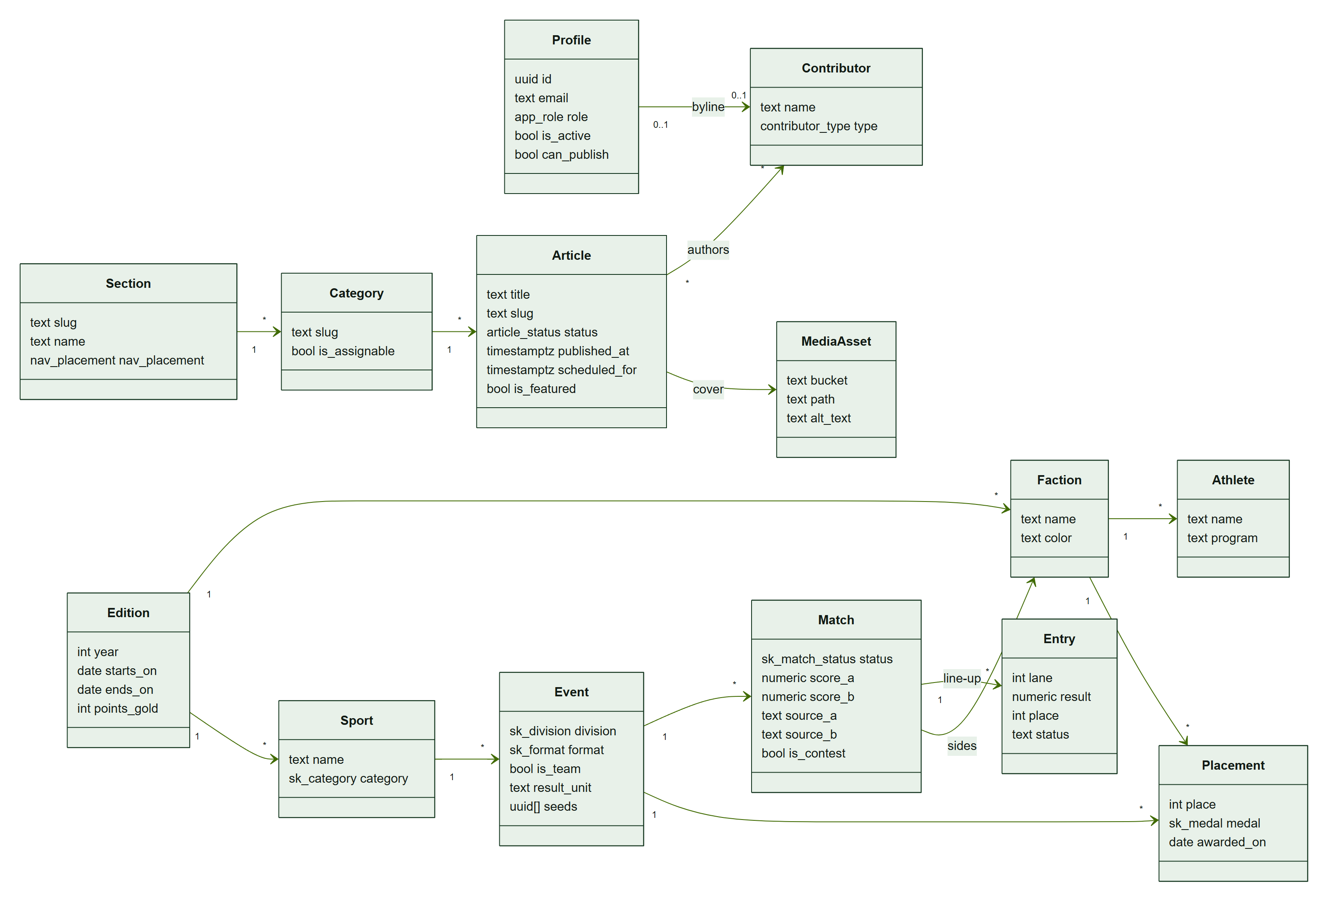
CLS-1 — the main domain entities and their relationships (simplified; full columns in AMR-DOC-04).

DEP-1 Deployment
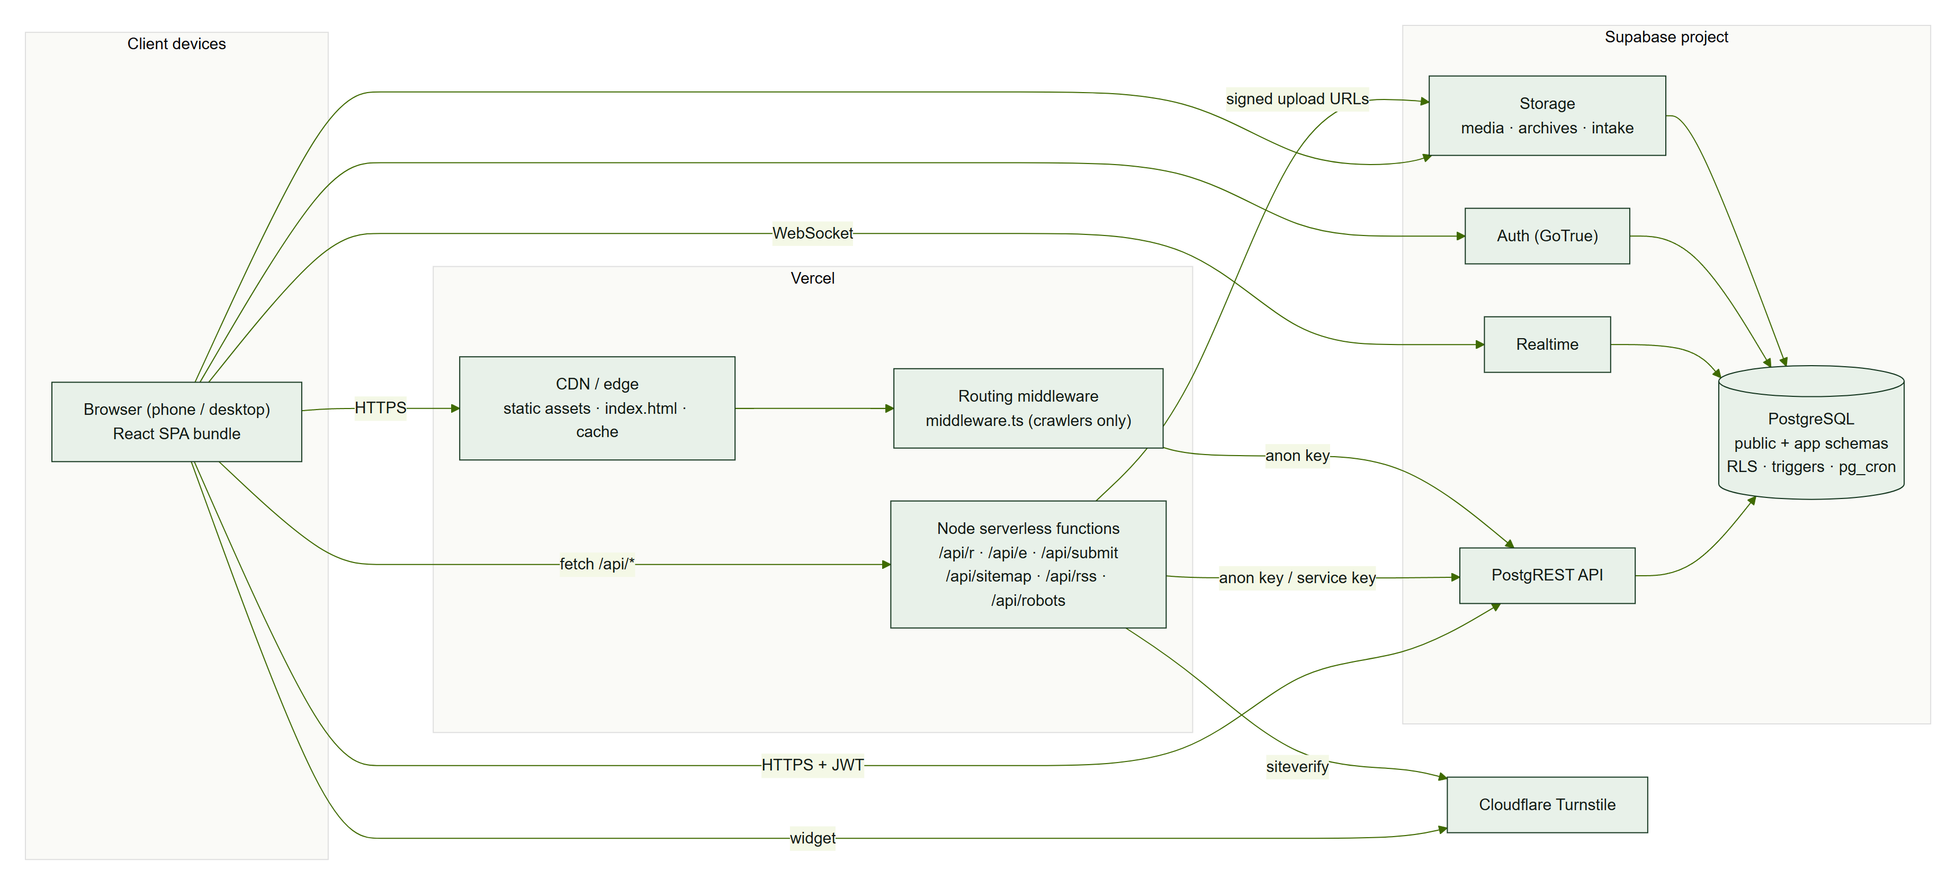
DEP-1 — browsers, Vercel and Supabase services.

7. States

STATE-1 Article lifecycle
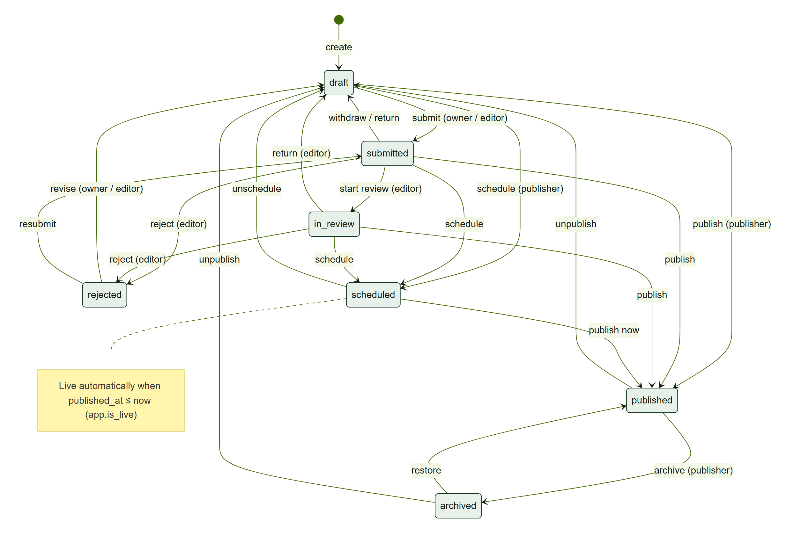
STATE-1 — article statuses and who may move between them.

STATE-2 Game status
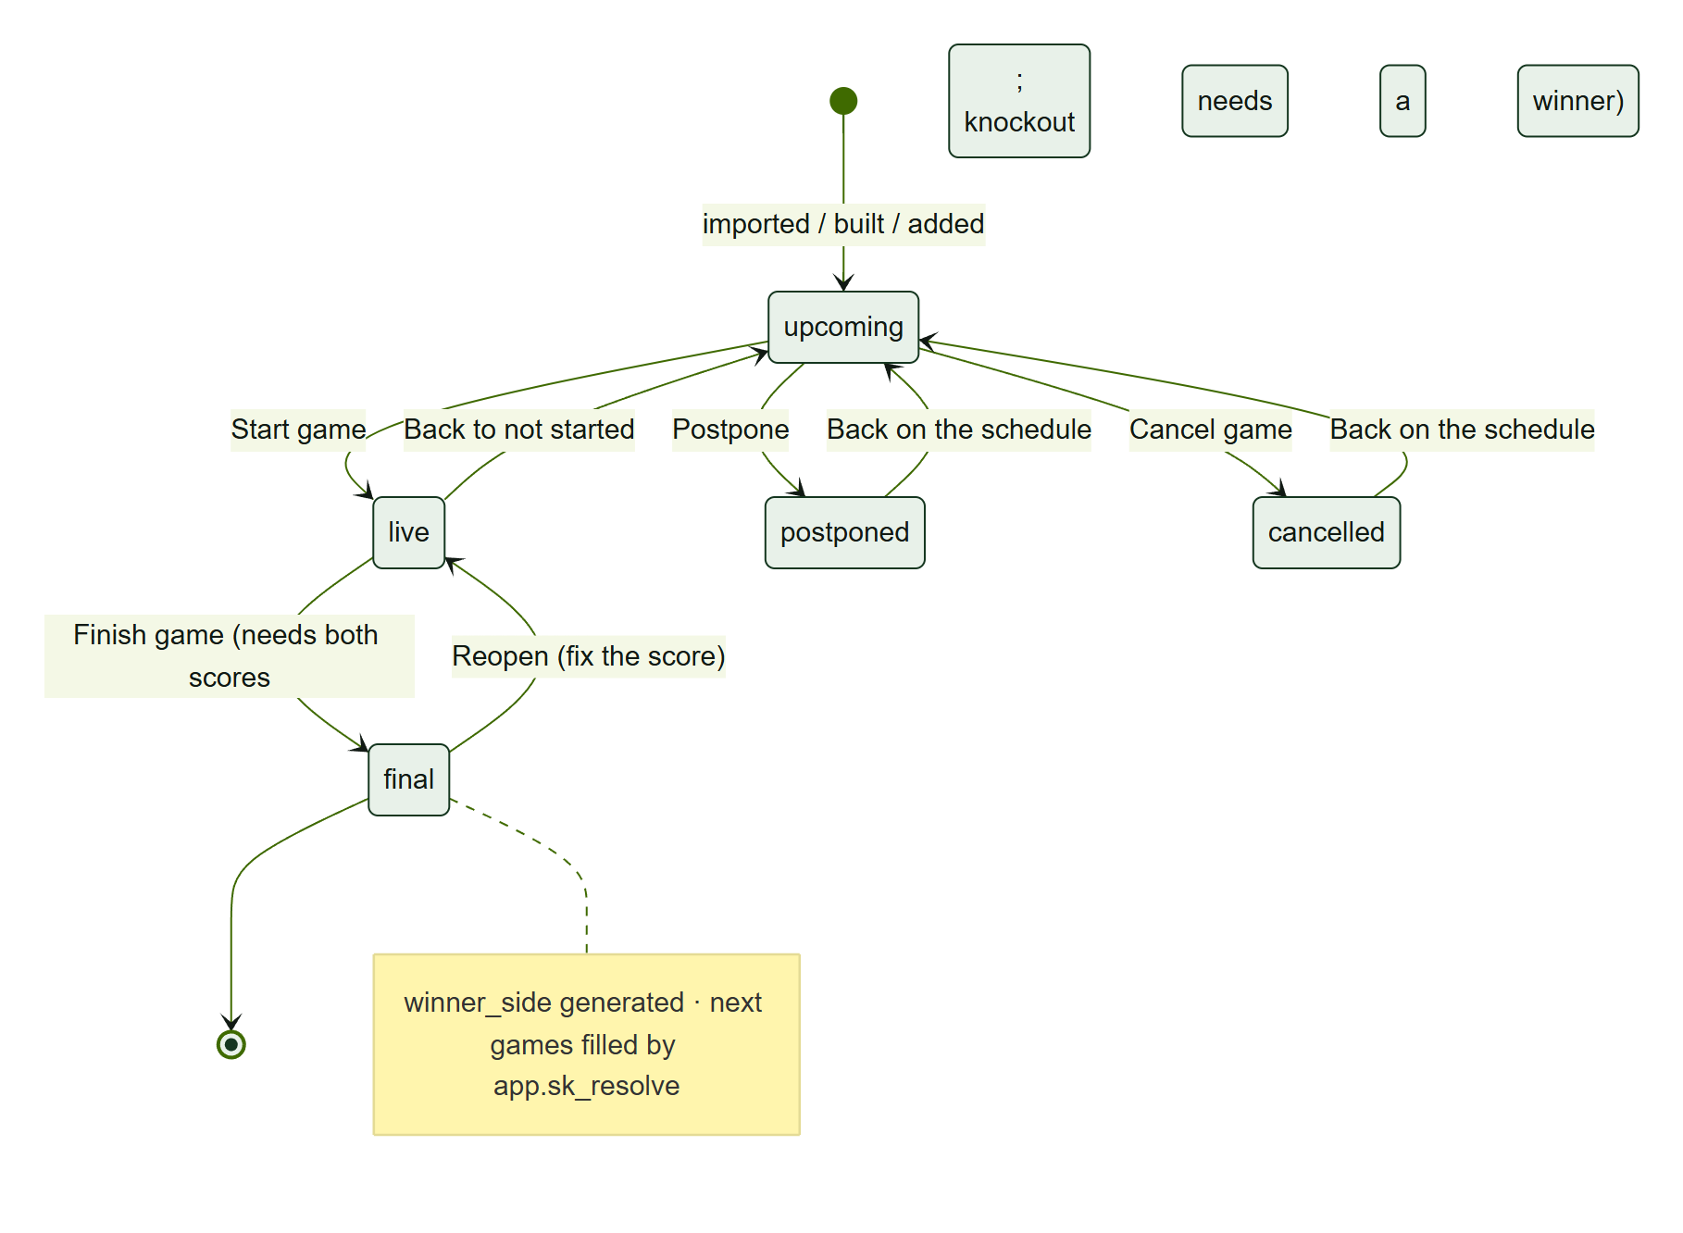
STATE-2 — statuses of a Salingkusog game (sk_match_status) and the scorekeeper actions.

8. Entity–relationship diagrams
These are generated from the SQL files and show primary keys, foreign keys and a few key columns. Grey boxes without columns are tables from another group, shown for context. The complete data dictionary is in AMR-DOC-04.

ERD-1 Content
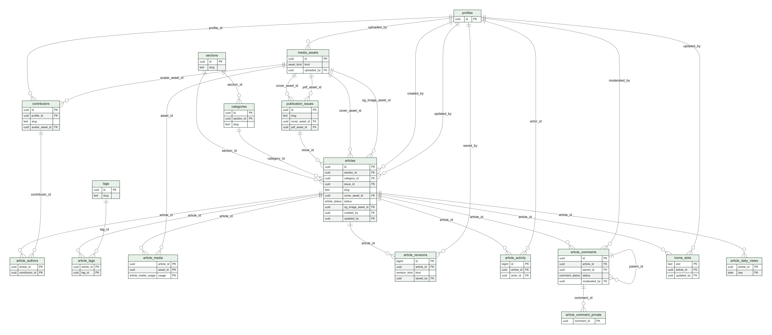
ERD-1 — sections, categories, articles and their related tables.

ERD-2 People, intake and settings
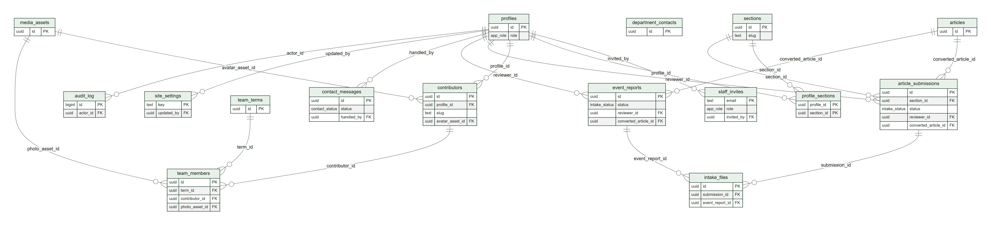
ERD-2 — staff, invitations, contributors, editorial board, public intake and settings.

ERD-3 Salingkusog
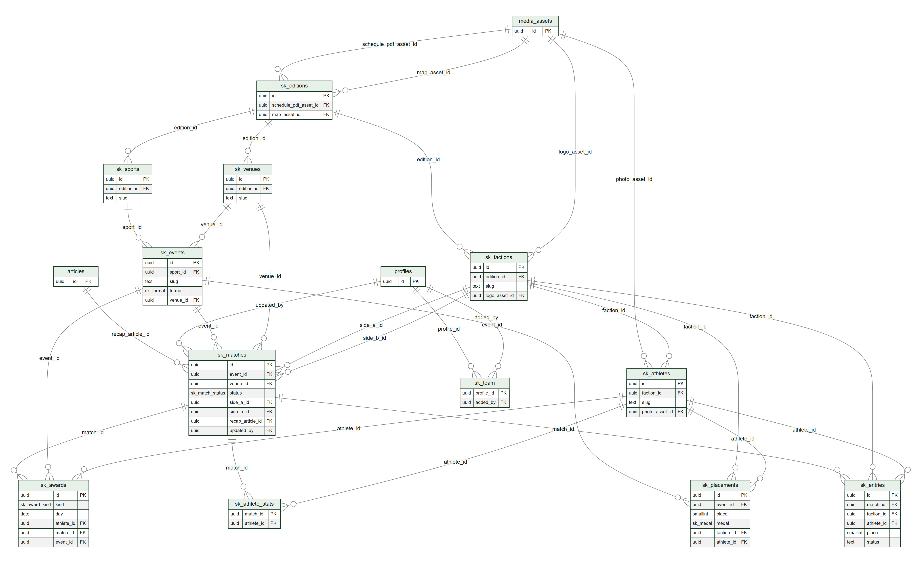
ERD-3 — editions, factions, sports, events, matches, entries, placements and awards.

ERD-4 Statistics
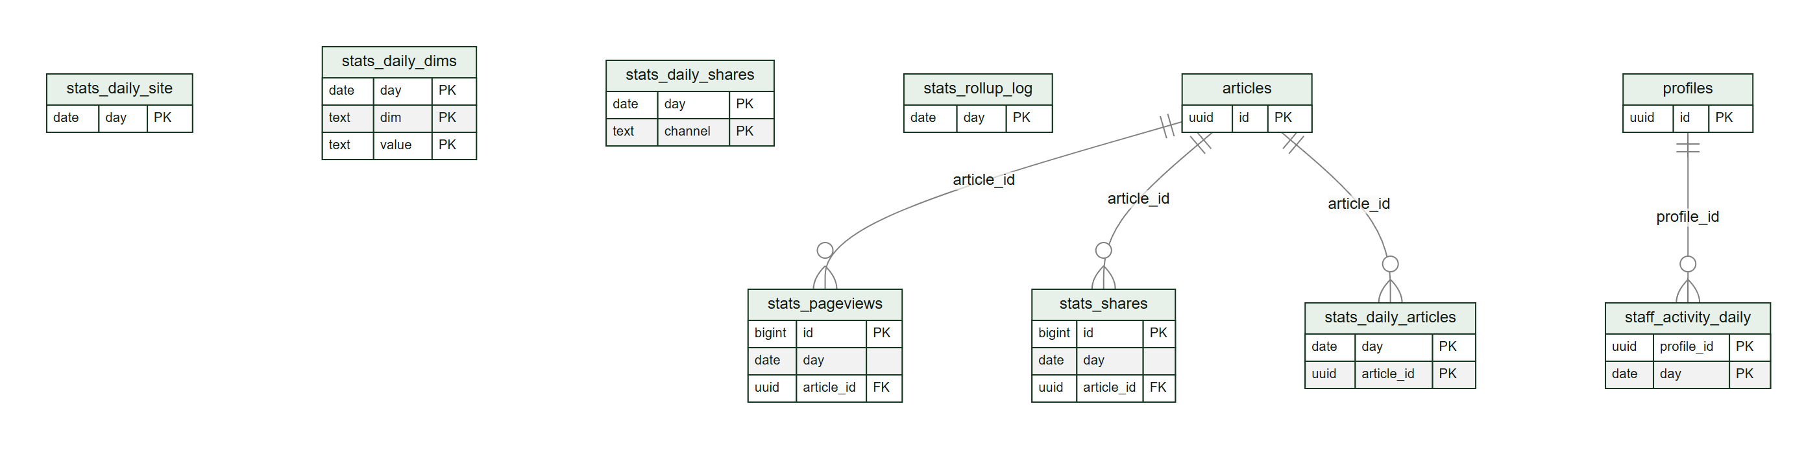
ERD-4 — raw events and daily rollups.

