User Manual — Executive Editor, Managing Editor and Super Admin
  - Amaranth v2 newsroom: staff, publishing, settings, statistics and Salingkusog oversight
2026-10-19

Document control
Field | Value
Title | User Manual — Executive Editor, Managing Editor and Super Admin
Document ID | AMR-DOC-11a
Version | 1.0
Date | 2026-10-19
Author | Amaranth development team [TO CONFIRM: names]
Status | Final draft
Screens | Captured from the development fixture screens with fictional data

Contents
- Who this manual is for
- Signing in
- The newsroom at a glance
- Managing staff
- Publishing: review, publish, schedule, archive
- Giving publishing access to staff
- The front page and the ticker
- Settings
- Moderation: comments, inbox, submissions, events
- Statistics
- Salingkusog oversight
- Good practice

1. Who this manual is for
You are | Role in the system | What only you can do
Executive Editor (Editor-in-Chief) | editor_in_chief | Everything below except granting the Super admin role
Super admin | super_admin | Everything, including granting or removing Super admin
Managing Editor | managing_editor | Publish, front page, ticker, editorial board, print issues, statistics, publishing access, Salingkusog team — but not roles, invites or general settings
Writing and editing articles is covered in AMR-DOC-11b; Salingkusog data entry in AMR-DOC-11c.

2. Signing in
- Go to /admin/login (or “Staff login” in the site footer).
- Enter your email and password, then Sign in.
- Forgot your password? Choose Forgot password, enter your email, and follow the link in the email to set a new one.
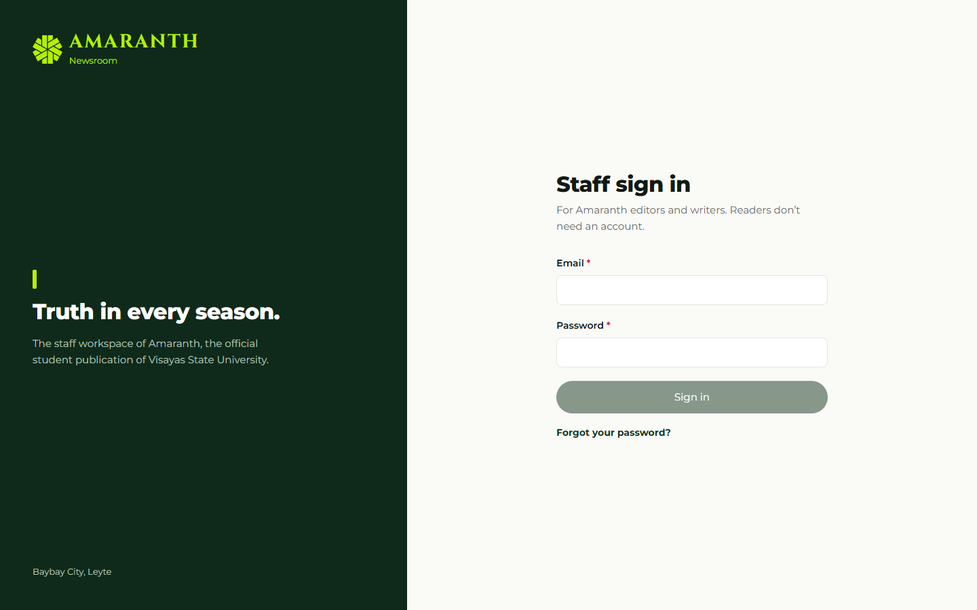
The staff sign-in screen.
If you see Access pending, your account has not been invited or has been deactivated; ask the Super admin.

3. The newsroom at a glance
The left menu shows Overview, Articles, Submissions, Events, Media Library, Salingkusog, Statistics, Staff, Settings. Items you cannot use are hidden. The Overview dashboard shows published, scheduled, drafts and in-review counts, and article views this month compared with last month.
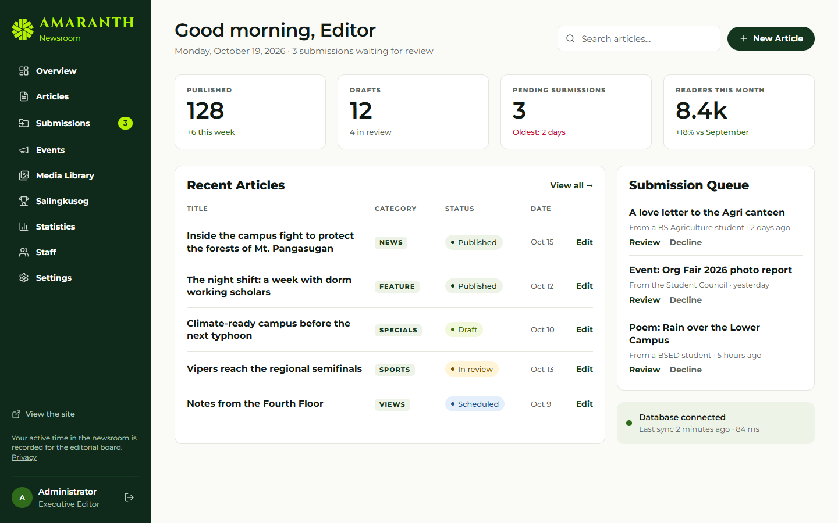
The newsroom dashboard for an editor.

4. Managing staff (Executive Editor, Super admin)
Invite someone
- Staff → Invites.
- Enter the Email, choose the Role, and for a Section editor tick the Sections they will edit.
- Save. Then, in Supabase, send the invitation email (Authentication → Invite user) [TO CONFIRM who does this step]; when they accept, their account is active with that role.
Change a role or deactivate
- Staff → Accounts → Edit next to the person.
- Change the Role, the sections, or untick Active — can sign in to the newsroom.
- Save. The change is recorded in the audit log.
Rules the system enforces: only a Super admin can make or remove another Super admin; you cannot deactivate yourself; at least one active Super admin must remain.
Contributors and editorial board
- Staff → Contributors: public bylines (staff, student, guest, faculty, alumni). Editors can add and edit them.
- Staff → Editorial board (Executive Editor, Managing Editor, Super admin): terms and members shown on the public Editorial Board page.

5. Publishing: review, publish, schedule, archive
Open Articles. Use the tabs All, Mine, Drafts, Needs review, Scheduled, Published, the section and status filters, or search by title.
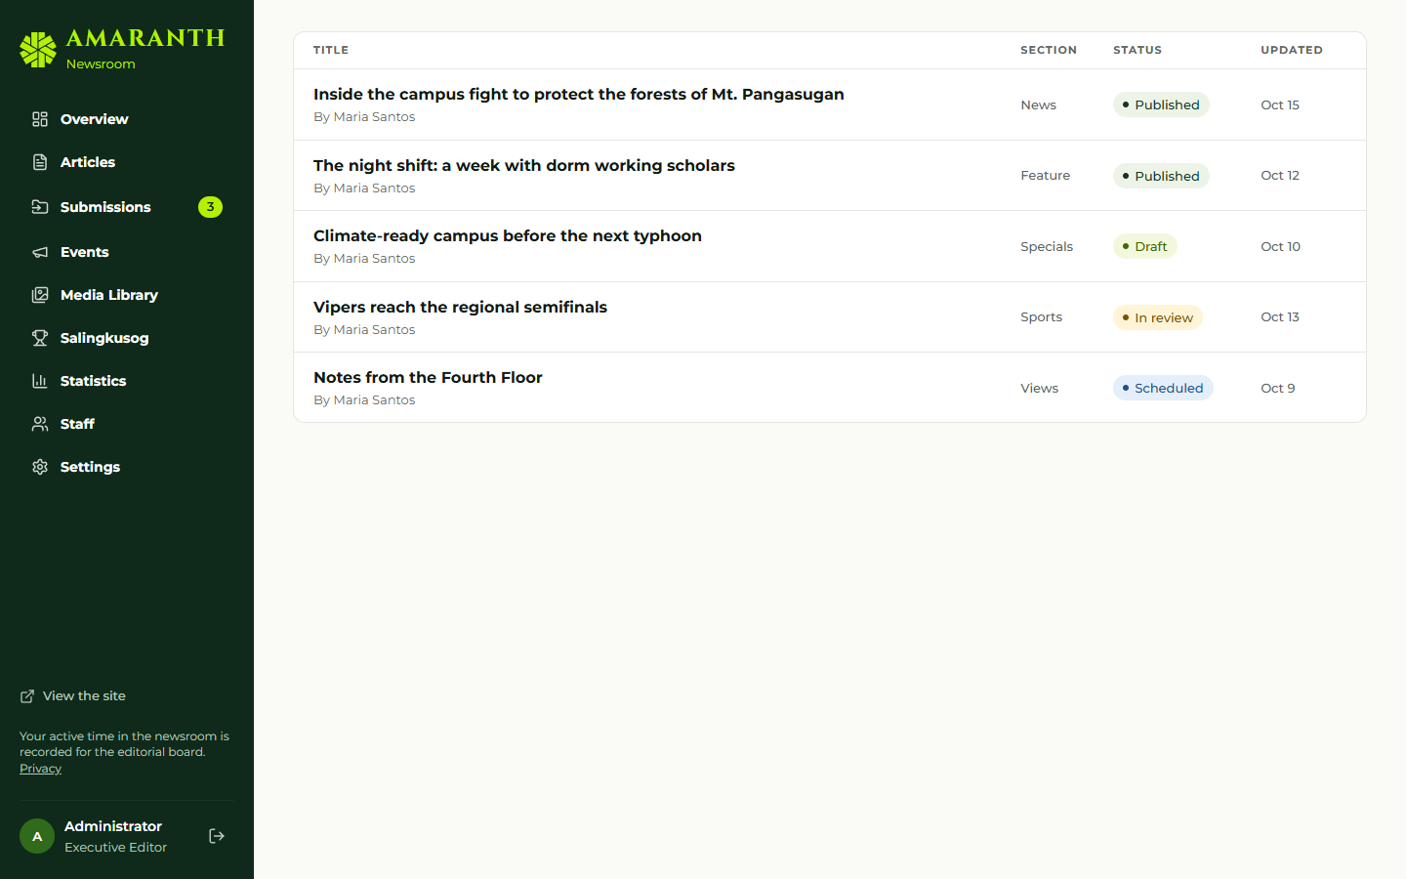
The articles list with filters.
Open an article. The Status panel on the right shows only the actions you are allowed to take:
Button | Effect
Start review | Submitted → In review (tells the writer you are on it)
Return to draft | Back to the writer, with your note
Reject | Rejected (a note is required)
Publish | Live now
Schedule | Pick a future date and time; it goes live by itself
Archive | Removes a published article from the site (it can be restored)
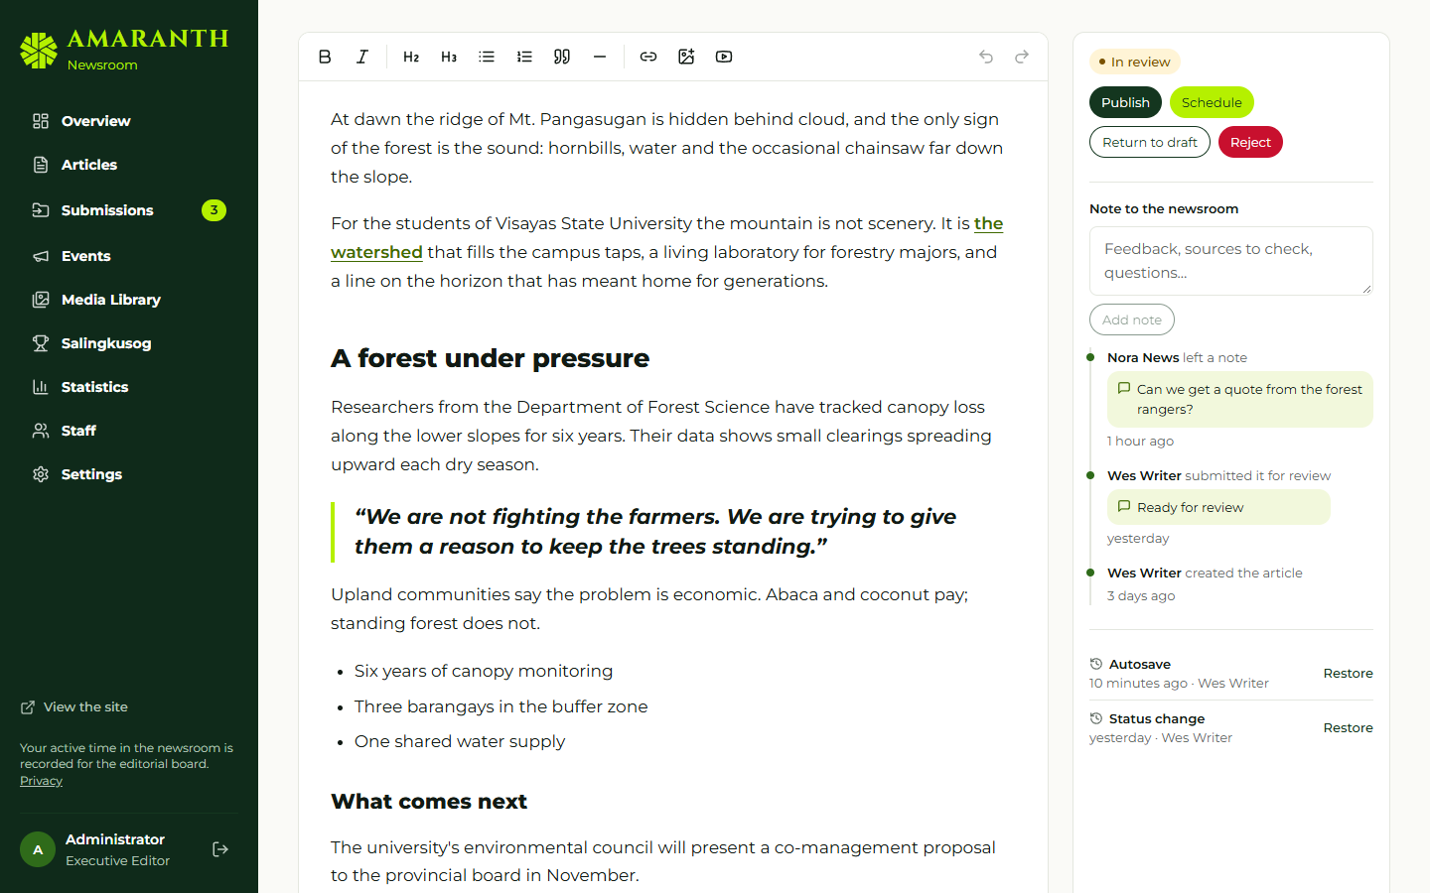
The article editor with the workflow panel.
Use Note to the newsroom → Add note to leave feedback without changing the status. Notes & activity shows who did what; Revisions lets you restore an earlier version. Article settings lets editors tick Feature on the front page.

6. Giving publishing access to staff (Executive Editor, Managing Editor, Super admin)
By default only the Super admin, Executive Editor, Managing Editor and Business Manager can publish or schedule. To trust a writer or section editor with publishing:
- Staff → Accounts → Edit next to the person.
- Under Publishing, tick Can publish and schedule articles.
- Save. The change is audited. Untick it to take the access back.
The Business Manager can publish but cannot give access to others.

7. The front page and the ticker (Executive Editor, Managing Editor, Super admin)
Settings → Front page:
- choose the lead story;
- choose the literary folio piece, with a Pull quote and Attribution;
- the latest-news ticker: Show “The newest headlines” or “My own announcements”, and How many.

8. Settings (Executive Editor, Super admin)
Tab | What you manage
Front page | Lead story, folio pick, ticker (also Managing Editor)
Comments | Moderation queue
Inbox | Contact form messages
Sections | Section names, descriptions, menu placement (main menu or “More”), order, whether they accept submissions; categories, including categories reserved for editors
Desks | Desk contacts shown on the Contact page
General | Site details, social links (web addresses only), comments on/off

9. Moderation: comments, inbox, submissions, events
- Settings → Comments: approve, reject or mark as spam. Comments are hidden until approved.
- Settings → Inbox: contact messages; mark in progress, resolved or spam.
- Submissions and Events: open an item, read it and its Attachments, write a Review note, then Decline, accept, or Turn into an article by choosing a Category for the new article. The draft opens in the editor and the submission is marked converted.
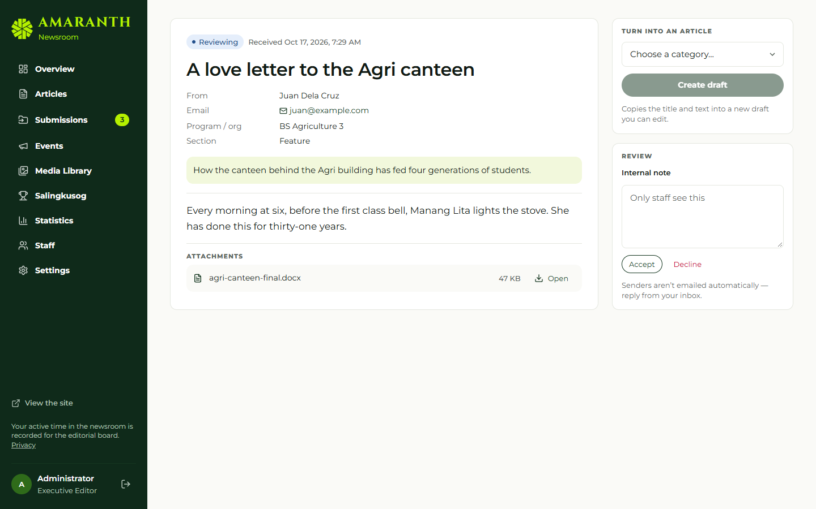
Reviewing a story submission.

10. Statistics (Executive Editor, Managing Editor, Super admin)
Statistics shows, for the date range you choose: pageviews, article views, readers, average read time, shares, a daily trend, top articles, authors, sections, traffic sources and referrers, devices and browsers, share channels, and staff active time (H:MM:SS). Each figure compares with the previous period.
Privacy: no cookies are set on readers, IP addresses are not stored, readers who ask browsers not to track are counted only as an anonymous pageview, and individual visits are deleted after 13 months (see /privacy).

11. Salingkusog oversight (Executive Editor, Managing Editor, Super admin)
- Salingkusog → Team: add or remove the staff who may enter Salingkusog data. You three always have access.
- Salingkusog → Edition: dates, medal points, publish the edition, and switch the countdown page on or off.
- Results & medals: confirm medals when an event shows Ready to confirm. Nothing counts in the medal tally until someone saves the results.
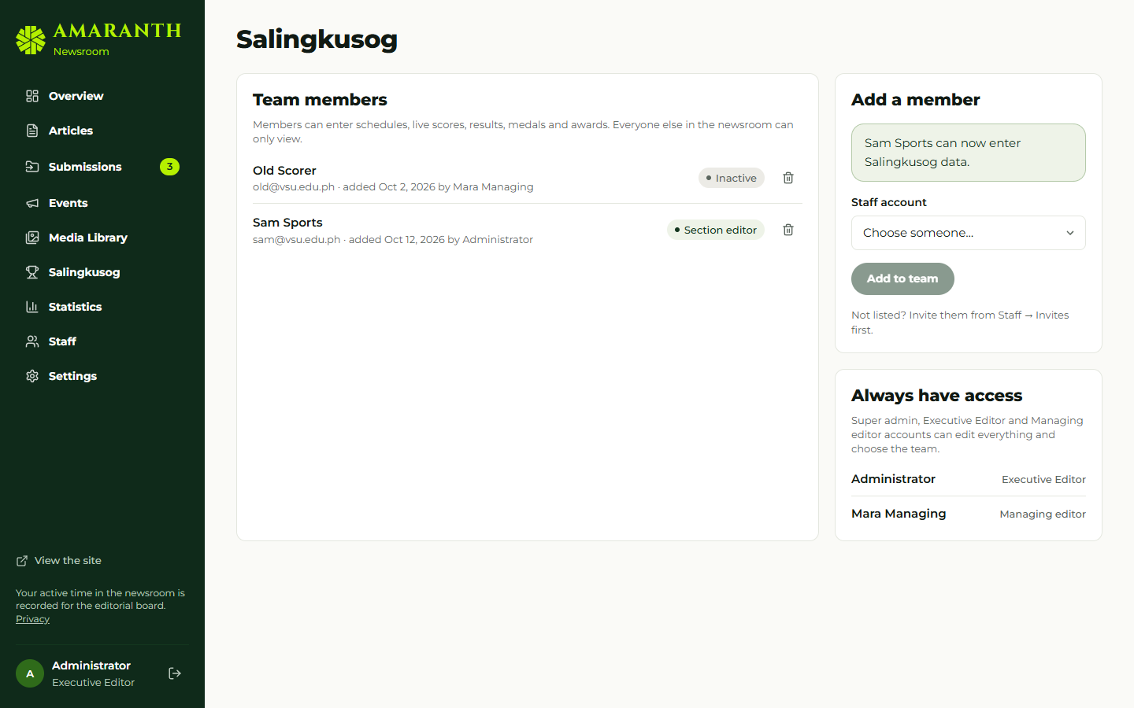
Choosing the Salingkusog team.
Full Salingkusog procedures: AMR-DOC-11c.

12. Good practice
- Give publishing access sparingly and review it each semester.
- Deactivate accounts of members who leave.
- Keep at least two people who can publish during events.
- Before the games, check the event-week checklist (AMR-DOC-09 §10).

