User Manual — Salingkusog Team
  - Setting up the games, schedules, live scores, contests, results, medals and awards
2026-10-19

Document control
Field | Value
Title | User Manual — Salingkusog Team
Document ID | AMR-DOC-11c
Version | 1.0
Date | 2026-10-19
Author | Amaranth development team [TO CONFIRM: names]
Status | Final draft
Screens | Development fixture screens with fictional factions and athletes

Contents
- Who can do what
- The Salingkusog newsroom
- Before the games: setup
- Creating the schedule (three ways)
- Keeping live scores
- Contests (dance, swimming, athletics, painting…)
- Results and medals
- Awards and social cards
- What readers see
- Troubleshooting

1. Who can do what
- Super admin, Executive Editor, Managing Editor: everything, plus choosing the team (Team tab) and the countdown.
- Team members (any staff added in Team): all setup, schedules, scores, results and awards.
- Other staff: can view but not change.

2. The Salingkusog newsroom
Salingkusog in the newsroom menu has these tabs: Scores, Results & medals, Awards, Athletes, Edition, Factions, Sports & events, Venues, Schedule import, Team.

3. Before the games: setup
Do these in order (about two weeks before):
- Edition — year, title, start and end dates, medal points (default Gold 5, Silver 3, Bronze 1), schedule PDF, venue map. Keep Published off until you are ready; only one edition can be current.
- Factions — name, short name (e.g. “PT”), motto, colour and logo for each team.
- Venues — name, description, and the number and position on the venue map.
- Sports & events — add each sport with its category, then its events:
  - Division: men, women, mixed or open;
  - Format: Bracket (knockout), Round robin, Round robin + final, Timed / measured, or Judged;
  - Team event or individual;
  - Result unit for timed or measured events: s = fastest wins; m or pts = highest wins;
  - main venue.
- Athletes — name, program (course and year) and an optional photo, per faction. Only publish photos with the athlete’s consent [TO CONFIRM consent process].
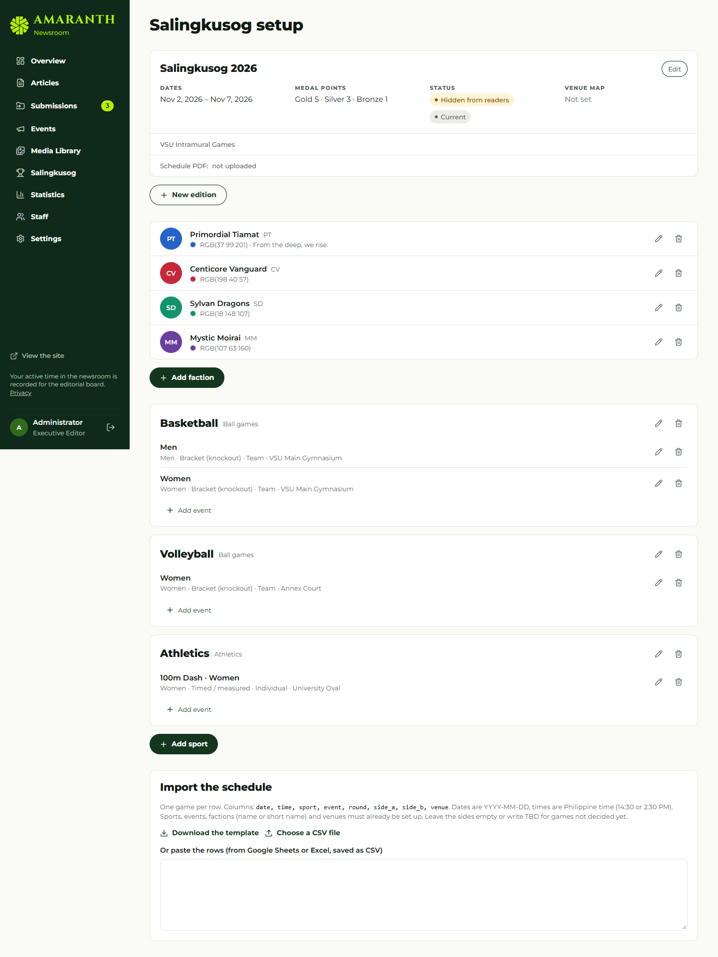
Setup screens: edition, factions, sports and events, import.

4. Creating the schedule (three ways)
Use | For | How
Build schedule | Brackets and round robins (team or individual, e.g. basketball, chess, arnis, kyorugi) | Sports & events → Build schedule on the event
Create contest | Events where every faction competes at once (dance, Pinoy pop, folkdance, hip-hop, painting, swimming, athletics) | Sports & events → Create contest on the event
Schedule import (CSV) | Any games you already have in a spreadsheet | Schedule import tab

4.1 Build schedule
- Choose the format: Single elimination (with optional bronze game; top seeds get a bye if the field isn’t 2, 4, 8 or 16), Round robin (everyone plays everyone once; each round fills in once the previous round is finished), or Round robin + final (1st v 2nd in the final, 3rd v 4th in the bronze game).
- Put the factions in seed order (seed 1 strongest) with the arrows; untick factions not taking part.
- Set the First game time, Hours between rounds (24 = one round a day), Minutes between games within a round, and the Venue.
- Check the line “Creates N games over R rounds”, then Create games. A list of the created games appears.
You only enter scores from now on: winners (and semifinal losers for the bronze game) move on by themselves. The system refuses to build if a game has been played, or if the last round would fall after the games end.

4.2 Create contest
Choose the start time, a name (usually “Final”), the venue, the performance order (faction order or Random draw), and tick the factions taking part. Create contest opens the contest scorekeeper (section 6).

4.3 CSV import
The file must have a header row. Columns (other accepted names in brackets):
Column | Example | Rules
date (day) | 2026-10-26 | YYYY-MM-DD, within the edition’s dates
time (start) | 08:00 or 2:30 PM | 24-hour or AM/PM
sport | Basketball | Must match a sport name
event (division) | Men | Needed when the sport has more than one event
round (stage) | Semifinal 1 | Free text
side_a (team_a, home) | Faction A or its short name | Must match a faction, or leave empty
side_b (team_b, away) | Faction B | Must differ from side A
venue (location) | Main Gym | Must match a venue name
Example:
date,time,sport,event,round,side_a,side_b,venue
2026-10-26,08:00,Basketball,Men,Semifinal 1,Faction A,Faction D,Main Gym
2026-10-26,2:30 PM,Volleyball,Women,Group A,FA,FB,Annex Court
Steps: paste or choose the file → the preview marks each row ready, duplicate (same event, time and sides already exist) or with an error message → Import brings in only the ready rows. A template can be downloaded from the tab.

5. Keeping live scores
- Scores — pick the day (and a sport if you like). Games are listed live first, then by time.
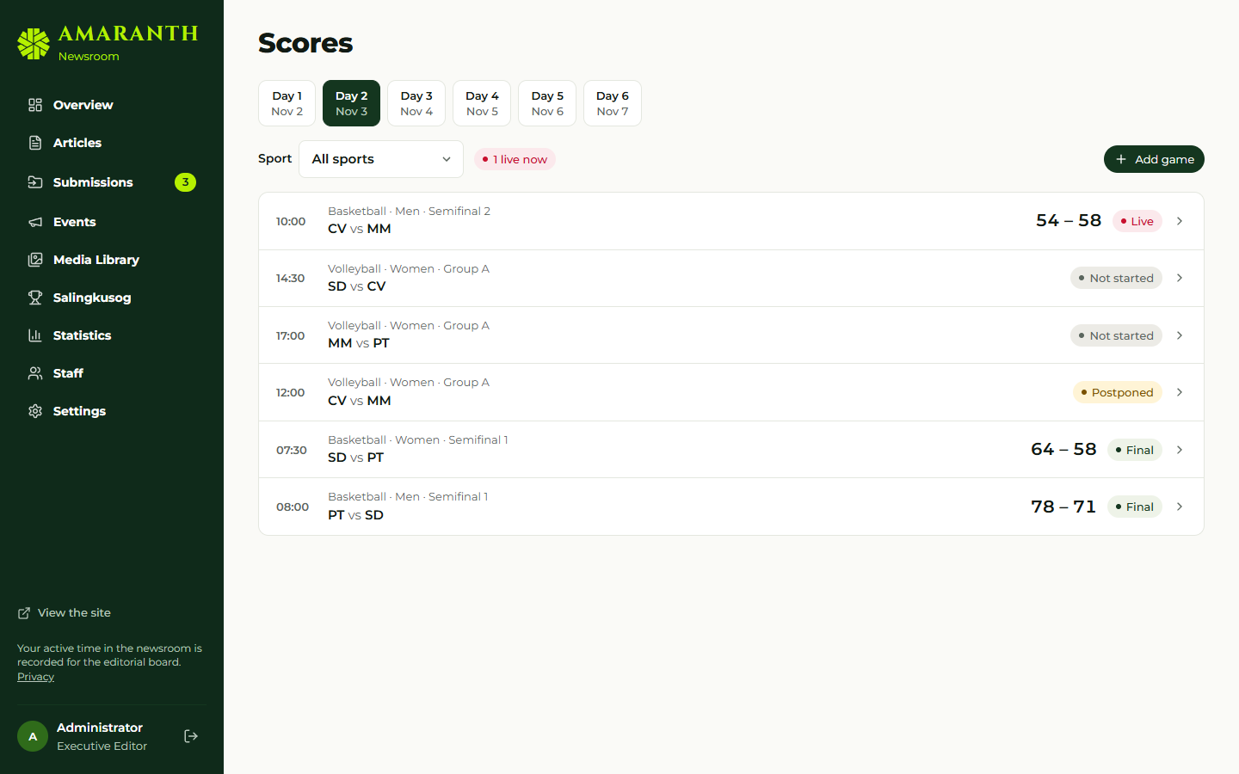
Games by day.
- Open a game. Press Start game at tip-off.
- Use the + / − buttons for each side (basketball has +1, +2, +3). The screen updates at once and saves after a short pause; readers see the change within seconds.
- Add periods (Q1, Q2 … or Set 1, Set 2 …), and a Live note such as “Q3 · 4:12”.
- Optional: team statistics and the athletes’ box score.
- Press Finish game when it ends. Both scores are needed; a knockout game cannot finish tied — add the overtime or tiebreak to the score first.
- Made a mistake? Reopen (fix the score). If the next game has already started, the system will not let the result change its teams; fix that game first.
- Other actions: Postpone, Cancel game, Back on the schedule, Edit game details (time, venue, recap article), Delete game.
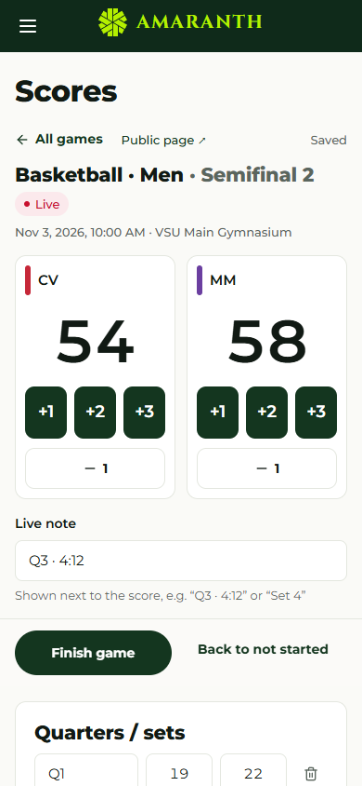
The scorekeeper on a phone.
For games created by Build schedule, the teams are filled in automatically and cannot be changed in Edit game details.

6. Contests
The contest scorekeeper lists every entry in performance order:
- Timed or measured: for individual events choose the faction’s athlete, then type the result: 12.84 or 1:02.45 for times, 5.42 for metres. Places update as you type (fastest or highest first); exact ties share a place.
- Judged: type the place each faction gets as the judges announce it; two factions can share a place.
- Mark entries Did not start, Did not finish or Disqualified; they get no place.
- Start contest at the beginning; Finish contest only works when every competing entry has a result or a place.
- Edit contest details changes time, venue or name.

7. Results and medals
When an event’s last game or contest is final:
- The scorekeeper shows “That was the last game of … Check and confirm the medals”. Results & medals marks the event Ready to confirm.
- Open the event. Places 1–3 are filled in from the games: for brackets, from the final and bronze game; for round robins, from the standings; for contests, from the places.
- Check them. For individual events choose the athlete for each place. You can add places, share a place (e.g. two bronzes), set the result text and the day awarded.
- Save results. Only now do the medals count; the medal tally, points race and podium update for everyone.
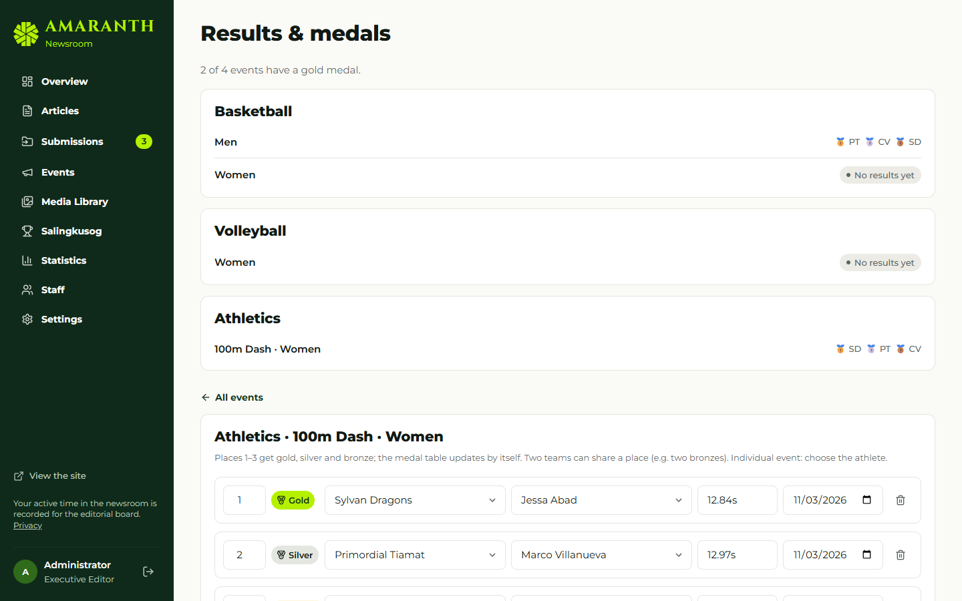
Results and medals for an event.
Medals follow the place automatically: 1 gold, 2 silver, 3 bronze.

8. Awards and social cards
Awards — choose the award (MVP of the Day, Athlete of the Day, Finals MVP), the day, the athlete, the event and game, a headline, a stat line (e.g. “PTS 24, REB 9”) and a quote; Save. Download the social cards (MVP 1080×1350, Athlete of the Day 1080×1080) as PNG for posting.
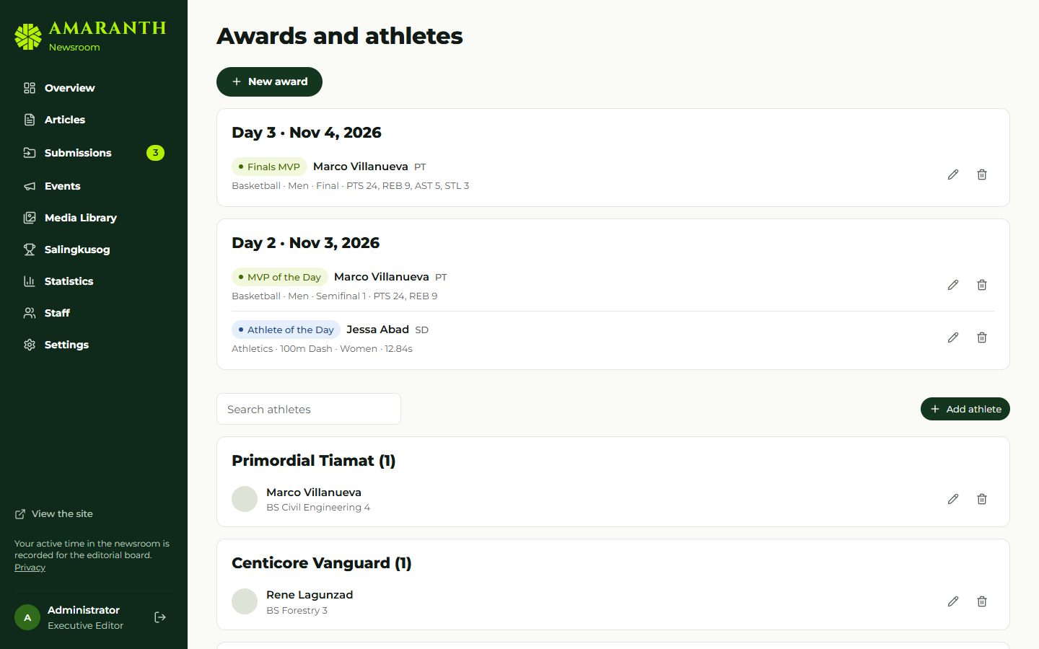
Awards and athletes.

9. What readers see
Page | Content
/salingkusog | Podium, “Results in: X of Y matches”, medal table (gold, silver, bronze tints for 1–3), points race (1h, 3h, 6h, 12h, Day), live and up next
/salingkusog/schedule | Day tabs; filters by sport, faction, venue; live, later, completed
/salingkusog/winners | Medallists per event
/salingkusog/sports/<sport> | Bracket with champion, round-robin standings, or contest results
/salingkusog/factions/<faction> | Faction profile, medals, head-to-head
/salingkusog/venues | Venue guide and map
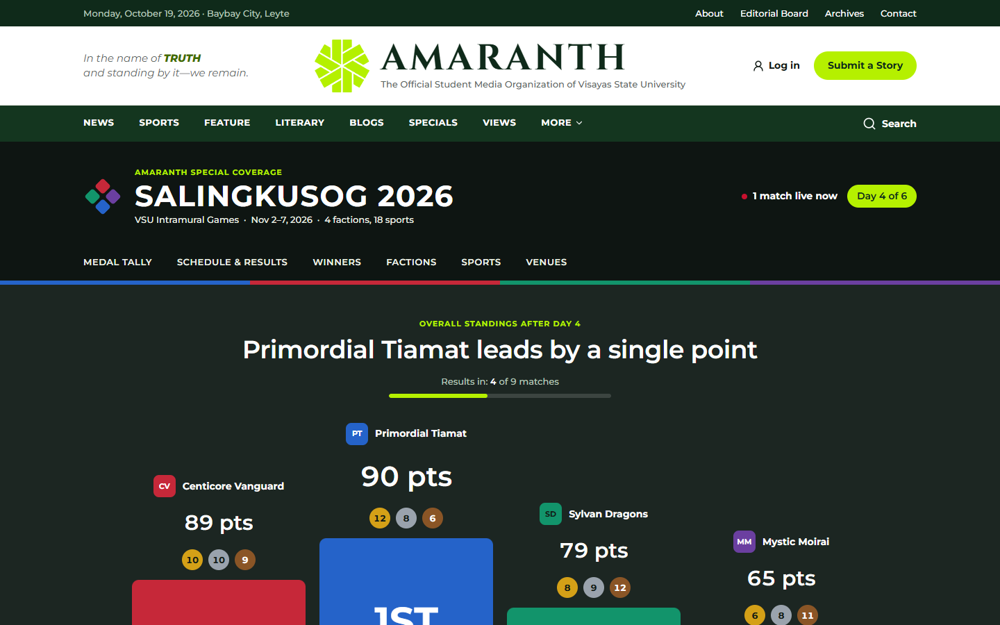
The public medal tally.
When every match is final, the page reads Official and final medal tally and names the champion and runners-up.

10. Troubleshooting
Message | What to do
“A knockout game needs a winner…” | Add the tiebreak to the score, then Finish
“… has already started, so its teams can’t change” | Correct the later game first, or ask an editor
“This event already has games played, so its schedule can’t be rebuilt” | Edit games one by one instead
“Enter every result first…” | Give every entry a result or mark it DNS/DNF/DQ
“Only the Salingkusog team can …” | Ask the Managing Editor to add you to the team
A game is not on the Scores tab | Check its date is within the edition and the day tab is correct

