One-Page Cheat Sheets
  - Architecture, roles, database and features at a glance
2026-10-19

Document control
Field | Value
Title | One-Page Cheat Sheets
Document ID | AMR-DOC-22
Version | 1.0
Date | 2026-10-19
Status | Final draft

Cheat sheet 1 — Architecture
Layer | What | Key files
Browser | React 18 + TypeScript SPA (Vite 7), TanStack Query, Tailwind v4 tokens | src/app/router.tsx, src/features/*
Edge | Vercel CDN; /api/r edge cache (60 s) | api/r.ts, src/lib/edgeCache.ts
Server | /api/submit (Turnstile + signed uploads + service RPCs), /api/e (stats), sitemap/RSS/robots, crawler middleware | api/*.ts, middleware.ts
Data and rules | PostgreSQL: 50 tables, 97 RLS policies, 40 triggers, 76 functions, 6 views | supabase/v2/*.sql
Platform | Supabase Auth, Storage (media, archives, intake), Realtime, pg_cron | Supabase
Principles: the database is the security boundary · secrets only in /api · computed standings · re-runnable SQL · one feature per branch.
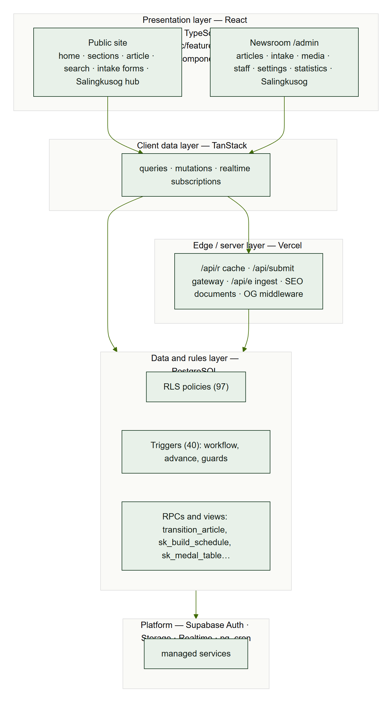
Layers

Cheat sheet 2 — Roles
Role | Write | Review | Publish | Staff & settings | Front page | Stats | Salingkusog
Super admin | ✔ | ✔ | ✔ | ✔ (+ grant SA) | ✔ | ✔ | ✔ + team
Executive Editor | ✔ | ✔ | ✔ | ✔ | ✔ | ✔ | ✔ + team
Managing Editor | ✔ | ✔ | ✔ | publishing access only | ✔ | ✔ | ✔ + team
Business Manager | ✔ | — | ✔ | — | — | — | if in team
Section editor | ✔ | own sections | if granted | — | — | — | if in team
Staff writer / Contributor | ✔ | — | if granted | — | — | — | if in team
Reader | — | — | — | — | — | — | view published
Helpers: is_staff · is_admin (SA, EE) · can_publish (SA, EE, ME) · can_publish_articles (+ BM, granted) · is_editor (+ SE) · can_view_stats · can_edit_sk (+ team).

Cheat sheet 3 — Database
Group | Tables
People | profiles, staff_invites, profile_sections, contributors, team_terms, team_members, audit_log
Content | sections, categories, tags, articles, article_authors, article_tags, article_media, article_revisions, article_activity, article_daily_views, publication_issues, media_assets, home_slots
Public input | article_comments, article_comment_private, article_submissions, event_reports, intake_files, contact_messages
Settings | site_settings, department_contacts
Salingkusog | sk_editions, sk_factions, sk_venues, sk_sports, sk_events, sk_athletes, sk_matches, sk_entries, sk_athlete_stats, sk_placements, sk_awards, sk_team
Statistics | stats_pageviews, stats_shares, staff_activity_daily, stats_daily_site, stats_daily_articles, stats_daily_dims, stats_daily_shares, stats_rollup_log (+ app.stats_salts)
Article workflow: draft → submitted → in_review → scheduled/published → archived (rejected → draft). Medal table: points = 5·gold + 3·silver + 1·bronze; rank by points, gold, silver.

Cheat sheet 4 — Features
Area | Features
Public site | Home, 12 section landings, article, search, archives, about, board, privacy, submit story, report event, contact, comments
Newsroom | Dashboard, article editor (autosave, revisions, notes, workflow, scheduling), submissions and events, media library (WebP sizes, in-use guard), staff and publishing access, settings, statistics
Salingkusog | Edition, factions, venues, sports and events, athletes, team; CSV import, Build schedule (bracket, round robin, RR + final), contests; live scorekeeper; results and medals (suggest + confirm); awards and social cards; medal tally, points race (1/3/6/12 h, day), official final tally, schedule, winners, factions, brackets, recaps, venues, countdown
Security | Invite-only accounts, RLS everywhere, workflow trigger, Turnstile gateway, signed uploads, rate limits, sanitising, security headers
Quality | 255 unit tests, 278 SQL checks, 53-screen accessibility sweep, WCAG AA contrast, Lighthouse a11y 100

