Analysis section

Introduction
In this section you should give a broad overview of what your project is about. Imagine a friend or relative has asked what your project is about, how would you explain what you’re going to do.

Computer hardware specification and performance analyser: Python, VSCode (Only for Windows 11, maybe Linux too) · The app will detect and return the user’s computer hardware, the type and make, and analyse its performance. · This analysis will be morphed into a graph for a more visual representation, in the form of a regularly updating scatter graph recording CPU, GPU and RAM usage. · The app will also contain a guide on the different hardware components in their computer (using theirs as examples), so the user can understand the purpose and importance of that component needed to use their computer, what they do, why they are need, why they need to be upgraded (if required or wanted). · The computer can analyse their benchmark scores (performance) of the computer (using python’s psutil library), such as RAM usage, storage usage, CPU performance, temperature, etc, and suggest upgrades based on a budget the user will be asked to input, from a database of known components, based on what type of computer the user is using (laptop, PC…) and give steps on how to replace the component if the user chooses to do it on their own (go to a professional if you don’t know how, or if their device build is different to what the guide says). · Every time the user accesses the app (first time accessing the user will sign up with a username and password), the opening page will display “Good morning/afternoon/evening [user]” and request their password to enter the rest of the app to protect sensitive PC hardware data. Using the benchmark scores found, the app can show the user issues that may arise with their device, such as overheating, excessive RAM usage, and suggest solutions to solve the issues, such as first running their antivirus to check for dodgy programs running in the background using computer resources, suggesting to try out debloating (removal on useless programs running in the background), or potentially suggest upgrading their RAM capacity if wanted.
The app will have a database of components that can be used to upgrade the device, separate for laptops and desktop PCs, such as a list of knows CPUs, types of RAM, each having the attributes mentioned below, so the app can recommend a better component than the one it detected based on the user’s budget. If the user wants to install the new component on their own, the app can display a general, simple guide on how to (since every device is build differently).

RAM: SIZE PRICE SPEED TYPE (SEPARATE SODIMM VERSION FOR LAPTOPS)
CPU: SPEED NO. CORES SIZE-OF-CACHE PRICE (DESKTOP ONLY)
STORAGE: TYPE SIZE SPEED PRICE (SEPARATE SATA VERSION FOR LAPTOPS)

If there are no upgrades in available budget, then the app will suggest searching for one manually, or not upgrading at all.

Problem identification and features
- Give a much more detailed explanation of what the problem is.
- Explain and justify the features that make the problem solvable by computational methods (refer specifically to the programming constructs that will be used and where in the proposed solution).
- Explain why the problem is ameanable to a computationl approach.
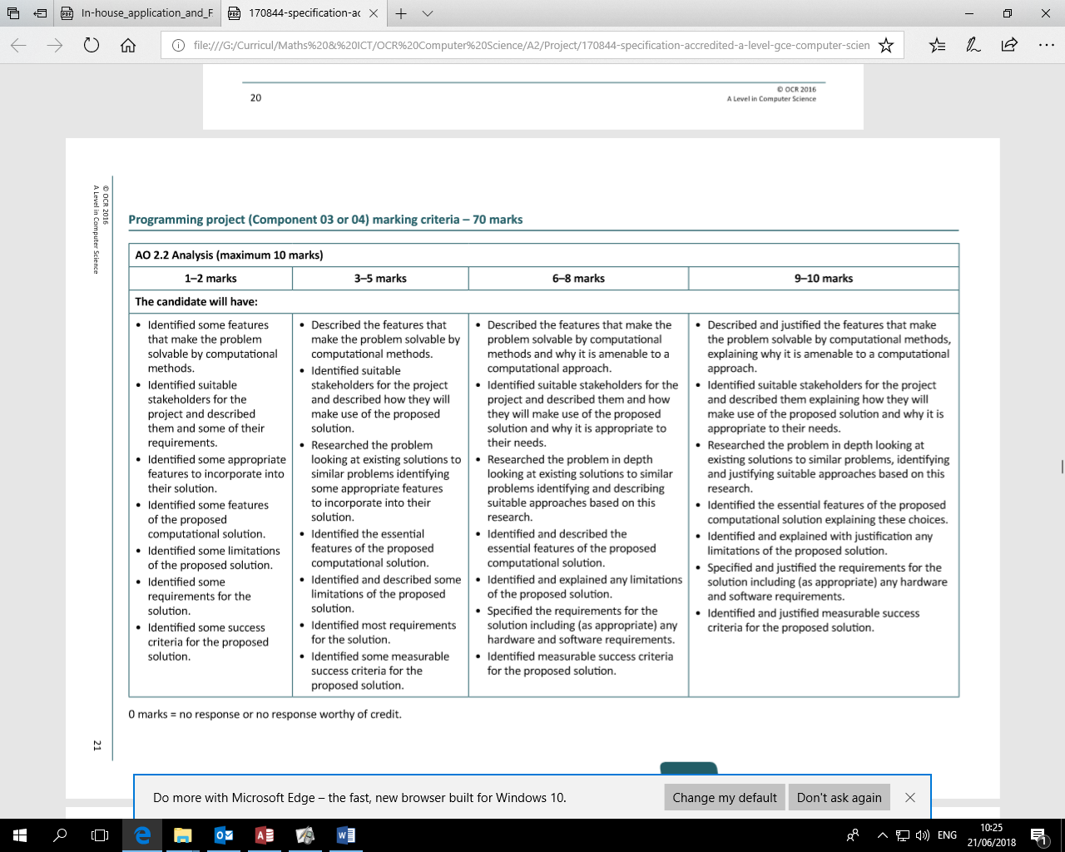
Many have issues with their devices running slow, can be due to old components, slow, low performance parts, malware, etc, so the app can help to derive the problems the user’s device may be suffering (excessive RAM usage, etc). This will be done using python in VSCode, using the “import psutil” command to detect and return the device’s components, and component performance to begin the analysis. This is also an interesting way to teach those who have little knowledge of their device and what the components inside it do to make the computer work. Through the guides, the user can learn the functions of these parts in a simple way.
First, I’ll use the ‘pip install psutil’ command for python, this will install the cross-platform, third-party library to return the names of the device, the names of its components, and the performance of the components, which will all be stored as separate variables for comparing later. Instead of browsing the entire web for a component that is better than the one already in the device to fit the user’s budget, the app will already have a pre-made database of components, the best at each price range, based on the attributes I listed earlier.

Stakeholders
- Identify stakeholders for the project (these are people that will have an interest in the success of the project). It could be the end users, or maybe a Manager or MD if the solution is to be used by their employees. If you can name individuals that is great, if not then give as much detail as you can about the characteristics of the proposed stakeholders.
- Describe the stakeholders in as much detail as you can, particularly their reasons for having an interest in the project and any characteristics that are relevant to the project.
- Explain what the stake holders requirements are for the proposed solution.
- Explain how the stake holders will make use of the proposed solution and why it is appropriate for their needs.

Timmy Tigglesworth: PC Gamer
- Plays games in his spare time, which needs good performance components in his desktop computer to run heavy games that require high power devices.
- Timmy uses this app to check his PC’s performance, check if its good enough to run his games, if he realises his PC is beginning to run slower when playing a certain game, he can check what this issue is through the performance data, and will be suggested a way to resolve the issue or a better component.
- This helps Timmy to improve his PC’s performance without wasting excessive money or time on finding one himself, letting Timmy play new games.
Sarah Sparkleton: IT Support Technician
- Diagnoses slow and laggy devices and checks the hardware performance of customer computers which have issues.
- This app helps Sarah easily diagnose these issues using the performance analysis and can find the name of the hardware components of the device briefly to fix the client’s device all in one place.
- This saves Sarah a lot of work and time on finding this information herself, not only saving her time, but the client’s time too, giving her better customer reviews.
Barry Bricklebottom: Computer Enthusiast
- Loves using and experimenting with computers at a more advanced level that the average person.
- Uses the app to monitor system usages and compare performance with his devices when completing different tasks.
- This allows him to record his device’s performance easily using the visual graphs and can even use it to plan future hardware updates.
Research the problem
- You will need a bibliography for this section to clearly reference where ideas have been found.
- Research existing solutions to the problem. If the problem is genuinely unique (as it should be!), there will not be an existing solution, so research similar solutions.
- Summarise your research by explaining in detail what existing solutions are out there, discuss the limitations of these existing systems or some reason for you not just using what is already out there.
- From your research, identify suitable approaches that you will adopt in your project. Reference where you found these approaches.
- Justify why these approaches are suitable to your project
- You can conduct surveys with your stake holders to help identify what the key features of the system will be

Existing Solution 1: Task Manager (Windows)
Windows Task Manager is a built-in Windows tool that allows users to monitor their computer's performance. It displays information such as CPU usage, RAM usage, disk activity, GPU usage, and running processes.
Advantages:
- Already installed on Windows.
- Provides real-time system monitoring.
- Easy for normal users to understand.
- Requires no additional installation.
Limitations:
- Does not provide upgrade recommendations.
- Does not compare hardware performance.
- Does not identify hardware bottlenecks.
- Does not explain how users can improve performance.
My project will improve on this by not only displaying system information but also analysing the information and providing recommendations. Windows Task Manager overview. Available at: https://learn.microsoft.com/en-us/shows/inside/task-manager

Existing Solution 2: Speccy
Speccy is a system information tool that displays detailed hardware information, including CPU, GPU, RAM, motherboard, and storage devices.
Advantages:
- Provides detailed hardware specifications.
- Presents information in an easy-to-read interface.
- Useful for identifying installed components.
Limitations:
- Mainly focuses on displaying information rather than analysing it.
- Does not provide personalised upgrade recommendations.
- Does not monitor performance over time.
My project will use a similar approach for hardware detection but will extend this by adding performance analysis and upgrade suggestions. Speccy (2025). System Information Tool. Available at:
Speccy by CCleaner

Research Findings
From researching existing systems, I found that most current solutions focus on only one area:
- Task Manager focuses on system usage.
- Speccy focuses on hardware information.
There is no simple application that combines:
- Hardware detection
- Performance monitoring
- Bottleneck detection
- Upgrade recommendations based on budget
- Advice for improving system performance
Therefore, my project will combine these features into one user-friendly application.

Hardware Detection:
I will use the Python library psutil to collect information about system resources, including CPU usage, RAM usage, storage usage, and memory usage. psutil is suitable because it supports multiple operating systems and provides accurate access to system information without requiring complex low-level programming.
Performance Visualisation:
I will use graphs to display CPU and RAM usage over time. Graphs allow users to quickly understand performance changes rather than interpreting raw numbers.

Upgrade Recommendation Algorithm:
I will create a database containing components with performance scores and prices. The program will compare the user's hardware against available upgrades and calculate the best value options. A scoring system allows recommendations to be generated consistently without requiring external AI services.

Features of the proposed solution
- Identify the features of the proposed solution, this should include all the things the system should do. Be as detailed and precise as you can.
- Describe the features of the solution in detail, explaining each choice. You can refer to your research and surveys here.

My app must be able to:
- Detect and return hardware information and performance in real time. Live updates must be used in this case, since old data can cause misinformation.
- Allow the user to customize the app to a limited extent to give the user more control over the app.
- Give upgrade/fix recommendations to the user based on a budget that the user inputted, if they would like to upgrade, but would ultimately recommend asking a living professional for recommendations and installation, since the database will not be regularly updated.
- Identify issues regarding the detected usage of the user device’s hardware and return indicators to the user to flag the issue.

Limitations
- Identify some limitations of the proposed solution. You have said what the system should do, what are the things that are beyond the scope of this project?
- Explain what these limitations are in detail.
- For each limitation, justify why the proposed solution will not have these features

Limitations:
- Relies mainly on the user to act on the information and recommendations the app gives them; the app can’t force the user to buy a certain component or install it for them, so a professional would be more reliable in this case compared to a python program.
- Requires the user to have a basic sense of understanding about what they’re doing with their device and what their device’s components do; though the app can teach it simply, it will not guarantee and force the information into the user’s head (not everyone can learn the same).

Requirements including hardware and software
- Identify what hardware and software will be required to run the proposed solution. Remember this is the requirements to run the final solution, not the requirements to make the solution. So although you might need Visual Studio to program the solution, the object code does not need Visual Studio in order to run. So think about the operating system that the object code will run on, think about minimum requirements to run your object code in terms of processor, RAM, hard drive space. What about what hardware will be needed in terms of monitor, mouse, keyboard or other sensors that will be needed.
- Justify each choice of hardware and software. Why are they needed? What made you decide on each hardware or software requirement?

Requirements:
- Device must be desktop or a laptop, using Windows 11. Code was built specifically to run on, since the hardware monitoring functions may only work for Windows.
- VS Code may be required to run the script, with each python library installed, however I will try to have the code run without the need of VS Code, if possible.
- 8GB RAM, so Windows 11 can run to a certain extent and launch other applications for testing, otherwise the device will continue to crash.
- CPUs better than the Intel i3 can run this script, since this program is not very resource heavy (~43MB RAM, more if using alongside VS Code)
- At least 64GB storage space, can be any type of secondary storage, enough to install other applications alongside TRACE, which uses up a very negligible percentage of storage space >5MB

Success criteria
Success criteria are things that can be used at the end of the project to measure its success. Where possible, use things that can actually be measured as this is easier to “prove” that you project was a success. You must refer to the problem identification and features as these clearly state what the proposed solution is meant to do.
- Identify measurable success criteria for the proposed solution
- Justify each of the success criteria. Why do you think this is a suitable measure of the project’s success? Again you can refer to the problem identification and features section to aid your explanation.
Success Criteria:
- Must be able to detect and return the usage of the device’s CPU, RAM and storage.
- Displays this information in the form of constantly updating graphs and percentages for a visual display, updating in real time.
- Usages and graphs must update every second.
- Stores and searches through a database of different hardware components for recommending upgrades for the user.
- Can recommend alternative methods of improving the user device’s performance, such as antiviruses, debloating using trusted and reliable software, disabling startup apps, etc.
- Can take the user’s budget for upgrades and compare their current component with the ones in the database.
- Allows the user to customise the app colours, such as the background and the buttons.

