+
Design section

+

Total marks 15
Decomposition of the problem
- Break the overall problem down into smaller, sub problems. Use a structure chart to represent how these sub problems fit together
- Give an explanation and justification as to how and why you broke the problem down in the way that you did. This section should allow you to show you know how to decompose a problem and show that you have a clear idea of how to approach solving this problem.
- Create a structure chart of all the sub routines and functions that will be used in the solution
1-4 | 5-8 | 9-12 | 13-15
 | Broke the problem down systematically into a series of smaller problems suitable for computational solutions describing the process. | Broke the problem down systematically into a series of smaller problems suitable for computational solutions explaining the process. | Broke the problem down systematically into a series of smaller problems suitable for computational solutions, explaining and justifying the process.
 | Defined the structure of the solution to be developed | Defined in detail the structure of the solution to be developed. | Defined in detail the structure of the solution to be developed.

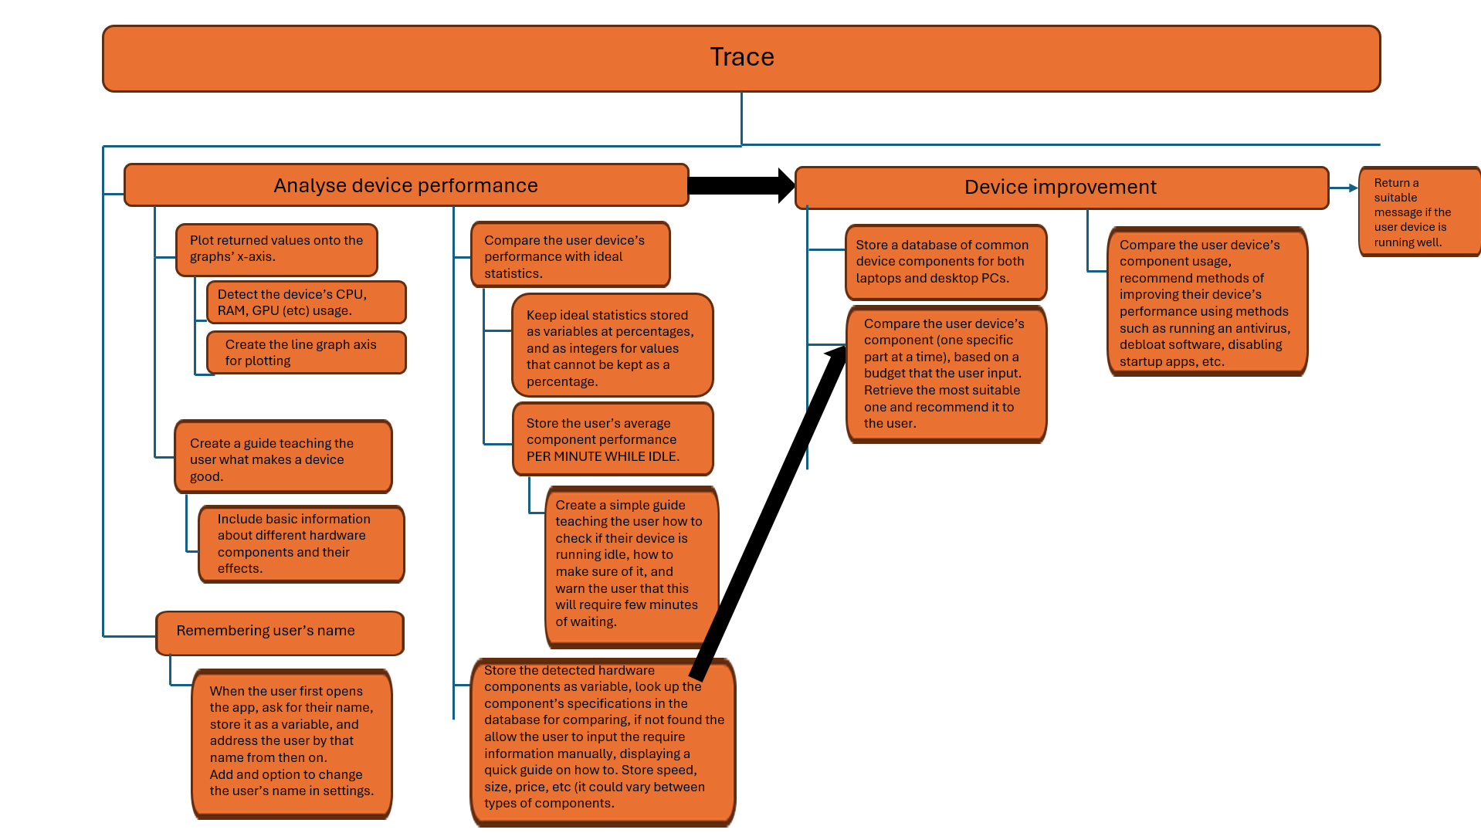

Algorithms
- For each of the sub problems identified above, create pseudo code algorithms for solving them
- Explain how each algorithm works, justifying its use in the project
- Explain and justify how the algorithms will work together to create a complete solution
- Note: you can use flowcharts to express the algorithms if you prefer
1-4 | 5-8 | 9-12 | 13-15
Described elements of the solution using algorithms. | Described the solution fully using appropriate and accurate algorithms. | Described the solution fully using appropriate and accurate algorithms explaining how these algorithms form a complete solution to the problem. | Described the solution fully using appropriate and accurate algorithms justifying how these algorithms form a complete solution to the problem

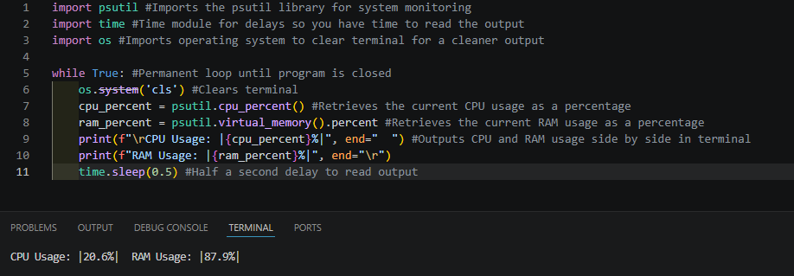
This is an example of the code I will use to obtain the RAM and CPU information of the user’s device (GPU info and other data is work in progess). By importing the module psutil, the program can return a lot of information regarding the user’s device’s hardware. By using the command “psutil.cpu_percent()” and “psutil.virtual_memory().percent” (VM usage does not come originally as a percentage, .percent converts it), we can assign the usages to variables that can be used to display the usages after. The time module gives the program a delay between each output of the infinite while loop, a 0.5 second delay between each reading. The os module allows the program to clear the terminal before printing the next output, so the terminal does not become clustered with readings, allowing for a clearer display. The /r in each print line also helps to give a clearer display, printing the values side by side rather than one under the other.

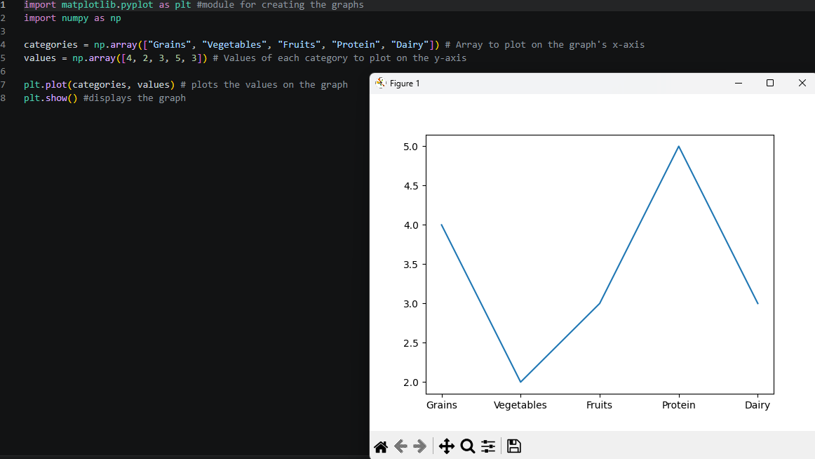
This is an example of the matplotlib module for python, used to build graphs. By listing categories in an arrange, and then listing the values that each category will have in another array, we can plot the categories of foods on the x axis and the values on the y axis, in the form (x, y), using plt.plot(categories, values), then use plt.show() to display the graph in a separate window after plotting. Ignore numpy, everything runs the same without it.

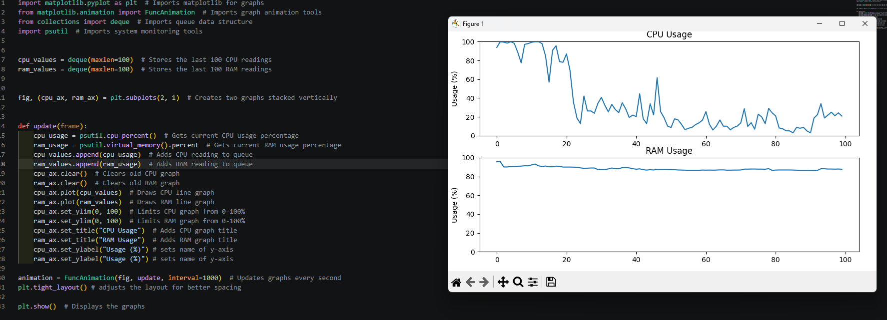
By incorporating these two modules, we can detect the CPU and RAM usage as a percentage per second and plot each value on the graph. Using the psutil module again, CPU and RAM can be returned and stored as a variable.
I’m also using the deque module, a queue structure than automatically removes the last value if a new value is inserted while the list is full, providing a limit to the number of values that can be put on the graphs for a clearer display. I created a list using “cpu_values = deque(maxlen=100)” for both CPU and RAM readings. Every 1000ms interval, a new CPU/RAM reading is detected and added to the queues using .append.
The graphs are stacked on top of each other using “fig. (cpu_ax, ram_ax) plt.subplot(2, 1)”, _ax being the names of the graphs for plotting readings. _ax.clear() clears the graphs of its contents before remaking the graph with the new added value in the queue. Without this, the graph would not change. “_ax.plot(list_values)” plots all of the values in the queue onto the graph, by default, putting the number of values in the queue on the x-axis, and the values of each reading on the y-axis, giving a line graph representing spikes and changes in usage. FuncAnimation makes the graph change, calling the function in 1000ms intervals to change the readings on the graph. “plt.tight_layout()” puts the graphs close together so they take up less space, just to make things look neater. Finally, use the plt.show() command to display the graph. (P.S. must run “pip install psutil” in the python terminal (same with the other modules if not installed) for this to work, since psutil does not come along with python install, and this also will not work on organisation computers since the use of terminal will usually be blocked if you are not an administrator, so the program (on any python program) will not run since python runs code on terminal. Using matplotlib to represent hardware usage readings achieves my goal of trying to display a clear way of analysing usage at a glance, since spikes in usage, when usage is low or high, can be seen very clearly just by a line shooting up or down on the graphs, helping the user notice changes clearly.
There is more that I can add, however I cannot list all of them because I’m planning to make and add features while making the app based on ideas I come up with while building, since I cannot be so sure I can make and implement a certain feature I had thought of prior making, and ideas I may have not come up with before may be sparked during making the app.
I also plan to add a app theme selection option, allowing the user to switch from light to dark backgrounds by selecting which one they want:
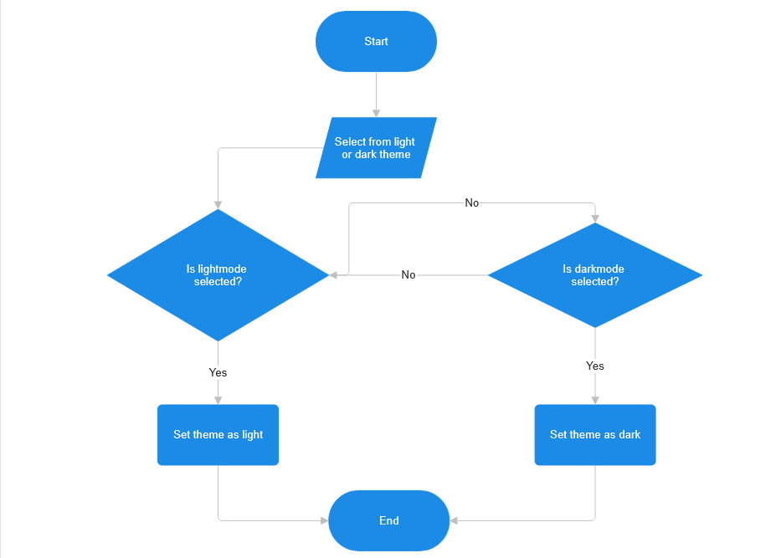
I also plan to add colour indicators for the live updating values of the component usage percerntages. For e.g. the text will change colour depending on the current percentage usage of the CPU:
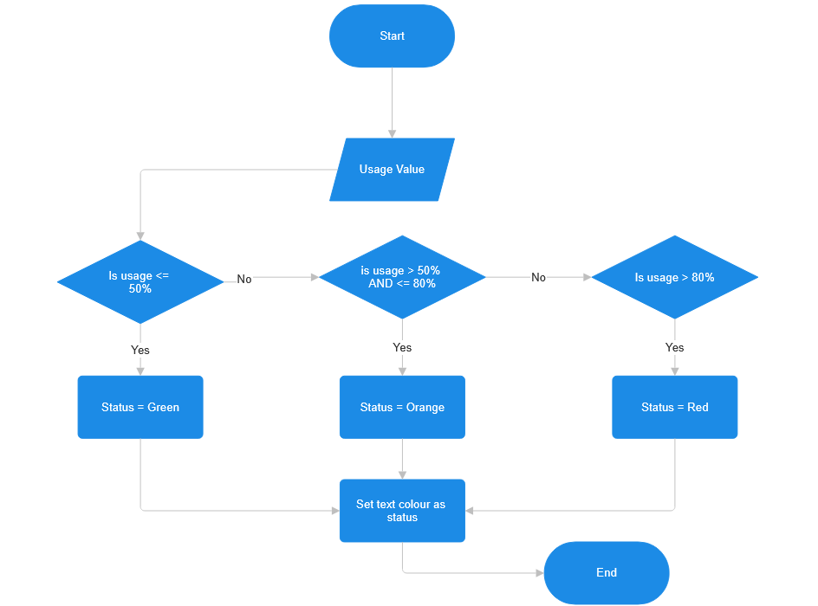

Usability features
- Describe the usability features of the proposed solution. Remember usability features are essentially all the features of the system that make it easy for your user to use. So you can talk about the controls you will allow the user to use, the interface you plan for your user to see and any other features like a help section, FAQ’s, tutorial or user guide that will help the user use the system more easily.
- Describe and fully justify your usability features for full marks.

1-4 | 5-8 | 9-12 | 13-15
Described some usability features to be included in the solution. | Described the usability features to be included in the solution. | Described, explaining choices made, the usability features to be included in the solution. | Described, justifying choices made, the usability features to be included in the solution.

The user interface will be clearly laid out and can be colour customised to a limited extent to change the colours of specific patterns, text and background, as well as displaying usage and performance graphs clearly using bold colours to display the plots and lines, to give users a meaningful display of the data collected by the program. There will be separate sections to different parts of the app, e.g. expanded graphs, database of stored components. For the database, I will use a relational database containing component names, a score out of 10 and a price tag (might add an option to add components not already in the database that the user can input manually, so the app can look through for comparing and detecting hardware). The user can also choose an option to detect their device’s component, one specified one at a time that the user selects, which gets at component’s performance, compares them with the ideal performance scores returning a colour indicator for ratings of good to bad, and returns whether their device could use an improvement or two. After suggesting for improvements, the user can choose a ‘yes’ option, which gives the user basic methods on how to improve their device’s situation, nothing very technical that could result in more issues if the user does something wrong.

Variables and data structures
- Identify (by name and data type) all the variables you plan to use in your proposed solution.
- Identify (by name and data type) the data structures you plan to use (this may include arrays, stacks, queues and text files)
- Justify the variables and data structured from above
- Justify and explain any validation needed. Remember validation is where you are checking a user’s input before the system can continue. A common form of validation is checking the length of a user name when registering or the strength of a password when registering. You can code certain rules to ensure what the user enters is valid.

1-4 | 5-8 | 9-12 | 13-15
Identified the key variables / data structures / classes  (as appropriate to the proposed solution). | Identified the key variables / data structures / classes (as appropriate to the proposed solution) and any necessary validation. | Identified and justified the key variables / data structures / classes (as appropriate to the proposed solution) explaining any necessary validation. | Identified and justified the key variables / data structures / classes (as appropriate to the proposed solution) justifying and explaining any necessary validation.

CPU_Usage and CPU_Percent stored as a float, RAM_Usage and RAM_Percent stored as a float, TEMP (temperature) stored as a float to 1d.p. GPU_Usage and GPU_Percent stored as a float. All of these are floats because these numbers will have to appear as decimals for higher accuracy since these readings can change on a miniscule level. This will not be taken from the user, it will be automatically be returned through the psutil module and kept as variables, not constants since these values will be changing regularly.

For the graphs, Ill use the python module “deque”, which is a queue structure, but when the queue is full, the first value is automatically removed when a new value is added without the need of a separate function. This allows the graph to be update live at a rate of 1 second by adding a new value, and removing the oldest value, so the graph does not become cluttered.
The graph will me made using the python module matplotlib, allows me to incorporate the deque queue into the x-axis, and plot in the form of a line graph, clearly displaying recorded data.
Storing the database is currently undecided, however I may choose to use SQL for storing, searching, etc, for components. When the user chooses to add a new component, it will check if the component already exists, reject the new one if it does, but will have to trust the user that the attributes of the components are correct, there is no way for the app to validate them unless it uses AI.
When the user inputs a colour, it will be in the form of a hexadecimal value. The program will force the input to begin with a #, while only allowing values from 000000 to FFFFFF being allowed, and must be 6 character long, otherwise it will be rejected because any other value will not work.

Test data
- Identify and justify test data to be used during the development phase of the project. Remember test data is data that you will use as inputs to test various parts of the solution, so you should include normal data, extreme data and erroneous data.
- Identify and justify test data to be used after the development of the project. So once it is ready to be tested by your stakeholders, what data will you use then to test the systems works correctly
1-4 | 5-8 | 9-12 | 13-15
Identified some test data to be used during the iterative or post development phase of the process. | Identified the test data to be used during the iterative development of the solution.  Identified any further data to be used in the post development phase. | Identified and justified the test data to be used during the iterative development of the solution.  Identified and justified any further data to be used in the post development phase. | Identified and justified the test data to be used during the iterative development of the solution.  Identified and justified any further data to be used in the post development phase.

For inputting new components into the database, I would use the name of an existent components already in the database to check if it will be rejected or not. Also, if the attributes for the components are not fully filled in, that component will not be saved, since the database will be unable to store it. I’m allowing the user to add components since it will take too long for me to list every single component currently in the market in the database, the user may have a component that the app does not recognise. By default, I will add the top 3 recommended components at each price range.
For User Interface colours, to change the colours of the text, background, outlines, etc, I will use a basic colour, such as #FFFFFF, to check if the UI changes colour, then I will use an invalid hexadecimal value, such as #GGGGGG, which should be rejected because the value does not exist. Then, I would enter without inputting any value, which should be rejected and then asks the user to enter a hex value. I’m adding this since the user will, I assume, most likely want to personalise the app a little. I will also add a reset button in case the user wants to revert changes, resetting the colours to the app’s original colours.

To do this, I’ll use custom tkinter, which can let me create the app’s design and layout. I plan to make the layout as something similar to Github, a simple format using white and black with a clean sidebar, except I’ll allow an option to switch from light to dark, and customise parts of the colour scheme and perhaps even add a custom background wallpaper. Here is the concept below:

