07/09/2026
Can Python fully retrieve CPU and RAM information using psutil? Could it be use to retrieve more information, such as device specifications, GPU performance, etc alongside?
Today, I am planning to build the base structure of the app first, the initial layout before adding any core functions to it.

To do this, I’ll use custom tkinter, which can let me create the app’s design and layout. I plan to make the layout as something similar to Github, a simple format using white and black with a clean sidebar, except I’ll allow an option to switch from light to dark, and customise parts of the colour scheme and perhaps even add a custom background wallpaper. Here is the concept below:

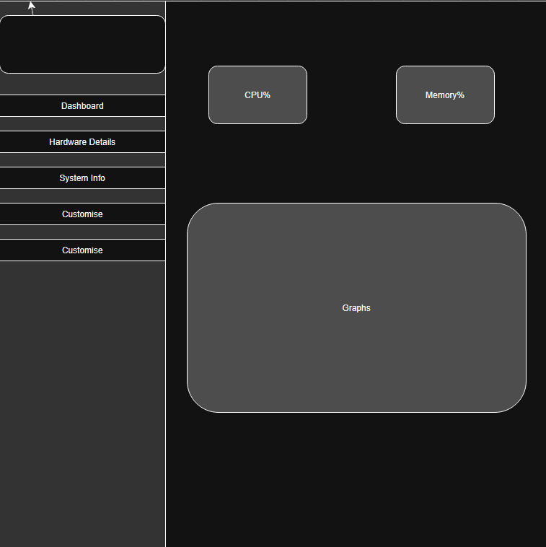
I used drawio.com to make this, hence why this concept looks so boxy. I plan on making the UI more streamlined, if possible, and obviously less boxy and full of squares.

07/09/2026

Graphical User Interface

I created the GUI for the app using customtkinter, blue buttons instead of black to make a less dark atmosphere, but I will attempt at making the colour customisable. The information shown on the cards are placeholders, psutil has not been connected yet, this is just the UI. I started off with building the application’s skeleton before adding any real features. I used a class to house all of the code I plan to reuse in the future.
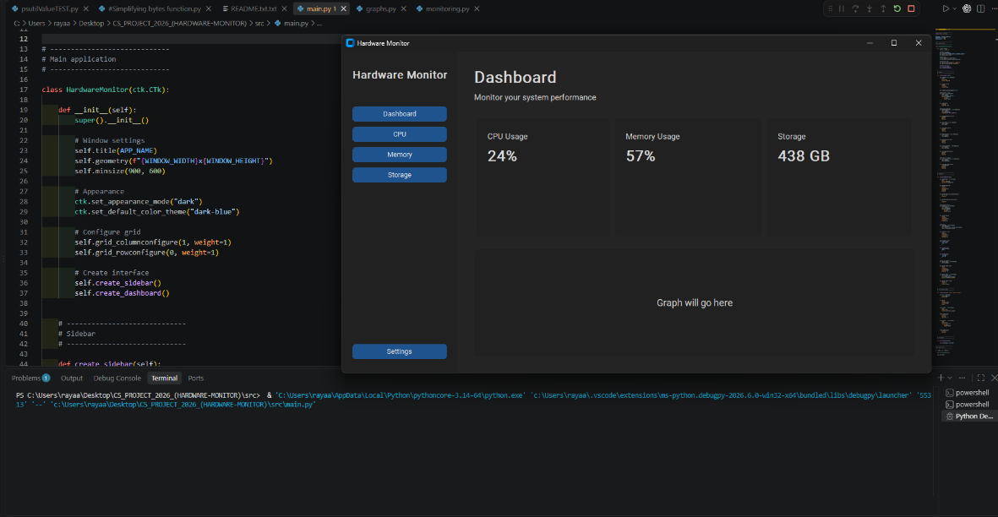

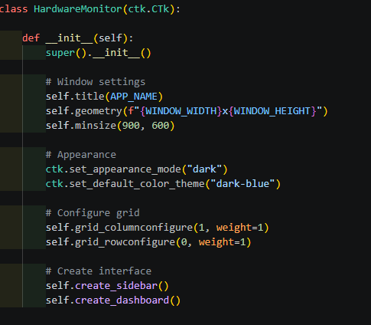
Under #window settings, is what I used to add the title and shape to the window, and under appearance, I set this as the dark-mode, specifically the dark blue colour scheme that sets the background as a dark grey and the buttons as blue. The under #Create interface, is what was used to build the sections that hold contents for the sidebar and the main dashboard.

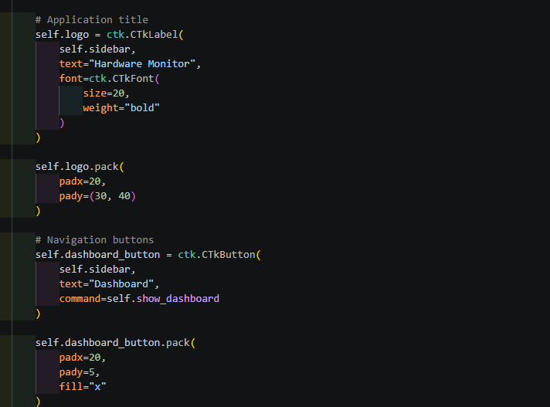
Under application title, I set the title as “Hardware Monitor” , setting the text bold just to make sure you can see it, to fill the empty space on the sidebar by adding a label to the sidebar using “text=”, setting it as bold by setting “weight” as “bold”.
For the navigation buttons, I use the same code format for each, all using the same shape and form, other than the text within it. For now, only the “Dashboard” button responds when clicked, returning “Dashboard selected”.
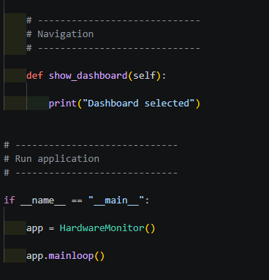
The code under #Navigations is used to form an output when a button on the sidebar is pressed, in this case it will print “Dashboard Selected” by calling the “show_dashboard()” function when clicked on. Later I will change it to open the dashboard when the other pages for the rest of the buttons are made.

08/09/2026

Basic Functions and Buttons

Added my Bytes and Seconds simplification functions to the beginning of the main program for future use. These will prove useful in shortening the large values that the program will return when making use of psutil.
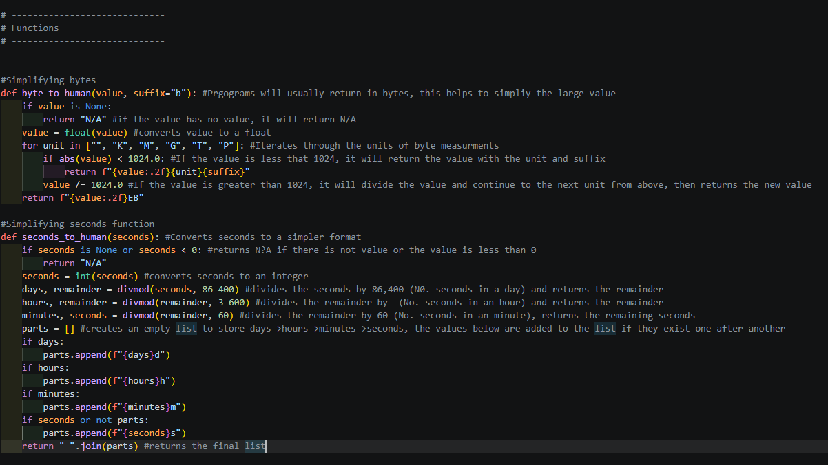
- Byte_to_human() will divide the value received by 1024, until the value can no longer be divided and changing the unit every time it is divided BkBMBGBTB.
- Seconds_to_Human() does the same, but divides in a different way since the number to divide by changes every stage of division. Secondsminuteshoursdays
I added the functions, in the same format for dashboard, that allows the rest of the buttons to recognise when clicked. For e.g. settings, using “command=self.show_settings” to call its function (Currently just outputs “{button name} selected.) Each button has a command that is executed (“command=”, followed by “self.{name of the function under #Navigation}):
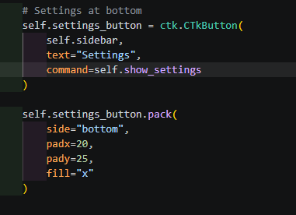
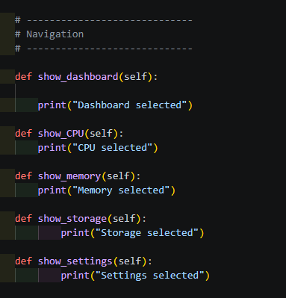
- Clicking the button will call the written function, and outputting what that function does, in this case it prints [button] selected.

14/09/2026

Making The Buttons Functional and Change Colour
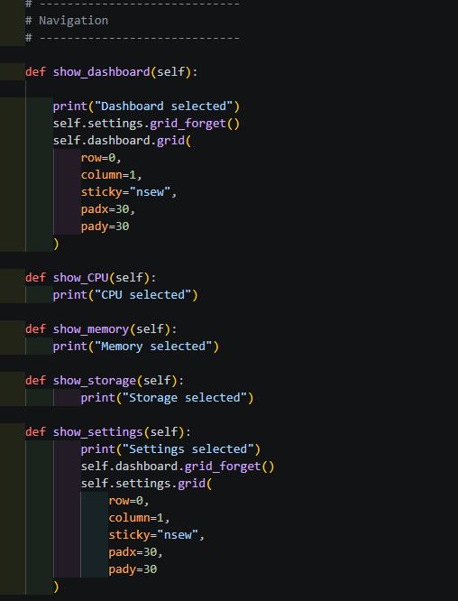
Programmed the show functions for dashboard and settings to be displayed when the button is clicked, by hiding the current page being displayed by using “grid_forget” and showing the new one by using “grid”. The remaining show functions will be added when the pages are created.

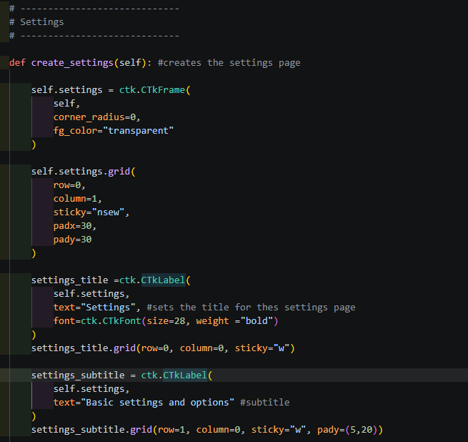
Created the settings page, I reused and copied the first two blocks of code for the frame from the dashboard function and changed it to settings. Next, I added a label/title using “ctk.CTkLabel” to show the word “settings”, and a smaller label under it for the subtitle. Now, when the settings button is clicked, it will open settings, and same with the dashboard.
Right under that, I formed the row that will contain the options to adjust the app’s appearance named “appearance”, similar to how I made the rows for the dashboard:
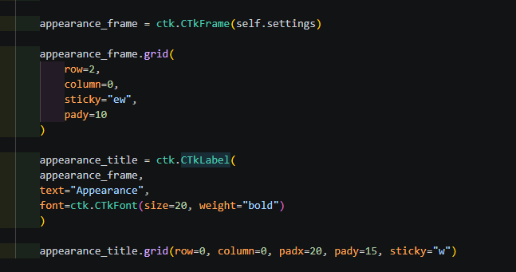
However, an issue now is that when the app opens, in starts off on settings, whereas I want it to start on the dashboard. This was a simple fix, I just had to put self.show_dashboard() at the bottom of my __init__ code:
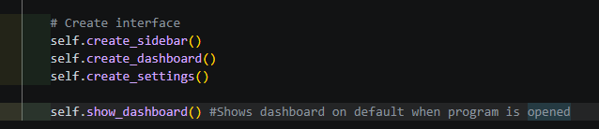
Under appearance, I added a soon to be functional button that allows the user to adjust some colours using tkinter’s “colorchooser”. This button is created using ctk.CTkButton() and is shown within the appearance row:
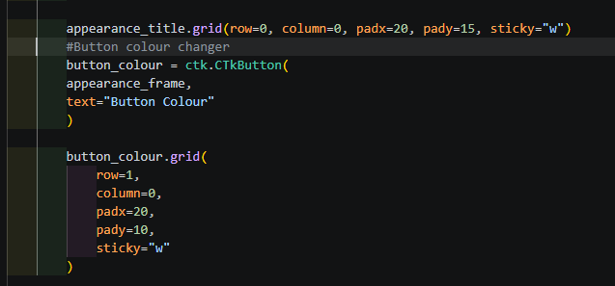
Here’s the current look of the settings page:
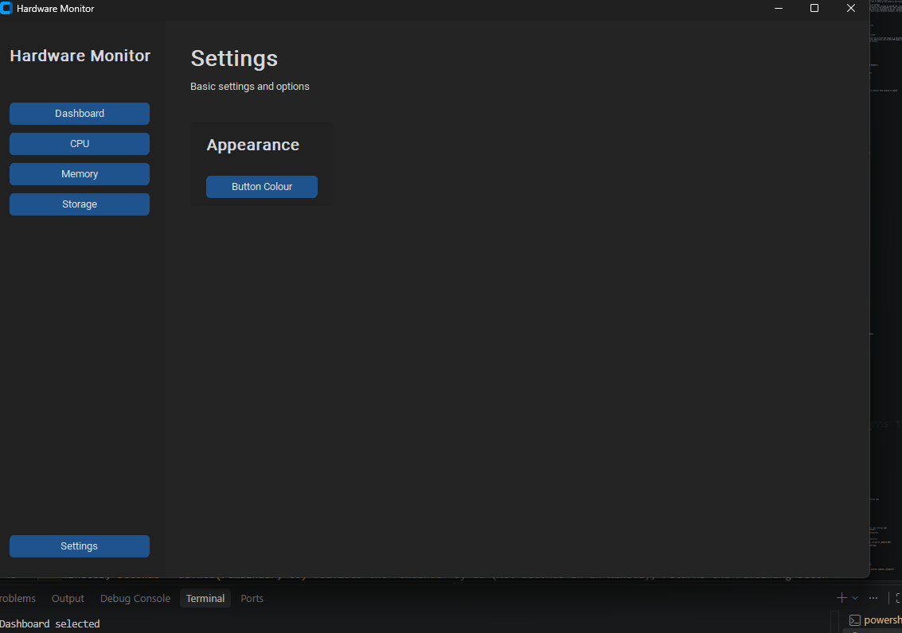
To make the button colour changer button, I made a new function in my HardwareMonitor class that calls upon colorpicker:
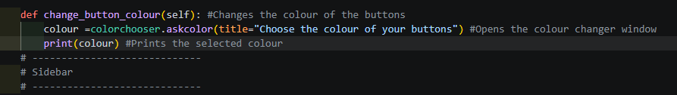
This opens a new window that lets the user pick a colour, saves it as the variable “colour”, and prints the colour’s hexadecimal code into the terminal. After adding “command=self.change_button_colour”, the window is opened when the button is pressed:
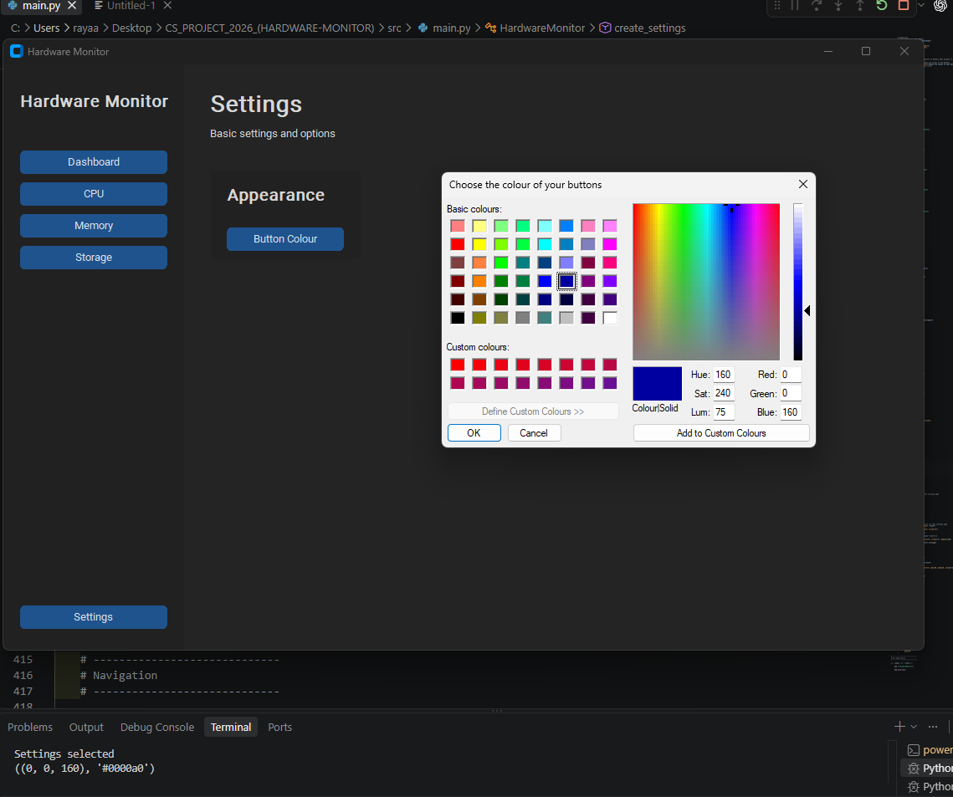
- Pressing the button called the function that opened up colorchooser. This lets the user freely pick a colour and put in a hex or RGB value if they want to too.

In the function for opening colour picker, I added a more code to take the hexadecimal value of the colour chosen and configure the colour of the buttons to that value. However, if none is chosen, the button colour will not change:
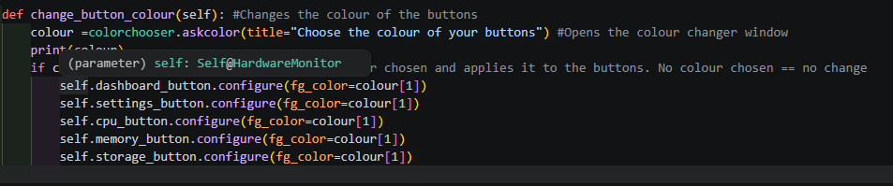
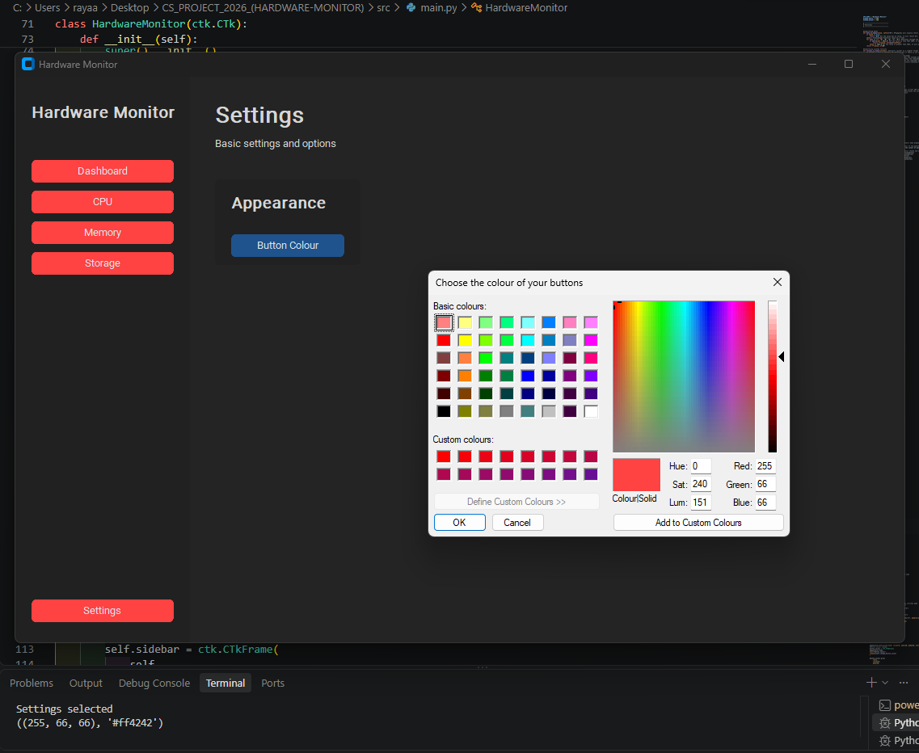
- The function takes the hexadecimal value of the colour chosen by the user and saves it as a varible “colour”. This colour is then used to configure the colour of the buttons on the sidebar.
Now the colour chosen will change the colour of the buttons on the sidebar, the button within the settings page will require different code to be able to change its colour.

17/09/2026

Setting Themes/Adding Live Values
Changed the “APP_NAME” variable to my desired name, Trace, now the window name and the name above the buttons are named.
Used the “psutil” library to display the device’s CPU and RAM usage percentage, however it does not get updated in real time:
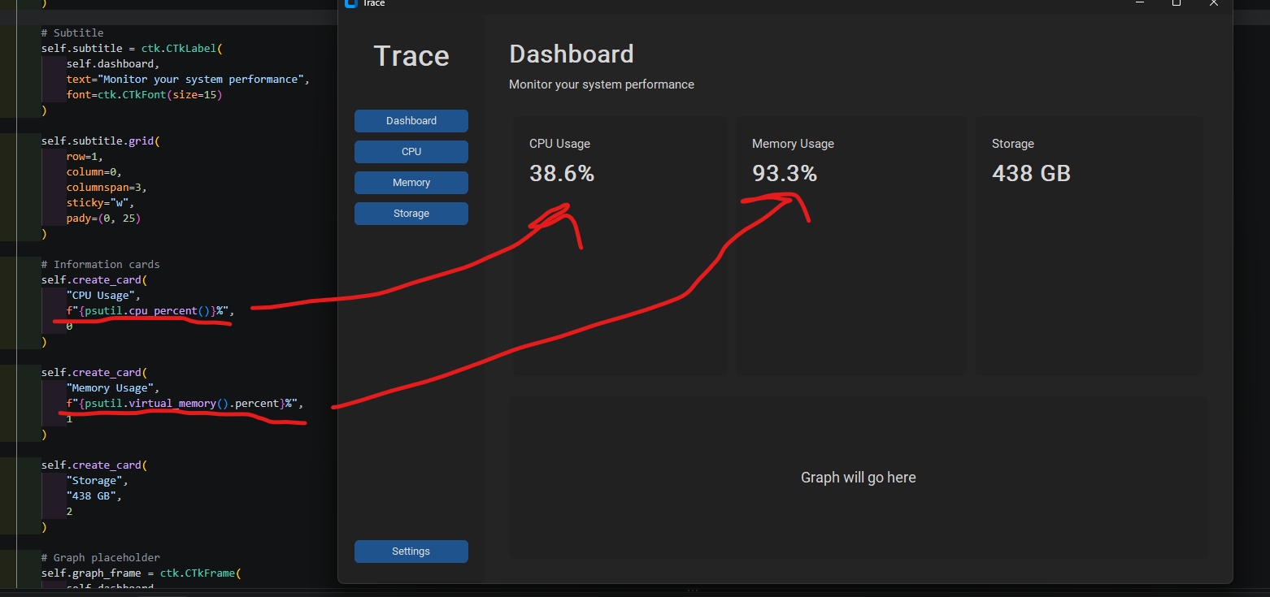

Added a new button in “Settings” that allows the user to switch between a “light” and “dark” background using a drop-down menu. This is useful for users with different visual preferences; the screen may not be bright/dark enough for them:
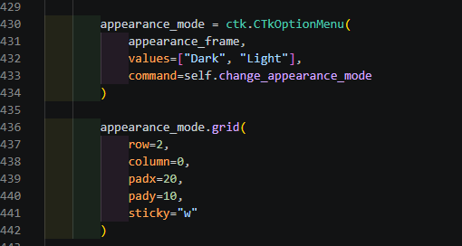
- Using ctk.CTkOptionMenu, a dropdown menu is formed that shows the values Light and Dark.
- The chosen options is used in appearance mode to set the appearance of the window
Selecting the menu will call upon the “change_appearance_mode” function:
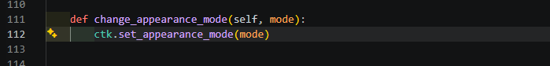
Selecting the “light” option turns the background white, the default light mode colour for custom tkinter:
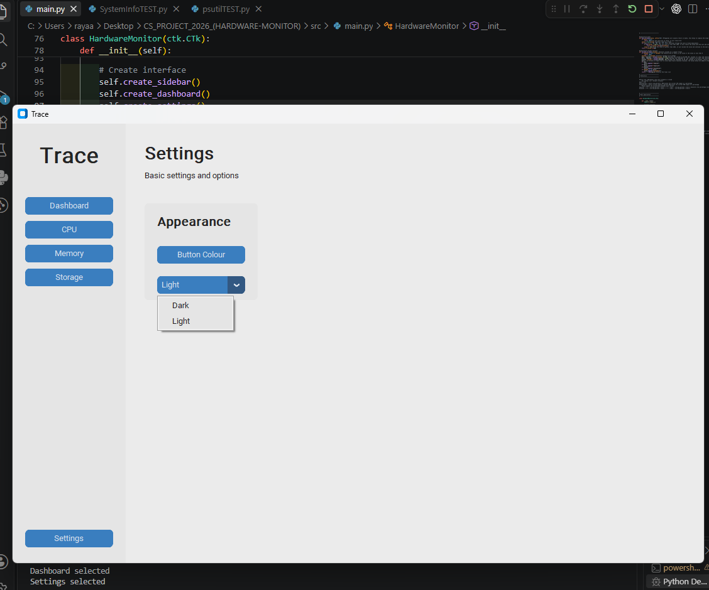
Also tweaked the information cards on the dashboard; they now display live, updating values that refresh every second (1000ms). I did this using the “update usage” function, which uses “psutil” to detect and return these updating values every 1000 milliseconds to be displayed on the information cards:
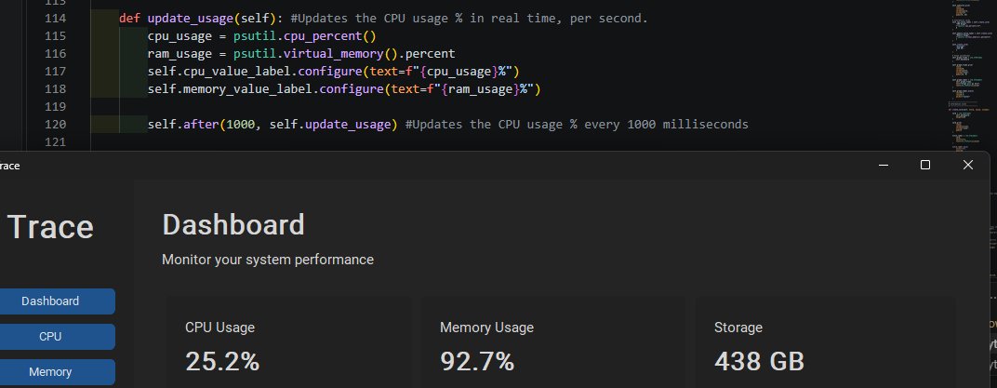
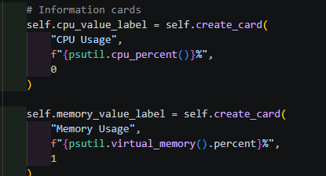
- The value labels for the cards are now updated per second in a function within my class instead of on the card itself.

Now, to detect the storage capacity of the device, I will use “psutil.disk_usage()”, which can be used to find the total size of the device’s secondary storage, and how much is being used. This is where the “byte_to_human()” subroutine can be utilised (I took this and the “seconds_to_human” function from a python article I found during my research phase, it was premade and very useful for simplifying the values psutil returned: https://thepythoncode.com/article/get-hardware-system-information-python):
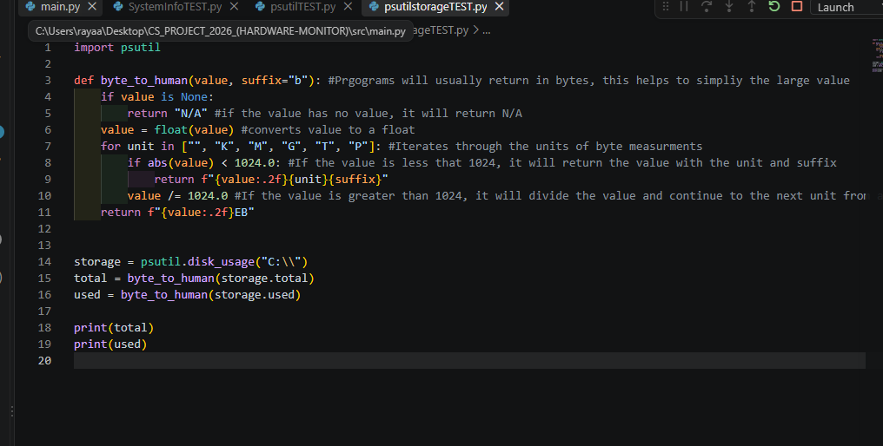
Which outputs:
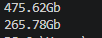
To implement these into my main code, I created a new function in my class:
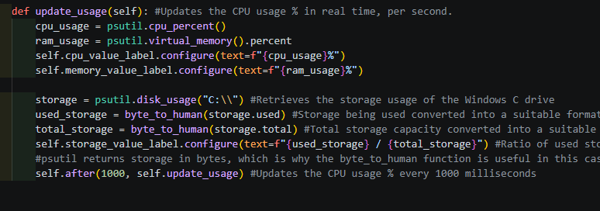
- Every 1000 milliseconds, a new value for both usage percentages is detected and displayed on the information card.

I used psutil to store the CPU and Memory usages as variables, which I used to configure the labels.
Storage needed more done to make it readable. Psutil returns storage information in bytes, which is why the bytes_to_human function is needed. I did this for both the total storage capacity of the hard drive and the amount of space used.
Then, the last line of code will have the values collected refreshed every 1000 milliseconds.
Then I adjusted the code for the information cards. Now they all begin with their corresponding label from the function (e.g. self.cpu_value_label):
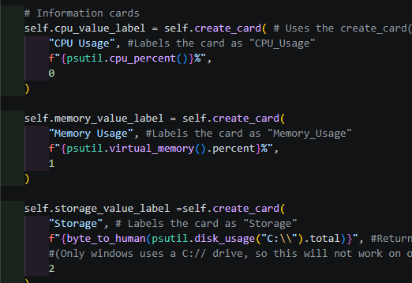
This now gives live values on the dashboard:
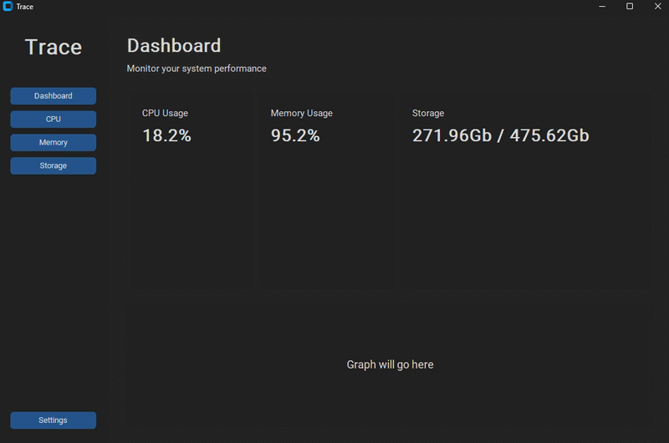
24/09/2026

Usage Graph (Dashboard)
Today, I plan on building the graphs for the dashboard displaying CPU and Memory percentage usage, which will update every second.
To do this, I will have to use a queue to store about 60 readings for the past minute (60 seconds). For this queue, I will use “deque” from Python’s collections library, and matplotlib to build the graph. This graph is going to replace the graph placeholder.
The plan is for the graph to lose its oldest value when a new value is pushed. Deque does this automatically, negating the need for extra code. So the oldest value in the queue will be pushed when a new one is pushed.
I created the queues above my class:
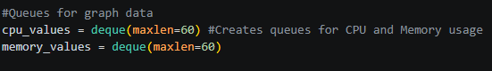
Then I cleaned up the code layout for my update_usage function, and added two lines of code to append the detected cpu/ram usages into the list (“cpu_values.append()”). I can forget about needing to delete the oldest value in the lists, deque does that already.
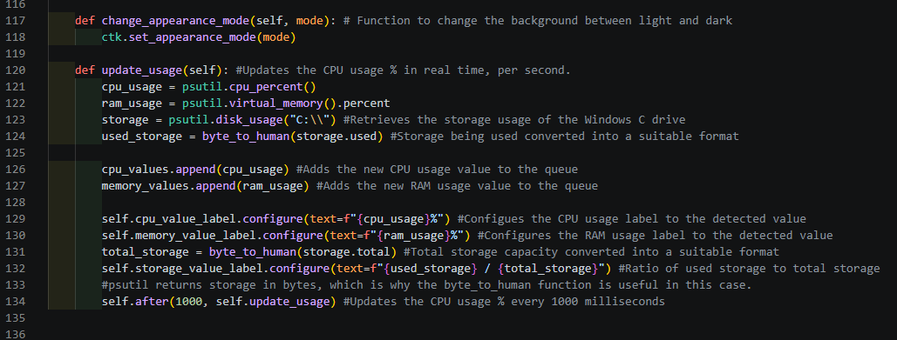
Under this function, I made a new function to build the graph called “update_graph”. During my separate matplotlib test, the test code would create a new window. I want it to be merged with the customtkinter window:
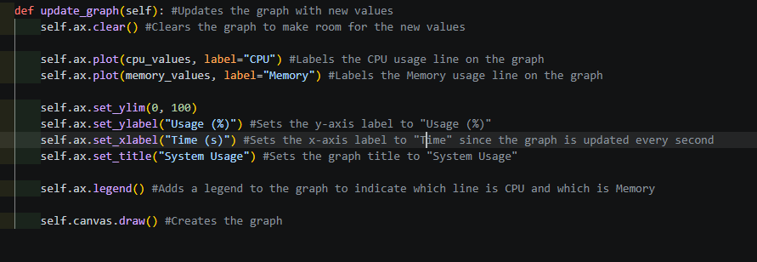
Then I called the function in the update_usage function:
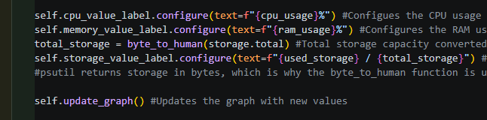
Now to create the graph, I used CanvasTkAgg to integrate the graph with the window instead of creating a whole new window to display the graph like matplotlib usually does:
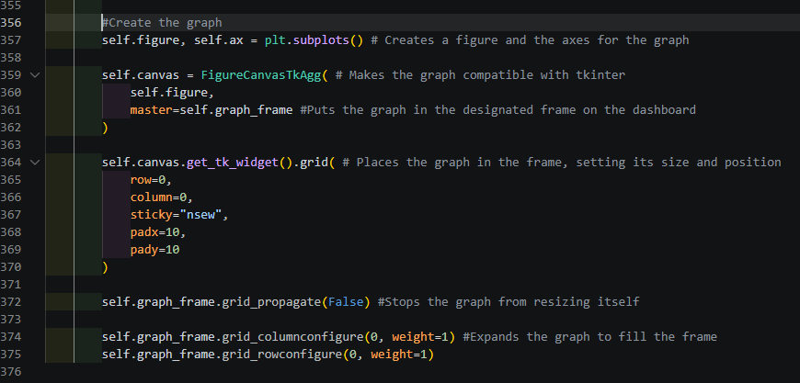
Now, the graph fits nicely in the dashboard:
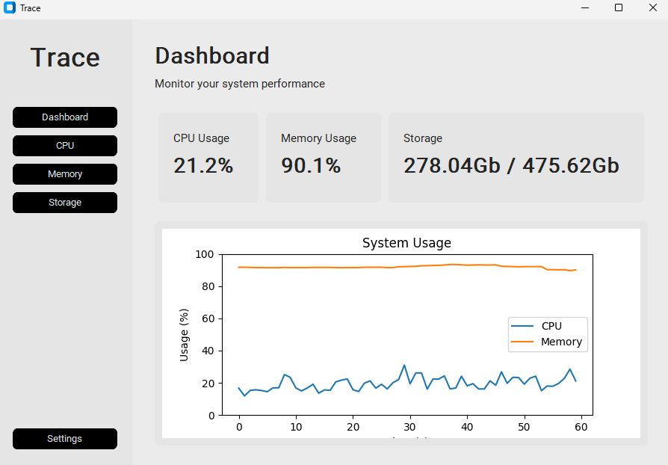

Next, I want to change the background colour of the graph to match the background colour of the application.
First, I set a default background colour to match the application’s default background:
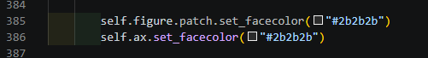
Then, in the update_graph() function, I changed the colours of the text to white so they can be seen properly in a dark grey background:
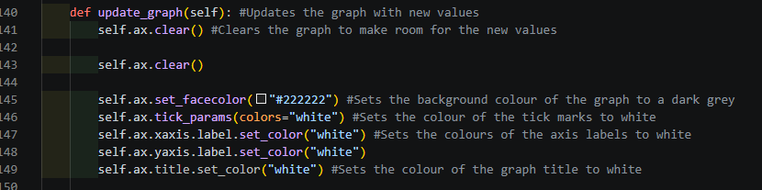
This:
- Set the background colour to a dark grey
- Set the ticks, labels, title and axis values to white for visibility

Now the graph looks like this:
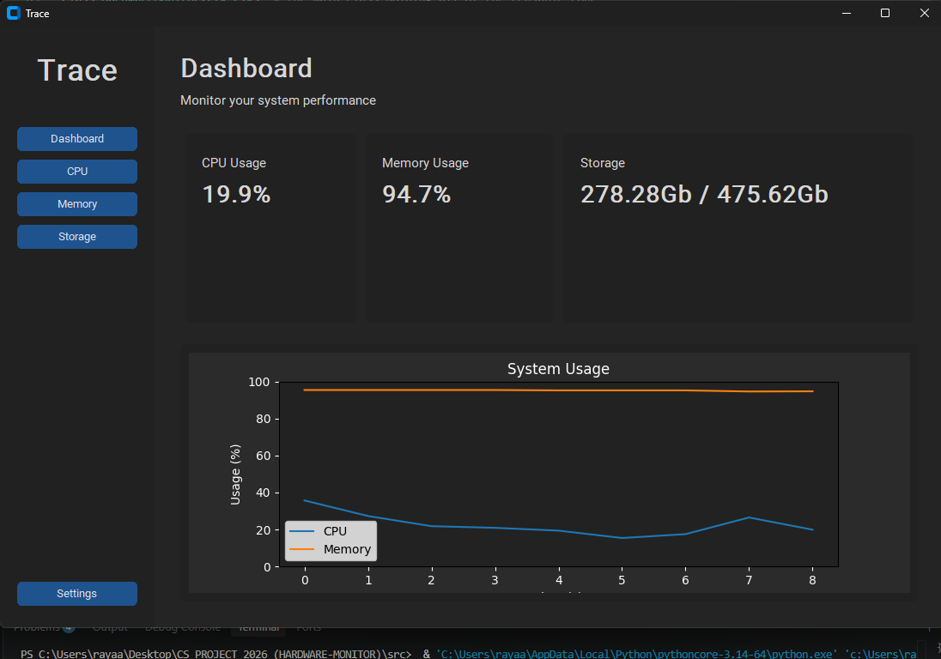
Now, in my update_graph() function, I added an If-Else statement that changed the graph’s theme based on the appearance mode of the window chosen by the user in settings:
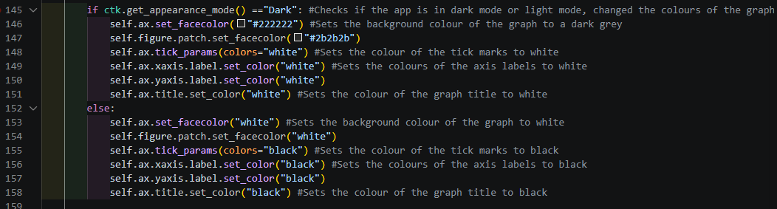
- The program will check if the appearance mode is light or dark.
- If dark, the colour scheme of the graph will be adjusted to match the window’s background. Same with light mode
Also, the default colour in the #Create graph section had to be removed in order for this to work. Now when selecting the “Light” option, the graph’s colour scheme now switches to a matching colour scheme:
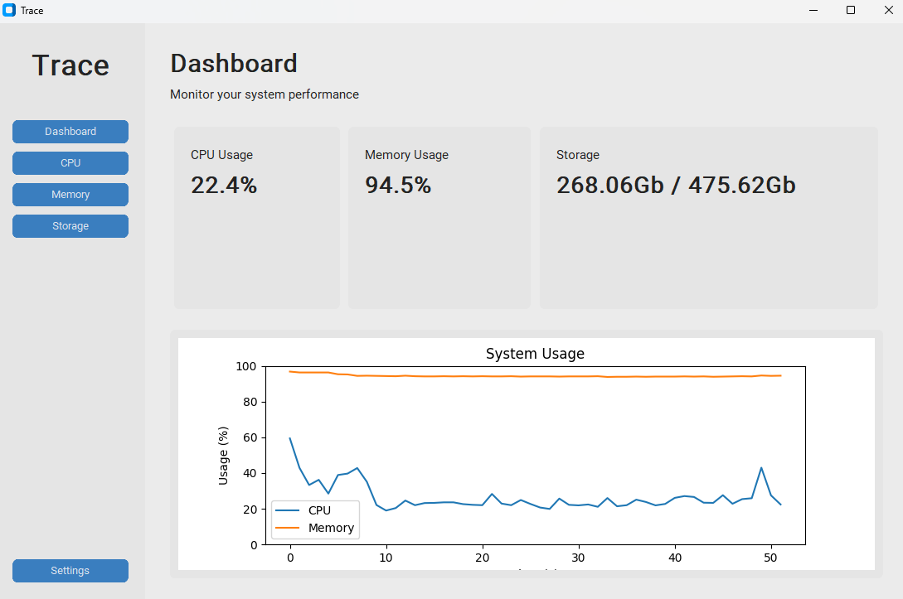

28/09/2026

Colour Indicators
Today, to begin with I will finish up the dashboard, changing the text colour of the usage percentages to indicate whether usage is optimal (🟩) alright(🟧) below optimal(🟥) (green, orange, red).
Underneath the my update_usage() function, I added a block of code that changes the text colour to the corresponding status. I did the same for memory:
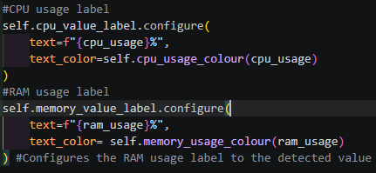
The usage colour is returned by another function in my class:
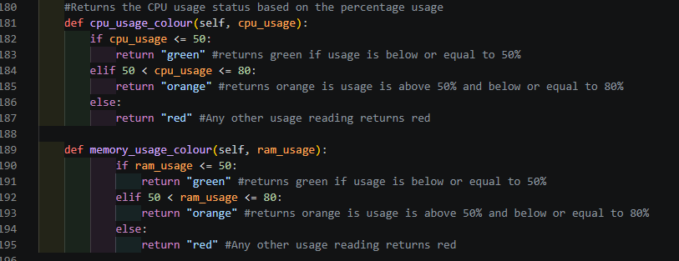
- The usage_colour() function will take the cpu/ram usage and return either green, orange or red.
- Next, in the update_usage() function, the function takes that returned value and updates the colour of the text (text_colour) when the value is refreshed.
Now the percentage usage text colour changes with the percentage:
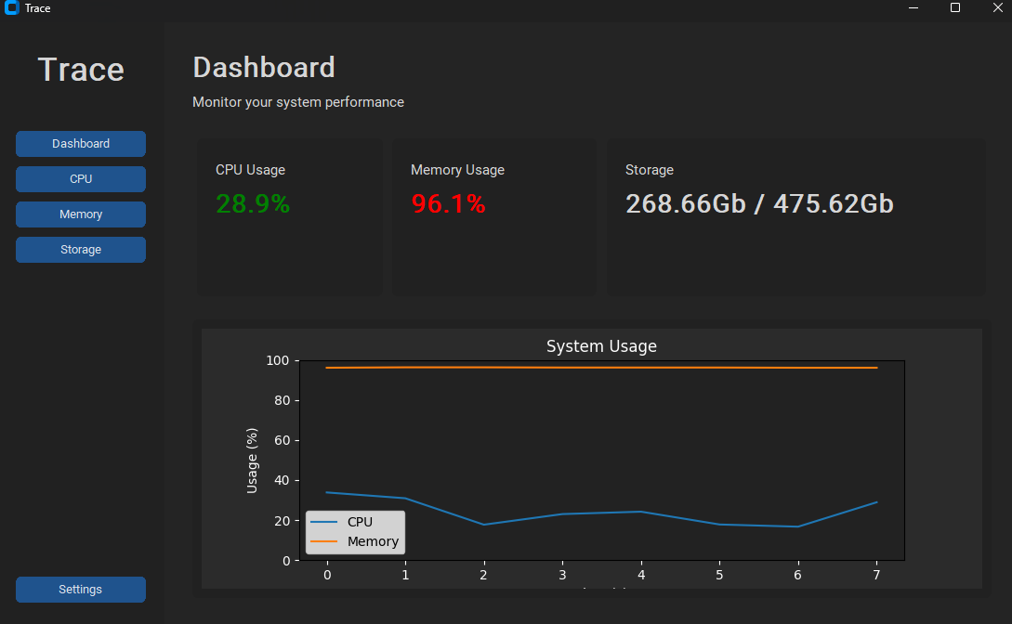
Next, I did the same for storage.
To find the percentage of the disk being used, I made a new variable in update_usage():
- storage_percent = storage.percent
And added a new function similar to the ones used for CPU and RAM for storage:
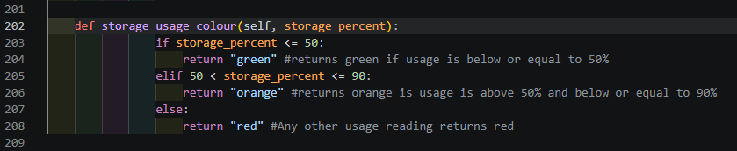
This takes the percentage of the disk being used to decide whether the usage is green, orange, or red if the statements are met, then it changed the colour of the disk usage ratio on the dashboard to the colour decided upon.
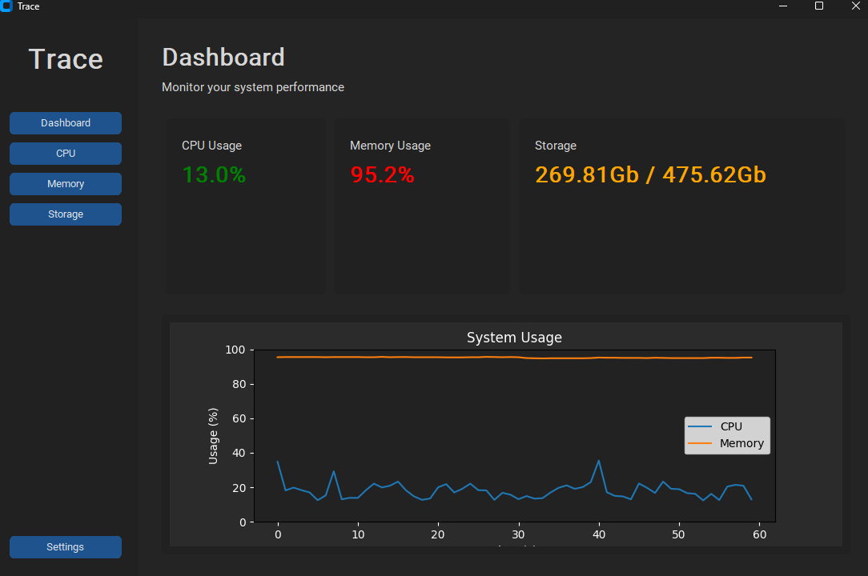
29/09/2026

Building the Dedicated Pages

Today, I plan on building the dedicated sections for the CPU, Memory and Storage buttons.
To begin with, I made a new function that hides all the pages currently active, so I do not have to write the code separately for each page:
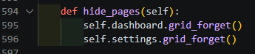
Next, I made another function, like the create_dashboard() and create_settings() functions, for the dedicated sections. I was able to make all three pages using one function since all three are going to follow a similar format.
I plan on each sections having:
- Its own graph
- Information regarding the component
- One button to open a document or website displaying what the component is and its purpose
- A second button to open the component’s database that lists the best components at each price range

This is the resultant code I used to build the CPU page:
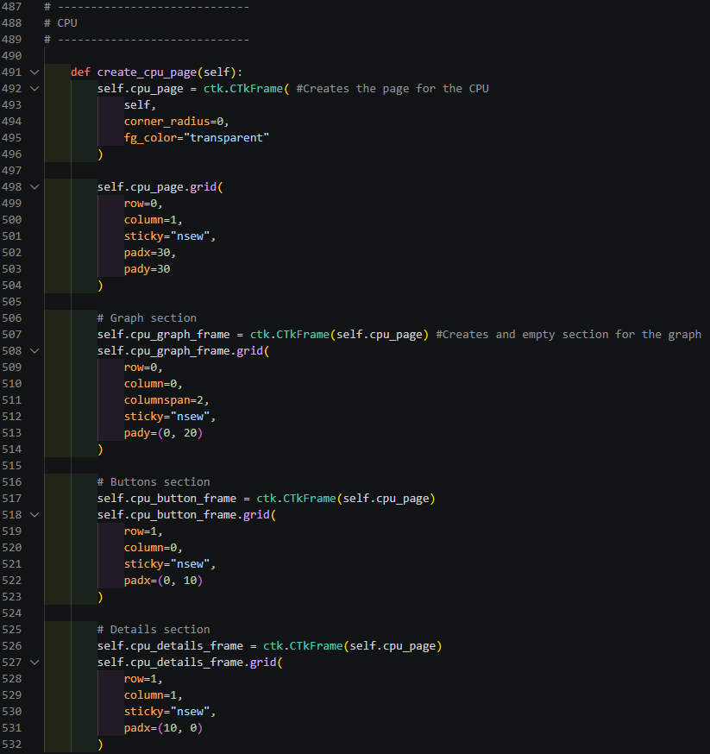
- The other two sections followed a near same format since they all will look similar
- The pages will have three sections, one at the top for the graph, two at the bottom for the buttons and component details

Next, I went back to my __init__ to create the pages:

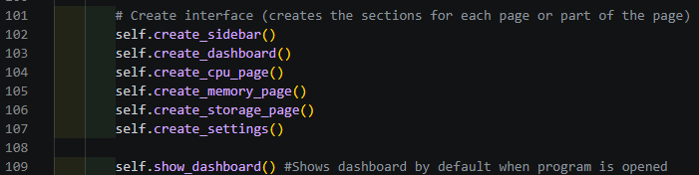

Now the pages are built when the application starts up and will open when clicked:
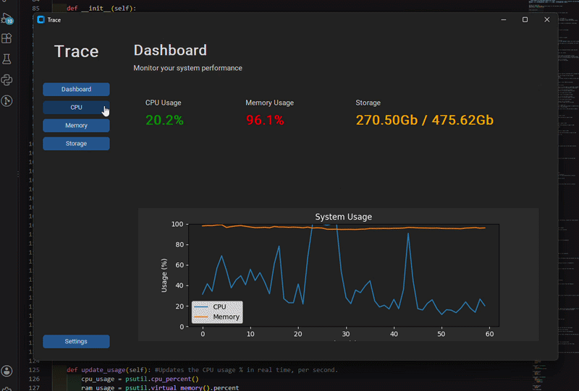

01/10/2026

Continuation of the Dedicated Pages

Today, before beginning to further develop my application, I ran the application, which then alerted my that my CPU usage was at 100% (I thought my computer was running a little slower than usual)
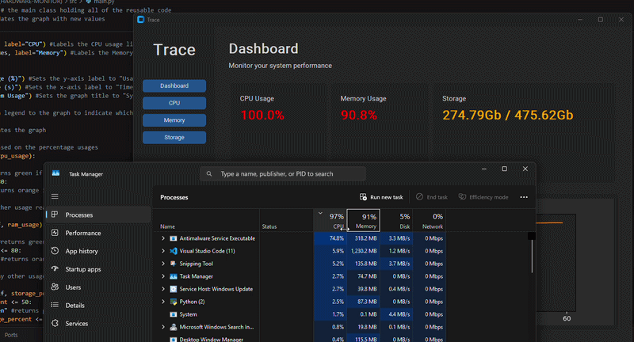
This was a live example of how I intended the application to be used; it indicated that my CPU usage was very high, which let me go to check on Task Manager to find out what the problem was: Windows’ antimalware services were starting up.
Also, there was an issue regarding closing the window, even after killing the program, the graph services would continue to run.
First, I used self.destroy() to close the window, which did not work. Upon reading a reddit help forum, I decided to try self.quit() instead, which did end up working.
Self.destroy() would destroy all widgets, such as the window, but not the graphs. Using self.quit() however exited out of all services after closing the tab, so app fully stops running after closure.

To begin the component page building, I started with resizing the pages so the frames fit better: (operating on all three simultaneously)
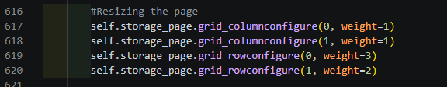
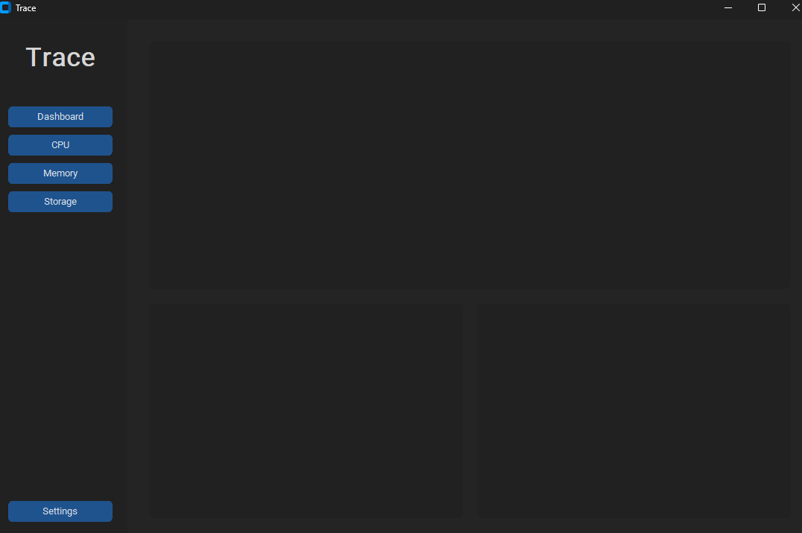
After that, I set the titles using ctk.CTkLabel:
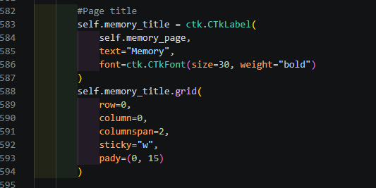
However, before doing that, I had to move every frame on the grid down a row to put the title at the top on row 0, otherwise the title would not show.
Result:
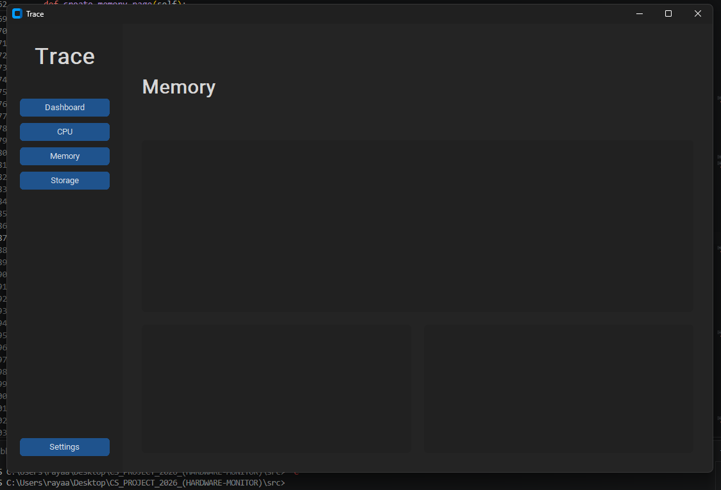

Next, I worked on the bottom left section, where the buttons that will open a “learn more” page and the component database. Each page used the same code (different names) to display the buttons in that frame.
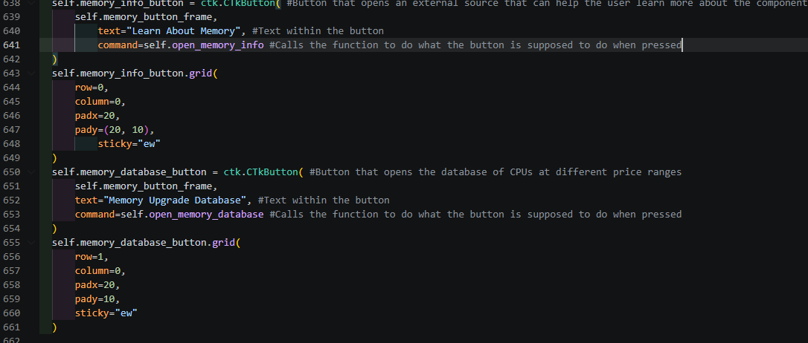
The functions used for the “command=” are going to be placeholder ones again, just like how the sidebar buttons worked, outputting “{button} selected” in the terminal:
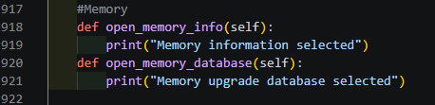
Another thing I added for the button frame was a line of code that resizes the buttons to fit in the box properly rather than take up a small section of the space:
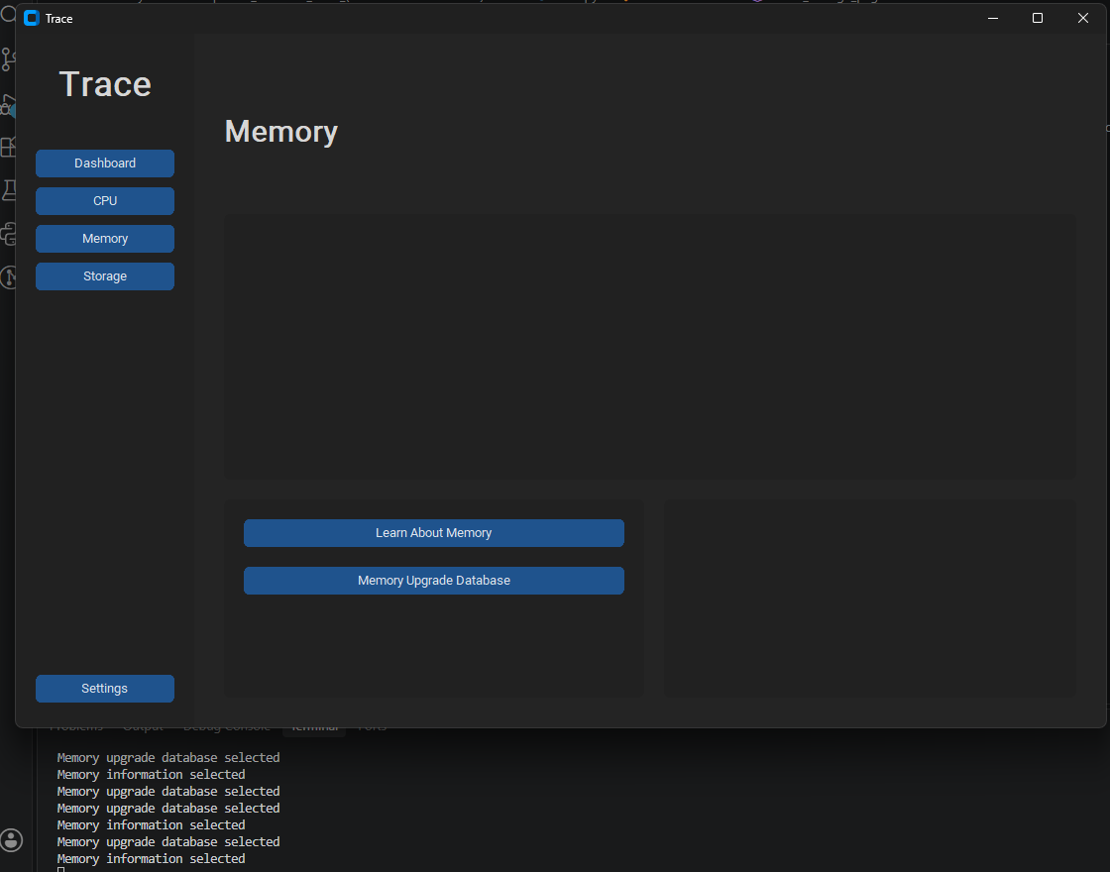
Since extra space remained underneath the buttons, I thought I would put the device uptime, the time the computer has been booted for, underneath the buttons.
First, I added a new variable that stores the calculation for the device uptime in update_usage():
Then I set the label as that value, which automatically updates per second due to update_usage(). One for each page:
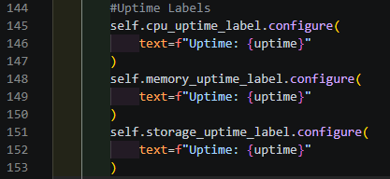
Underneath where I made the buttons, I added a label underneath that displays the current, live uptime:
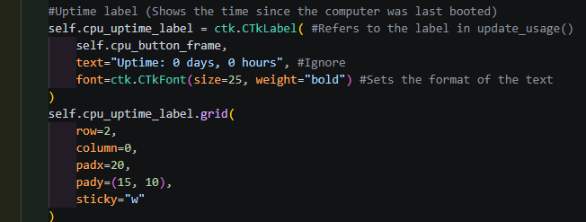
Result:
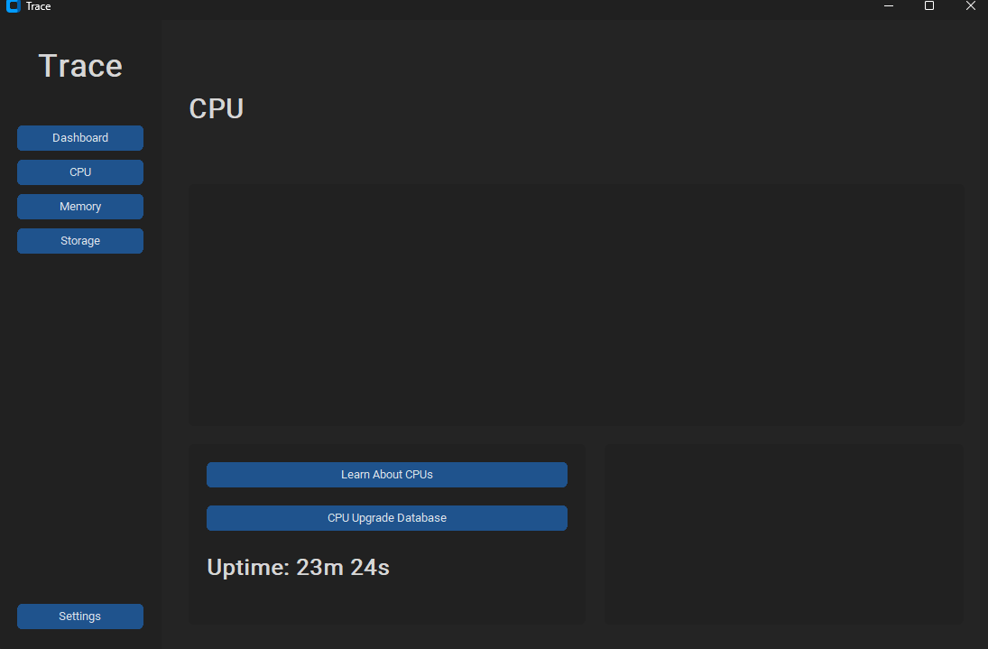
03/10/2026

Component Details

Today, I want to work on the bottom right section of each page, which will display the details regarding the component detected.
I took inspiration of what to include from Microsoft’s Task Manager:
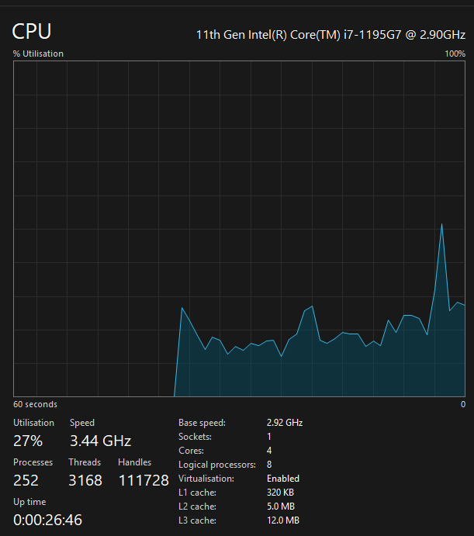

First, I update_usage(), I wrote the code that returns the information that I wanted to display in that frame, the current frequency, max frequency, name of the CPU, number of cores and logical cores:
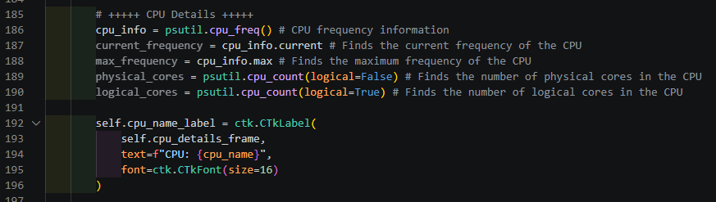
To get the name of the CPU, platform returned a generic name for my device’s CPU, not the exact one. Instead, I imported winreg, which lets me get the name of the CPU through the device’s Windows Registry. Here is the code I put into update_usage():
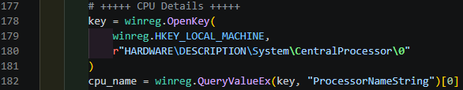

Then, under CPU details in the CPU page section, I created the labels for each value:
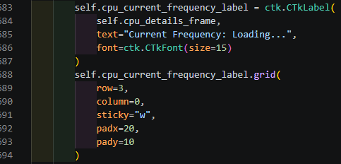
(Each label took a similar format)

Then I configured each label to contain their designated value in update_usage():
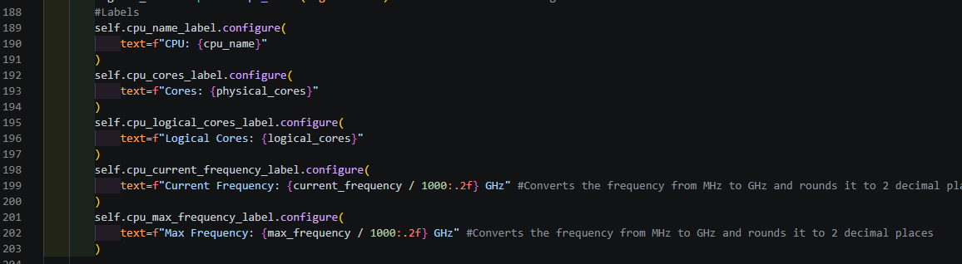
Here is the final product:
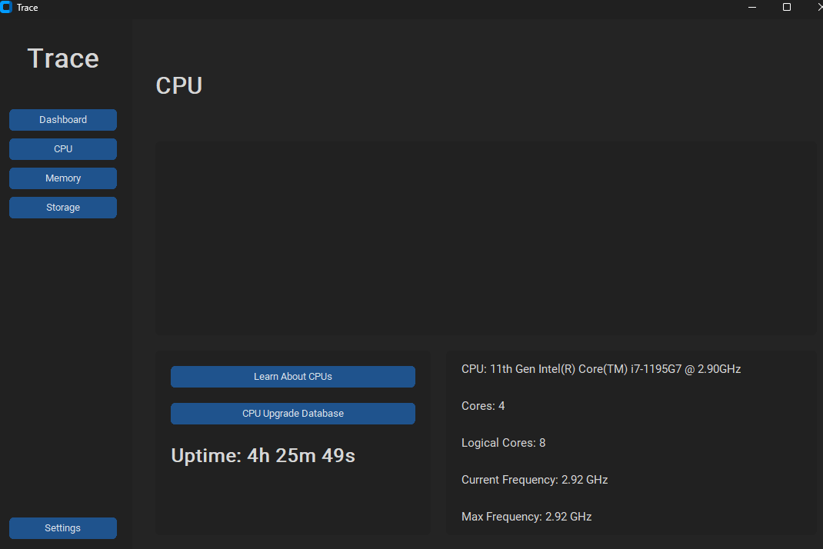

05/10/2026

Component Graphs
Today, I will develop the graph for the CPU page. Once again, I will use FigureCanvasTkAgg to merge the graph with the tkinter window.
To begin, I will create the axis for the graph within the space I created for the graph to be placed in:
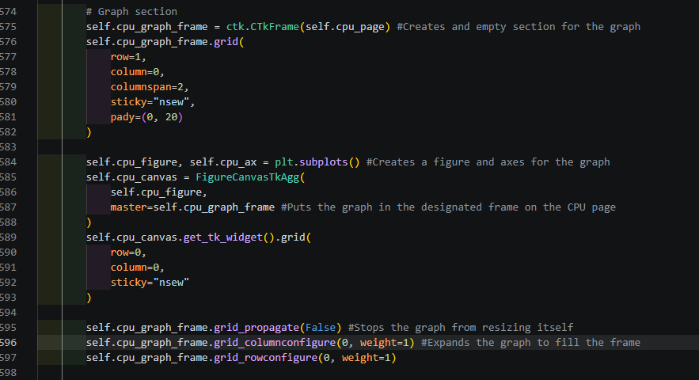
Then I made the graph its own updating function so it will update on its own:
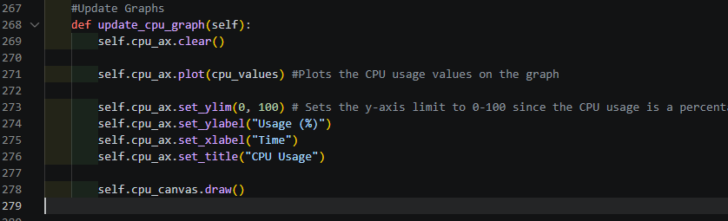
Then I called the function in update_usage() so the graph update per second:
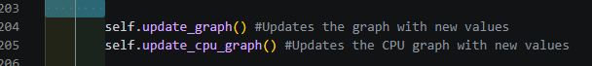
Result:
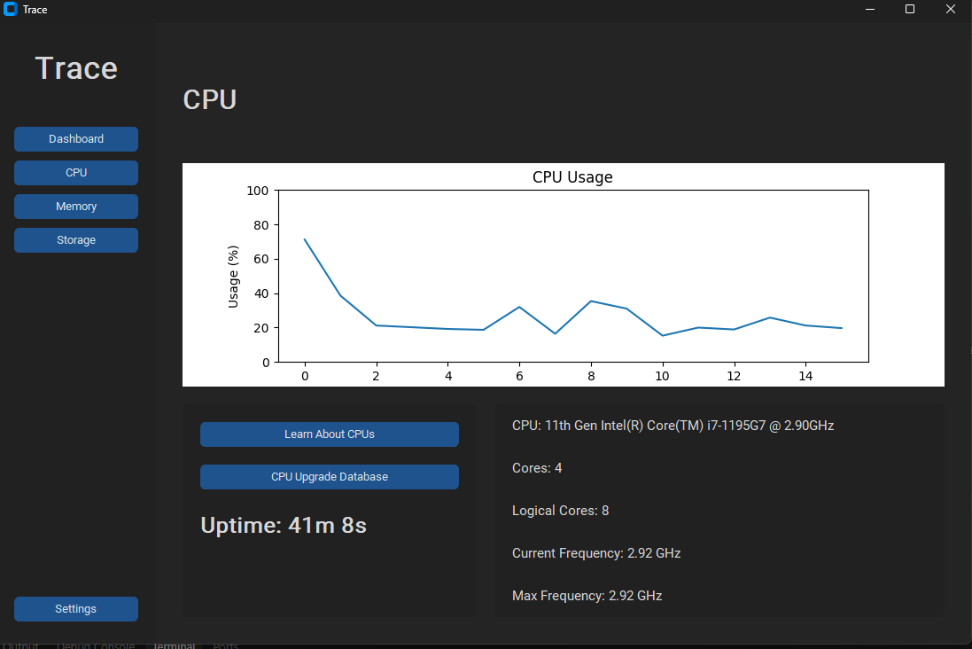
Next, I reused some code from the update_graph() function to change the colour of this graph too:
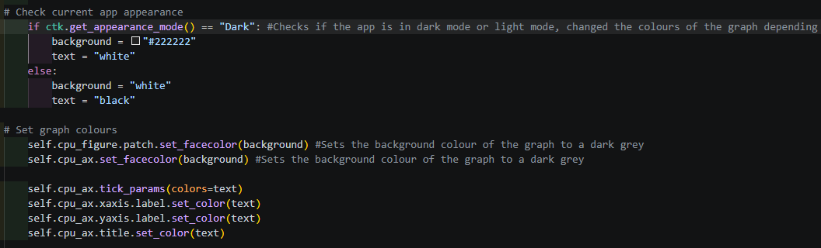
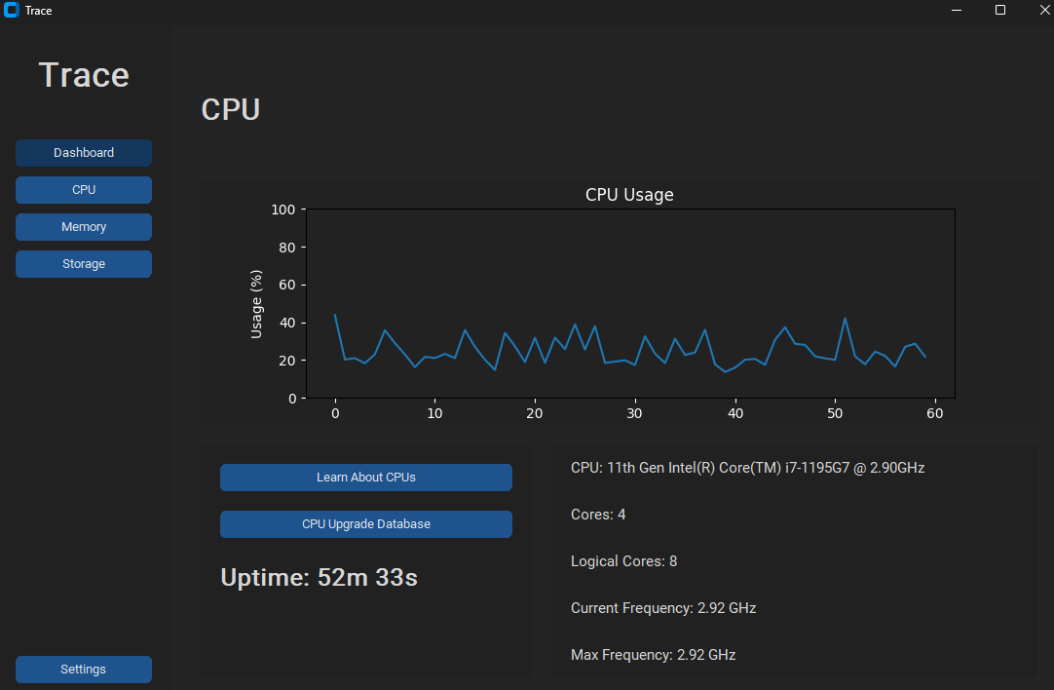
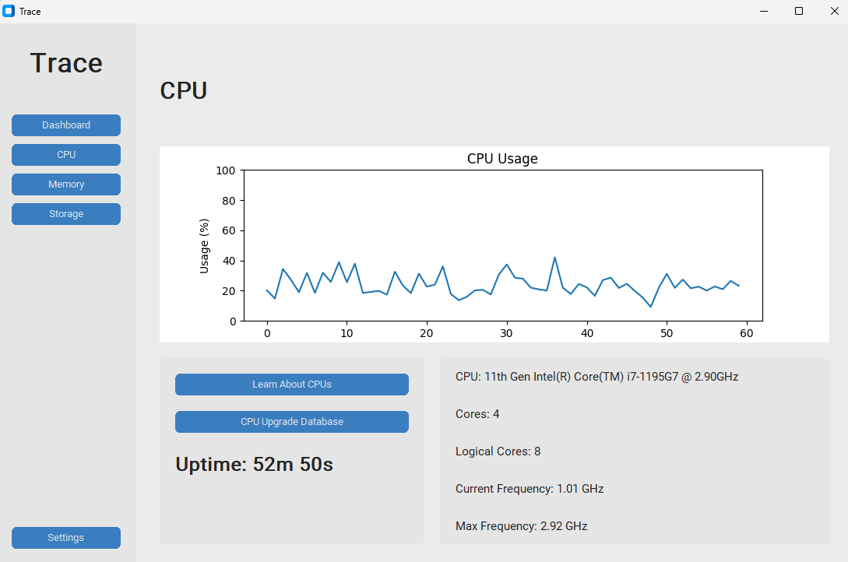
I repeated this process for the Memory and Storage pages, since they used similar code to make, I only changed the variable/constant names:
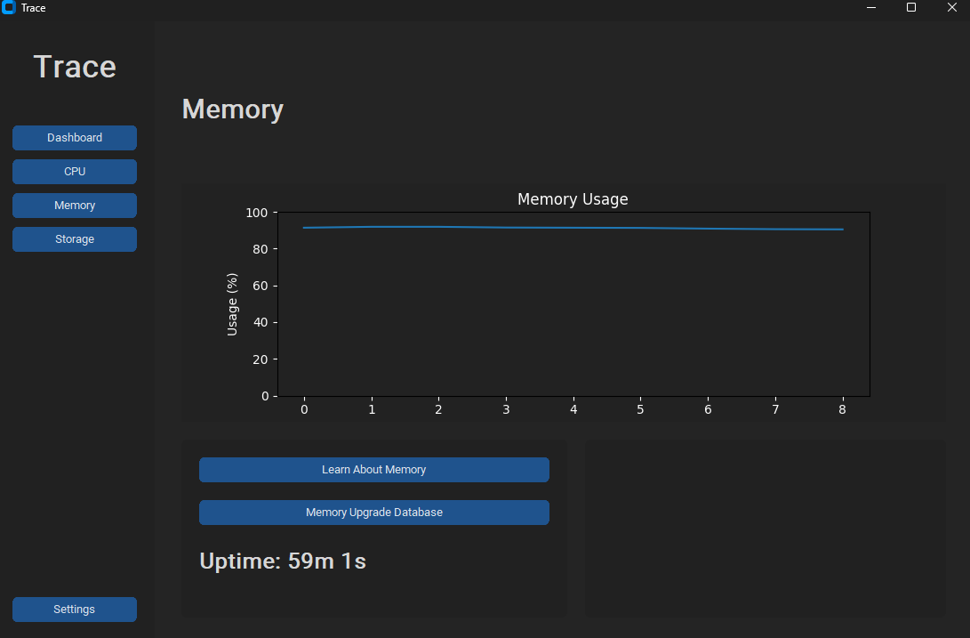
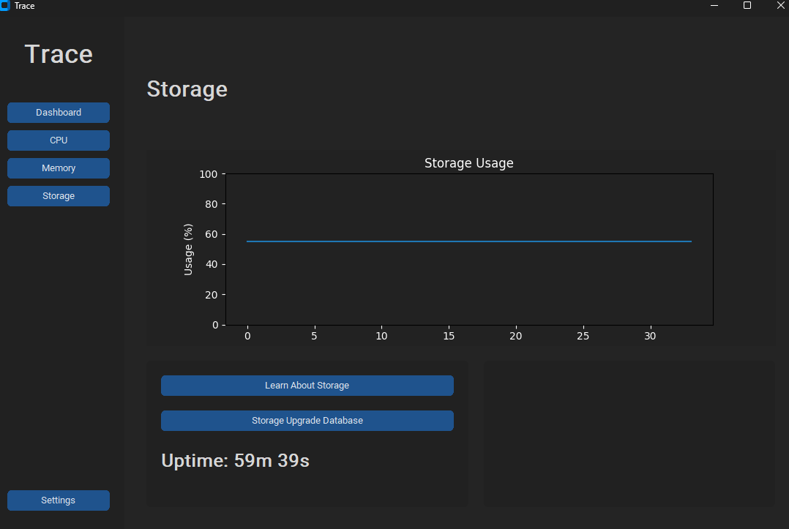

07/10/2026

Memory and Storage Details

Today, I plan on adding the details regarding memory, like how I displayed the details for the CPU page in the bottom right frame of the page.
The details I want to display consist of:
- Type of RAM / physical form factor (e.g. SODIMM laptop memory)
- Amount of RAM
- How much RAM is being used up
- How many RAM slots are occupied on the motherboard
- Amount of virtual memory (swap)
- How much space is being used in virtual memory
To do this, I will use labels that will require configuring, just like how CPU details worked, updating them using functions within the class.
I will use psutil to return numerical values, however names will require the use of subprocess since psutil is unable to return those kinds of values.
First, in update_usage(), I added code that allowed the program to return the total amount of installed RAM, amount of it being used, and the amount available and configured their labels after converting the returned values using byte_to_human() to a simplified format:
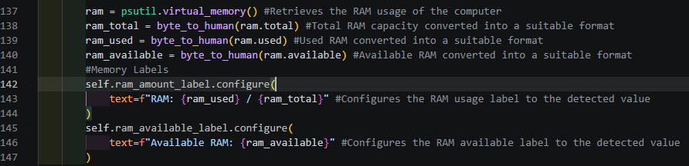
I did the same for the swap memory:

Next, I created the subprocesses to get:
- RAM type
- Form factor
- Total slots
- Used slots
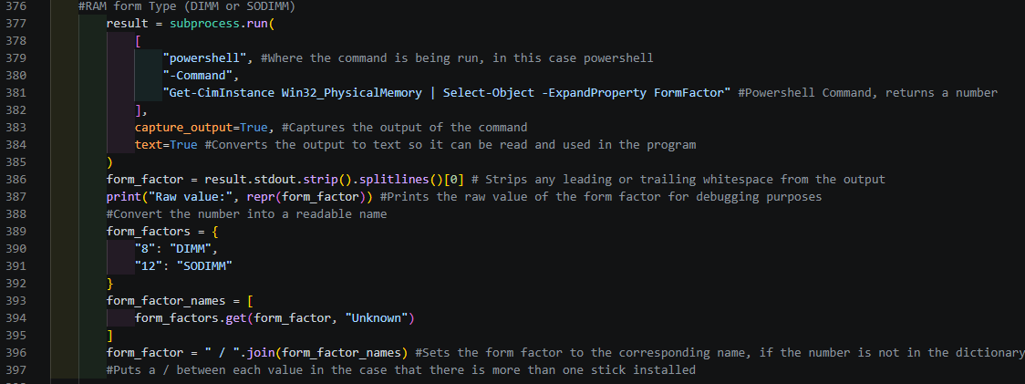
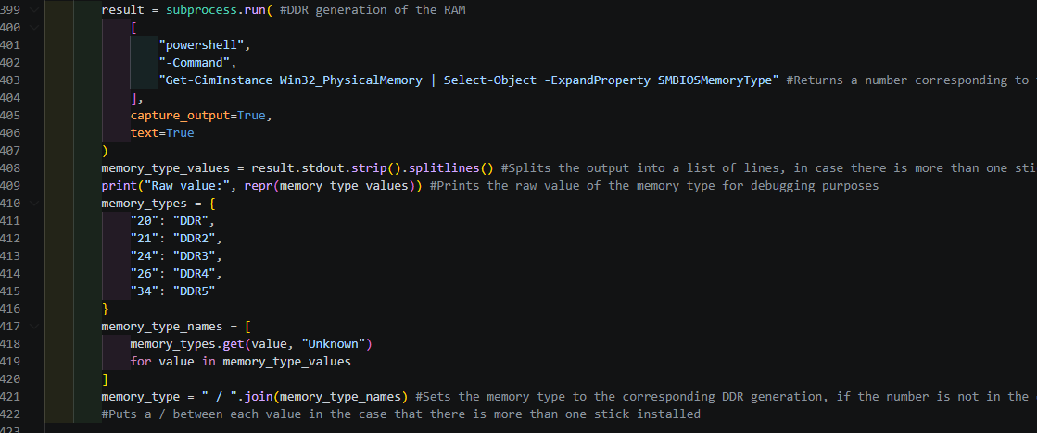
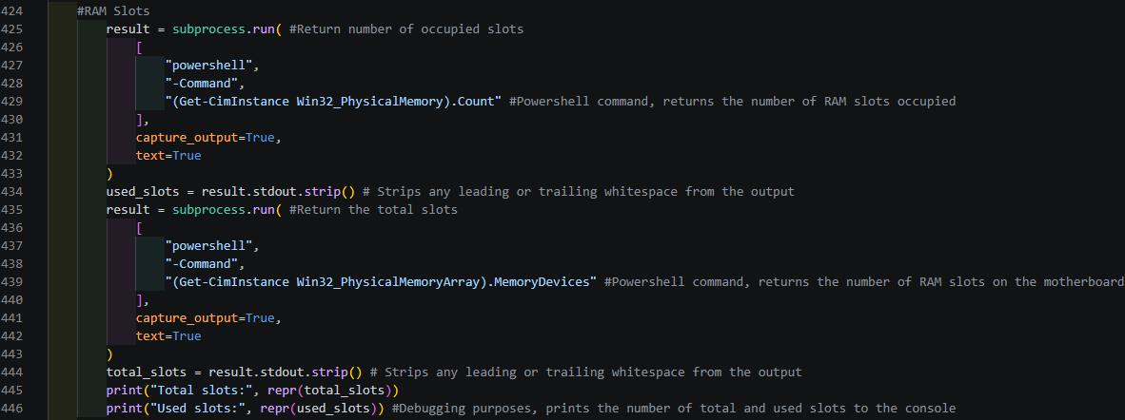

Then the labels under the details section of the memory page to display the values:
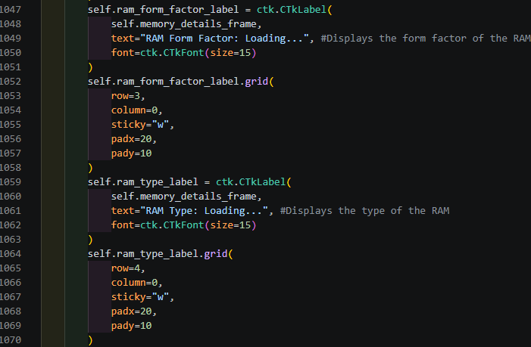
Then I set the labels to contain the returned value from the subprocesses within get_memory_details():
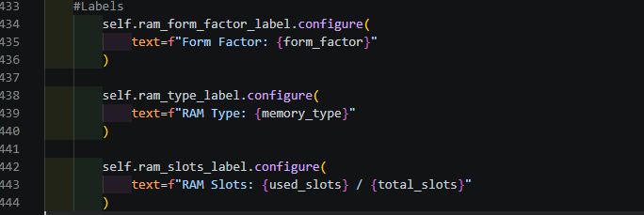
Result:
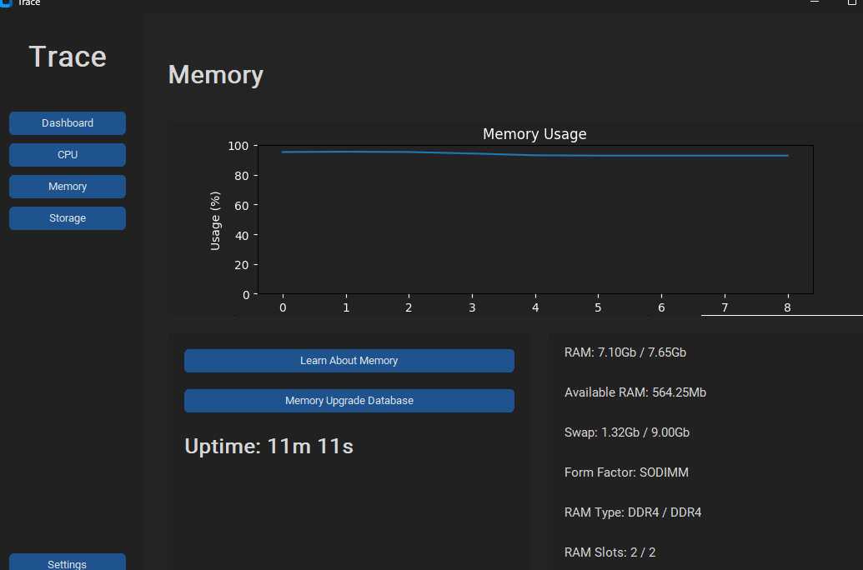

09/10/2026

Storage details:

Today, I will add the details surrounding the device’s hard drive.
This will include values such as:
- Read/Write speeds
- Max capacity
- Used capacity
- Type of storage media (e.g. SSD)
I started off with the subprocess. It will run the command:
- Get-PhysicalDisk | Select-Object -ExpandProperty MediaType
Which will return the type of hard drive as “SSD” or “HDD”:

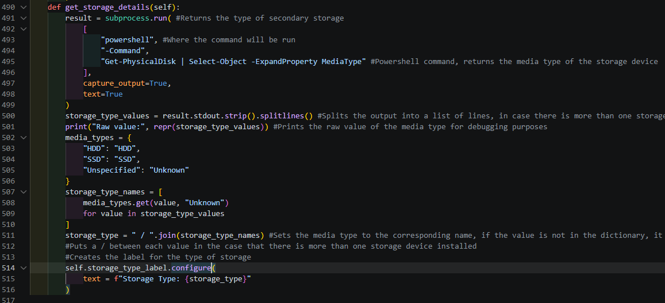
If the command returns “unspecified”, the label will be set as “unknown”.
If there are more than one storage medias installed, they will be separated using “/” to avoid bad outputs (e.g. HDDHDDHDD). Similar to the other subprocesses.
I then set the output as the storage_type_label to display in the details section.
Then I created another set of variables to display the total capacity, used capacity, write and read speeds using psutil:
I put the code for this inside the update_usage() function so a new value can be retrieved every second:
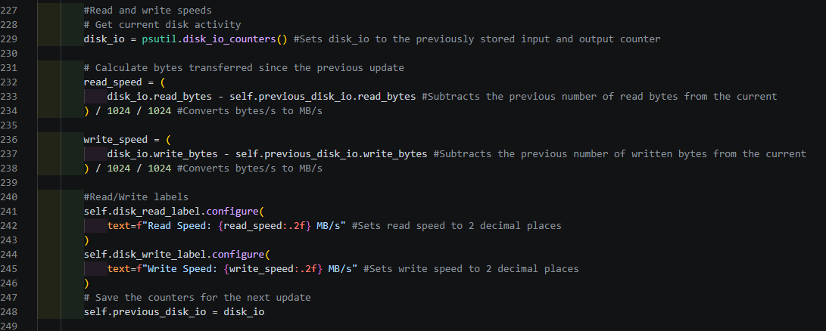
I used psutil to return the input/output counter. To get the number of bytes read and written, I subtracted the number of bytes now by the number of bytes before to find the difference between them. This got me the number of bytes written/ read at that moment. Then I divided the number of bytes by 1024 twice to convert it to MB/s. MB/s is the unit I want the read/write number to be by default, hence why I did not use byte_to_human().
Lastly, I reused the variables containing the total capacity and used capacity in update_usage() to make a new label for the details section, almost the same as the one used for the dashboard.
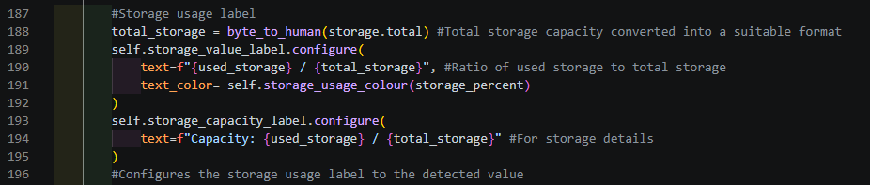
Here is the end product:
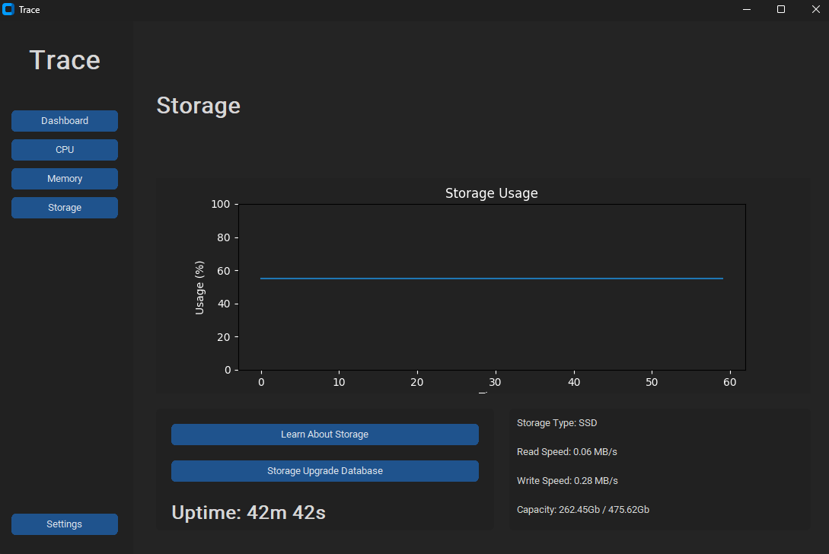
If I were to be downloading anything at the moment, the read/write speeds would have been greater than the ones currently displayed.

12/10/2026

Storage Page Continuation
Today, I decided to add the drive name to the list of details in the storage page. I also want to change up the graph, since it is mostly stationary. I wanted to change the graph to display read and write speeds instead since I believe it will be more useful than a straight line that updates every second.
I began with the subprocess to return the name of the storage media (drive):
This went into get_storage_details():
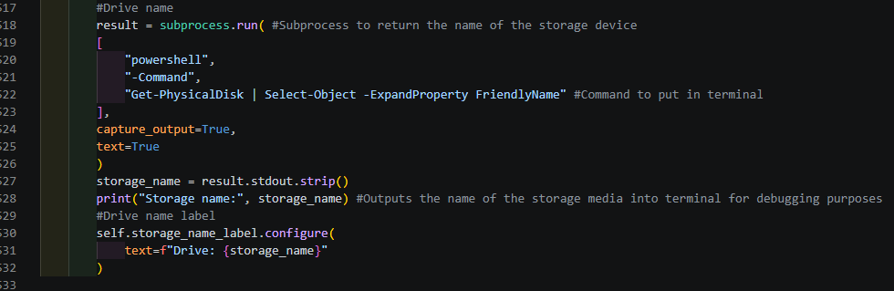
The command would be put into powershell to return the name of the device’s drive.
The name would then be extracted from the output of the powershell and pasted into terminal for me to see what output it returned.
Then I set the label to be displayed in the details section as the name of the drive at the bottom of the block of code.
Next, I created the label under #Details in the storage page section, aligning with the other labels:
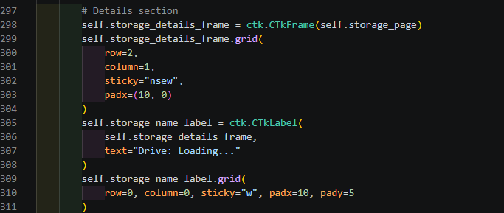
Result:
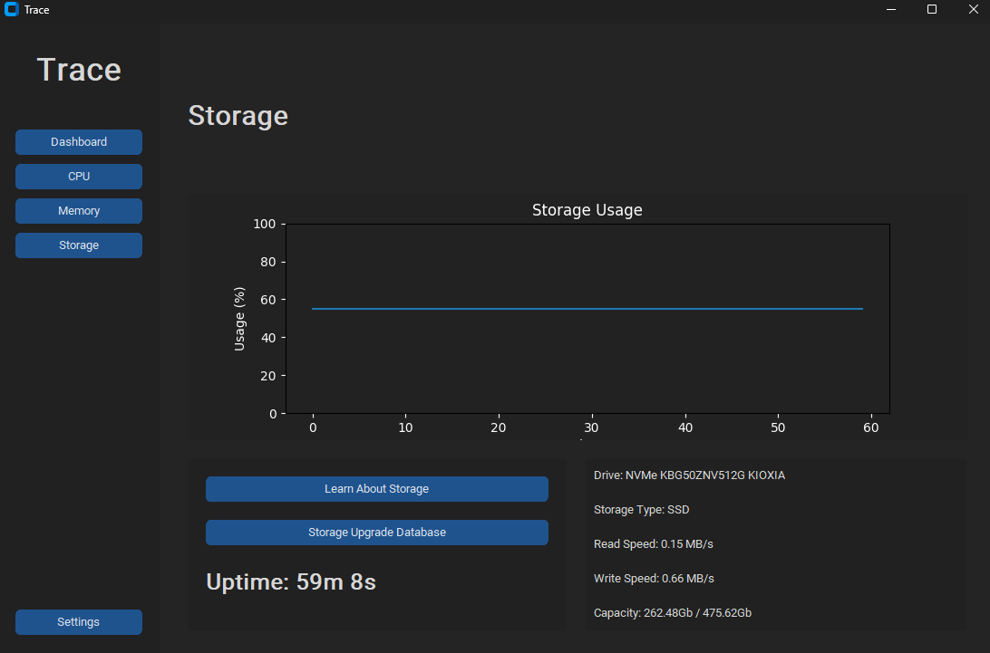

13/10/2026

Making the Application Independent to VS Code

Today, I plan on making my application run without the use of VS Code.
To do this, I will make use of pyinstaller and my requirements.txt file.
I installed pyinstaller by running the command:
- py -m pip install pyinstaller
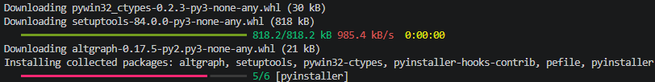
In the requirements.txt file, I listed the names of the external libraries I used in my code:
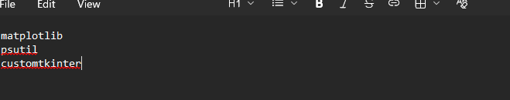
Next, I tested if the requirements would be installed when I ran the command:
- py -m pip install -r requirements.txt
Which returned no error, which was a good sign that it worked.
After that, I built the executable file using the terminal command:
- py -m PyInstaller --onefile --windowed --name Trace src/main.py
--onefile is used to make one .exe file. –windowed is used to prevent a separate console window from appearing, and –name names the .exe file to “Trace.exe”.
src/main.py is the the main python file holding my code, which I wanted to convert to an executable.
Here is the file structure before, for reference: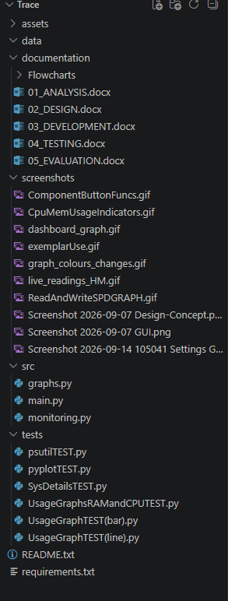
After using the command, a new “dist” file was created to launch the app without VS Code. The .spec file was also created as a sort of “recipe” to use when turning main.py into an .exe file.

To update the executable when changes are made to main.py, I can run the command:
- py -m PyInstaller Trace.spec
In the VS Code terminal to update that “recipe” to launch the new version of main.py.
Now, when opening the “Trace” file in “dist”:
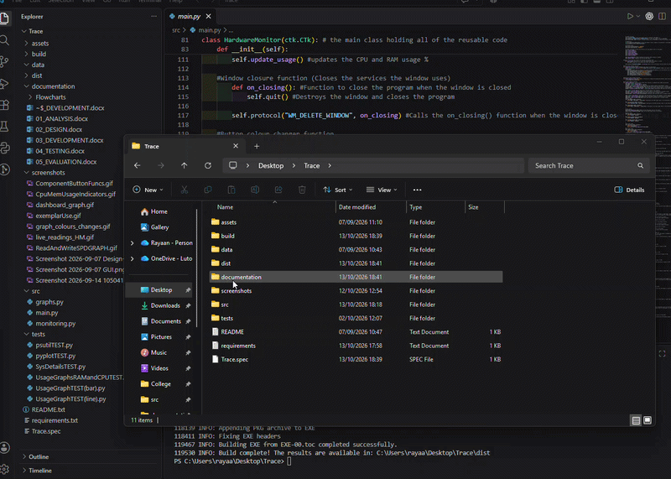
Full clip:


15/10/2026

Making the “Learn About…” Button Functional

Today, I plan on making the learn about buttons on the component pages work, as in they can open a webpage that can provide information about that component when clicked on.
For the webpages, I will have the buttons open Microsoft’s “Everything about” tutorials since they include information alongside videos.
First, I added webbrowser to my list of imports:
Next, I took my existing open_cpu_info() in navigation, which currently just prints “CPU information selected” into terminal, and changed it to open the link to the webpage:
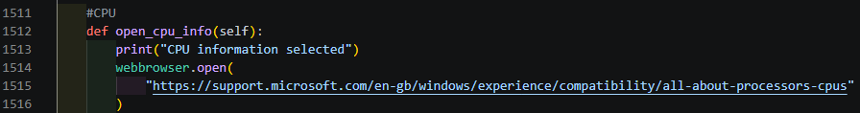
I repeated this process for the memory and storage pages:
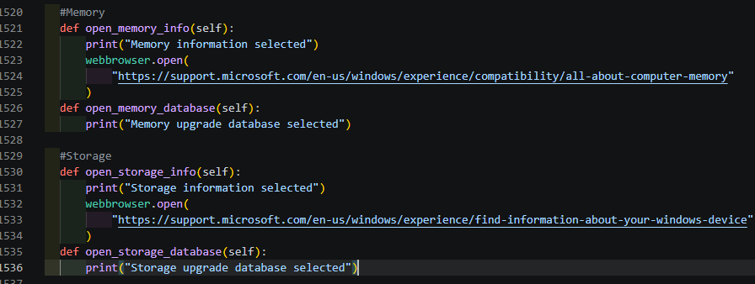

The webpages by Microsoft that I used:
CPU - https://support.microsoft.com/en-gb/windows/experience/compatibility/all-about-processors-cpus
Memory - https://support.microsoft.com/en-us/windows/all-about-computer-memory-79a75280-86ff-457c-bfbd-8439e7f7f88b
Storage - https://support.microsoft.com/en-us/windows/experience/find-information-about-your-windows-device

Next, I worked on the relational databases. To build the databases, I used SQL Lite.
I started off with the CPU database, which should include the fields:
- brand, model
- cores, threads
- base_ghz
- boost_ghz
- socket
- price_gbp
- product_url
- price_checked
Which are the details I found about the CPUs on https://pcparts.uk/.
After creating the fields, I inserted the data of each entity into the table:
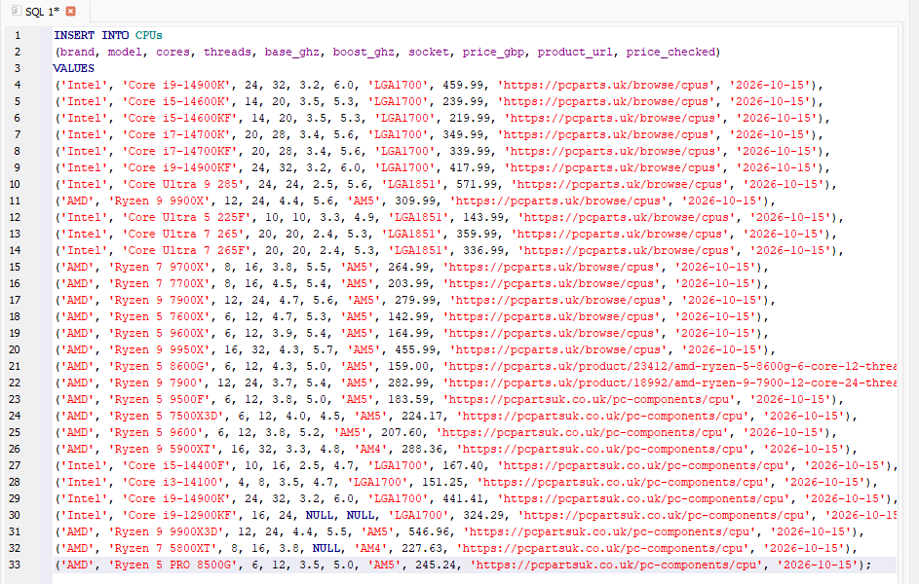
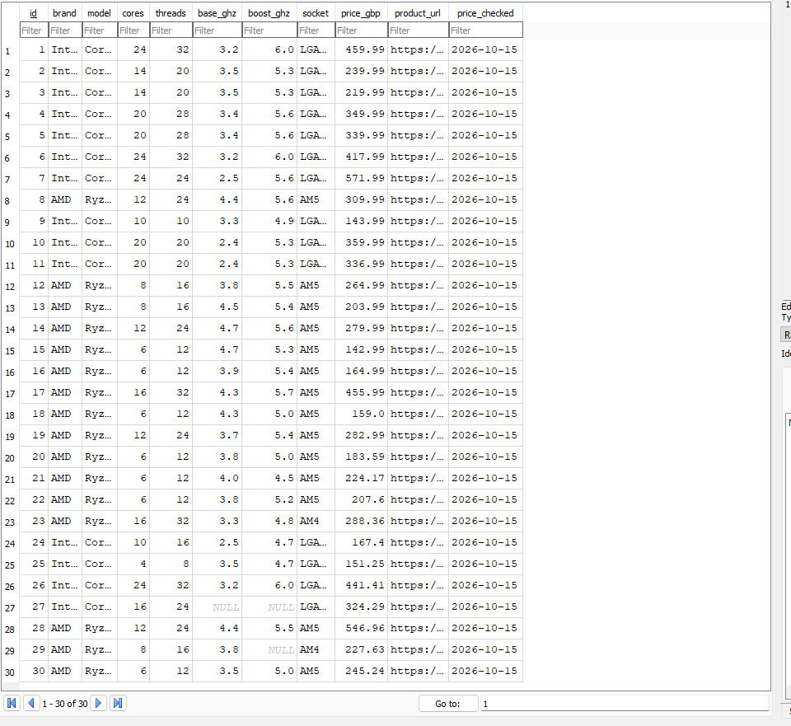
The records with “NULL” in any of the fields are like that because I was unable to find the information for that field.
Then I did the same for RAM and Storage:
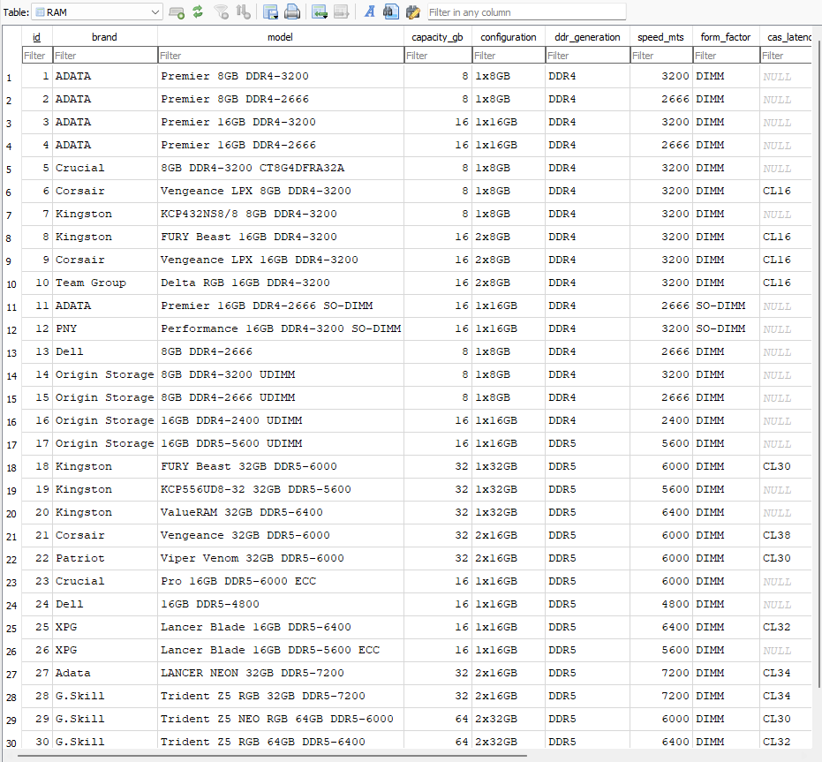
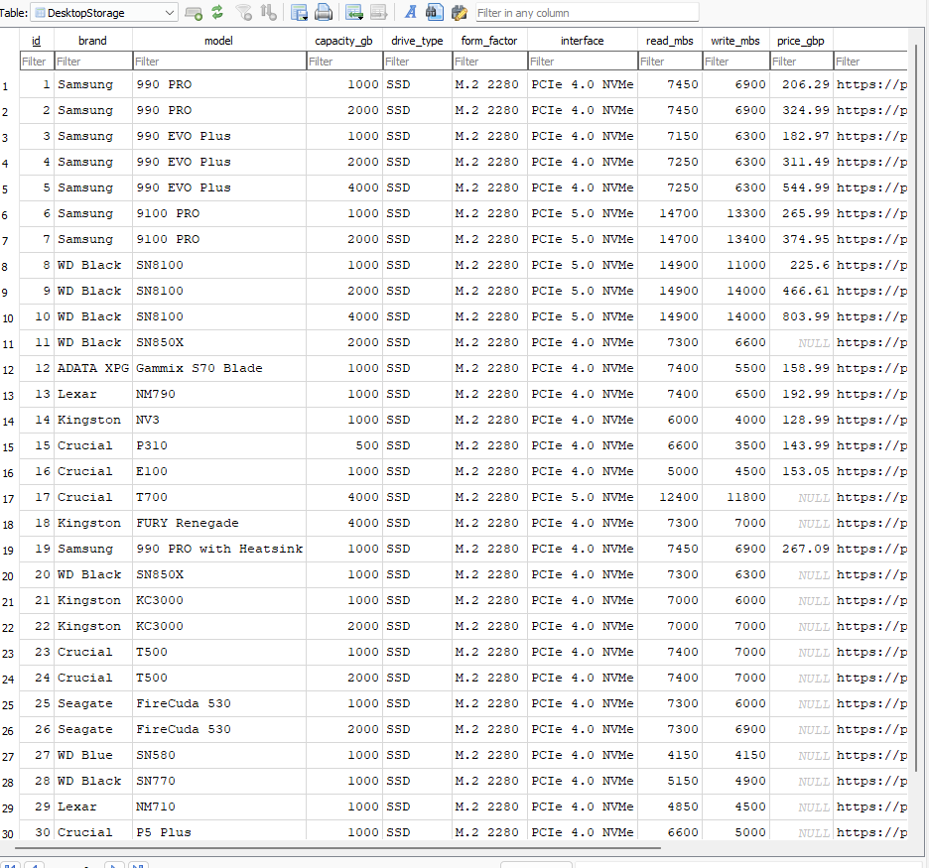
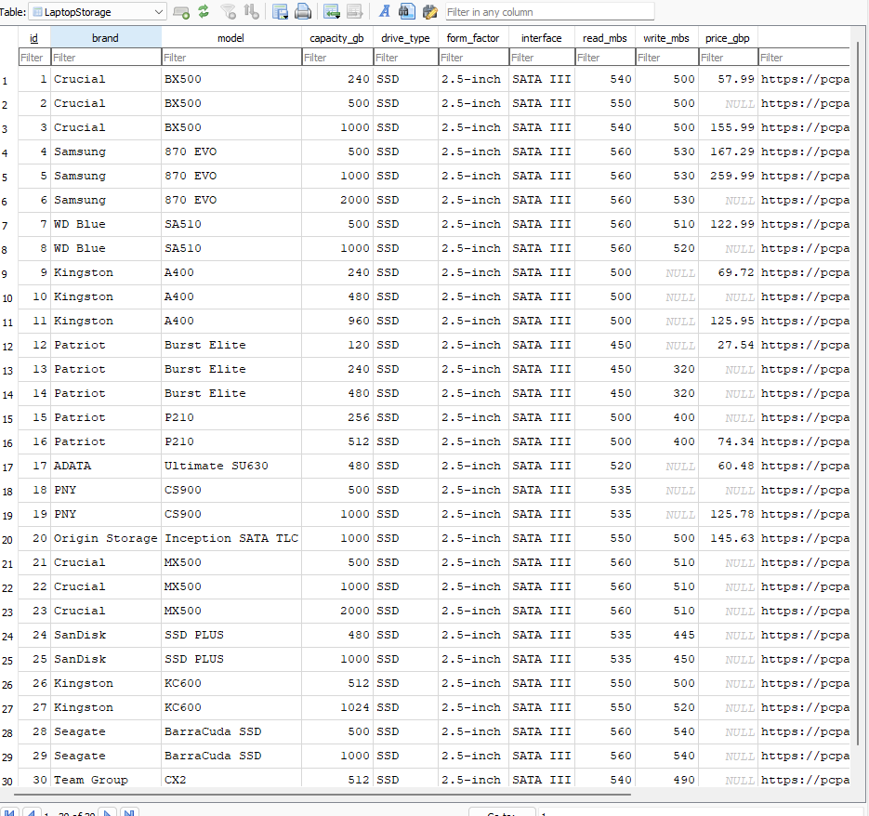
I split laptop and desktop storages into two tables since they both use different form factors.
Fields:
RAM: brand, model, capacity_gb, configuration, ddr_generation, speed_mts, form_factor, cas_latency, price_gbp, product_url, price_checked
Desktop Storage: brand, model, capacity_gb, drive_type, form_factor, interface, read_mbs, write_mbs, price_gbp, product_url, price_checked
Laptop Storage: brand, model, capacity_gb, drive_type, form_factor, interface, read_mbs, write_mbs, price_gbp, product_url, price_checked.

SQL Code example for DesktopStorage:
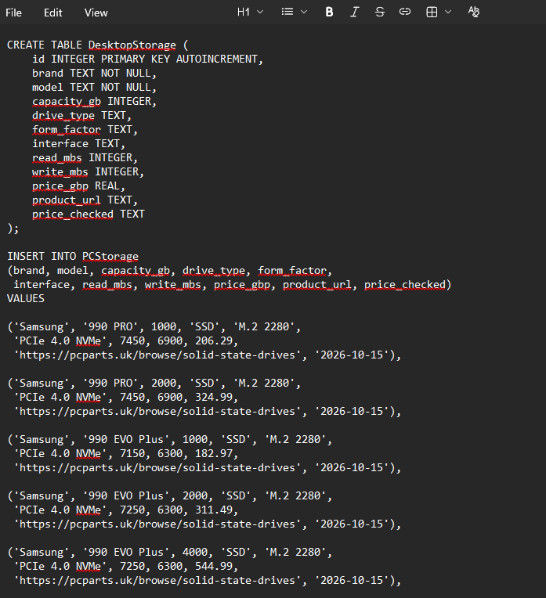
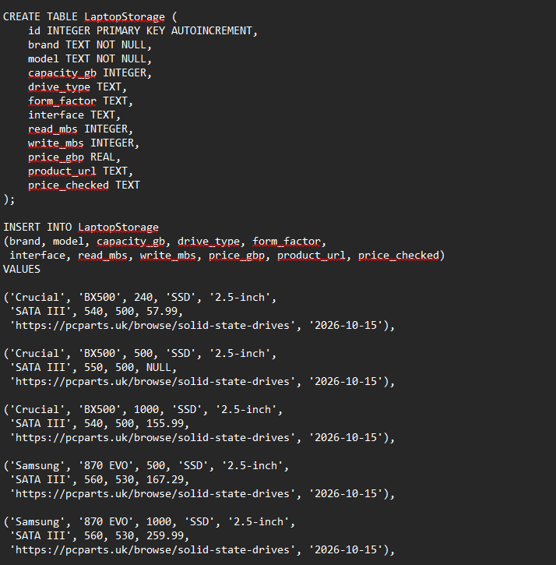
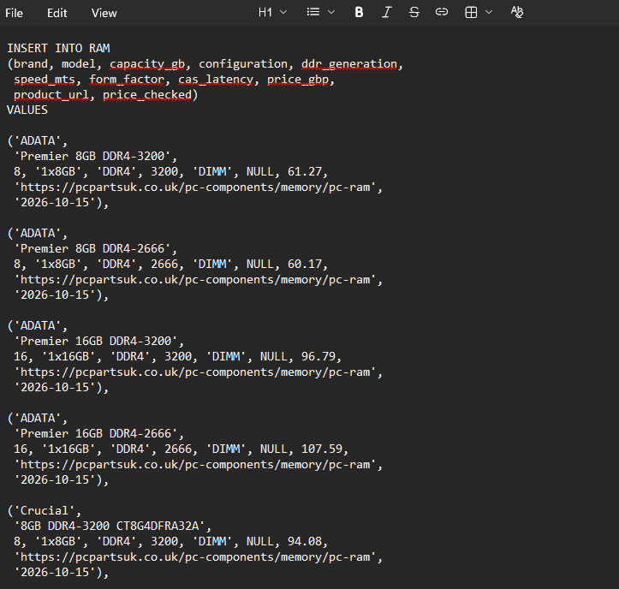
I added roughly 30 components to each table, I was unable to return all of the information for each record, hence why some values are null.

Now, to get the main application to use the databases, I first imported sqlite3 to connect the database to the python code and then connected the components.db file:
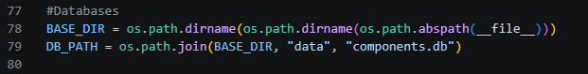

Next, I created the function to display the records in the tables in a separate window opened by clicking on the storage upgrade database button.
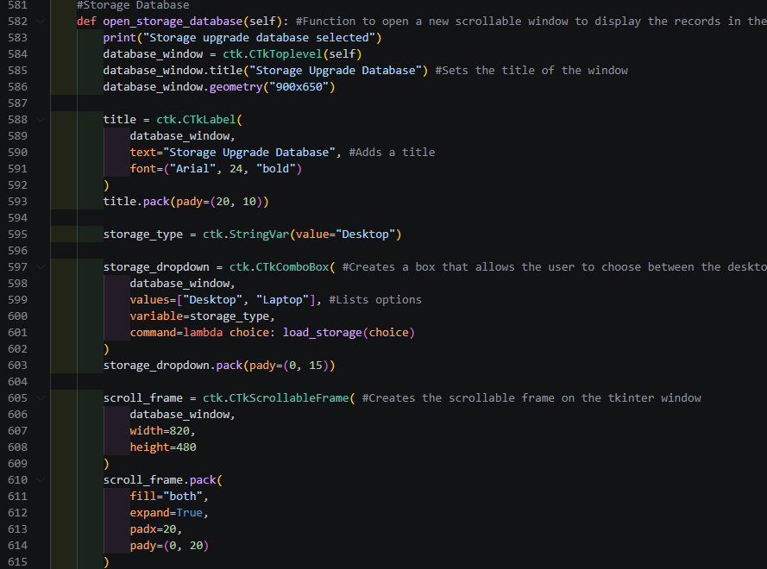
Followed by a sub function to return parts of the table to display on the window in a bullet-point style format:
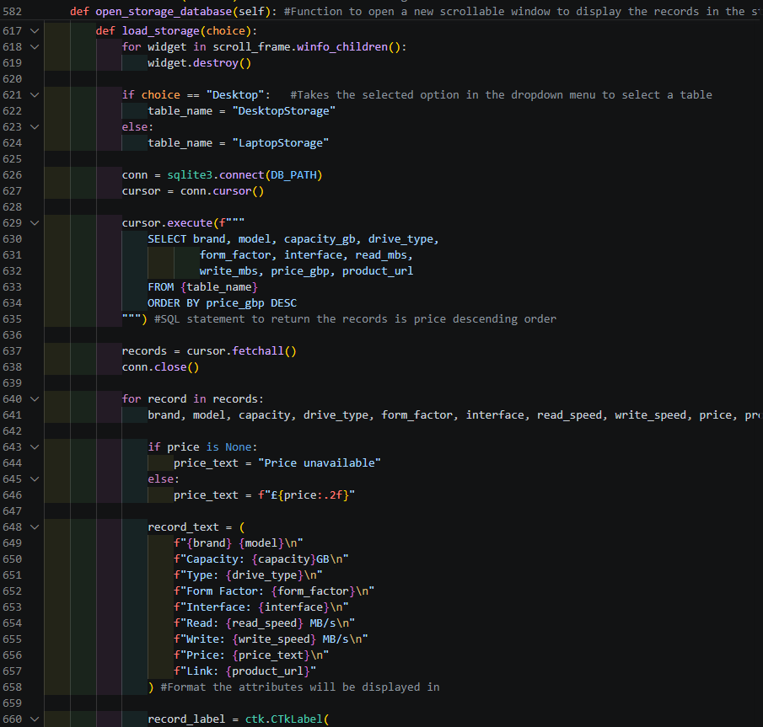
This open a new window with a scroller when the function is called. This window will contain a dropmenu at the top that allows the user to switch from laptop and desktop PC secondary storage. In the desktop page, the attributes listed in the SQL statement will be displayed on the window from the DesktopStorage, same for laptop storage when its selected, it will display the attributes from LaptopStorage.
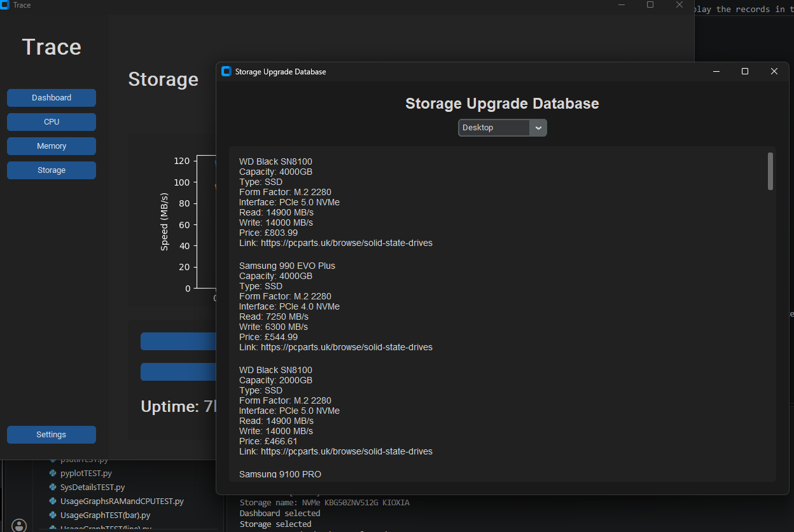
I did the same procedure for both memory and CPU, just without the dropdown menu since it is unnecessary, and took a similar code format:
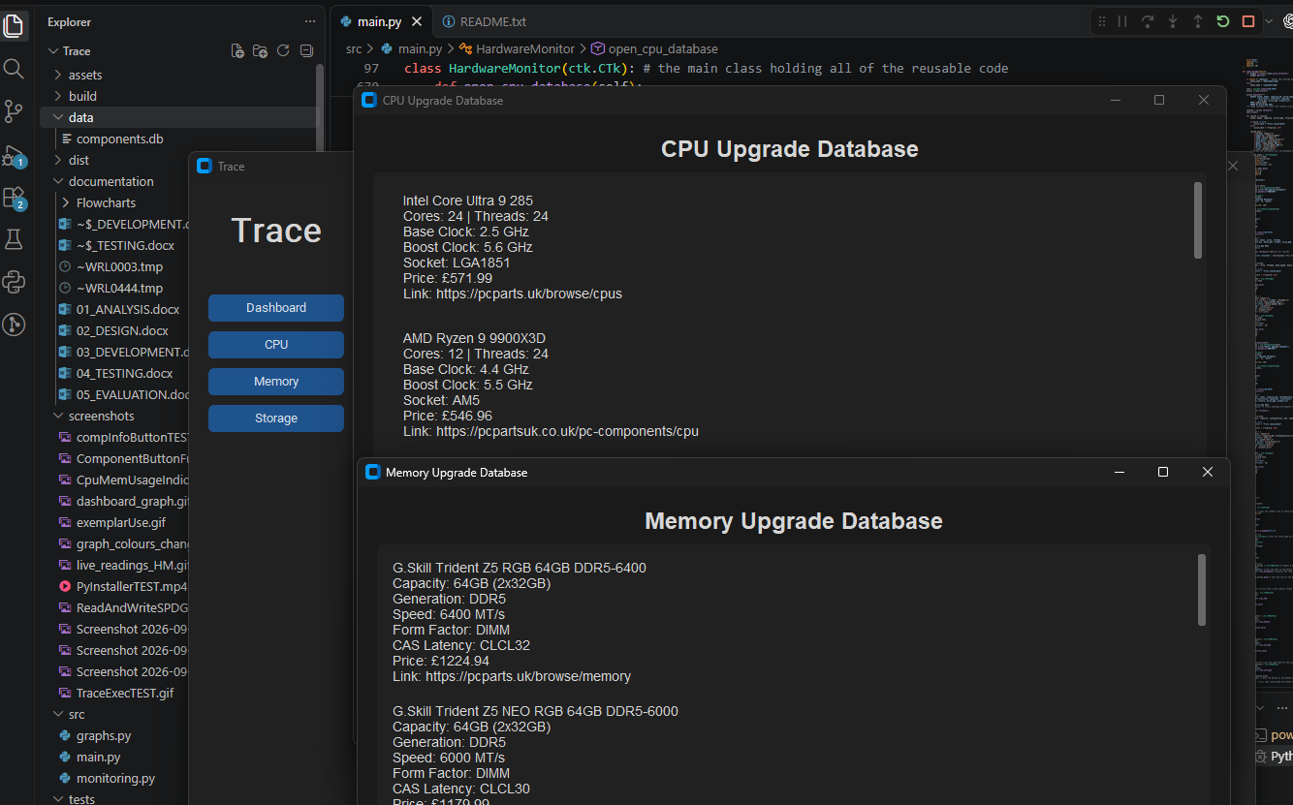

END OF IMPLEMENTATION

